UNITED STATES
SECURITIES AND EXCHANGE COMMISSION
Washington, D.C. 20549
___________________________
FORM 6-K
___________________________
REPORT OF FOREIGN PRIVATE ISSUER PURSUANT TO
SECTION 13a-16 OR 15d-16
UNDER THE SECURITIES EXCHANGE ACT OF 1934
Date: For the month of October 2026
Commission File Number: 001-41912
___________________________
Ferrovial N.V.
___________________________
Gustav Mahlerplein 61-63
Symphony Towers, 14th Floor
1082 MS Amsterdam
The Netherlands
Tel: +31 20798 37 02
(Address of principal executive office)
Indicate by check mark whether the registrant files or will file annual reports under cover of
Form 20-F or Form 40-F.
Form 20-F ☒ Form 40-F ☐

EXPLANATORY NOTE

Ferrovial N.V.(“Ferrovial”) is submitting this current report on Form 6-K to announce that the consortium of which
Ferrovial is a member has been selected to deliver Georgia’s I-285 East Express Lanes.
Attached to this current report on Form 6-K is:
(1) a press release dated October 15, 2026 as Exhibit 99.1.

EXHIBIT INDEX

SIGNATURES
99.1

Exhibit
No.
Description
Ferrovial N.V.
Pursuant to the requirements of the Securities Exchange Act of 1934, as amended, the registrant

has duly caused this report to be signed on its behalf by the undersigned, thereunto duly

authorized.
Date: October 15, 2026
By: /s/ Ernesto López Mozo
Ernesto López Mozo
Chief Financial Officer
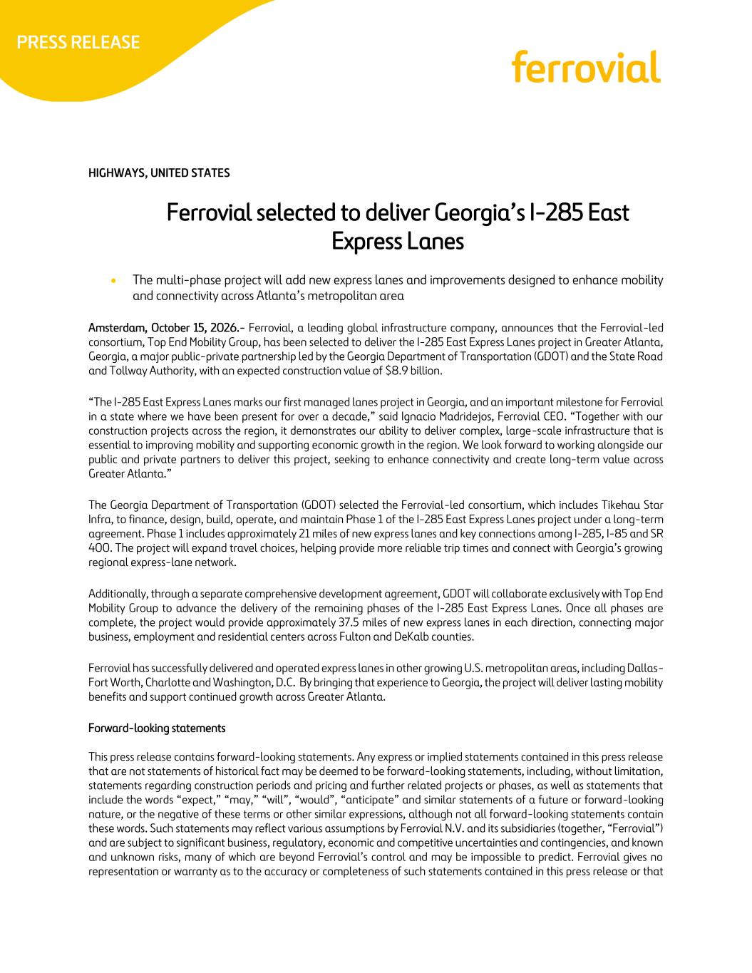
HIGHWAYS, UNITED STATES Ferrovial selected to deliver Georgia’s I-285 East Express Lanes • The multi-phase project will add new express lanes and improvements designed to enhance mobility and connectivity across Atlanta’s metropolitan area Amsterdam, October 15, 2026.- Ferrovial, a leading global infrastructure company, announces that the Ferrovial-led consortium, Top End Mobility Group, has been selected to deliver the I-285 East Express Lanes project in Greater Atlanta, Georgia, a major public-private partnership led by the Georgia Department of Transportation (GDOT) and the State Road and Tollway Authority, with an expected construction value of $8.9 billion. “The I-285 East Express Lanes marks our first managed lanes project in Georgia, and an important milestone for Ferrovial in a state where we have been present for over a decade,” said Ignacio Madridejos, Ferrovial CEO. “Together with our construction projects across the region, it demonstrates our ability to deliver complex, large-scale infrastructure that is essential to improving mobility and supporting economic growth in the region. We look forward to working alongside our public and private partners to deliver this project, seeking to enhance connectivity and create long-term value across Greater Atlanta.” The Georgia Department of Transportation (GDOT) selected the Ferrovial-led consortium, which includes Tikehau Star Infra, to finance, design, build, operate, and maintain Phase 1 of the I-285 East Express Lanes project under a long-term agreement. Phase 1 includes approximately 21 miles of new express lanes and key connections among I-285, I-85 and SR 400. The project will expand travel choices, helping provide more reliable trip times and connect with Georgia’s growing regional express-lane network. Additionally, through a separate comprehensive development agreement, GDOT will collaborate exclusively with Top End Mobility Group to advance the delivery of the remaining phases of the I-285 East Express Lanes. Once all phases are complete, the project would provide approximately 37.5 miles of new express lanes in each direction, connecting major business, employment and residential centers across Fulton and DeKalb counties. Ferrovial has successfully delivered and operated express lanes in other growing U.S. metropolitan areas, including Dallas- Fort Worth, Charlotte and Washington, D.C. By bringing that experience to Georgia, the project will deliver lasting mobility benefits and support continued growth across Greater Atlanta. Forward-looking statements This press release contains forward-looking statements. Any express or implied statements contained in this press release that are not statements of historical fact may be deemed to be forward-looking statements, including, without limitation, statements regarding construction periods and pricing and further related projects or phases, as well as statements that include the words “expect,” “may,” “will”, “would”, “anticipate” and similar statements of a future or forward-looking nature, or the negative of these terms or other similar expressions, although not all forward-looking statements contain these words. Such statements may reflect various assumptions by Ferrovial N.V. and its subsidiaries (together, “Ferrovial”) and are subject to significant business, regulatory, economic and competitive uncertainties and contingencies, and known and unknown risks, many of which are beyond Ferrovial’s control and may be impossible to predict. Ferrovial gives no representation or warranty as to the accuracy or completeness of such statements contained in this press release or that

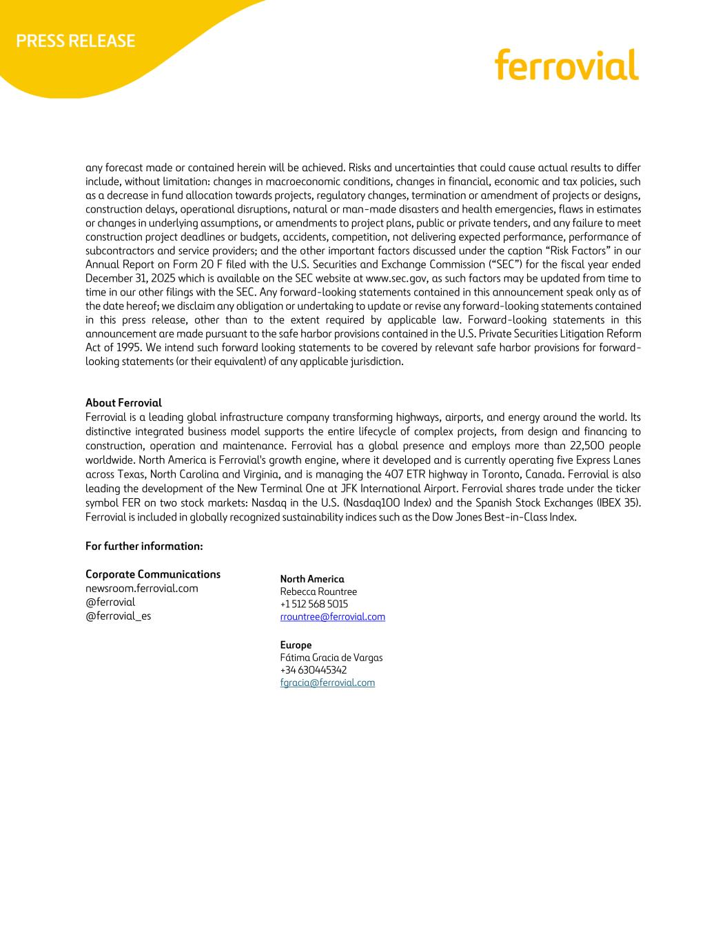
any forecast made or contained herein will be achieved. Risks and uncertainties that could cause actual results to differ include, without limitation: changes in macroeconomic conditions, changes in financial, economic and tax policies, such as a decrease in fund allocation towards projects, regulatory changes, termination or amendment of projects or designs, construction delays, operational disruptions, natural or man-made disasters and health emergencies, flaws in estimates or changes in underlying assumptions, or amendments to project plans, public or private tenders, and any failure to meet construction project deadlines or budgets, accidents, competition, not delivering expected performance, performance of subcontractors and service providers; and the other important factors discussed under the caption “Risk Factors” in our Annual Report on Form 20 F filed with the U.S. Securities and Exchange Commission (“SEC”) for the fiscal year ended December 31, 2025 which is available on the SEC website at www.sec.gov, as such factors may be updated from time to time in our other filings with the SEC. Any forward-looking statements contained in this announcement speak only as of the date hereof; we disclaim any obligation or undertaking to update or revise any forward-looking statements contained in this press release, other than to the extent required by applicable law. Forward-looking statements in this announcement are made pursuant to the safe harbor provisions contained in the U.S. Private Securities Litigation Reform Act of 1995. We intend such forward looking statements to be covered by relevant safe harbor provisions for forward- looking statements (or their equivalent) of any applicable jurisdiction. About Ferrovial Ferrovial is a leading global infrastructure company transforming highways, airports, and energy around the world. Its distinctive integrated business model supports the entire lifecycle of complex projects, from design and financing to construction, operation and maintenance. Ferrovial has a global presence and employs more than 22,500 people worldwide. North America is Ferrovial's growth engine, where it developed and is currently operating five Express Lanes across Texas, North Carolina and Virginia, and is managing the 407 ETR highway in Toronto, Canada. Ferrovial is also leading the development of the New Terminal One at JFK International Airport. Ferrovial shares trade under the ticker symbol FER on two stock markets: Nasdaq in the U.S. (Nasdaq100 Index) and the Spanish Stock Exchanges (IBEX 35). Ferrovial is included in globally recognized sustainability indices such as the Dow Jones Best-in-Class Index. For further information: Corporate Communications newsroom.ferrovial.com @ferrovial @ferrovial_es North America Rebecca Rountree +1 512 568 5015 rrountree@ferrovial.com Europe Fátima Gracia de Vargas +34 630445342 fgracia@ferrovial.com

