UNITED STATES
SECURITIES AND EXCHANGE COMMISSION
Washington, D.C. 20549
___________________________
FORM 6-K
___________________________
REPORT OF FOREIGN PRIVATE ISSUER PURSUANT TO
SECTION 13a-16 OR 15d-16
UNDER THE SECURITIES EXCHANGE ACT OF 1934
Date: For the month of July 2026
Commission File Number: 001-41912
___________________________
Ferrovial N.V.
___________________________
Gustav Mahlerplein 61-63
Symphony Towers, 14th Floor
1082 MS Amsterdam
The Netherlands
Tel: +31 20798 37 02
(Address of principal executive office)
Indicate by check mark whether the registrant files or will file annual reports under cover of
Form 20-F or Form 40-F.
Form 20-F ☒ Form 40-F ☐

EXPLANATORY NOTE

Ferrovial N.V. is submitting this current report on Form 6-K to disclose changes in the
composition of its Board of Directors.
Attached to this report on Form 6-K is:
(1) a press release dated July 28, 2026 as Exhibit 99.1.

EXHIBIT INDEX

SIGNATURES
99.1

Exhibit
No.
Description
Ferrovial N.V.
Pursuant to the requirements of the Securities Exchange Act of 1934, as amended, the registrant

has duly caused this report to be signed on its behalf by the undersigned, thereunto duly

authorized.
Date: July 28, 2026
By: /s/ Ernesto López Mozo
Ernesto López Mozo
Chief Financial Officer
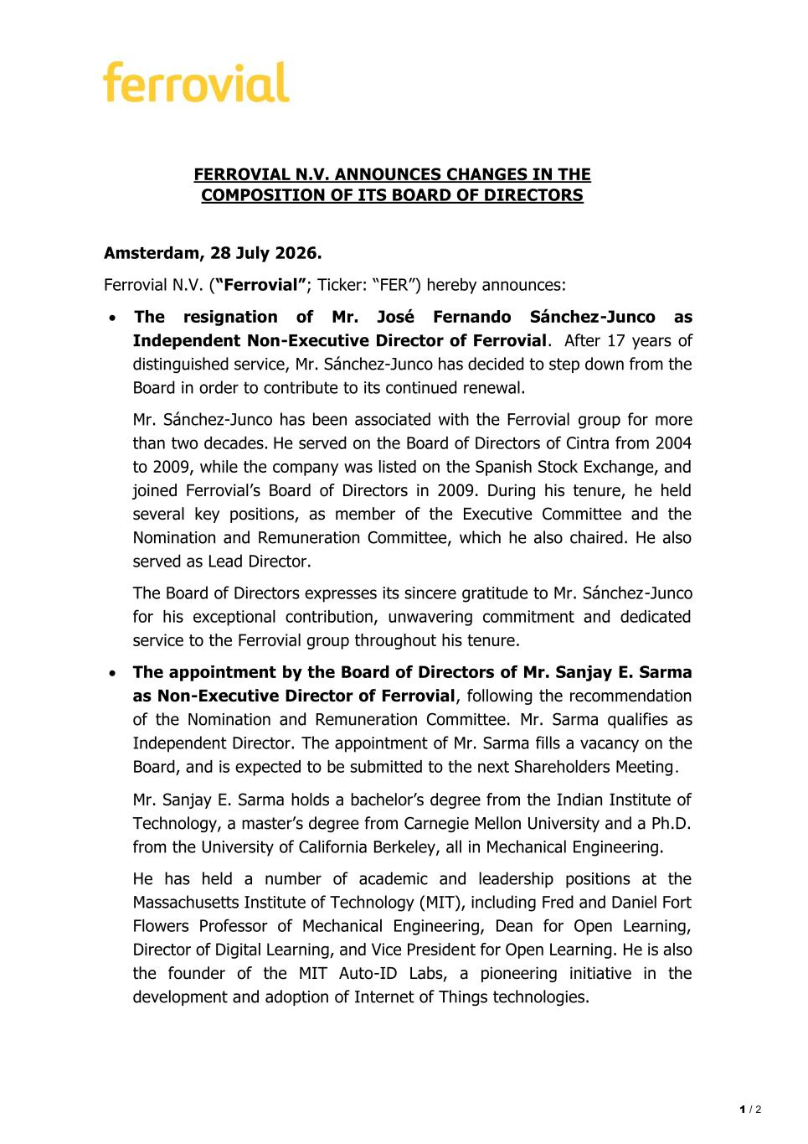
1 / 2 FERROVIAL N.V. ANNOUNCES CHANGES IN THE COMPOSITION OF ITS BOARD OF DIRECTORS Amsterdam, 28 July 2026. Ferrovial N.V. (“Ferrovial”; Ticker: “FER”) hereby announces: • The resignation of Mr. José Fernando Sánchez-Junco as Independent Non-Executive Director of Ferrovial. After 17 years of distinguished service, Mr. Sánchez-Junco has decided to step down from the Board in order to contribute to its continued renewal. Mr. Sánchez-Junco has been associated with the Ferrovial group for more than two decades. He served on the Board of Directors of Cintra from 2004 to 2009, while the company was listed on the Spanish Stock Exchange, and joined Ferrovial’s Board of Directors in 2009. During his tenure, he held several key positions, as member of the Executive Committee and the Nomination and Remuneration Committee, which he also chaired. He also served as Lead Director. The Board of Directors expresses its sincere gratitude to Mr. Sánchez-Junco for his exceptional contribution, unwavering commitment and dedicated service to the Ferrovial group throughout his tenure. • The appointment by the Board of Directors of Mr. Sanjay E. Sarma as Non-Executive Director of Ferrovial, following the recommendation of the Nomination and Remuneration Committee. Mr. Sarma qualifies as Independent Director. The appointment of Mr. Sarma fills a vacancy on the Board, and is expected to be submitted to the next Shareholders Meeting. Mr. Sanjay E. Sarma holds a bachelor’s degree from the Indian Institute of Technology, a master’s degree from Carnegie Mellon University and a Ph.D. from the University of California Berkeley, all in Mechanical Engineering. He has held a number of academic and leadership positions at the Massachusetts Institute of Technology (MIT), including Fred and Daniel Fort Flowers Professor of Mechanical Engineering, Dean for Open Learning, Director of Digital Learning, and Vice President for Open Learning. He is also the founder of the MIT Auto-ID Labs, a pioneering initiative in the development and adoption of Internet of Things technologies.

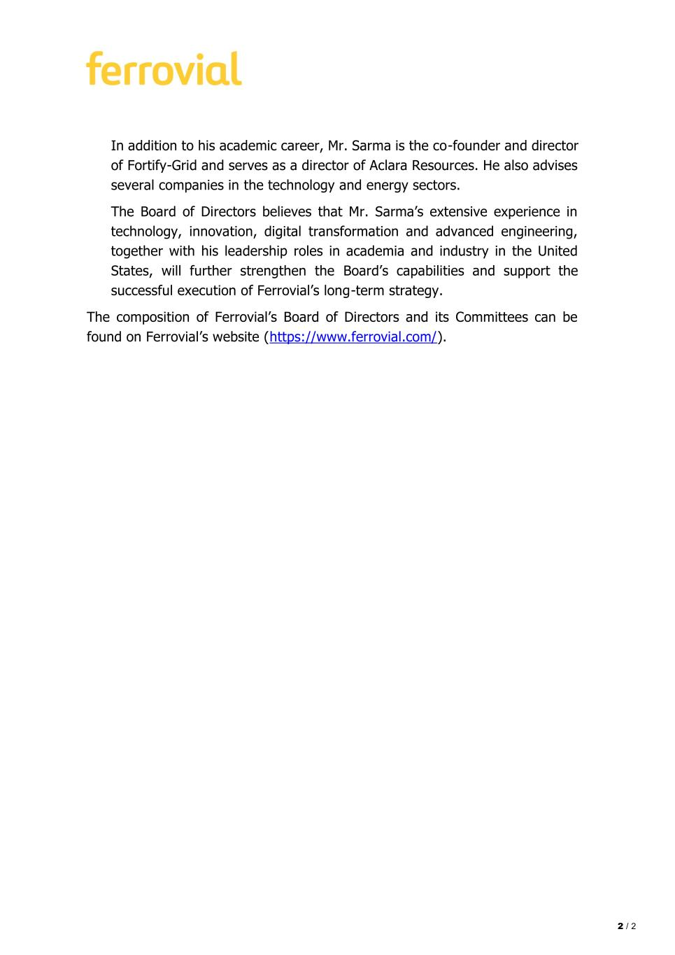
2 / 2 In addition to his academic career, Mr. Sarma is the co-founder and director of Fortify-Grid and serves as a director of Aclara Resources. He also advises several companies in the technology and energy sectors. The Board of Directors believes that Mr. Sarma’s extensive experience in technology, innovation, digital transformation and advanced engineering, together with his leadership roles in academia and industry in the United States, will further strengthen the Board’s capabilities and support the successful execution of Ferrovial’s long-term strategy. The composition of Ferrovial’s Board of Directors and its Committees can be found on Ferrovial’s website (https://www.ferrovial.com/).

