UNITED STATES
SECURITIES AND EXCHANGE COMMISSION
Washington, D.C. 20549
___________________________
FORM 6-K
___________________________
REPORT OF FOREIGN PRIVATE ISSUER PURSUANT TO
SECTION 13a-16 OR 15d-16
UNDER THE SECURITIES EXCHANGE ACT OF 1934
Date: for the month of July 2026
Commission File Number: 001-41912
___________________________
Ferrovial N.V.
___________________________
Gustav Mahlerplein 61-63
Symphony Towers, 14th Floor
1082 MS Amsterdam
The Netherlands
Tel: +31 20798 37 02
(Address of principal executive office)
Indicate by check mark whether the registrant files or will file annual reports under cover of
Form 20-F or Form 40-F.
Form 20-F ☒ Form 40-F ☐

EXPLANATORY NOTE
On July 28, 2026, Ferrovial N.V. (the “Company”) released information regarding its financial results and results of
operations for the six months ended June 30, 2026. A copy of the Company’s Management’s Discussion and
Analysis of Financial Condition and Results of Operations (Management Report), the unaudited interim condensed
consolidated financial statements of the Company as of and for the six months ended June 30, 2026, the related
presentation materials, and the related press release are furnished herewith as Exhibits 99.1, 99.2 and 99.3,
respectively.
Attached as exhibits to this current report on Form 6-K are:
(1) Ferrovial’s Management’s Discussion and Analysis of Financial Condition and Results of Operations
(Management Report) and the unaudited interim condensed consolidated financial statements of the Company as of
and for the six months ended June 30, 2026
(2) Results presentation for the six months ended June 30, 2026
(3) Press Release dated July 28, 2026

EXHIBIT INDEX

SIGNATURES
99.1
99.2
99.3

Exhibit
No.
Description
Pursuant to the requirements of the Securities Exchange Act of 1934, as amended, the registrant
has duly caused this report to be signed on its behalf by the undersigned, thereunto duly
authorized.
Ferrovial N.V.
Date: July 28, 2026
By: /s/ Ernesto López Mozo_______________
Ernesto López Mozo
Chief Financial Officer
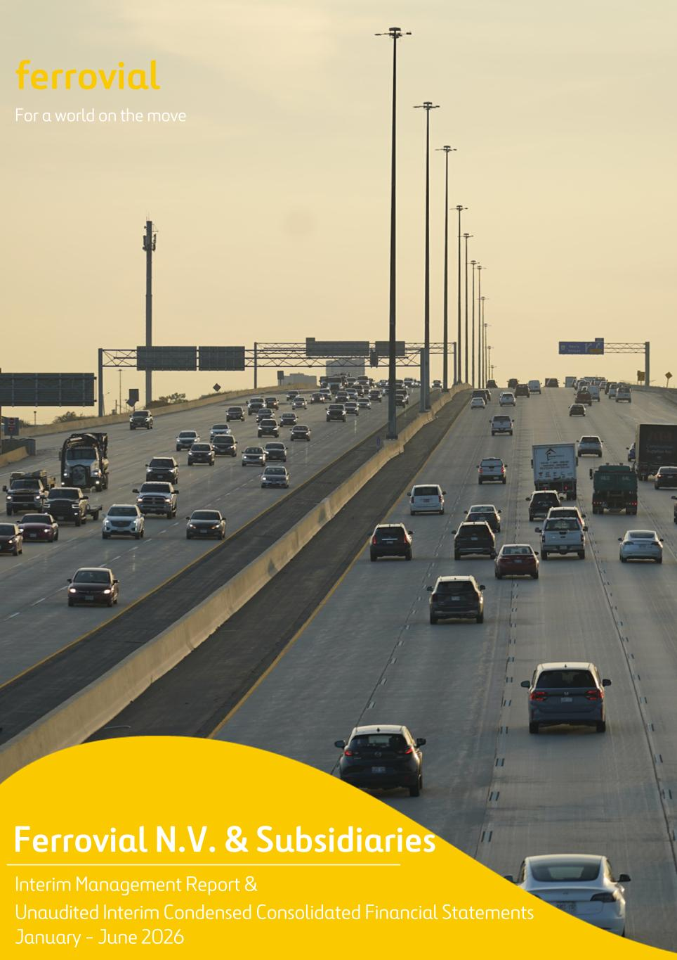
ferrovial For a world on the move Ferrovial N.V. & Subsidiaries Interim Management Report & Unaudited Interim Condensed Consolidated Financial Statements January - June 2026



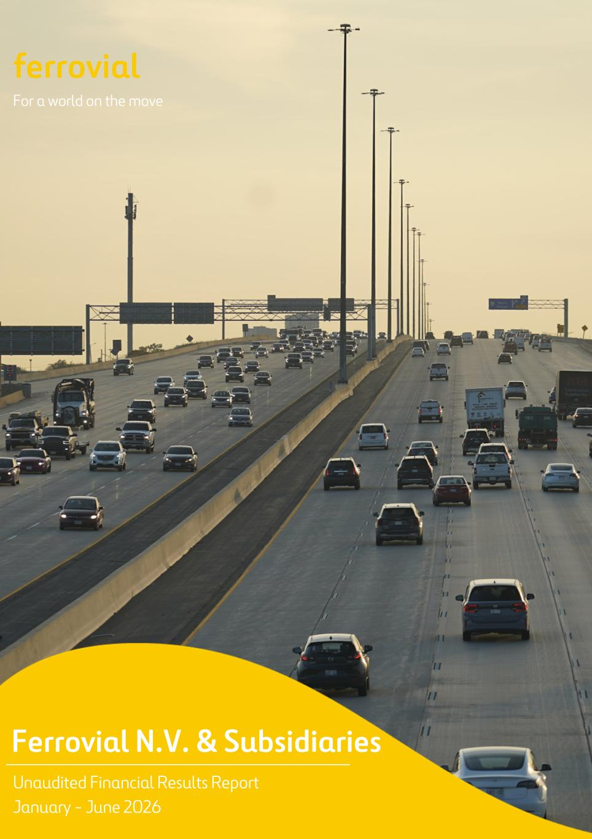
ferrovial For a world on the move Ferrovial N.V. & Subsidiaries Unaudited Financial Results Report January - June 2026

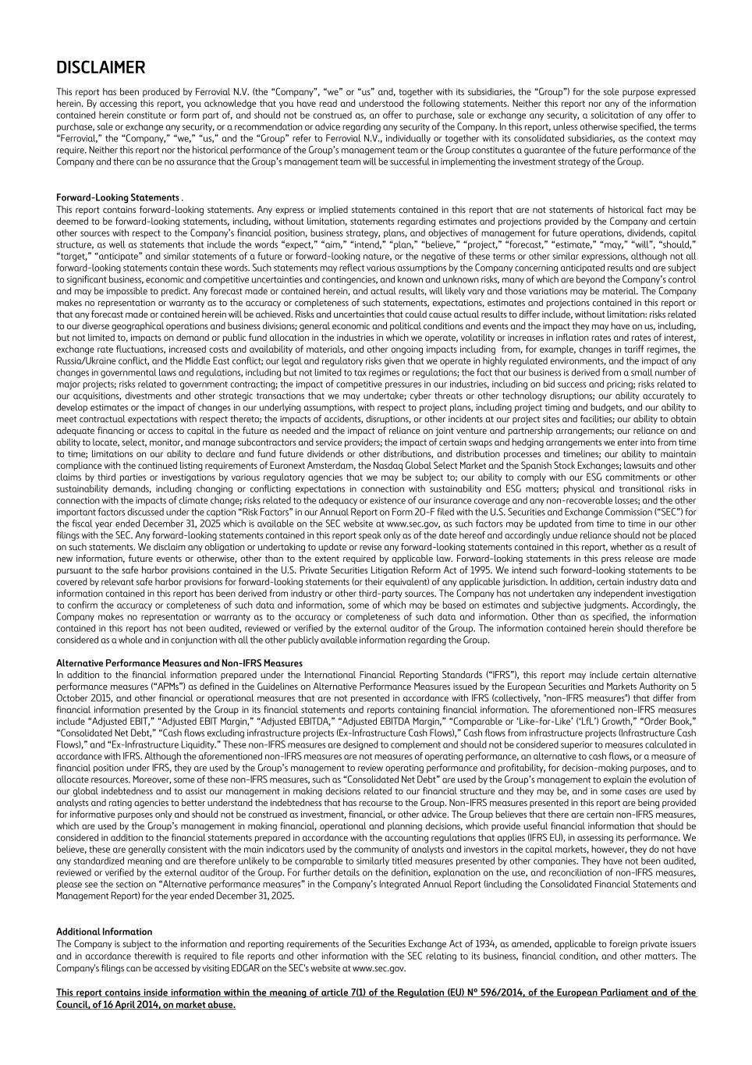
DISCLAIMER This report has been produced by Ferrovial N.V. (the “Company”, “we” or “us” and, together with its subsidiaries, the “Group”) for the sole purpose expressed herein. By accessing this report, you acknowledge that you have read and understood the following statements. Neither this report nor any of the information contained herein constitute or form part of, and should not be construed as, an offer to purchase, sale or exchange any security, a solicitation of any offer to purchase, sale or exchange any security, or a recommendation or advice regarding any security of the Company. In this report, unless otherwise specified, the terms “Ferrovial,” the “Company,” “we,” “us,” and the “Group” refer to Ferrovial N.V., individually or together with its consolidated subsidiaries, as the context may require. Neither this report nor the historical performance of the Group’s management team or the Group constitutes a guarantee of the future performance of the Company and there can be no assurance that the Group’s management team will be successful in implementing the investment strategy of the Group. Forward-Looking Statements . This report contains forward-looking statements. Any express or implied statements contained in this report that are not statements of historical fact may be deemed to be forward-looking statements, including, without limitation, statements regarding estimates and projections provided by the Company and certain other sources with respect to the Company’s financial position, business strategy, plans, and objectives of management for future operations, dividends, capital structure, as well as statements that include the words “expect,” “aim,” “intend,” “plan,” “believe,” “project,” “forecast,” “estimate,” “may,” “will”, “should,” “target,” “anticipate” and similar statements of a future or forward-looking nature, or the negative of these terms or other similar expressions, although not all forward-looking statements contain these words. Such statements may reflect various assumptions by the Company concerning anticipated results and are subject to significant business, economic and competitive uncertainties and contingencies, and known and unknown risks, many of which are beyond the Company’s control and may be impossible to predict. Any forecast made or contained herein, and actual results, will likely vary and those variations may be material. The Company makes no representation or warranty as to the accuracy or completeness of such statements, expectations, estimates and projections contained in this report or that any forecast made or contained herein will be achieved. Risks and uncertainties that could cause actual results to differ include, without limitation: risks related to our diverse geographical operations and business divisions; general economic and political conditions and events and the impact they may have on us, including, but not limited to, impacts on demand or public fund allocation in the industries in which we operate, volatility or increases in inflation rates and rates of interest, exchange rate fluctuations, increased costs and availability of materials, and other ongoing impacts including from, for example, changes in tariff regimes, the Russia/Ukraine conflict, and the Middle East conflict; our legal and regulatory risks given that we operate in highly regulated environments, and the impact of any changes in governmental laws and regulations, including but not limited to tax regimes or regulations; the fact that our business is derived from a small number of major projects; risks related to government contracting; the impact of competitive pressures in our industries, including on bid success and pricing; risks related to our acquisitions, divestments and other strategic transactions that we may undertake; cyber threats or other technology disruptions; our ability accurately to develop estimates or the impact of changes in our underlying assumptions, with respect to project plans, including project timing and budgets, and our ability to meet contractual expectations with respect thereto; the impacts of accidents, disruptions, or other incidents at our project sites and facilities; our ability to obtain adequate financing or access to capital in the future as needed and the impact of reliance on joint venture and partnership arrangements; our reliance on and ability to locate, select, monitor, and manage subcontractors and service providers; the impact of certain swaps and hedging arrangements we enter into from time to time; limitations on our ability to declare and fund future dividends or other distributions, and distribution processes and timelines; our ability to maintain compliance with the continued listing requirements of Euronext Amsterdam, the Nasdaq Global Select Market and the Spanish Stock Exchanges; lawsuits and other claims by third parties or investigations by various regulatory agencies that we may be subject to; our ability to comply with our ESG commitments or other sustainability demands, including changing or conflicting expectations in connection with sustainability and ESG matters; physical and transitional risks in connection with the impacts of climate change; risks related to the adequacy or existence of our insurance coverage and any non-recoverable losses; and the other important factors discussed under the caption “Risk Factors” in our Annual Report on Form 20-F filed with the U.S. Securities and Exchange Commission (“SEC”) for the fiscal year ended December 31, 2025 which is available on the SEC website at www.sec.gov, as such factors may be updated from time to time in our other filings with the SEC. Any forward-looking statements contained in this report speak only as of the date hereof and accordingly undue reliance should not be placed on such statements. We disclaim any obligation or undertaking to update or revise any forward-looking statements contained in this report, whether as a result of new information, future events or otherwise, other than to the extent required by applicable law. Forward-looking statements in this press release are made pursuant to the safe harbor provisions contained in the U.S. Private Securities Litigation Reform Act of 1995. We intend such forward-looking statements to be covered by relevant safe harbor provisions for forward-looking statements (or their equivalent) of any applicable jurisdiction. In addition, certain industry data and information contained in this report has been derived from industry or other third-party sources. The Company has not undertaken any independent investigation to confirm the accuracy or completeness of such data and information, some of which may be based on estimates and subjective judgments. Accordingly, the Company makes no representation or warranty as to the accuracy or completeness of such data and information. Other than as specified, the information contained in this report has not been audited, reviewed or verified by the external auditor of the Group. The information contained herein should therefore be considered as a whole and in conjunction with all the other publicly available information regarding the Group. Alternative Performance Measures and Non-IFRS Measures In addition to the financial information prepared under the International Financial Reporting Standards (“IFRS”), this report may include certain alternative performance measures (“APMs”) as defined in the Guidelines on Alternative Performance Measures issued by the European Securities and Markets Authority on 5 October 2015, and other financial or operational measures that are not presented in accordance with IFRS (collectively, "non-IFRS measures") that differ from financial information presented by the Group in its financial statements and reports containing financial information. The aforementioned non-IFRS measures include “Adjusted EBIT,” “Adjusted EBIT Margin,” “Adjusted EBITDA,” “Adjusted EBITDA Margin,” “Comparable or ‘Like-for-Like’ (‘LfL’) Growth,” “Order Book,” “Consolidated Net Debt,” “Cash flows excluding infrastructure projects (Ex-Infrastructure Cash Flows),” Cash flows from infrastructure projects (Infrastructure Cash Flows),” and “Ex-Infrastructure Liquidity.” These non-IFRS measures are designed to complement and should not be considered superior to measures calculated in accordance with IFRS. Although the aforementioned non-IFRS measures are not measures of operating performance, an alternative to cash flows, or a measure of financial position under IFRS, they are used by the Group’s management to review operating performance and profitability, for decision-making purposes, and to allocate resources. Moreover, some of these non-IFRS measures, such as “Consolidated Net Debt” are used by the Group’s management to explain the evolution of our global indebtedness and to assist our management in making decisions related to our financial structure and they may be, and in some cases are used by analysts and rating agencies to better understand the indebtedness that has recourse to the Group. Non-IFRS measures presented in this report are being provided for informative purposes only and should not be construed as investment, financial, or other advice. The Group believes that there are certain non-IFRS measures, which are used by the Group’s management in making financial, operational and planning decisions, which provide useful financial information that should be considered in addition to the financial statements prepared in accordance with the accounting regulations that applies (IFRS EU), in assessing its performance. We believe, these are generally consistent with the main indicators used by the community of analysts and investors in the capital markets, however, they do not have any standardized meaning and are therefore unlikely to be comparable to similarly titled measures presented by other companies. They have not been audited, reviewed or verified by the external auditor of the Group. For further details on the definition, explanation on the use, and reconciliation of non-IFRS measures, please see the section on “Alternative performance measures” in the Company’s Integrated Annual Report (including the Consolidated Financial Statements and Management Report) for the year ended December 31, 2025. Additional Information The Company is subject to the information and reporting requirements of the Securities Exchange Act of 1934, as amended, applicable to foreign private issuers and in accordance therewith is required to file reports and other information with the SEC relating to its business, financial condition, and other matters. The Company's filings can be accessed by visiting EDGAR on the SEC's website at www.sec.gov. This report contains inside information within the meaning of article 7(1) of the Regulation (EU) Nº 596/2014, of the European Parliament and of the Council, of 16 April 2014, on market abuse.

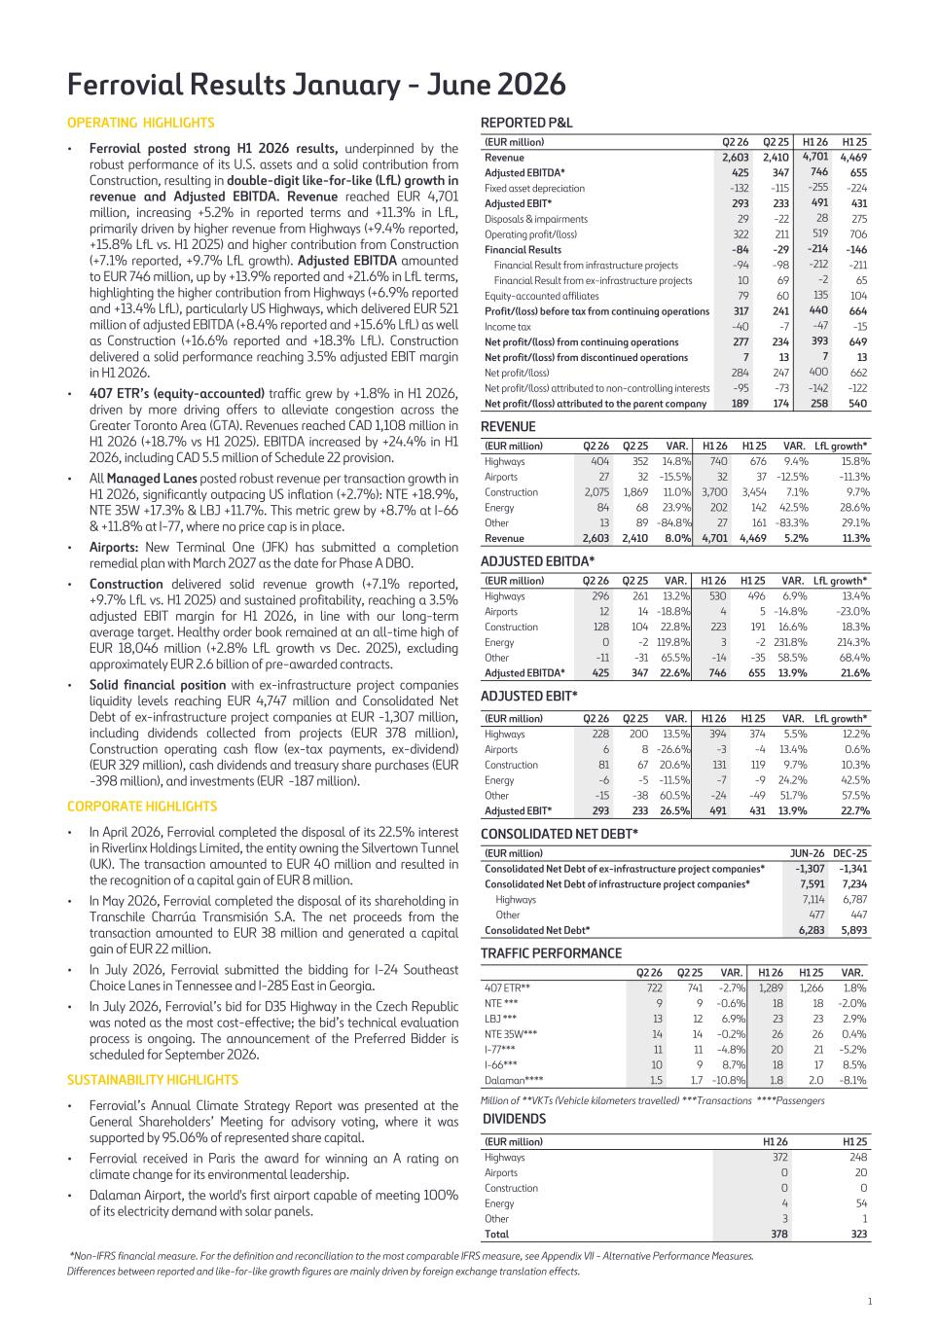
Ferrovial Results January - June 2026 OPERATING HIGHLIGHTS • Ferrovial posted strong H1 2026 results, underpinned by the robust performance of its U.S. assets and a solid contribution from Construction, resulting in double-digit like-for-like (LfL) growth in revenue and Adjusted EBITDA. Revenue reached EUR 4,701 million, increasing +5.2% in reported terms and +11.3% in LfL, primarily driven by higher revenue from Highways (+9.4% reported, +15.8% LfL vs. H1 2025) and higher contribution from Construction (+7.1% reported, +9.7% LfL growth). Adjusted EBITDA amounted to EUR 746 million, up by +13.9% reported and +21.6% in LfL terms, highlighting the higher contribution from Highways (+6.9% reported and +13.4% LfL), particularly US Highways, which delivered EUR 521 million of adjusted EBITDA (+8.4% reported and +15.6% LfL) as well as Construction (+16.6% reported and +18.3% LfL). Construction delivered a solid performance reaching 3.5% adjusted EBIT margin in H1 2026. • 407 ETR’s (equity-accounted) traffic grew by +1.8% in H1 2026, driven by more driving offers to alleviate congestion across the Greater Toronto Area (GTA). Revenues reached CAD 1,108 million in H1 2026 (+18.7% vs H1 2025). EBITDA increased by +24.4% in H1 2026, including CAD 5.5 million of Schedule 22 provision. • All Managed Lanes posted robust revenue per transaction growth in H1 2026, significantly outpacing US inflation (+2.7%): NTE +18.9%, NTE 35W +17.3% & LBJ +11.7%. This metric grew by +8.7% at I-66 & +11.8% at I-77, where no price cap is in place. • Airports: New Terminal One (JFK) has submitted a completion remedial plan with March 2027 as the date for Phase A DBO. • Construction delivered solid revenue growth (+7.1% reported, +9.7% LfL vs. H1 2025) and sustained profitability, reaching a 3.5% adjusted EBIT margin for H1 2026, in line with our long-term average target. Healthy order book remained at an all-time high of EUR 18,046 million (+2.8% LfL growth vs Dec. 2025), excluding approximately EUR 2.6 billion of pre-awarded contracts. • Solid financial position with ex-infrastructure project companies liquidity levels reaching EUR 4,747 million and Consolidated Net Debt of ex-infrastructure project companies at EUR -1,307 million, including dividends collected from projects (EUR 378 million), Construction operating cash flow (ex-tax payments, ex-dividend) (EUR 329 million), cash dividends and treasury share purchases (EUR -398 million), and investments (EUR -187 million). CORPORATE HIGHLIGHTS • In April 2026, Ferrovial completed the disposal of its 22.5% interest in Riverlinx Holdings Limited, the entity owning the Silvertown Tunnel (UK). The transaction amounted to EUR 40 million and resulted in the recognition of a capital gain of EUR 8 million. • In May 2026, Ferrovial completed the disposal of its shareholding in Transchile Charrúa Transmisión S.A. The net proceeds from the transaction amounted to EUR 38 million and generated a capital gain of EUR 22 million. • In July 2026, Ferrovial submitted the bidding for I-24 Southeast Choice Lanes in Tennessee and I-285 East in Georgia. • In July 2026, Ferrovial’s bid for D35 Highway in the Czech Republic was noted as the most cost-effective; the bid’s technical evaluation process is ongoing. The announcement of the Preferred Bidder is scheduled for September 2026. SUSTAINABILITY HIGHLIGHTS • Ferrovial’s Annual Climate Strategy Report was presented at the General Shareholders’ Meeting for advisory voting, where it was supported by 95.06% of represented share capital. • Ferrovial received in Paris the award for winning an A rating on climate change for its environmental leadership. • Dalaman Airport, the world's first airport capable of meeting 100% of its electricity demand with solar panels. REPORTED P&L (EUR million) Q2 26 Q2 25 H1 26 H1 25 Revenue 2,603 2,410 4,701 4,469 Adjusted EBITDA* 425 347 746 655 Fixed asset depreciation -132 -115 -255 -224 Adjusted EBIT* 293 233 491 431 Disposals & impairments 29 -22 28 275 Operating profit/(loss) 322 211 519 706 Financial Results -84 -29 -214 -146 Financial Result from infrastructure projects -94 -98 -212 -211 Financial Result from ex-infrastructure projects 10 69 -2 65 Equity-accounted affiliates 79 60 135 104 Profit/(loss) before tax from continuing operations 317 241 440 664 Income tax -40 -7 -47 -15 Net profit/(loss) from continuing operations 277 234 393 649 Net profit/(loss) from discontinued operations 7 13 7 13 Net profit/(loss) 284 247 400 662 Net profit/(loss) attributed to non-controlling interests -95 -73 -142 -122 Net profit/(loss) attributed to the parent company 189 174 258 540 REVENUE (EUR million) Q2 26 Q2 25 VAR. H1 26 H1 25 VAR. LfL growth* Highways 404 352 14.8 % 740 676 9.4 % 15.8 % Airports 27 32 -15.5 % 32 37 -12.5 % -11.3 % Construction 2,075 1,869 11.0 % 3,700 3,454 7.1 % 9.7 % Energy 84 68 23.9 % 202 142 42.5 % 28.6 % Other 13 89 -84.8 % 27 161 -83.3 % 29.1 % Revenue 2,603 2,410 8.0 % 4,701 4,469 5.2 % 11.3 % ADJUSTED EBITDA* (EUR million) Q2 26 Q2 25 VAR. H1 26 H1 25 VAR. LfL growth* Highways 296 261 13.2 % 530 496 6.9 % 13.4 % Airports 12 14 -18.8 % 4 5 -14.8 % -23.0 % Construction 128 104 22.8 % 223 191 16.6 % 18.3 % Energy 0 -2 119.8 % 3 -2 231.8 % 214.3 % Other -11 -31 65.5 % -14 -35 58.5 % 68.4 % Adjusted EBITDA* 425 347 22.6 % 746 655 13.9 % 21.6 % ADJUSTED EBIT* (EUR million) Q2 26 Q2 25 VAR. H1 26 H1 25 VAR. LfL growth* Highways 228 200 13.5 % 394 374 5.5 % 12.2 % Airports 6 8 -26.6 % -3 -4 13.4 % 0.6 % Construction 81 67 20.6 % 131 119 9.7 % 10.3 % Energy -6 -5 -11.5 % -7 -9 24.2 % 42.5 % Other -15 -38 60.5 % -24 -49 51.7 % 57.5 % Adjusted EBIT* 293 233 26.5 % 491 431 13.9 % 22.7 % CONSOLIDATED NET DEBT* (EUR million) JUN-26 DEC-25 Consolidated Net Debt of ex-infrastructure project companies* -1,307 -1,341 Consolidated Net Debt of infrastructure project companies* 7,591 7,234 Highways 7,114 6,787 Other 477 447 Consolidated Net Debt* 6,283 5,893 TRAFFIC PERFORMANCE Q2 26 Q2 25 VAR. H1 26 H1 25 VAR. 407 ETR** 722 741 -2.7 % 1,289 1,266 1.8 % NTE *** 9 9 -0.6 % 18 18 -2.0 % LBJ *** 13 12 6.9 % 23 23 2.9 % NTE 35W*** 14 14 -0.2 % 26 26 0.4 % I-77*** 11 11 -4.8 % 20 21 -5.2 % I-66*** 10 9 8.7 % 18 17 8.5 % Dalaman**** 1.5 1.7 -10.8 % 1.8 2.0 -8.1 % Million of **VKTs (Vehicle kilometers travelled) ***Transactions ****Passengers DIVIDENDS (EUR million) H1 26 H1 25 Highways 372 248 Airports 0 20 Construction 0 0 Energy 4 54 Other 3 1 Total 378 323 *Non-IFRS financial measure. For the definition and reconciliation to the most comparable IFRS measure, see Appendix VII - Alternative Performance Measures. Differences between reported and like-for-like growth figures are mainly driven by foreign exchange translation effects. 1

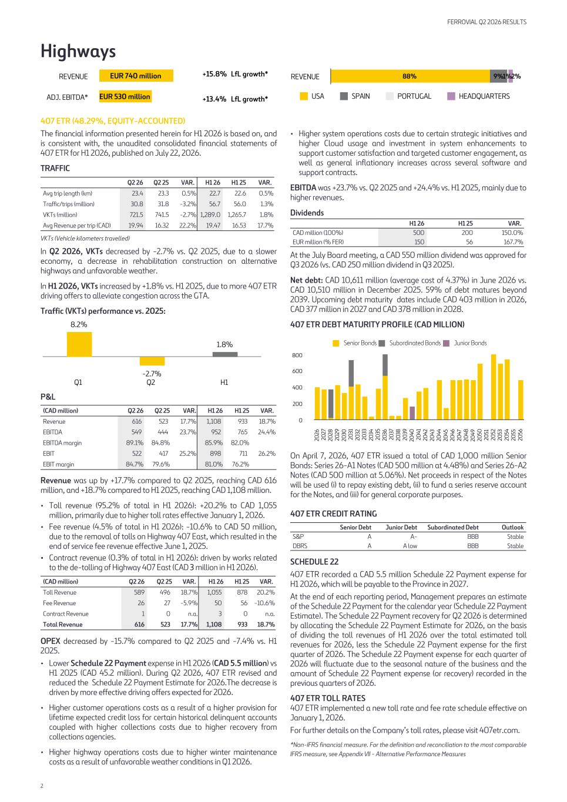
Highways EUR 740 million EUR 530 million REVENUE ADJ. EBITDA* +15.8% LfL growth* +13.4% LfL growth* 88% 9%1%2% USA SPAIN PORTUGAL HEADQUARTERS REVENUE 407 ETR (48.29%, EQUITY-ACCOUNTED) The financial information presented herein for H1 2026 is based on, and is consistent with, the unaudited consolidated financial statements of 407 ETR for H1 2026, published on July 22, 2026. TRAFFIC Q2 26 Q2 25 VAR. H1 26 H1 25 VAR. Avg trip length (km) 23.4 23.3 0.5 % 22.7 22.6 0.5 % Traffic/trips (million) 30.8 31.8 -3.2 % 56.7 56.0 1.3 % VKTs (million) 721.5 741.5 -2.7 % 1,289.0 1,265.7 1.8 % Avg Revenue per trip (CAD) 19.94 16.32 22.2 % 19.47 16.53 17.7 % VKTs (Vehicle kilometers travelled) In Q2 2026, VKTs decreased by -2.7% vs. Q2 2025, due to a slower economy, a decrease in rehabilitation construction on alternative highways and unfavorable weather. In H1 2026, VKTs increased by +1.8% vs. H1 2025, due to more 407 ETR driving offers to alleviate congestion across the GTA. Traffic (VKTs) performance vs. 2025: 8.2% -2.7% 1.8% Q1 Q2 H1 P&L (CAD million) Q2 26 Q2 25 VAR. H1 26 H1 25 VAR. Revenue 616 523 17.7 % 1,108 933 18.7 % EBITDA 549 444 23.7 % 952 765 24.4 % EBITDA margin 89.1 % 84.8 % 85.9 % 82.0 % EBIT 522 417 25.2 % 898 711 26.2 % EBIT margin 84.7 % 79.6 % 81.0 % 76.2 % Revenue was up by +17.7% compared to Q2 2025, reaching CAD 616 million, and +18.7% compared to H1 2025, reaching CAD 1,108 million. • Toll revenue (95.2% of total in H1 2026): +20.2% to CAD 1,055 million, primarily due to higher toll rates effective January 1, 2026. • Fee revenue (4.5% of total in H1 2026): -10.6% to CAD 50 million, due to the removal of tolls on Highway 407 East, which resulted in the end of service fee revenue effective June 1, 2025. • Contract revenue (0.3% of total in H1 2026): driven by works related to the de-tolling of Highway 407 East (CAD 3 million in H1 2026). (CAD million) Q2 26 Q2 25 VAR. H1 26 H1 25 VAR. Toll Revenue 589 496 18.7 % 1,055 878 20.2 % Fee Revenue 26 27 -5.9 % 50 56 -10.6 % Contract Revenue 1 0 n.a. 3 0 n.a. Total Revenue 616 523 17.7 % 1,108 933 18.7 % OPEX decreased by -15.7% compared to Q2 2025 and -7.4% vs. H1 2025. • Lower Schedule 22 Payment expense in H1 2026 (CAD 5.5 million) vs H1 2025 (CAD 45.2 million). During Q2 2026, 407 ETR revised and reduced the Schedule 22 Payment Estimate for 2026.The decrease is driven by more effective driving offers expected for 2026. • Higher customer operations costs as a result of a higher provision for lifetime expected credit loss for certain historical delinquent accounts coupled with higher collections costs due to higher recovery from collections agencies. • Higher highway operations costs due to higher winter maintenance costs as a result of unfavorable weather conditions in Q1 2026. • Higher system operations costs due to certain strategic initiatives and higher Cloud usage and investment in system enhancements to support customer satisfaction and targeted customer engagement, as well as general inflationary increases across several software and support contracts. EBITDA was +23.7% vs. Q2 2025 and +24.4% vs. H1 2025, mainly due to higher revenues. Dividends H1 26 H1 25 VAR. CAD million (100%) 500 200 150.0 % EUR million (% FER) 150 56 167.7 % At the July Board meeting, a CAD 550 million dividend was approved for Q3 2026 (vs. CAD 250 million dividend in Q3 2025). Net debt: CAD 10,611 million (average cost of 4.37%) in June 2026 vs. CAD 10,510 million in December 2025. 59% of debt matures beyond 2039. Upcoming debt maturity dates include CAD 403 million in 2026, CAD 377 million in 2027 and CAD 378 million in 2028. 407 ETR DEBT MATURITY PROFILE (CAD MILLION) Senior Bonds Subordinated Bonds Junior Bonds 20 26 20 27 20 28 20 29 20 30 20 31 20 32 20 33 20 34 20 35 20 36 20 37 20 38 20 39 20 40 20 41 20 42 20 43 20 44 20 45 20 46 20 47 20 48 20 49 20 50 20 51 20 52 20 53 20 54 20 55 20 56 0 200 400 600 800 On April 7, 2026, 407 ETR issued a total of CAD 1,000 million Senior Bonds: Series 26-A1 Notes (CAD 500 million at 4.48%) and Series 26-A2 Notes (CAD 500 million at 5.06%). Net proceeds in respect of the Notes will be used (i) to repay existing debt, (ii) to fund a series reserve account for the Notes, and (iii) for general corporate purposes. 407 ETR CREDIT RATING Senior Debt Junior Debt Subordinated Debt Outlook S&P A A- BBB Stable DBRS A A low BBB Stable SCHEDULE 22 407 ETR recorded a CAD 5.5 million Schedule 22 Payment expense for H1 2026, which will be payable to the Province in 2027. At the end of each reporting period, Management prepares an estimate of the Schedule 22 Payment for the calendar year (Schedule 22 Payment Estimate). The Schedule 22 Payment recovery for Q2 2026 is determined by allocating the Schedule 22 Payment Estimate for 2026, on the basis of dividing the toll revenues of H1 2026 over the total estimated toll revenues for 2026, less the Schedule 22 Payment expense for the first quarter of 2026. The Schedule 22 Payment expense for each quarter of 2026 will fluctuate due to the seasonal nature of the business and the amount of Schedule 22 Payment expense (or recovery) recorded in the previous quarters of 2026. 407 ETR TOLL RATES 407 ETR implemented a new toll rate and fee rate schedule effective on January 1, 2026. For further details on the Company’s toll rates, please visit 407etr.com. *Non-IFRS financial measure. For the definition and reconciliation to the most comparable IFRS measure, see Appendix VII - Alternative Performance Measures FERROVIAL Q2 2026 RESULTS 2

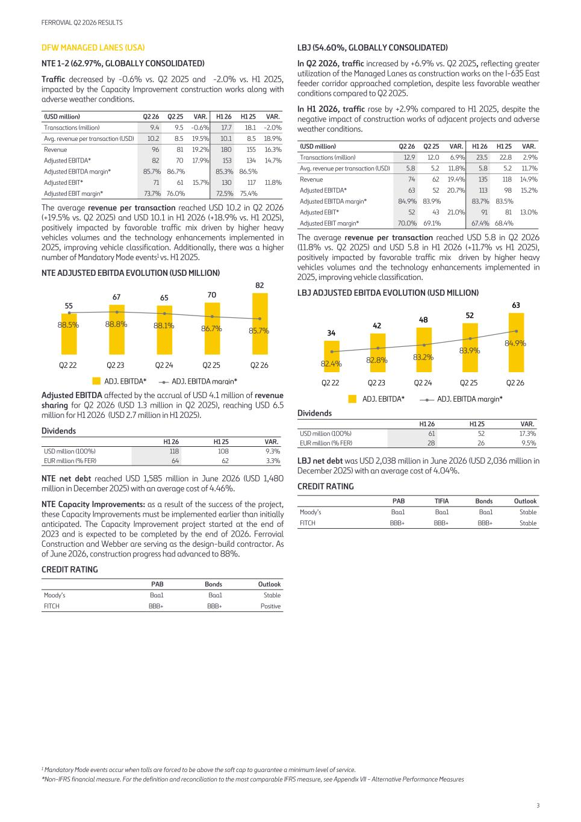
DFW MANAGED LANES (USA) NTE 1-2 (62.97%, GLOBALLY CONSOLIDATED) Traffic decreased by -0.6% vs. Q2 2025 and -2.0% vs. H1 2025, impacted by the Capacity Improvement construction works along with adverse weather conditions. (USD million) Q2 26 Q2 25 VAR. H1 26 H1 25 VAR. Transactions (million) 9.4 9.5 -0.6 % 17.7 18.1 -2.0 % Avg. revenue per transaction (USD) 10.2 8.5 19.5 % 10.1 8.5 18.9 % Revenue 96 81 19.2 % 180 155 16.3 % Adjusted EBITDA* 82 70 17.9 % 153 134 14.7 % Adjusted EBITDA margin* 85.7 % 86.7 % 85.3 % 86.5 % Adjusted EBIT* 71 61 15.7 % 130 117 11.8 % Adjusted EBIT margin* 73.7 % 76.0 % 72.5 % 75.4 % The average revenue per transaction reached USD 10.2 in Q2 2026 (+19.5% vs. Q2 2025) and USD 10.1 in H1 2026 (+18.9% vs. H1 2025), positively impacted by favorable traffic mix driven by higher heavy vehicles volumes and the technology enhancements implemented in 2025, improving vehicle classification. Additionally, there was a higher number of Mandatory Mode events1 vs. H1 2025. NTE ADJUSTED EBITDA EVOLUTION (USD MILLION) 55 67 65 70 82 88.5% 88.8% 88.1% 86.7% 85.7% ADJ. EBITDA* ADJ. EBITDA margin* Q2 22 Q2 23 Q2 24 Q2 25 Q2 26 Adjusted EBITDA affected by the accrual of USD 4.1 million of revenue sharing for Q2 2026 (USD 1.3 million in Q2 2025), reaching USD 6.5 million for H1 2026 (USD 2.7 million in H1 2025). Dividends H1 26 H1 25 VAR. USD million (100%) 118 108 9.3 % EUR million (% FER) 64 62 3.3 % NTE net debt reached USD 1,585 million in June 2026 (USD 1,480 million in December 2025) with an average cost of 4.46%. NTE Capacity Improvements: as a result of the success of the project, these Capacity Improvements must be implemented earlier than initially anticipated. The Capacity Improvement project started at the end of 2023 and is expected to be completed by the end of 2026. Ferrovial Construction and Webber are serving as the design-build contractor. As of June 2026, construction progress had advanced to 88%. CREDIT RATING PAB Bonds Outlook Moody’s Baa1 Baa1 Stable FITCH BBB+ BBB+ Positive LBJ (54.60%, GLOBALLY CONSOLIDATED) In Q2 2026, traffic increased by +6.9% vs. Q2 2025, reflecting greater utilization of the Managed Lanes as construction works on the I-635 East feeder corridor approached completion, despite less favorable weather conditions compared to Q2 2025. In H1 2026, traffic rose by +2.9% compared to H1 2025, despite the negative impact of construction works of adjacent projects and adverse weather conditions. (USD million) Q2 26 Q2 25 VAR. H1 26 H1 25 VAR. Transactions (million) 12.9 12.0 6.9 % 23.5 22.8 2.9 % Avg. revenue per transaction (USD) 5.8 5.2 11.8 % 5.8 5.2 11.7 % Revenue 74 62 19.4 % 135 118 14.9 % Adjusted EBITDA* 63 52 20.7 % 113 98 15.2 % Adjusted EBITDA margin* 84.9 % 83.9 % 83.7 % 83.5 % Adjusted EBIT* 52 43 21.0 % 91 81 13.0 % Adjusted EBIT margin* 70.0 % 69.1 % 67.4 % 68.4 % The average revenue per transaction reached USD 5.8 in Q2 2026 (11.8% vs. Q2 2025) and USD 5.8 in H1 2026 (+11.7% vs H1 2025), positively impacted by favorable traffic mix driven by higher heavy vehicles volumes and the technology enhancements implemented in 2025, improving vehicle classification. LBJ ADJUSTED EBITDA EVOLUTION (USD MILLION) 34 42 48 52 63 82.4% 82.8% 83.2% 83.9% 84.9% ADJ. EBITDA* ADJ. EBITDA margin* Q2 22 Q2 23 Q2 24 Q2 25 Q2 26 Dividends H1 26 H1 25 VAR. USD million (100%) 61 52 17.3 % EUR million (% FER) 28 26 9.5 % LBJ net debt was USD 2,038 million in June 2026 (USD 2,036 million in December 2025) with an average cost of 4.04%. CREDIT RATING PAB TIFIA Bonds Outlook Moody’s Baa1 Baa1 Baa1 Stable FITCH BBB+ BBB+ BBB+ Stable 1 Mandatory Mode events occur when tolls are forced to be above the soft cap to guarantee a minimum level of service. *Non-IFRS financial measure. For the definition and reconciliation to the most comparable IFRS measure, see Appendix VII - Alternative Performance Measures FERROVIAL Q2 2026 RESULTS 3

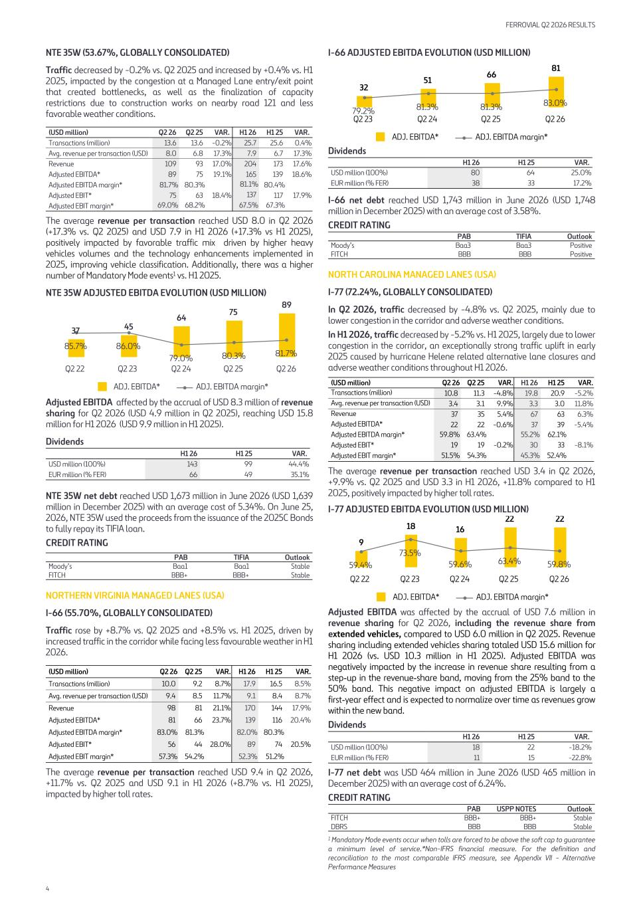
NTE 35W (53.67%, GLOBALLY CONSOLIDATED) Traffic decreased by -0.2% vs. Q2 2025 and increased by +0.4% vs. H1 2025, impacted by the congestion at a Managed Lane entry/exit point that created bottlenecks, as well as the finalization of capacity restrictions due to construction works on nearby road 121 and less favorable weather conditions. (USD million) Q2 26 Q2 25 VAR. H1 26 H1 25 VAR. Transactions (million) 13.6 13.6 -0.2 % 25.7 25.6 0.4 % Avg. revenue per transaction (USD) 8.0 6.8 17.3 % 7.9 6.7 17.3 % Revenue 109 93 17.0 % 204 173 17.6 % Adjusted EBITDA* 89 75 19.1 % 165 139 18.6 % Adjusted EBITDA margin* 81.7 % 80.3 % 81.1 % 80.4 % Adjusted EBIT* 75 63 18.4 % 137 117 17.9 % Adjusted EBIT margin* 69.0 % 68.2 % 67.5 % 67.3 % The average revenue per transaction reached USD 8.0 in Q2 2026 (+17.3% vs. Q2 2025) and USD 7.9 in H1 2026 (+17.3% vs H1 2025), positively impacted by favorable traffic mix driven by higher heavy vehicles volumes and the technology enhancements implemented in 2025, improving vehicle classification. Additionally, there was a higher number of Mandatory Mode events1 vs. H1 2025. NTE 35W ADJUSTED EBITDA EVOLUTION (USD MILLION) 37 45 64 75 89 85.7% 86.0% 79.0% 80.3% 81.7% ADJ. EBITDA* ADJ. EBITDA margin* Q2 22 Q2 23 Q2 24 Q2 25 Q2 26 Adjusted EBITDA affected by the accrual of USD 8.3 million of revenue sharing for Q2 2026 (USD 4.9 million in Q2 2025), reaching USD 15.8 million for H1 2026 (USD 9.9 million in H1 2025). Dividends H1 26 H1 25 VAR. USD million (100%) 143 99 44.4 % EUR million (% FER) 66 49 35.1 % NTE 35W net debt reached USD 1,673 million in June 2026 (USD 1,639 million in December 2025) with an average cost of 5.34%. On June 25, 2026, NTE 35W used the proceeds from the issuance of the 2025C Bonds to fully repay its TIFIA loan. CREDIT RATING PAB TIFIA Outlook Moody’s Baa1 Baa1 Stable FITCH BBB+ BBB+ Stable NORTHERN VIRGINIA MANAGED LANES (USA) I-66 (55.70%, GLOBALLY CONSOLIDATED) Traffic rose by +8.7% vs. Q2 2025 and +8.5% vs. H1 2025, driven by increased traffic in the corridor while facing less favourable weather in H1 2026. (USD million) Q2 26 Q2 25 VAR. H1 26 H1 25 VAR. Transactions (million) 10.0 9.2 8.7 % 17.9 16.5 8.5 % Avg. revenue per transaction (USD) 9.4 8.5 11.7 % 9.1 8.4 8.7 % Revenue 98 81 21.1 % 170 144 17.9 % Adjusted EBITDA* 81 66 23.7 % 139 116 20.4 % Adjusted EBITDA margin* 83.0 % 81.3 % 82.0 % 80.3 % Adjusted EBIT* 56 44 28.0 % 89 74 20.5 % Adjusted EBIT margin* 57.3 % 54.2 % 52.3 % 51.2 % The average revenue per transaction reached USD 9.4 in Q2 2026, +11.7% vs. Q2 2025 and USD 9.1 in H1 2026 (+8.7% vs. H1 2025), impacted by higher toll rates. I-66 ADJUSTED EBITDA EVOLUTION (USD MILLION) 32 51 66 81 79.2% 81.3% 81.3% 83.0% ADJ. EBITDA* ADJ. EBITDA margin* Q2 23 Q2 24 Q2 25 Q2 26 Dividends H1 26 H1 25 VAR. USD million (100%) 80 64 25.0 % EUR million (% FER) 38 33 17.2 % I-66 net debt reached USD 1,743 million in June 2026 (USD 1,748 million in December 2025) with an average cost of 3.58%. CREDIT RATING PAB TIFIA Outlook Moody’s Baa3 Baa3 Positive FITCH BBB BBB Positive NORTH CAROLINA MANAGED LANES (USA) I-77 (72.24%, GLOBALLY CONSOLIDATED) In Q2 2026, traffic decreased by -4.8% vs. Q2 2025, mainly due to lower congestion in the corridor and adverse weather conditions. In H1 2026, traffic decreased by -5.2% vs. H1 2025, largely due to lower congestion in the corridor, an exceptionally strong traffic uplift in early 2025 caused by hurricane Helene related alternative lane closures and adverse weather conditions throughout H1 2026. (USD million) Q2 26 Q2 25 VAR. H1 26 H1 25 VAR. Transactions (million) 10.8 11.3 -4.8 % 19.8 20.9 -5.2 % Avg. revenue per transaction (USD) 3.4 3.1 9.9 % 3.3 3.0 11.8 % Revenue 37 35 5.4 % 67 63 6.3 % Adjusted EBITDA* 22 22 -0.6 % 37 39 -5.4 % Adjusted EBITDA margin* 59.8 % 63.4 % 55.2 % 62.1 % Adjusted EBIT* 19 19 -0.2 % 30 33 -8.1 % Adjusted EBIT margin* 51.5 % 54.3 % 45.3 % 52.4 % The average revenue per transaction reached USD 3.4 in Q2 2026, +9.9% vs. Q2 2025 and USD 3.3 in H1 2026, +11.8% compared to H1 2025, positively impacted by higher toll rates. I-77 ADJUSTED EBITDA EVOLUTION (USD MILLION) 9 18 16 22 22 59.4% 73.5% 59.6% 63.4% 59.8% ADJ. EBITDA* ADJ. EBITDA margin* Q2 22 Q2 23 Q2 24 Q2 25 Q2 26 Adjusted EBITDA was affected by the accrual of USD 7.6 million in revenue sharing for Q2 2026, including the revenue share from extended vehicles, compared to USD 6.0 million in Q2 2025. Revenue sharing including extended vehicles sharing totaled USD 15.6 million for H1 2026 (vs. USD 10.3 million in H1 2025). Adjusted EBITDA was negatively impacted by the increase in revenue share resulting from a step-up in the revenue-share band, moving from the 25% band to the 50% band. This negative impact on adjusted EBITDA is largely a first-year effect and is expected to normalize over time as revenues grow within the new band. Dividends H1 26 H1 25 VAR. USD million (100%) 18 22 -18.2 % EUR million (% FER) 11 15 -22.8 % I-77 net debt was USD 464 million in June 2026 (USD 465 million in December 2025) with an average cost of 6.24%. CREDIT RATING PAB USPP NOTES Outlook FITCH BBB+ BBB+ Stable DBRS BBB BBB Stable 1 Mandatory Mode events occur when tolls are forced to be above the soft cap to guarantee a minimum level of service.*Non-IFRS financial measure. For the definition and reconciliation to the most comparable IFRS measure, see Appendix VII - Alternative Performance Measures FERROVIAL Q2 2026 RESULTS 4

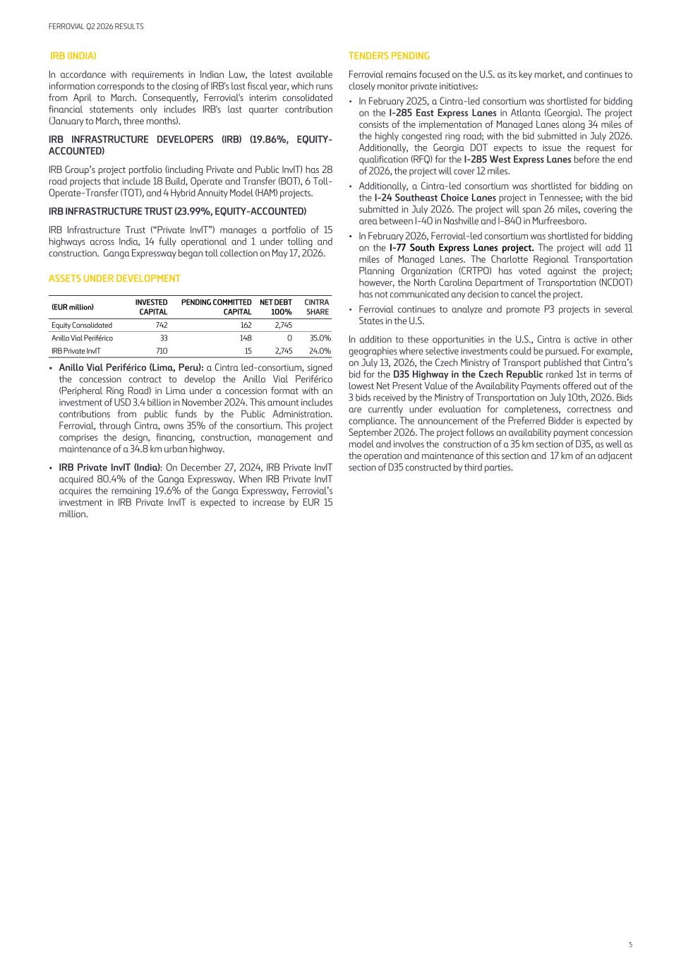
IRB (INDIA) In accordance with requirements in Indian Law, the latest available information corresponds to the closing of IRB's last fiscal year, which runs from April to March. Consequently, Ferrovial's interim consolidated financial statements only includes IRB's last quarter contribution (January to March, three months). IRB INFRASTRUCTURE DEVELOPERS (IRB) (19.86%, EQUITY- ACCOUNTED) IRB Group’s project portfolio (including Private and Public InvIT) has 28 road projects that include 18 Build, Operate and Transfer (BOT), 6 Toll- Operate-Transfer (TOT), and 4 Hybrid Annuity Model (HAM) projects. IRB INFRASTRUCTURE TRUST (23.99%, EQUITY-ACCOUNTED) IRB Infrastructure Trust (“Private InvIT”) manages a portfolio of 15 highways across India, 14 fully operational and 1 under tolling and construction. Ganga Expressway began toll collection on May 17, 2026. ASSETS UNDER DEVELOPMENT (EUR million) INVESTED CAPITAL PENDING COMMITTED CAPITAL NET DEBT 100% CINTRA SHARE Equity Consolidated 742 162 2,745 Anillo Vial Periférico 33 148 0 35.0 % IRB Private InvIT 710 15 2,745 24.0 % • Anillo Vial Periférico (Lima, Peru): a Cintra led-consortium, signed the concession contract to develop the Anillo Vial Periférico (Peripheral Ring Road) in Lima under a concession format with an investment of USD 3.4 billion in November 2024. This amount includes contributions from public funds by the Public Administration. Ferrovial, through Cintra, owns 35% of the consortium. This project comprises the design, financing, construction, management and maintenance of a 34.8 km urban highway. • IRB Private InvIT (India): On December 27, 2024, IRB Private InvIT acquired 80.4% of the Ganga Expressway. When IRB Private InvIT acquires the remaining 19.6% of the Ganga Expressway, Ferrovial’s investment in IRB Private InvIT is expected to increase by EUR 15 million. TENDERS PENDING Ferrovial remains focused on the U.S. as its key market, and continues to closely monitor private initiatives: • In February 2025, a Cintra-led consortium was shortlisted for bidding on the I-285 East Express Lanes in Atlanta (Georgia). The project consists of the implementation of Managed Lanes along 34 miles of the highly congested ring road; with the bid submitted in July 2026. Additionally, the Georgia DOT expects to issue the request for qualification (RFQ) for the I-285 West Express Lanes before the end of 2026, the project will cover 12 miles. • Additionally, a Cintra-led consortium was shortlisted for bidding on the I-24 Southeast Choice Lanes project in Tennessee; with the bid submitted in July 2026. The project will span 26 miles, covering the area between I-40 in Nashville and I-840 in Murfreesboro. • In February 2026, Ferrovial-led consortium was shortlisted for bidding on the I-77 South Express Lanes project. The project will add 11 miles of Managed Lanes. The Charlotte Regional Transportation Planning Organization (CRTPO) has voted against the project; however, the North Carolina Department of Transportation (NCDOT) has not communicated any decision to cancel the project. • Ferrovial continues to analyze and promote P3 projects in several States in the U.S. In addition to these opportunities in the U.S., Cintra is active in other geographies where selective investments could be pursued. For example, on July 13, 2026, the Czech Ministry of Transport published that Cintra’s bid for the D35 Highway in the Czech Republic ranked 1st in terms of lowest Net Present Value of the Availability Payments offered out of the 3 bids received by the Ministry of Transportation on July 10th, 2026. Bids are currently under evaluation for completeness, correctness and compliance. The announcement of the Preferred Bidder is expected by September 2026. The project follows an availability payment concession model and involves the construction of a 35 km section of D35, as well as the operation and maintenance of this section and 17 km of an adjacent section of D35 constructed by third parties. FERROVIAL Q2 2026 RESULTS 5

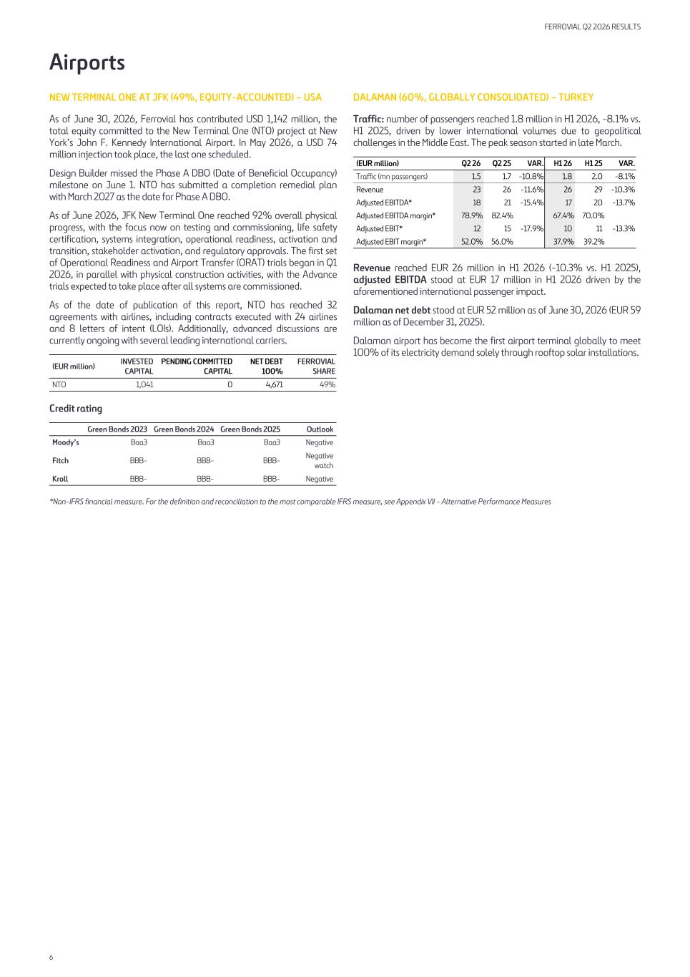
Airports NEW TERMINAL ONE AT JFK (49%, EQUITY-ACCOUNTED) – USA As of June 30, 2026, Ferrovial has contributed USD 1,142 million, the total equity committed to the New Terminal One (NTO) project at New York’s John F. Kennedy International Airport. In May 2026, a USD 74 million injection took place, the last one scheduled. Design Builder missed the Phase A DBO (Date of Beneficial Occupancy) milestone on June 1. NTO has submitted a completion remedial plan with March 2027 as the date for Phase A DBO. As of June 2026, JFK New Terminal One reached 92% overall physical progress, with the focus now on testing and commissioning, life safety certification, systems integration, operational readiness, activation and transition, stakeholder activation, and regulatory approvals. The first set of Operational Readiness and Airport Transfer (ORAT) trials began in Q1 2026, in parallel with physical construction activities, with the Advance trials expected to take place after all systems are commissioned. As of the date of publication of this report, NTO has reached 32 agreements with airlines, including contracts executed with 24 airlines and 8 letters of intent (LOIs). Additionally, advanced discussions are currently ongoing with several leading international carriers. (EUR million) INVESTED CAPITAL PENDING COMMITTED CAPITAL NET DEBT 100% FERROVIAL SHARE NTO 1,041 0 4,671 49 % Credit rating Green Bonds 2023 Green Bonds 2024 Green Bonds 2025 Outlook Moody’s Baa3 Baa3 Baa3 Negative Fitch BBB- BBB- BBB- Negative watch Kroll BBB- BBB- BBB- Negative DALAMAN (60%, GLOBALLY CONSOLIDATED) – TURKEY Traffic: number of passengers reached 1.8 million in H1 2026, -8.1% vs. H1 2025, driven by lower international volumes due to geopolitical challenges in the Middle East. The peak season started in late March. (EUR million) Q2 26 Q2 25 VAR. H1 26 H1 25 VAR. Traffic (mn passengers) 1.5 1.7 -10.8 % 1.8 2.0 -8.1 % Revenue 23 26 -11.6 % 26 29 -10.3 % Adjusted EBITDA* 18 21 -15.4 % 17 20 -13.7 % Adjusted EBITDA margin* 78.9 % 82.4 % 67.4 % 70.0 % Adjusted EBIT* 12 15 -17.9 % 10 11 -13.3 % Adjusted EBIT margin* 52.0 % 56.0 % 37.9 % 39.2 % Revenue reached EUR 26 million in H1 2026 (-10.3% vs. H1 2025), adjusted EBITDA stood at EUR 17 million in H1 2026 driven by the aforementioned international passenger impact. Dalaman net debt stood at EUR 52 million as of June 30, 2026 (EUR 59 million as of December 31, 2025). Dalaman airport has become the first airport terminal globally to meet 100% of its electricity demand solely through rooftop solar installations. *Non-IFRS financial measure. For the definition and reconciliation to the most comparable IFRS measure, see Appendix VII - Alternative Performance Measures FERROVIAL Q2 2026 RESULTS 6

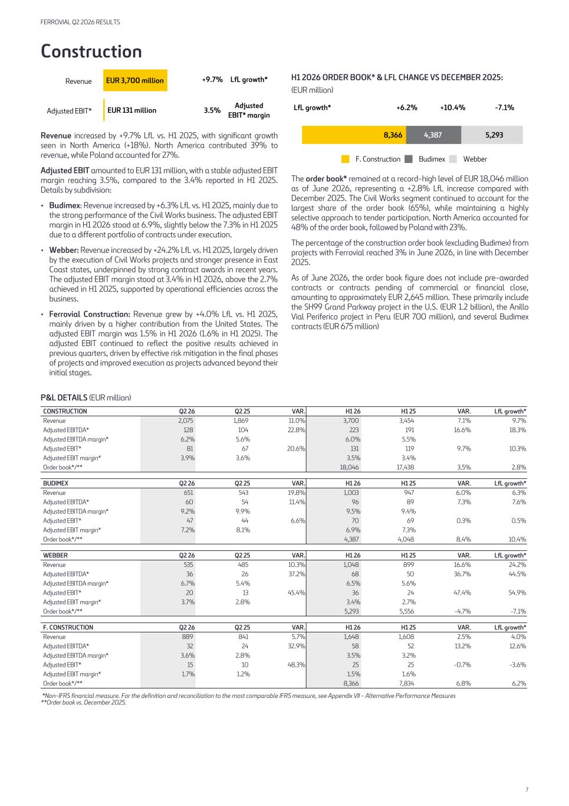
Construction EUR 3,700 million EUR 131 million Revenue Adjusted EBIT* +9.7% LfL growth* 3.5% Adjusted EBIT* margin Revenue increased by +9.7% LfL vs. H1 2025, with significant growth seen in North America (+18%). North America contributed 39% to revenue, while Poland accounted for 27%. Adjusted EBIT amounted to EUR 131 million, with a stable adjusted EBIT margin reaching 3.5%, compared to the 3.4% reported in H1 2025. Details by subdivision: • Budimex: Revenue increased by +6.3% LfL vs. H1 2025, mainly due to the strong performance of the Civil Works business. The adjusted EBIT margin in H1 2026 stood at 6.9%, slightly below the 7.3% in H1 2025 due to a different portfolio of contracts under execution. • Webber: Revenue increased by +24.2% LfL vs. H1 2025, largely driven by the execution of Civil Works projects and stronger presence in East Coast states, underpinned by strong contract awards in recent years. The adjusted EBIT margin stood at 3.4% in H1 2026, above the 2.7% achieved in H1 2025, supported by operational efficiencies across the business. • Ferrovial Construction: Revenue grew by +4.0% LfL vs. H1 2025, mainly driven by a higher contribution from the United States. The adjusted EBIT margin was 1.5% in H1 2026 (1.6% in H1 2025). The adjusted EBIT continued to reflect the positive results achieved in previous quarters, driven by effective risk mitigation in the final phases of projects and improved execution as projects advanced beyond their initial stages. H1 2026 ORDER BOOK* & LFL CHANGE VS DECEMBER 2025: (EUR million) LfL growth* +6.2 % +10.4 % -7.1 % 8,366 4,387 5,293 F. Construction Budimex Webber The order book* remained at a record-high level of EUR 18,046 million as of June 2026, representing a +2.8% LfL increase compared with December 2025. The Civil Works segment continued to account for the largest share of the order book (65%), while maintaining a highly selective approach to tender participation. North America accounted for 48% of the order book, followed by Poland with 23%. The percentage of the construction order book (excluding Budimex) from projects with Ferrovial reached 3% in June 2026, in line with December 2025. As of June 2026, the order book figure does not include pre-awarded contracts or contracts pending of commercial or financial close, amounting to approximately EUR 2,645 million. These primarily include the SH99 Grand Parkway project in the U.S. (EUR 1.2 billion), the Anillo Vial Periferico project in Peru (EUR 700 million), and several Budimex contracts (EUR 675 million) P&L DETAILS (EUR million) CONSTRUCTION Q2 26 Q2 25 VAR. H1 26 H1 25 VAR. LfL growth* Revenue 2,075 1,869 11.0 % 3,700 3,454 7.1 % 9.7 % Adjusted EBITDA* 128 104 22.8 % 223 191 16.6 % 18.3 % Adjusted EBITDA margin* 6.2 % 5.6 % 6.0 % 5.5 % Adjusted EBIT* 81 67 20.6 % 131 119 9.7 % 10.3 % Adjusted EBIT margin* 3.9 % 3.6 % 3.5 % 3.4 % Order book*/** 18,046 17,438 3.5 % 2.8 % BUDIMEX Q2 26 Q2 25 VAR. H1 26 H1 25 VAR. LfL growth* Revenue 651 543 19.8 % 1,003 947 6.0 % 6.3 % Adjusted EBITDA* 60 54 11.4 % 96 89 7.3 % 7.6 % Adjusted EBITDA margin* 9.2 % 9.9 % 9.5 % 9.4 % Adjusted EBIT* 47 44 6.6 % 70 69 0.3 % 0.5 % Adjusted EBIT margin* 7.2 % 8.1 % 6.9 % 7.3 % Order book*/** 4,387 4,048 8.4 % 10.4 % WEBBER Q2 26 Q2 25 VAR. H1 26 H1 25 VAR. LfL growth* Revenue 535 485 10.3 % 1,048 899 16.6 % 24.2 % Adjusted EBITDA* 36 26 37.2 % 68 50 36.7 % 44.5 % Adjusted EBITDA margin* 6.7 % 5.4 % 6.5 % 5.6 % Adjusted EBIT* 20 13 45.4 % 36 24 47.4 % 54.9 % Adjusted EBIT margin* 3.7 % 2.8 % 3.4 % 2.7 % Order book*/** 5,293 5,556 -4.7 % -7.1 % F. CONSTRUCTION Q2 26 Q2 25 VAR. H1 26 H1 25 VAR. LfL growth* Revenue 889 841 5.7 % 1,648 1,608 2.5 % 4.0 % Adjusted EBITDA* 32 24 32.9 % 58 52 13.2 % 12.6 % Adjusted EBITDA margin* 3.6 % 2.8 % 3.5 % 3.2 % Adjusted EBIT* 15 10 48.3 % 25 25 -0.7 % -3.6 % Adjusted EBIT margin* 1.7 % 1.2 % 1.5 % 1.6 % Order book*/** 8,366 7,834 6.8 % 6.2 % *Non-IFRS financial measure. For the definition and reconciliation to the most comparable IFRS measure, see Appendix VII - Alternative Performance Measures **Order book vs. December 2025. FERROVIAL Q2 2026 RESULTS 7

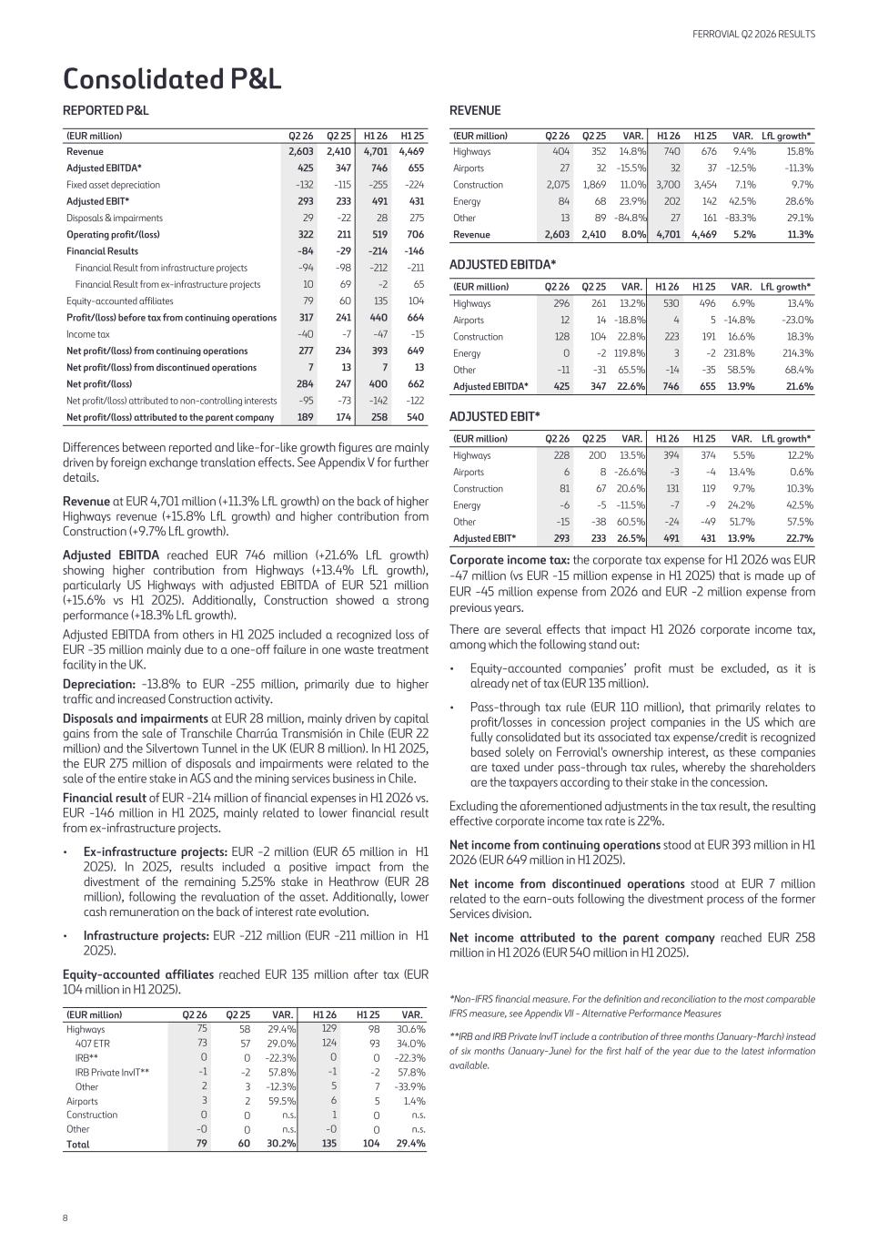
Consolidated P&L REPORTED P&L (EUR million) Q2 26 Q2 25 H1 26 H1 25 Revenue 2,603 2,410 4,701 4,469 Adjusted EBITDA* 425 347 746 655 Fixed asset depreciation -132 -115 -255 -224 Adjusted EBIT* 293 233 491 431 Disposals & impairments 29 -22 28 275 Operating profit/(loss) 322 211 519 706 Financial Results -84 -29 -214 -146 Financial Result from infrastructure projects -94 -98 -212 -211 Financial Result from ex-infrastructure projects 10 69 -2 65 Equity-accounted affiliates 79 60 135 104 Profit/(loss) before tax from continuing operations 317 241 440 664 Income tax -40 -7 -47 -15 Net profit/(loss) from continuing operations 277 234 393 649 Net profit/(loss) from discontinued operations 7 13 7 13 Net profit/(loss) 284 247 400 662 Net profit/(loss) attributed to non-controlling interests -95 -73 -142 -122 Net profit/(loss) attributed to the parent company 189 174 258 540 Differences between reported and like-for-like growth figures are mainly driven by foreign exchange translation effects. See Appendix V for further details. Revenue at EUR 4,701 million (+11.3% LfL growth) on the back of higher Highways revenue (+15.8% LfL growth) and higher contribution from Construction (+9.7% LfL growth). Adjusted EBITDA reached EUR 746 million (+21.6% LfL growth) showing higher contribution from Highways (+13.4% LfL growth), particularly US Highways with adjusted EBITDA of EUR 521 million (+15.6% vs H1 2025). Additionally, Construction showed a strong performance (+18.3% LfL growth). Adjusted EBITDA from others in H1 2025 included a recognized loss of EUR -35 million mainly due to a one-off failure in one waste treatment facility in the UK. Depreciation: -13.8% to EUR -255 million, primarily due to higher traffic and increased Construction activity. Disposals and impairments at EUR 28 million, mainly driven by capital gains from the sale of Transchile Charrúa Transmisión in Chile (EUR 22 million) and the Silvertown Tunnel in the UK (EUR 8 million). In H1 2025, the EUR 275 million of disposals and impairments were related to the sale of the entire stake in AGS and the mining services business in Chile. Financial result of EUR -214 million of financial expenses in H1 2026 vs. EUR -146 million in H1 2025, mainly related to lower financial result from ex-infrastructure projects. • Ex-infrastructure projects: EUR -2 million (EUR 65 million in H1 2025). In 2025, results included a positive impact from the divestment of the remaining 5.25% stake in Heathrow (EUR 28 million), following the revaluation of the asset. Additionally, lower cash remuneration on the back of interest rate evolution. • Infrastructure projects: EUR -212 million (EUR -211 million in H1 2025). Equity-accounted affiliates reached EUR 135 million after tax (EUR 104 million in H1 2025). (EUR million) Q2 26 Q2 25 VAR. H1 26 H1 25 VAR. Highways 75 58 29.4 % 129 98 30.6 % 407 ETR 73 57 29.0 % 124 93 34.0 % IRB** 0 0 -22.3 % 0 0 -22.3 % IRB Private InvIT** -1 -2 57.8 % -1 -2 57.8 % Other 2 3 -12.3 % 5 7 -33.9 % Airports 3 2 59.5 % 6 5 1.4 % Construction 0 0 n.s. 1 0 n.s. Other -0 0 n.s. -0 0 n.s. Total 79 60 30.2 % 135 104 29.4 % REVENUE (EUR million) Q2 26 Q2 25 VAR. H1 26 H1 25 VAR. LfL growth* Highways 404 352 14.8 % 740 676 9.4 % 15.8 % Airports 27 32 -15.5 % 32 37 -12.5 % -11.3 % Construction 2,075 1,869 11.0 % 3,700 3,454 7.1 % 9.7 % Energy 84 68 23.9 % 202 142 42.5 % 28.6 % Other 13 89 -84.8 % 27 161 -83.3 % 29.1 % Revenue 2,603 2,410 8.0 % 4,701 4,469 5.2 % 11.3 % ADJUSTED EBITDA* (EUR million) Q2 26 Q2 25 VAR. H1 26 H1 25 VAR. LfL growth* Highways 296 261 13.2 % 530 496 6.9 % 13.4 % Airports 12 14 -18.8 % 4 5 -14.8 % -23.0 % Construction 128 104 22.8 % 223 191 16.6 % 18.3 % Energy 0 -2 119.8 % 3 -2 231.8 % 214.3 % Other -11 -31 65.5 % -14 -35 58.5 % 68.4 % Adjusted EBITDA* 425 347 22.6 % 746 655 13.9 % 21.6 % ADJUSTED EBIT* (EUR million) Q2 26 Q2 25 VAR. H1 26 H1 25 VAR. LfL growth* Highways 228 200 13.5 % 394 374 5.5 % 12.2 % Airports 6 8 -26.6 % -3 -4 13.4 % 0.6 % Construction 81 67 20.6 % 131 119 9.7 % 10.3 % Energy -6 -5 -11.5 % -7 -9 24.2 % 42.5 % Other -15 -38 60.5 % -24 -49 51.7 % 57.5 % Adjusted EBIT* 293 233 26.5 % 491 431 13.9 % 22.7 % Corporate income tax: the corporate tax expense for H1 2026 was EUR -47 million (vs EUR -15 million expense in H1 2025) that is made up of EUR -45 million expense from 2026 and EUR -2 million expense from previous years. There are several effects that impact H1 2026 corporate income tax, among which the following stand out: • Equity-accounted companies’ profit must be excluded, as it is already net of tax (EUR 135 million). • Pass-through tax rule (EUR 110 million), that primarily relates to profit/losses in concession project companies in the US which are fully consolidated but its associated tax expense/credit is recognized based solely on Ferrovial's ownership interest, as these companies are taxed under pass-through tax rules, whereby the shareholders are the taxpayers according to their stake in the concession. Excluding the aforementioned adjustments in the tax result, the resulting effective corporate income tax rate is 22%. Net income from continuing operations stood at EUR 393 million in H1 2026 (EUR 649 million in H1 2025). Net income from discontinued operations stood at EUR 7 million related to the earn-outs following the divestment process of the former Services division. Net income attributed to the parent company reached EUR 258 million in H1 2026 (EUR 540 million in H1 2025). *Non-IFRS financial measure. For the definition and reconciliation to the most comparable IFRS measure, see Appendix VII - Alternative Performance Measures **IRB and IRB Private InvIT include a contribution of three months (January-March) instead of six months (January-June) for the first half of the year due to the latest information available. FERROVIAL Q2 2026 RESULTS 8

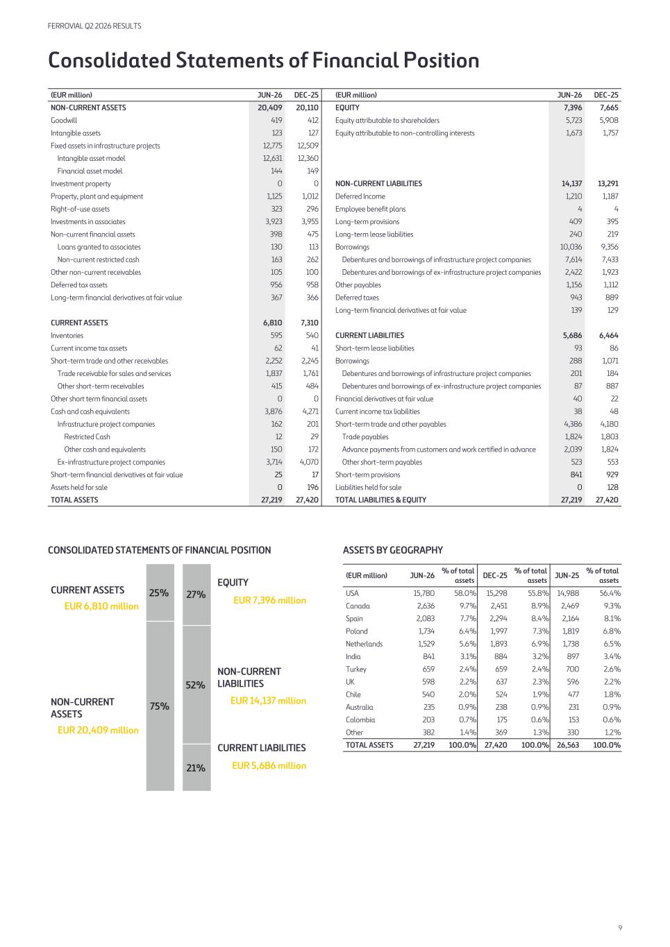
Consolidated Statements of Financial Position (EUR million) JUN-26 DEC-25 (EUR million) JUN-26 DEC-25 NON-CURRENT ASSETS 20,409 20,110 EQUITY 7,396 7,665 Goodwill 419 412 Equity attributable to shareholders 5,723 5,908 Intangible assets 123 127 Equity attributable to non-controlling interests 1,673 1,757 Fixed assets in infrastructure projects 12,775 12,509 Intangible asset model 12,631 12,360 Financial asset model 144 149 Investment property 0 0 NON-CURRENT LIABILITIES 14,137 13,291 Property, plant and equipment 1,125 1,012 Deferred Income 1,210 1,187 Right-of-use assets 323 296 Employee benefit plans 4 4 Investments in associates 3,923 3,955 Long-term provisions 409 395 Non-current financial assets 398 475 Long-term lease liabilities 240 219 Loans granted to associates 130 113 Borrowings 10,036 9,356 Non-current restricted cash 163 262 Debentures and borrowings of infrastructure project companies 7,614 7,433 Other non-current receivables 105 100 Debentures and borrowings of ex-infrastructure project companies 2,422 1,923 Deferred tax assets 956 958 Other payables 1,156 1,112 Long-term financial derivatives at fair value 367 366 Deferred taxes 943 889 Long-term financial derivatives at fair value 139 129 CURRENT ASSETS 6,810 7,310 Inventories 595 540 CURRENT LIABILITIES 5,686 6,464 Current income tax assets 62 41 Short-term lease liabilities 93 86 Short-term trade and other receivables 2,252 2,245 Borrowings 288 1,071 Trade receivable for sales and services 1,837 1,761 Debentures and borrowings of infrastructure project companies 201 184 Other short-term receivables 415 484 Debentures and borrowings of ex-infrastructure project companies 87 887 Other short term financial assets 0 0 Financial derivatives at fair value 40 22 Cash and cash equivalents 3,876 4,271 Current income tax liabilities 38 48 Infrastructure project companies 162 201 Short-term trade and other payables 4,386 4,180 Restricted Cash 12 29 Trade payables 1,824 1,803 Other cash and equivalents 150 172 Advance payments from customers and work certified in advance 2,039 1,824 Ex-infrastructure project companies 3,714 4,070 Other short-term payables 523 553 Short-term financial derivatives at fair value 25 17 Short-term provisions 841 929 Assets held for sale 0 196 Liabilities held for sale 0 128 TOTAL ASSETS 27,219 27,420 TOTAL LIABILITIES & EQUITY 27,219 27,420 CONSOLIDATED STATEMENTS OF FINANCIAL POSITION CURRENT ASSETS EUR 6,810 million NON-CURRENT ASSETS EUR 20,409 million 75% 25% 21% 52% 27% EQUITY EUR 7,396 million NON-CURRENT LIABILITIES EUR 14,137 million CURRENT LIABILITIES EUR 5,686 million ASSETS BY GEOGRAPHY (EUR million) JUN-26 % of total assets DEC-25 % of total assets JUN-25 % of total assets USA 15,780 58.0 % 15,298 55.8 % 14,988 56.4 % Canada 2,636 9.7 % 2,451 8.9 % 2,469 9.3 % Spain 2,083 7.7 % 2,294 8.4 % 2,164 8.1 % Poland 1,734 6.4 % 1,997 7.3 % 1,819 6.8 % Netherlands 1,529 5.6 % 1,893 6.9 % 1,738 6.5 % India 841 3.1 % 884 3.2 % 897 3.4 % Turkey 659 2.4 % 659 2.4 % 700 2.6 % UK 598 2.2 % 637 2.3 % 596 2.2 % Chile 540 2.0 % 524 1.9 % 477 1.8 % Australia 235 0.9 % 238 0.9 % 231 0.9 % Colombia 203 0.7 % 175 0.6 % 153 0.6 % Other 382 1.4 % 369 1.3 % 330 1.2 % TOTAL ASSETS 27,219 100.0 % 27,420 100.0 % 26,563 100.0 % FERROVIAL Q2 2026 RESULTS 9

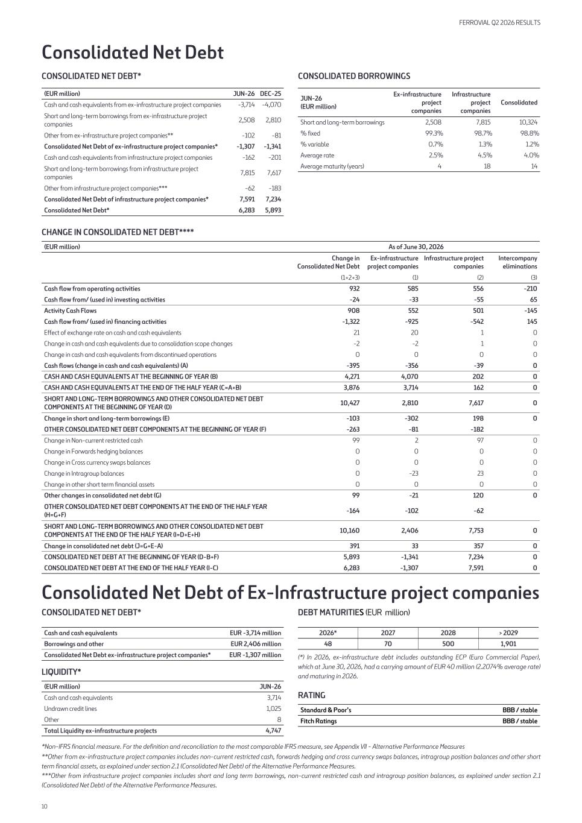
Consolidated Net Debt CONSOLIDATED NET DEBT* (EUR million) JUN-26 DEC-25 Cash and cash equivalents from ex-infrastructure project companies -3,714 -4,070 Short and long-term borrowings from ex-infrastructure project companies 2,508 2,810 Other from ex-infrastructure project companies** -102 -81 Consolidated Net Debt of ex-infrastructure project companies* -1,307 -1,341 Cash and cash equivalents from infrastructure project companies -162 -201 Short and long-term borrowings from infrastructure project companies 7,815 7,617 Other from infrastructure project companies*** -62 -183 Consolidated Net Debt of infrastructure project companies* 7,591 7,234 Consolidated Net Debt* 6,283 5,893 CONSOLIDATED BORROWINGS JUN-26 (EUR million) Ex-infrastructure project companies Infrastructure project companies Consolidated Short and long-term borrowings 2,508 7,815 10,324 % fixed 99.3 % 98.7 % 98.8 % % variable 0.7 % 1.3 % 1.2 % Average rate 2.5 % 4.5 % 4.0 % Average maturity (years) 4 18 14 CHANGE IN CONSOLIDATED NET DEBT**** (EUR million) As of June 30, 2026 Change in Consolidated Net Debt Ex-infrastructure project companies Infrastructure project companies Intercompany eliminations (1+2+3) (1) (2) (3) Cash flow from operating activities 932 585 556 -210 Cash flow from/ (used in) investing activities -24 -33 -55 65 Activity Cash Flows 908 552 501 -145 Cash flow from/ (used in) financing activities -1,322 -925 -542 145 Effect of exchange rate on cash and cash equivalents 21 20 1 0 Change in cash and cash equivalents due to consolidation scope changes -2 -2 1 0 Change in cash and cash equivalents from discontinued operations 0 0 0 0 Cash flows (change in cash and cash equivalents) (A) -395 -356 -39 0 CASH AND CASH EQUIVALENTS AT THE BEGINNING OF YEAR (B) 4,271 4,070 202 0 CASH AND CASH EQUIVALENTS AT THE END OF THE HALF YEAR (C=A+B) 3,876 3,714 162 0 SHORT AND LONG-TERM BORROWINGS AND OTHER CONSOLIDATED NET DEBT COMPONENTS AT THE BEGINNING OF YEAR (D) 10,427 2,810 7,617 0 Change in short and long-term borrowings (E) -103 -302 198 0 OTHER CONSOLIDATED NET DEBT COMPONENTS AT THE BEGINNING OF YEAR (F) -263 -81 -182 Change in Non-current restricted cash 99 2 97 0 Change in Forwards hedging balances 0 0 0 0 Change in Cross currency swaps balances 0 0 0 0 Change in Intragroup balances 0 -23 23 0 Change in other short term financial assets 0 0 0 0 Other changes in consolidated net debt (G) 99 -21 120 0 OTHER CONSOLIDATED NET DEBT COMPONENTS AT THE END OF THE HALF YEAR (H=G+F) -164 -102 -62 SHORT AND LONG-TERM BORROWINGS AND OTHER CONSOLIDATED NET DEBT COMPONENTS AT THE END OF THE HALF YEAR (I=D+E+H) 10,160 2,406 7,753 0 Change in consolidated net debt (J=G+E-A) 391 33 357 0 CONSOLIDATED NET DEBT AT THE BEGINNING OF YEAR (D-B+F) 5,893 -1,341 7,234 0 CONSOLIDATED NET DEBT AT THE END OF THE HALF YEAR (I-C) 6,283 -1,307 7,591 0 Consolidated Net Debt of Ex-Infrastructure project companies CONSOLIDATED NET DEBT* Cash and cash equivalents EUR -3,714 million Borrowings and other EUR 2,406 million Consolidated Net Debt ex-infrastructure project companies* EUR -1,307 million LIQUIDITY* (EUR million) JUN-26 Cash and cash equivalents 3,714 Undrawn credit lines 1,025 Other 8 Total Liquidity ex-infrastructure projects 4,747 DEBT MATURITIES (EUR million) 2026* 2027 2028 > 2029 48 70 500 1,901 (*) In 2026, ex-infrastructure debt includes outstanding ECP (Euro Commercial Paper), which at June 30, 2026, had a carrying amount of EUR 40 million (2.2074% average rate) and maturing in 2026. RATING Standard & Poor’s BBB / stable Fitch Ratings BBB / stable *Non-IFRS financial measure. For the definition and reconciliation to the most comparable IFRS measure, see Appendix VII - Alternative Performance Measures **Other from ex-infrastructure project companies includes non-current restricted cash, forwards hedging and cross currency swaps balances, intragroup position balances and other short term financial assets, as explained under section 2.1 (Consolidated Net Debt) of the Alternative Performance Measures. ***Other from infrastructure project companies includes short and long term borrowings, non-current restricted cash and intragroup position balances, as explained under section 2.1 (Consolidated Net Debt) of the Alternative Performance Measures. FERROVIAL Q2 2026 RESULTS 10

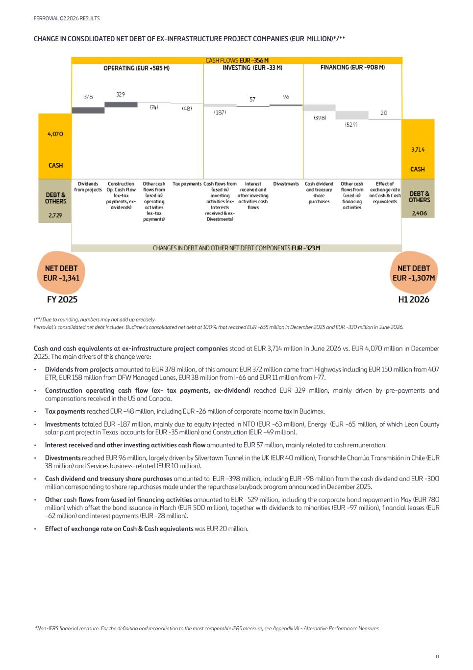
CHANGE IN CONSOLIDATED NET DEBT OF EX-INFRASTRUCTURE PROJECT COMPANIES (EUR MILLION)*/** (**) Due to rounding, numbers may not add up precisely. Ferrovial’s consolidated net debt includes Budimex’s consolidated net debt at 100% that reached EUR -655 million in December 2025 and EUR -330 million in June 2026. Cash and cash equivalents at ex-infrastructure project companies stood at EUR 3,714 million in June 2026 vs. EUR 4,070 million in December 2025. The main drivers of this change were: • Dividends from projects amounted to EUR 378 million, of this amount EUR 372 million came from Highways including EUR 150 million from 407 ETR, EUR 158 million from DFW Managed Lanes, EUR 38 million from I-66 and EUR 11 million from I-77. • Construction operating cash flow (ex- tax payments, ex-dividend) reached EUR 329 million, mainly driven by pre-payments and compensations received in the US and Canada. • Tax payments reached EUR -48 million, including EUR -26 million of corporate income tax in Budimex. • Investments totaled EUR -187 million, mainly due to equity injected in NTO (EUR -63 million), Energy (EUR -65 million, of which Leon County solar plant project in Texas accounts for EUR -35 million) and Construction (EUR -49 million). • Interest received and other investing activities cash flow amounted to EUR 57 million, mainly related to cash remuneration. • Divestments reached EUR 96 million, largely driven by Silvertown Tunnel in the UK (EUR 40 million), Transchile Charrúa Transmisión in Chile (EUR 38 million) and Services business-related (EUR 10 million). • Cash dividend and treasury share purchases amounted to EUR -398 million, including EUR -98 million from the cash dividend and EUR -300 million corresponding to share repurchases made under the repurchase buyback program announced in December 2025. • Other cash flows from (used in) financing activities amounted to EUR -529 million, including the corporate bond repayment in May (EUR 780 million) which offset the bond issuance in March (EUR 500 million), together with dividends to minorities (EUR -97 million), financial leases (EUR -62 million) and interest payments (EUR -28 million). • Effect of exchange rate on Cash & Cash equivalents was EUR 20 million. *Non-IFRS financial measure. For the definition and reconciliation to the most comparable IFRS measure, see Appendix VII - Alternative Performance Measures FERROVIAL Q2 2026 RESULTS 11

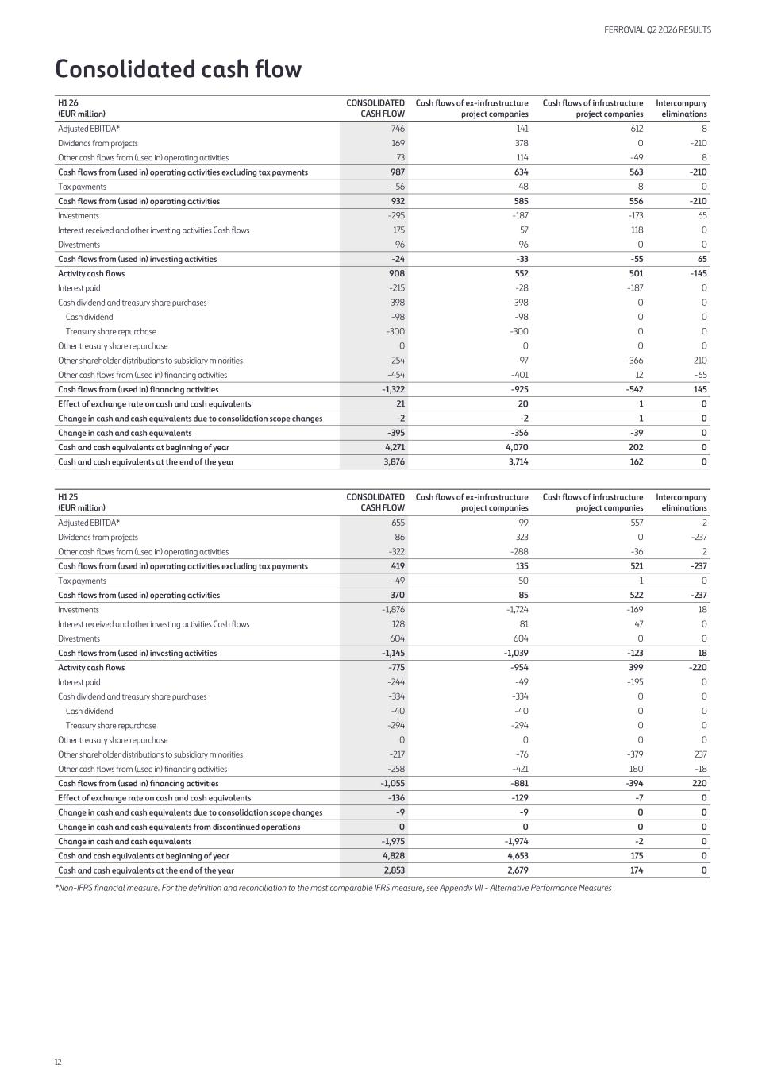
Consolidated cash flow H1 26 (EUR million) CONSOLIDATED CASH FLOW Cash flows of ex-infrastructure project companies Cash flows of infrastructure project companies Intercompany eliminations Adjusted EBITDA* 746 141 612 -8 Dividends from projects 169 378 0 -210 Other cash flows from (used in) operating activities 73 114 -49 8 Cash flows from (used in) operating activities excluding tax payments 987 634 563 -210 Tax payments -56 -48 -8 0 Cash flows from (used in) operating activities 932 585 556 -210 Investments -295 -187 -173 65 Interest received and other investing activities Cash flows 175 57 118 0 Divestments 96 96 0 0 Cash flows from (used in) investing activities -24 -33 -55 65 Activity cash flows 908 552 501 -145 Interest paid -215 -28 -187 0 Cash dividend and treasury share purchases -398 -398 0 0 Cash dividend -98 -98 0 0 Treasury share repurchase -300 -300 0 0 Other treasury share repurchase 0 0 0 0 Other shareholder distributions to subsidiary minorities -254 -97 -366 210 Other cash flows from (used in) financing activities -454 -401 12 -65 Cash flows from (used in) financing activities -1,322 -925 -542 145 Effect of exchange rate on cash and cash equivalents 21 20 1 0 Change in cash and cash equivalents due to consolidation scope changes -2 -2 1 0 Change in cash and cash equivalents -395 -356 -39 0 Cash and cash equivalents at beginning of year 4,271 4,070 202 0 Cash and cash equivalents at the end of the year 3,876 3,714 162 0 H1 25 (EUR million) CONSOLIDATED CASH FLOW Cash flows of ex-infrastructure project companies Cash flows of infrastructure project companies Intercompany eliminations Adjusted EBITDA* 655 99 557 -2 Dividends from projects 86 323 0 -237 Other cash flows from (used in) operating activities -322 -288 -36 2 Cash flows from (used in) operating activities excluding tax payments 419 135 521 -237 Tax payments -49 -50 1 0 Cash flows from (used in) operating activities 370 85 522 -237 Investments -1,876 -1,724 -169 18 Interest received and other investing activities Cash flows 128 81 47 0 Divestments 604 604 0 0 Cash flows from (used in) investing activities -1,145 -1,039 -123 18 Activity cash flows -775 -954 399 -220 Interest paid -244 -49 -195 0 Cash dividend and treasury share purchases -334 -334 0 0 Cash dividend -40 -40 0 0 Treasury share repurchase -294 -294 0 0 Other treasury share repurchase 0 0 0 0 Other shareholder distributions to subsidiary minorities -217 -76 -379 237 Other cash flows from (used in) financing activities -258 -421 180 -18 Cash flows from (used in) financing activities -1,055 -881 -394 220 Effect of exchange rate on cash and cash equivalents -136 -129 -7 0 Change in cash and cash equivalents due to consolidation scope changes -9 -9 0 0 Change in cash and cash equivalents from discontinued operations 0 0 0 0 Change in cash and cash equivalents -1,975 -1,974 -2 0 Cash and cash equivalents at beginning of year 4,828 4,653 175 0 Cash and cash equivalents at the end of the year 2,853 2,679 174 0 *Non-IFRS financial measure. For the definition and reconciliation to the most comparable IFRS measure, see Appendix VII - Alternative Performance Measures FERROVIAL Q2 2026 RESULTS 12

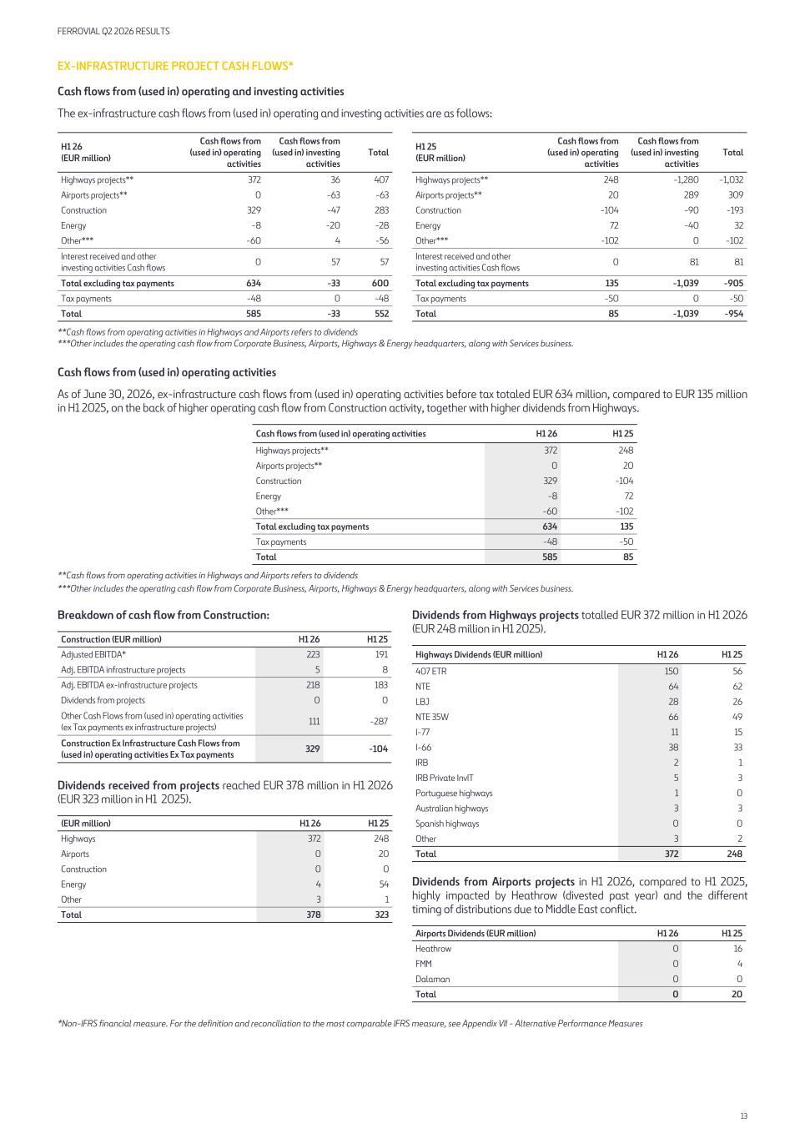
EX-INFRASTRUCTURE PROJECT CASH FLOWS* Cash flows from (used in) operating and investing activities The ex-infrastructure cash flows from (used in) operating and investing activities are as follows: H1 26 (EUR million) Cash flows from (used in) operating activities Cash flows from (used in) investing activities Total Highways projects** 372 36 407 Airports projects** 0 -63 -63 Construction 329 -47 283 Energy -8 -20 -28 Other*** -60 4 -56 Interest received and other investing activities Cash flows 0 57 57 Total excluding tax payments 634 -33 600 Tax payments -48 0 -48 Total 585 -33 552 H1 25 (EUR million) Cash flows from (used in) operating activities Cash flows from (used in) investing activities Total Highways projects** 248 -1,280 -1,032 Airports projects** 20 289 309 Construction -104 -90 -193 Energy 72 -40 32 Other*** -102 0 -102 Interest received and other investing activities Cash flows 0 81 81 Total excluding tax payments 135 -1,039 -905 Tax payments -50 0 -50 Total 85 -1,039 -954 **Cash flows from operating activities in Highways and Airports refers to dividends ***Other includes the operating cash flow from Corporate Business, Airports, Highways & Energy headquarters, along with Services business. Cash flows from (used in) operating activities As of June 30, 2026, ex-infrastructure cash flows from (used in) operating activities before tax totaled EUR 634 million, compared to EUR 135 million in H1 2025, on the back of higher operating cash flow from Construction activity, together with higher dividends from Highways. Cash flows from (used in) operating activities H1 26 H1 25 Highways projects** 372 248 Airports projects** 0 20 Construction 329 -104 Energy -8 72 Other*** -60 -102 Total excluding tax payments 634 135 Tax payments -48 -50 Total 585 85 **Cash flows from operating activities in Highways and Airports refers to dividends ***Other includes the operating cash flow from Corporate Business, Airports, Highways & Energy headquarters, along with Services business. Breakdown of cash flow from Construction: Construction (EUR million) H1 26 H1 25 Adjusted EBITDA* 223 191 Adj. EBITDA infrastructure projects 5 8 Adj. EBITDA ex-infrastructure projects 218 183 Dividends from projects 0 0 Other Cash Flows from (used in) operating activities (ex Tax payments ex infrastructure projects) 111 -287 Construction Ex Infrastructure Cash Flows from (used in) operating activities Ex Tax payments 329 -104 Dividends received from projects reached EUR 378 million in H1 2026 (EUR 323 million in H1 2025). (EUR million) H1 26 H1 25 Highways 372 248 Airports 0 20 Construction 0 0 Energy 4 54 Other 3 1 Total 378 323 Dividends from Highways projects totalled EUR 372 million in H1 2026 (EUR 248 million in H1 2025). Highways Dividends (EUR million) H1 26 H1 25 407 ETR 150 56 NTE 64 62 LBJ 28 26 NTE 35W 66 49 I-77 11 15 I-66 38 33 IRB 2 1 IRB Private InvIT 5 3 Portuguese highways 1 0 Australian highways 3 3 Spanish highways 0 0 Other 3 2 Total 372 248 Dividends from Airports projects in H1 2026, compared to H1 2025, highly impacted by Heathrow (divested past year) and the different timing of distributions due to Middle East conflict. Airports Dividends (EUR million) H1 26 H1 25 Heathrow 0 16 FMM 0 4 Dalaman 0 0 Total 0 20 *Non-IFRS financial measure. For the definition and reconciliation to the most comparable IFRS measure, see Appendix VII - Alternative Performance Measures FERROVIAL Q2 2026 RESULTS 13

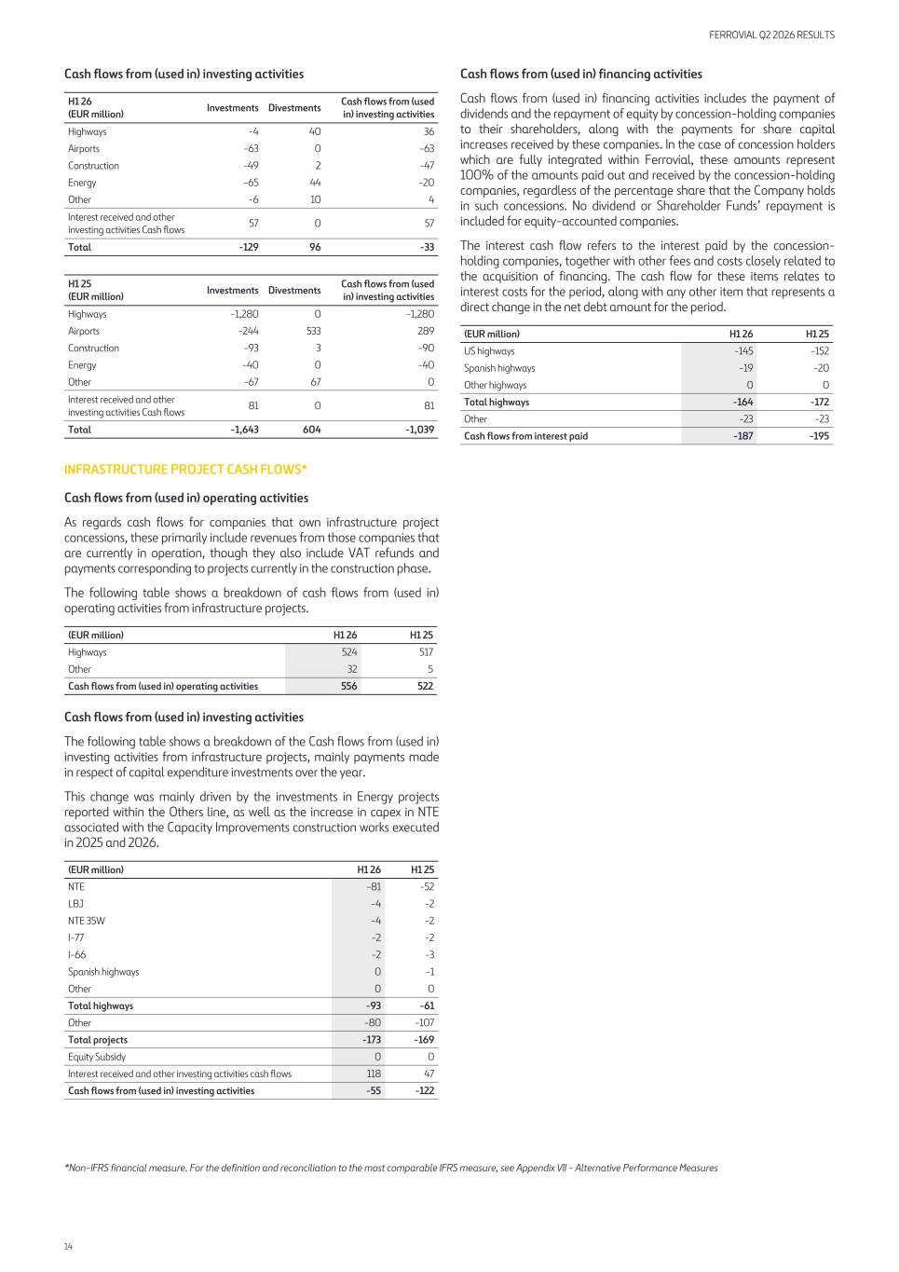
Cash flows from (used in) investing activities H1 26 (EUR million) Investments Divestments Cash flows from (used in) investing activities Highways -4 40 36 Airports -63 0 -63 Construction -49 2 -47 Energy -65 44 -20 Other -6 10 4 Interest received and other investing activities Cash flows 57 0 57 Total -129 96 -33 H1 25 (EUR million) Investments Divestments Cash flows from (used in) investing activities Highways -1,280 0 -1,280 Airports -244 533 289 Construction -93 3 -90 Energy -40 0 -40 Other -67 67 0 Interest received and other investing activities Cash flows 81 0 81 Total -1,643 604 -1,039 INFRASTRUCTURE PROJECT CASH FLOWS* Cash flows from (used in) operating activities As regards cash flows for companies that own infrastructure project concessions, these primarily include revenues from those companies that are currently in operation, though they also include VAT refunds and payments corresponding to projects currently in the construction phase. The following table shows a breakdown of cash flows from (used in) operating activities from infrastructure projects. (EUR million) H1 26 H1 25 Highways 524 517 Other 32 5 Cash flows from (used in) operating activities 556 522 Cash flows from (used in) investing activities The following table shows a breakdown of the Cash flows from (used in) investing activities from infrastructure projects, mainly payments made in respect of capital expenditure investments over the year. This change was mainly driven by the investments in Energy projects reported within the Others line, as well as the increase in capex in NTE associated with the Capacity Improvements construction works executed in 2025 and 2026. (EUR million) H1 26 H1 25 NTE -81 -52 LBJ -4 -2 NTE 35W -4 -2 I-77 -2 -2 I-66 -2 -3 Spanish highways 0 -1 Other 0 0 Total highways -93 -61 Other -80 -107 Total projects -173 -169 Equity Subsidy 0 0 Interest received and other investing activities cash flows 118 47 Cash flows from (used in) investing activities -55 -122 Cash flows from (used in) financing activities Cash flows from (used in) financing activities includes the payment of dividends and the repayment of equity by concession-holding companies to their shareholders, along with the payments for share capital increases received by these companies. In the case of concession holders which are fully integrated within Ferrovial, these amounts represent 100% of the amounts paid out and received by the concession-holding companies, regardless of the percentage share that the Company holds in such concessions. No dividend or Shareholder Funds’ repayment is included for equity-accounted companies. The interest cash flow refers to the interest paid by the concession- holding companies, together with other fees and costs closely related to the acquisition of financing. The cash flow for these items relates to interest costs for the period, along with any other item that represents a direct change in the net debt amount for the period. (EUR million) H1 26 H1 25 US highways -145 -152 Spanish highways -19 -20 Other highways 0 0 Total highways -164 -172 Other -23 -23 Cash flows from interest paid -187 -195 *Non-IFRS financial measure. For the definition and reconciliation to the most comparable IFRS measure, see Appendix VII - Alternative Performance Measures FERROVIAL Q2 2026 RESULTS 14

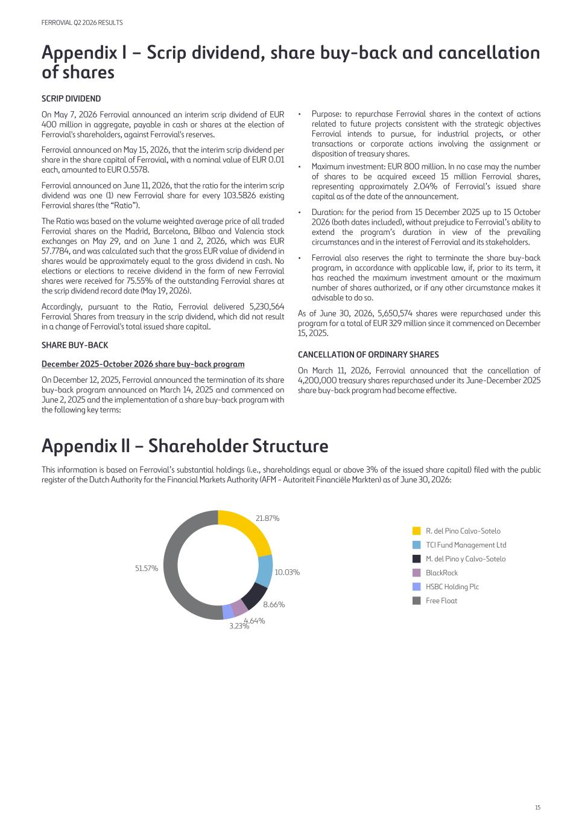
Appendix I – Scrip dividend, share buy-back and cancellation of shares SCRIP DIVIDEND On May 7, 2026 Ferrovial announced an interim scrip dividend of EUR 400 million in aggregate, payable in cash or shares at the election of Ferrovial's shareholders, against Ferrovial's reserves. Ferrovial announced on May 15, 2026, that the interim scrip dividend per share in the share capital of Ferrovial, with a nominal value of EUR 0.01 each, amounted to EUR 0.5578. Ferrovial announced on June 11, 2026, that the ratio for the interim scrip dividend was one (1) new Ferrovial share for every 103.5826 existing Ferrovial shares (the “Ratio”). The Ratio was based on the volume weighted average price of all traded Ferrovial shares on the Madrid, Barcelona, Bilbao and Valencia stock exchanges on May 29, and on June 1 and 2, 2026, which was EUR 57.7784, and was calculated such that the gross EUR value of dividend in shares would be approximately equal to the gross dividend in cash. No elections or elections to receive dividend in the form of new Ferrovial shares were received for 75.55% of the outstanding Ferrovial shares at the scrip dividend record date (May 19, 2026). Accordingly, pursuant to the Ratio, Ferrovial delivered 5,230,564 Ferrovial Shares from treasury in the scrip dividend, which did not result in a change of Ferrovial's total issued share capital. SHARE BUY-BACK December 2025-October 2026 share buy-back program On December 12, 2025, Ferrovial announced the termination of its share buy-back program announced on March 14, 2025 and commenced on June 2, 2025 and the implementation of a share buy-back program with the following key terms: • Purpose: to repurchase Ferrovial shares in the context of actions related to future projects consistent with the strategic objectives Ferrovial intends to pursue, for industrial projects, or other transactions or corporate actions involving the assignment or disposition of treasury shares. • Maximum investment: EUR 800 million. In no case may the number of shares to be acquired exceed 15 million Ferrovial shares, representing approximately 2.04% of Ferrovial’s issued share capital as of the date of the announcement. • Duration: for the period from 15 December 2025 up to 15 October 2026 (both dates included), without prejudice to Ferrovial’s ability to extend the program’s duration in view of the prevailing circumstances and in the interest of Ferrovial and its stakeholders. • Ferrovial also reserves the right to terminate the share buy-back program, in accordance with applicable law, if, prior to its term, it has reached the maximum investment amount or the maximum number of shares authorized, or if any other circumstance makes it advisable to do so. As of June 30, 2026, 5,650,574 shares were repurchased under this program for a total of EUR 329 million since it commenced on December 15, 2025. CANCELLATION OF ORDINARY SHARES On March 11, 2026, Ferrovial announced that the cancellation of 4,200,000 treasury shares repurchased under its June-December 2025 share buy-back program had become effective. Appendix II – Shareholder Structure This information is based on Ferrovial’s substantial holdings (i.e., shareholdings equal or above 3% of the issued share capital) filed with the public register of the Dutch Authority for the Financial Markets Authority (AFM - Autoriteit Financiële Markten) as of June 30, 2026: 21.87% 10.03% 8.66% 4.64% 3.23% 51.57% R. del Pino Calvo-Sotelo TCI Fund Management Ltd M. del Pino y Calvo-Sotelo BlackRock HSBC Holding Plc Free Float FERROVIAL Q2 2026 RESULTS 15

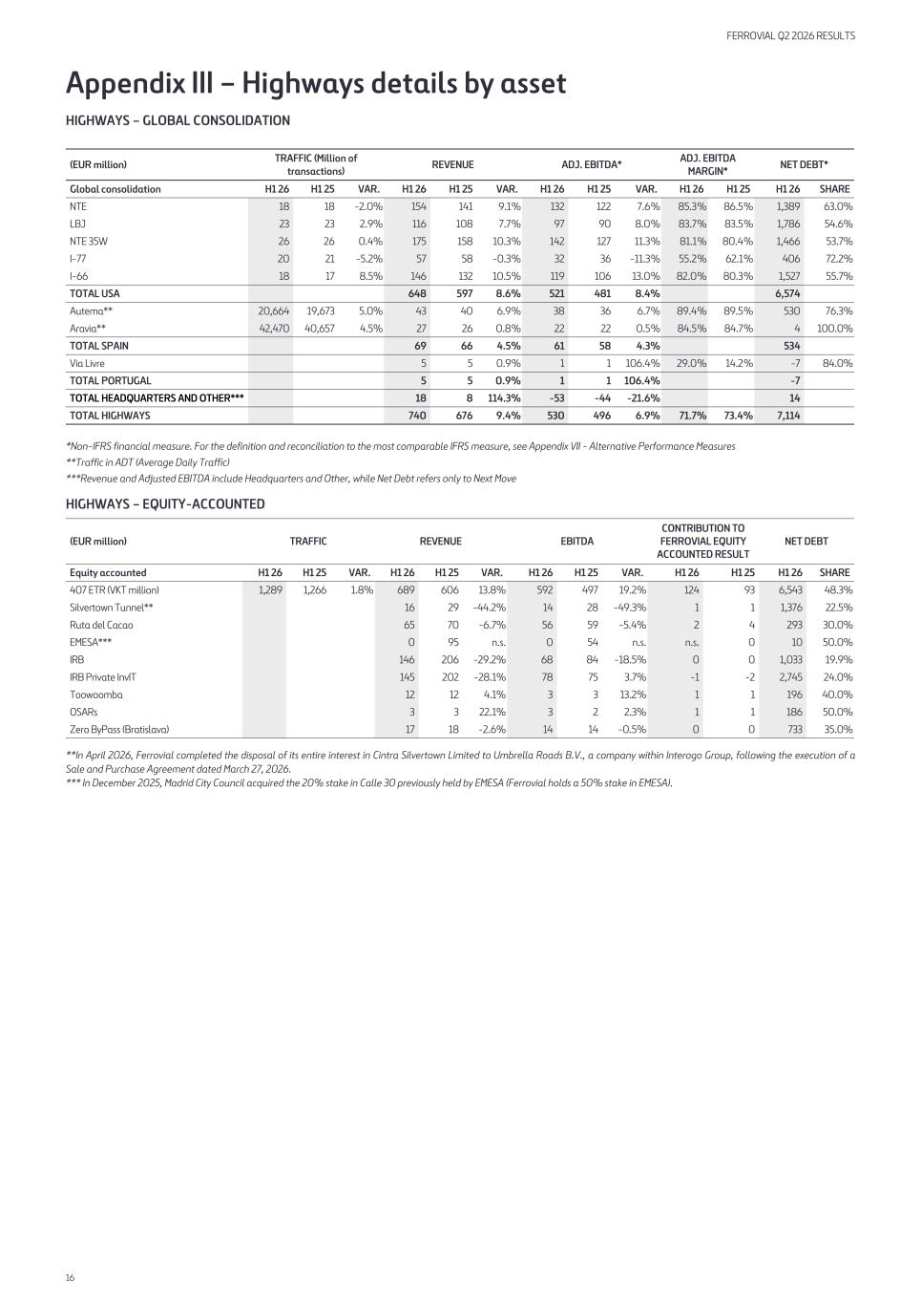
Appendix III – Highways details by asset HIGHWAYS – GLOBAL CONSOLIDATION (EUR million) TRAFFIC (Million of transactions) REVENUE ADJ. EBITDA* ADJ. EBITDA MARGIN* NET DEBT* Global consolidation H1 26 H1 25 VAR. H1 26 H1 25 VAR. H1 26 H1 25 VAR. H1 26 H1 25 H1 26 SHARE NTE 18 18 -2.0 % 154 141 9.1 % 132 122 7.6 % 85.3 % 86.5 % 1,389 63.0 % LBJ 23 23 2.9 % 116 108 7.7 % 97 90 8.0 % 83.7 % 83.5 % 1,786 54.6 % NTE 35W 26 26 0.4 % 175 158 10.3 % 142 127 11.3 % 81.1 % 80.4 % 1,466 53.7 % I-77 20 21 -5.2 % 57 58 -0.3 % 32 36 -11.3 % 55.2 % 62.1 % 406 72.2 % I-66 18 17 8.5 % 146 132 10.5 % 119 106 13.0 % 82.0 % 80.3 % 1,527 55.7 % TOTAL USA 648 597 8.6 % 521 481 8.4 % 6,574 Autema** 20,664 19,673 5.0 % 43 40 6.9 % 38 36 6.7 % 89.4 % 89.5 % 530 76.3 % Aravia** 42,470 40,657 4.5 % 27 26 0.8 % 22 22 0.5 % 84.5 % 84.7 % 4 100.0 % TOTAL SPAIN 69 66 4.5 % 61 58 4.3 % 534 Via Livre 5 5 0.9 % 1 1 106.4 % 29.0 % 14.2 % -7 84.0 % TOTAL PORTUGAL 5 5 0.9 % 1 1 106.4 % -7 TOTAL HEADQUARTERS AND OTHER*** 18 8 114.3 % -53 -44 -21.6 % 14 TOTAL HIGHWAYS 740 676 9.4 % 530 496 6.9 % 71.7 % 73.4 % 7,114 *Non-IFRS financial measure. For the definition and reconciliation to the most comparable IFRS measure, see Appendix VII - Alternative Performance Measures **Traffic in ADT (Average Daily Traffic) ***Revenue and Adjusted EBITDA include Headquarters and Other, while Net Debt refers only to Next Move HIGHWAYS – EQUITY-ACCOUNTED (EUR million) TRAFFIC REVENUE EBITDA CONTRIBUTION TO FERROVIAL EQUITY ACCOUNTED RESULT NET DEBT Equity accounted H1 26 H1 25 VAR. H1 26 H1 25 VAR. H1 26 H1 25 VAR. H1 26 H1 25 H1 26 SHARE 407 ETR (VKT million) 1,289 1,266 1.8 % 689 606 13.8 % 592 497 19.2 % 124 93 6,543 48.3 % Silvertown Tunnel** 16 29 -44.2 % 14 28 -49.3 % 1 1 1,376 22.5 % Ruta del Cacao 65 70 -6.7 % 56 59 -5.4 % 2 4 293 30.0 % EMESA*** 0 95 n.s. 0 54 n.s. n.s. 0 10 50.0 % IRB 146 206 -29.2 % 68 84 -18.5 % 0 0 1,033 19.9 % IRB Private InvIT 145 202 -28.1 % 78 75 3.7 % -1 -2 2,745 24.0 % Toowoomba 12 12 4.1 % 3 3 13.2 % 1 1 196 40.0 % OSARs 3 3 22.1 % 3 2 2.3 % 1 1 186 50.0 % Zero ByPass (Bratislava) 17 18 -2.6 % 14 14 -0.5 % 0 0 733 35.0 % **In April 2026, Ferrovial completed the disposal of its entire interest in Cintra Silvertown Limited to Umbrella Roads B.V., a company within Interogo Group, following the execution of a Sale and Purchase Agreement dated March 27, 2026. *** In December 2025, Madrid City Council acquired the 20% stake in Calle 30 previously held by EMESA (Ferrovial holds a 50% stake in EMESA). FERROVIAL Q2 2026 RESULTS 16

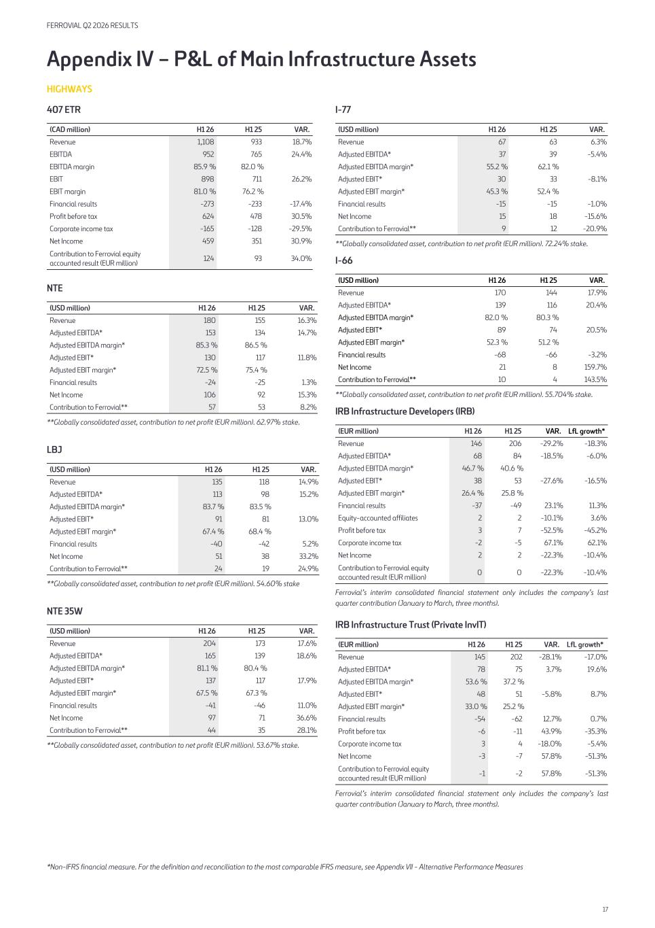
Appendix IV – P&L of Main Infrastructure Assets HIGHWAYS 407 ETR (CAD million) H1 26 H1 25 VAR. Revenue 1,108 933 18.7 % EBITDA 952 765 24.4 % EBITDA margin 85.9 % 82.0 % EBIT 898 711 26.2 % EBIT margin 81.0 % 76.2 % Financial results -273 -233 -17.4 % Profit before tax 624 478 30.5 % Corporate income tax -165 -128 -29.5 % Net Income 459 351 30.9 % Contribution to Ferrovial equity accounted result (EUR million) 124 93 34.0 % NTE (USD million) H1 26 H1 25 VAR. Revenue 180 155 16.3 % Adjusted EBITDA* 153 134 14.7 % Adjusted EBITDA margin* 85.3 % 86.5 % Adjusted EBIT* 130 117 11.8 % Adjusted EBIT margin* 72.5 % 75.4 % Financial results -24 -25 1.3 % Net Income 106 92 15.3 % Contribution to Ferrovial** 57 53 8.2 % **Globally consolidated asset, contribution to net profit (EUR million). 62.97% stake. LBJ (USD million) H1 26 H1 25 VAR. Revenue 135 118 14.9 % Adjusted EBITDA* 113 98 15.2 % Adjusted EBITDA margin* 83.7 % 83.5 % Adjusted EBIT* 91 81 13.0 % Adjusted EBIT margin* 67.4 % 68.4 % Financial results -40 -42 5.2 % Net Income 51 38 33.2 % Contribution to Ferrovial** 24 19 24.9 % **Globally consolidated asset, contribution to net profit (EUR million). 54.60% stake NTE 35W (USD million) H1 26 H1 25 VAR. Revenue 204 173 17.6 % Adjusted EBITDA* 165 139 18.6 % Adjusted EBITDA margin* 81.1 % 80.4 % Adjusted EBIT* 137 117 17.9 % Adjusted EBIT margin* 67.5 % 67.3 % Financial results -41 -46 11.0 % Net Income 97 71 36.6 % Contribution to Ferrovial** 44 35 28.1 % **Globally consolidated asset, contribution to net profit (EUR million). 53.67% stake. I-77 (USD million) H1 26 H1 25 VAR. Revenue 67 63 6.3 % Adjusted EBITDA* 37 39 -5.4 % Adjusted EBITDA margin* 55.2 % 62.1 % Adjusted EBIT* 30 33 -8.1 % Adjusted EBIT margin* 45.3 % 52.4 % Financial results -15 -15 -1.0 % Net Income 15 18 -15.6 % Contribution to Ferrovial** 9 12 -20.9 % **Globally consolidated asset, contribution to net profit (EUR million). 72.24% stake. I-66 (USD million) H1 26 H1 25 VAR. Revenue 170 144 17.9 % Adjusted EBITDA* 139 116 20.4 % Adjusted EBITDA margin* 82.0 % 80.3 % Adjusted EBIT* 89 74 20.5 % Adjusted EBIT margin* 52.3 % 51.2 % Financial results -68 -66 -3.2 % Net Income 21 8 159.7 % Contribution to Ferrovial** 10 4 143.5 % **Globally consolidated asset, contribution to net profit (EUR million). 55.704% stake. IRB Infrastructure Developers (IRB) (EUR million) H1 26 H1 25 VAR. LfL growth* Revenue 146 206 -29.2 % -18.3 % Adjusted EBITDA* 68 84 -18.5 % -6.0 % Adjusted EBITDA margin* 46.7 % 40.6 % Adjusted EBIT* 38 53 -27.6 % -16.5 % Adjusted EBIT margin* 26.4 % 25.8 % Financial results -37 -49 23.1 % 11.3 % Equity-accounted affiliates 2 2 -10.1 % 3.6 % Profit before tax 3 7 -52.5 % -45.2 % Corporate income tax -2 -5 67.1 % 62.1 % Net Income 2 2 -22.3 % -10.4 % Contribution to Ferrovial equity accounted result (EUR million) 0 0 -22.3 % -10.4 % Ferrovial’s interim consolidated financial statement only includes the company’s last quarter contribution (January to March, three months). IRB Infrastructure Trust (Private InvIT) (EUR million) H1 26 H1 25 VAR. LfL growth* Revenue 145 202 -28.1 % -17.0 % Adjusted EBITDA* 78 75 3.7 % 19.6 % Adjusted EBITDA margin* 53.6 % 37.2 % Adjusted EBIT* 48 51 -5.8 % 8.7 % Adjusted EBIT margin* 33.0 % 25.2 % Financial results -54 -62 12.7 % 0.7 % Profit before tax -6 -11 43.9 % -35.3 % Corporate income tax 3 4 -18.0 % -5.4 % Net Income -3 -7 57.8 % -51.3 % Contribution to Ferrovial equity accounted result (EUR million) -1 -2 57.8 % -51.3 % Ferrovial’s interim consolidated financial statement only includes the company’s last quarter contribution (January to March, three months). *Non-IFRS financial measure. For the definition and reconciliation to the most comparable IFRS measure, see Appendix VII - Alternative Performance Measures FERROVIAL Q2 2026 RESULTS 17

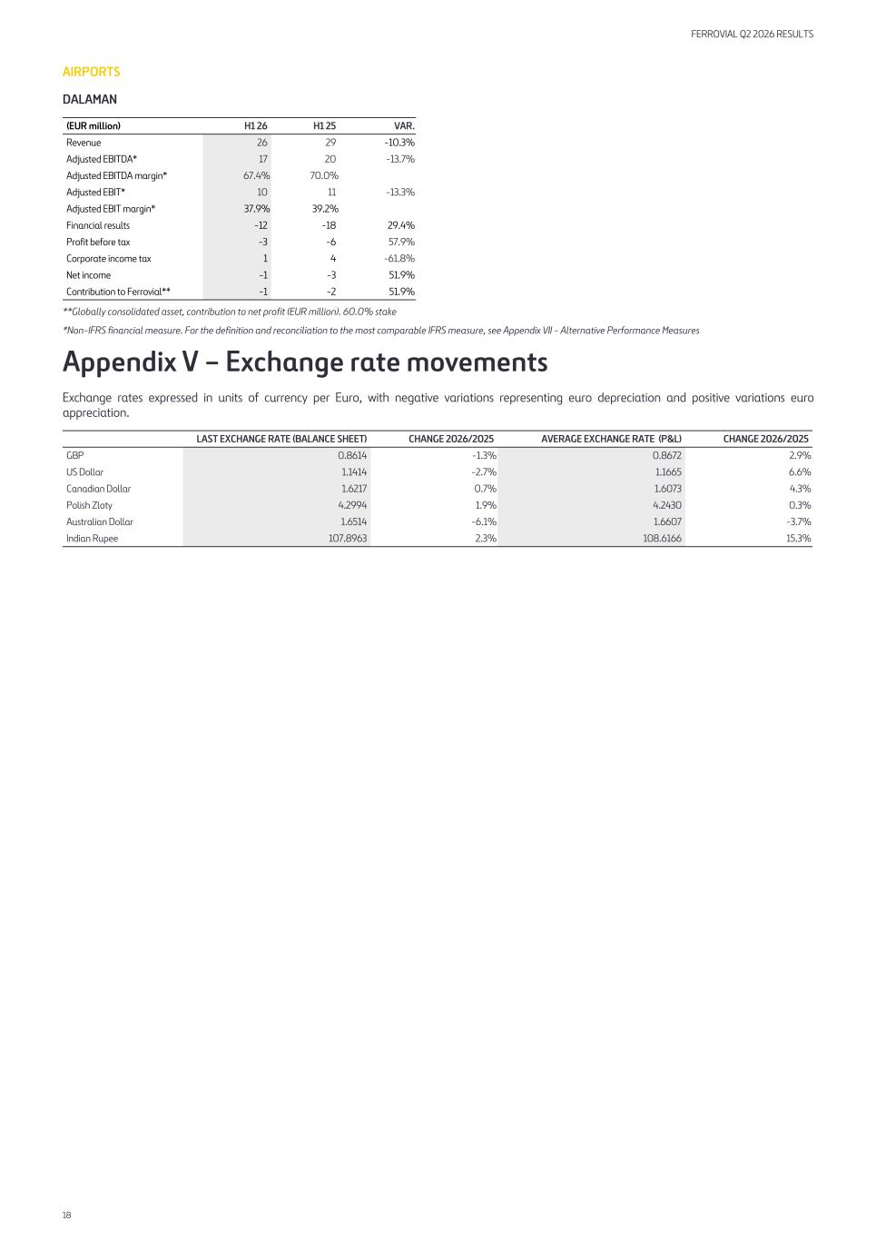
AIRPORTS DALAMAN (EUR million) H1 26 H1 25 VAR. Revenue 26 29 -10.3 % Adjusted EBITDA* 17 20 -13.7 % Adjusted EBITDA margin* 67.4 % 70.0 % Adjusted EBIT* 10 11 -13.3 % Adjusted EBIT margin* 37.9 % 39.2 % Financial results -12 -18 29.4 % Profit before tax -3 -6 57.9 % Corporate income tax 1 4 -61.8 % Net income -1 -3 51.9 % Contribution to Ferrovial** -1 -2 51.9 % **Globally consolidated asset, contribution to net profit (EUR million). 60.0% stake *Non-IFRS financial measure. For the definition and reconciliation to the most comparable IFRS measure, see Appendix VII - Alternative Performance Measures Appendix V – Exchange rate movements Exchange rates expressed in units of currency per Euro, with negative variations representing euro depreciation and positive variations euro appreciation. LAST EXCHANGE RATE (BALANCE SHEET) CHANGE 2026/2025 AVERAGE EXCHANGE RATE (P&L) CHANGE 2026/2025 GBP 0.8614 -1.3 % 0.8672 2.9 % US Dollar 1.1414 -2.7 % 1.1665 6.6 % Canadian Dollar 1.6217 0.7 % 1.6073 4.3 % Polish Zloty 4.2994 1.9 % 4.2430 0.3 % Australian Dollar 1.6514 -6.1 % 1.6607 -3.7 % Indian Rupee 107.8963 2.3 % 108.6166 15.3 % FERROVIAL Q2 2026 RESULTS 18

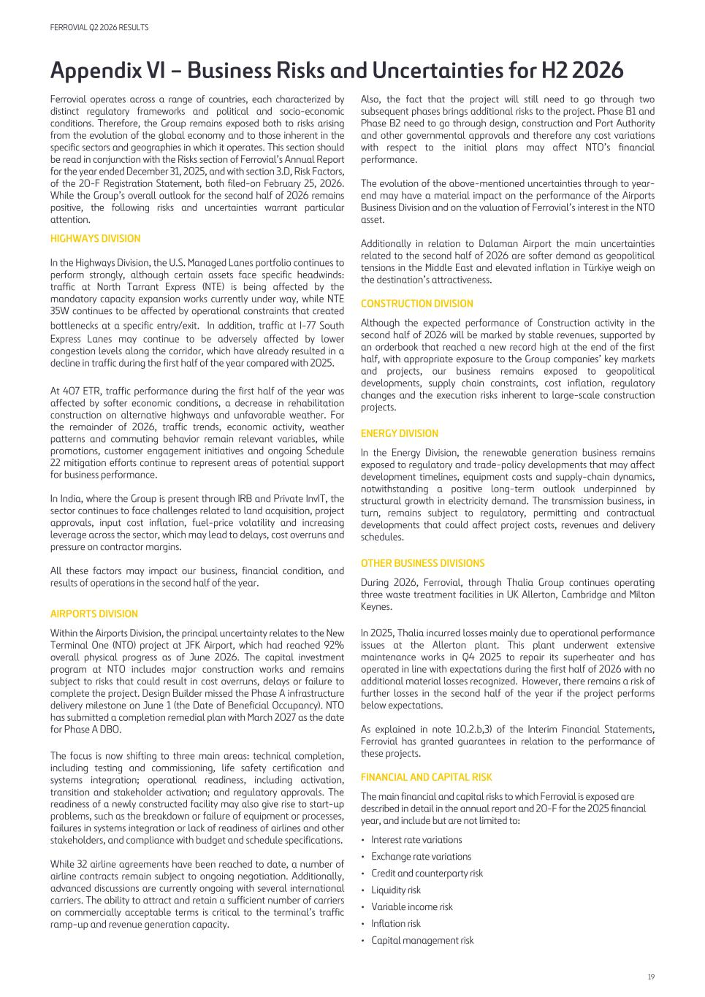
Appendix VI – Business Risks and Uncertainties for H2 2026 Ferrovial operates across a range of countries, each characterized by distinct regulatory frameworks and political and socio-economic conditions. Therefore, the Group remains exposed both to risks arising from the evolution of the global economy and to those inherent in the specific sectors and geographies in which it operates. This section should be read in conjunction with the Risks section of Ferrovial’s Annual Report for the year ended December 31, 2025, and with section 3.D, Risk Factors, of the 20-F Registration Statement, both filed-on February 25, 2026. While the Group’s overall outlook for the second half of 2026 remains positive, the following risks and uncertainties warrant particular attention. HIGHWAYS DIVISION In the Highways Division, the U.S. Managed Lanes portfolio continues to perform strongly, although certain assets face specific headwinds: traffic at North Tarrant Express (NTE) is being affected by the mandatory capacity expansion works currently under way, while NTE 35W continues to be affected by operational constraints that created bottlenecks at a specific entry/exit. In addition, traffic at I-77 South Express Lanes may continue to be adversely affected by lower congestion levels along the corridor, which have already resulted in a decline in traffic during the first half of the year compared with 2025. At 407 ETR, traffic performance during the first half of the year was affected by softer economic conditions, a decrease in rehabilitation construction on alternative highways and unfavorable weather. For the remainder of 2026, traffic trends, economic activity, weather patterns and commuting behavior remain relevant variables, while promotions, customer engagement initiatives and ongoing Schedule 22 mitigation efforts continue to represent areas of potential support for business performance. In India, where the Group is present through IRB and Private InvIT, the sector continues to face challenges related to land acquisition, project approvals, input cost inflation, fuel-price volatility and increasing leverage across the sector, which may lead to delays, cost overruns and pressure on contractor margins. All these factors may impact our business, financial condition, and results of operations in the second half of the year. AIRPORTS DIVISION Within the Airports Division, the principal uncertainty relates to the New Terminal One (NTO) project at JFK Airport, which had reached 92% overall physical progress as of June 2026. The capital investment program at NTO includes major construction works and remains subject to risks that could result in cost overruns, delays or failure to complete the project. Design Builder missed the Phase A infrastructure delivery milestone on June 1 (the Date of Beneficial Occupancy). NTO has submitted a completion remedial plan with March 2027 as the date for Phase A DBO. The focus is now shifting to three main areas: technical completion, including testing and commissioning, life safety certification and systems integration; operational readiness, including activation, transition and stakeholder activation; and regulatory approvals. The readiness of a newly constructed facility may also give rise to start-up problems, such as the breakdown or failure of equipment or processes, failures in systems integration or lack of readiness of airlines and other stakeholders, and compliance with budget and schedule specifications. While 32 airline agreements have been reached to date, a number of airline contracts remain subject to ongoing negotiation. Additionally, advanced discussions are currently ongoing with several international carriers. The ability to attract and retain a sufficient number of carriers on commercially acceptable terms is critical to the terminal’s traffic ramp-up and revenue generation capacity. Also, the fact that the project will still need to go through two subsequent phases brings additional risks to the project. Phase B1 and Phase B2 need to go through design, construction and Port Authority and other governmental approvals and therefore any cost variations with respect to the initial plans may affect NTO’s financial performance. The evolution of the above-mentioned uncertainties through to year- end may have a material impact on the performance of the Airports Business Division and on the valuation of Ferrovial’s interest in the NTO asset. Additionally in relation to Dalaman Airport the main uncertainties related to the second half of 2026 are softer demand as geopolitical tensions in the Middle East and elevated inflation in Türkiye weigh on the destination’s attractiveness. CONSTRUCTION DIVISION Although the expected performance of Construction activity in the second half of 2026 will be marked by stable revenues, supported by an orderbook that reached a new record high at the end of the first half, with appropriate exposure to the Group companies’ key markets and projects, our business remains exposed to geopolitical developments, supply chain constraints, cost inflation, regulatory changes and the execution risks inherent to large-scale construction projects. ENERGY DIVISION In the Energy Division, the renewable generation business remains exposed to regulatory and trade-policy developments that may affect development timelines, equipment costs and supply-chain dynamics, notwithstanding a positive long-term outlook underpinned by structural growth in electricity demand. The transmission business, in turn, remains subject to regulatory, permitting and contractual developments that could affect project costs, revenues and delivery schedules. OTHER BUSINESS DIVISIONS During 2026, Ferrovial, through Thalia Group continues operating three waste treatment facilities in UK Allerton, Cambridge and Milton Keynes. In 2025, Thalia incurred losses mainly due to operational performance issues at the Allerton plant. This plant underwent extensive maintenance works in Q4 2025 to repair its superheater and has operated in line with expectations during the first half of 2026 with no additional material losses recognized. However, there remains a risk of further losses in the second half of the year if the project performs below expectations. As explained in note 10.2.b,3) of the Interim Financial Statements, Ferrovial has granted guarantees in relation to the performance of these projects. FINANCIAL AND CAPITAL RISK The main financial and capital risks to which Ferrovial is exposed are described in detail in the annual report and 20-F for the 2025 financial year, and include but are not limited to: • Interest rate variations • Exchange rate variations • Credit and counterparty risk • Liquidity risk • Variable income risk • Inflation risk • Capital management risk FERROVIAL Q2 2026 RESULTS 19

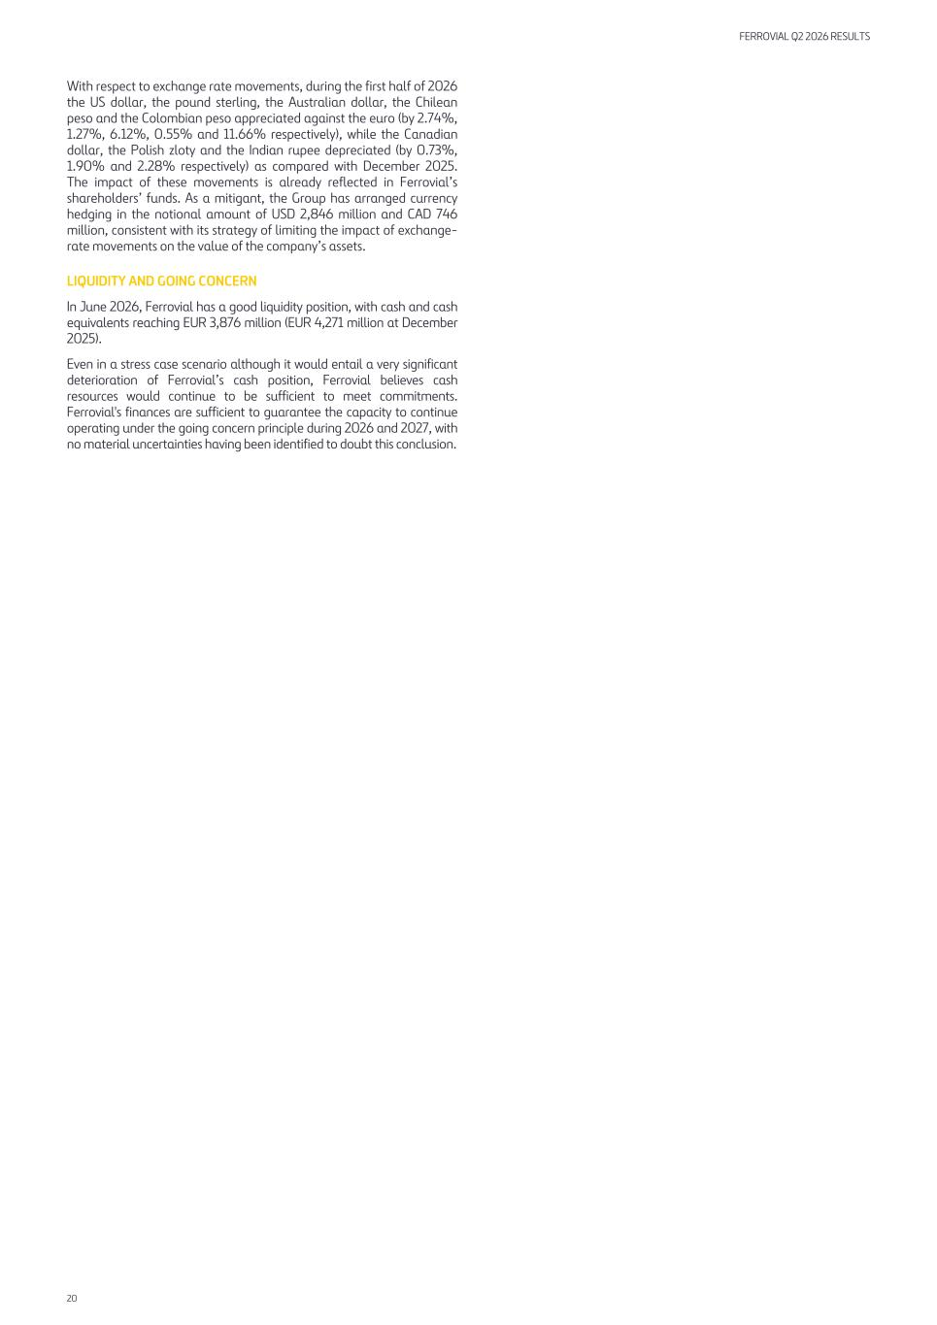
With respect to exchange rate movements, during the first half of 2026 the US dollar, the pound sterling, the Australian dollar, the Chilean peso and the Colombian peso appreciated against the euro (by 2.74%, 1.27%, 6.12%, 0.55% and 11.66% respectively), while the Canadian dollar, the Polish zloty and the Indian rupee depreciated (by 0.73%, 1.90% and 2.28% respectively) as compared with December 2025. The impact of these movements is already reflected in Ferrovial’s shareholders’ funds. As a mitigant, the Group has arranged currency hedging in the notional amount of USD 2,846 million and CAD 746 million, consistent with its strategy of limiting the impact of exchange- rate movements on the value of the company’s assets. LIQUIDITY AND GOING CONCERN In June 2026, Ferrovial has a good liquidity position, with cash and cash equivalents reaching EUR 3,876 million (EUR 4,271 million at December 2025). Even in a stress case scenario although it would entail a very significant deterioration of Ferrovial’s cash position, Ferrovial believes cash resources would continue to be sufficient to meet commitments. Ferrovial's finances are sufficient to guarantee the capacity to continue operating under the going concern principle during 2026 and 2027, with no material uncertainties having been identified to doubt this conclusion. FERROVIAL Q2 2026 RESULTS 20

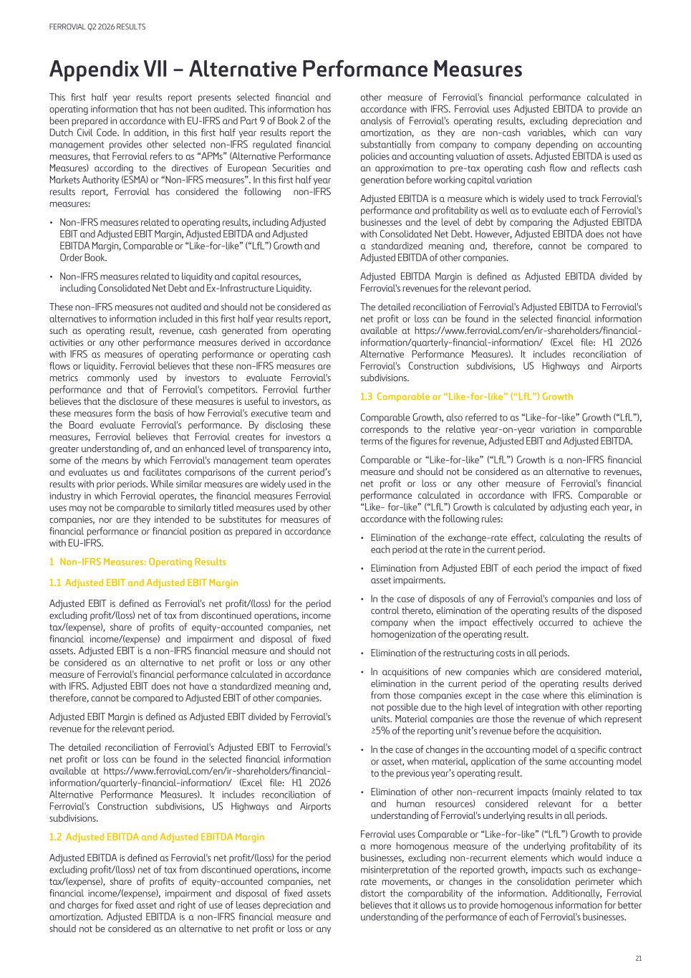
Appendix VII – Alternative Performance Measures This first half year results report presents selected financial and operating information that has not been audited. This information has been prepared in accordance with EU-IFRS and Part 9 of Book 2 of the Dutch Civil Code. In addition, in this first half year results report the management provides other selected non-IFRS regulated financial measures, that Ferrovial refers to as “APMs” (Alternative Performance Measures) according to the directives of European Securities and Markets Authority (ESMA) or “Non-IFRS measures”. In this first half year results report, Ferrovial has considered the following non-IFRS measures: • Non-IFRS measures related to operating results, including Adjusted EBIT and Adjusted EBIT Margin, Adjusted EBITDA and Adjusted EBITDA Margin, Comparable or “Like-for-like” (“LfL”) Growth and Order Book. • Non-IFRS measures related to liquidity and capital resources, including Consolidated Net Debt and Ex-Infrastructure Liquidity. These non-IFRS measures not audited and should not be considered as alternatives to information included in this first half year results report, such as operating result, revenue, cash generated from operating activities or any other performance measures derived in accordance with IFRS as measures of operating performance or operating cash flows or liquidity. Ferrovial believes that these non-IFRS measures are metrics commonly used by investors to evaluate Ferrovial's performance and that of Ferrovial's competitors. Ferrovial further believes that the disclosure of these measures is useful to investors, as these measures form the basis of how Ferrovial's executive team and the Board evaluate Ferrovial's performance. By disclosing these measures, Ferrovial believes that Ferrovial creates for investors a greater understanding of, and an enhanced level of transparency into, some of the means by which Ferrovial's management team operates and evaluates us and facilitates comparisons of the current period’s results with prior periods. While similar measures are widely used in the industry in which Ferrovial operates, the financial measures Ferrovial uses may not be comparable to similarly titled measures used by other companies, nor are they intended to be substitutes for measures of financial performance or financial position as prepared in accordance with EU-IFRS. 1 Non-IFRS Measures: Operating Results 1.1 Adjusted EBIT and Adjusted EBIT Margin Adjusted EBIT is defined as Ferrovial's net profit/(loss) for the period excluding profit/(loss) net of tax from discontinued operations, income tax/(expense), share of profits of equity-accounted companies, net financial income/(expense) and impairment and disposal of fixed assets. Adjusted EBIT is a non-IFRS financial measure and should not be considered as an alternative to net profit or loss or any other measure of Ferrovial's financial performance calculated in accordance with IFRS. Adjusted EBIT does not have a standardized meaning and, therefore, cannot be compared to Adjusted EBIT of other companies. Adjusted EBIT Margin is defined as Adjusted EBIT divided by Ferrovial's revenue for the relevant period. The detailed reconciliation of Ferrovial's Adjusted EBIT to Ferrovial's net profit or loss can be found in the selected financial information available at https://www.ferrovial.com/en/ir-shareholders/financial- information/quarterly-financial-information/ (Excel file: H1 2026 Alternative Performance Measures). It includes reconciliation of Ferrovial's Construction subdivisions, US Highways and Airports subdivisions. 1.2 Adjusted EBITDA and Adjusted EBITDA Margin Adjusted EBITDA is defined as Ferrovial's net profit/(loss) for the period excluding profit/(loss) net of tax from discontinued operations, income tax/(expense), share of profits of equity-accounted companies, net financial income/(expense), impairment and disposal of fixed assets and charges for fixed asset and right of use of leases depreciation and amortization. Adjusted EBITDA is a non-IFRS financial measure and should not be considered as an alternative to net profit or loss or any other measure of Ferrovial's financial performance calculated in accordance with IFRS. Ferrovial uses Adjusted EBITDA to provide an analysis of Ferrovial's operating results, excluding depreciation and amortization, as they are non-cash variables, which can vary substantially from company to company depending on accounting policies and accounting valuation of assets. Adjusted EBITDA is used as an approximation to pre-tax operating cash flow and reflects cash generation before working capital variation Adjusted EBITDA is a measure which is widely used to track Ferrovial's performance and profitability as well as to evaluate each of Ferrovial's businesses and the level of debt by comparing the Adjusted EBITDA with Consolidated Net Debt. However, Adjusted EBITDA does not have a standardized meaning and, therefore, cannot be compared to Adjusted EBITDA of other companies. Adjusted EBITDA Margin is defined as Adjusted EBITDA divided by Ferrovial's revenues for the relevant period. The detailed reconciliation of Ferrovial's Adjusted EBITDA to Ferrovial's net profit or loss can be found in the selected financial information available at https://www.ferrovial.com/en/ir-shareholders/financial- information/quarterly-financial-information/ (Excel file: H1 2026 Alternative Performance Measures). It includes reconciliation of Ferrovial's Construction subdivisions, US Highways and Airports subdivisions. 1.3 Comparable or “Like-for-like” (“LfL”) Growth Comparable Growth, also referred to as “Like-for-like” Growth (“LfL”), corresponds to the relative year-on-year variation in comparable terms of the figures for revenue, Adjusted EBIT and Adjusted EBITDA. Comparable or “Like-for-like” (“LfL”) Growth is a non-IFRS financial measure and should not be considered as an alternative to revenues, net profit or loss or any other measure of Ferrovial's financial performance calculated in accordance with IFRS. Comparable or “Like- for-like” (“LfL”) Growth is calculated by adjusting each year, in accordance with the following rules: • Elimination of the exchange-rate effect, calculating the results of each period at the rate in the current period. • Elimination from Adjusted EBIT of each period the impact of fixed asset impairments. • In the case of disposals of any of Ferrovial's companies and loss of control thereto, elimination of the operating results of the disposed company when the impact effectively occurred to achieve the homogenization of the operating result. • Elimination of the restructuring costs in all periods. • In acquisitions of new companies which are considered material, elimination in the current period of the operating results derived from those companies except in the case where this elimination is not possible due to the high level of integration with other reporting units. Material companies are those the revenue of which represent ≥5% of the reporting unit’s revenue before the acquisition. • In the case of changes in the accounting model of a specific contract or asset, when material, application of the same accounting model to the previous year’s operating result. • Elimination of other non-recurrent impacts (mainly related to tax and human resources) considered relevant for a better understanding of Ferrovial's underlying results in all periods. Ferrovial uses Comparable or “Like-for-like” (“LfL”) Growth to provide a more homogenous measure of the underlying profitability of its businesses, excluding non-recurrent elements which would induce a misinterpretation of the reported growth, impacts such as exchange- rate movements, or changes in the consolidation perimeter which distort the comparability of the information. Additionally, Ferrovial believes that it allows us to provide homogenous information for better understanding of the performance of each of Ferrovial's businesses. FERROVIAL Q2 2026 RESULTS 21

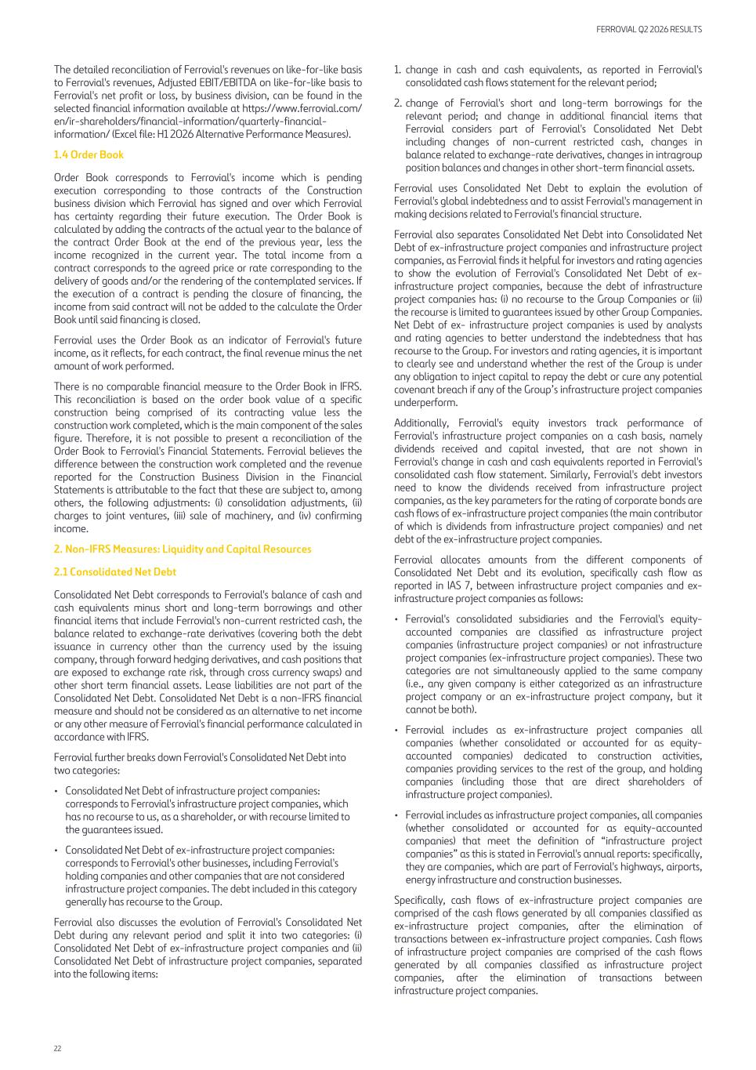
The detailed reconciliation of Ferrovial's revenues on like-for-like basis to Ferrovial's revenues, Adjusted EBIT/EBITDA on like-for-like basis to Ferrovial's net profit or loss, by business division, can be found in the selected financial information available at https://www.ferrovial.com/ en/ir-shareholders/financial-information/quarterly-financial- information/ (Excel file: H1 2026 Alternative Performance Measures). 1.4 Order Book Order Book corresponds to Ferrovial's income which is pending execution corresponding to those contracts of the Construction business division which Ferrovial has signed and over which Ferrovial has certainty regarding their future execution. The Order Book is calculated by adding the contracts of the actual year to the balance of the contract Order Book at the end of the previous year, less the income recognized in the current year. The total income from a contract corresponds to the agreed price or rate corresponding to the delivery of goods and/or the rendering of the contemplated services. If the execution of a contract is pending the closure of financing, the income from said contract will not be added to the calculate the Order Book until said financing is closed. Ferrovial uses the Order Book as an indicator of Ferrovial's future income, as it reflects, for each contract, the final revenue minus the net amount of work performed. There is no comparable financial measure to the Order Book in IFRS. This reconciliation is based on the order book value of a specific construction being comprised of its contracting value less the construction work completed, which is the main component of the sales figure. Therefore, it is not possible to present a reconciliation of the Order Book to Ferrovial's Financial Statements. Ferrovial believes the difference between the construction work completed and the revenue reported for the Construction Business Division in the Financial Statements is attributable to the fact that these are subject to, among others, the following adjustments: (i) consolidation adjustments, (ii) charges to joint ventures, (iii) sale of machinery, and (iv) confirming income. 2. Non-IFRS Measures: Liquidity and Capital Resources 2.1 Consolidated Net Debt Consolidated Net Debt corresponds to Ferrovial's balance of cash and cash equivalents minus short and long-term borrowings and other financial items that include Ferrovial's non-current restricted cash, the balance related to exchange-rate derivatives (covering both the debt issuance in currency other than the currency used by the issuing company, through forward hedging derivatives, and cash positions that are exposed to exchange rate risk, through cross currency swaps) and other short term financial assets. Lease liabilities are not part of the Consolidated Net Debt. Consolidated Net Debt is a non-IFRS financial measure and should not be considered as an alternative to net income or any other measure of Ferrovial's financial performance calculated in accordance with IFRS. Ferrovial further breaks down Ferrovial's Consolidated Net Debt into two categories: • Consolidated Net Debt of infrastructure project companies: corresponds to Ferrovial's infrastructure project companies, which has no recourse to us, as a shareholder, or with recourse limited to the guarantees issued. • Consolidated Net Debt of ex-infrastructure project companies: corresponds to Ferrovial's other businesses, including Ferrovial's holding companies and other companies that are not considered infrastructure project companies. The debt included in this category generally has recourse to the Group. Ferrovial also discusses the evolution of Ferrovial's Consolidated Net Debt during any relevant period and split it into two categories: (i) Consolidated Net Debt of ex-infrastructure project companies and (ii) Consolidated Net Debt of infrastructure project companies, separated into the following items: 1. change in cash and cash equivalents, as reported in Ferrovial's consolidated cash flows statement for the relevant period; 2. change of Ferrovial's short and long-term borrowings for the relevant period; and change in additional financial items that Ferrovial considers part of Ferrovial's Consolidated Net Debt including changes of non-current restricted cash, changes in balance related to exchange-rate derivatives, changes in intragroup position balances and changes in other short-term financial assets. Ferrovial uses Consolidated Net Debt to explain the evolution of Ferrovial's global indebtedness and to assist Ferrovial's management in making decisions related to Ferrovial's financial structure. Ferrovial also separates Consolidated Net Debt into Consolidated Net Debt of ex-infrastructure project companies and infrastructure project companies, as Ferrovial finds it helpful for investors and rating agencies to show the evolution of Ferrovial's Consolidated Net Debt of ex- infrastructure project companies, because the debt of infrastructure project companies has: (i) no recourse to the Group Companies or (ii) the recourse is limited to guarantees issued by other Group Companies. Net Debt of ex- infrastructure project companies is used by analysts and rating agencies to better understand the indebtedness that has recourse to the Group. For investors and rating agencies, it is important to clearly see and understand whether the rest of the Group is under any obligation to inject capital to repay the debt or cure any potential covenant breach if any of the Group’s infrastructure project companies underperform. Additionally, Ferrovial's equity investors track performance of Ferrovial's infrastructure project companies on a cash basis, namely dividends received and capital invested, that are not shown in Ferrovial's change in cash and cash equivalents reported in Ferrovial's consolidated cash flow statement. Similarly, Ferrovial's debt investors need to know the dividends received from infrastructure project companies, as the key parameters for the rating of corporate bonds are cash flows of ex-infrastructure project companies (the main contributor of which is dividends from infrastructure project companies) and net debt of the ex-infrastructure project companies. Ferrovial allocates amounts from the different components of Consolidated Net Debt and its evolution, specifically cash flow as reported in IAS 7, between infrastructure project companies and ex- infrastructure project companies as follows: • Ferrovial's consolidated subsidiaries and the Ferrovial's equity- accounted companies are classified as infrastructure project companies (infrastructure project companies) or not infrastructure project companies (ex-infrastructure project companies). These two categories are not simultaneously applied to the same company (i.e., any given company is either categorized as an infrastructure project company or an ex-infrastructure project company, but it cannot be both). • Ferrovial includes as ex-infrastructure project companies all companies (whether consolidated or accounted for as equity- accounted companies) dedicated to construction activities, companies providing services to the rest of the group, and holding companies (including those that are direct shareholders of infrastructure project companies). • Ferrovial includes as infrastructure project companies, all companies (whether consolidated or accounted for as equity-accounted companies) that meet the definition of “infrastructure project companies” as this is stated in Ferrovial's annual reports: specifically, they are companies, which are part of Ferrovial's highways, airports, energy infrastructure and construction businesses. Specifically, cash flows of ex-infrastructure project companies are comprised of the cash flows generated by all companies classified as ex-infrastructure project companies, after the elimination of transactions between ex-infrastructure project companies. Cash flows of infrastructure project companies are comprised of the cash flows generated by all companies classified as infrastructure project companies, after the elimination of transactions between infrastructure project companies. FERROVIAL Q2 2026 RESULTS 22

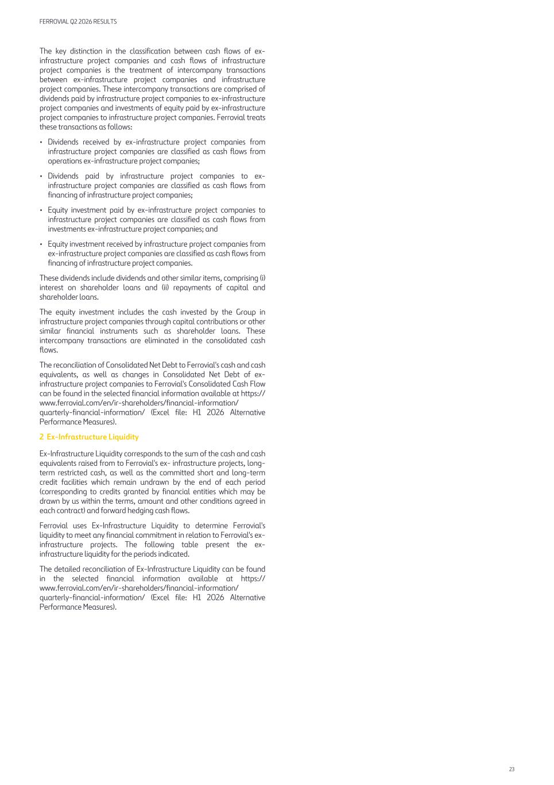
The key distinction in the classification between cash flows of ex- infrastructure project companies and cash flows of infrastructure project companies is the treatment of intercompany transactions between ex-infrastructure project companies and infrastructure project companies. These intercompany transactions are comprised of dividends paid by infrastructure project companies to ex-infrastructure project companies and investments of equity paid by ex-infrastructure project companies to infrastructure project companies. Ferrovial treats these transactions as follows: • Dividends received by ex-infrastructure project companies from infrastructure project companies are classified as cash flows from operations ex-infrastructure project companies; • Dividends paid by infrastructure project companies to ex- infrastructure project companies are classified as cash flows from financing of infrastructure project companies; • Equity investment paid by ex-infrastructure project companies to infrastructure project companies are classified as cash flows from investments ex-infrastructure project companies; and • Equity investment received by infrastructure project companies from ex-infrastructure project companies are classified as cash flows from financing of infrastructure project companies. These dividends include dividends and other similar items, comprising (i) interest on shareholder loans and (ii) repayments of capital and shareholder loans. The equity investment includes the cash invested by the Group in infrastructure project companies through capital contributions or other similar financial instruments such as shareholder loans. These intercompany transactions are eliminated in the consolidated cash flows. The reconciliation of Consolidated Net Debt to Ferrovial's cash and cash equivalents, as well as changes in Consolidated Net Debt of ex- infrastructure project companies to Ferrovial's Consolidated Cash Flow can be found in the selected financial information available at https:// www.ferrovial.com/en/ir-shareholders/financial-information/ quarterly-financial-information/ (Excel file: H1 2026 Alternative Performance Measures). 2 Ex-Infrastructure Liquidity Ex-Infrastructure Liquidity corresponds to the sum of the cash and cash equivalents raised from to Ferrovial's ex- infrastructure projects, long- term restricted cash, as well as the committed short and long-term credit facilities which remain undrawn by the end of each period (corresponding to credits granted by financial entities which may be drawn by us within the terms, amount and other conditions agreed in each contract) and forward hedging cash flows. Ferrovial uses Ex-Infrastructure Liquidity to determine Ferrovial's liquidity to meet any financial commitment in relation to Ferrovial's ex- infrastructure projects. The following table present the ex- infrastructure liquidity for the periods indicated. The detailed reconciliation of Ex-Infrastructure Liquidity can be found in the selected financial information available at https:// www.ferrovial.com/en/ir-shareholders/financial-information/ quarterly-financial-information/ (Excel file: H1 2026 Alternative Performance Measures). FERROVIAL Q2 2026 RESULTS 23


ferrovial For a world on the move Ferrovial N.V. & Subsidiaries Unaudited Interim Condensed Consolidated Financial Statements June 2026

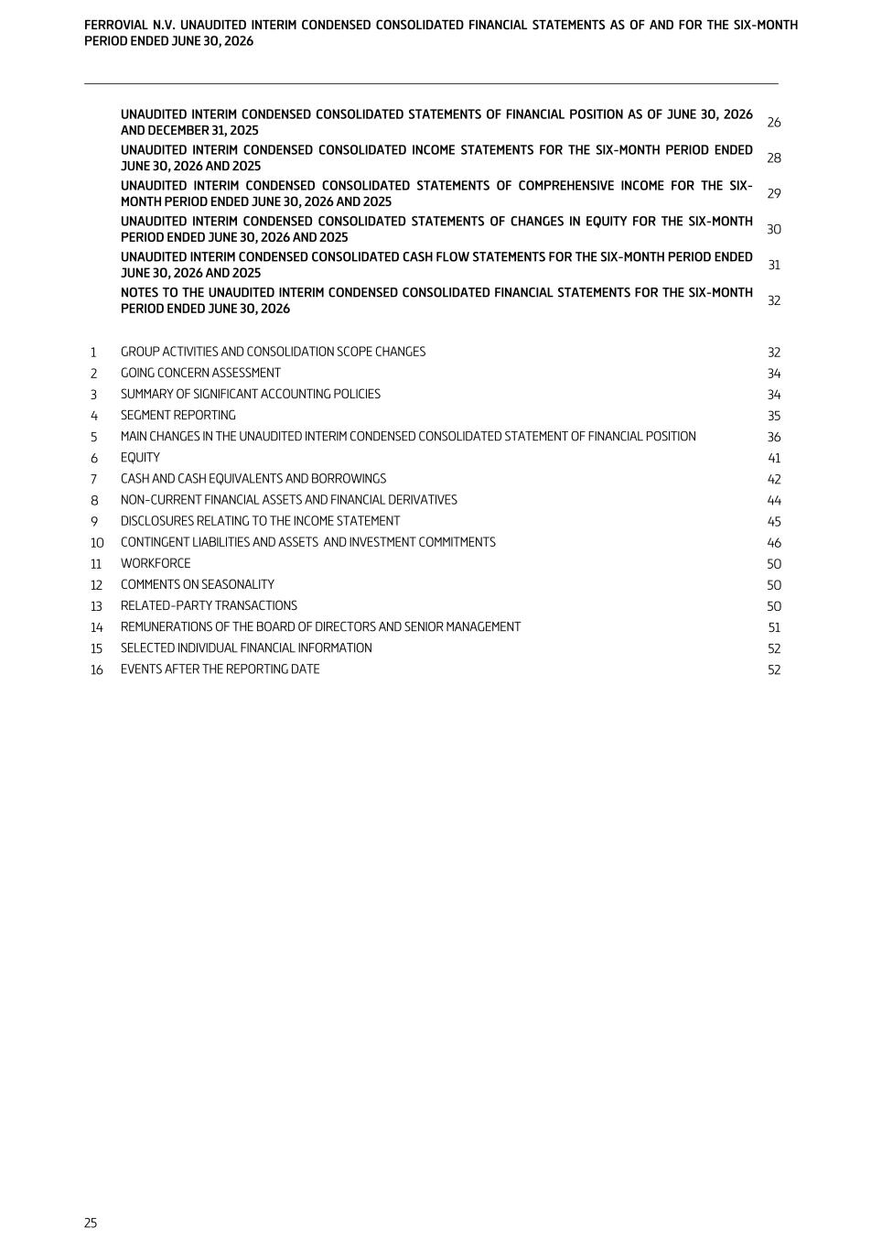
UNAUDITED INTERIM CONDENSED CONSOLIDATED STATEMENTS OF FINANCIAL POSITION AS OF JUNE 30, 2026 AND DECEMBER 31, 2025 26 UNAUDITED INTERIM CONDENSED CONSOLIDATED INCOME STATEMENTS FOR THE SIX-MONTH PERIOD ENDED JUNE 30, 2026 AND 2025 28 UNAUDITED INTERIM CONDENSED CONSOLIDATED STATEMENTS OF COMPREHENSIVE INCOME FOR THE SIX- MONTH PERIOD ENDED JUNE 30, 2026 AND 2025 29 UNAUDITED INTERIM CONDENSED CONSOLIDATED STATEMENTS OF CHANGES IN EQUITY FOR THE SIX-MONTH PERIOD ENDED JUNE 30, 2026 AND 2025 30 UNAUDITED INTERIM CONDENSED CONSOLIDATED CASH FLOW STATEMENTS FOR THE SIX-MONTH PERIOD ENDED JUNE 30, 2026 AND 2025 31 NOTES TO THE UNAUDITED INTERIM CONDENSED CONSOLIDATED FINANCIAL STATEMENTS FOR THE SIX-MONTH PERIOD ENDED JUNE 30, 2026 32 1 GROUP ACTIVITIES AND CONSOLIDATION SCOPE CHANGES 32 2 GOING CONCERN ASSESSMENT 34 3 SUMMARY OF SIGNIFICANT ACCOUNTING POLICIES 34 4 SEGMENT REPORTING 35 5 MAIN CHANGES IN THE UNAUDITED INTERIM CONDENSED CONSOLIDATED STATEMENT OF FINANCIAL POSITION 36 6 EQUITY 41 7 CASH AND CASH EQUIVALENTS AND BORROWINGS 42 8 NON-CURRENT FINANCIAL ASSETS AND FINANCIAL DERIVATIVES 44 9 DISCLOSURES RELATING TO THE INCOME STATEMENT 45 10 CONTINGENT LIABILITIES AND ASSETS AND INVESTMENT COMMITMENTS 46 11 WORKFORCE 50 12 COMMENTS ON SEASONALITY 50 13 RELATED-PARTY TRANSACTIONS 50 14 REMUNERATIONS OF THE BOARD OF DIRECTORS AND SENIOR MANAGEMENT 51 15 SELECTED INDIVIDUAL FINANCIAL INFORMATION 52 16 EVENTS AFTER THE REPORTING DATE 52 FERROVIAL N.V. UNAUDITED INTERIM CONDENSED CONSOLIDATED FINANCIAL STATEMENTS AS OF AND FOR THE SIX-MONTH PERIOD ENDED JUNE 30, 2026 25

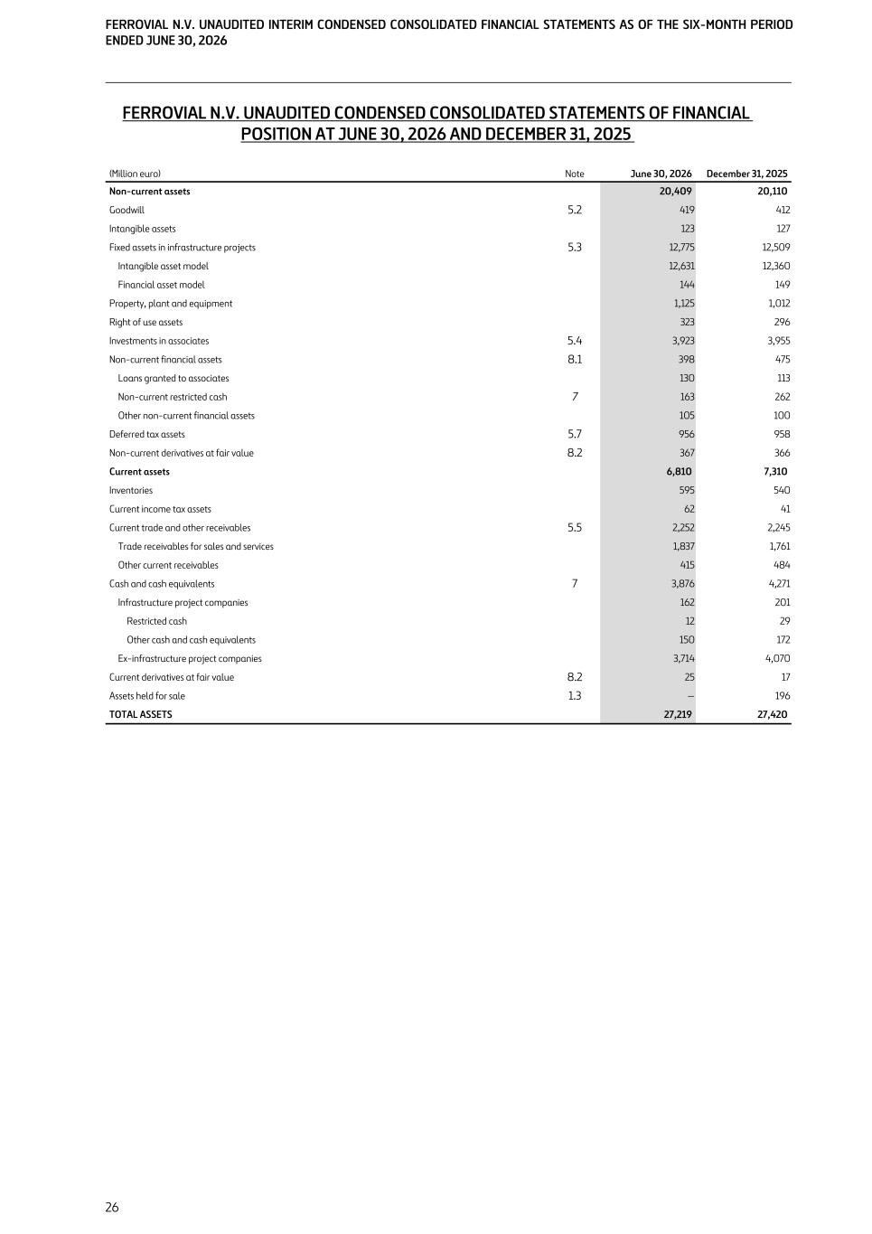
FERROVIAL N.V. UNAUDITED CONDENSED CONSOLIDATED STATEMENTS OF FINANCIAL POSITION AT JUNE 30, 2026 AND DECEMBER 31, 2025 (Million euro) Note June 30, 2026 December 31, 2025 Non-current assets 20,409 20,110 Goodwill 5.2 419 412 Intangible assets 123 127 Fixed assets in infrastructure projects 5.3 12,775 12,509 Intangible asset model 12,631 12,360 Financial asset model 144 149 Property, plant and equipment 1,125 1,012 Right of use assets 323 296 Investments in associates 5.4 3,923 3,955 Non-current financial assets 8.1 398 475 Loans granted to associates 130 113 Non-current restricted cash 7 163 262 Other non-current financial assets 105 100 Deferred tax assets 5.7 956 958 Non-current derivatives at fair value 8.2 367 366 Current assets 6,810 7,310 Inventories 595 540 Current income tax assets 62 41 Current trade and other receivables 5.5 2,252 2,245 Trade receivables for sales and services 1,837 1,761 Other current receivables 415 484 Cash and cash equivalents 7 3,876 4,271 Infrastructure project companies 162 201 Restricted cash 12 29 Other cash and cash equivalents 150 172 Ex-infrastructure project companies 3,714 4,070 Current derivatives at fair value 8.2 25 17 Assets held for sale 1.3 — 196 TOTAL ASSETS 27,219 27,420 FERROVIAL N.V. UNAUDITED INTERIM CONDENSED CONSOLIDATED FINANCIAL STATEMENTS AS OF THE SIX-MONTH PERIOD ENDED JUNE 30, 2026 26

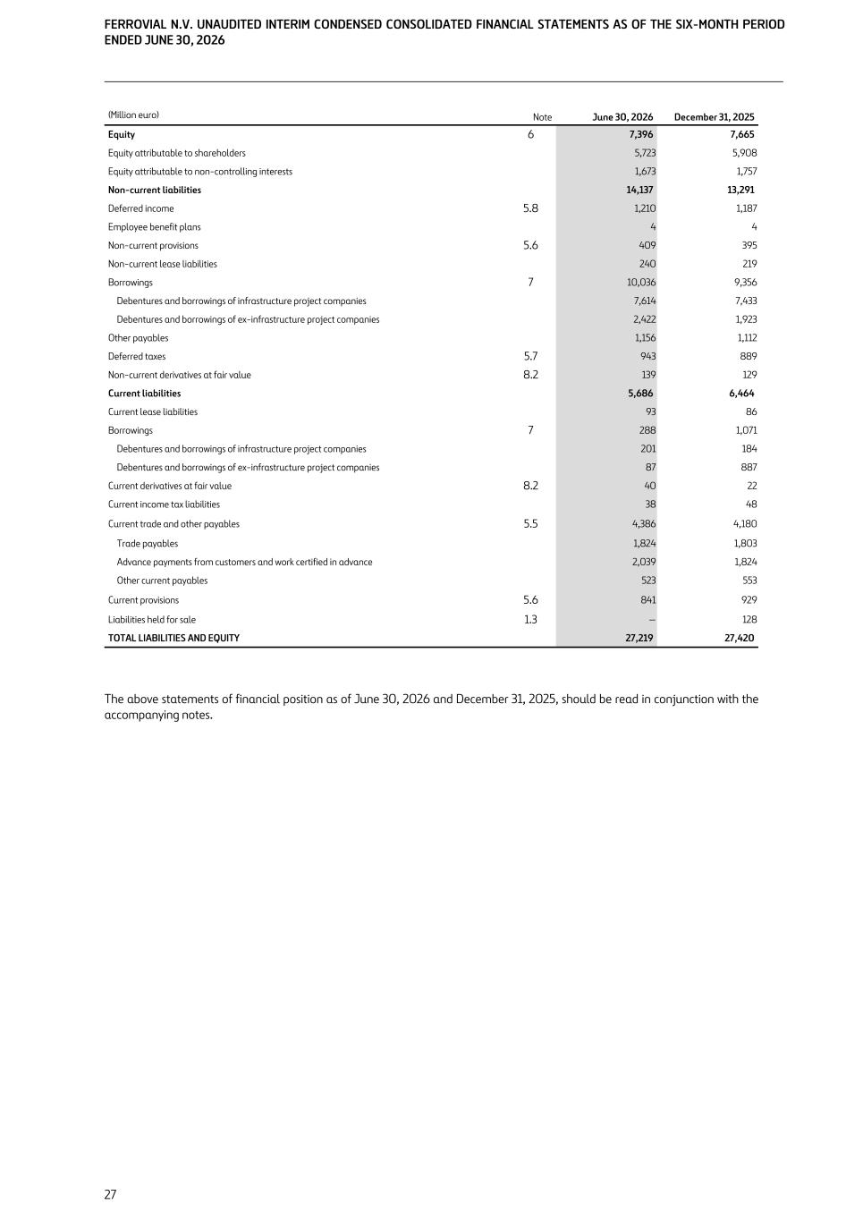
(Million euro) Note June 30, 2026 December 31, 2025 Equity 6 7,396 7,665 Equity attributable to shareholders 5,723 5,908 Equity attributable to non-controlling interests 1,673 1,757 Non-current liabilities 14,137 13,291 Deferred income 5.8 1,210 1,187 Employee benefit plans 4 4 Non-current provisions 5.6 409 395 Non-current lease liabilities 240 219 Borrowings 7 10,036 9,356 Debentures and borrowings of infrastructure project companies 7,614 7,433 Debentures and borrowings of ex-infrastructure project companies 2,422 1,923 Other payables 1,156 1,112 Deferred taxes 5.7 943 889 Non-current derivatives at fair value 8.2 139 129 Current liabilities 5,686 6,464 Current lease liabilities 93 86 Borrowings 7 288 1,071 Debentures and borrowings of infrastructure project companies 201 184 Debentures and borrowings of ex-infrastructure project companies 87 887 Current derivatives at fair value 8.2 40 22 Current income tax liabilities 38 48 Current trade and other payables 5.5 4,386 4,180 Trade payables 1,824 1,803 Advance payments from customers and work certified in advance 2,039 1,824 Other current payables 523 553 Current provisions 5.6 841 929 Liabilities held for sale 1.3 — 128 TOTAL LIABILITIES AND EQUITY 27,219 27,420 The above statements of financial position as of June 30, 2026 and December 31, 2025, should be read in conjunction with the accompanying notes. FERROVIAL N.V. UNAUDITED INTERIM CONDENSED CONSOLIDATED FINANCIAL STATEMENTS AS OF THE SIX-MONTH PERIOD ENDED JUNE 30, 2026 27

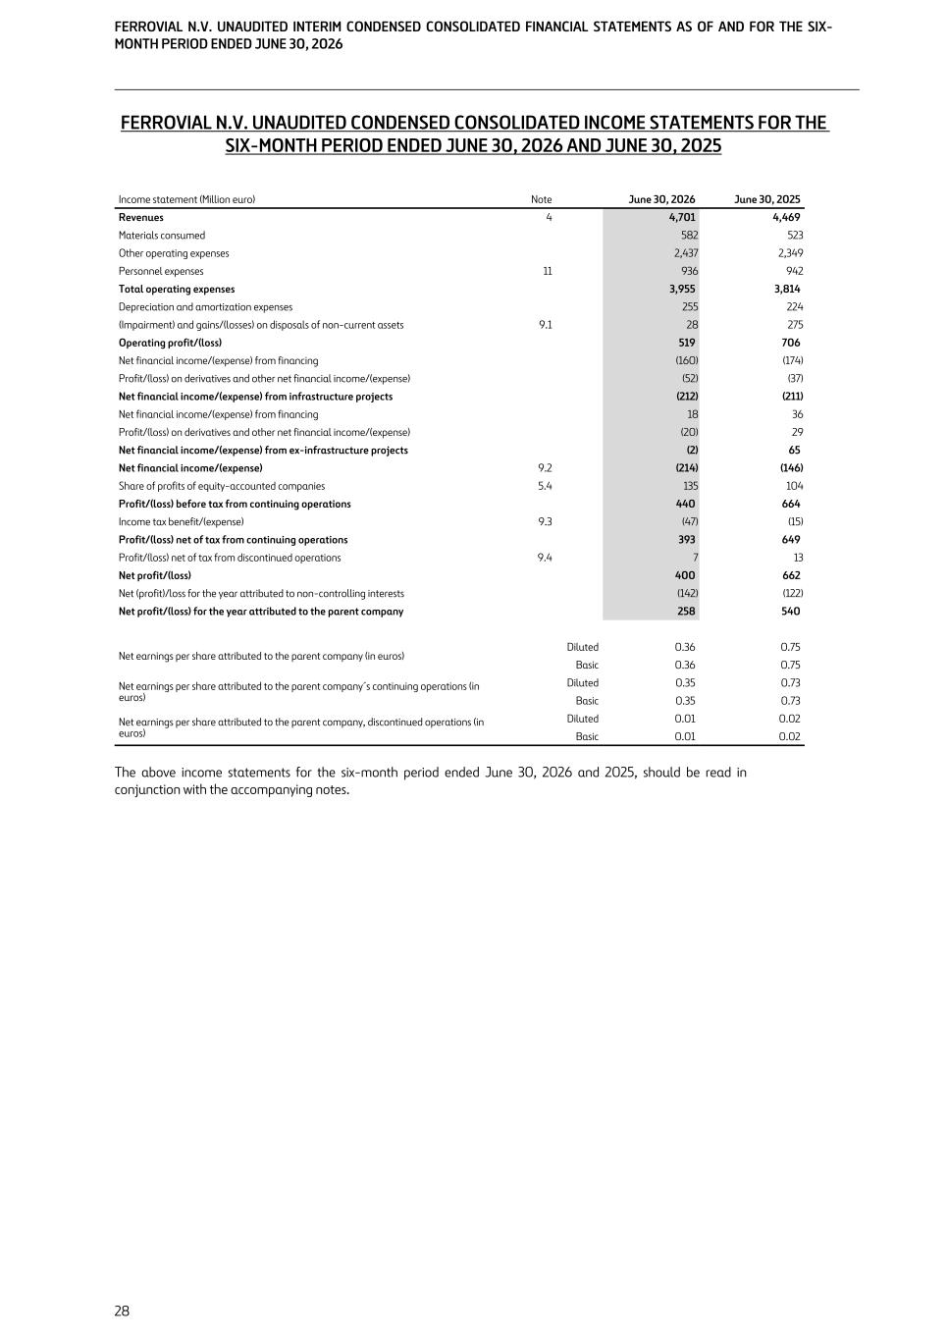
FERROVIAL N.V. UNAUDITED CONDENSED CONSOLIDATED INCOME STATEMENTS FOR THE SIX-MONTH PERIOD ENDED JUNE 30, 2026 AND JUNE 30, 2025 Income statement (Million euro) Note June 30, 2026 June 30, 2025 Revenues 4 4,701 4,469 Materials consumed 582 523 Other operating expenses 2,437 2,349 Personnel expenses 11 936 942 Total operating expenses 3,955 3,814 Depreciation and amortization expenses 255 224 (Impairment) and gains/(losses) on disposals of non-current assets 9.1 28 275 Operating profit/(loss) 519 706 Net financial income/(expense) from financing (160) (174) Profit/(loss) on derivatives and other net financial income/(expense) (52) (37) Net financial income/(expense) from infrastructure projects (212) (211) Net financial income/(expense) from financing 18 36 Profit/(loss) on derivatives and other net financial income/(expense) (20) 29 Net financial income/(expense) from ex-infrastructure projects (2) 65 Net financial income/(expense) 9.2 (214) (146) Share of profits of equity-accounted companies 5.4 135 104 Profit/(loss) before tax from continuing operations 440 664 Income tax benefit/(expense) 9.3 (47) (15) Profit/(loss) net of tax from continuing operations 393 649 Profit/(loss) net of tax from discontinued operations 9.4 7 13 Net profit/(loss) 400 662 Net (profit)/loss for the year attributed to non-controlling interests (142) (122) Net profit/(loss) for the year attributed to the parent company 258 540 Net earnings per share attributed to the parent company (in euros) Diluted 0.36 0.75 Basic 0.36 0.75 Net earnings per share attributed to the parent company´s continuing operations (in euros) Diluted 0.35 0.73 Basic 0.35 0.73 Net earnings per share attributed to the parent company, discontinued operations (in euros) Diluted 0.01 0.02 Basic 0.01 0.02 The above income statements for the six-month period ended June 30, 2026 and 2025, should be read in conjunction with the accompanying notes. FERROVIAL N.V. UNAUDITED INTERIM CONDENSED CONSOLIDATED FINANCIAL STATEMENTS AS OF AND FOR THE SIX- MONTH PERIOD ENDED JUNE 30, 2026 28

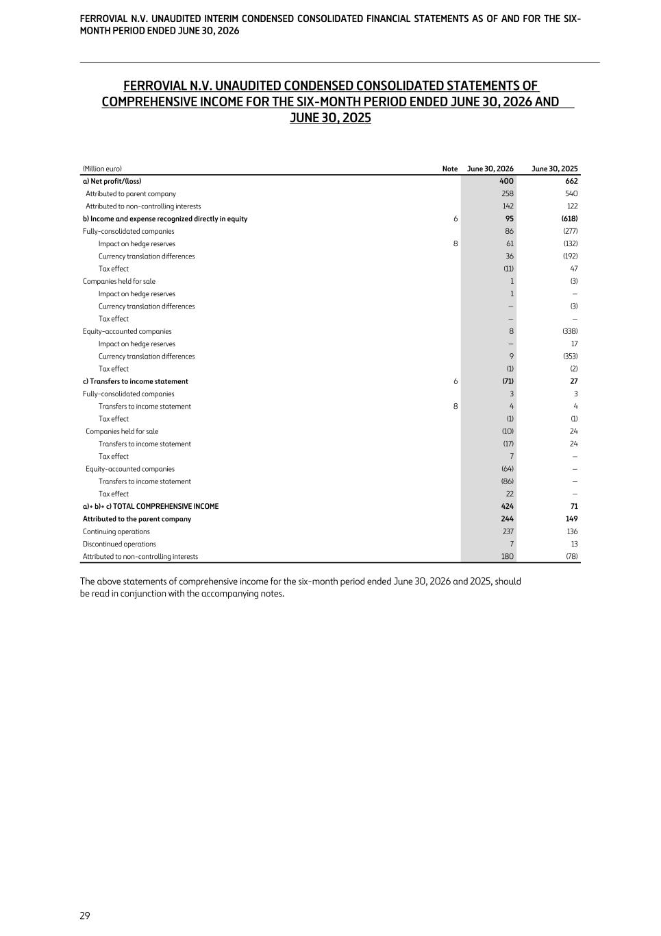
FERROVIAL N.V. UNAUDITED CONDENSED CONSOLIDATED STATEMENTS OF COMPREHENSIVE INCOME FOR THE SIX-MONTH PERIOD ENDED JUNE 30, 2026 AND JUNE 30, 2025 (Million euro) Note June 30, 2026 June 30, 2025 a) Net profit/(loss) 400 662 Attributed to parent company 258 540 Attributed to non-controlling interests 142 122 b) Income and expense recognized directly in equity 6 95 (618) Fully-consolidated companies 86 (277) Impact on hedge reserves 8 61 (132) Currency translation differences 36 (192) Tax effect (11) 47 Companies held for sale 1 (3) Impact on hedge reserves 1 — Currency translation differences — (3) Tax effect — — Equity-accounted companies 8 (338) Impact on hedge reserves — 17 Currency translation differences 9 (353) Tax effect (1) (2) c) Transfers to income statement 6 (71) 27 Fully-consolidated companies 3 3 Transfers to income statement 8 4 4 Tax effect (1) (1) Companies held for sale (10) 24 Transfers to income statement (17) 24 Tax effect 7 — Equity-accounted companies (64) — Transfers to income statement (86) — Tax effect 22 — a)+ b)+ c) TOTAL COMPREHENSIVE INCOME 424 71 Attributed to the parent company 244 149 Continuing operations 237 136 Discontinued operations 7 13 Attributed to non-controlling interests 180 (78) The above statements of comprehensive income for the six-month period ended June 30, 2026 and 2025, should be read in conjunction with the accompanying notes. FERROVIAL N.V. UNAUDITED INTERIM CONDENSED CONSOLIDATED FINANCIAL STATEMENTS AS OF AND FOR THE SIX- MONTH PERIOD ENDED JUNE 30, 2026 29

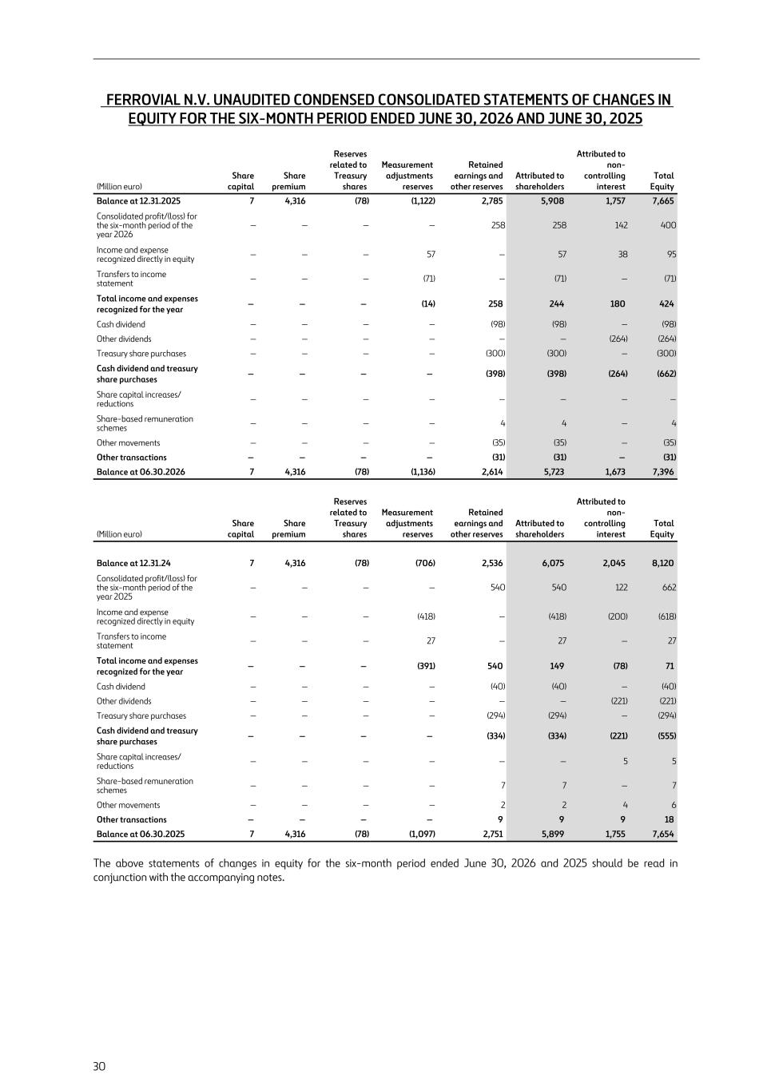
FERROVIAL N.V. UNAUDITED CONDENSED CONSOLIDATED STATEMENTS OF CHANGES IN EQUITY FOR THE SIX-MONTH PERIOD ENDED JUNE 30, 2026 AND JUNE 30, 2025 (Million euro) Share capital Share premium Reserves related to Treasury shares Measurement adjustments reserves Retained earnings and other reserves Attributed to shareholders Attributed to non- controlling interest Total Equity Balance at 12.31.2025 7 4,316 (78) (1,122) 2,785 5,908 1,757 7,665 Consolidated profit/(loss) for the six-month period of the year 2026 — — — — 258 258 142 400 Income and expense recognized directly in equity — — — 57 — 57 38 95 Transfers to income statement — — — (71) — (71) — (71) Total income and expenses recognized for the year — — — (14) 258 244 180 424 Cash dividend — — — — (98) (98) — (98) Other dividends — — — — — — (264) (264) Treasury share purchases — — — — (300) (300) — (300) Cash dividend and treasury share purchases — — — — (398) (398) (264) (662) Share capital increases/ reductions — — — — — — — — Share-based remuneration schemes — — — — 4 4 — 4 Other movements — — — — (35) (35) — (35) Other transactions — — — — (31) (31) — (31) Balance at 06.30.2026 7 4,316 (78) (1,136) 2,614 5,723 1,673 7,396 (Million euro) Share capital Share premium Reserves related to Treasury shares Measurement adjustments reserves Retained earnings and other reserves Attributed to shareholders Attributed to non- controlling interest Total Equity Balance at 12.31.24 7 4,316 (78) (706) 2,536 6,075 2,045 8,120 Consolidated profit/(loss) for the six-month period of the year 2025 — — — — 540 540 122 662 Income and expense recognized directly in equity — — — (418) — (418) (200) (618) Transfers to income statement — — — 27 — 27 — 27 Total income and expenses recognized for the year — — — (391) 540 149 (78) 71 Cash dividend — — — — (40) (40) — (40) Other dividends — — — — — — (221) (221) Treasury share purchases — — — — (294) (294) — (294) Cash dividend and treasury share purchases — — — — (334) (334) (221) (555) Share capital increases/ reductions — — — — — — 5 5 Share-based remuneration schemes — — — — 7 7 — 7 Other movements — — — — 2 2 4 6 Other transactions — — — — 9 9 9 18 Balance at 06.30.2025 7 4,316 (78) (1,097) 2,751 5,899 1,755 7,654 The above statements of changes in equity for the six-month period ended June 30, 2026 and 2025 should be read in conjunction with the accompanying notes. 30

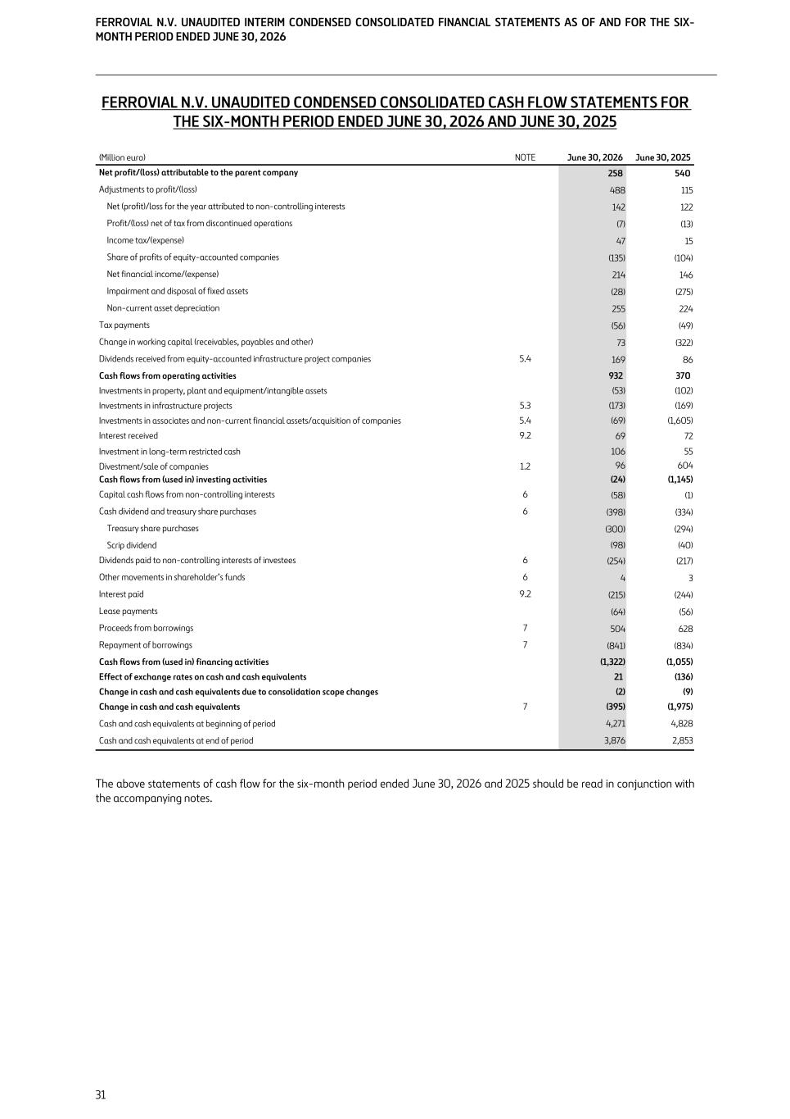
FERROVIAL N.V. UNAUDITED CONDENSED CONSOLIDATED CASH FLOW STATEMENTS FOR THE SIX-MONTH PERIOD ENDED JUNE 30, 2026 AND JUNE 30, 2025 (Million euro) NOTE June 30, 2026 June 30, 2025 Net profit/(loss) attributable to the parent company 258 540 Adjustments to profit/(loss) 488 115 Net (profit)/loss for the year attributed to non-controlling interests 142 122 Profit/(loss) net of tax from discontinued operations (7) (13) Income tax/(expense) 47 15 Share of profits of equity-accounted companies (135) (104) Net financial income/(expense) 214 146 Impairment and disposal of fixed assets (28) (275) Non-current asset depreciation 255 224 Tax payments (56) (49) Change in working capital (receivables, payables and other) 73 (322) Dividends received from equity-accounted infrastructure project companies 5.4 169 86 Cash flows from operating activities 932 370 Investments in property, plant and equipment/intangible assets (53) (102) Investments in infrastructure projects 5.3 (173) (169) Investments in associates and non-current financial assets/acquisition of companies 5.4 (69) (1,605) Interest received 9.2 69 72 Investment in long-term restricted cash 106 55 Divestment/sale of companies 1.2 96 604 Cash flows from (used in) investing activities (24) (1,145) Capital cash flows from non-controlling interests 6 (58) (1) Cash dividend and treasury share purchases 6 (398) (334) Treasury share purchases (300) (294) Scrip dividend (98) (40) Dividends paid to non-controlling interests of investees 6 (254) (217) Other movements in shareholder’s funds 6 4 3 Interest paid 9.2 (215) (244) Lease payments (64) (56) Proceeds from borrowings 7 504 628 Repayment of borrowings 7 (841) (834) Cash flows from (used in) financing activities (1,322) (1,055) Effect of exchange rates on cash and cash equivalents 21 (136) Change in cash and cash equivalents due to consolidation scope changes (2) (9) Change in cash and cash equivalents 7 (395) (1,975) Cash and cash equivalents at beginning of period 4,271 4,828 Cash and cash equivalents at end of period 3,876 2,853 The above statements of cash flow for the six-month period ended June 30, 2026 and 2025 should be read in conjunction with the accompanying notes. FERROVIAL N.V. UNAUDITED INTERIM CONDENSED CONSOLIDATED FINANCIAL STATEMENTS AS OF AND FOR THE SIX- MONTH PERIOD ENDED JUNE 30, 2026 31

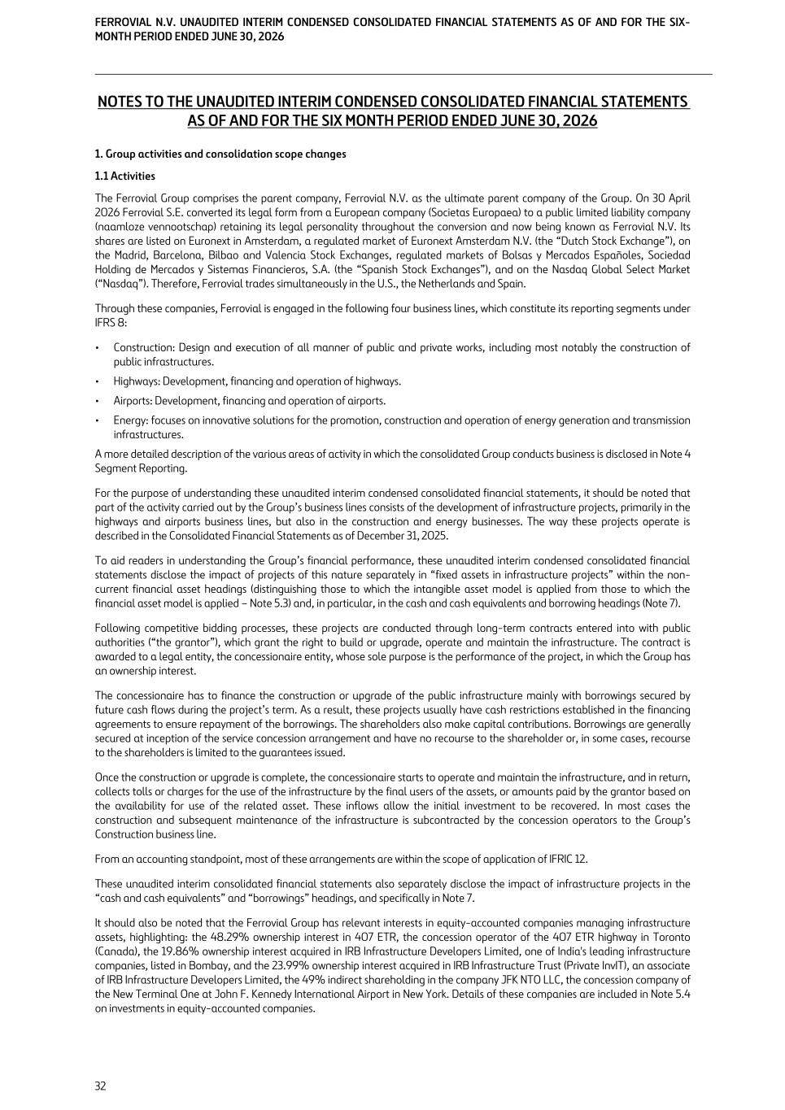
NOTES TO THE UNAUDITED INTERIM CONDENSED CONSOLIDATED FINANCIAL STATEMENTS AS OF AND FOR THE SIX MONTH PERIOD ENDED JUNE 30, 2026 1. Group activities and consolidation scope changes 1.1 Activities The Ferrovial Group comprises the parent company, Ferrovial N.V. as the ultimate parent company of the Group. On 30 April 2026 Ferrovial S.E. converted its legal form from a European company (Societas Europaea) to a public limited liability company (naamloze vennootschap) retaining its legal personality throughout the conversion and now being known as Ferrovial N.V. Its shares are listed on Euronext in Amsterdam, a regulated market of Euronext Amsterdam N.V. (the “Dutch Stock Exchange”), on the Madrid, Barcelona, Bilbao and Valencia Stock Exchanges, regulated markets of Bolsas y Mercados Españoles, Sociedad Holding de Mercados y Sistemas Financieros, S.A. (the “Spanish Stock Exchanges”), and on the Nasdaq Global Select Market (“Nasdaq”). Therefore, Ferrovial trades simultaneously in the U.S., the Netherlands and Spain. Through these companies, Ferrovial is engaged in the following four business lines, which constitute its reporting segments under IFRS 8: • Construction: Design and execution of all manner of public and private works, including most notably the construction of public infrastructures. • Highways: Development, financing and operation of highways. • Airports: Development, financing and operation of airports. • Energy: focuses on innovative solutions for the promotion, construction and operation of energy generation and transmission infrastructures. A more detailed description of the various areas of activity in which the consolidated Group conducts business is disclosed in Note 4 Segment Reporting. For the purpose of understanding these unaudited interim condensed consolidated financial statements, it should be noted that part of the activity carried out by the Group’s business lines consists of the development of infrastructure projects, primarily in the highways and airports business lines, but also in the construction and energy businesses. The way these projects operate is described in the Consolidated Financial Statements as of December 31, 2025. To aid readers in understanding the Group’s financial performance, these unaudited interim condensed consolidated financial statements disclose the impact of projects of this nature separately in “fixed assets in infrastructure projects” within the non- current financial asset headings (distinguishing those to which the intangible asset model is applied from those to which the financial asset model is applied – Note 5.3) and, in particular, in the cash and cash equivalents and borrowing headings (Note 7). Following competitive bidding processes, these projects are conducted through long-term contracts entered into with public authorities (“the grantor”), which grant the right to build or upgrade, operate and maintain the infrastructure. The contract is awarded to a legal entity, the concessionaire entity, whose sole purpose is the performance of the project, in which the Group has an ownership interest. The concessionaire has to finance the construction or upgrade of the public infrastructure mainly with borrowings secured by future cash flows during the project’s term. As a result, these projects usually have cash restrictions established in the financing agreements to ensure repayment of the borrowings. The shareholders also make capital contributions. Borrowings are generally secured at inception of the service concession arrangement and have no recourse to the shareholder or, in some cases, recourse to the shareholders is limited to the guarantees issued. Once the construction or upgrade is complete, the concessionaire starts to operate and maintain the infrastructure, and in return, collects tolls or charges for the use of the infrastructure by the final users of the assets, or amounts paid by the grantor based on the availability for use of the related asset. These inflows allow the initial investment to be recovered. In most cases the construction and subsequent maintenance of the infrastructure is subcontracted by the concession operators to the Group’s Construction business line. From an accounting standpoint, most of these arrangements are within the scope of application of IFRIC 12. These unaudited interim consolidated financial statements also separately disclose the impact of infrastructure projects in the “cash and cash equivalents” and “borrowings” headings, and specifically in Note 7. It should also be noted that the Ferrovial Group has relevant interests in equity-accounted companies managing infrastructure assets, highlighting: the 48.29% ownership interest in 407 ETR, the concession operator of the 407 ETR highway in Toronto (Canada), the 19.86% ownership interest acquired in IRB Infrastructure Developers Limited, one of India's leading infrastructure companies, listed in Bombay, and the 23.99% ownership interest acquired in IRB Infrastructure Trust (Private InvIT), an associate of IRB Infrastructure Developers Limited, the 49% indirect shareholding in the company JFK NTO LLC, the concession company of the New Terminal One at John F. Kennedy International Airport in New York. Details of these companies are included in Note 5.4 on investments in equity-accounted companies. FERROVIAL N.V. UNAUDITED INTERIM CONDENSED CONSOLIDATED FINANCIAL STATEMENTS AS OF AND FOR THE SIX- MONTH PERIOD ENDED JUNE 30, 2026 32

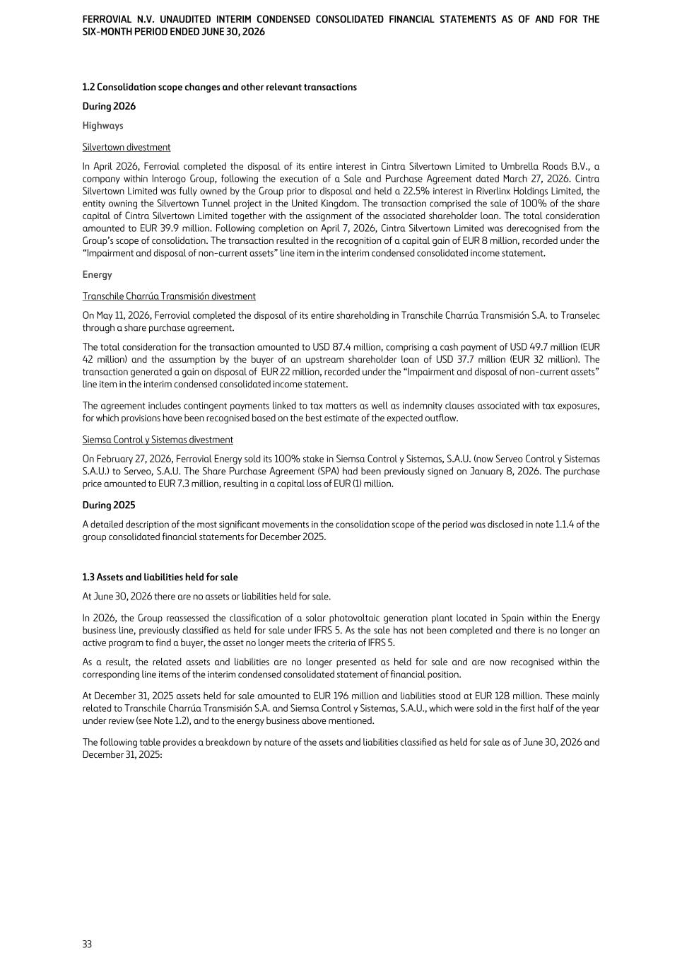
1.2 Consolidation scope changes and other relevant transactions During 2026 Highways Silvertown divestment In April 2026, Ferrovial completed the disposal of its entire interest in Cintra Silvertown Limited to Umbrella Roads B.V., a company within Interogo Group, following the execution of a Sale and Purchase Agreement dated March 27, 2026. Cintra Silvertown Limited was fully owned by the Group prior to disposal and held a 22.5% interest in Riverlinx Holdings Limited, the entity owning the Silvertown Tunnel project in the United Kingdom. The transaction comprised the sale of 100% of the share capital of Cintra Silvertown Limited together with the assignment of the associated shareholder loan. The total consideration amounted to EUR 39.9 million. Following completion on April 7, 2026, Cintra Silvertown Limited was derecognised from the Group’s scope of consolidation. The transaction resulted in the recognition of a capital gain of EUR 8 million, recorded under the “Impairment and disposal of non-current assets” line item in the interim condensed consolidated income statement. Energy Transchile Charrúa Transmisión divestment On May 11, 2026, Ferrovial completed the disposal of its entire shareholding in Transchile Charrúa Transmisión S.A. to Transelec through a share purchase agreement. The total consideration for the transaction amounted to USD 87.4 million, comprising a cash payment of USD 49.7 million (EUR 42 million) and the assumption by the buyer of an upstream shareholder loan of USD 37.7 million (EUR 32 million). The transaction generated a gain on disposal of EUR 22 million, recorded under the “Impairment and disposal of non-current assets” line item in the interim condensed consolidated income statement. The agreement includes contingent payments linked to tax matters as well as indemnity clauses associated with tax exposures, for which provisions have been recognised based on the best estimate of the expected outflow. Siemsa Control y Sistemas divestment On February 27, 2026, Ferrovial Energy sold its 100% stake in Siemsa Control y Sistemas, S.A.U. (now Serveo Control y Sistemas S.A.U.) to Serveo, S.A.U. The Share Purchase Agreement (SPA) had been previously signed on January 8, 2026. The purchase price amounted to EUR 7.3 million, resulting in a capital loss of EUR (1) million. During 2025 A detailed description of the most significant movements in the consolidation scope of the period was disclosed in note 1.1.4 of the group consolidated financial statements for December 2025. 1.3 Assets and liabilities held for sale At June 30, 2026 there are no assets or liabilities held for sale. In 2026, the Group reassessed the classification of a solar photovoltaic generation plant located in Spain within the Energy business line, previously classified as held for sale under IFRS 5. As the sale has not been completed and there is no longer an active program to find a buyer, the asset no longer meets the criteria of IFRS 5. As a result, the related assets and liabilities are no longer presented as held for sale and are now recognised within the corresponding line items of the interim condensed consolidated statement of financial position. At December 31, 2025 assets held for sale amounted to EUR 196 million and liabilities stood at EUR 128 million. These mainly related to Transchile Charrúa Transmisión S.A. and Siemsa Control y Sistemas, S.A.U., which were sold in the first half of the year under review (see Note 1.2), and to the energy business above mentioned. The following table provides a breakdown by nature of the assets and liabilities classified as held for sale as of June 30, 2026 and December 31, 2025: FERROVIAL N.V. UNAUDITED INTERIM CONDENSED CONSOLIDATED FINANCIAL STATEMENTS AS OF AND FOR THE SIX-MONTH PERIOD ENDED JUNE 30, 2026 33

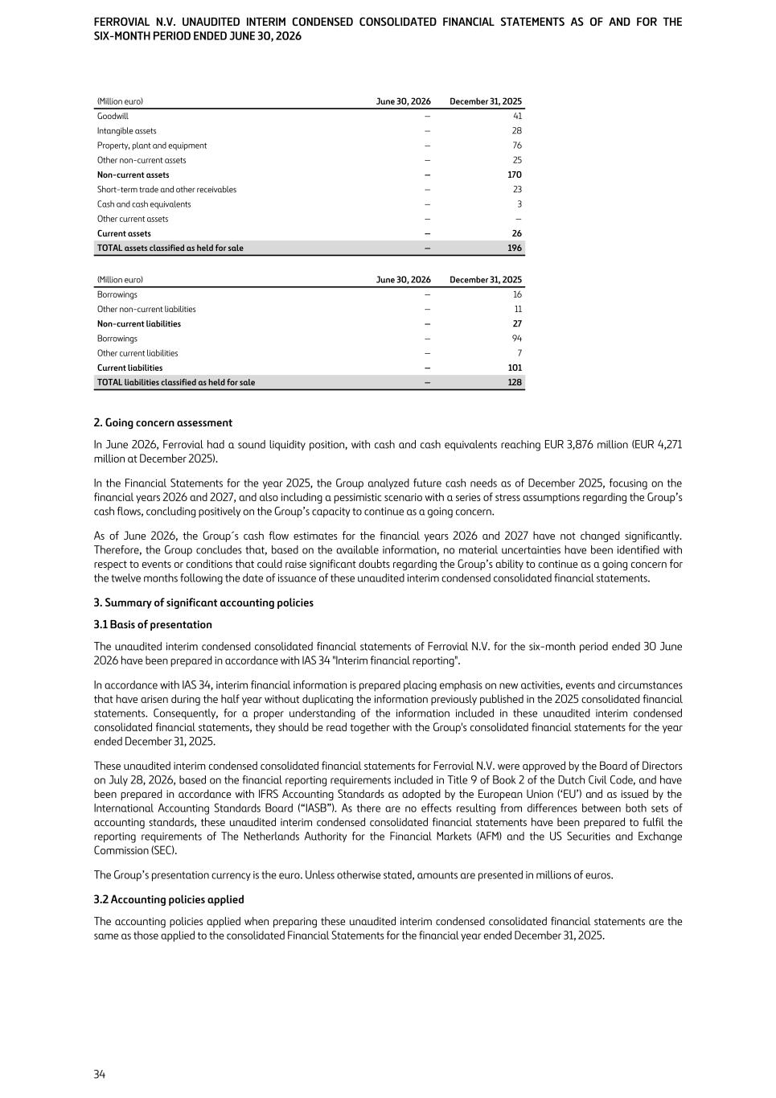
(Million euro) June 30, 2026 December 31, 2025 Goodwill — 41 Intangible assets — 28 Property, plant and equipment — 76 Other non-current assets — 25 Non-current assets — 170 Short-term trade and other receivables — 23 Cash and cash equivalents — 3 Other current assets — — Current assets — 26 TOTAL assets classified as held for sale — 196 (Million euro) June 30, 2026 December 31, 2025 Borrowings — 16 Other non-current liabilities — 11 Non-current liabilities — 27 Borrowings — 94 Other current liabilities — 7 Current liabilities — 101 TOTAL liabilities classified as held for sale — 128 2. Going concern assessment In June 2026, Ferrovial had a sound liquidity position, with cash and cash equivalents reaching EUR 3,876 million (EUR 4,271 million at December 2025). In the Financial Statements for the year 2025, the Group analyzed future cash needs as of December 2025, focusing on the financial years 2026 and 2027, and also including a pessimistic scenario with a series of stress assumptions regarding the Group’s cash flows, concluding positively on the Group’s capacity to continue as a going concern. As of June 2026, the Group´s cash flow estimates for the financial years 2026 and 2027 have not changed significantly. Therefore, the Group concludes that, based on the available information, no material uncertainties have been identified with respect to events or conditions that could raise significant doubts regarding the Group’s ability to continue as a going concern for the twelve months following the date of issuance of these unaudited interim condensed consolidated financial statements. 3. Summary of significant accounting policies 3.1 Basis of presentation The unaudited interim condensed consolidated financial statements of Ferrovial N.V. for the six-month period ended 30 June 2026 have been prepared in accordance with IAS 34 "Interim financial reporting". In accordance with IAS 34, interim financial information is prepared placing emphasis on new activities, events and circumstances that have arisen during the half year without duplicating the information previously published in the 2025 consolidated financial statements. Consequently, for a proper understanding of the information included in these unaudited interim condensed consolidated financial statements, they should be read together with the Group's consolidated financial statements for the year ended December 31, 2025. These unaudited interim condensed consolidated financial statements for Ferrovial N.V. were approved by the Board of Directors on July 28, 2026, based on the financial reporting requirements included in Title 9 of Book 2 of the Dutch Civil Code, and have been prepared in accordance with IFRS Accounting Standards as adopted by the European Union (‘EU’) and as issued by the International Accounting Standards Board (“IASB”). As there are no effects resulting from differences between both sets of accounting standards, these unaudited interim condensed consolidated financial statements have been prepared to fulfil the reporting requirements of The Netherlands Authority for the Financial Markets (AFM) and the US Securities and Exchange Commission (SEC). The Group’s presentation currency is the euro. Unless otherwise stated, amounts are presented in millions of euros. 3.2 Accounting policies applied The accounting policies applied when preparing these unaudited interim condensed consolidated financial statements are the same as those applied to the consolidated Financial Statements for the financial year ended December 31, 2025. FERROVIAL N.V. UNAUDITED INTERIM CONDENSED CONSOLIDATED FINANCIAL STATEMENTS AS OF AND FOR THE SIX-MONTH PERIOD ENDED JUNE 30, 2026 34

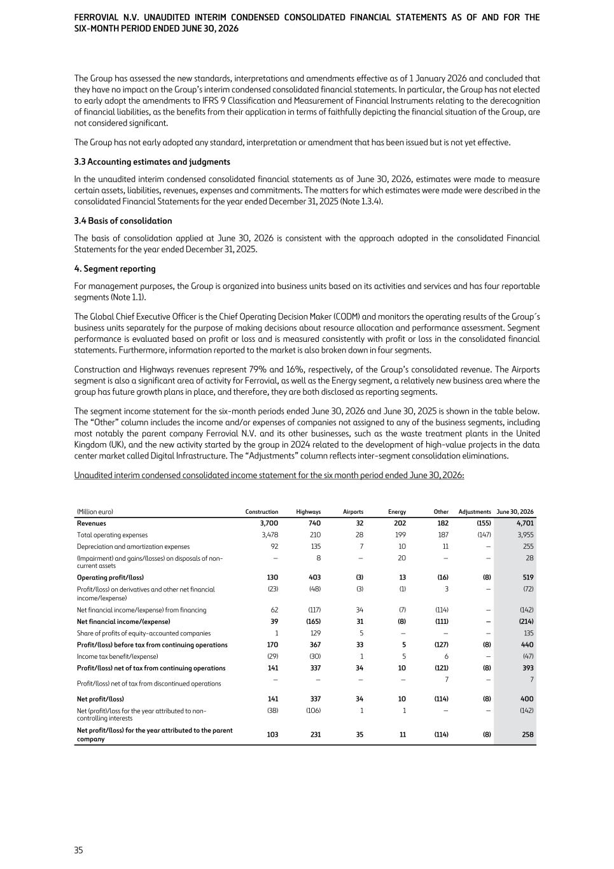
The Group has assessed the new standards, interpretations and amendments effective as of 1 January 2026 and concluded that they have no impact on the Group’s interim condensed consolidated financial statements. In particular, the Group has not elected to early adopt the amendments to IFRS 9 Classification and Measurement of Financial Instruments relating to the derecognition of financial liabilities, as the benefits from their application in terms of faithfully depicting the financial situation of the Group, are not considered significant. The Group has not early adopted any standard, interpretation or amendment that has been issued but is not yet effective. 3.3 Accounting estimates and judgments In the unaudited interim condensed consolidated financial statements as of June 30, 2026, estimates were made to measure certain assets, liabilities, revenues, expenses and commitments. The matters for which estimates were made were described in the consolidated Financial Statements for the year ended December 31, 2025 (Note 1.3.4). 3.4 Basis of consolidation The basis of consolidation applied at June 30, 2026 is consistent with the approach adopted in the consolidated Financial Statements for the year ended December 31, 2025. 4. Segment reporting For management purposes, the Group is organized into business units based on its activities and services and has four reportable segments (Note 1.1). The Global Chief Executive Officer is the Chief Operating Decision Maker (CODM) and monitors the operating results of the Group´s business units separately for the purpose of making decisions about resource allocation and performance assessment. Segment performance is evaluated based on profit or loss and is measured consistently with profit or loss in the consolidated financial statements. Furthermore, information reported to the market is also broken down in four segments. Construction and Highways revenues represent 79% and 16%, respectively, of the Group’s consolidated revenue. The Airports segment is also a significant area of activity for Ferrovial, as well as the Energy segment, a relatively new business area where the group has future growth plans in place, and therefore, they are both disclosed as reporting segments. The segment income statement for the six-month periods ended June 30, 2026 and June 30, 2025 is shown in the table below. The “Other” column includes the income and/or expenses of companies not assigned to any of the business segments, including most notably the parent company Ferrovial N.V. and its other businesses, such as the waste treatment plants in the United Kingdom (UK), and the new activity started by the group in 2024 related to the development of high-value projects in the data center market called Digital Infrastructure. The “Adjustments” column reflects inter-segment consolidation eliminations. Unaudited interim condensed consolidated income statement for the six month period ended June 30, 2026: (Million euro) Construction Highways Airports Energy Other Adjustments June 30, 2026 Revenues 3,700 740 32 202 182 (155) 4,701 Total operating expenses 3,478 210 28 199 187 (147) 3,955 Depreciation and amortization expenses 92 135 7 10 11 — 255 (Impairment) and gains/(losses) on disposals of non- current assets — 8 — 20 — — 28 Operating profit/(loss) 130 403 (3) 13 (16) (8) 519 Profit/(loss) on derivatives and other net financial income/(expense) (23) (48) (3) (1) 3 — (72) Net financial income/(expense) from financing 62 (117) 34 (7) (114) — (142) Net financial income/(expense) 39 (165) 31 (8) (111) — (214) Share of profits of equity-accounted companies 1 129 5 — — — 135 Profit/(loss) before tax from continuing operations 170 367 33 5 (127) (8) 440 Income tax benefit/(expense) (29) (30) 1 5 6 — (47) Profit/(loss) net of tax from continuing operations 141 337 34 10 (121) (8) 393 Profit/(loss) net of tax from discontinued operations — — — — 7 — 7 Net profit/(loss) 141 337 34 10 (114) (8) 400 Net (profit)/loss for the year attributed to non- controlling interests (38) (106) 1 1 — — (142) Net profit/(loss) for the year attributed to the parent company 103 231 35 11 (114) (8) 258 FERROVIAL N.V. UNAUDITED INTERIM CONDENSED CONSOLIDATED FINANCIAL STATEMENTS AS OF AND FOR THE SIX-MONTH PERIOD ENDED JUNE 30, 2026 35

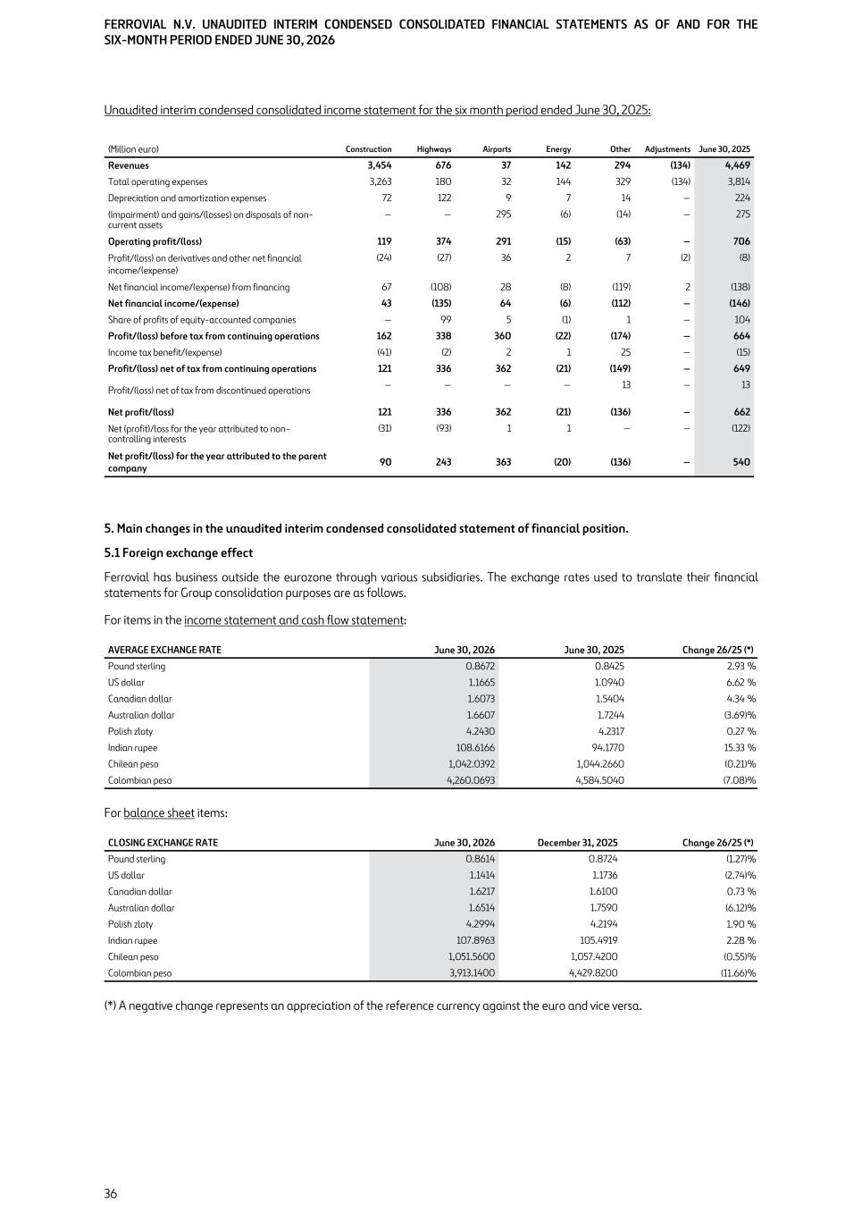
Unaudited interim condensed consolidated income statement for the six month period ended June 30, 2025: (Million euro) Construction Highways Airports Energy Other Adjustments June 30, 2025 Revenues 3,454 676 37 142 294 (134) 4,469 Total operating expenses 3,263 180 32 144 329 (134) 3,814 Depreciation and amortization expenses 72 122 9 7 14 — 224 (Impairment) and gains/(losses) on disposals of non- current assets — — 295 (6) (14) — 275 Operating profit/(loss) 119 374 291 (15) (63) — 706 Profit/(loss) on derivatives and other net financial income/(expense) (24) (27) 36 2 7 (2) (8) Net financial income/(expense) from financing 67 (108) 28 (8) (119) 2 (138) Net financial income/(expense) 43 (135) 64 (6) (112) — (146) Share of profits of equity-accounted companies — 99 5 (1) 1 — 104 Profit/(loss) before tax from continuing operations 162 338 360 (22) (174) — 664 Income tax benefit/(expense) (41) (2) 2 1 25 — (15) Profit/(loss) net of tax from continuing operations 121 336 362 (21) (149) — 649 Profit/(loss) net of tax from discontinued operations — — — — 13 — 13 Net profit/(loss) 121 336 362 (21) (136) — 662 Net (profit)/loss for the year attributed to non- controlling interests (31) (93) 1 1 — — (122) Net profit/(loss) for the year attributed to the parent company 90 243 363 (20) (136) — 540 5. Main changes in the unaudited interim condensed consolidated statement of financial position. 5.1 Foreign exchange effect Ferrovial has business outside the eurozone through various subsidiaries. The exchange rates used to translate their financial statements for Group consolidation purposes are as follows. For items in the income statement and cash flow statement: AVERAGE EXCHANGE RATE June 30, 2026 June 30, 2025 Change 26/25 (*) Pound sterling 0.8672 0.8425 2.93 % US dollar 1.1665 1.0940 6.62 % Canadian dollar 1.6073 1.5404 4.34 % Australian dollar 1.6607 1.7244 (3.69) % Polish zloty 4.2430 4.2317 0.27 % Indian rupee 108.6166 94.1770 15.33 % Chilean peso 1,042.0392 1,044.2660 (0.21) % Colombian peso 4,260.0693 4,584.5040 (7.08) % For balance sheet items: CLOSING EXCHANGE RATE June 30, 2026 December 31, 2025 Change 26/25 (*) Pound sterling 0.8614 0.8724 (1.27) % US dollar 1.1414 1.1736 (2.74) % Canadian dollar 1.6217 1.6100 0.73 % Australian dollar 1.6514 1.7590 (6.12) % Polish zloty 4.2994 4.2194 1.90 % Indian rupee 107.8963 105.4919 2.28 % Chilean peso 1,051.5600 1,057.4200 (0.55) % Colombian peso 3,913.1400 4,429.8200 (11.66) % (*) A negative change represents an appreciation of the reference currency against the euro and vice versa. FERROVIAL N.V. UNAUDITED INTERIM CONDENSED CONSOLIDATED FINANCIAL STATEMENTS AS OF AND FOR THE SIX-MONTH PERIOD ENDED JUNE 30, 2026 36

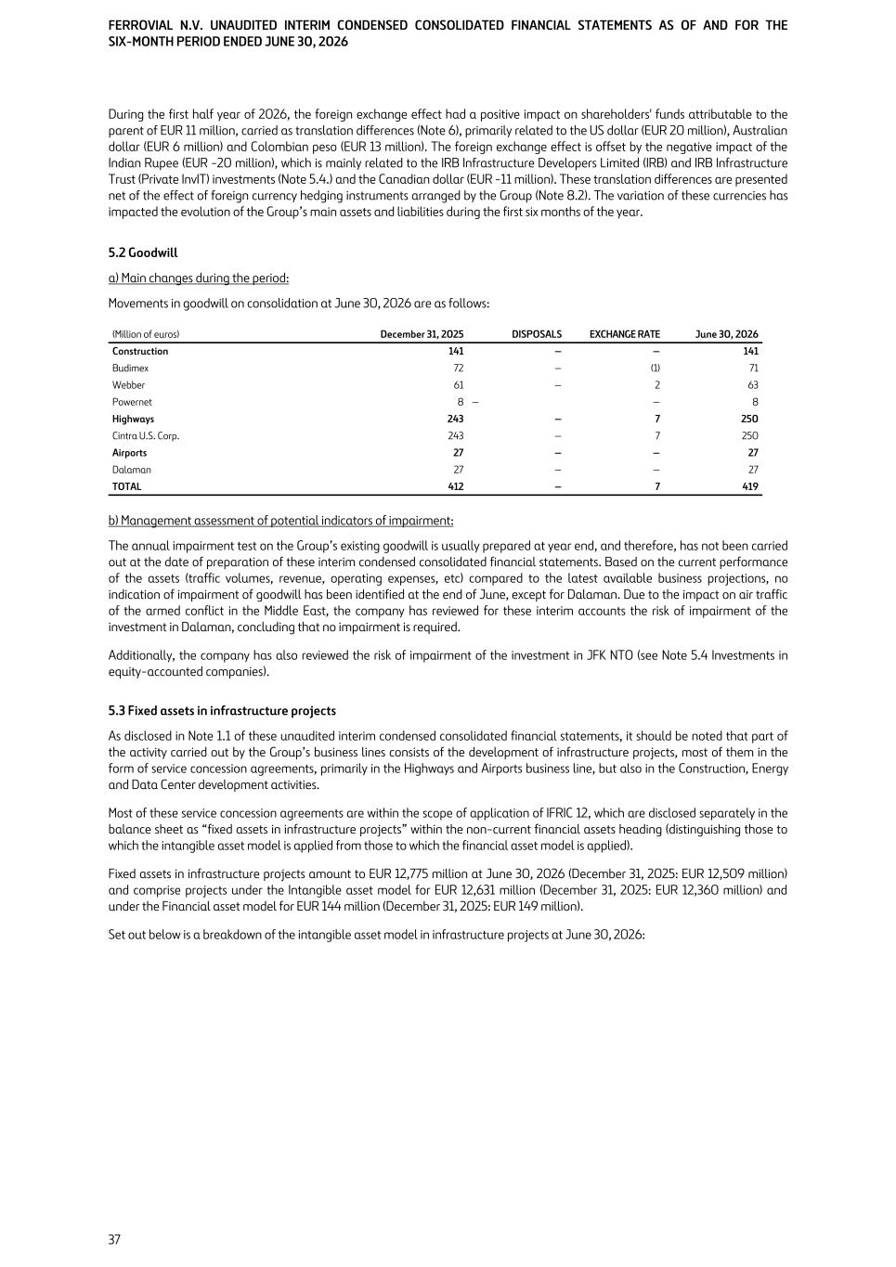
During the first half year of 2026, the foreign exchange effect had a positive impact on shareholders' funds attributable to the parent of EUR 11 million, carried as translation differences (Note 6), primarily related to the US dollar (EUR 20 million), Australian dollar (EUR 6 million) and Colombian peso (EUR 13 million). The foreign exchange effect is offset by the negative impact of the Indian Rupee (EUR -20 million), which is mainly related to the IRB Infrastructure Developers Limited (IRB) and IRB Infrastructure Trust (Private InvIT) investments (Note 5.4.) and the Canadian dollar (EUR -11 million). These translation differences are presented net of the effect of foreign currency hedging instruments arranged by the Group (Note 8.2). The variation of these currencies has impacted the evolution of the Group’s main assets and liabilities during the first six months of the year. 5.2 Goodwill a) Main changes during the period: Movements in goodwill on consolidation at June 30, 2026 are as follows: Budimex 72 — (1) 71 Webber 61 — 2 63 Powernet 8 — — 8 Highways 243 — 7 250 Cintra U.S. Corp. 243 — 7 250 Airports 27 — — 27 Dalaman 27 — — 27 TOTAL 412 — 7 419 (Million of euros) December 31, 2025 DISPOSALS EXCHANGE RATE June 30, 2026 Construction 141 — — 141 b) Management assessment of potential indicators of impairment: The annual impairment test on the Group’s existing goodwill is usually prepared at year end, and therefore, has not been carried out at the date of preparation of these interim condensed consolidated financial statements. Based on the current performance of the assets (traffic volumes, revenue, operating expenses, etc) compared to the latest available business projections, no indication of impairment of goodwill has been identified at the end of June, except for Dalaman. Due to the impact on air traffic of the armed conflict in the Middle East, the company has reviewed for these interim accounts the risk of impairment of the investment in Dalaman, concluding that no impairment is required. Additionally, the company has also reviewed the risk of impairment of the investment in JFK NTO (see Note 5.4 Investments in equity-accounted companies). 5.3 Fixed assets in infrastructure projects As disclosed in Note 1.1 of these unaudited interim condensed consolidated financial statements, it should be noted that part of the activity carried out by the Group’s business lines consists of the development of infrastructure projects, most of them in the form of service concession agreements, primarily in the Highways and Airports business line, but also in the Construction, Energy and Data Center development activities. Most of these service concession agreements are within the scope of application of IFRIC 12, which are disclosed separately in the balance sheet as “fixed assets in infrastructure projects” within the non-current financial assets heading (distinguishing those to which the intangible asset model is applied from those to which the financial asset model is applied). Fixed assets in infrastructure projects amount to EUR 12,775 million at June 30, 2026 (December 31, 2025: EUR 12,509 million) and comprise projects under the Intangible asset model for EUR 12,631 million (December 31, 2025: EUR 12,360 million) and under the Financial asset model for EUR 144 million (December 31, 2025: EUR 149 million). Set out below is a breakdown of the intangible asset model in infrastructure projects at June 30, 2026: FERROVIAL N.V. UNAUDITED INTERIM CONDENSED CONSOLIDATED FINANCIAL STATEMENTS AS OF AND FOR THE SIX-MONTH PERIOD ENDED JUNE 30, 2026 37

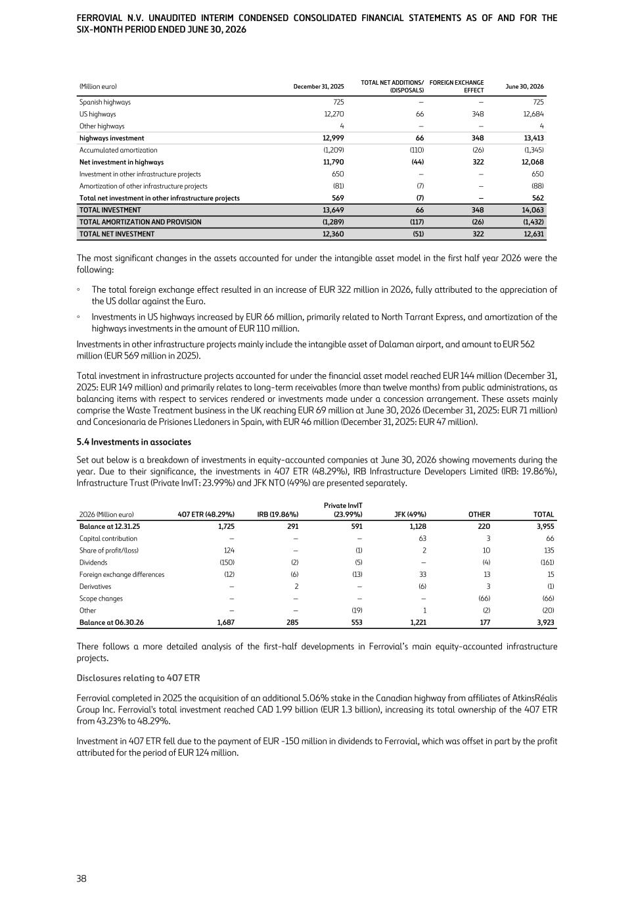
(Million euro) December 31, 2025 TOTAL NET ADDITIONS/ (DISPOSALS) FOREIGN EXCHANGE EFFECT June 30, 2026 Spanish highways 725 — — 725 US highways 12,270 66 348 12,684 Other highways 4 — — 4 highways investment 12,999 66 348 13,413 Accumulated amortization (1,209) (110) (26) (1,345) Net investment in highways 11,790 (44) 322 12,068 Investment in other infrastructure projects 650 — — 650 Amortization of other infrastructure projects (81) (7) — (88) Total net investment in other infrastructure projects 569 (7) — 562 TOTAL INVESTMENT 13,649 66 348 14,063 TOTAL AMORTIZATION AND PROVISION (1,289) (117) (26) (1,432) TOTAL NET INVESTMENT 12,360 (51) 322 12,631 The most significant changes in the assets accounted for under the intangible asset model in the first half year 2026 were the following: ◦ The total foreign exchange effect resulted in an increase of EUR 322 million in 2026, fully attributed to the appreciation of the US dollar against the Euro. ◦ Investments in US highways increased by EUR 66 million, primarily related to North Tarrant Express, and amortization of the highways investments in the amount of EUR 110 million. Investments in other infrastructure projects mainly include the intangible asset of Dalaman airport, and amount to EUR 562 million (EUR 569 million in 2025). Total investment in infrastructure projects accounted for under the financial asset model reached EUR 144 million (December 31, 2025: EUR 149 million) and primarily relates to long-term receivables (more than twelve months) from public administrations, as balancing items with respect to services rendered or investments made under a concession arrangement. These assets mainly comprise the Waste Treatment business in the UK reaching EUR 69 million at June 30, 2026 (December 31, 2025: EUR 71 million) and Concesionaria de Prisiones Lledoners in Spain, with EUR 46 million (December 31, 2025: EUR 47 million). 5.4 Investments in associates Set out below is a breakdown of investments in equity-accounted companies at June 30, 2026 showing movements during the year. Due to their significance, the investments in 407 ETR (48.29%), IRB Infrastructure Developers Limited (IRB: 19.86%), Infrastructure Trust (Private InvIT: 23.99%) and JFK NTO (49%) are presented separately. 2026 (Million euro) 407 ETR (48.29%) IRB (19.86%) Private InvIT (23.99%) JFK (49%) OTHER TOTAL Balance at 12.31.25 1,725 291 591 1,128 220 3,955 Capital contribution — — — 63 3 66 Share of profit/(loss) 124 — (1) 2 10 135 Dividends (150) (2) (5) — (4) (161) Foreign exchange differences (12) (6) (13) 33 13 15 Derivatives — 2 — (6) 3 (1) Scope changes — — — — (66) (66) Other — — (19) 1 (2) (20) Balance at 06.30.26 1,687 285 553 1,221 177 3,923 There follows a more detailed analysis of the first-half developments in Ferrovial’s main equity-accounted infrastructure projects. Disclosures relating to 407 ETR Ferrovial completed in 2025 the acquisition of an additional 5.06% stake in the Canadian highway from affiliates of AtkinsRéalis Group Inc. Ferrovial's total investment reached CAD 1.99 billion (EUR 1.3 billion), increasing its total ownership of the 407 ETR from 43.23% to 48.29%. Investment in 407 ETR fell due to the payment of EUR -150 million in dividends to Ferrovial, which was offset in part by the profit attributed for the period of EUR 124 million. FERROVIAL N.V. UNAUDITED INTERIM CONDENSED CONSOLIDATED FINANCIAL STATEMENTS AS OF AND FOR THE SIX-MONTH PERIOD ENDED JUNE 30, 2026 38

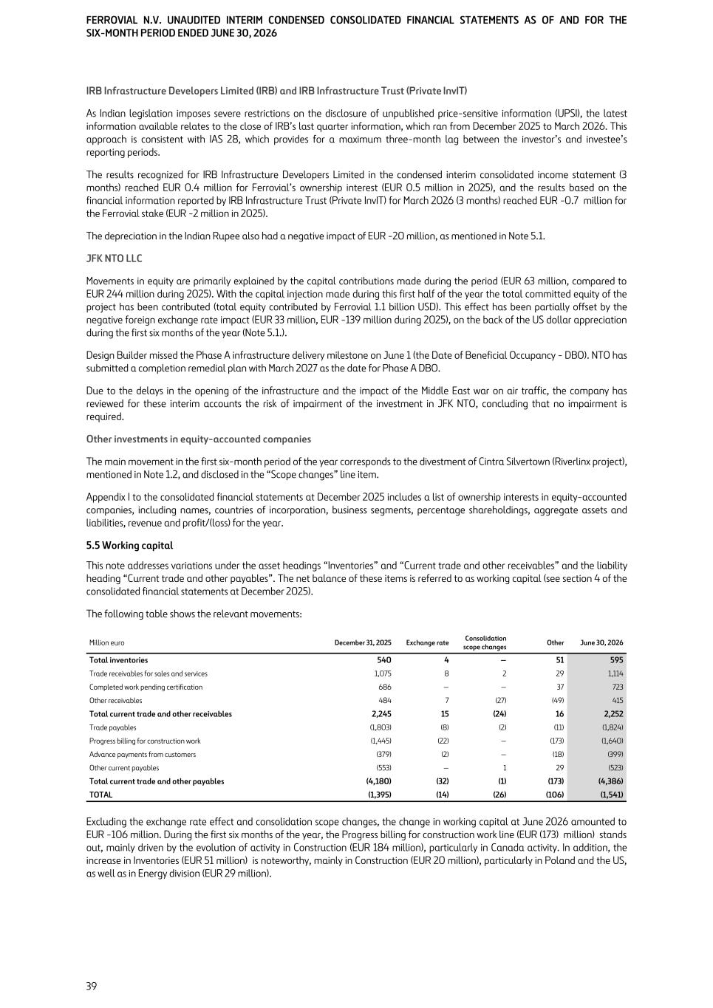
IRB Infrastructure Developers Limited (IRB) and IRB Infrastructure Trust (Private InvIT) As Indian legislation imposes severe restrictions on the disclosure of unpublished price-sensitive information (UPSI), the latest information available relates to the close of IRB’s last quarter information, which ran from December 2025 to March 2026. This approach is consistent with IAS 28, which provides for a maximum three-month lag between the investor’s and investee’s reporting periods. The results recognized for IRB Infrastructure Developers Limited in the condensed interim consolidated income statement (3 months) reached EUR 0.4 million for Ferrovial’s ownership interest (EUR 0.5 million in 2025), and the results based on the financial information reported by IRB Infrastructure Trust (Private InvIT) for March 2026 (3 months) reached EUR -0.7 million for the Ferrovial stake (EUR -2 million in 2025). The depreciation in the Indian Rupee also had a negative impact of EUR -20 million, as mentioned in Note 5.1. JFK NTO LLC Movements in equity are primarily explained by the capital contributions made during the period (EUR 63 million, compared to EUR 244 million during 2025). With the capital injection made during this first half of the year the total committed equity of the project has been contributed (total equity contributed by Ferrovial 1.1 billion USD). This effect has been partially offset by the negative foreign exchange rate impact (EUR 33 million, EUR -139 million during 2025), on the back of the US dollar appreciation during the first six months of the year (Note 5.1.). Design Builder missed the Phase A infrastructure delivery milestone on June 1 (the Date of Beneficial Occupancy - DBO). NTO has submitted a completion remedial plan with March 2027 as the date for Phase A DBO. Due to the delays in the opening of the infrastructure and the impact of the Middle East war on air traffic, the company has reviewed for these interim accounts the risk of impairment of the investment in JFK NTO, concluding that no impairment is required. Other investments in equity-accounted companies The main movement in the first six-month period of the year corresponds to the divestment of Cintra Silvertown (Riverlinx project), mentioned in Note 1.2, and disclosed in the “Scope changes” line item. Appendix I to the consolidated financial statements at December 2025 includes a list of ownership interests in equity-accounted companies, including names, countries of incorporation, business segments, percentage shareholdings, aggregate assets and liabilities, revenue and profit/(loss) for the year. 5.5 Working capital This note addresses variations under the asset headings “Inventories” and “Current trade and other receivables” and the liability heading “Current trade and other payables”. The net balance of these items is referred to as working capital (see section 4 of the consolidated financial statements at December 2025). The following table shows the relevant movements: Million euro December 31, 2025 Exchange rate Consolidation scope changes Other June 30, 2026 Total inventories 540 4 — 51 595 Trade receivables for sales and services 1,075 8 2 29 1,114 Completed work pending certification 686 — — 37 723 Other receivables 484 7 (27) (49) 415 Total current trade and other receivables 2,245 15 (24) 16 2,252 Trade payables (1,803) (8) (2) (11) (1,824) Progress billing for construction work (1,445) (22) — (173) (1,640) Advance payments from customers (379) (2) — (18) (399) Other current payables (553) — 1 29 (523) Total current trade and other payables (4,180) (32) (1) (173) (4,386) TOTAL (1,395) (14) (26) (106) (1,541) Excluding the exchange rate effect and consolidation scope changes, the change in working capital at June 2026 amounted to EUR -106 million. During the first six months of the year, the Progress billing for construction work line (EUR (173) million) stands out, mainly driven by the evolution of activity in Construction (EUR 184 million), particularly in Canada activity. In addition, the increase in Inventories (EUR 51 million) is noteworthy, mainly in Construction (EUR 20 million), particularly in Poland and the US, as well as in Energy division (EUR 29 million). FERROVIAL N.V. UNAUDITED INTERIM CONDENSED CONSOLIDATED FINANCIAL STATEMENTS AS OF AND FOR THE SIX-MONTH PERIOD ENDED JUNE 30, 2026 39

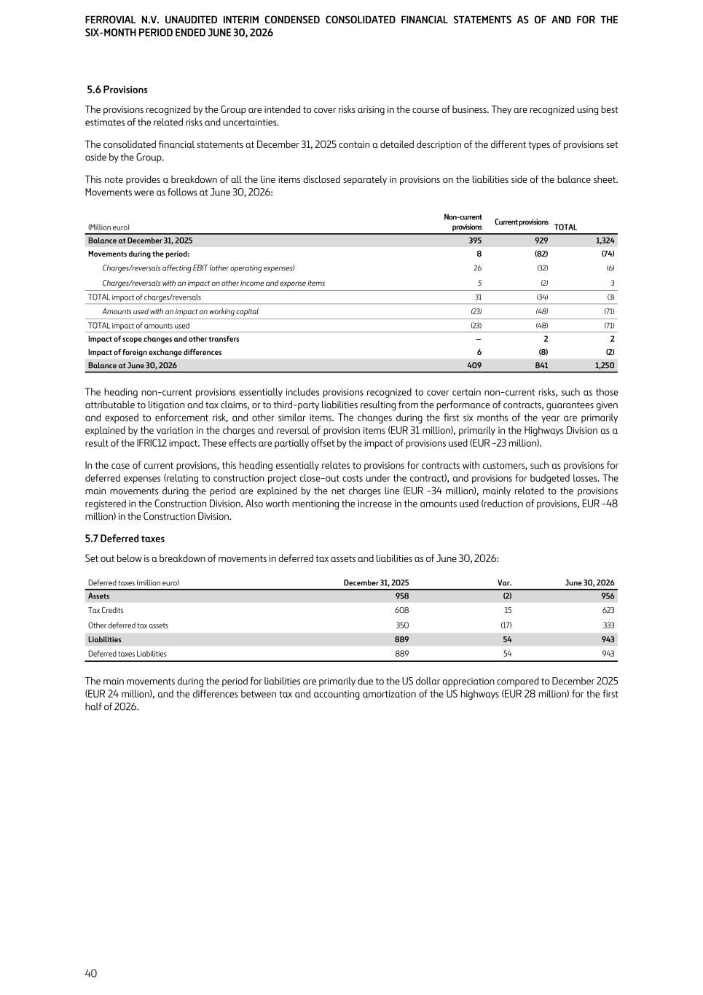
5.6 Provisions The provisions recognized by the Group are intended to cover risks arising in the course of business. They are recognized using best estimates of the related risks and uncertainties. The consolidated financial statements at December 31, 2025 contain a detailed description of the different types of provisions set aside by the Group. This note provides a breakdown of all the line items disclosed separately in provisions on the liabilities side of the balance sheet. Movements were as follows at June 30, 2026: (Million euro) Non-current provisions Current provisions TOTAL Balance at December 31, 2025 395 929 1,324 Movements during the period: 8 (82) (74) Charges/reversals affecting EBIT (other operating expenses) 26 (32) (6) Charges/reversals with an impact on other income and expense items 5 (2) 3 TOTAL impact of charges/reversals 31 (34) (3) Amounts used with an impact on working capital (23) (48) (71) TOTAL impact of amounts used (23) (48) (71) Impact of scope changes and other transfers — 2 2 Impact of foreign exchange differences 6 (8) (2) Balance at June 30, 2026 409 841 1,250 The heading non-current provisions essentially includes provisions recognized to cover certain non-current risks, such as those attributable to litigation and tax claims, or to third-party liabilities resulting from the performance of contracts, guarantees given and exposed to enforcement risk, and other similar items. The changes during the first six months of the year are primarily explained by the variation in the charges and reversal of provision items (EUR 31 million), primarily in the Highways Division as a result of the IFRIC12 impact. These effects are partially offset by the impact of provisions used (EUR -23 million). In the case of current provisions, this heading essentially relates to provisions for contracts with customers, such as provisions for deferred expenses (relating to construction project close-out costs under the contract), and provisions for budgeted losses. The main movements during the period are explained by the net charges line (EUR -34 million), mainly related to the provisions registered in the Construction Division. Also worth mentioning the increase in the amounts used (reduction of provisions, EUR -48 million) in the Construction Division. 5.7 Deferred taxes Set out below is a breakdown of movements in deferred tax assets and liabilities as of June 30, 2026: Deferred taxes (million euro) December 31, 2025 Var. June 30, 2026 Assets 958 (2) 956 Tax Credits 608 15 623 Other deferred tax assets 350 (17) 333 Liabilities 889 54 943 Deferred taxes Liabilities 889 54 943 The main movements during the period for liabilities are primarily due to the US dollar appreciation compared to December 2025 (EUR 24 million), and the differences between tax and accounting amortization of the US highways (EUR 28 million) for the first half of 2026. FERROVIAL N.V. UNAUDITED INTERIM CONDENSED CONSOLIDATED FINANCIAL STATEMENTS AS OF AND FOR THE SIX-MONTH PERIOD ENDED JUNE 30, 2026 40

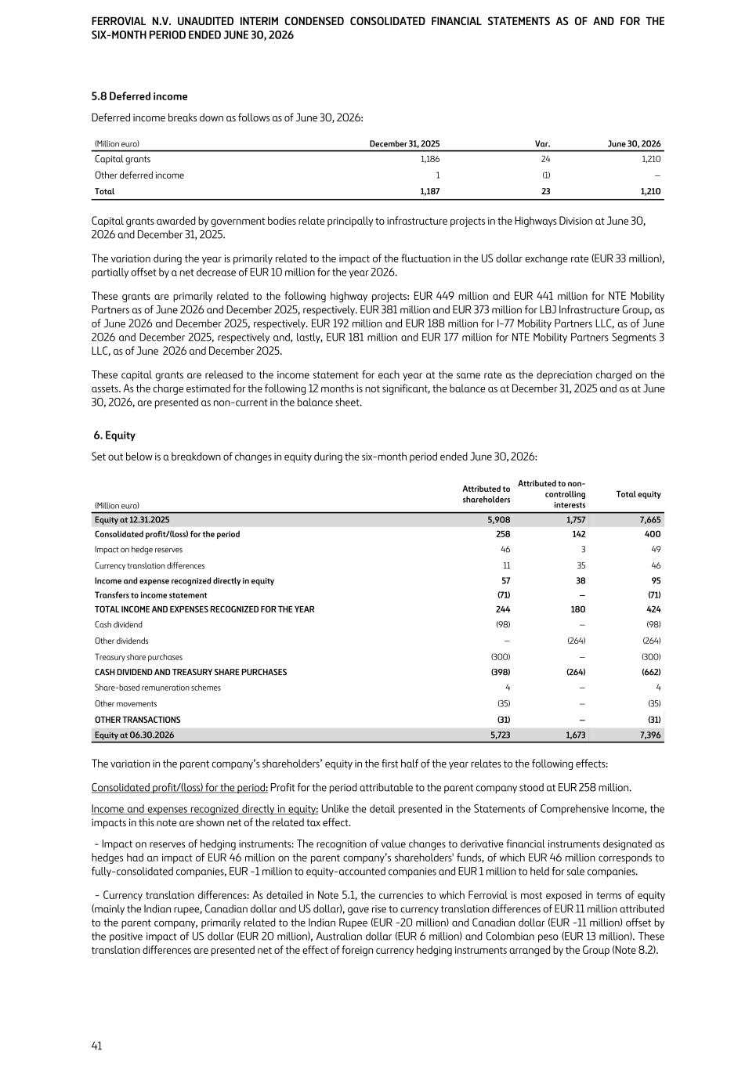
5.8 Deferred income Deferred income breaks down as follows as of June 30, 2026: (Million euro) December 31, 2025 Var. June 30, 2026 Capital grants 1,186 24 1,210 Other deferred income 1 (1) — Total 1,187 23 1,210 Capital grants awarded by government bodies relate principally to infrastructure projects in the Highways Division at June 30, 2026 and December 31, 2025. The variation during the year is primarily related to the impact of the fluctuation in the US dollar exchange rate (EUR 33 million), partially offset by a net decrease of EUR 10 million for the year 2026. These grants are primarily related to the following highway projects: EUR 449 million and EUR 441 million for NTE Mobility Partners as of June 2026 and December 2025, respectively. EUR 381 million and EUR 373 million for LBJ Infrastructure Group, as of June 2026 and December 2025, respectively. EUR 192 million and EUR 188 million for I-77 Mobility Partners LLC, as of June 2026 and December 2025, respectively and, lastly, EUR 181 million and EUR 177 million for NTE Mobility Partners Segments 3 LLC, as of June 2026 and December 2025. These capital grants are released to the income statement for each year at the same rate as the depreciation charged on the assets. As the charge estimated for the following 12 months is not significant, the balance as at December 31, 2025 and as at June 30, 2026, are presented as non-current in the balance sheet. 6. Equity Set out below is a breakdown of changes in equity during the six-month period ended June 30, 2026: (Million euro) Attributed to shareholders Attributed to non- controlling interests Total equity Equity at 12.31.2025 5,908 1,757 7,665 Consolidated profit/(loss) for the period 258 142 400 Impact on hedge reserves 46 3 49 Currency translation differences 11 35 46 Income and expense recognized directly in equity 57 38 95 Transfers to income statement (71) — (71) TOTAL INCOME AND EXPENSES RECOGNIZED FOR THE YEAR 244 180 424 Cash dividend (98) — (98) Other dividends — (264) (264) Treasury share purchases (300) — (300) CASH DIVIDEND AND TREASURY SHARE PURCHASES (398) (264) (662) Share-based remuneration schemes 4 — 4 Other movements (35) — (35) OTHER TRANSACTIONS (31) — (31) Equity at 06.30.2026 5,723 1,673 7,396 The variation in the parent company’s shareholders’ equity in the first half of the year relates to the following effects: Consolidated profit/(loss) for the period: Profit for the period attributable to the parent company stood at EUR 258 million. Income and expenses recognized directly in equity: Unlike the detail presented in the Statements of Comprehensive Income, the impacts in this note are shown net of the related tax effect. - Impact on reserves of hedging instruments: The recognition of value changes to derivative financial instruments designated as hedges had an impact of EUR 46 million on the parent company’s shareholders' funds, of which EUR 46 million corresponds to fully-consolidated companies, EUR -1 million to equity-accounted companies and EUR 1 million to held for sale companies. - Currency translation differences: As detailed in Note 5.1, the currencies to which Ferrovial is most exposed in terms of equity (mainly the Indian rupee, Canadian dollar and US dollar), gave rise to currency translation differences of EUR 11 million attributed to the parent company, primarily related to the Indian Rupee (EUR -20 million) and Canadian dollar (EUR -11 million) offset by the positive impact of US dollar (EUR 20 million), Australian dollar (EUR 6 million) and Colombian peso (EUR 13 million). These translation differences are presented net of the effect of foreign currency hedging instruments arranged by the Group (Note 8.2). FERROVIAL N.V. UNAUDITED INTERIM CONDENSED CONSOLIDATED FINANCIAL STATEMENTS AS OF AND FOR THE SIX-MONTH PERIOD ENDED JUNE 30, 2026 41

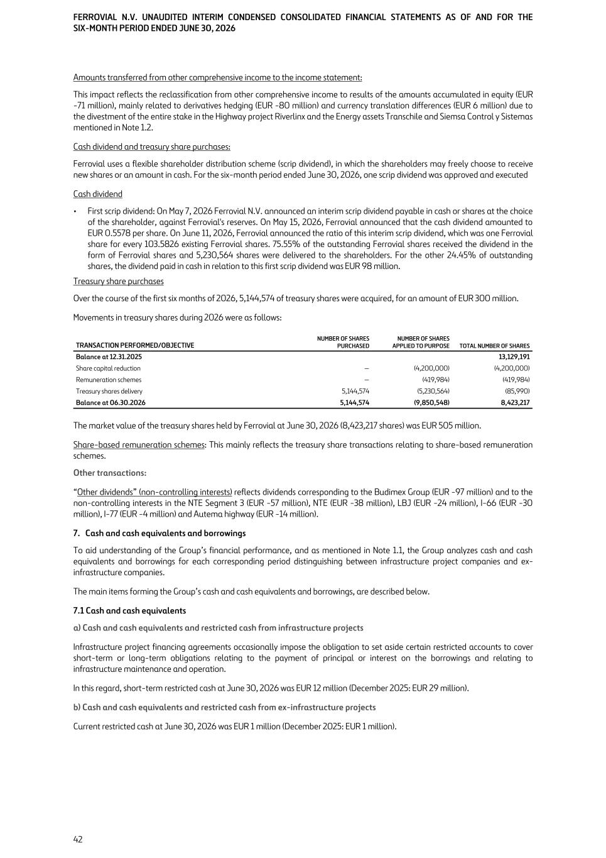
Amounts transferred from other comprehensive income to the income statement: This impact reflects the reclassification from other comprehensive income to results of the amounts accumulated in equity (EUR -71 million), mainly related to derivatives hedging (EUR -80 million) and currency translation differences (EUR 6 million) due to the divestment of the entire stake in the Highway project Riverlinx and the Energy assets Transchile and Siemsa Control y Sistemas mentioned in Note 1.2. Cash dividend and treasury share purchases: Ferrovial uses a flexible shareholder distribution scheme (scrip dividend), in which the shareholders may freely choose to receive new shares or an amount in cash. For the six-month period ended June 30, 2026, one scrip dividend was approved and executed Cash dividend • First scrip dividend: On May 7, 2026 Ferrovial N.V. announced an interim scrip dividend payable in cash or shares at the choice of the shareholder, against Ferrovial's reserves. On May 15, 2026, Ferrovial announced that the cash dividend amounted to EUR 0.5578 per share. On June 11, 2026, Ferrovial announced the ratio of this interim scrip dividend, which was one Ferrovial share for every 103.5826 existing Ferrovial shares. 75.55% of the outstanding Ferrovial shares received the dividend in the form of Ferrovial shares and 5,230,564 shares were delivered to the shareholders. For the other 24.45% of outstanding shares, the dividend paid in cash in relation to this first scrip dividend was EUR 98 million. Treasury share purchases Over the course of the first six months of 2026, 5,144,574 of treasury shares were acquired, for an amount of EUR 300 million. Movements in treasury shares during 2026 were as follows: TRANSACTION PERFORMED/OBJECTIVE NUMBER OF SHARES PURCHASED NUMBER OF SHARES APPLIED TO PURPOSE TOTAL NUMBER OF SHARES Balance at 12.31.2025 13,129,191 Share capital reduction — (4,200,000) (4,200,000) Remuneration schemes — (419,984) (419,984) Treasury shares delivery 5,144,574 (5,230,564) (85,990) Balance at 06.30.2026 5,144,574 (9,850,548) 8,423,217 The market value of the treasury shares held by Ferrovial at June 30, 2026 (8,423,217 shares) was EUR 505 million. Share-based remuneration schemes: This mainly reflects the treasury share transactions relating to share-based remuneration schemes. Other transactions: “Other dividends” (non-controlling interests) reflects dividends corresponding to the Budimex Group (EUR -97 million) and to the non-controlling interests in the NTE Segment 3 (EUR -57 million), NTE (EUR -38 million), LBJ (EUR -24 million), I-66 (EUR -30 million), I-77 (EUR -4 million) and Autema highway (EUR -14 million). 7. Cash and cash equivalents and borrowings To aid understanding of the Group’s financial performance, and as mentioned in Note 1.1, the Group analyzes cash and cash equivalents and borrowings for each corresponding period distinguishing between infrastructure project companies and ex- infrastructure companies. The main items forming the Group’s cash and cash equivalents and borrowings, are described below. 7.1 Cash and cash equivalents a) Cash and cash equivalents and restricted cash from infrastructure projects Infrastructure project financing agreements occasionally impose the obligation to set aside certain restricted accounts to cover short-term or long-term obligations relating to the payment of principal or interest on the borrowings and relating to infrastructure maintenance and operation. In this regard, short-term restricted cash at June 30, 2026 was EUR 12 million (December 2025: EUR 29 million). b) Cash and cash equivalents and restricted cash from ex-infrastructure projects Current restricted cash at June 30, 2026 was EUR 1 million (December 2025: EUR 1 million). FERROVIAL N.V. UNAUDITED INTERIM CONDENSED CONSOLIDATED FINANCIAL STATEMENTS AS OF AND FOR THE SIX-MONTH PERIOD ENDED JUNE 30, 2026 42

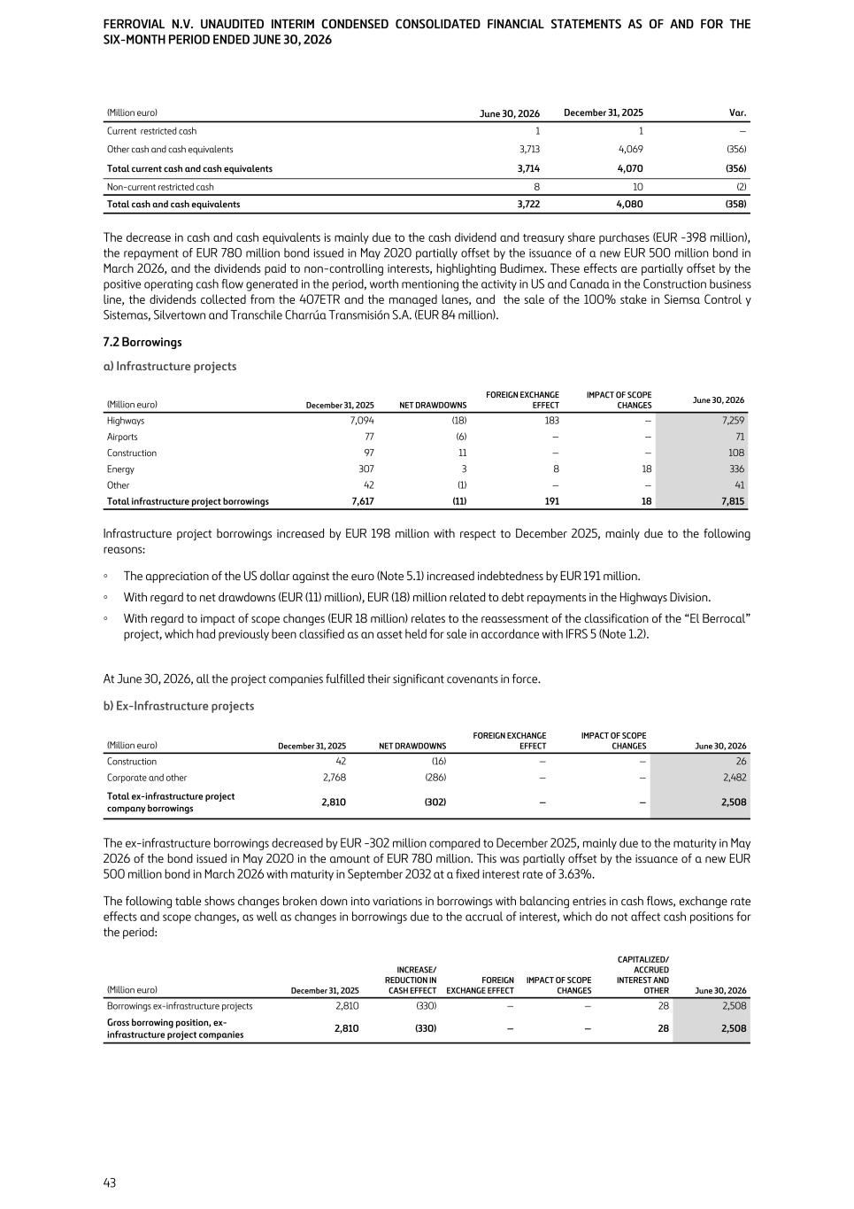
(Million euro) June 30, 2026 December 31, 2025 Var. Current restricted cash 1 1 — Other cash and cash equivalents 3,713 4,069 (356) Total current cash and cash equivalents 3,714 4,070 (356) Non-current restricted cash 8 10 (2) Total cash and cash equivalents 3,722 4,080 (358) The decrease in cash and cash equivalents is mainly due to the cash dividend and treasury share purchases (EUR -398 million), the repayment of EUR 780 million bond issued in May 2020 partially offset by the issuance of a new EUR 500 million bond in March 2026, and the dividends paid to non-controlling interests, highlighting Budimex. These effects are partially offset by the positive operating cash flow generated in the period, worth mentioning the activity in US and Canada in the Construction business line, the dividends collected from the 407ETR and the managed lanes, and the sale of the 100% stake in Siemsa Control y Sistemas, Silvertown and Transchile Charrúa Transmisión S.A. (EUR 84 million). 7.2 Borrowings a) Infrastructure projects (Million euro) December 31, 2025 NET DRAWDOWNS FOREIGN EXCHANGE EFFECT IMPACT OF SCOPE CHANGES June 30, 2026 Highways 7,094 (18) 183 — 7,259 Airports 77 (6) — — 71 Construction 97 11 — — 108 Energy 307 3 8 18 336 Other 42 (1) — — 41 Total infrastructure project borrowings 7,617 (11) 191 18 7,815 Infrastructure project borrowings increased by EUR 198 million with respect to December 2025, mainly due to the following reasons: ◦ The appreciation of the US dollar against the euro (Note 5.1) increased indebtedness by EUR 191 million. ◦ With regard to net drawdowns (EUR (11) million), EUR (18) million related to debt repayments in the Highways Division. ◦ With regard to impact of scope changes (EUR 18 million) relates to the reassessment of the classification of the “El Berrocal” project, which had previously been classified as an asset held for sale in accordance with IFRS 5 (Note 1.2). At June 30, 2026, all the project companies fulfilled their significant covenants in force. b) Ex-Infrastructure projects (Million euro) December 31, 2025 NET DRAWDOWNS FOREIGN EXCHANGE EFFECT IMPACT OF SCOPE CHANGES June 30, 2026 Construction 42 (16) — — 26 Corporate and other 2,768 (286) — — 2,482 Total ex-infrastructure project company borrowings 2,810 (302) — — 2,508 The ex-infrastructure borrowings decreased by EUR -302 million compared to December 2025, mainly due to the maturity in May 2026 of the bond issued in May 2020 in the amount of EUR 780 million. This was partially offset by the issuance of a new EUR 500 million bond in March 2026 with maturity in September 2032 at a fixed interest rate of 3.63%. The following table shows changes broken down into variations in borrowings with balancing entries in cash flows, exchange rate effects and scope changes, as well as changes in borrowings due to the accrual of interest, which do not affect cash positions for the period: (Million euro) December 31, 2025 INCREASE/ REDUCTION IN CASH EFFECT FOREIGN EXCHANGE EFFECT IMPACT OF SCOPE CHANGES CAPITALIZED/ ACCRUED INTEREST AND OTHER June 30, 2026 Borrowings ex-infrastructure projects 2,810 (330) — — 28 2,508 Gross borrowing position, ex- infrastructure project companies 2,810 (330) — — 28 2,508 FERROVIAL N.V. UNAUDITED INTERIM CONDENSED CONSOLIDATED FINANCIAL STATEMENTS AS OF AND FOR THE SIX-MONTH PERIOD ENDED JUNE 30, 2026 43

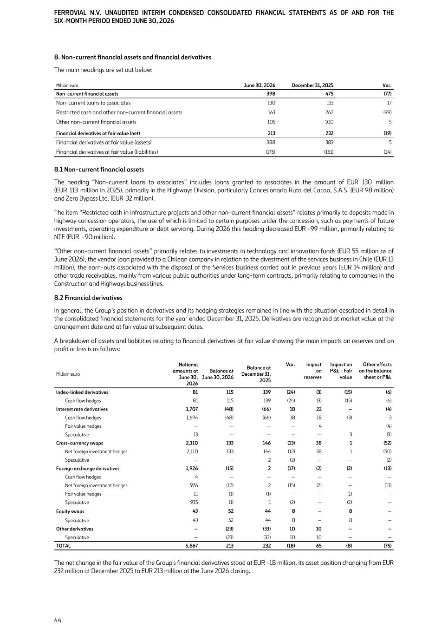
8. Non-current financial assets and financial derivatives The main headings are set out below: Million euro June 30, 2026 December 31, 2025 Var. Non-current financial assets 398 475 (77) Non-current loans to associates 130 113 17 Restricted cash and other non-current financial assets 163 262 (99) Other non-current financial assets 105 100 5 Financial derivatives at fair value (net) 213 232 (19) Financial derivatives at fair value (assets) 388 383 5 Financial derivatives at fair value (liabilities) (175) (151) (24) 8.1 Non-current financial assets The heading “Non-current loans to associates” includes loans granted to associates in the amount of EUR 130 million (EUR 113 million in 2025), primarily in the Highways Division, particularly Concesionaria Ruta del Cacao, S.A.S. (EUR 98 million) and Zero Bypass Ltd. (EUR 32 million). The item “Restricted cash in infrastructure projects and other non-current financial assets” relates primarily to deposits made in highway concession operators, the use of which is limited to certain purposes under the concession, such as payments of future investments, operating expenditure or debt servicing. During 2026 this heading decreased EUR -99 million, primarily relating to NTE (EUR -90 million). “Other non-current financial assets” primarily relates to investments in technology and innovation funds (EUR 55 million as of June 2026), the vendor loan provided to a Chilean company in relation to the divestment of the services business in Chile (EUR 13 million), the earn-outs associated with the disposal of the Services Business carried out in previous years (EUR 14 million) and other trade receivables, mainly from various public authorities under long-term contracts, primarily relating to companies in the Construction and Highways business lines. 8.2 Financial derivatives In general, the Group’s position in derivatives and its hedging strategies remained in line with the situation described in detail in the consolidated financial statements for the year ended December 31, 2025. Derivatives are recognized at market value at the arrangement date and at fair value at subsequent dates. A breakdown of assets and liabilities relating to financial derivatives at fair value showing the main impacts on reserves and on profit or loss is as follows: Million euro Notional amounts at June 30, 2026 Balance at June 30, 2026 Balance at December 31, 2025 Var. Impact on reserves Impact on P&L - Fair value Other effects on the balance sheet or P&L Index-linked derivatives 81 115 139 (24) (3) (15) (6) Cash flow hedges 81 115 139 (24) (3) (15) (6) Interest rate derivatives 1,707 (48) (66) 18 22 — (4) Cash flow hedges 1,694 (48) (66) 18 18 (3) 3 Fair value hedges — — — — 4 (4) Speculative 13 — — — — 3 (3) Cross-currency swaps 2,110 133 146 (13) 38 1 (52) Net foreign investment hedges 2,110 133 144 (12) 38 1 (50) Speculative — — 2 (2) — — (2) Foreign exchange derivatives 1,926 (15) 2 (17) (2) (2) (13) Cash flow hedges 4 — — — — — — Net foreign investment hedges 976 (12) 2 (15) (2) — (13) Fair value hedges 11 (1) (1) — — (1) — Speculative 935 (1) 1 (2) — (2) — Equity swaps 43 52 44 8 — 8 — Speculative 43 52 44 8 — 8 — Other derivatives — (23) (33) 10 10 — — Speculative — (23) (33) 10 10 — — TOTAL 5,867 213 232 (18) 65 (8) (75) The net change in the fair value of the Group's financial derivatives stood at EUR -18 million, its asset position changing from EUR 232 million at December 2025 to EUR 213 million at the June 2026 closing. FERROVIAL N.V. UNAUDITED INTERIM CONDENSED CONSOLIDATED FINANCIAL STATEMENTS AS OF AND FOR THE SIX-MONTH PERIOD ENDED JUNE 30, 2026 44

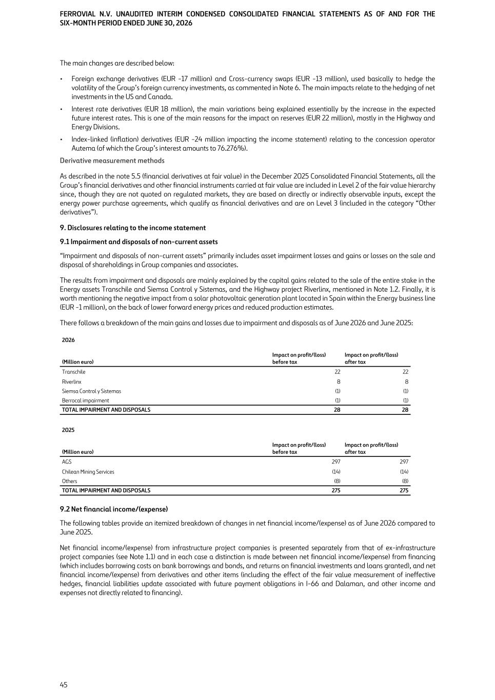
The main changes are described below: • Foreign exchange derivatives (EUR -17 million) and Cross-currency swaps (EUR -13 million), used basically to hedge the volatility of the Group’s foreign currency investments, as commented in Note 6. The main impacts relate to the hedging of net investments in the US and Canada. • Interest rate derivatives (EUR 18 million), the main variations being explained essentially by the increase in the expected future interest rates. This is one of the main reasons for the impact on reserves (EUR 22 million), mostly in the Highway and Energy Divisions. • Index-linked (inflation) derivatives (EUR -24 million impacting the income statement) relating to the concession operator Autema (of which the Group’s interest amounts to 76.276%). Derivative measurement methods As described in the note 5.5 (financial derivatives at fair value) in the December 2025 Consolidated Financial Statements, all the Group’s financial derivatives and other financial instruments carried at fair value are included in Level 2 of the fair value hierarchy since, though they are not quoted on regulated markets, they are based on directly or indirectly observable inputs, except the energy power purchase agreements, which qualify as financial derivatives and are on Level 3 (included in the category “Other derivatives”). 9. Disclosures relating to the income statement 9.1 Impairment and disposals of non-current assets “Impairment and disposals of non-current assets” primarily includes asset impairment losses and gains or losses on the sale and disposal of shareholdings in Group companies and associates. The results from impairment and disposals are mainly explained by the capital gains related to the sale of the entire stake in the Energy assets Transchile and Siemsa Control y Sistemas, and the Highway project Riverlinx, mentioned in Note 1.2. Finally, it is worth mentioning the negative impact from a solar photovoltaic generation plant located in Spain within the Energy business line (EUR -1 million), on the back of lower forward energy prices and reduced production estimates. There follows a breakdown of the main gains and losses due to impairment and disposals as of June 2026 and June 2025: 2026 (Million euro) Impact on profit/(loss) before tax Impact on profit/(loss) after tax Transchile 22 22 Riverlinx 8 8 Siemsa Control y Sistemas (1) (1) Berrocal impairment (1) (1) TOTAL IMPAIRMENT AND DISPOSALS 28 28 2025 (Million euro) Impact on profit/(loss) before tax Impact on profit/(loss) after tax AGS 297 297 Chilean Mining Services (14) (14) Others (8) (8) TOTAL IMPAIRMENT AND DISPOSALS 275 275 9.2 Net financial income/(expense) The following tables provide an itemized breakdown of changes in net financial income/(expense) as of June 2026 compared to June 2025. Net financial income/(expense) from infrastructure project companies is presented separately from that of ex-infrastructure project companies (see Note 1.1) and in each case a distinction is made between net financial income/(expense) from financing (which includes borrowing costs on bank borrowings and bonds, and returns on financial investments and loans granted), and net financial income/(expense) from derivatives and other items (including the effect of the fair value measurement of ineffective hedges, financial liabilities update associated with future payment obligations in I-66 and Dalaman, and other income and expenses not directly related to financing). FERROVIAL N.V. UNAUDITED INTERIM CONDENSED CONSOLIDATED FINANCIAL STATEMENTS AS OF AND FOR THE SIX-MONTH PERIOD ENDED JUNE 30, 2026 45

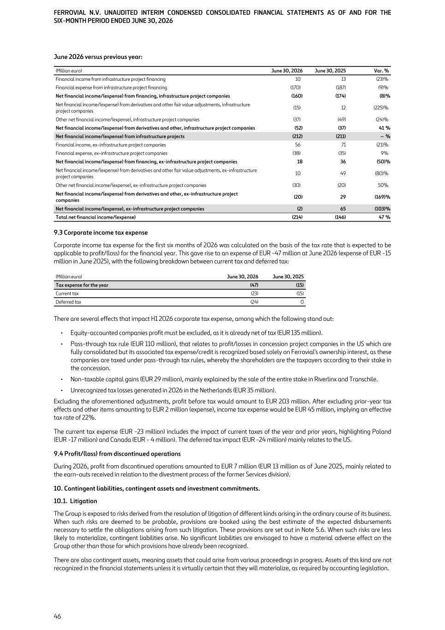
June 2026 versus previous year: (Million euro) June 30, 2026 June 30, 2025 Var. % Financial income from infrastructure project financing 10 13 (23) % Financial expense from infrastructure project financing (170) (187) (9) % Net financial income/(expense) from financing, infrastructure project companies (160) (174) (8) % Net financial income/(expense) from derivatives and other fair value adjustments, infrastructure project companies (15) 12 (225) % Other net financial income/(expense), infrastructure project companies (37) (49) (24) % Net financial income/(expense) from derivatives and other, infrastructure project companies (52) (37) 41 % Net financial income/(expense) from infrastructure projects (212) (211) — % Financial income, ex-infrastructure project companies 56 71 (21) % Financial expense, ex-infrastructure project companies (38) (35) 9 % Net financial income/(expense) from financing, ex-infrastructure project companies 18 36 (50) % Net financial income/(expense) from derivatives and other fair value adjustments, ex-infrastructure project companies 10 49 (80) % Other net financial income/(expense), ex-infrastructure project companies (30) (20) 50 % Net financial income/(expense) from derivatives and other, ex-infrastructure project companies (20) 29 (169) % Net financial income/(expense), ex-infrastructure project companies (2) 65 (103) % Total net financial income/(expense) (214) (146) 47 % 9.3 Corporate income tax expense Corporate income tax expense for the first six months of 2026 was calculated on the basis of the tax rate that is expected to be applicable to profit/(loss) for the financial year. This gave rise to an expense of EUR -47 million at June 2026 (expense of EUR -15 million in June 2025), with the following breakdown between current tax and deferred tax: (Million euro) June 30, 2026 June 30, 2025 Tax expense for the year (47) (15) Current tax (23) (15) Deferred tax (24) 0 There are several effects that impact H1 2026 corporate tax expense, among which the following stand out: • Equity-accounted companies profit must be excluded, as it is already net of tax (EUR 135 million). • Pass-through tax rule (EUR 110 million), that relates to profit/losses in concession project companies in the US which are fully consolidated but its associated tax expense/credit is recognized based solely on Ferrovial's ownership interest, as these companies are taxed under pass-through tax rules, whereby the shareholders are the taxpayers according to their stake in the concession. • Non-taxable capital gains (EUR 29 million), mainly explained by the sale of the entire stake in Riverlinx and Transchile. • Unrecognized tax losses generated in 2026 in the Netherlands (EUR 35 million). Excluding the aforementioned adjustments, profit before tax would amount to EUR 203 million. After excluding prior-year tax effects and other items amounting to EUR 2 million (expense), income tax expense would be EUR 45 million, implying an effective tax rate of 22%. The current tax expense (EUR -23 million) includes the impact of current taxes of the year and prior years, highlighting Poland (EUR -17 million) and Canada (EUR - 4 million). The deferred tax impact (EUR -24 million) mainly relates to the US. 9.4 Profit/(loss) from discontinued operations During 2026, profit from discontinued operations amounted to EUR 7 million (EUR 13 million as of June 2025, mainly related to the earn-outs received in relation to the divestment process of the former Services division). 10. Contingent liabilities, contingent assets and investment commitments. 10.1. Litigation The Group is exposed to risks derived from the resolution of litigation of different kinds arising in the ordinary course of its business. When such risks are deemed to be probable, provisions are booked using the best estimate of the expected disbursements necessary to settle the obligations arising from such litigation. These provisions are set out in Note 5.6. When such risks are less likely to materialize, contingent liabilities arise. No significant liabilities are envisaged to have a material adverse effect on the Group other than those for which provisions have already been recognized. There are also contingent assets, meaning assets that could arise from various proceedings in progress. Assets of this kind are not recognized in the financial statements unless it is virtually certain that they will materialize, as required by accounting legislation. FERROVIAL N.V. UNAUDITED INTERIM CONDENSED CONSOLIDATED FINANCIAL STATEMENTS AS OF AND FOR THE SIX-MONTH PERIOD ENDED JUNE 30, 2026 46

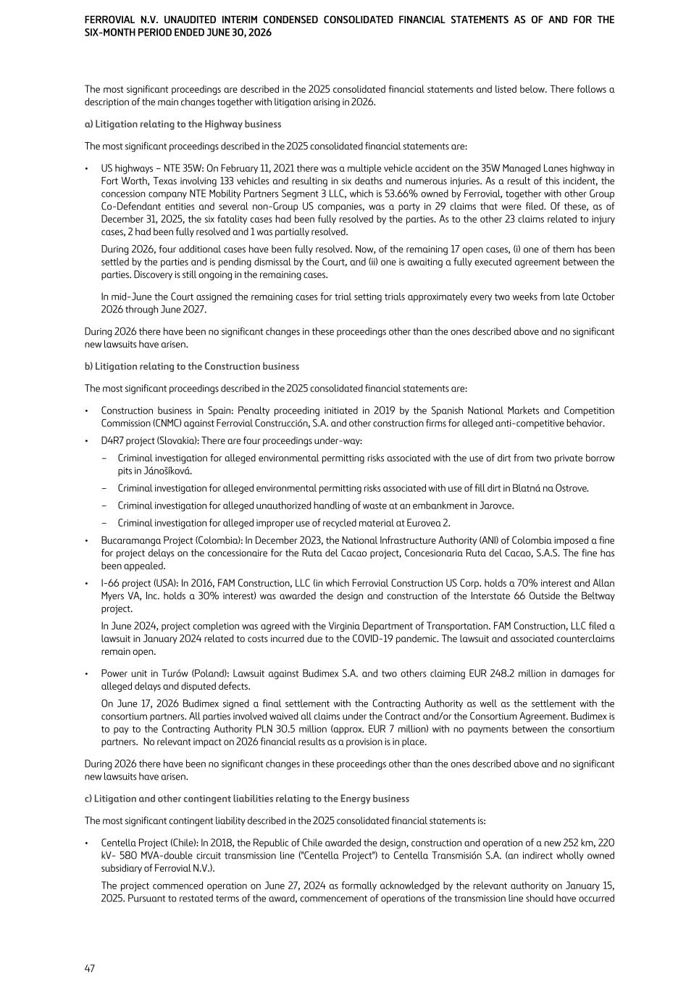
The most significant proceedings are described in the 2025 consolidated financial statements and listed below. There follows a description of the main changes together with litigation arising in 2026. a) Litigation relating to the Highway business The most significant proceedings described in the 2025 consolidated financial statements are: • US highways – NTE 35W: On February 11, 2021 there was a multiple vehicle accident on the 35W Managed Lanes highway in Fort Worth, Texas involving 133 vehicles and resulting in six deaths and numerous injuries. As a result of this incident, the concession company NTE Mobility Partners Segment 3 LLC, which is 53.66% owned by Ferrovial, together with other Group Co-Defendant entities and several non-Group US companies, was a party in 29 claims that were filed. Of these, as of December 31, 2025, the six fatality cases had been fully resolved by the parties. As to the other 23 claims related to injury cases, 2 had been fully resolved and 1 was partially resolved. During 2026, four additional cases have been fully resolved. Now, of the remaining 17 open cases, (i) one of them has been settled by the parties and is pending dismissal by the Court, and (ii) one is awaiting a fully executed agreement between the parties. Discovery is still ongoing in the remaining cases. In mid-June the Court assigned the remaining cases for trial setting trials approximately every two weeks from late October 2026 through June 2027. During 2026 there have been no significant changes in these proceedings other than the ones described above and no significant new lawsuits have arisen. b) Litigation relating to the Construction business The most significant proceedings described in the 2025 consolidated financial statements are: • Construction business in Spain: Penalty proceeding initiated in 2019 by the Spanish National Markets and Competition Commission (CNMC) against Ferrovial Construcción, S.A. and other construction firms for alleged anti-competitive behavior. • D4R7 project (Slovakia): There are four proceedings under-way: – Criminal investigation for alleged environmental permitting risks associated with the use of dirt from two private borrow pits in Jánošíková. – Criminal investigation for alleged environmental permitting risks associated with use of fill dirt in Blatná na Ostrove. – Criminal investigation for alleged unauthorized handling of waste at an embankment in Jarovce. – Criminal investigation for alleged improper use of recycled material at Eurovea 2. • Bucaramanga Project (Colombia): In December 2023, the National Infrastructure Authority (ANI) of Colombia imposed a fine for project delays on the concessionaire for the Ruta del Cacao project, Concesionaria Ruta del Cacao, S.A.S. The fine has been appealed. • I-66 project (USA): In 2016, FAM Construction, LLC (in which Ferrovial Construction US Corp. holds a 70% interest and Allan Myers VA, Inc. holds a 30% interest) was awarded the design and construction of the Interstate 66 Outside the Beltway project. In June 2024, project completion was agreed with the Virginia Department of Transportation. FAM Construction, LLC filed a lawsuit in January 2024 related to costs incurred due to the COVID-19 pandemic. The lawsuit and associated counterclaims remain open. • Power unit in Turów (Poland): Lawsuit against Budimex S.A. and two others claiming EUR 248.2 million in damages for alleged delays and disputed defects. On June 17, 2026 Budimex signed a final settlement with the Contracting Authority as well as the settlement with the consortium partners. All parties involved waived all claims under the Contract and/or the Consortium Agreement. Budimex is to pay to the Contracting Authority PLN 30.5 million (approx. EUR 7 million) with no payments between the consortium partners. No relevant impact on 2026 financial results as a provision is in place. During 2026 there have been no significant changes in these proceedings other than the ones described above and no significant new lawsuits have arisen. c) Litigation and other contingent liabilities relating to the Energy business The most significant contingent liability described in the 2025 consolidated financial statements is: • Centella Project (Chile): In 2018, the Republic of Chile awarded the design, construction and operation of a new 252 km, 220 kV- 580 MVA-double circuit transmission line ("Centella Project") to Centella Transmisión S.A. (an indirect wholly owned subsidiary of Ferrovial N.V.). The project commenced operation on June 27, 2024 as formally acknowledged by the relevant authority on January 15, 2025. Pursuant to restated terms of the award, commencement of operations of the transmission line should have occurred FERROVIAL N.V. UNAUDITED INTERIM CONDENSED CONSOLIDATED FINANCIAL STATEMENTS AS OF AND FOR THE SIX-MONTH PERIOD ENDED JUNE 30, 2026 47

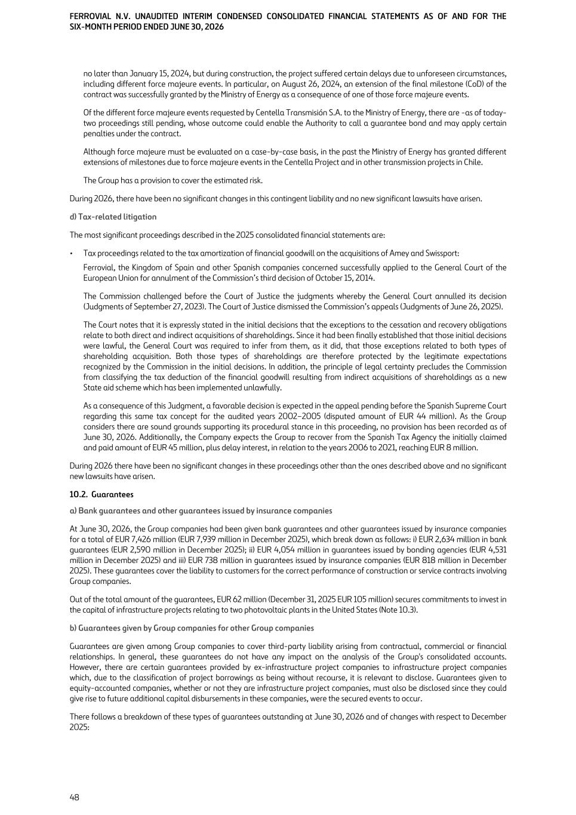
no later than January 15, 2024, but during construction, the project suffered certain delays due to unforeseen circumstances, including different force majeure events. In particular, on August 26, 2024, an extension of the final milestone (CoD) of the contract was successfully granted by the Ministry of Energy as a consequence of one of those force majeure events. Of the different force majeure events requested by Centella Transmisión S.A. to the Ministry of Energy, there are -as of today- two proceedings still pending, whose outcome could enable the Authority to call a guarantee bond and may apply certain penalties under the contract. Although force majeure must be evaluated on a case-by-case basis, in the past the Ministry of Energy has granted different extensions of milestones due to force majeure events in the Centella Project and in other transmission projects in Chile. The Group has a provision to cover the estimated risk. During 2026, there have been no significant changes in this contingent liability and no new significant lawsuits have arisen. d) Tax-related litigation The most significant proceedings described in the 2025 consolidated financial statements are: • Tax proceedings related to the tax amortization of financial goodwill on the acquisitions of Amey and Swissport: Ferrovial, the Kingdom of Spain and other Spanish companies concerned successfully applied to the General Court of the European Union for annulment of the Commission’s third decision of October 15, 2014. The Commission challenged before the Court of Justice the judgments whereby the General Court annulled its decision (Judgments of September 27, 2023). The Court of Justice dismissed the Commission’s appeals (Judgments of June 26, 2025). The Court notes that it is expressly stated in the initial decisions that the exceptions to the cessation and recovery obligations relate to both direct and indirect acquisitions of shareholdings. Since it had been finally established that those initial decisions were lawful, the General Court was required to infer from them, as it did, that those exceptions related to both types of shareholding acquisition. Both those types of shareholdings are therefore protected by the legitimate expectations recognized by the Commission in the initial decisions. In addition, the principle of legal certainty precludes the Commission from classifying the tax deduction of the financial goodwill resulting from indirect acquisitions of shareholdings as a new State aid scheme which has been implemented unlawfully. As a consequence of this Judgment, a favorable decision is expected in the appeal pending before the Spanish Supreme Court regarding this same tax concept for the audited years 2002–2005 (disputed amount of EUR 44 million). As the Group considers there are sound grounds supporting its procedural stance in this proceeding, no provision has been recorded as of June 30, 2026. Additionally, the Company expects the Group to recover from the Spanish Tax Agency the initially claimed and paid amount of EUR 45 million, plus delay interest, in relation to the years 2006 to 2021, reaching EUR 8 million. During 2026 there have been no significant changes in these proceedings other than the ones described above and no significant new lawsuits have arisen. 10.2. Guarantees a) Bank guarantees and other guarantees issued by insurance companies At June 30, 2026, the Group companies had been given bank guarantees and other guarantees issued by insurance companies for a total of EUR 7,426 million (EUR 7,939 million in December 2025), which break down as follows: i) EUR 2,634 million in bank guarantees (EUR 2,590 million in December 2025); ii) EUR 4,054 million in guarantees issued by bonding agencies (EUR 4,531 million in December 2025) and iii) EUR 738 million in guarantees issued by insurance companies (EUR 818 million in December 2025). These guarantees cover the liability to customers for the correct performance of construction or service contracts involving Group companies. Out of the total amount of the guarantees, EUR 62 million (December 31, 2025 EUR 105 million) secures commitments to invest in the capital of infrastructure projects relating to two photovoltaic plants in the United States (Note 10.3). b) Guarantees given by Group companies for other Group companies Guarantees are given among Group companies to cover third-party liability arising from contractual, commercial or financial relationships. In general, these guarantees do not have any impact on the analysis of the Group's consolidated accounts. However, there are certain guarantees provided by ex-infrastructure project companies to infrastructure project companies which, due to the classification of project borrowings as being without recourse, it is relevant to disclose. Guarantees given to equity-accounted companies, whether or not they are infrastructure project companies, must also be disclosed since they could give rise to future additional capital disbursements in these companies, were the secured events to occur. There follows a breakdown of these types of guarantees outstanding at June 30, 2026 and of changes with respect to December 2025: FERROVIAL N.V. UNAUDITED INTERIM CONDENSED CONSOLIDATED FINANCIAL STATEMENTS AS OF AND FOR THE SIX-MONTH PERIOD ENDED JUNE 30, 2026 48

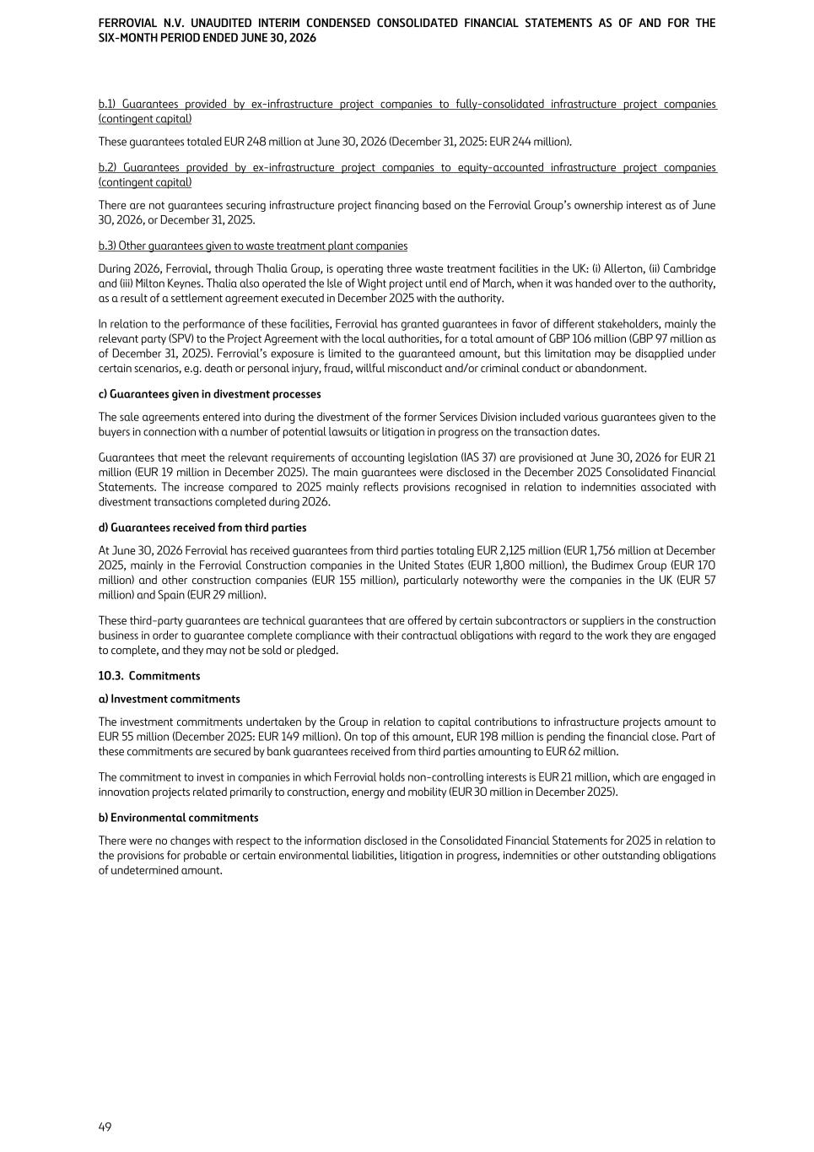
b.1) Guarantees provided by ex-infrastructure project companies to fully-consolidated infrastructure project companies (contingent capital) These guarantees totaled EUR 248 million at June 30, 2026 (December 31, 2025: EUR 244 million). b.2) Guarantees provided by ex-infrastructure project companies to equity-accounted infrastructure project companies (contingent capital) There are not guarantees securing infrastructure project financing based on the Ferrovial Group’s ownership interest as of June 30, 2026, or December 31, 2025. b.3) Other guarantees given to waste treatment plant companies During 2026, Ferrovial, through Thalia Group, is operating three waste treatment facilities in the UK: (i) Allerton, (ii) Cambridge and (iii) Milton Keynes. Thalia also operated the Isle of Wight project until end of March, when it was handed over to the authority, as a result of a settlement agreement executed in December 2025 with the authority. In relation to the performance of these facilities, Ferrovial has granted guarantees in favor of different stakeholders, mainly the relevant party (SPV) to the Project Agreement with the local authorities, for a total amount of GBP 106 million (GBP 97 million as of December 31, 2025). Ferrovial’s exposure is limited to the guaranteed amount, but this limitation may be disapplied under certain scenarios, e.g. death or personal injury, fraud, willful misconduct and/or criminal conduct or abandonment. c) Guarantees given in divestment processes The sale agreements entered into during the divestment of the former Services Division included various guarantees given to the buyers in connection with a number of potential lawsuits or litigation in progress on the transaction dates. Guarantees that meet the relevant requirements of accounting legislation (IAS 37) are provisioned at June 30, 2026 for EUR 21 million (EUR 19 million in December 2025). The main guarantees were disclosed in the December 2025 Consolidated Financial Statements. The increase compared to 2025 mainly reflects provisions recognised in relation to indemnities associated with divestment transactions completed during 2026. d) Guarantees received from third parties At June 30, 2026 Ferrovial has received guarantees from third parties totaling EUR 2,125 million (EUR 1,756 million at December 2025, mainly in the Ferrovial Construction companies in the United States (EUR 1,800 million), the Budimex Group (EUR 170 million) and other construction companies (EUR 155 million), particularly noteworthy were the companies in the UK (EUR 57 million) and Spain (EUR 29 million). These third-party guarantees are technical guarantees that are offered by certain subcontractors or suppliers in the construction business in order to guarantee complete compliance with their contractual obligations with regard to the work they are engaged to complete, and they may not be sold or pledged. 10.3. Commitments a) Investment commitments The investment commitments undertaken by the Group in relation to capital contributions to infrastructure projects amount to EUR 55 million (December 2025: EUR 149 million). On top of this amount, EUR 198 million is pending the financial close. Part of these commitments are secured by bank guarantees received from third parties amounting to EUR 62 million. The commitment to invest in companies in which Ferrovial holds non-controlling interests is EUR 21 million, which are engaged in innovation projects related primarily to construction, energy and mobility (EUR 30 million in December 2025). b) Environmental commitments There were no changes with respect to the information disclosed in the Consolidated Financial Statements for 2025 in relation to the provisions for probable or certain environmental liabilities, litigation in progress, indemnities or other outstanding obligations of undetermined amount. FERROVIAL N.V. UNAUDITED INTERIM CONDENSED CONSOLIDATED FINANCIAL STATEMENTS AS OF AND FOR THE SIX-MONTH PERIOD ENDED JUNE 30, 2026 49

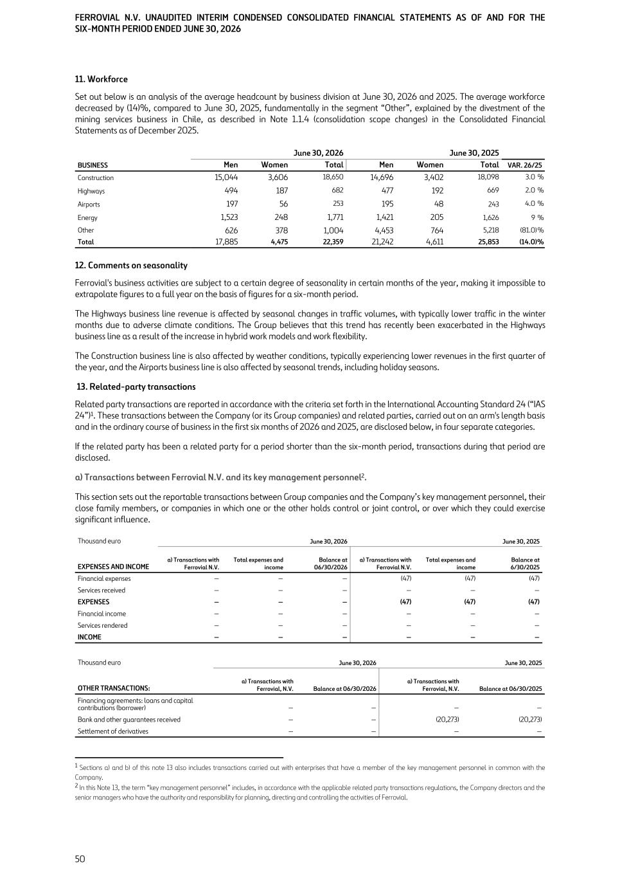
11. Workforce Set out below is an analysis of the average headcount by business division at June 30, 2026 and 2025. The average workforce decreased by (14)%, compared to June 30, 2025, fundamentally in the segment “Other”, explained by the divestment of the mining services business in Chile, as described in Note 1.1.4 (consolidation scope changes) in the Consolidated Financial Statements as of December 2025. June 30, 2026 June 30, 2025 BUSINESS Men Women Total Men Women Total VAR. 26/25 Construction 15,044 3,606 18,650 14,696 3,402 18,098 3.0 % Highways 494 187 682 477 192 669 2.0 % Airports 197 56 253 195 48 243 4.0 % Energy 1,523 248 1,771 1,421 205 1,626 9 % Other 626 378 1,004 4,453 764 5,218 (81.0) % Total 17,885 4,475 22,359 21,242 4,611 25,853 (14.0) % 12. Comments on seasonality Ferrovial's business activities are subject to a certain degree of seasonality in certain months of the year, making it impossible to extrapolate figures to a full year on the basis of figures for a six-month period. The Highways business line revenue is affected by seasonal changes in traffic volumes, with typically lower traffic in the winter months due to adverse climate conditions. The Group believes that this trend has recently been exacerbated in the Highways business line as a result of the increase in hybrid work models and work flexibility. The Construction business line is also affected by weather conditions, typically experiencing lower revenues in the first quarter of the year, and the Airports business line is also affected by seasonal trends, including holiday seasons. 13. Related-party transactions Related party transactions are reported in accordance with the criteria set forth in the International Accounting Standard 24 (“IAS 24”)1. These transactions between the Company (or its Group companies) and related parties, carried out on an arm's length basis and in the ordinary course of business in the first six months of 2026 and 2025, are disclosed below, in four separate categories. If the related party has been a related party for a period shorter than the six-month period, transactions during that period are disclosed. a) Transactions between Ferrovial N.V. and its key management personnel2. This section sets out the reportable transactions between Group companies and the Company’s key management personnel, their close family members, or companies in which one or the other holds control or joint control, or over which they could exercise significant influence. Thousand euro June 30, 2026 June 30, 2025 EXPENSES AND INCOME a) Transactions with Ferrovial N.V. Total expenses and income Balance at 06/30/2026 a) Transactions with Ferrovial N.V. Total expenses and income Balance at 6/30/2025 Financial expenses — — — (47) (47) (47) Services received — — — — — — EXPENSES — — — (47) (47) (47) Financial income — — — — — — Services rendered — — — — — — INCOME — — — — — — Thousand euro June 30, 2026 June 30, 2025 OTHER TRANSACTIONS: a) Transactions with Ferrovial, N.V. Balance at 06/30/2026 a) Transactions with Ferrovial, N.V. Balance at 06/30/2025 Financing agreements: loans and capital contributions (borrower) — — — — Bank and other guarantees received — — (20,273) (20,273) Settlement of derivatives — — — — FERROVIAL N.V. UNAUDITED INTERIM CONDENSED CONSOLIDATED FINANCIAL STATEMENTS AS OF AND FOR THE SIX-MONTH PERIOD ENDED JUNE 30, 2026 50 1 Sections a) and b) of this note 13 also includes transactions carried out with enterprises that have a member of the key management personnel in common with the Company. 2 In this Note 13, the term “key management personnel” includes, in accordance with the applicable related party transactions regulations, the Company directors and the senior managers who have the authority and responsibility for planning, directing and controlling the activities of Ferrovial.

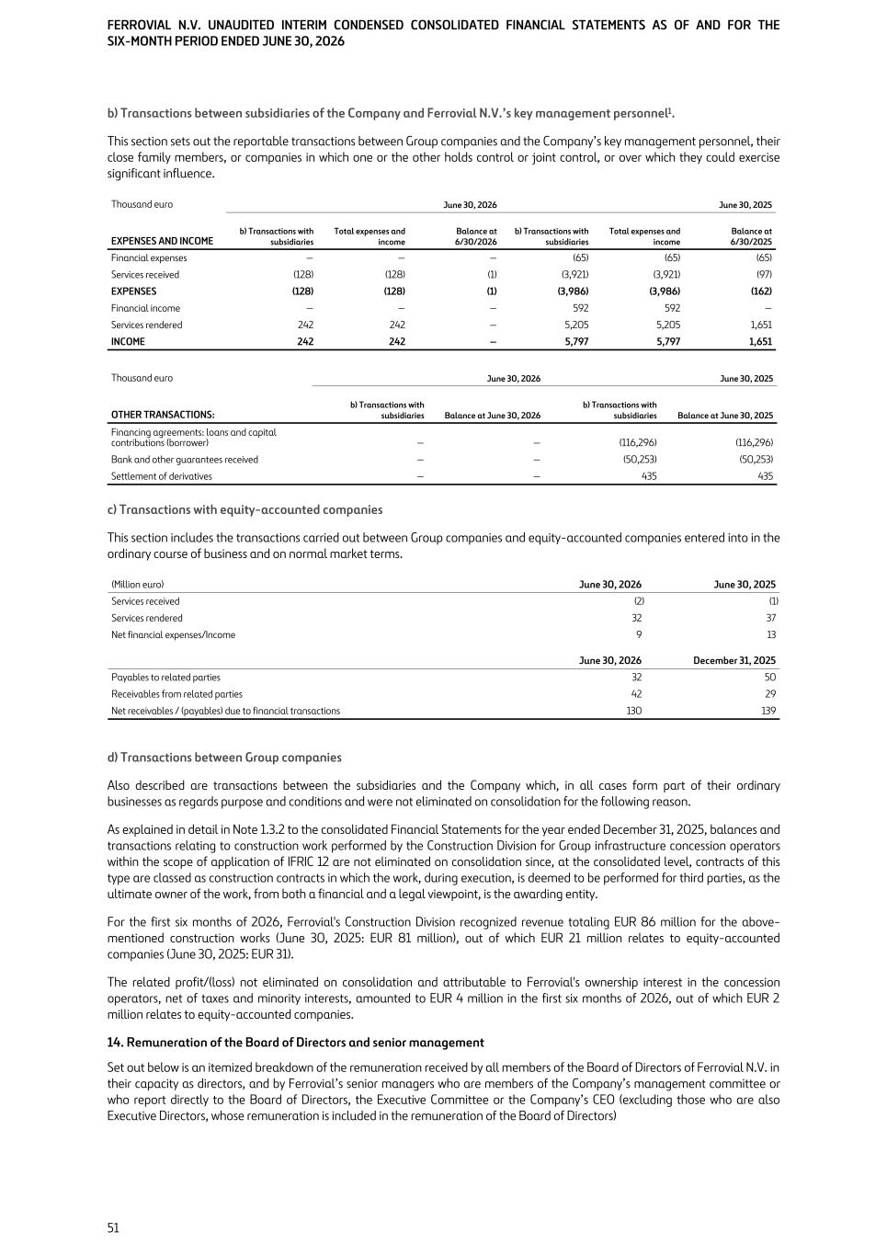
b) Transactions between subsidiaries of the Company and Ferrovial N.V.’s key management personnel1. This section sets out the reportable transactions between Group companies and the Company’s key management personnel, their close family members, or companies in which one or the other holds control or joint control, or over which they could exercise significant influence. Thousand euro June 30, 2026 June 30, 2025 EXPENSES AND INCOME b) Transactions with subsidiaries Total expenses and income Balance at 6/30/2026 b) Transactions with subsidiaries Total expenses and income Balance at 6/30/2025 Financial expenses — — — (65) (65) (65) Services received (128) (128) (1) (3,921) (3,921) (97) EXPENSES (128) (128) (1) (3,986) (3,986) (162) Financial income — — — 592 592 — Services rendered 242 242 — 5,205 5,205 1,651 INCOME 242 242 — 5,797 5,797 1,651 Thousand euro June 30, 2026 June 30, 2025 OTHER TRANSACTIONS: b) Transactions with subsidiaries Balance at June 30, 2026 b) Transactions with subsidiaries Balance at June 30, 2025 Financing agreements: loans and capital contributions (borrower) — — (116,296) (116,296) Bank and other guarantees received — — (50,253) (50,253) Settlement of derivatives — — 435 435 c) Transactions with equity-accounted companies This section includes the transactions carried out between Group companies and equity-accounted companies entered into in the ordinary course of business and on normal market terms. (Million euro) June 30, 2026 June 30, 2025 Services received (2) (1) Services rendered 32 37 Net financial expenses/Income 9 13 June 30, 2026 December 31, 2025 Payables to related parties 32 50 Receivables from related parties 42 29 Net receivables / (payables) due to financial transactions 130 139 d) Transactions between Group companies Also described are transactions between the subsidiaries and the Company which, in all cases form part of their ordinary businesses as regards purpose and conditions and were not eliminated on consolidation for the following reason. As explained in detail in Note 1.3.2 to the consolidated Financial Statements for the year ended December 31, 2025, balances and transactions relating to construction work performed by the Construction Division for Group infrastructure concession operators within the scope of application of IFRIC 12 are not eliminated on consolidation since, at the consolidated level, contracts of this type are classed as construction contracts in which the work, during execution, is deemed to be performed for third parties, as the ultimate owner of the work, from both a financial and a legal viewpoint, is the awarding entity. For the first six months of 2026, Ferrovial's Construction Division recognized revenue totaling EUR 86 million for the above- mentioned construction works (June 30, 2025: EUR 81 million), out of which EUR 21 million relates to equity-accounted companies (June 30, 2025: EUR 31). The related profit/(loss) not eliminated on consolidation and attributable to Ferrovial's ownership interest in the concession operators, net of taxes and minority interests, amounted to EUR 4 million in the first six months of 2026, out of which EUR 2 million relates to equity-accounted companies. 14. Remuneration of the Board of Directors and senior management Set out below is an itemized breakdown of the remuneration received by all members of the Board of Directors of Ferrovial N.V. in their capacity as directors, and by Ferrovial’s senior managers who are members of the Company’s management committee or who report directly to the Board of Directors, the Executive Committee or the Company’s CEO (excluding those who are also Executive Directors, whose remuneration is included in the remuneration of the Board of Directors) FERROVIAL N.V. UNAUDITED INTERIM CONDENSED CONSOLIDATED FINANCIAL STATEMENTS AS OF AND FOR THE SIX-MONTH PERIOD ENDED JUNE 30, 2026 51

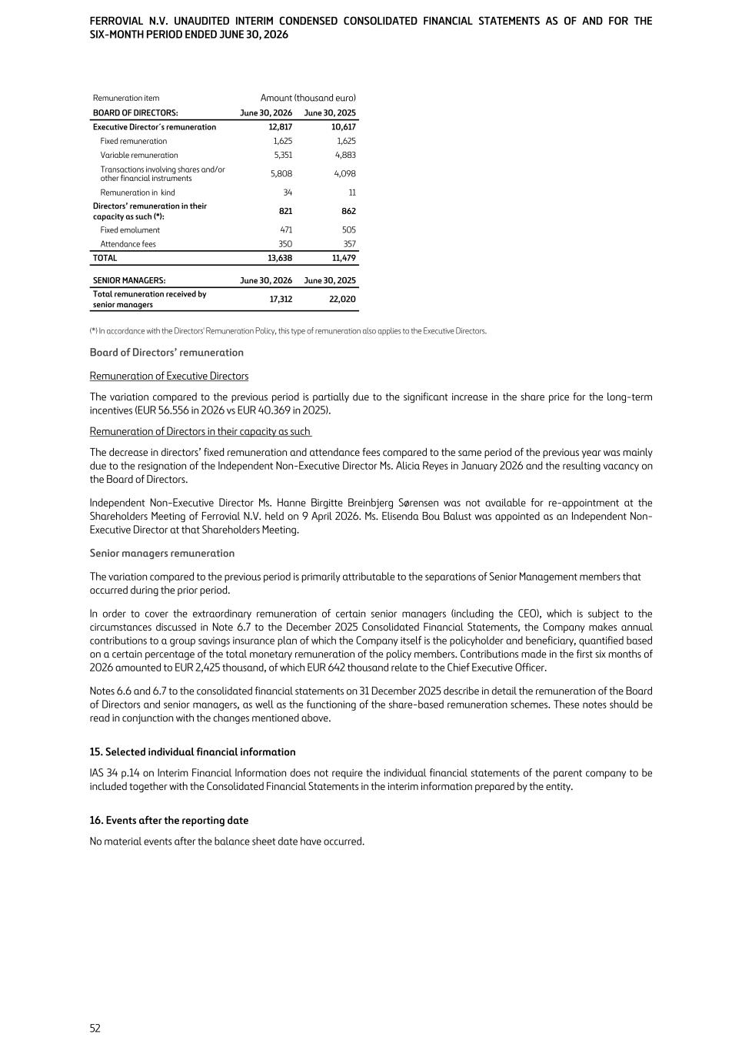
Remuneration item Amount (thousand euro) BOARD OF DIRECTORS: June 30, 2026 June 30, 2025 Executive Director´s remuneration 12,817 10,617 Fixed remuneration 1,625 1,625 Variable remuneration 5,351 4,883 Transactions involving shares and/or other financial instruments 5,808 4,098 Remuneration in kind 34 11 Directors’ remuneration in their capacity as such (*): 821 862 Fixed emolument 471 505 Attendance fees 350 357 TOTAL 13,638 11,479 SENIOR MANAGERS: June 30, 2026 June 30, 2025 Total remuneration received by senior managers 17,312 22,020 (*) In accordance with the Directors' Remuneration Policy, this type of remuneration also applies to the Executive Directors. Board of Directors’ remuneration Remuneration of Executive Directors The variation compared to the previous period is partially due to the significant increase in the share price for the long-term incentives (EUR 56.556 in 2026 vs EUR 40.369 in 2025). Remuneration of Directors in their capacity as such The decrease in directors’ fixed remuneration and attendance fees compared to the same period of the previous year was mainly due to the resignation of the Independent Non-Executive Director Ms. Alicia Reyes in January 2026 and the resulting vacancy on the Board of Directors. Independent Non-Executive Director Ms. Hanne Birgitte Breinbjerg Sørensen was not available for re-appointment at the Shareholders Meeting of Ferrovial N.V. held on 9 April 2026. Ms. Elisenda Bou Balust was appointed as an Independent Non- Executive Director at that Shareholders Meeting. Senior managers remuneration The variation compared to the previous period is primarily attributable to the separations of Senior Management members that occurred during the prior period. In order to cover the extraordinary remuneration of certain senior managers (including the CEO), which is subject to the circumstances discussed in Note 6.7 to the December 2025 Consolidated Financial Statements, the Company makes annual contributions to a group savings insurance plan of which the Company itself is the policyholder and beneficiary, quantified based on a certain percentage of the total monetary remuneration of the policy members. Contributions made in the first six months of 2026 amounted to EUR 2,425 thousand, of which EUR 642 thousand relate to the Chief Executive Officer. Notes 6.6 and 6.7 to the consolidated financial statements on 31 December 2025 describe in detail the remuneration of the Board of Directors and senior managers, as well as the functioning of the share-based remuneration schemes. These notes should be read in conjunction with the changes mentioned above. 15. Selected individual financial information IAS 34 p.14 on Interim Financial Information does not require the individual financial statements of the parent company to be included together with the Consolidated Financial Statements in the interim information prepared by the entity. 16. Events after the reporting date No material events after the balance sheet date have occurred. FERROVIAL N.V. UNAUDITED INTERIM CONDENSED CONSOLIDATED FINANCIAL STATEMENTS AS OF AND FOR THE SIX-MONTH PERIOD ENDED JUNE 30, 2026 52

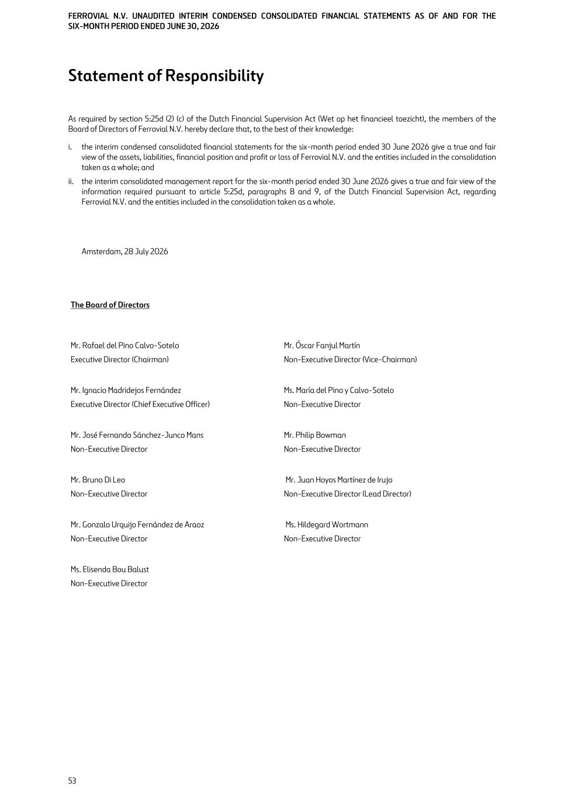
Statement of Responsibility As required by section 5:25d (2) (c) of the Dutch Financial Supervision Act (Wet op het financieel toezicht), the members of the Board of Directors of Ferrovial N.V. hereby declare that, to the best of their knowledge: i. the interim condensed consolidated financial statements for the six-month period ended 30 June 2026 give a true and fair view of the assets, liabilities, financial position and profit or loss of Ferrovial N.V. and the entities included in the consolidation taken as a whole; and ii. the interim consolidated management report for the six-month period ended 30 June 2026 gives a true and fair view of the information required pursuant to article 5:25d, paragraphs 8 and 9, of the Dutch Financial Supervision Act, regarding Ferrovial N.V. and the entities included in the consolidation taken as a whole. Amsterdam, 28 July 2026 The Board of Directors Mr. Rafael del Pino Calvo-Sotelo Executive Director (Chairman) Mr. Óscar Fanjul Martín Non-Executive Director (Vice-Chairman) Mr. Ignacio Madridejos Fernández Executive Director (Chief Executive Officer) Ms. María del Pino y Calvo-Sotelo Non-Executive Director Mr. José Fernando Sánchez-Junco Mans Non-Executive Director Mr. Philip Bowman Non-Executive Director Mr. Bruno Di Leo Non-Executive Director Mr. Juan Hoyos Martínez de Irujo Non-Executive Director (Lead Director) Mr. Gonzalo Urquijo Fernández de Araoz Non-Executive Director Ms. Hildegard Wortmann Non-Executive Director Ms. Elisenda Bou Balust Non-Executive Director FERROVIAL N.V. UNAUDITED INTERIM CONDENSED CONSOLIDATED FINANCIAL STATEMENTS AS OF AND FOR THE SIX-MONTH PERIOD ENDED JUNE 30, 2026 53

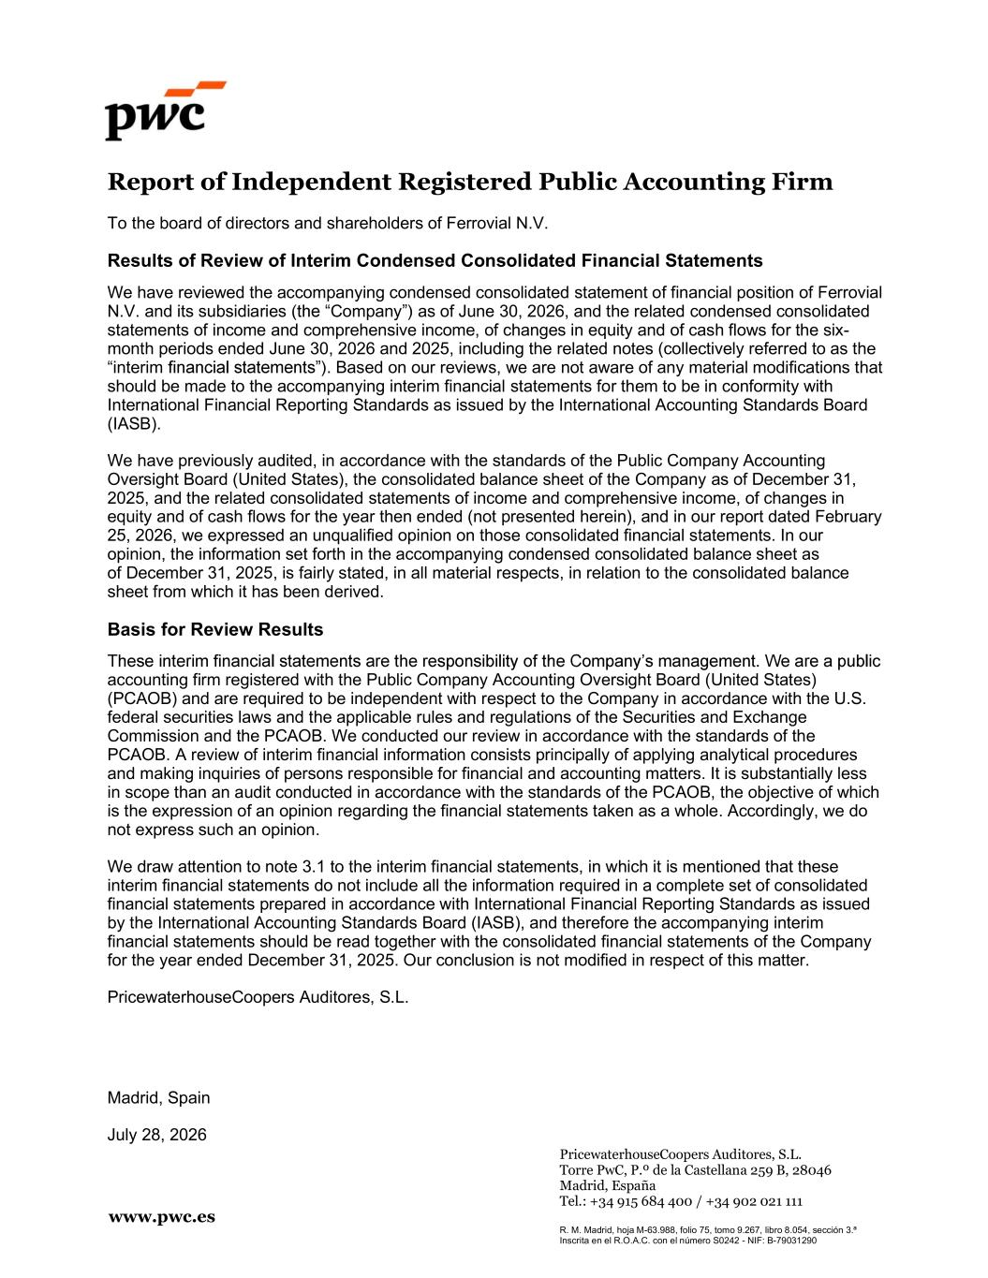
PricewaterhouseCoopers Auditores, S.L. Torre PwC, P.º de la Castellana 259 B, 28046 Madrid, España Tel.: +34 915 684 400 / +34 902 021 111 R. M. Madrid, hoja M-63.988, folio 75, tomo 9.267, libro 8.054, sección 3.ª Inscrita en el R.O.A.C. con el número S0242 - NIF: B-79031290 www.pwc.es Report of Independent Registered Public Accounting Firm To the board of directors and shareholders of Ferrovial N.V. Results of Review of Interim Condensed Consolidated Financial Statements We have reviewed the accompanying condensed consolidated statement of financial position of Ferrovial N.V. and its subsidiaries Company as of June 30, 2026, and the related condensed consolidated statements of income and comprehensive income, of changes in equity and of cash flows for the six- month periods ended June 30, 2026 and 2025, including the related notes (collectively referred to as the interim . Based on our reviews, we are not aware of any material modifications that should be made to the accompanying interim financial statements for them to be in conformity with International Financial Reporting Standards as issued by the International Accounting Standards Board (IASB). We have previously audited, in accordance with the standards of the Public Company Accounting Oversight Board (United States), the consolidated balance sheet of the Company as of December 31, 2025, and the related consolidated statements of income and comprehensive income, of changes in equity and of cash flows for the year then ended (not presented herein), and in our report dated February 25, 2026, we expressed an unqualified opinion on those consolidated financial statements. In our opinion, the information set forth in the accompanying condensed consolidated balance sheet as of December 31, 2025, is fairly stated, in all material respects, in relation to the consolidated balance sheet from which it has been derived. Basis for Review Results accounting firm registered with the Public Company Accounting Oversight Board (United States) (PCAOB) and are required to be independent with respect to the Company in accordance with the U.S. federal securities laws and the applicable rules and regulations of the Securities and Exchange Commission and the PCAOB. We conducted our review in accordance with the standards of the PCAOB. A review of interim financial information consists principally of applying analytical procedures and making inquiries of persons responsible for financial and accounting matters. It is substantially less in scope than an audit conducted in accordance with the standards of the PCAOB, the objective of which is the expression of an opinion regarding the financial statements taken as a whole. Accordingly, we do not express such an opinion. We draw attention to note 3.1 to the interim financial statements, in which it is mentioned that these interim financial statements do not include all the information required in a complete set of consolidated financial statements prepared in accordance with International Financial Reporting Standards as issued by the International Accounting Standards Board (IASB), and therefore the accompanying interim financial statements should be read together with the consolidated financial statements of the Company for the year ended December 31, 2025. Our conclusion is not modified in respect of this matter. PricewaterhouseCoopers Auditores, S.L. Madrid, Spain July 28, 2026


H1 2026 Financial Results 1 P ic tu re : 4 0 7 ET R (C a n a da ) July 28, 2026 H1 2026 FINANCIAL RESULTS

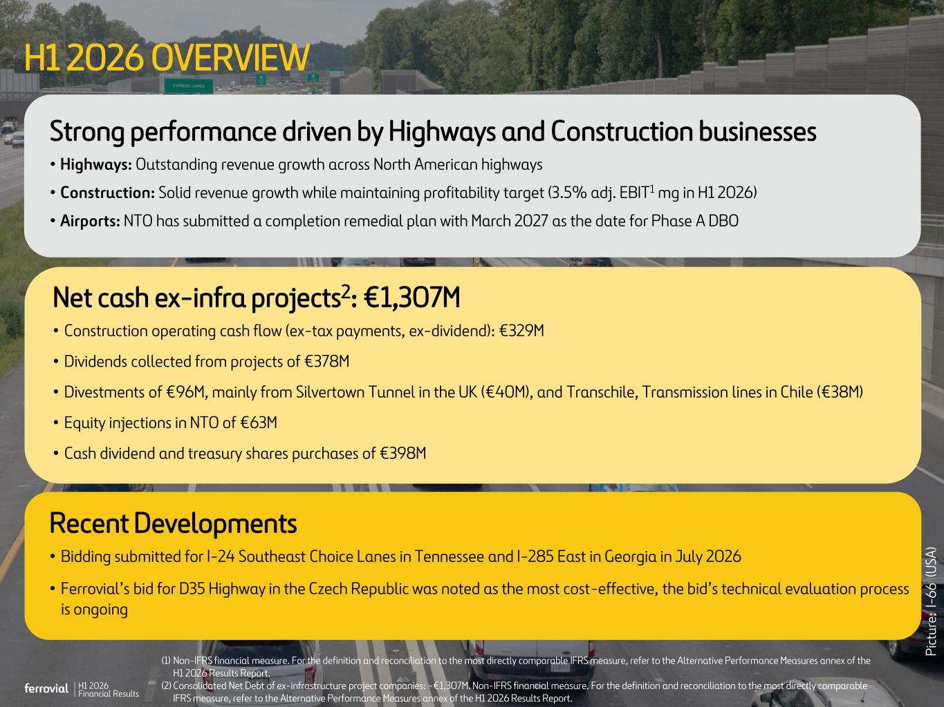
H1 2026 Financial Results 2 H1 2026 OVERVIEW Strong performance driven by Highways and Construction businesses • Highways: Outstanding revenue growth across North American highways • Construction: Solid revenue growth while maintaining profitability target (3.5% adj. EBIT1 mg in H1 2026) • Airports: NTO has submitted a completion remedial plan with March 2027 as the date for Phase A DBO Net cash ex-infra projects2: €1,307M • Construction operating cash flow (ex-tax payments, ex-dividend): €329M • Dividends collected from projects of €378M • Divestments of €96M, mainly from Silvertown Tunnel in the UK (€40M), and Transchile, Transmission lines in Chile (€38M) • Equity injections in NTO of €63M • Cash dividend and treasury shares purchases of €398M (1) Non-IFRS financial measure. For the definition and reconciliation to the most directly comparable IFRS measure, refer to the Alternative Performance Measures annex of the H1 2026 Results Report. (2) Consolidated Net Debt of ex-infrastructure project companies: -€1,307M. Non-IFRS financial measure. For the definition and reconciliation to the most directly comparable IFRS measure, refer to the Alternative Performance Measures annex of the H1 2026 Results Report. P ic tu re : I- 6 6 ( U SA ) Recent Developments • Bidding submitted for I-24 Southeast Choice Lanes in Tennessee and I-285 East in Georgia in July 2026 • Ferrovial’s bid for D35 Highway in the Czech Republic was noted as the most cost-effective, the bid’s technical evaluation process is ongoing

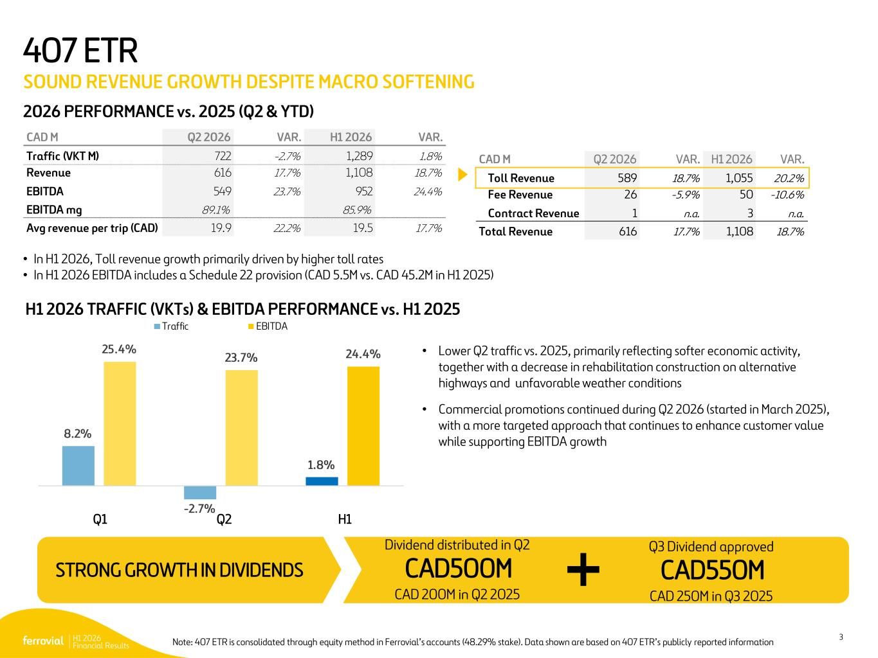
H1 2026 Financial Results 3 25.4% 23.7% 24.4% 8.2% - 2.7% 1.8% Traffic EBITDA 2026 PERFORMANCE vs. 2025 (Q2 & YTD) 407 ETR SOUND REVENUE GROWTH DESPITE MACRO SOFTENING H1 2026 TRAFFIC (VKTs) & EBITDA PERFORMANCE vs. H1 2025 • In H1 2026, Toll revenue growth primarily driven by higher toll rates • In H1 2026 EBITDA includes a Schedule 22 provision (CAD 5.5M vs. CAD 45.2M in H1 2025) • Lower Q2 traffic vs. 2025, primarily reflecting softer economic activity, together with a decrease in rehabilitation construction on alternative highways and unfavorable weather conditions • Commercial promotions continued during Q2 2026 (started in March 2025), with a more targeted approach that continues to enhance customer value while supporting EBITDA growth CAD550MSTRONG GROWTH IN DIVIDENDS Q1 Q2 H1 CAD M Q2 2026 VAR. H1 2026 VAR. Traffic (VKT M) 722 -2.7% 1,289 1.8% Revenue 616 17.7% 1,108 18.7% EBITDA 549 23.7% 952 24.4% EBITDA mg 89.1% 85.9% Avg revenue per trip (CAD) 19.9 22.2% 19.5 17.7% CAD M Q2 2026 VAR. H1 2026 VAR. Toll Revenue 589 18.7% 1,055 20.2% Fee Revenue 26 -5.9% 50 -10.6% Contract Revenue 1 n.a. 3 n.a. Total Revenue 616 17.7% 1,108 18.7% Q3 Dividend approved CAD 250M in Q3 2025 CAD500M Dividend distributed in Q2 CAD 200M in Q2 2025 Note: 407 ETR is consolidated through equity method in Ferrovial’s accounts (48.29% stake). Data shown are based on 407 ETR’s publicly reported information

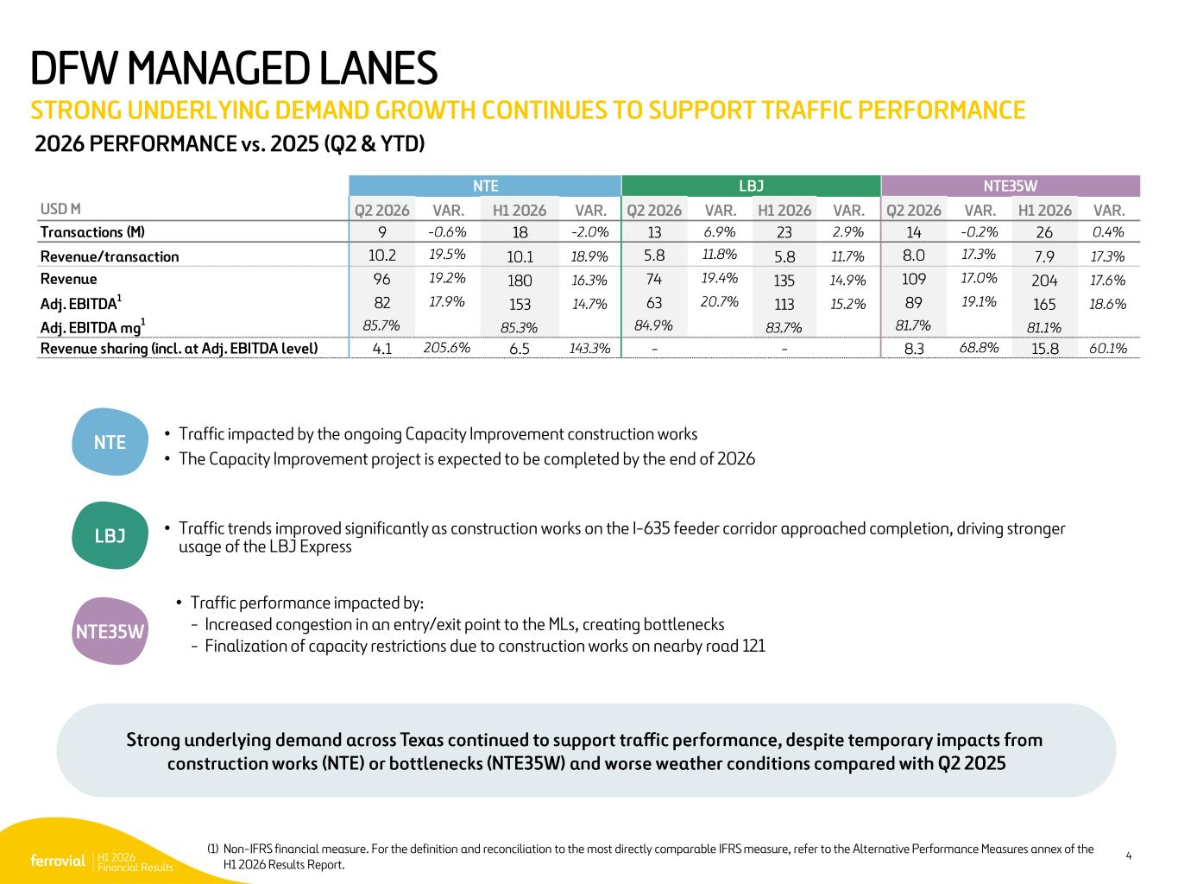
H1 2026 Financial Results 4 2026 PERFORMANCE vs. 2025 (Q2 & YTD) NTE NTE35W LBJ • Traffic trends improved significantly as construction works on the I-635 feeder corridor approached completion, driving stronger usage of the LBJ Express • Traffic impacted by the ongoing Capacity Improvement construction works • The Capacity Improvement project is expected to be completed by the end of 2026 • Traffic performance impacted by: - Increased congestion in an entry/exit point to the MLs, creating bottlenecks - Finalization of capacity restrictions due to construction works on nearby road 121 (1) Non-IFRS financial measure. For the definition and reconciliation to the most directly comparable IFRS measure, refer to the Alternative Performance Measures annex of the H1 2026 Results Report. DFW MANAGED LANES STRONG UNDERLYING DEMAND GROWTH CONTINUES TO SUPPORT TRAFFIC PERFORMANCE NTE LBJ NTE35W USD M Q2 2026 VAR. H1 2026 VAR. Q2 2026 VAR. H1 2026 VAR. Q2 2026 VAR. H1 2026 VAR. Transactions (M) 9 -0.6% 18 -2.0% 13 6.9% 23 2.9% 14 -0.2% 26 0.4% Revenue/transaction 10.2 19.5% 10.1 18.9% 5.8 11.8% 5.8 11.7% 8.0 17.3% 7.9 17.3% Revenue 96 19.2% 180 16.3% 74 19.4% 135 14.9% 109 17.0% 204 17.6% Adj. EBITDA1 82 17.9% 153 14.7% 63 20.7% 113 15.2% 89 19.1% 165 18.6% Adj. EBITDA mg1 85.7% 85.3% 84.9% 83.7% 81.7% 81.1% Revenue sharing (incl. at Adj. EBITDA level) 4.1 205.6% 6.5 143.3% - - 8.3 68.8% 15.8 60.1% Strong underlying demand across Texas continued to support traffic performance, despite temporary impacts from construction works (NTE) or bottlenecks (NTE35W) and worse weather conditions compared with Q2 2025

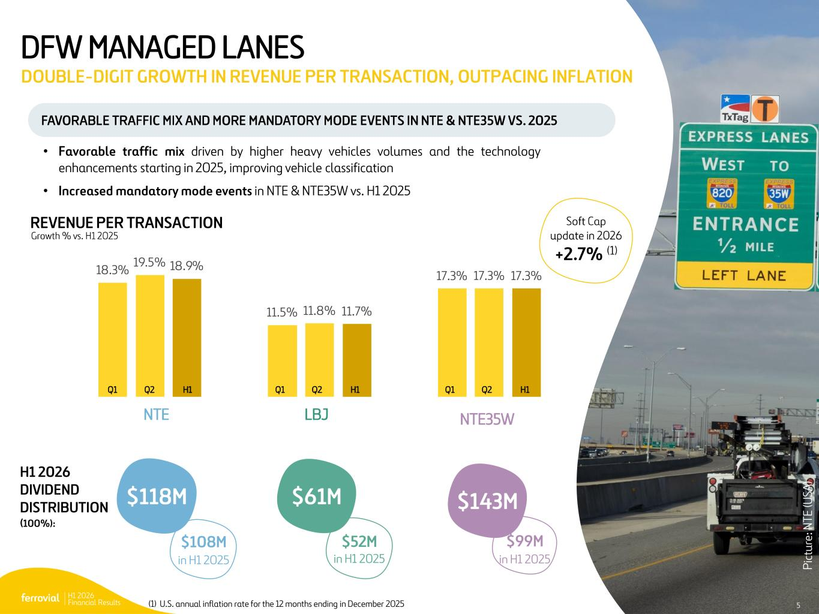
H1 2026 Financial Results 5 P ic : L B J 5 Growth % vs. H1 2025 REVENUE PER TRANSACTION DFW MANAGED LANES DOUBLE-DIGIT GROWTH IN REVENUE PER TRANSACTION, OUTPACING INFLATION FAVORABLE TRAFFIC MIX AND MORE MANDATORY MODE EVENTS IN NTE & NTE35W VS. 2025 H1 2026 DIVIDEND DISTRIBUTION (100%): P ic tu re : N T E (U SA ) $118M $61M $143M Soft Cap update in 2026 +2.7% (1) 18.3% 11.5% 17.3% 19.5% 11.8% 17.3% 18.9% 11.7% 17.3% Q1 Q2 H1 Q1 Q2 H1 Q1 Q2 H1 NTE LBJ NTE35W • Favorable traffic mix driven by higher heavy vehicles volumes and the technology enhancements starting in 2025, improving vehicle classification • Increased mandatory mode events in NTE & NTE35W vs. H1 2025 $108M in H1 2025 $52M in H1 2025 $99M in H1 2025 (1) U.S. annual inflation rate for the 12 months ending in December 2025 5

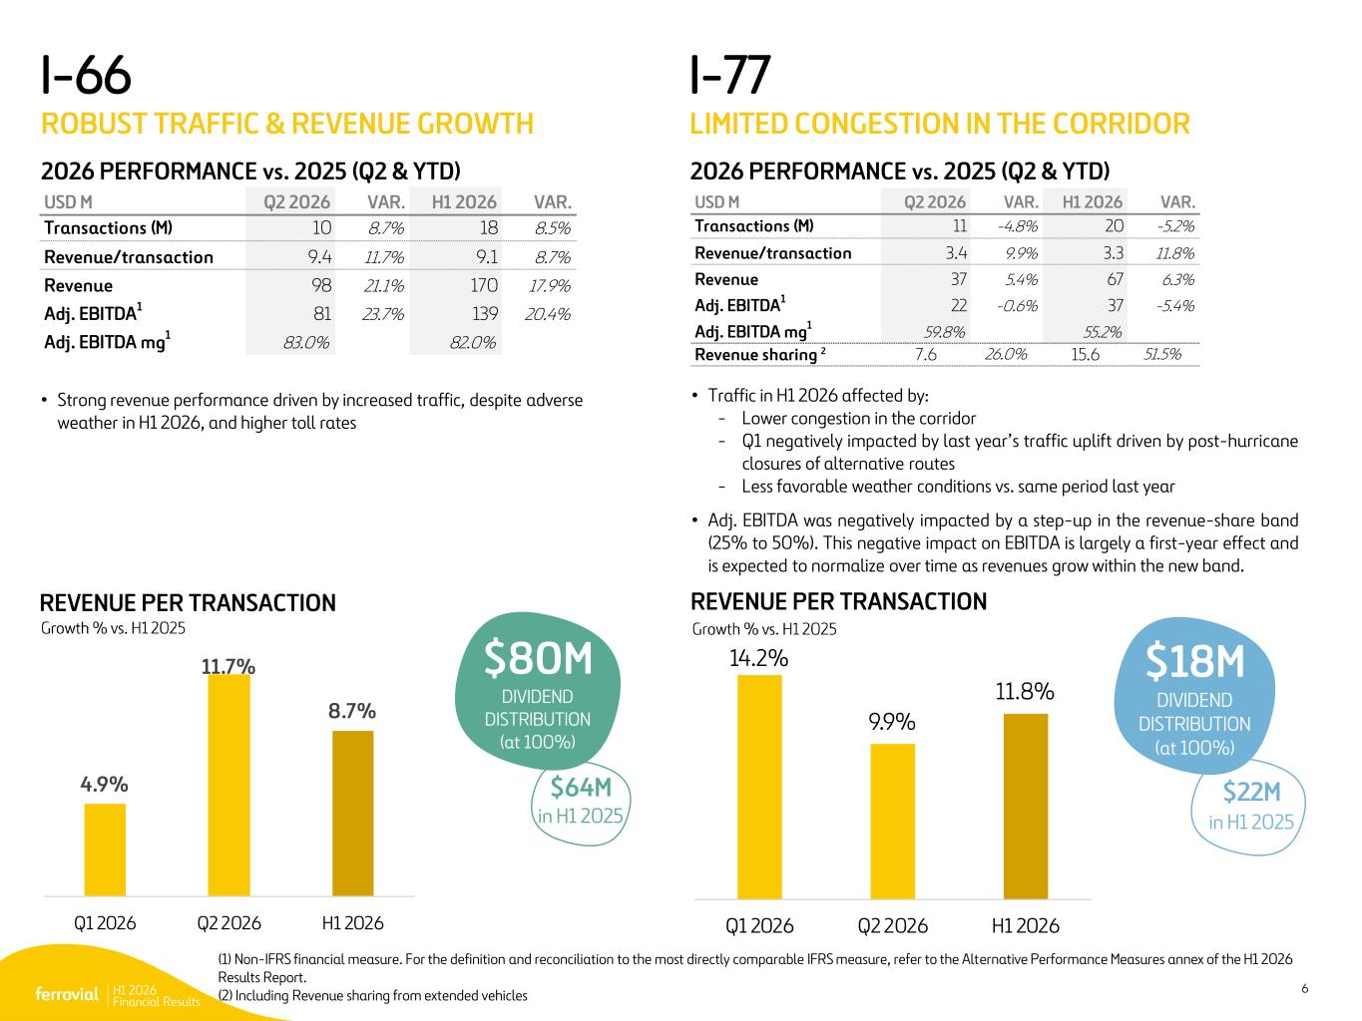
H1 2026 Financial Results 6 I-77 LIMITED CONGESTION IN THE CORRIDOR (1) Non-IFRS financial measure. For the definition and reconciliation to the most directly comparable IFRS measure, refer to the Alternative Performance Measures annex of the H1 2026 Results Report. (2) Including Revenue sharing from extended vehicles 2026 PERFORMANCE vs. 2025 (Q2 & YTD) • Traffic in H1 2026 affected by: - Lower congestion in the corridor - Q1 negatively impacted by last year’s traffic uplift driven by post-hurricane closures of alternative routes - Less favorable weather conditions vs. same period last year • Adj. EBITDA was negatively impacted by a step-up in the revenue-share band (25% to 50%). This negative impact on EBITDA is largely a first-year effect and is expected to normalize over time as revenues grow within the new band. REVENUE PER TRANSACTION $18M DIVIDEND DISTRIBUTION (at 100%) I-66 ROBUST TRAFFIC & REVENUE GROWTH 2026 PERFORMANCE vs. 2025 (Q2 & YTD) REVENUE PER TRANSACTION • Strong revenue performance driven by increased traffic, despite adverse weather in H1 2026, and higher toll rates $80M DIVIDEND DISTRIBUTION (at 100%) 14.2% 9.9% 11.8% Q1 2026 Q2 2026 H1 2026 4.9% 11.7% 8.7% Q1 2026 Q2 2026 H1 2026 Growth % vs. H1 2025Growth % vs. H1 2025 $22M in H1 2025 $64M in H1 2025 USD M Q2 2026 VAR. H1 2026 VAR. Transactions (M) 10 8.7% 18 8.5% Revenue/transaction 9.4 11.7% 9.1 8.7% Revenue 98 21.1% 170 17.9% Adj. EBITDA1 81 23.7% 139 20.4% Adj. EBITDA mg 1 83.0% 82.0% USD M Q2 2026 VAR. H1 2026 VAR. Transactions (M) 11 -4.8% 20 -5.2% Revenue/transaction 3.4 9.9% 3.3 11.8% Revenue 37 5.4% 67 6.3% Adj. EBITDA 1 22 -0.6% 37 -5.4% Adj. EBITDA mg1 59.8% 55.2% Revenue sharing 2 7.6 26.0% 15.6 51.5%

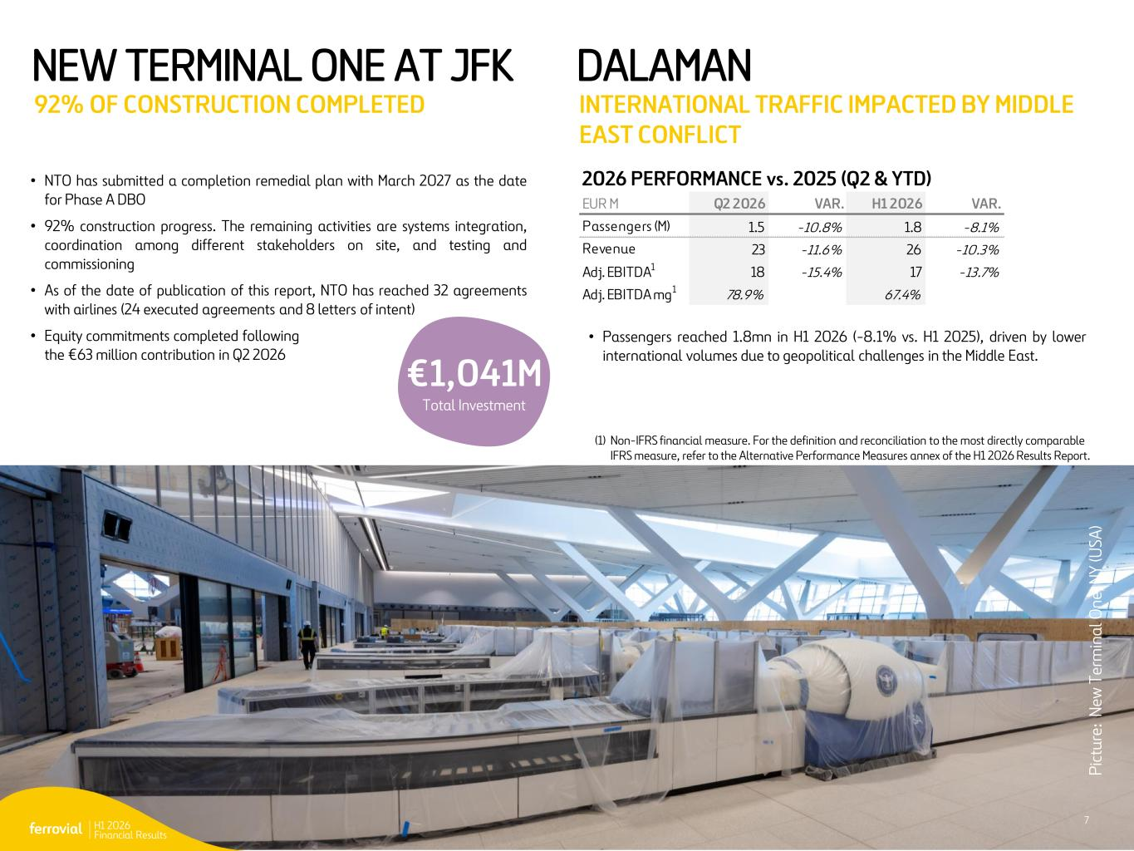
H1 2026 Financial Results 7 NEW TERMINAL ONE AT JFK 92% OF CONSTRUCTION COMPLETED DALAMAN INTERNATIONAL TRAFFIC IMPACTED BY MIDDLE EAST CONFLICT • Passengers reached 1.8mn in H1 2026 (-8.1% vs. H1 2025), driven by lower international volumes due to geopolitical challenges in the Middle East. • NTO has submitted a completion remedial plan with March 2027 as the date for Phase A DBO • 92% construction progress. The remaining activities are systems integration, coordination among different stakeholders on site, and testing and commissioning • As of the date of publication of this report, NTO has reached 32 agreements with airlines (24 executed agreements and 8 letters of intent) • Equity commitments completed following the €63 million contribution in Q2 2026 (1) Non-IFRS financial measure. For the definition and reconciliation to the most directly comparable IFRS measure, refer to the Alternative Performance Measures annex of the H1 2026 Results Report. P ic tu re : N ew T er m in a l O n e, N Y (U SA ) 2026 PERFORMANCE vs. 2025 (Q2 & YTD) EUR M Q2 2026 VAR. H1 2026 VAR. Passengers (M) 1.5 -10.8% 1.8 -8.1% Revenue 23 -11.6% 26 -10.3% Adj. EBITDA1 18 -15.4% 17 -13.7% Adj. EBITDA mg1 78.9% 67.4% 7 €1,041M Total Investment

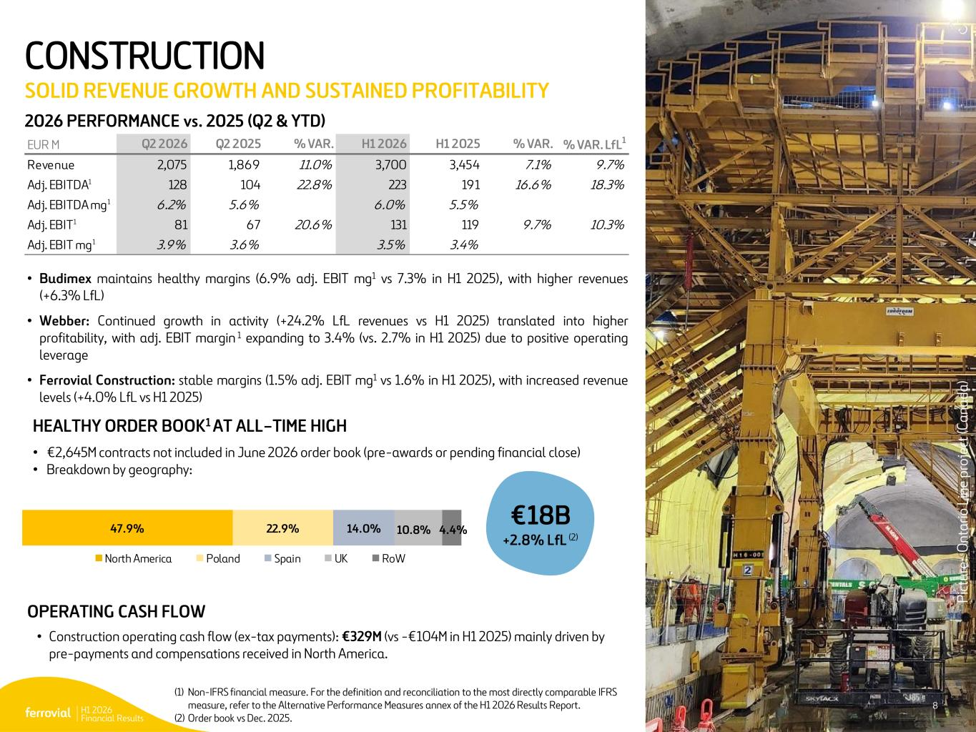
H1 2026 Financial Results 8 CONSTRUCTION SOLID REVENUE GROWTH AND SUSTAINED PROFITABILITY HEALTHY ORDER BOOK1 AT ALL–TIME HIGH • €2,645M contracts not included in June 2026 order book (pre-awards or pending financial close) • Breakdown by geography: • Budimex maintains healthy margins (6.9% adj. EBIT mg1 vs 7.3% in H1 2025), with higher revenues (+6.3% LfL) • Webber: Continued growth in activity (+24.2% LfL revenues vs H1 2025) translated into higher profitability, with adj. EBIT margin 1 expanding to 3.4% (vs. 2.7% in H1 2025) due to positive operating leverage • Ferrovial Construction: stable margins (1.5% adj. EBIT mg1 vs 1.6% in H1 2025), with increased revenue levels (+4.0% LfL vs H1 2025) 8 2026 PERFORMANCE vs. 2025 (Q2 & YTD) €18B +2.8% LfL (2) (1) Non-IFRS financial measure. For the definition and reconciliation to the most directly comparable IFRS measure, refer to the Alternative Performance Measures annex of the H1 2026 Results Report. (2) Order book vs Dec. 2025. P ic tu re : O n ta ri o L in e pr o je ct (C a n a da ) • Construction operating cash flow (ex-tax payments): €329M (vs -€104M in H1 2025) mainly driven by pre-payments and compensations received in North America. OPERATING CASH FLOW 47.9% 22.9% 14.0% 10.8% 4.4% North America Poland Spain UK RoW EUR M Q2 2026 Q2 2025 % VAR. H1 2026 H1 2025 % VAR. % VAR. LfL1 Revenue 2,075 1,869 11.0% 3,700 3,454 7.1% 9.7% Adj. EBITDA1 128 104 22.8% 223 191 16.6% 18.3% Adj. EBITDA mg1 6.2% 5.6% 6.0% 5.5% Adj. EBIT1 81 67 20.6% 131 119 9.7% 10.3% Adj. EBIT mg1 3.9% 3.6% 3.5% 3.4%

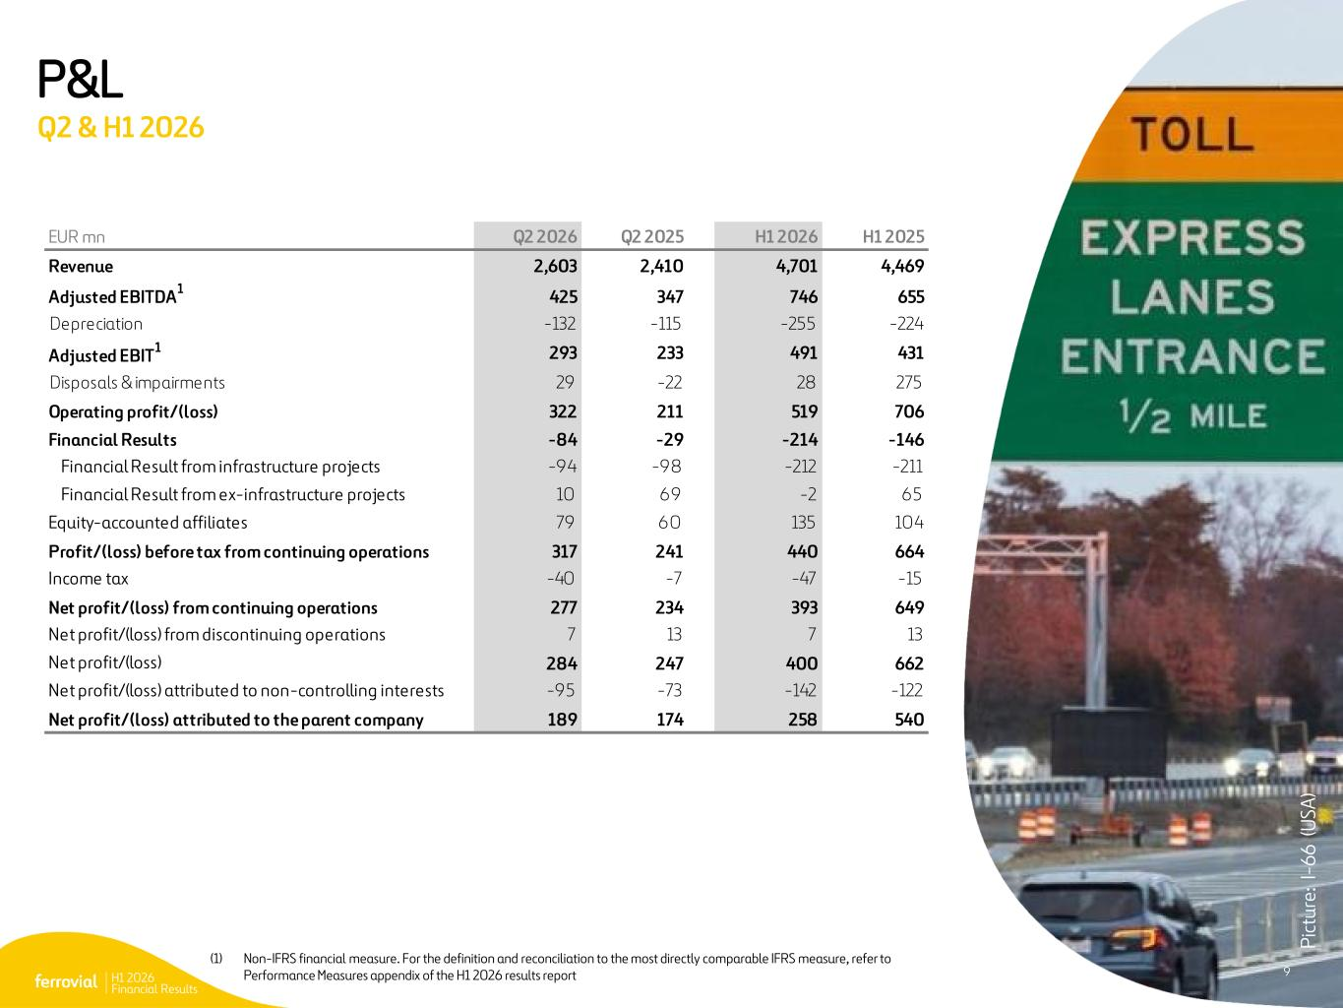
H1 2026 Financial Results 9 (1) Non-IFRS financial measure. For the definition and reconciliation to the most directly comparable IFRS measure, refer to the Alternative Performance Measures appendix of the H1 2026 results report P&L Q2 & H1 2026 P ic tu re : I- 6 6 ( U SA ) 9 EUR mn Q2 2026 Q2 2025 H1 2026 H1 2025 Revenue 2,603 2,410 4,701 4,469 Adjusted EBITDA 1 425 347 746 655 Depreciation -132 -115 -255 -224 Adjusted EBIT 1 293 233 491 431 Disposals & impairments 29 -22 28 275 Operating profit/(loss) 322 211 519 706 Financial Results -84 -29 -214 -146 Financial Result from infrastructure projects -94 -98 -212 -211 Financial Result from ex-infrastructure projects 10 69 -2 65 Equity-accounted affiliates 79 60 135 104 Profit/(loss) before tax from continuing operations 317 241 440 664 Income tax -40 -7 -47 -15 Net profit/(loss) from continuing operations 277 234 393 649 Net profit/(loss) from discontinuing operations 7 13 7 13 Net profit/(loss) 284 247 400 662 Net profit/(loss) attributed to non-controlling interests -9 5 -73 -142 -122 Net profit/(loss) attributed to the parent company 189 174 258 540

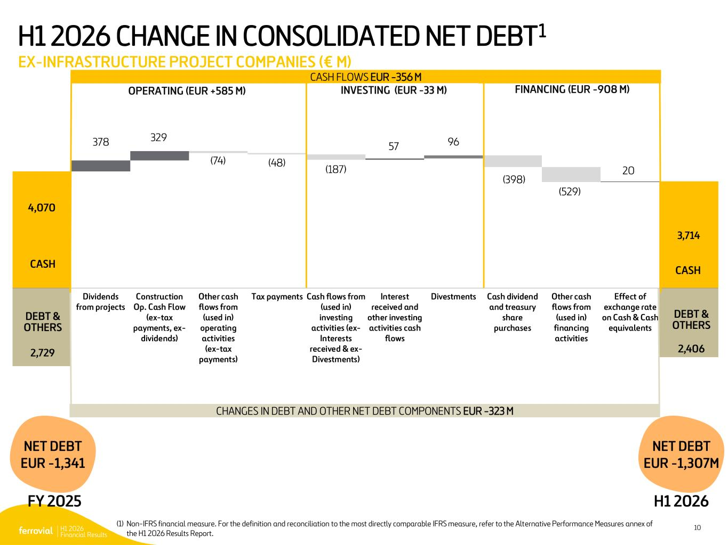
H1 2026 Financial Results 10 H1 2026 CHANGE IN CONSOLIDATED NET DEBT1 EX-INFRASTRUCTURE PROJECT COMPANIES (€ M) (1) Non-IFRS financial measure. For the definition and reconciliation to the most directly comparable IFRS measure, refer to the Alternative Performance Measures annex of the H1 2026 Results Report. - 2,729 3,714 4,070 378 329 (74) (48) (187) 57 96 (398) (529) 20 - 2,406 Dividends from projects Construction Op. Cash Flow (ex-tax payments, ex- dividends) Other cash flows from (used in) operating activities (ex-tax payments) Tax payments Cash flows from (used in) investing activities (ex- Interests received & ex- Divestments) Interest received and other investing activities cash flows Divestments Cash dividend and treasury share purchases Other cash flows from (used in) financing activities Effect of exchange rate on Cash & Cash equivalents CASH FLOWS EUR -356 M FINANCING (EUR -908 M)INVESTING (EUR -33 M)OPERATING (EUR +585 M) NET DEBT EUR -1,341 CASH CASH DEBT & OTHERS DEBT & OTHERS CHANGES IN DEBT AND OTHER NET DEBT COMPONENTS EUR -323 M FY 2025 H1 2026 NET DEBT EUR -1,307M


H1 2026 Financial Results 11 Q&A 5 P ic tu re : N T E (U SA )

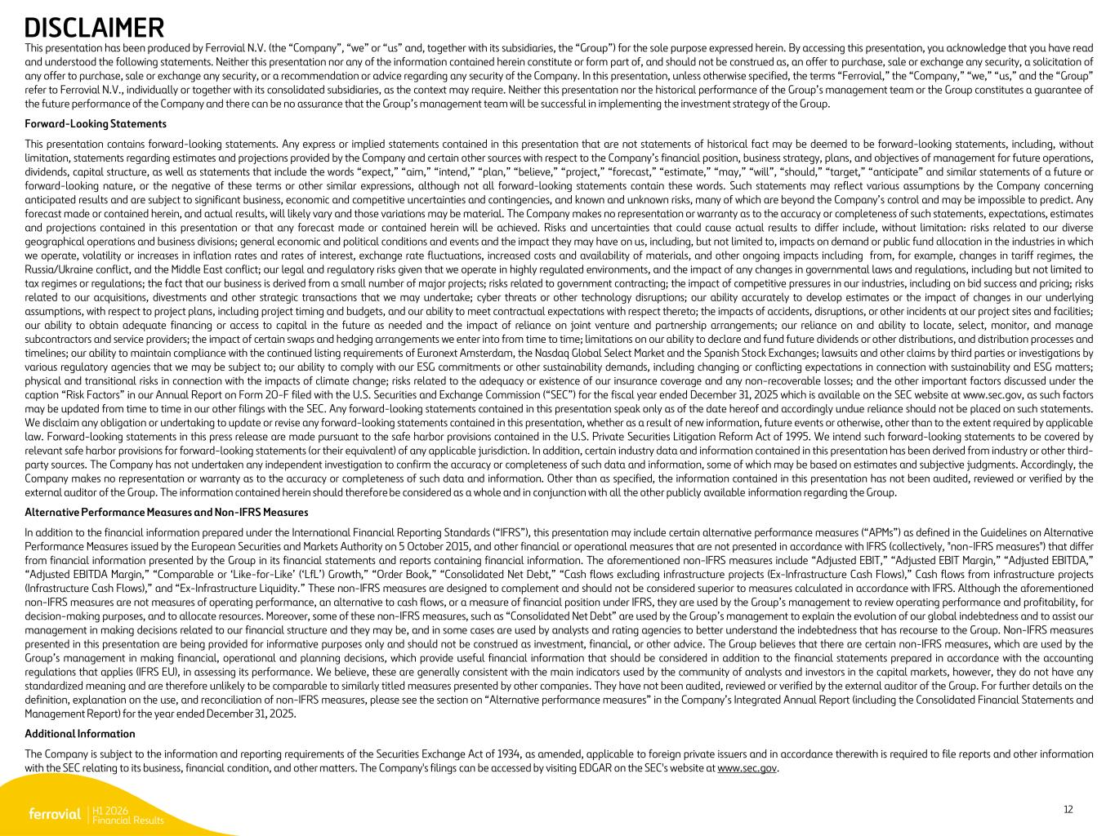
H1 2026 Financial Results 12 DISCLAIMER This presentation has been produced by Ferrovial N.V. (the “Company”, “we” or “us” and, together with its subsidiaries, the “Group”) for the sole purpose expressed herein. By accessing this presentation, you acknowledge that you have read and understood the following statements. Neither this presentation nor any of the information contained herein constitute or form part of, and should not be construed as, an offer to purchase, sale or exchange any security, a solicitation of any offer to purchase, sale or exchange any security, or a recommendation or advice regarding any security of the Company. In this presentation, unless otherwise specified, the terms “Ferrovial,” the “Company,” “we,” “us,” and the “Group” refer to Ferrovial N.V., individually or together with its consolidated subsidiaries, as the context may require. Neither this presentation nor the historical performance of the Group’s management team or the Group constitutes a guarantee of the future performance of the Company and there can be no assurance that the Group’s management team will be successful in implementing the investment strategy of the Group. Forward-Looking Statements This presentation contains forward-looking statements. Any express or implied statements contained in this presentation that are not statements of historical fact may be deemed to be forward-looking statements, including, without limitation, statements regarding estimates and projections provided by the Company and certain other sources with respect to the Company’s financial position, business strategy, plans, and objectives of management for future operations, dividends, capital structure, as well as statements that include the words “expect,” “aim,” “intend,” “plan,” “believe,” “project,” “forecast,” “estimate,” “may,” “will”, “should,” “target,” “anticipate” and similar statements of a future or forward-looking nature, or the negative of these terms or other similar expressions, although not all forward-looking statements contain these words. Such statements may reflect various assumptions by the Company concerning anticipated results and are subject to significant business, economic and competitive uncertainties and contingencies, and known and unknown risks, many of which are beyond the Company’s control and may be impossible to predict. Any forecast made or contained herein, and actual results, will likely vary and those variations may be material. The Company makes no representation or warranty as to the accuracy or completeness of such statements, expectations, estimates and projections contained in this presentation or that any forecast made or contained herein will be achieved. Risks and uncertainties that could cause actual results to differ include, without limitation: risks related to our diverse geographical operations and business divisions; general economic and political conditions and events and the impact they may have on us, including, but not limited to, impacts on demand or public fund allocation in the industries in which we operate, volatility or increases in inflation rates and rates of interest, exchange rate fluctuations, increased costs and availability of materials, and other ongoing impacts including from, for example, changes in tariff regimes, the Russia/Ukraine conflict, and the Middle East conflict; our legal and regulatory risks given that we operate in highly regulated environments, and the impact of any changes in governmental laws and regulations, including but not limited to tax regimes or regulations; the fact that our business is derived from a small number of major projects; risks related to government contracting; the impact of competitive pressures in our industries, including on bid success and pricing; risks related to our acquisitions, divestments and other strategic transactions that we may undertake; cyber threats or other technology disruptions; our ability accurately to develop estimates or the impact of changes in our underlying assumptions, with respect to project plans, including project timing and budgets, and our ability to meet contractual expectations with respect thereto; the impacts of accidents, disruptions, or other incidents at our project sites and facilities; our ability to obtain adequate financing or access to capital in the future as needed and the impact of reliance on joint venture and partnership arrangements; our reliance on and ability to locate, select, monitor, and manage subcontractors and service providers; the impact of certain swaps and hedging arrangements we enter into from time to time; limitations on our ability to declare and fund future dividends or other distributions, and distribution processes and timelines; our ability to maintain compliance with the continued listing requirements of Euronext Amsterdam, the Nasdaq Global Select Market and the Spanish Stock Exchanges; lawsuits and other claims by third parties or investigations by various regulatory agencies that we may be subject to; our ability to comply with our ESG commitments or other sustainability demands, including changing or conflicting expectations in connection with sustainability and ESG matters; physical and transitional risks in connection with the impacts of climate change; risks related to the adequacy or existence of our insurance coverage and any non-recoverable losses; and the other important factors discussed under the caption “Risk Factors” in our Annual Report on Form 20-F filed with the U.S. Securities and Exchange Commission (“SEC”) for the fiscal year ended December 31, 2025 which is available on the SEC website at www.sec.gov, as such factors may be updated from time to time in our other filings with the SEC. Any forward-looking statements contained in this presentation speak only as of the date hereof and accordingly undue reliance should not be placed on such statements. We disclaim any obligation or undertaking to update or revise any forward-looking statements contained in this presentation, whether as a result of new information, future events or otherwise, other than to the extent required by applicable law. Forward-looking statements in this press release are made pursuant to the safe harbor provisions contained in the U.S. Private Securities Litigation Reform Act of 1995. We intend such forward-looking statements to be covered by relevant safe harbor provisions for forward-looking statements (or their equivalent) of any applicable jurisdiction. In addition, certain industry data and information contained in this presentation has been derived from industry or other third- party sources. The Company has not undertaken any independent investigation to confirm the accuracy or completeness of such data and information, some of which may be based on estimates and subjective judgments. Accordingly, the Company makes no representation or warranty as to the accuracy or completeness of such data and information. Other than as specified, the information contained in this presentation has not been audited, reviewed or verified by the external auditor of the Group. The information contained herein should therefore be considered as a whole and in conjunction with all the other publicly available information regarding the Group. Alternative Performance Measures and Non-IFRS Measures In addition to the financial information prepared under the International Financial Reporting Standards (“IFRS”), this presentation may include certain alternative performance measures (“APMs”) as defined in the Guidelines on Alternative Performance Measures issued by the European Securities and Markets Authority on 5 October 2015, and other financial or operational measures that are not presented in accordance with IFRS (collectively, "non-IFRS measures") that differ from financial information presented by the Group in its financial statements and reports containing financial information. The aforementioned non-IFRS measures include “Adjusted EBIT,” “Adjusted EBIT Margin,” “Adjusted EBITDA,” “Adjusted EBITDA Margin,” “Comparable or ‘Like-for-Like’ (‘LfL’) Growth,” “Order Book,” “Consolidated Net Debt,” “Cash flows excluding infrastructure projects (Ex-Infrastructure Cash Flows),” Cash flows from infrastructure projects (Infrastructure Cash Flows),” and “Ex-Infrastructure Liquidity.” These non-IFRS measures are designed to complement and should not be considered superior to measures calculated in accordance with IFRS. Although the aforementioned non-IFRS measures are not measures of operating performance, an alternative to cash flows, or a measure of financial position under IFRS, they are used by the Group’s management to review operating performance and profitability, for decision-making purposes, and to allocate resources. Moreover, some of these non-IFRS measures, such as “Consolidated Net Debt” are used by the Group’s management to explain the evolution of our global indebtedness and to assist our management in making decisions related to our financial structure and they may be, and in some cases are used by analysts and rating agencies to better understand the indebtedness that has recourse to the Group. Non-IFRS measures presented in this presentation are being provided for informative purposes only and should not be construed as investment, financial, or other advice. The Group believes that there are certain non-IFRS measures, which are used by the Group’s management in making financial, operational and planning decisions, which provide useful financial information that should be considered in addition to the financial statements prepared in accordance with the accounting regulations that applies (IFRS EU), in assessing its performance. We believe, these are generally consistent with the main indicators used by the community of analysts and investors in the capital markets, however, they do not have any standardized meaning and are therefore unlikely to be comparable to similarly titled measures presented by other companies. They have not been audited, reviewed or verified by the external auditor of the Group. For further details on the definition, explanation on the use, and reconciliation of non-IFRS measures, please see the section on “Alternative performance measures” in the Company’s Integrated Annual Report (including the Consolidated Financial Statements and Management Report) for the year ended December 31, 2025. Additional Information The Company is subject to the information and reporting requirements of the Securities Exchange Act of 1934, as amended, applicable to foreign private issuers and in accordance therewith is required to file reports and other information with the SEC relating to its business, financial condition, and other matters. The Company's filings can be accessed by visiting EDGAR on the SEC's website at www.sec.gov.

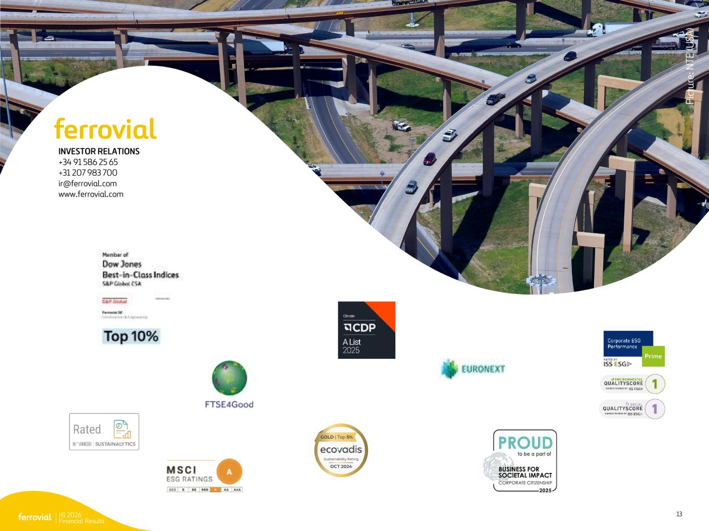
H1 2026 Financial Results 13 INVESTOR RELATIONS +34 91 586 25 65 +31 207 983 700 ir@ferrovial.com www.ferrovial.com P ic tu re : N T E (U SA )

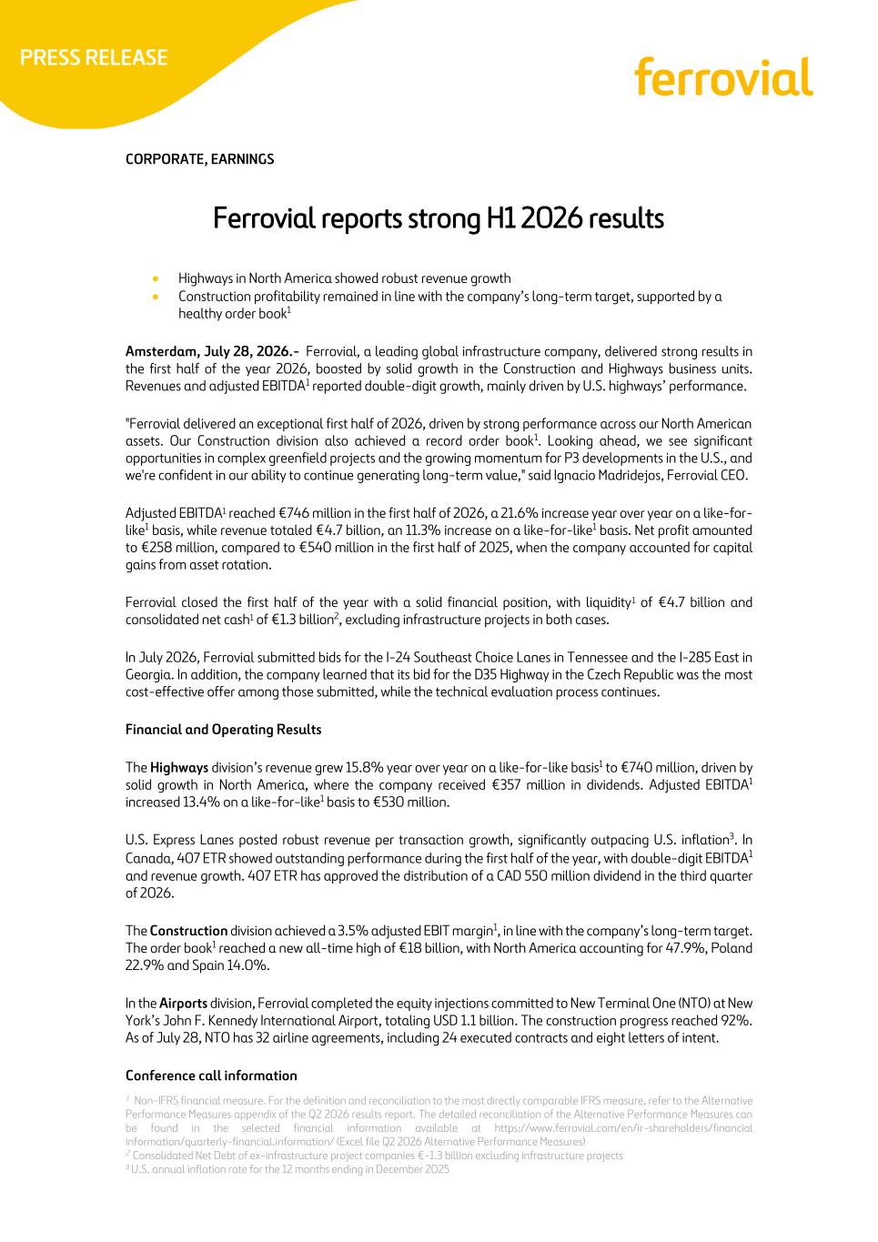
1 Non-IFRS financial measure. For the definition and reconciliation to the most directly comparable IFRS measure, refer to the Alternative Performance Measures appendix of the Q2 2026 results report. The detailed reconciliation of the Alternative Performance Measures can be found in the selected financial information available at https://www.ferrovial.com/en/ir-shareholders/financial information/quarterly-financial.information/ (Excel file Q2 2026 Alternative Performance Measures) 2 Consolidated Net Debt of ex-infrastructure project companies €-1.3 billion excluding infrastructure projects 3 U.S. annual inflation rate for the 12 months ending in December 2025 CORPORATE, EARNINGS Ferrovial reports strong H1 2026 results • Highways in North America showed robust revenue growth • Construction profitability remained in line with the company’s long-term target, supported by a healthy order book1 Amsterdam, July 28, 2026.- Ferrovial, a leading global infrastructure company, delivered strong results in the first half of the year 2026, boosted by solid growth in the Construction and Highways business units. Revenues and adjusted EBITDA1 reported double-digit growth, mainly driven by U.S. highways’ performance. "Ferrovial delivered an exceptional first half of 2026, driven by strong performance across our North American assets. Our Construction division also achieved a record order book1. Looking ahead, we see significant opportunities in complex greenfield projects and the growing momentum for P3 developments in the U.S., and we're confident in our ability to continue generating long-term value," said Ignacio Madridejos, Ferrovial CEO. Adjusted EBITDA1 reached €746 million in the first half of 2026, a 21.6% increase year over year on a like-for- like1 basis, while revenue totaled €4.7 billion, an 11.3% increase on a like-for-like1 basis. Net profit amounted to €258 million, compared to €540 million in the first half of 2025, when the company accounted for capital gains from asset rotation. Ferrovial closed the first half of the year with a solid financial position, with liquidity1 of €4.7 billion and consolidated net cash1 of €1.3 billion2, excluding infrastructure projects in both cases. In July 2026, Ferrovial submitted bids for the I-24 Southeast Choice Lanes in Tennessee and the I-285 East in Georgia. In addition, the company learned that its bid for the D35 Highway in the Czech Republic was the most cost-effective offer among those submitted, while the technical evaluation process continues. Financial and Operating Results The Highways division’s revenue grew 15.8% year over year on a like-for-like basis1 to €740 million, driven by solid growth in North America, where the company received €357 million in dividends. Adjusted EBITDA1 increased 13.4% on a like-for-like1 basis to €530 million. U.S. Express Lanes posted robust revenue per transaction growth, significantly outpacing U.S. inflation3. In Canada, 407 ETR showed outstanding performance during the first half of the year, with double-digit EBITDA1 and revenue growth. 407 ETR has approved the distribution of a CAD 550 million dividend in the third quarter of 2026. The Construction division achieved a 3.5% adjusted EBIT margin1, in line with the company’s long-term target. The order book1 reached a new all-time high of €18 billion, with North America accounting for 47.9%, Poland 22.9% and Spain 14.0%. In the Airports division, Ferrovial completed the equity injections committed to New Terminal One (NTO) at New York’s John F. Kennedy International Airport, totaling USD 1.1 billion. The construction progress reached 92%. As of July 28, NTO has 32 airline agreements, including 24 executed contracts and eight letters of intent. Conference call information

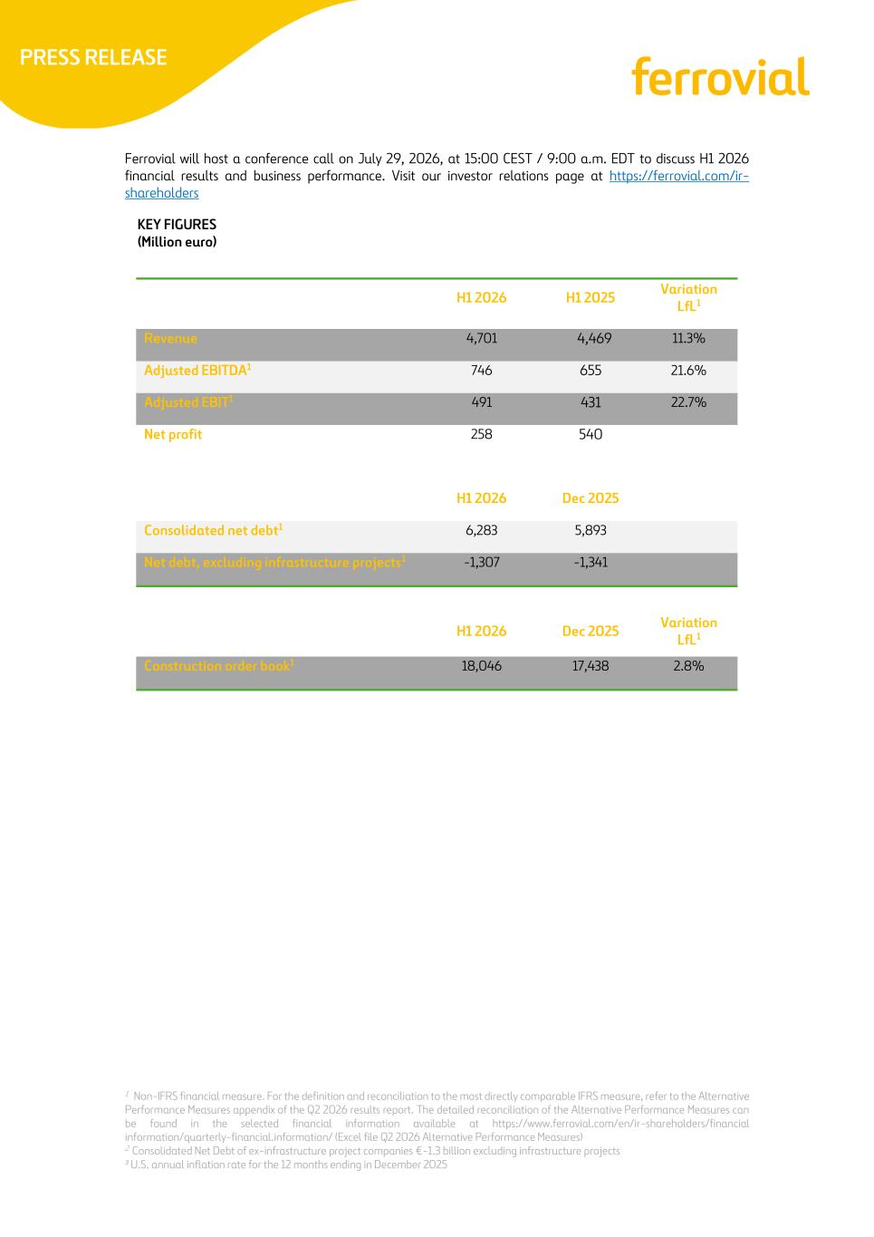
1 Non-IFRS financial measure. For the definition and reconciliation to the most directly comparable IFRS measure, refer to the Alternative Performance Measures appendix of the Q2 2026 results report. The detailed reconciliation of the Alternative Performance Measures can be found in the selected financial information available at https://www.ferrovial.com/en/ir-shareholders/financial information/quarterly-financial.information/ (Excel file Q2 2026 Alternative Performance Measures) 2 Consolidated Net Debt of ex-infrastructure project companies €-1.3 billion excluding infrastructure projects 3 U.S. annual inflation rate for the 12 months ending in December 2025 Ferrovial will host a conference call on July 29, 2026, at 15:00 CEST / 9:00 a.m. EDT to discuss H1 2026 financial results and business performance. Visit our investor relations page at https://ferrovial.com/ir- shareholders KEY FIGURES (Million euro) H1 2026 H1 2025 Variation LfL1 Revenue 4,701 4,469 11.3% Adjusted EBITDA1 746 655 21.6% Adjusted EBIT1 491 431 22.7% Net profit 258 540 H1 2026 Dec 2025 Consolidated net debt1 6,283 5,893 Net debt, excluding infrastructure projects1 -1,307 -1,341 H1 2026 Dec 2025 Variation LfL1 Construction order book1 18,046 17,438 2.8%

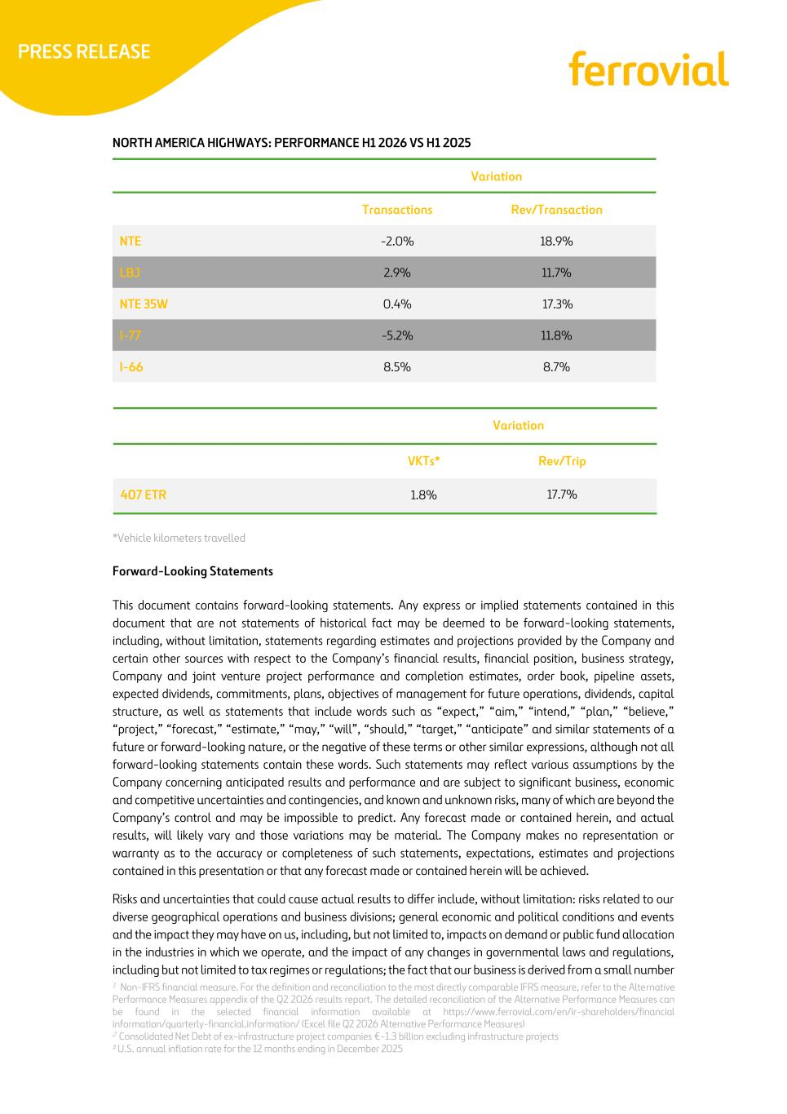
1 Non-IFRS financial measure. For the definition and reconciliation to the most directly comparable IFRS measure, refer to the Alternative Performance Measures appendix of the Q2 2026 results report. The detailed reconciliation of the Alternative Performance Measures can be found in the selected financial information available at https://www.ferrovial.com/en/ir-shareholders/financial information/quarterly-financial.information/ (Excel file Q2 2026 Alternative Performance Measures) 2 Consolidated Net Debt of ex-infrastructure project companies €-1.3 billion excluding infrastructure projects 3 U.S. annual inflation rate for the 12 months ending in December 2025 NORTH AMERICA HIGHWAYS: PERFORMANCE H1 2026 VS H1 2025 Variation Transactions Rev/Transaction NTE -2.0% 18.9% LBJ 2.9% 11.7% NTE 35W 0.4% 17.3% I-77 -5.2% 11.8% I-66 8.5% 8.7% *Vehicle kilometers travelled Forward-Looking Statements This document contains forward-looking statements. Any express or implied statements contained in this document that are not statements of historical fact may be deemed to be forward-looking statements, including, without limitation, statements regarding estimates and projections provided by the Company and certain other sources with respect to the Company’s financial results, financial position, business strategy, Company and joint venture project performance and completion estimates, order book, pipeline assets, expected dividends, commitments, plans, objectives of management for future operations, dividends, capital structure, as well as statements that include words such as “expect,” “aim,” “intend,” “plan,” “believe,” “project,” “forecast,” “estimate,” “may,” “will”, “should,” “target,” “anticipate” and similar statements of a future or forward-looking nature, or the negative of these terms or other similar expressions, although not all forward-looking statements contain these words. Such statements may reflect various assumptions by the Company concerning anticipated results and performance and are subject to significant business, economic and competitive uncertainties and contingencies, and known and unknown risks, many of which are beyond the Company’s control and may be impossible to predict. Any forecast made or contained herein, and actual results, will likely vary and those variations may be material. The Company makes no representation or warranty as to the accuracy or completeness of such statements, expectations, estimates and projections contained in this presentation or that any forecast made or contained herein will be achieved. Risks and uncertainties that could cause actual results to differ include, without limitation: risks related to our diverse geographical operations and business divisions; general economic and political conditions and events and the impact they may have on us, including, but not limited to, impacts on demand or public fund allocation in the industries in which we operate, and the impact of any changes in governmental laws and regulations, including but not limited to tax regimes or regulations; the fact that our business is derived from a small number Variation VKTs* Rev/Trip 407 ETR 1.8% 17.7%

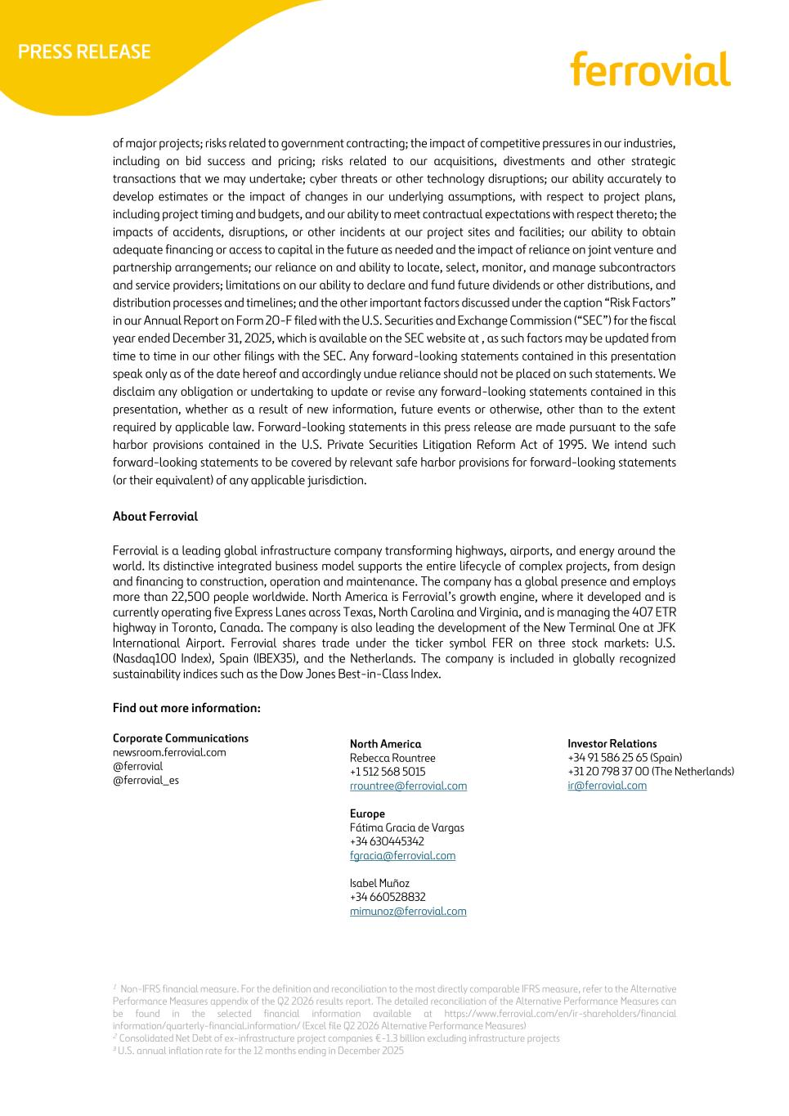
1 Non-IFRS financial measure. For the definition and reconciliation to the most directly comparable IFRS measure, refer to the Alternative Performance Measures appendix of the Q2 2026 results report. The detailed reconciliation of the Alternative Performance Measures can be found in the selected financial information available at https://www.ferrovial.com/en/ir-shareholders/financial information/quarterly-financial.information/ (Excel file Q2 2026 Alternative Performance Measures) 2 Consolidated Net Debt of ex-infrastructure project companies €-1.3 billion excluding infrastructure projects 3 U.S. annual inflation rate for the 12 months ending in December 2025 of major projects; risks related to government contracting; the impact of competitive pressures in our industries, including on bid success and pricing; risks related to our acquisitions, divestments and other strategic transactions that we may undertake; cyber threats or other technology disruptions; our ability accurately to develop estimates or the impact of changes in our underlying assumptions, with respect to project plans, including project timing and budgets, and our ability to meet contractual expectations with respect thereto; the impacts of accidents, disruptions, or other incidents at our project sites and facilities; our ability to obtain adequate financing or access to capital in the future as needed and the impact of reliance on joint venture and partnership arrangements; our reliance on and ability to locate, select, monitor, and manage subcontractors and service providers; limitations on our ability to declare and fund future dividends or other distributions, and distribution processes and timelines; and the other important factors discussed under the caption “Risk Factors” in our Annual Report on Form 20-F filed with the U.S. Securities and Exchange Commission (“SEC”) for the fiscal year ended December 31, 2025, which is available on the SEC website at , as such factors may be updated from time to time in our other filings with the SEC. Any forward-looking statements contained in this presentation speak only as of the date hereof and accordingly undue reliance should not be placed on such statements. We disclaim any obligation or undertaking to update or revise any forward-looking statements contained in this presentation, whether as a result of new information, future events or otherwise, other than to the extent required by applicable law. Forward-looking statements in this press release are made pursuant to the safe harbor provisions contained in the U.S. Private Securities Litigation Reform Act of 1995. We intend such forward-looking statements to be covered by relevant safe harbor provisions for forward-looking statements (or their equivalent) of any applicable jurisdiction. About Ferrovial Ferrovial is a leading global infrastructure company transforming highways, airports, and energy around the world. Its distinctive integrated business model supports the entire lifecycle of complex projects, from design and financing to construction, operation and maintenance. The company has a global presence and employs more than 22,500 people worldwide. North America is Ferrovial’s growth engine, where it developed and is currently operating five Express Lanes across Texas, North Carolina and Virginia, and is managing the 407 ETR highway in Toronto, Canada. The company is also leading the development of the New Terminal One at JFK International Airport. Ferrovial shares trade under the ticker symbol FER on three stock markets: U.S. (Nasdaq100 Index), Spain (IBEX35), and the Netherlands. The company is included in globally recognized sustainability indices such as the Dow Jones Best-in-Class Index. Find out more information: Corporate Communications newsroom.ferrovial.com @ferrovial @ferrovial_es Investor Relations +34 91 586 25 65 (Spain) +31 20 798 37 00 (The Netherlands) ir@ferrovial.com North America Rebecca Rountree +1 512 568 5015 rrountree@ferrovial.com Europe Fátima Gracia de Vargas +34 630445342 fgracia@ferrovial.com Isabel Muñoz +34 660528832 mimunoz@ferrovial.com

