UNITED STATES
SECURITIES AND EXCHANGE COMMISSION
Washington, D.C. 20549
___________________________
FORM 6-K
___________________________
REPORT OF FOREIGN PRIVATE ISSUER PURSUANT TO
SECTION 13a-16 OR 15d-16
UNDER THE SECURITIES EXCHANGE ACT OF 1934
Date: for the month of October 2026
Commission File Number: 001-41912
___________________________
Ferrovial N.V.
___________________________
Gustav Mahlerplein 61-63
Symphony Towers, 14th Floor
1082 MS Amsterdam
The Netherlands
Tel: +31 20798 37 02
(Address of principal executive office)
Indicate by check mark whether the registrant files or will file annual reports under cover of
Form 20-F or Form 40-F.
Form 20-F ☒ Form 40-F ☐

EXPLANATORY NOTE
On October 05, 2026, Ferrovial N.V. (the “Company”) issued an investor presentation on I-24 Choice Lanes that it
intends to present during the conference call on the same date, a copy of which is furnished as Exhibit 99.1, and is
available on the Company’s investor relations website at https://www.ferrovial.com/en/ir-shareholders/financial-
information/investors-presentations/.
The information contained in the investor presentation is being provided as of October 05, 2026, and the Company
does not undertake any obligation to update the presentation in the future or to update forward-looking statements
therein to reflect actual results or performance that subsequently may occur unless the Company is required to do so
under applicable law.
Attached as exhibits to this current report on Form 6-K are:
(1) Ferrovial’s Investor presentation on I-24 Choice Lanes.

EXHIBIT INDEX

SIGNATURES
99.1

Exhibit
No.
Description
Pursuant to the requirements of the Securities Exchange Act of 1934, as amended, the registrant
has duly caused this report to be signed on its behalf by the undersigned, thereunto duly
authorized.
Ferrovial N.V.
Date: October 05, 2026
By: /s/ Ernesto López Mozo_______________
Ernesto López Mozo
Chief Financial Officer

Investor Presentation I-40 terminus towards Inner Loop I-24 Choice Lanes October 5, 2026

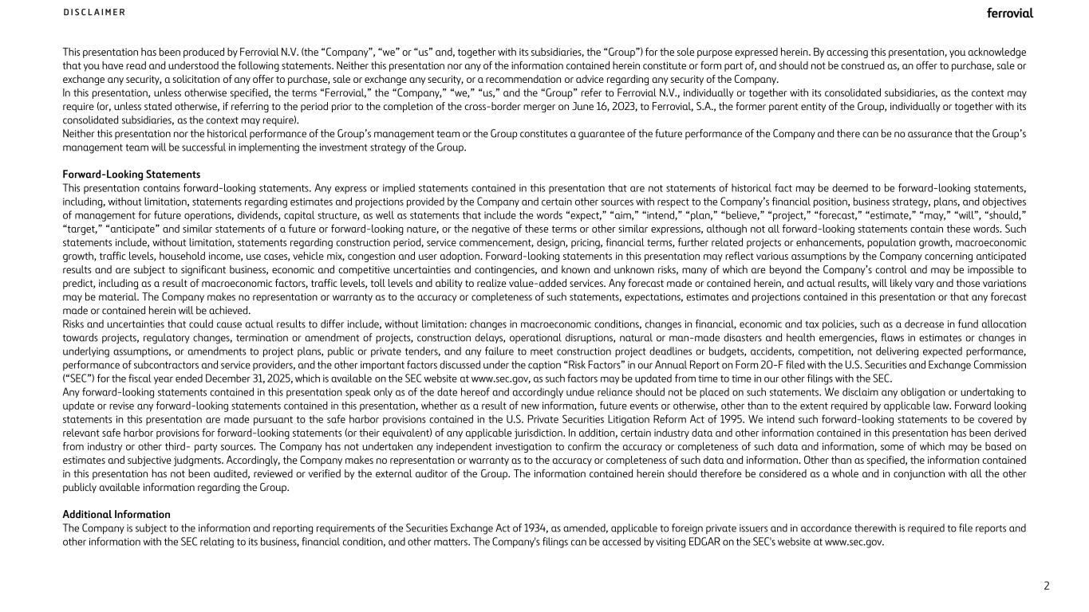
2 D I S C L A I M E R This presentation has been produced by Ferrovial N.V. (the “Company”, “we” or “us” and, together with its subsidiaries, the “Group”) for the sole purpose expressed herein. By accessing this presentation, you acknowledge that you have read and understood the following statements. Neither this presentation nor any of the information contained herein constitute or form part of, and should not be construed as, an offer to purchase, sale or exchange any security, a solicitation of any offer to purchase, sale or exchange any security, or a recommendation or advice regarding any security of the Company. In this presentation, unless otherwise specified, the terms “Ferrovial,” the “Company,” “we,” “us,” and the “Group” refer to Ferrovial N.V., individually or together with its consolidated subsidiaries, as the context may require (or, unless stated otherwise, if referring to the period prior to the completion of the cross-border merger on June 16, 2023, to Ferrovial, S.A., the former parent entity of the Group, individually or together with its consolidated subsidiaries, as the context may require). Neither this presentation nor the historical performance of the Group’s management team or the Group constitutes a guarantee of the future performance of the Company and there can be no assurance that the Group’s management team will be successful in implementing the investment strategy of the Group. Forward-Looking Statements This presentation contains forward-looking statements. Any express or implied statements contained in this presentation that are not statements of historical fact may be deemed to be forward-looking statements, including, without limitation, statements regarding estimates and projections provided by the Company and certain other sources with respect to the Company’s financial position, business strategy, plans, and objectives of management for future operations, dividends, capital structure, as well as statements that include the words “expect,” “aim,” “intend,” “plan,” “believe,” “project,” “forecast,” “estimate,” “may,” “will”, “should,” “target,” “anticipate” and similar statements of a future or forward-looking nature, or the negative of these terms or other similar expressions, although not all forward-looking statements contain these words. Such statements include, without limitation, statements regarding construction period, service commencement, design, pricing, financial terms, further related projects or enhancements, population growth, macroeconomic growth, traffic levels, household income, use cases, vehicle mix, congestion and user adoption. Forward-looking statements in this presentation may reflect various assumptions by the Company concerning anticipated results and are subject to significant business, economic and competitive uncertainties and contingencies, and known and unknown risks, many of which are beyond the Company’s control and may be impossible to predict, including as a result of macroeconomic factors, traffic levels, toll levels and ability to realize value-added services. Any forecast made or contained herein, and actual results, will likely vary and those variations may be material. The Company makes no representation or warranty as to the accuracy or completeness of such statements, expectations, estimates and projections contained in this presentation or that any forecast made or contained herein will be achieved. Risks and uncertainties that could cause actual results to differ include, without limitation: changes in macroeconomic conditions, changes in financial, economic and tax policies, such as a decrease in fund allocation towards projects, regulatory changes, termination or amendment of projects, construction delays, operational disruptions, natural or man-made disasters and health emergencies, flaws in estimates or changes in underlying assumptions, or amendments to project plans, public or private tenders, and any failure to meet construction project deadlines or budgets, accidents, competition, not delivering expected performance, performance of subcontractors and service providers, and the other important factors discussed under the caption “Risk Factors” in our Annual Report on Form 20-F filed with the U.S. Securities and Exchange Commission (“SEC”) for the fiscal year ended December 31, 2025, which is available on the SEC website at www.sec.gov, as such factors may be updated from time to time in our other filings with the SEC. Any forward-looking statements contained in this presentation speak only as of the date hereof and accordingly undue reliance should not be placed on such statements. We disclaim any obligation or undertaking to update or revise any forward-looking statements contained in this presentation, whether as a result of new information, future events or otherwise, other than to the extent required by applicable law. Forward looking statements in this presentation are made pursuant to the safe harbor provisions contained in the U.S. Private Securities Litigation Reform Act of 1995. We intend such forward-looking statements to be covered by relevant safe harbor provisions for forward-looking statements (or their equivalent) of any applicable jurisdiction. In addition, certain industry data and other information contained in this presentation has been derived from industry or other third- party sources. The Company has not undertaken any independent investigation to confirm the accuracy or completeness of such data and information, some of which may be based on estimates and subjective judgments. Accordingly, the Company makes no representation or warranty as to the accuracy or completeness of such data and information. Other than as specified, the information contained in this presentation has not been audited, reviewed or verified by the external auditor of the Group. The information contained herein should therefore be considered as a whole and in conjunction with all the other publicly available information regarding the Group. Additional Information The Company is subject to the information and reporting requirements of the Securities Exchange Act of 1934, as amended, applicable to foreign private issuers and in accordance therewith is required to file reports and other information with the SEC relating to its business, financial condition, and other matters. The Company's filings can be accessed by visiting EDGAR on the SEC's website at www.sec.gov.

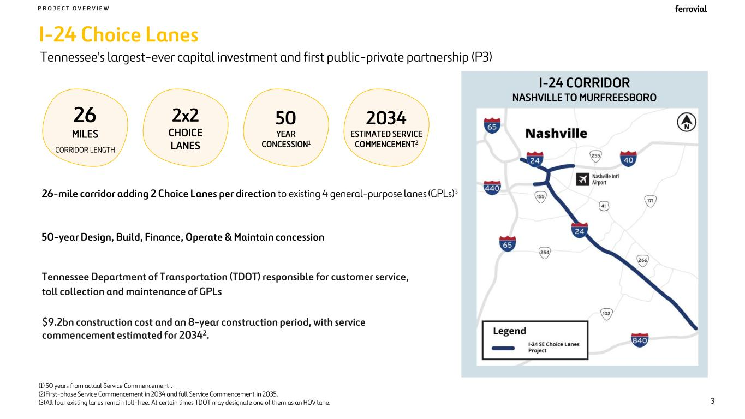
I-24 CORRIDOR NASHVILLE TO MURFREESBORO I-24 Choice Lanes 50-year Design, Build, Finance, Operate & Maintain concession P R O J E C T O V E R V I E W Tennessee Department of Transportation (TDOT) responsible for customer service, toll collection and maintenance of GPLs 26-mile corridor adding 2 Choice Lanes per direction to existing 4 general-purpose lanes (GPLs)3 50 YEAR CONCESSION1 26 MILES CORRIDOR LENGTH 2x2 CHOICE LANES (1) 50 years from actual Service Commencement . (2)First-phase Service Commencement in 2034 and full Service Commencement in 2035. (3)All four existing lanes remain toll-free. At certain times TDOT may designate one of them as an HOV lane. Tennessee's largest-ever capital investment and first public-private partnership (P3) 3 $9.2bn construction cost and an 8-year construction period, with service commencement estimated for 20342. 2034 ESTIMATED SERVICE COMMENCEMENT2

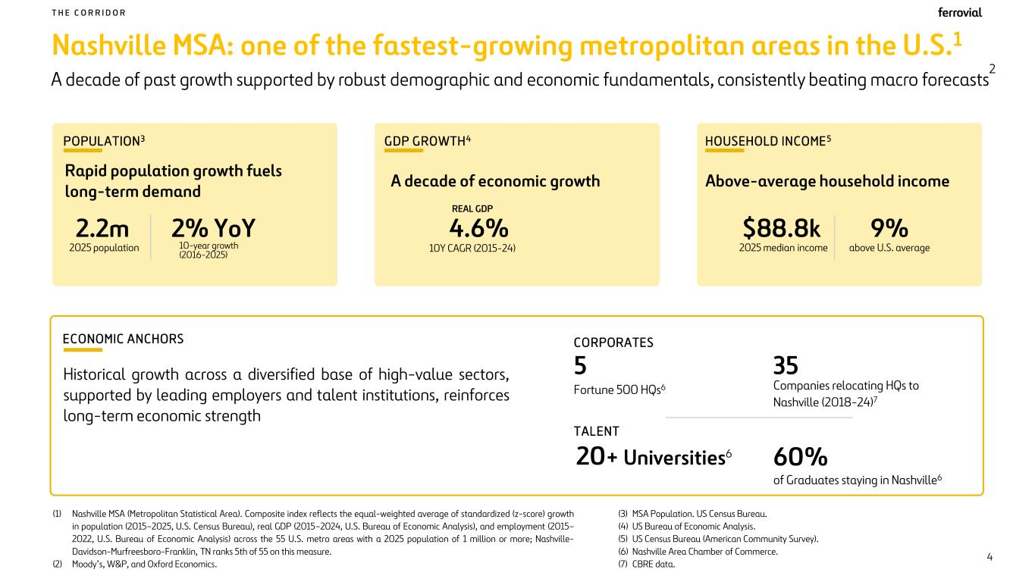
Nashville MSA: one of the fastest-growing metropolitan areas in the U.S.1 A decade of past growth supported by robust demographic and economic fundamentals, consistently beating macro forecasts 2 T H E C O R R I D O R 4 (1) Nashville MSA (Metropolitan Statistical Area). Composite index reflects the equal-weighted average of standardized (z-score) growth in population (2015–2025, U.S. Census Bureau), real GDP (2015–2024, U.S. Bureau of Economic Analysis), and employment (2015– 2022, U.S. Bureau of Economic Analysis) across the 55 U.S. metro areas with a 2025 population of 1 million or more; Nashville- Davidson-Murfreesboro-Franklin, TN ranks 5th of 55 on this measure. (2) Moody’s, W&P, and Oxford Economics. (3) MSA Population. US Census Bureau. (4) US Bureau of Economic Analysis. (5) US Census Bureau (American Community Survey). (6) Nashville Area Chamber of Commerce. (7) CBRE data. 20+ Universities6 ECONOMIC ANCHORS 5 60% of Graduates staying in Nashville6 Historical growth across a diversified base of high-value sectors, supported by leading employers and talent institutions, reinforces long-term economic strength CORPORATES TALENT 35 Companies relocating HQs to Nashville (2018-24)7 Fortune 500 HQs6 POPULATION 3 Rapid population growth fuels long-term demand 2.2m 2025 population 2% YoY 10-year growth (2016-2025) HOUSEHOLD INCOME 5 Above-average household income $88.8k 2025 median income 9% above U.S. average GDP GROWTH4 A decade of economic growth 4.6% REAL GDP 10Y CAGR (2015-24)

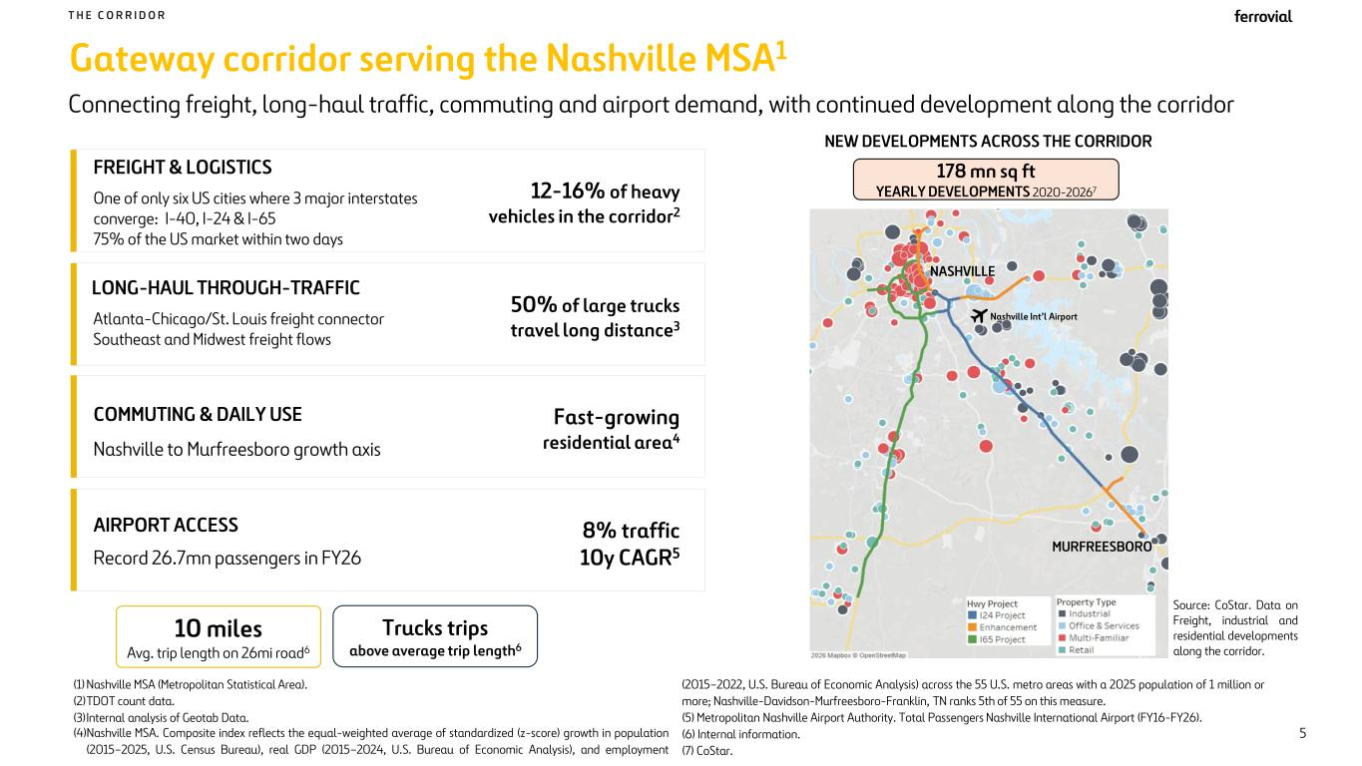
Gateway corridor serving the Nashville MSA1 10 miles Avg. trip length on 26mi road6 Trucks trips above average trip length6 FREIGHT & LOGISTICS One of only six US cities where 3 major interstates converge: I-40, I-24 & I-65 75% of the US market within two days AIRPORT ACCESS Record 26.7mn passengers in FY26 LONG-HAUL THROUGH-TRAFFIC Atlanta-Chicago/St. Louis freight connector Southeast and Midwest freight flows Connecting freight, long-haul traffic, commuting and airport demand, with continued development along the corridor NEW DEVELOPMENTS ACROSS THE CORRIDOR COMMUTING & DAILY USE Nashville to Murfreesboro growth axis NASHVILLE MURFREESBORO T H E C O R R I D O R Nashville Int’l Airport 5 Source: CoStar. Data on Freight, industrial and residential developments along the corridor. 50% of large trucks travel long distance3 12-16% of heavy vehicles in the corridor2 Fast-growing residential area4 8% traffic 10y CAGR5 178 mn sq ft YEARLY DEVELOPMENTS 2020-20267 (1) Nashville MSA (Metropolitan Statistical Area). (2)TDOT count data. (3)Internal analysis of Geotab Data. (4)Nashville MSA. Composite index reflects the equal-weighted average of standardized (z-score) growth in population (2015–2025, U.S. Census Bureau), real GDP (2015–2024, U.S. Bureau of Economic Analysis), and employment (2015–2022, U.S. Bureau of Economic Analysis) across the 55 U.S. metro areas with a 2025 population of 1 million or more; Nashville-Davidson-Murfreesboro-Franklin, TN ranks 5th of 55 on this measure. (5) Metropolitan Nashville Airport Authority. Total Passengers Nashville International Airport (FY16-FY26). (6) Internal information. (7) CoStar.

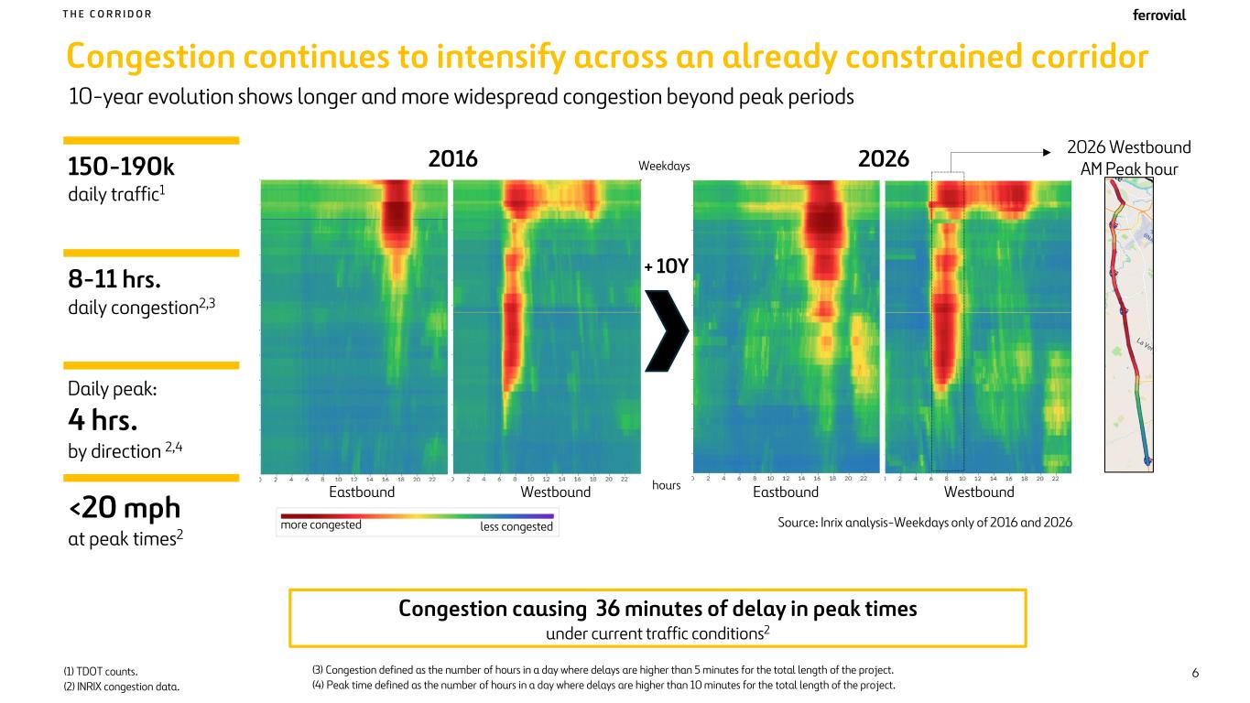
Congestion continues to intensify across an already constrained corridor 10-year evolution shows longer and more widespread congestion beyond peak periods T H E C O R R I D O R Congestion causing 36 minutes of delay in peak times under current traffic conditions2 6(1) TDOT counts. (2) INRIX congestion data. 2026 Westbound AM Peak hour150-190k daily traffic1 8-11 hrs. daily congestion2,3 Daily peak: 4 hrs. by direction 2,4 <20 mph at peak times2 less congestedmore congested + 10Y 2016 2026 hours Weekdays Source: Inrix analysis-Weekdays only of 2016 and 2026 Eastbound Westbound Eastbound Westbound (3) Congestion defined as the number of hours in a day where delays are higher than 5 minutes for the total length of the project. (4) Peak time defined as the number of hours in a day where delays are higher than 10 minutes for the total length of the project.

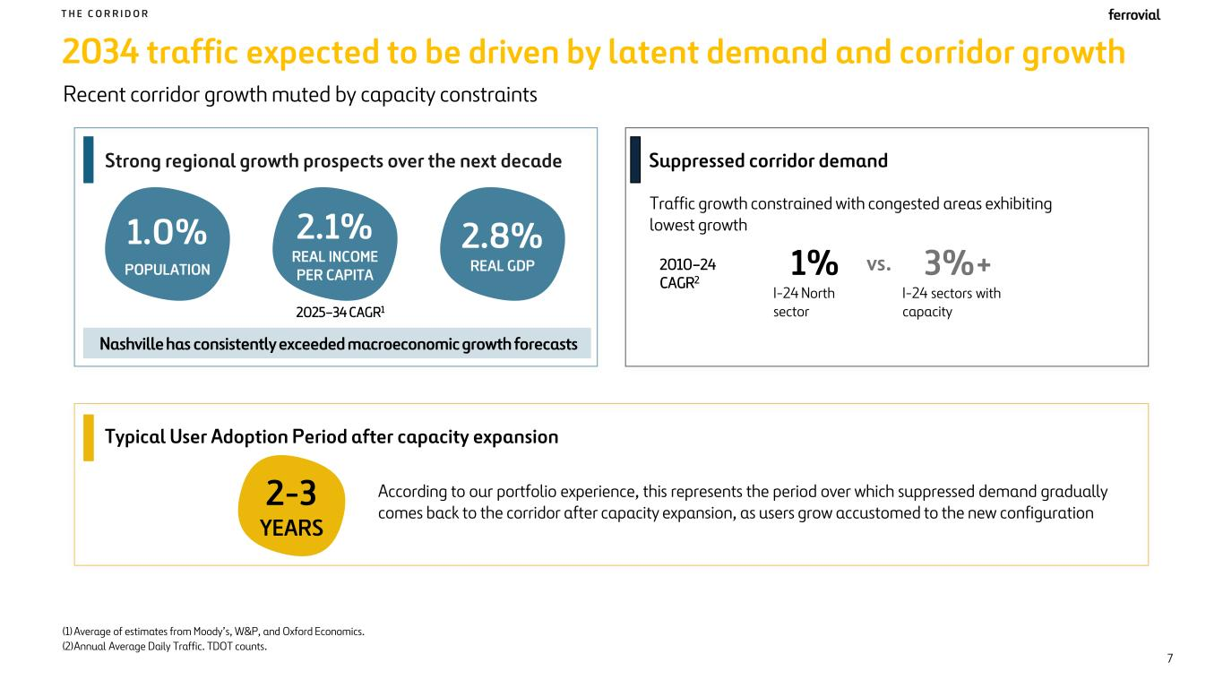
2034 traffic expected to be driven by latent demand and corridor growth Recent corridor growth muted by capacity constraints T H E C O R R I D O R 1.0% POPULATION 2.1% REAL INCOME PER CAPITA 2.8% REAL GDP (1) Average of estimates from Moody’s, W&P, and Oxford Economics. (2)Annual Average Daily Traffic. TDOT counts. 7 Nashville has consistently exceeded macroeconomic growth forecasts 1% 3%+ Traffic growth constrained with congested areas exhibiting lowest growth I-24 North sector I-24 sectors with capacity Suppressed corridor demandStrong regional growth prospects over the next decade According to our portfolio experience, this represents the period over which suppressed demand gradually comes back to the corridor after capacity expansion, as users grow accustomed to the new configuration 2-3 YEARS vs. 2025–34 CAGR1 2010–24 CAGR2 Typical User Adoption Period after capacity expansion

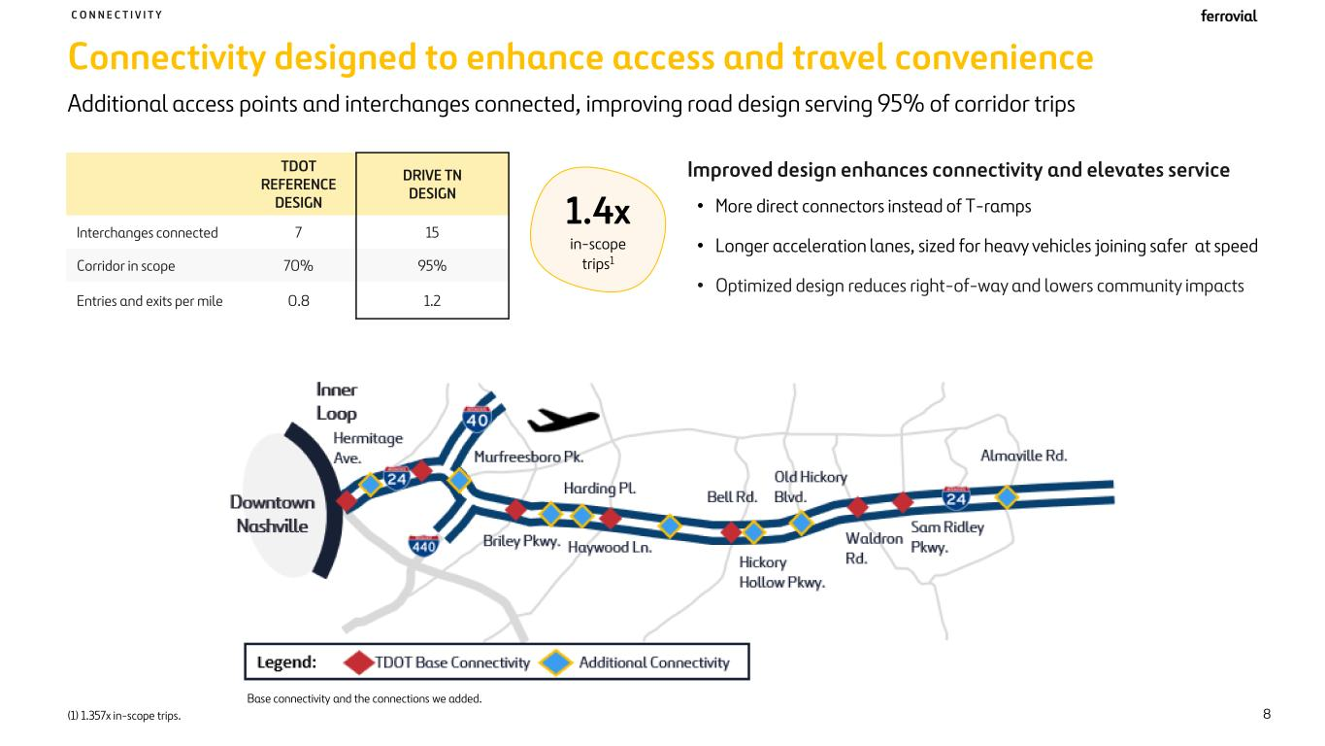
Connectivity designed to enhance access and travel convenience TDOT REFERENCE DESIGN DRIVE TN DESIGN Interchanges connected 7 15 Corridor in scope 70% 95% Entries and exits per mile 0.8 1.2 Improved design enhances connectivity and elevates service • More direct connectors instead of T-ramps • Longer acceleration lanes, sized for heavy vehicles joining safer at speed • Optimized design reduces right-of-way and lowers community impacts Base connectivity and the connections we added. Additional access points and interchanges connected, improving road design serving 95% of corridor trips C O N N E C T I V I T Y 1.4x in-scope trips1 8(1) 1.357x in-scope trips.

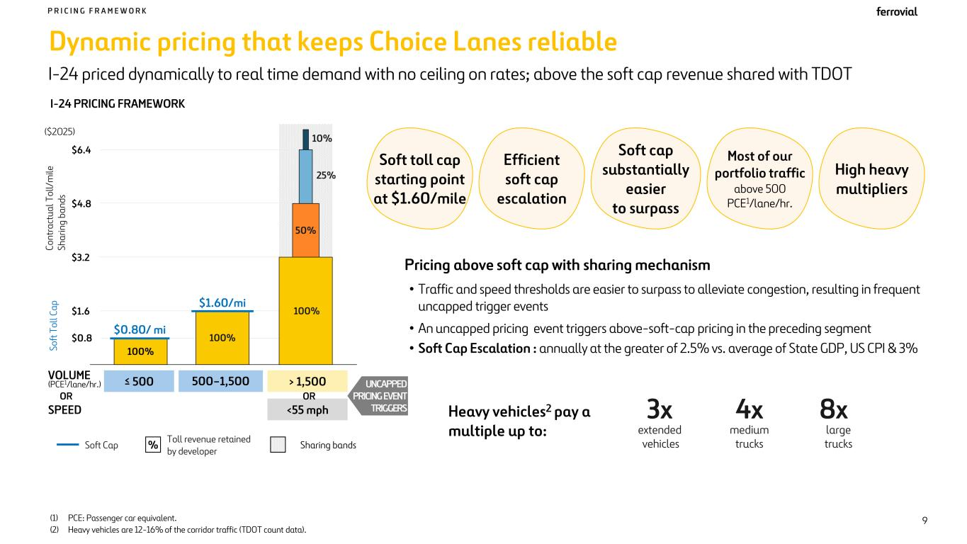
3x extended vehicles 4x medium trucks 8x large trucks (1) PCE: Passenger car equivalent. (2) Heavy vehicles are 12-16% of the corridor traffic (TDOT count data). Pricing above soft cap with sharing mechanism • Traffic and speed thresholds are easier to surpass to alleviate congestion, resulting in frequent uncapped trigger events • An uncapped pricing event triggers above-soft-cap pricing in the preceding segment • Soft Cap Escalation : annually at the greater of 2.5% vs. average of State GDP, US CPI & 3% Heavy vehicles2 pay a multiple up to: Dynamic pricing that keeps Choice Lanes reliable I-24 priced dynamically to real time demand with no ceiling on rates; above the soft cap revenue shared with TDOT P R I C I N G F R A M E W O R K High heavy multipliers Soft toll cap starting point at $1.60/mile C o n tr a ct u a l T o ll/ m ile Sh a ri n g ba n ds $0.8 $1.6 $3.2 $4.8 $6.4 100% 100% $0.80/ mi $1.60/mi Toll revenue retained by developer %Soft Cap VOLUME (PCE1/lane/hr.) ≤ 500 500–1,500 > 1,500 SPEED <55 mph UNCAPPED PRICING EVENT TRIGGERS 50% 25% 10% Sharing bands Efficient soft cap escalation Most of our portfolio traffic above 500 PCE1/lane/hr. 9 OR OR So ft T o ll C a p I-24 PRICING FRAMEWORK Soft cap substantially easier to surpass 100% ($2025)

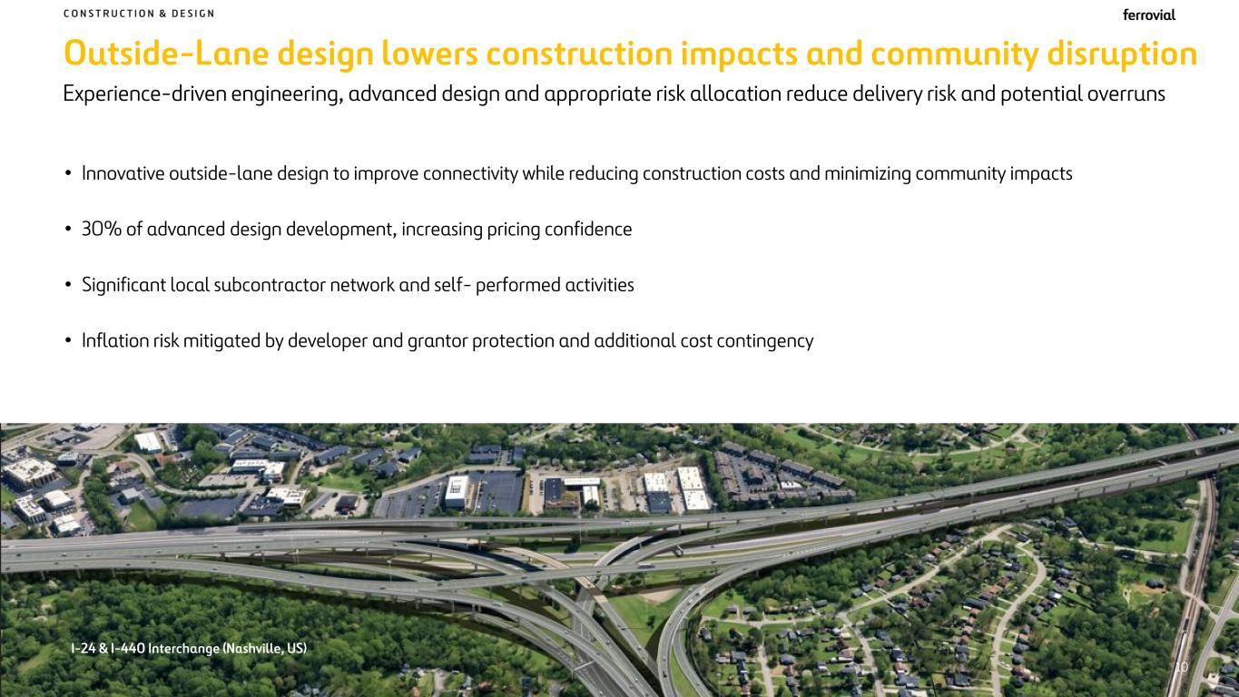
Outside-Lane design lowers construction impacts and community disruption C O N S T R U C T I O N & D E S I G N • Innovative outside-lane design to improve connectivity while reducing construction costs and minimizing community impacts • 30% of advanced design development, increasing pricing confidence • Significant local subcontractor network and self- performed activities • Inflation risk mitigated by developer and grantor protection and additional cost contingency Experience-driven engineering, advanced design and appropriate risk allocation reduce delivery risk and potential overruns I-24 & I-440 Interchange (Nashville, US) 10

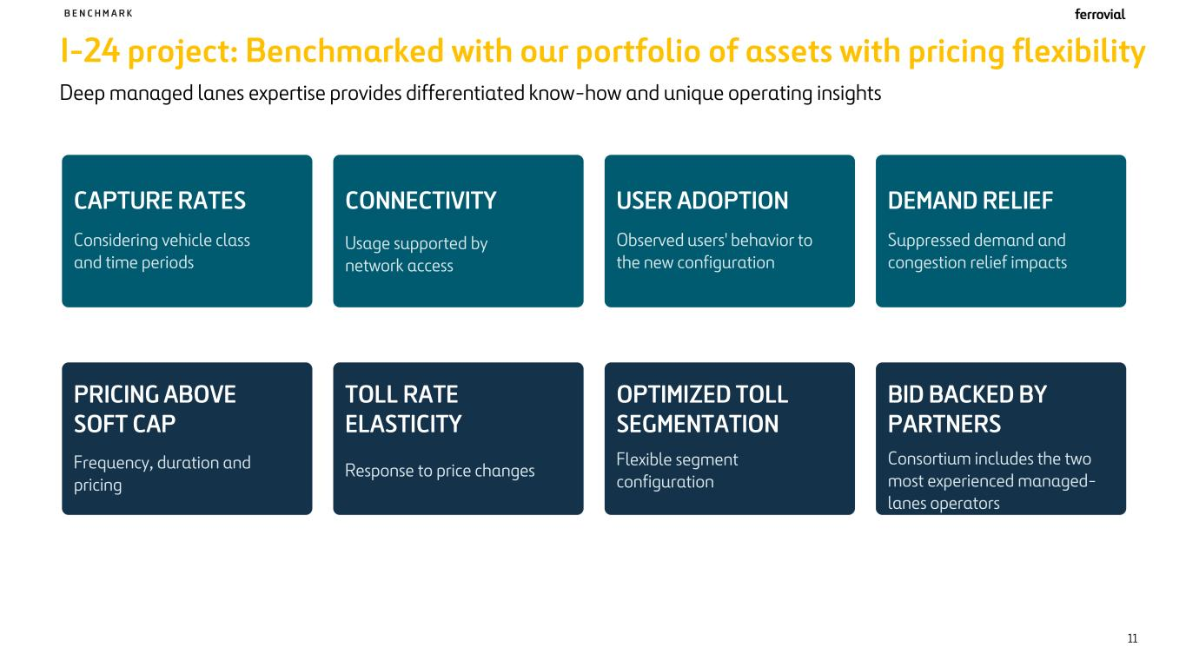
I-24 project: Benchmarked with our portfolio of assets with pricing flexibility B E N C H M A R K Deep managed lanes expertise provides differentiated know-how and unique operating insights 11 CAPTURE RATES Considering vehicle class and time periods CONNECTIVITY Usage supported by network access USER ADOPTION Observed users' behavior to the new configuration DEMAND RELIEF Suppressed demand and congestion relief impacts PRICING ABOVE SOFT CAP Frequency, duration and pricing TOLL RATE ELASTICITY Response to price changes OPTIMIZED TOLL SEGMENTATION BID BACKED BY PARTNERS Consortium includes the two most experienced managed- lanes operators Flexible segment configuration

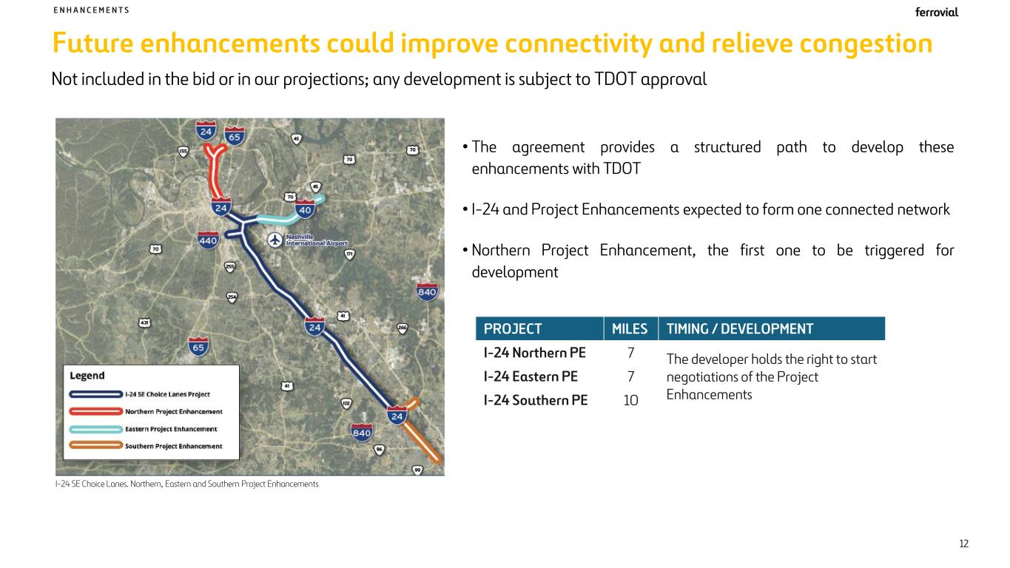
Future enhancements could improve connectivity and relieve congestion I-24 SE Choice Lanes. Northern, Eastern and Southern Project Enhancements • The agreement provides a structured path to develop these enhancements with TDOT • I-24 and Project Enhancements expected to form one connected network • Northern Project Enhancement, the first one to be triggered for development PROJECT MILES TIMING / DEVELOPMENT I-24 Northern PE 7 The developer holds the right to start negotiations of the Project Enhancements I-24 Eastern PE 7 I-24 Southern PE 10 Not included in the bid or in our projections; any development is subject to TDOT approval E N H A N C E M E N T S 12

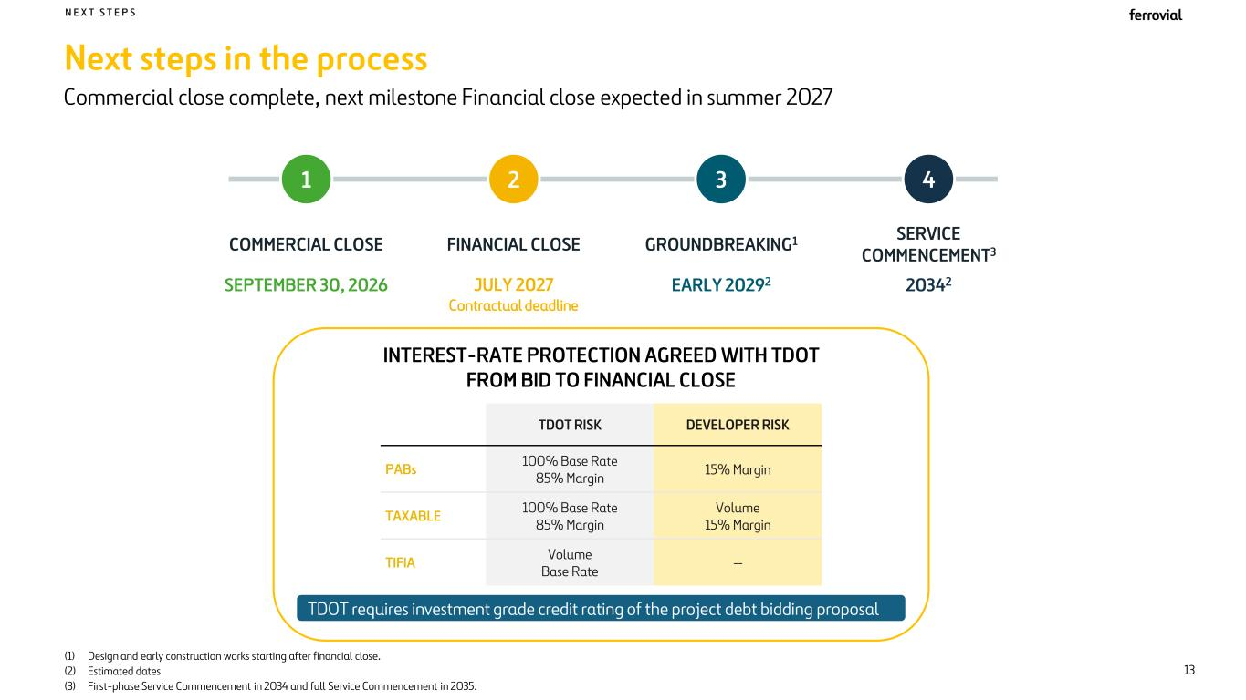
Next steps in the process N E X T S T E P S Commercial close complete, next milestone Financial close expected in summer 2027 13 1 COMMERCIAL CLOSE SEPTEMBER 30, 2026 2 FINANCIAL CLOSE JULY 2027 Contractual deadline 3 GROUNDBREAKING1 EARLY 20292 4 SERVICE COMMENCEMENT3 20342 INTEREST-RATE PROTECTION AGREED WITH TDOT FROM BID TO FINANCIAL CLOSE TDOT RISK DEVELOPER RISK PABs 100% Base Rate 85% Margin 15% Margin TAXABLE 100% Base Rate 85% Margin Volume 15% Margin TIFIA Volume Base Rate — TDOT requires investment grade credit rating of the project debt bidding proposal (1) Design and early construction works starting after financial close. (2) Estimated dates (3) First-phase Service Commencement in 2034 and full Service Commencement in 2035.

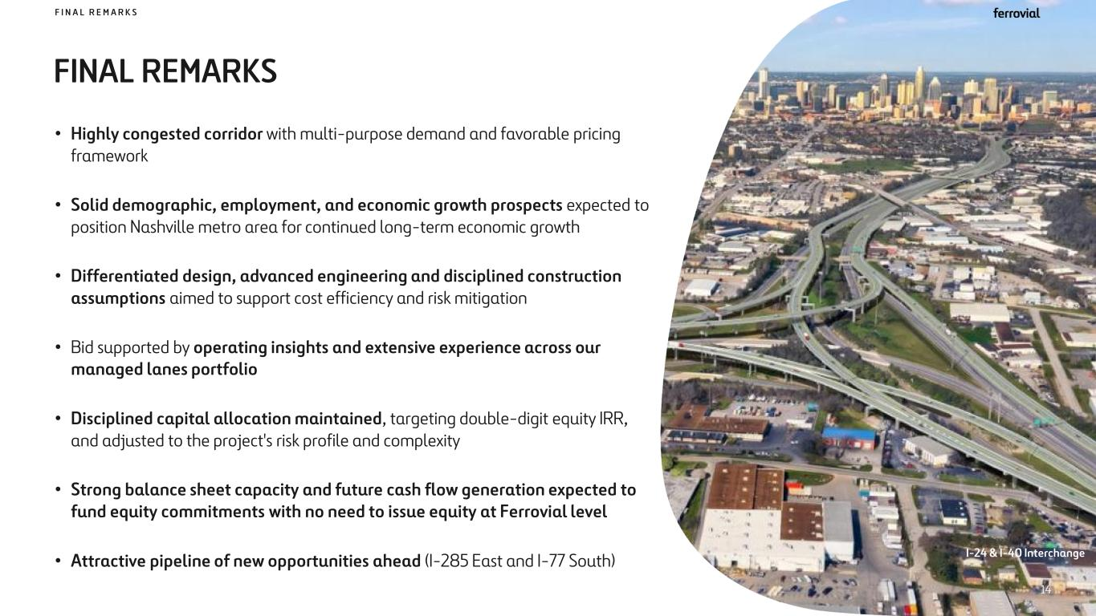
FINAL REMARKS F I N A L R E M A R K S • Highly congested corridor with multi-purpose demand and favorable pricing framework • Solid demographic, employment, and economic growth prospects expected to position Nashville metro area for continued long-term economic growth • Differentiated design, advanced engineering and disciplined construction assumptions aimed to support cost efficiency and risk mitigation • Bid supported by operating insights and extensive experience across our managed lanes portfolio • Disciplined capital allocation maintained, targeting double-digit equity IRR, and adjusted to the project's risk profile and complexity • Strong balance sheet capacity and future cash flow generation expected to fund equity commitments with no need to issue equity at Ferrovial level • Attractive pipeline of new opportunities ahead (I-285 East and I-77 South) I-24 & I-40 Interchange 14

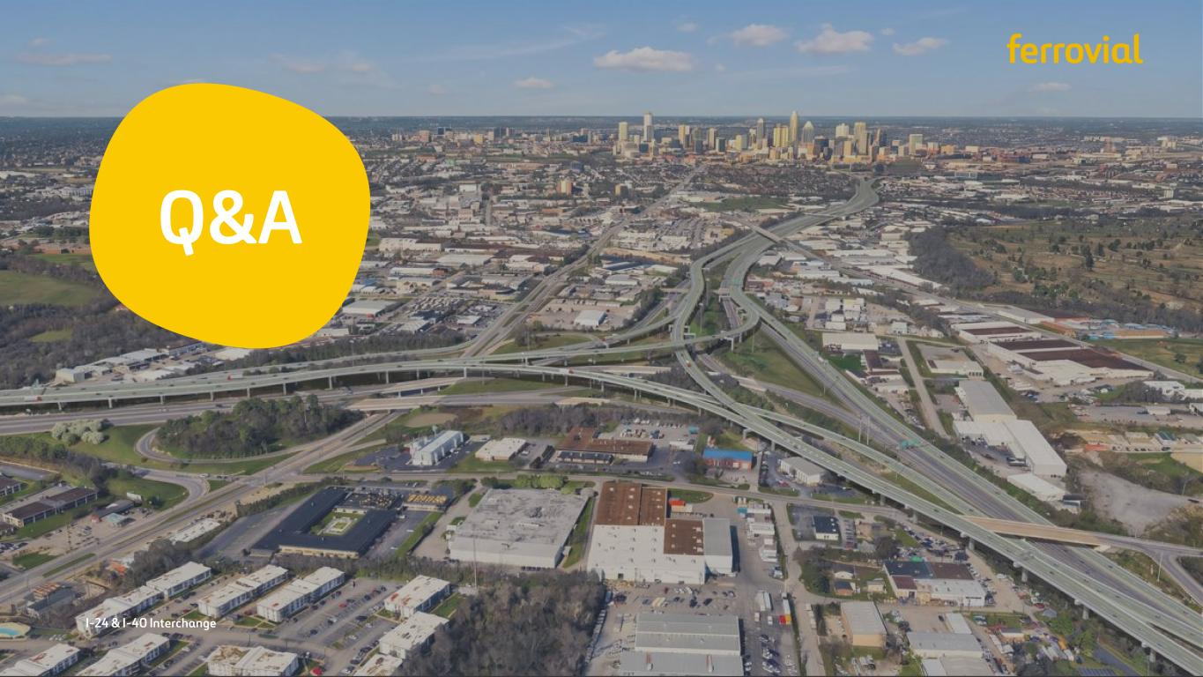
Q&A I-24 & I-40 Interchange

