UNITED STATES
SECURITIES AND EXCHANGE COMMISSION
Washington, D.C. 20549
___________________________
FORM 6-K
___________________________
REPORT OF FOREIGN PRIVATE ISSUER PURSUANT TO
SECTION 13a-16 OR 15d-16
UNDER THE SECURITIES EXCHANGE ACT OF 1934
Date: For the month of September 2026
Commission File Number: 001-41912
___________________________
Ferrovial N.V.
___________________________
Gustav Mahlerplein 61-63
Symphony Towers, 14th Floor
1082 MS Amsterdam
The Netherlands
Tel: +31 20798 37 02
(Address of principal executive office)
Indicate by check mark whether the registrant files or will file annual reports under cover of
Form 20-F or Form 40-F.
Form 20-F ☒ Form 40-F ☐

EXPLANATORY NOTE

Ferrovial N.V. is submitting this current report on Form 6-K to announce that the delisting of its
ordinary shares from Euronext Amsterdam announced on August 13, 2026 has become effective.
Attached to this report on Form 6-K is:
(1) a press release dated September 11, 2026 as Exhibit 99.1.

EXHIBIT INDEX

SIGNATURES
99.1

Exhibit
No.
Description
Ferrovial N.V.
Pursuant to the requirements of the Securities Exchange Act of 1934, as amended, the registrant

has duly caused this report to be signed on its behalf by the undersigned, thereunto duly

authorized.
Date: September 11, 2026
By: /s/ Ernesto López Mozo
Ernesto López Mozo
Chief Financial Officer
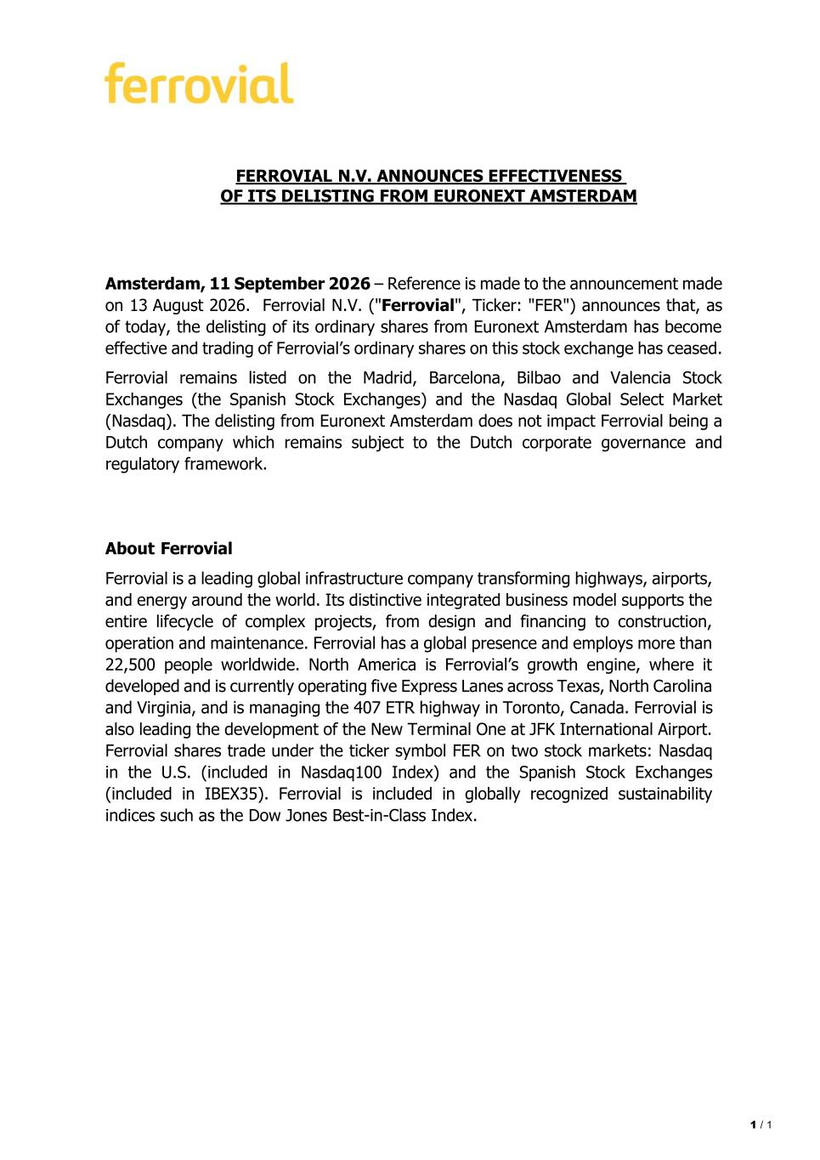
1 / 1 FERROVIAL N.V. ANNOUNCES EFFECTIVENESS OF ITS DELISTING FROM EURONEXT AMSTERDAM Amsterdam, 11 September 2026 – Reference is made to the announcement made on 13 August 2026. Ferrovial N.V. ("Ferrovial", Ticker: "FER") announces that, as of today, the delisting of its ordinary shares from Euronext Amsterdam has become effective and trading of Ferrovial’s ordinary shares on this stock exchange has ceased. Ferrovial remains listed on the Madrid, Barcelona, Bilbao and Valencia Stock Exchanges (the Spanish Stock Exchanges) and the Nasdaq Global Select Market (Nasdaq). The delisting from Euronext Amsterdam does not impact Ferrovial being a Dutch company which remains subject to the Dutch corporate governance and regulatory framework. About Ferrovial Ferrovial is a leading global infrastructure company transforming highways, airports, and energy around the world. Its distinctive integrated business model supports the entire lifecycle of complex projects, from design and financing to construction, operation and maintenance. Ferrovial has a global presence and employs more than 22,500 people worldwide. North America is Ferrovial’s growth engine, where it developed and is currently operating five Express Lanes across Texas, North Carolina and Virginia, and is managing the 407 ETR highway in Toronto, Canada. Ferrovial is also leading the development of the New Terminal One at JFK International Airport. Ferrovial shares trade under the ticker symbol FER on two stock markets: Nasdaq in the U.S. (included in Nasdaq100 Index) and the Spanish Stock Exchanges (included in IBEX35). Ferrovial is included in globally recognized sustainability indices such as the Dow Jones Best-in-Class Index.

