UNITED STATES
SECURITIES AND EXCHANGE COMMISSION
Washington, D.C. 20549
___________________________
FORM 6-K
___________________________
REPORT OF FOREIGN PRIVATE ISSUER PURSUANT TO
SECTION 13a-16 OR 15d-16
UNDER THE SECURITIES EXCHANGE ACT OF 1934
For the month of September 2026
Commission File Number: 001-41912
___________________________
Ferrovial N.V.
___________________________
Gustav Mahlerplein 61-63
Symphony Towers, 14th Floor
1082 MS Amsterdam
The Netherlands
Tel: +31 20798 37 00
(Address of principal executive office)
Indicate by check mark whether the registrant files or will file annual reports under cover of
Form 20-F or Form 40-F.
Form 20-F ☒ Form 40-F ☐

EXPLANATORY NOTE

Ferrovial N.V. (the “Company”) is submitting this current report on Form 6-K to report the transactions carried out
by the Company from July 27, 2026 to August 28, 2026 under the share repurchase program started on December
15, 2025.
Attached to this current report on Form 6-K are:
(1) a press release dated August 4, 2026 as Exhibit 99.1.
(2) a press release dated August 11, 2026 as Exhibit 99.2.
(3) a press release dated August 18, 2026 as Exhibit 99.3.
(4) a press release dated August 25, 2026 as Exhibit 99.4.
(5) a press release dated September 1, 2026 as Exhibit 99.5.

EXHIBIT INDEX

SIGNATURES
99.1
99.2
99.3
99.4
99.5

Exhibit
No.
Description
Pursuant to the requirements of the Securities Exchange Act of 1934, as amended, the registrant
has duly caused this report to be signed on its behalf by the undersigned, thereunto duly
authorized.
Ferrovial N.V.
Date: September 2, 2026
By: /s/ Ernesto López Mozo
Ernesto López Mozo
Chief Financial Officer
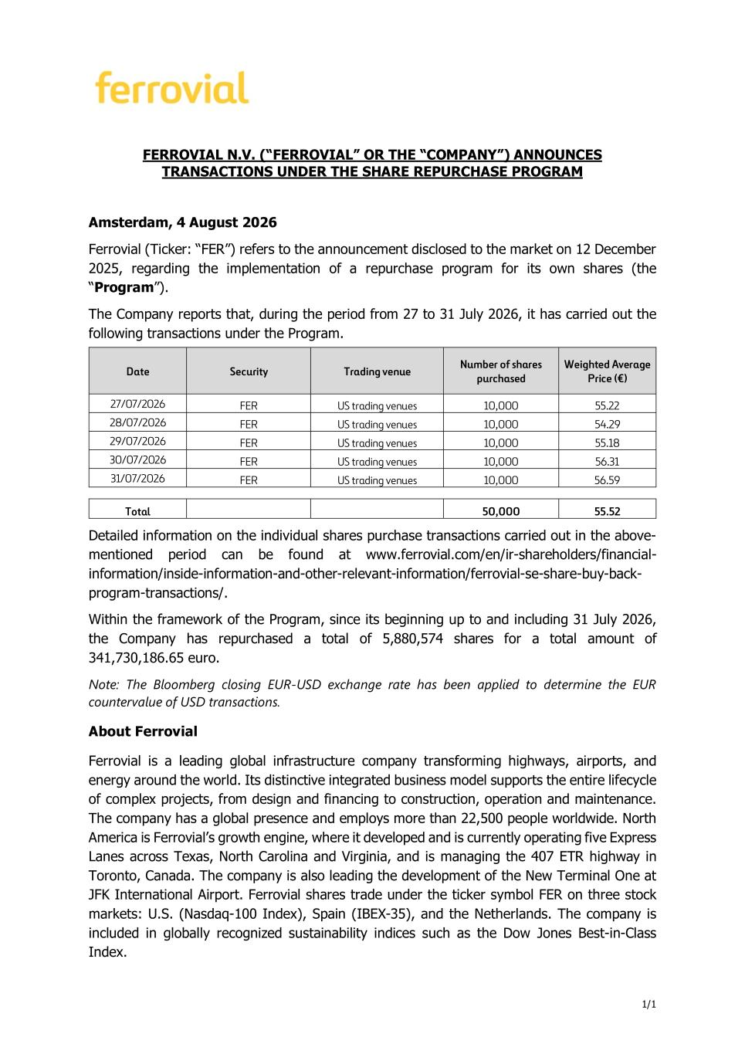
1/1 FERROVIAL N.V. (“FERROVIAL” OR THE “COMPANY”) ANNOUNCES TRANSACTIONS UNDER THE SHARE REPURCHASE PROGRAM Amsterdam, 4 August 2026 Ferrovial (Ticker: “FER”) refers to the announcement disclosed to the market on 12 December 2025, regarding the implementation of a repurchase program for its own shares (the “Program”). The Company reports that, during the period from 27 to 31 July 2026, it has carried out the following transactions under the Program. Detailed information on the individual shares purchase transactions carried out in the above- mentioned period can be found at www.ferrovial.com/en/ir-shareholders/financial- information/inside-information-and-other-relevant-information/ferrovial-se-share-buy-back- program-transactions/. Within the framework of the Program, since its beginning up to and including 31 July 2026, the Company has repurchased a total of 5,880,574 shares for a total amount of 341,730,186.65 euro. Note: The Bloomberg closing EUR-USD exchange rate has been applied to determine the EUR countervalue of USD transactions. About Ferrovial Ferrovial is a leading global infrastructure company transforming highways, airports, and energy around the world. Its distinctive integrated business model supports the entire lifecycle of complex projects, from design and financing to construction, operation and maintenance. The company has a global presence and employs more than 22,500 people worldwide. North America is Ferrovial’s growth engine, where it developed and is currently operating five Express Lanes across Texas, North Carolina and Virginia, and is managing the 407 ETR highway in Toronto, Canada. The company is also leading the development of the New Terminal One at JFK International Airport. Ferrovial shares trade under the ticker symbol FER on three stock markets: U.S. (Nasdaq-100 Index), Spain (IBEX-35), and the Netherlands. The company is included in globally recognized sustainability indices such as the Dow Jones Best-in-Class Index. Date Security Trading venue Number of shares purchased Weighted Average Price (€) 27/07/2026 FER US trading venues 10,000 55.22 28/07/2026 FER US trading venues 10,000 54.29 29/07/2026 FER US trading venues 10,000 55.18 30/07/2026 FER US trading venues 10,000 56.31 31/07/2026 FER US trading venues 10,000 56.59 Total 50,000 55.52

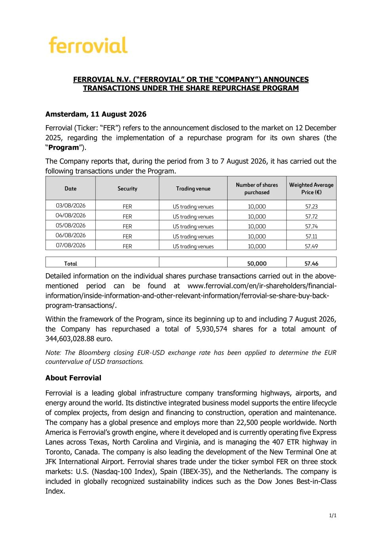
1/1 FERROVIAL N.V. (“FERROVIAL” OR THE “COMPANY”) ANNOUNCES TRANSACTIONS UNDER THE SHARE REPURCHASE PROGRAM Amsterdam, 11 August 2026 Ferrovial (Ticker: “FER”) refers to the announcement disclosed to the market on 12 December 2025, regarding the implementation of a repurchase program for its own shares (the “Program”). The Company reports that, during the period from 3 to 7 August 2026, it has carried out the following transactions under the Program. Date Security Trading venue Number of shares purchased Weighted Average Price (€) 03/08/2026 FER US trading venues 10,000 57.23 04/08/2026 FER US trading venues 10,000 57.72 05/08/2026 FER US trading venues 10,000 57.74 06/08/2026 FER US trading venues 10,000 57.11 07/08/2026 FER US trading venues 10,000 57.49 Total 50,000 57.46 Detailed information on the individual shares purchase transactions carried out in the above- mentioned period can be found at www.ferrovial.com/en/ir-shareholders/financial- information/inside-information-and-other-relevant-information/ferrovial-se-share-buy-back- program-transactions/. Within the framework of the Program, since its beginning up to and including 7 August 2026, the Company has repurchased a total of 5,930,574 shares for a total amount of 344,603,028.88 euro. Note: The Bloomberg closing EUR-USD exchange rate has been applied to determine the EUR countervalue of USD transactions. About Ferrovial Ferrovial is a leading global infrastructure company transforming highways, airports, and energy around the world. Its distinctive integrated business model supports the entire lifecycle of complex projects, from design and financing to construction, operation and maintenance. The company has a global presence and employs more than 22,500 people worldwide. North America is Ferrovial’s growth engine, where it developed and is currently operating five Express Lanes across Texas, North Carolina and Virginia, and is managing the 407 ETR highway in Toronto, Canada. The company is also leading the development of the New Terminal One at JFK International Airport. Ferrovial shares trade under the ticker symbol FER on three stock markets: U.S. (Nasdaq-100 Index), Spain (IBEX-35), and the Netherlands. The company is included in globally recognized sustainability indices such as the Dow Jones Best-in-Class Index.

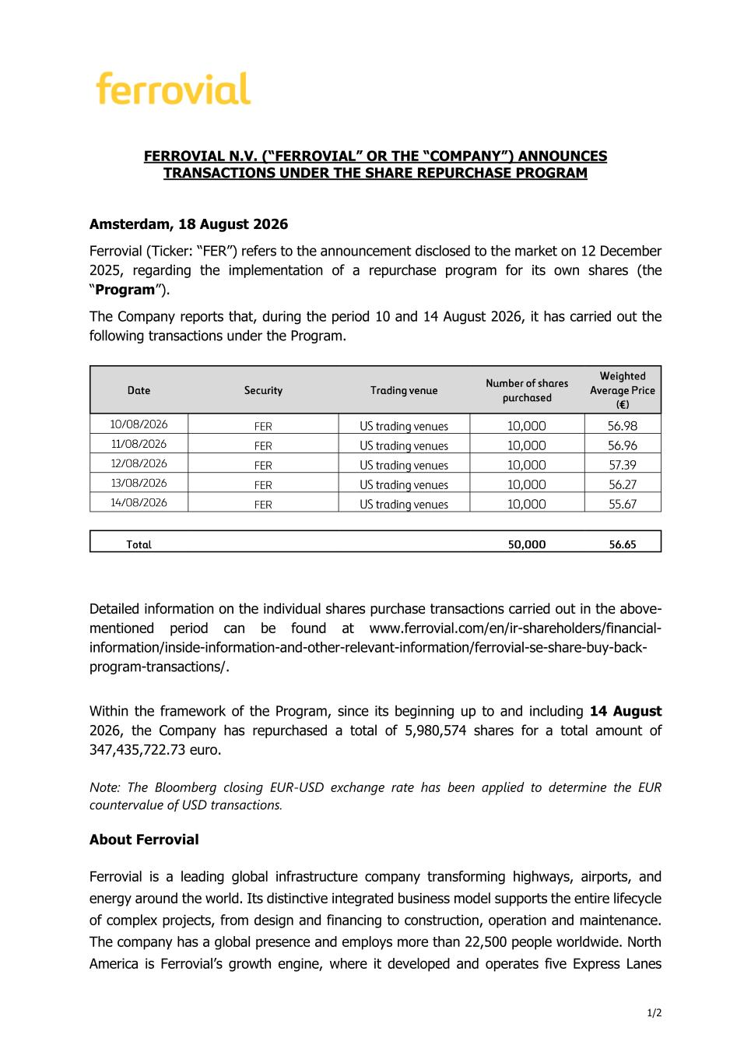
1/2 FERROVIAL N.V. (“FERROVIAL” OR THE “COMPANY”) ANNOUNCES TRANSACTIONS UNDER THE SHARE REPURCHASE PROGRAM Amsterdam, 18 August 2026 Ferrovial (Ticker: “FER”) refers to the announcement disclosed to the market on 12 December 2025, regarding the implementation of a repurchase program for its own shares (the “Program”). The Company reports that, during the period 10 and 14 August 2026, it has carried out the following transactions under the Program. Date Security Trading venue Number of shares purchased Weighted Average Price (€) 10/08/2026 FER US trading venues 10,000 56.98 11/08/2026 FER US trading venues 10,000 56.96 12/08/2026 FER US trading venues 10,000 57.39 13/08/2026 FER US trading venues 10,000 56.27 14/08/2026 FER US trading venues 10,000 55.67 Total 50 ,000 56.65 Detailed information on the individual shares purchase transactions carried out in the above- mentioned period can be found at www.ferrovial.com/en/ir-shareholders/financial- information/inside-information-and-other-relevant-information/ferrovial-se-share-buy-back- program-transactions/. Within the framework of the Program, since its beginning up to and including 14 August 2026, the Company has repurchased a total of 5,980,574 shares for a total amount of 347,435,722.73 euro. Note: The Bloomberg closing EUR-USD exchange rate has been applied to determine the EUR countervalue of USD transactions. About Ferrovial Ferrovial is a leading global infrastructure company transforming highways, airports, and energy around the world. Its distinctive integrated business model supports the entire lifecycle of complex projects, from design and financing to construction, operation and maintenance. The company has a global presence and employs more than 22,500 people worldwide. North America is Ferrovial’s growth engine, where it developed and operates five Express Lanes

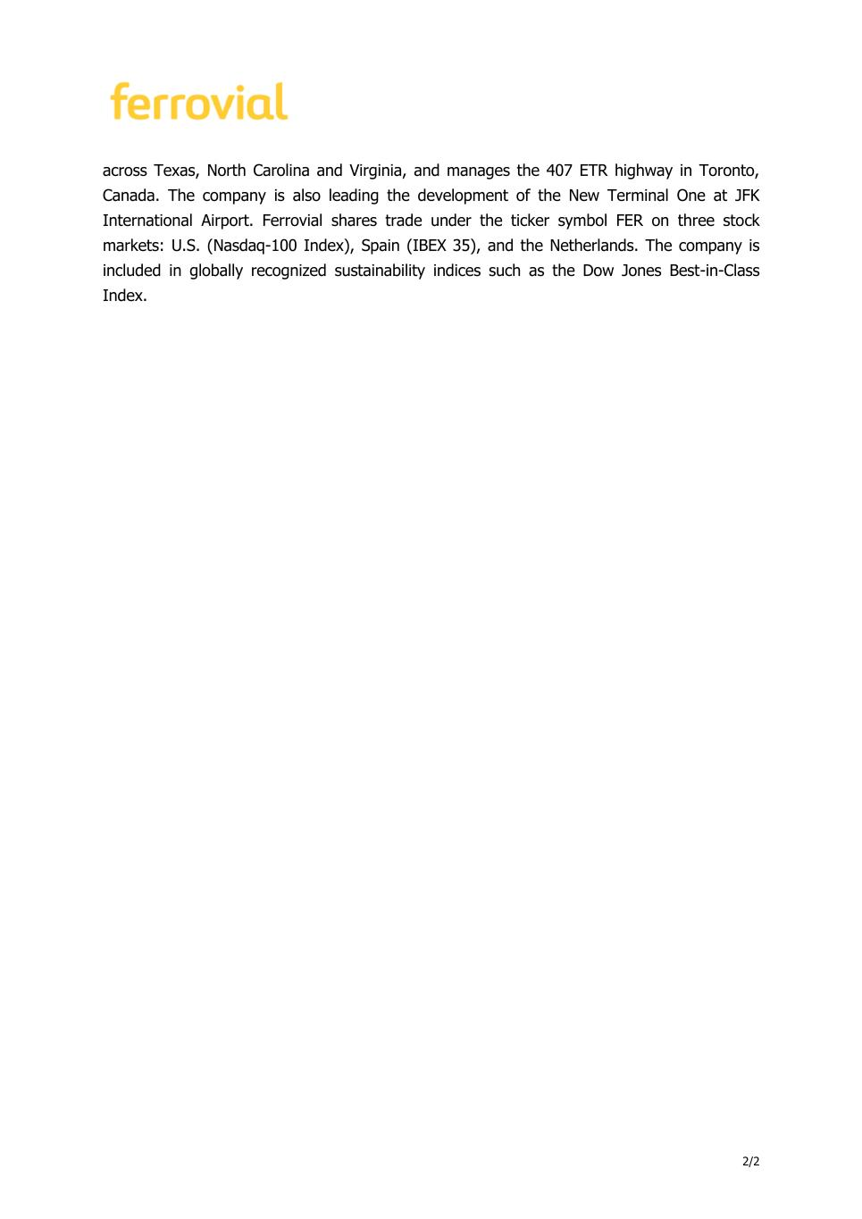
2/2 across Texas, North Carolina and Virginia, and manages the 407 ETR highway in Toronto, Canada. The company is also leading the development of the New Terminal One at JFK International Airport. Ferrovial shares trade under the ticker symbol FER on three stock markets: U.S. (Nasdaq-100 Index), Spain (IBEX 35), and the Netherlands. The company is included in globally recognized sustainability indices such as the Dow Jones Best-in-Class Index.

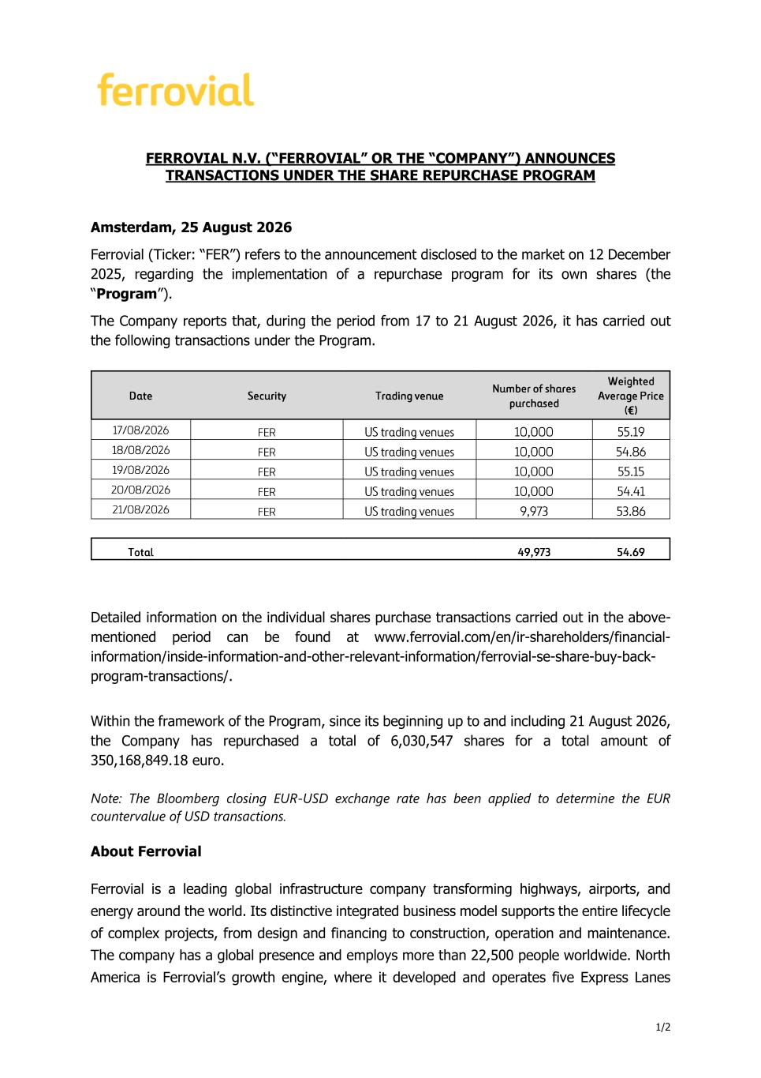
1/2 FERROVIAL N.V. (“FERROVIAL” OR THE “COMPANY”) ANNOUNCES TRANSACTIONS UNDER THE SHARE REPURCHASE PROGRAM Amsterdam, 25 August 2026 Ferrovial (Ticker: “FER”) refers to the announcement disclosed to the market on 12 December 2025, regarding the implementation of a repurchase program for its own shares (the “Program”). The Company reports that, during the period from 17 to 21 August 2026, it has carried out the following transactions under the Program. Date Security Trading venue Number of shares purchased Weighted Average Price (€) 17/08/2026 FER US trading venues 10,000 55.19 18/08/2026 FER US trading venues 10,000 54.86 19/08/2026 FER US trading venues 10,000 55.15 20/08/2026 FER US trading venues 10,000 54.41 21/08/2026 FER US trading venues 9,973 53.86 Total 49,973 54.69 Detailed information on the individual shares purchase transactions carried out in the above- mentioned period can be found at www.ferrovial.com/en/ir-shareholders/financial- information/inside-information-and-other-relevant-information/ferrovial-se-share-buy-back- program-transactions/. Within the framework of the Program, since its beginning up to and including 21 August 2026, the Company has repurchased a total of 6,030,547 shares for a total amount of 350,168,849.18 euro. Note: The Bloomberg closing EUR-USD exchange rate has been applied to determine the EUR countervalue of USD transactions. About Ferrovial Ferrovial is a leading global infrastructure company transforming highways, airports, and energy around the world. Its distinctive integrated business model supports the entire lifecycle of complex projects, from design and financing to construction, operation and maintenance. The company has a global presence and employs more than 22,500 people worldwide. North America is Ferrovial’s growth engine, where it developed and operates five Express Lanes

2/2 across Texas, North Carolina and Virginia, and manages the 407 ETR highway in Toronto, Canada. The company is also leading the development of the New Terminal One at JFK International Airport. Ferrovial shares trade under the ticker symbol FER on three stock markets: U.S. (Nasdaq-100 Index), Spain (IBEX 35), and the Netherlands. The company is included in globally recognized sustainability indices such as the Dow Jones Best-in-Class Index.

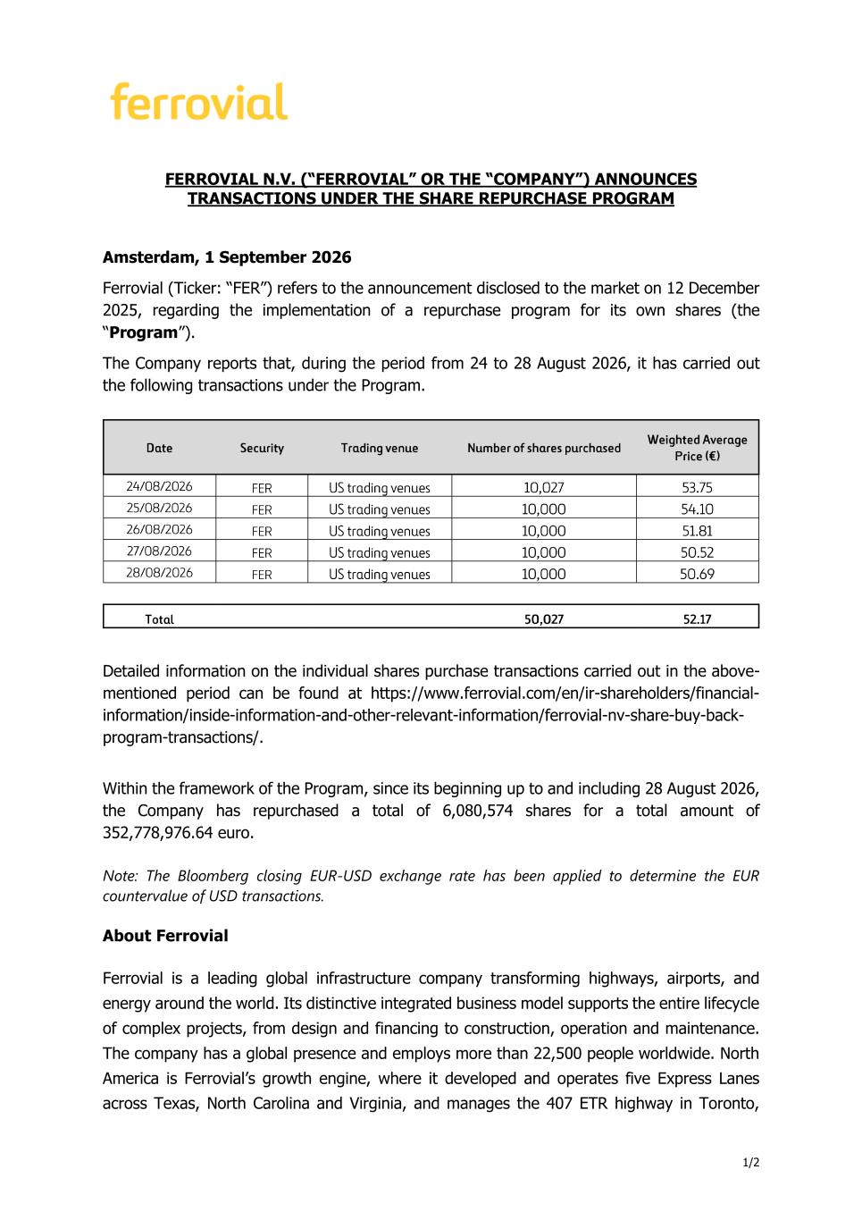
1/2 FERROVIAL N.V. (“FERROVIAL” OR THE “COMPANY”) ANNOUNCES TRANSACTIONS UNDER THE SHARE REPURCHASE PROGRAM Amsterdam, 1 September 2026 Ferrovial (Ticker: “FER”) refers to the announcement disclosed to the market on 12 December 2025, regarding the implementation of a repurchase program for its own shares (the “Program”). The Company reports that, during the period from 24 to 28 August 2026, it has carried out the following transactions under the Program. Date Security Trading venue Number of shares purchased Weighted Average Price (€) 24/08/2026 FER US trading venues 10,027 53.75 25/08/2026 FER US trading venues 10,000 54.10 26/08/2026 FER US trading venues 10,000 51.81 27/08/2026 FER US trading venues 10,000 50.52 28/08/2026 FER US trading venues 10,000 50.69 Total 50 ,027 52.17 Detailed information on the individual shares purchase transactions carried out in the above- mentioned period can be found at https://www.ferrovial.com/en/ir-shareholders/financial- information/inside-information-and-other-relevant-information/ferrovial-nv-share-buy-back- program-transactions/. Within the framework of the Program, since its beginning up to and including 28 August 2026, the Company has repurchased a total of 6,080,574 shares for a total amount of 352,778,976.64 euro. Note: The Bloomberg closing EUR-USD exchange rate has been applied to determine the EUR countervalue of USD transactions. About Ferrovial Ferrovial is a leading global infrastructure company transforming highways, airports, and energy around the world. Its distinctive integrated business model supports the entire lifecycle of complex projects, from design and financing to construction, operation and maintenance. The company has a global presence and employs more than 22,500 people worldwide. North America is Ferrovial’s growth engine, where it developed and operates five Express Lanes across Texas, North Carolina and Virginia, and manages the 407 ETR highway in Toronto,

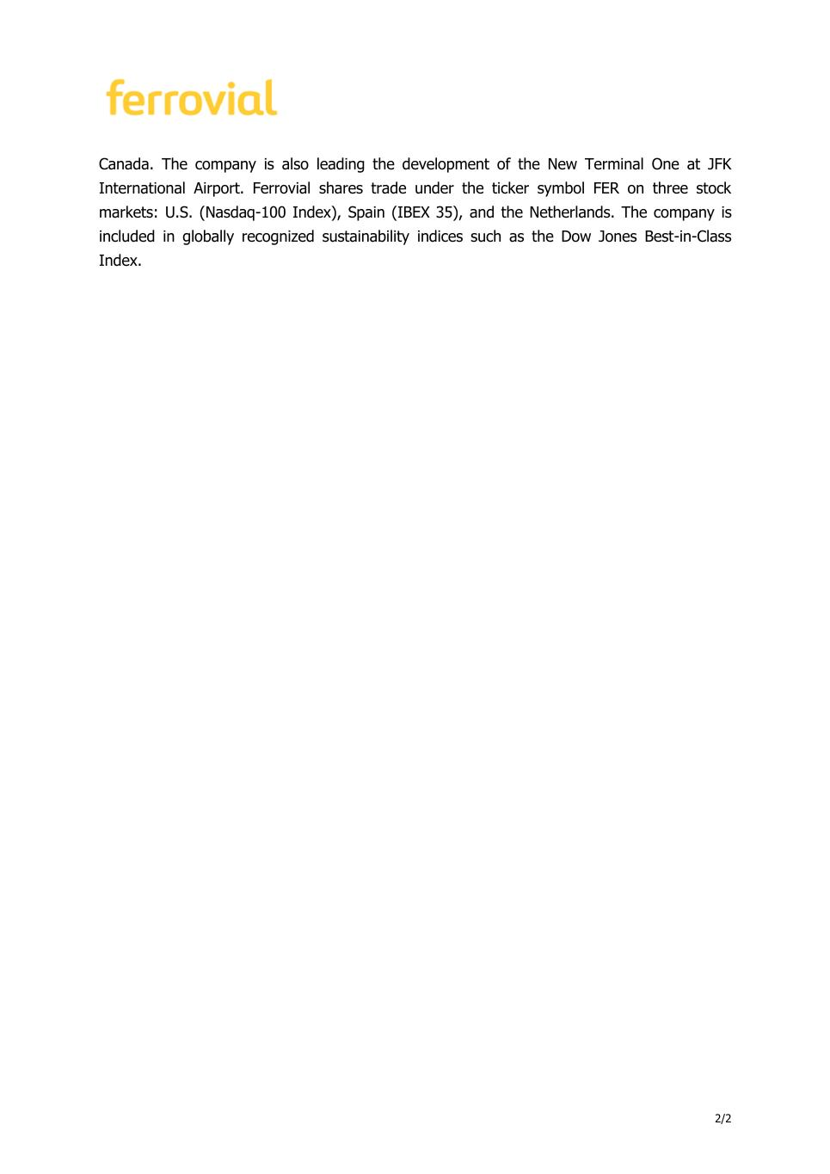
2/2 Canada. The company is also leading the development of the New Terminal One at JFK International Airport. Ferrovial shares trade under the ticker symbol FER on three stock markets: U.S. (Nasdaq-100 Index), Spain (IBEX 35), and the Netherlands. The company is included in globally recognized sustainability indices such as the Dow Jones Best-in-Class Index.

