UNITED STATES
SECURITIES AND EXCHANGE COMMISSION
Washington, D.C. 20549
___________________________
FORM 6-K/A
___________________________
REPORT OF FOREIGN PRIVATE ISSUER PURSUANT TO
SECTION 13a-16 OR 15d-16
UNDER THE SECURITIES EXCHANGE ACT OF 1934
Date: for the month of July 2026
Commission File Number: 001-41912
___________________________
Ferrovial N.V.
___________________________
Gustav Mahlerplein 61-63
Symphony Towers, 14th Floor
1082 MS Amsterdam
The Netherlands
Tel: +31 20798 37 02
(Address of principal executive office)
Indicate by check mark whether the registrant files or will file annual reports under cover of
Form 20-F or Form 40-F.
Form 20-F ☒ Form 40-F ☐

EXPLANATORY NOTE
Ferrovial N.V. (the “Company” or “Ferrovial”) hereby furnishes this Amendment No. 1 on Form 6-K solely to file
an updated version of the Investor Presentation included as Exhibit 99.1 to the form 6-K furnished on May 8, 2026
(the “Original Form 6-K”). The update corrects two errors contained in the previous version of the presentation.
The amendments relate to (i) the amount of equity invested by Ferrovial in 407 ETR (slide 27) and (ii) the debt
maturity chart for the bonds issued by New Terminal One (“NTO”) (slide 95).
Other than as expressly set forth above, this Form 6-K/A does not, and does not purport to, amend, update, or restate
the information in any other item of the Original Form 6-K, or reflect any events that have occurred after the
Original Form 6-K was filed.

EXHIBIT INDEX

SIGNATURES
99.1

Exhibit
No.
Description
Ferrovial N.V.
Pursuant to the requirements of the Securities Exchange Act of 1934, as amended, the registrant

has duly caused this report to be signed on its behalf by the undersigned, thereunto duly

authorized.
Date: July 31, 2026
By: /s/ Ernesto López Mozo________________
Ernesto López Mozo
Chief Financial Officer
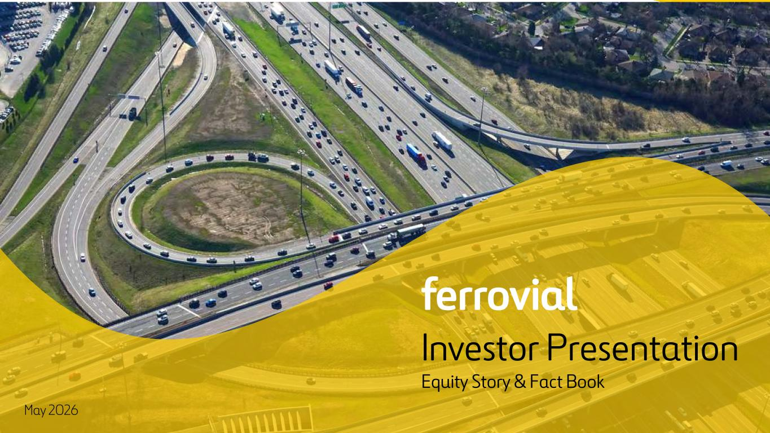
1 Investor Presentation Equity Story & Fact Book May 2026

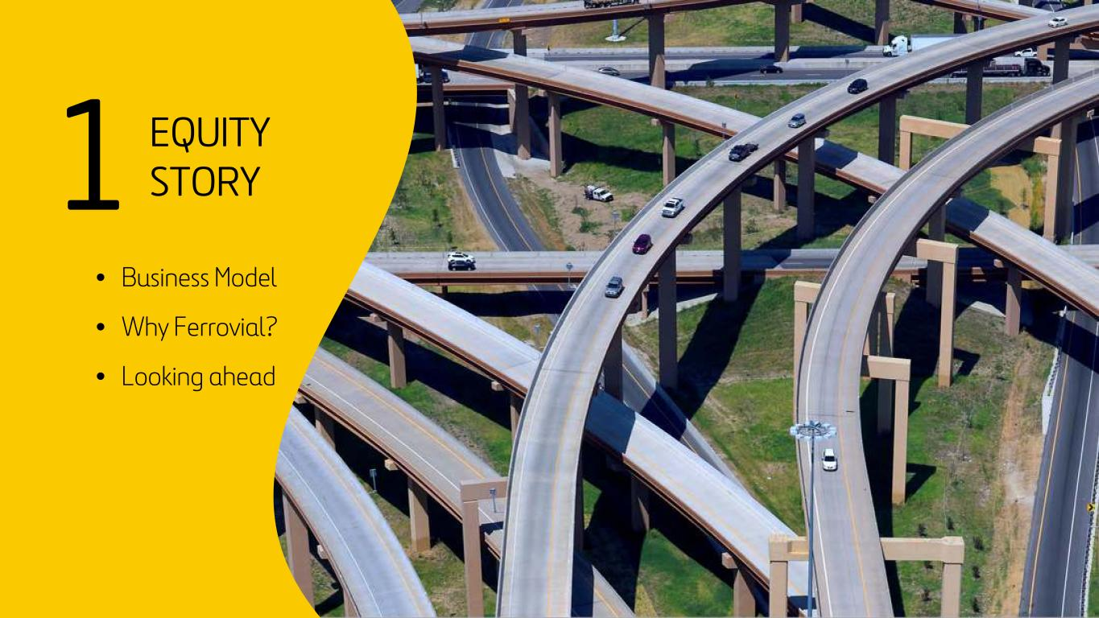
2 1 EQUITY STORY • Business Model • Why Ferrovial? • Looking ahead

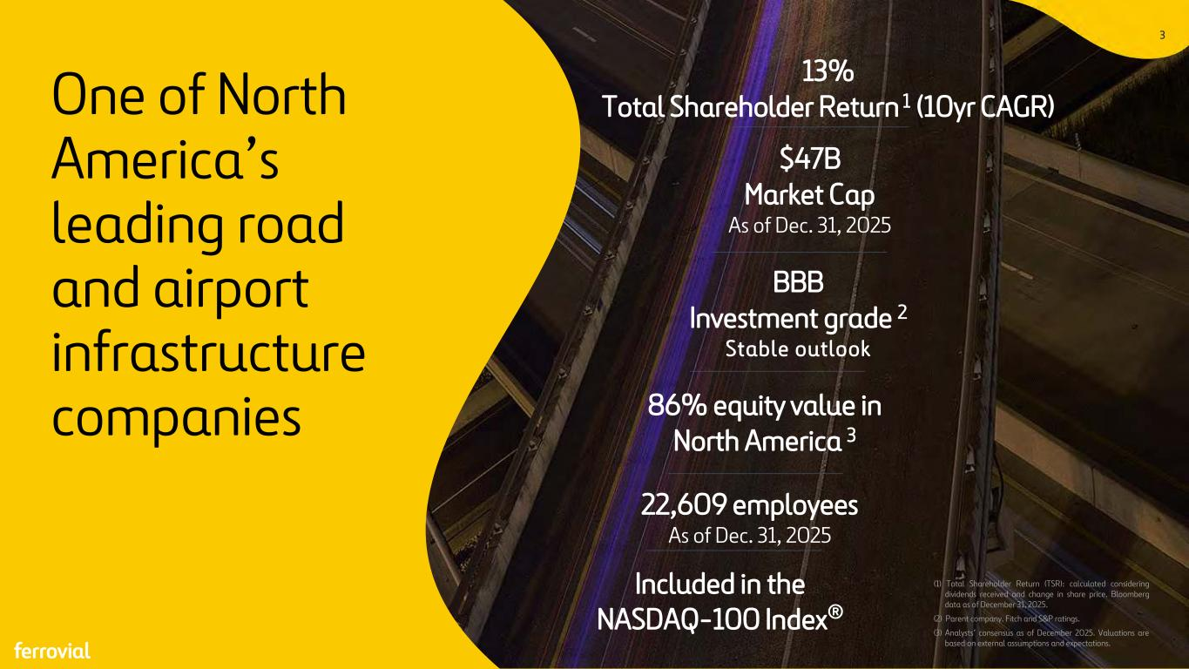
3 One of North America’s leading road and airport infrastructure companies (1) Total Shareholder Return (TSR): calculated considering dividends received and change in share price. Bloomberg data as of December 31, 2025. (2) Parent company. Fitch and S&P ratings. (3) Analysts’ consensus as of December 2025. Valuations are based on external assumptions and expectations. 13% Total Shareholder Return 1 (10yr CAGR) $47B Market Cap As of Dec. 31, 2025 BBB Investment grade 2 Stable outlook 86% equity value in North America 3 22,609 employees As of Dec. 31, 2025 Included in the NASDAQ-100 Index® 3

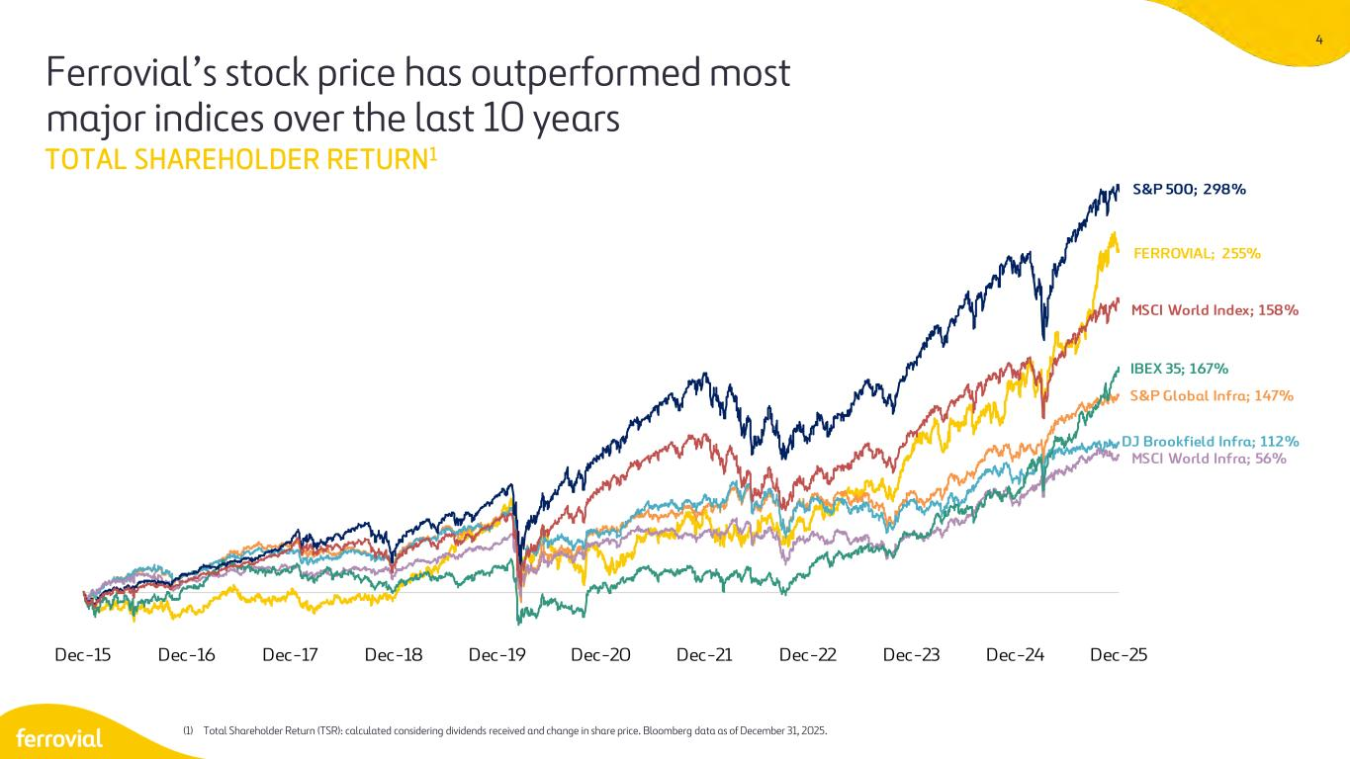
4 Ferrovial’s stock price has outperformed most major indices over the last 10 years TOTAL SHAREHOLDER RETURN1 (1) Total Shareholder Return (TSR): calculated considering dividends received and change in share price. Bloomberg data as of December 31, 2025. FERROVIAL; 255% S&P Global Infra; 147% DJ Brookfield Infra; 112% MSCI World Infra; 56% IBEX 35; 167% S&P 500; 298% MSCI World Index; 158% Dec-15 Dec-16 Dec-17 Dec-18 Dec-19 Dec-20 Dec-21 Dec-22 Dec-23 Dec-24 Dec-25

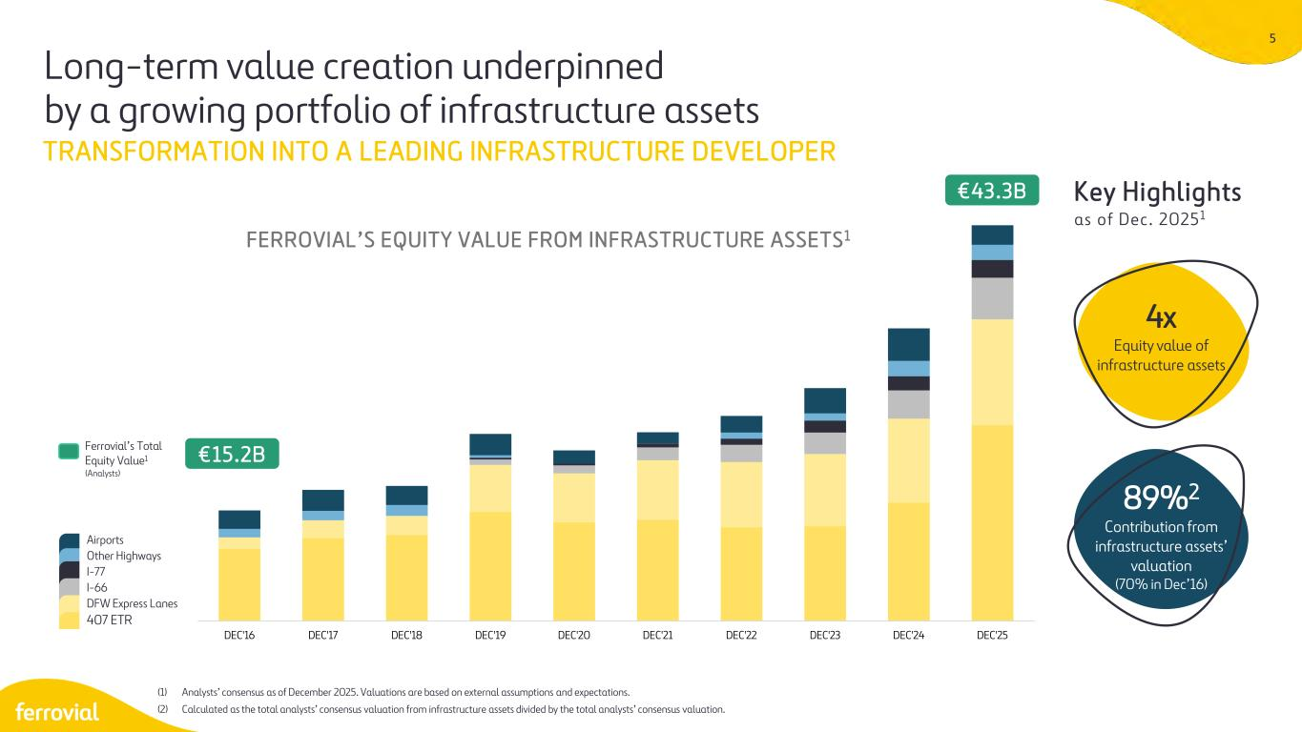
5 DEC'16 DEC'17 DEC'18 DEC'19 DEC'20 DEC'21 DEC'22 DEC'23 DEC'24 DEC'25 4x Equity value of infrastructure assets 89%2 Contribution from infrastructure assets’ valuation (70% in Dec’16) Airports Other Highways I-77 I-66 DFW Express Lanes 407 ETR Ferrovial’s Total Equity Value1 (Analysts) €15.2B FERROVIAL’S EQUITY VALUE FROM INFRASTRUCTURE ASSETS1 Key Highlights as of Dec. 20251 Long-term value creation underpinned by a growing portfolio of infrastructure assets (1) Analysts’ consensus as of December 2025. Valuations are based on external assumptions and expectations. (2) Calculated as the total analysts’ consensus valuation from infrastructure assets divided by the total analysts’ consensus valuation. TRANSFORMATION INTO A LEADING INFRASTRUCTURE DEVELOPER €43.3B

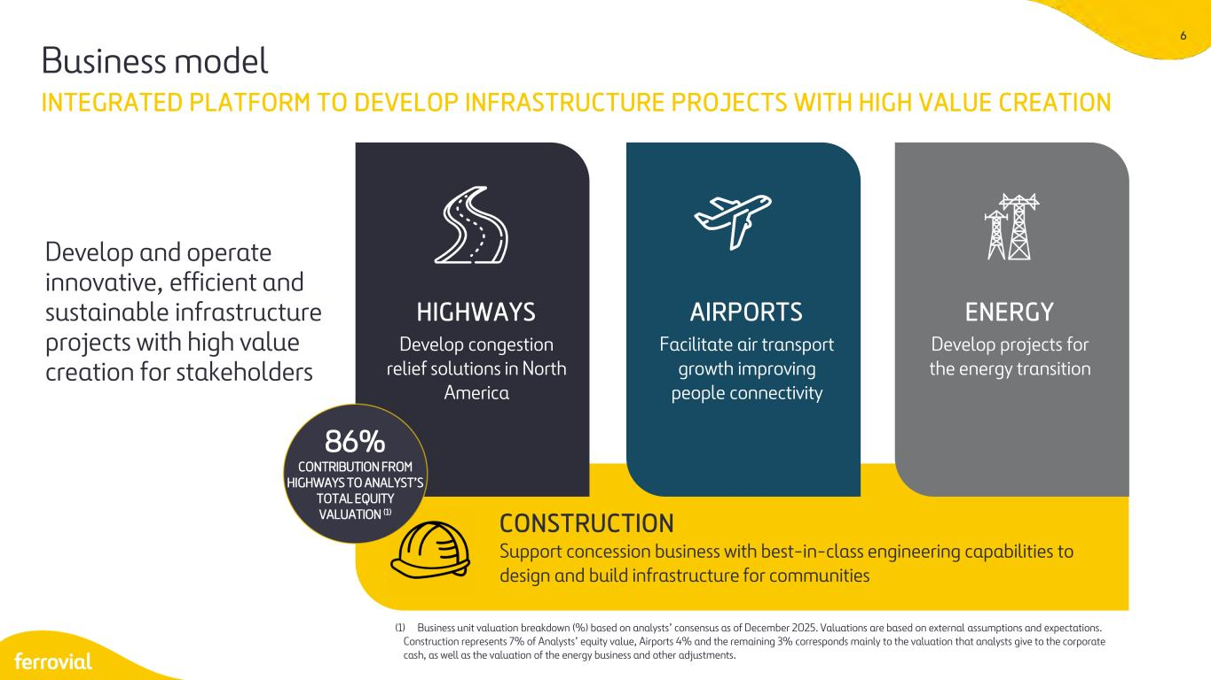
6 INTEGRATED PLATFORM TO DEVELOP INFRASTRUCTURE PROJECTS WITH HIGH VALUE CREATION (1) Business unit valuation breakdown (%) based on analysts’ consensus as of December 2025. Valuations are based on external assumptions and expectations. Construction represents 7% of Analysts’ equity value, Airports 4% and the remaining 3% corresponds mainly to the valuation that analysts give to the corporate cash, as well as the valuation of the energy business and other adjustments. HIGHWAYS Develop congestion relief solutions in North America AIRPORTS Facilitate air transport growth improving people connectivity ENERGY Develop projects for the energy transition CONSTRUCTION Support concession business with best-in-class engineering capabilities to design and build infrastructure for communities Business model Develop and operate innovative, efficient and sustainable infrastructure projects with high value creation for stakeholders 86% CONTRIBUTION FROM HIGHWAYS TO ANALYST’S TOTAL EQUITY VALUATION (1)

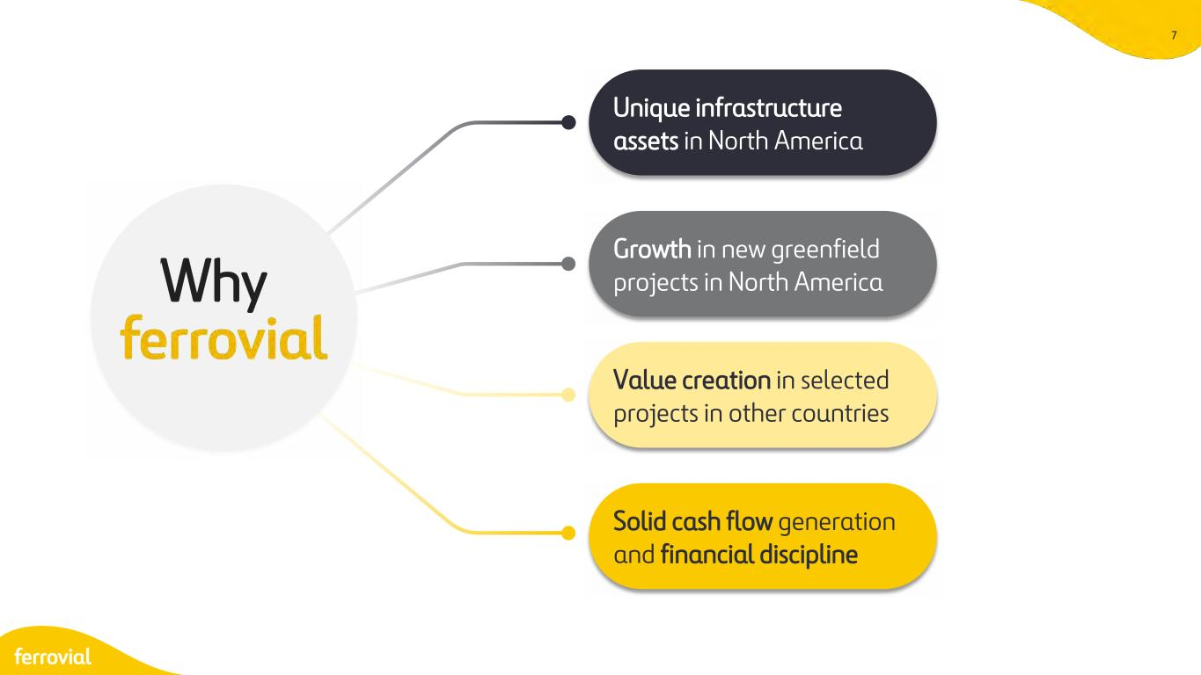
7 Why Unique infrastructure assets in North America Growth in new greenfield projects in North America Value creation in selected projects in other countries Solid cash flow generation and financial discipline

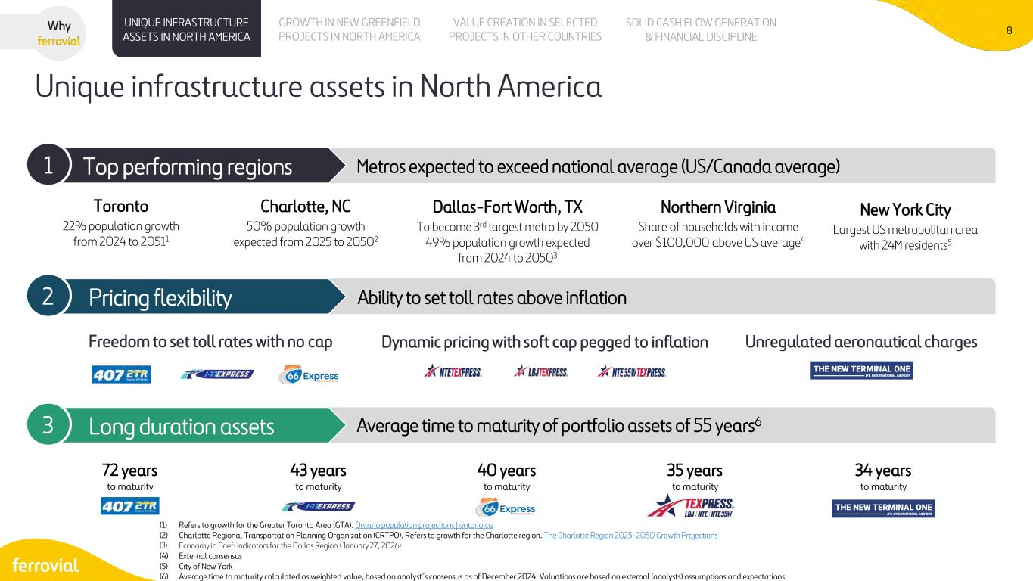
8 Unique infrastructure assets in North America (1) Refers to growth for the Greater Toronto Area (GTA). Ontario population projections | ontario.ca (2) Charlotte Regional Transportation Planning Organization (CRTPO). Refers to growth for the Charlotte region. The Charlotte Region 2025-2050 Growth Projections (3) Economy in Brief: Indicators for the Dallas Region (January 27, 2026) (4) External consensus (5) City of New York (6) Average time to maturity calculated as weighted value, based on analyst´s consensus as of December 2024. Valuations are based on external (analysts) assumptions and expectations UNIQUE INFRASTRUCTURE ASSETS IN NORTH AMERICA VALUE CREATION IN SELECTED PROJECTS IN OTHER COUNTRIES SOLID CASH FLOW GENERATION & FINANCIAL DISCIPLINE GROWTH IN NEW GREENFIELD PROJECTS IN NORTH AMERICA Why Top performing regions Top performing regions Metros expected to exceed national average (US/Canada average) 1 Pricing flexibility Ability to set toll rates above inflation2 Long duration assets Average time to maturity of portfolio assets of 55 years63 Toronto 22% population growth from 2024 to 20511 Charlotte, NC 50% population growth expected from 2025 to 20502 Dallas-Fort Worth, TX To become 3rd largest metro by 2050 49% population growth expected from 2024 to 20503 Freedom to set toll rates with no cap Dynamic pricing with soft cap pegged to inflation Unregulated aeronautical charges 72 years to maturity 43 years to maturity 40 years to maturity 35 years to maturity 34 years to maturity New York City Largest US metropolitan area with 24M residents5 Northern Virginia Share of households with income over $100,000 above US average4

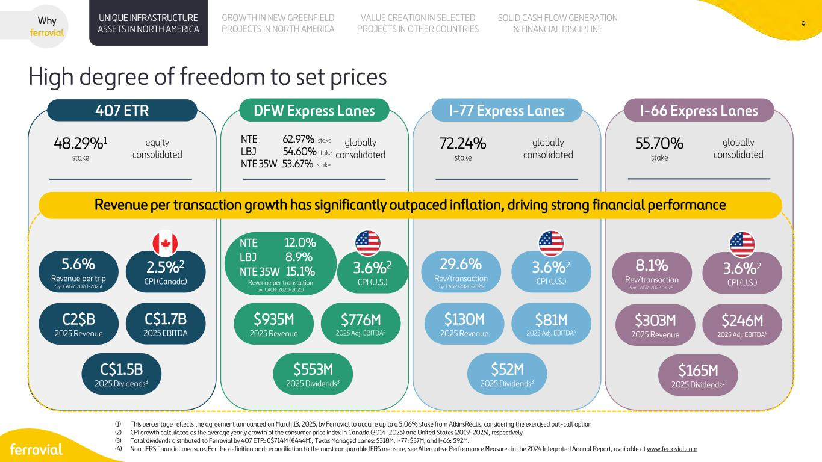
9 High degree of freedom to set prices (1) This percentage reflects the agreement announced on March 13, 2025, by Ferrovial to acquire up to a 5.06% stake from AtkinsRéalis, considering the exercised put-call option (2) CPI growth calculated as the average yearly growth of the consumer price index in Canada (2014-2025) and United States (2019-2025), respectively (3) Total dividends distributed to Ferrovial by 407 ETR: C$714M (€444M), Texas Managed Lanes: $318M, I-77: $37M, and I-66: $92M. (4) Non-IFRS financial measure. For the definition and reconciliation to the most comparable IFRS measure, see Alternative Performance Measures in the 2024 Integrated Annual Report, available at www.ferrovial.com UNIQUE INFRASTRUCTURE ASSETS IN NORTH AMERICA VALUE CREATION IN SELECTED PROJECTS IN OTHER COUNTRIES SOLID CASH FLOW GENERATION & FINANCIAL DISCIPLINE GROWTH IN NEW GREENFIELD PROJECTS IN NORTH AMERICA Why 407 ETR DFW Express Lanes I-77 Express Lanes I-66 Express Lanes 48.29%1 stake equity consolidated 72.24% stake globally consolidated C2$B 2025 Revenue C$1.7B 2025 EBITDA C$1.5B 2025 Dividends3 NTE 62.97% stake LBJ 54.60% stake NTE 35W 53.67% stake globally consolidated 55.70% stake globally consolidated 5.6% Revenue per trip 5 yr CAGR (2020-2025) 2.5%2 CPI (Canada) $935M 2025 Revenue $776M 2025 Adj. EBITDA4 $553M 2025 Dividends3 NTE 12.0% LBJ 8.9% NTE 35W 15.1% Revenue per transaction 5yr CAGR (2020-2025) 3.6%2 CPI (U.S.) $130M 2025 Revenue $81M 2025 Adj. EBITDA4 $52M 2025 Dividends3 29.6% Rev/transaction 5 yr CAGR (2020-2025) 3.6%2 CPI (U.S.) $303M 2025 Revenue $246M 2025 Adj. EBITDA4 $165M 2025 Dividends3 8.1% Rev/transaction 5 yr CAGR (2022-2025) 3.6%2 CPI (U.S.) Revenue per transaction growth has significantly outpaced inflation, driving strong financial performance

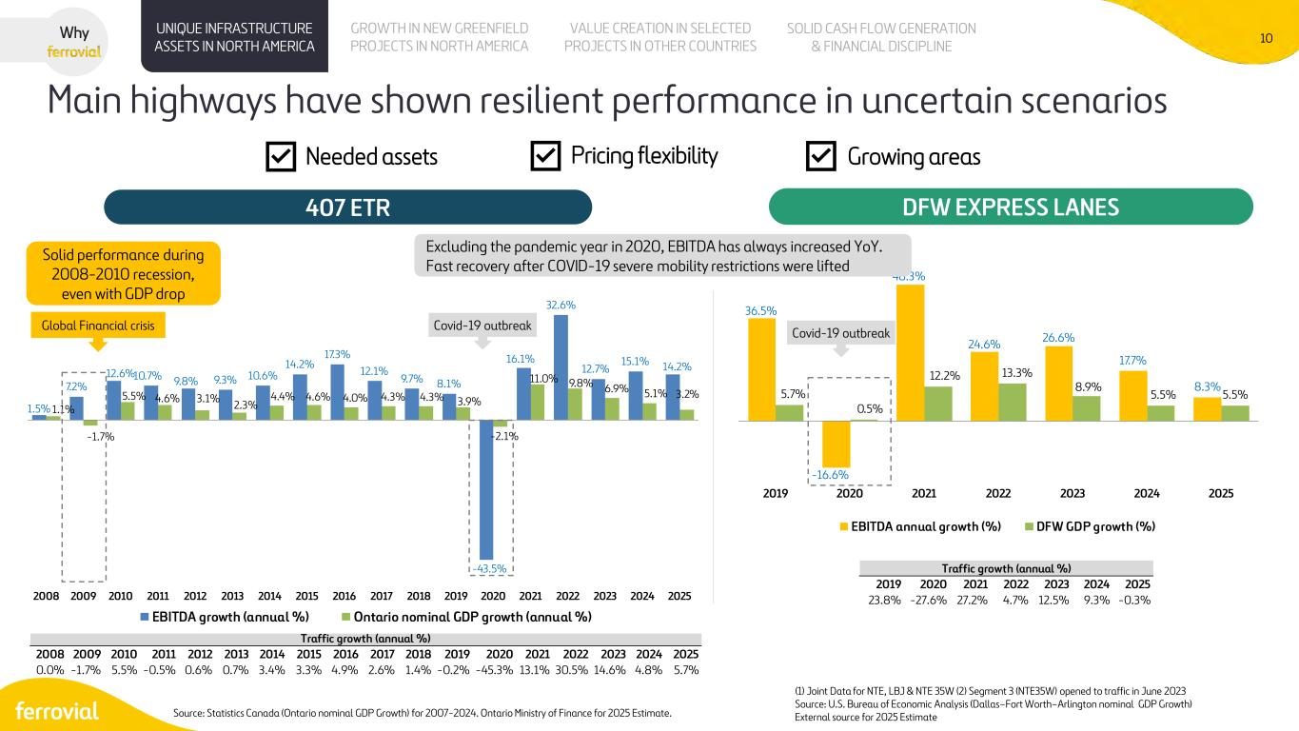
10 1.5% 7.2% 12.6%10.7% 9.8% 9.3% 10.6% 14.2% 17.3% 12.1% 9.7% 8.1% -43.5% 16.1% 32.6% 12.7% 15.1% 14.2% 1.1% -1.7% 5.5% 4.6% 3.1% 2.3% 4.4% 4.6% 4.0% 4.3% 4.3% 3.9% -2.1% 11.0% 9.8% 6.9% 5.1% 3.2% 2008 2009 2010 2011 2012 2013 2014 2015 2016 2017 2018 2019 2020 2021 2022 2023 2024 2025 EBITDA growth (annual %) Ontario nominal GDP growth (annual %) 36.5% -16.6% 48.3% 24.6% 26.6% 17.7% 8.3%5.7% 0.5% 12.2% 13.3% 8.9% 5.5% 5.5% 2019 2020 2021 2022 2023 2024 2025 EBITDA annual growth (%) DFW GDP growth (%) Main highways have shown resilient performance in uncertain scenarios 407 ETR DFW EXPRESS LANES Why UNIQUE INFRASTRUCTURE ASSETS IN NORTH AMERICA VALUE CREATION IN SELECTED PROJECTS IN OTHER COUNTRIES SOLID CASH FLOW GENERATION & FINANCIAL DISCIPLINE GROWTH IN NEW GREENFIELD PROJECTS IN NORTH AMERICA Global Financial crisis (1) Joint Data for NTE, LBJ & NTE 35W (2) Segment 3 (NTE35W) opened to traffic in June 2023 Source: U.S. Bureau of Economic Analysis (Dallas–Fort Worth–Arlington nominal GDP Growth) External source for 2025 Estimate Needed assets Growing areasPricing flexibility Covid-19 outbreak Source: Statistics Canada (Ontario nominal GDP Growth) for 2007-2024. Ontario Ministry of Finance for 2025 Estimate. Excluding the pandemic year in 2020, EBITDA has always increased YoY. Fast recovery after COVID-19 severe mobility restrictions were lifted Solid performance during 2008-2010 recession, even with GDP drop Covid-19 outbreak 2008 2009 2010 2011 2012 2013 2014 2015 2016 2017 2018 2019 2020 2021 2022 2023 2024 2025 0.0% -1.7% 5.5% -0.5% 0.6% 0.7% 3.4% 3.3% 4.9% 2.6% 1.4% -0.2% -45.3% 13.1% 30.5% 14.6% 4.8% 5.7% Traffic growth (annual %) 2019 2020 2021 2022 2023 2024 2025 23.8% -27.6% 27.2% 4.7% 12.5% 9.3% -0.3% Traffic growth (annual %)

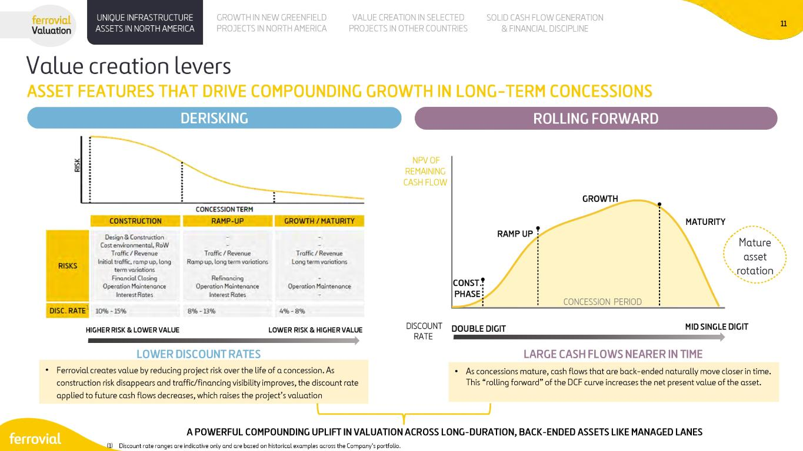

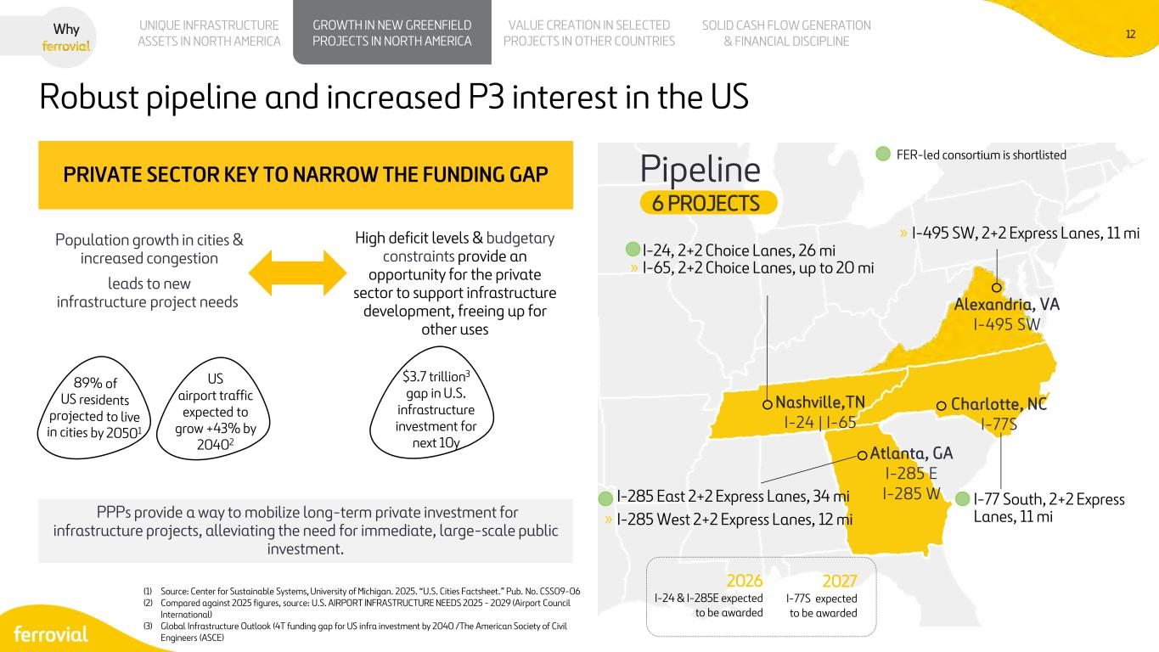
12 Atlanta, GA I-285 E I-285 W Charlotte, NC I-77S Nashville,TN I-24 | I-65 Pipeline 6 PROJECTS Alexandria, VA I-495 SW PRIVATE SECTOR KEY TO NARROW THE FUNDING GAP Population growth in cities & increased congestion leads to new infrastructure project needs US airport traffic expected to grow +43% by 20402 UNIQUE INFRASTRUCTURE ASSETS IN NORTH AMERICA VALUE CREATION IN SELECTED PROJECTS IN OTHER COUNTRIES SOLID CASH FLOW GENERATION & FINANCIAL DISCIPLINE GROWTH IN NEW GREENFIELD PROJECTS IN NORTH AMERICA Why Robust pipeline and increased P3 interest in the US (1) Source: Center for Sustainable Systems, University of Michigan. 2025. “U.S. Cities Factsheet.” Pub. No. CSS09-06 (2) Compared against 2025 figures, source: U.S. AIRPORT INFRASTRUCTURE NEEDS 2025 - 2029 (Airport Council International) (3) Global Infrastructure Outlook (4T funding gap for US infra investment by 2040 /The American Society of Civil Engineers (ASCE) » I-495 SW, 2+2 Express Lanes, 11 mi » I-77 South, 2+2 Express Lanes, 11 mi » I-24, 2+2 Choice Lanes, 26 mi » I-65, 2+2 Choice Lanes, up to 20 mi » I-285 East 2+2 Express Lanes, 34 mi » I-285 West 2+2 Express Lanes, 12 mi High deficit levels & budgetary constraints provide an opportunity for the private sector to support infrastructure development, freeing up for other uses PPPs provide a way to mobilize long-term private investment for infrastructure projects, alleviating the need for immediate, large-scale public investment. $3.7 trillion3 gap in U.S. infrastructure investment for next 10y FER-led consortium is shortlisted 2026 I-24 & I-285E expected to be awarded 2027 I-77S expected to be awarded

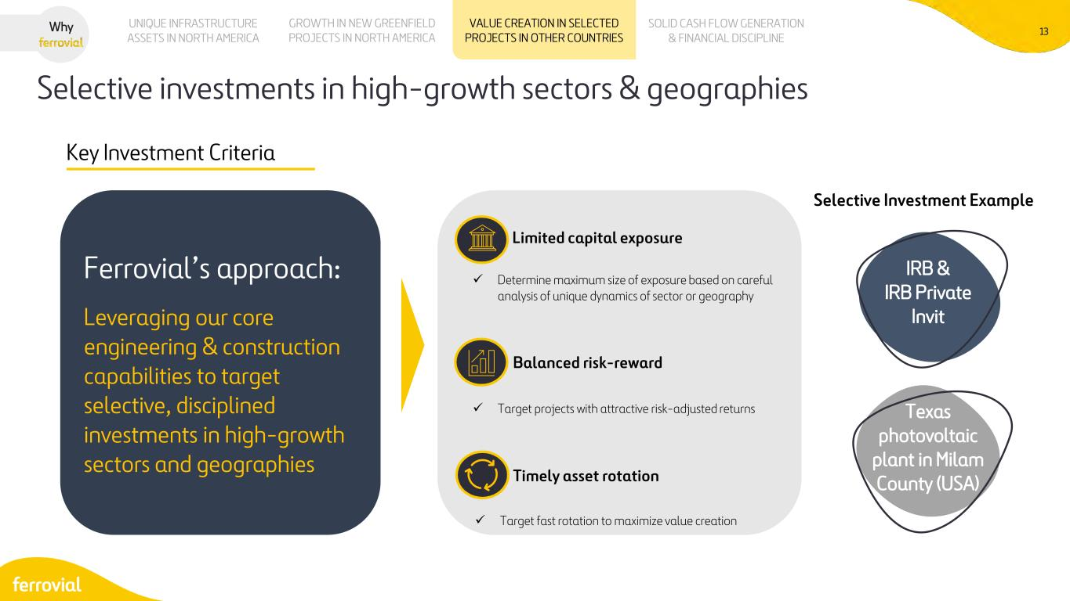
13 UNIQUE INFRASTRUCTURE ASSETS IN NORTH AMERICA VALUE CREATION IN SELECTED PROJECTS IN OTHER COUNTRIES SOLID CASH FLOW GENERATION & FINANCIAL DISCIPLINE GROWTH IN NEW GREENFIELD PROJECTS IN NORTH AMERICA Why Selective investments in high-growth sectors & geographies Ferrovial’s approach: Leveraging our core engineering & construction capabilities to target selective, disciplined investments in high-growth sectors and geographies Limited capital exposure Balanced risk-reward ✓ Determine maximum size of exposure based on careful analysis of unique dynamics of sector or geography ✓ Target projects with attractive risk-adjusted returns ✓ Target fast rotation to maximize value creation Timely asset rotation Key Investment Criteria IRB & IRB Private Invit Selective Investment Example Texas photovoltaic plant in Milam County (USA)

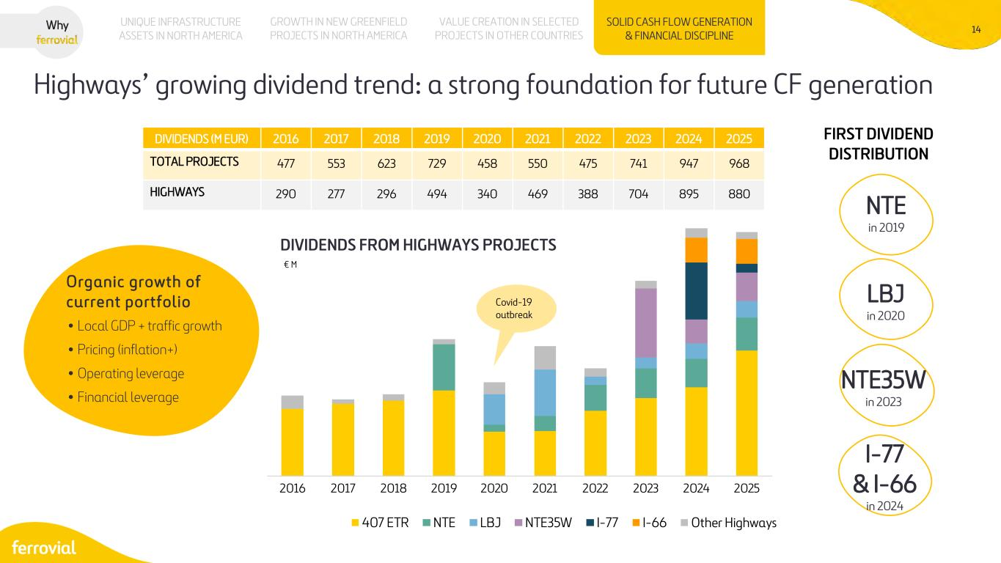
14 DIVIDENDS FROM HIGHWAYS PROJECTS € M UNIQUE INFRASTRUCTURE ASSETS IN NORTH AMERICA VALUE CREATION IN SELECTED PROJECTS IN OTHER COUNTRIES SOLID CASH FLOW GENERATION & FINANCIAL DISCIPLINE GROWTH IN NEW GREENFIELD PROJECTS IN NORTH AMERICA Why Highways’ growing dividend trend: a strong foundation for future CF generation DIVIDENDS (M EUR) 2016 2017 2018 2019 2020 2021 2022 2023 2024 2025 TOTAL PROJECTS 477 553 623 729 458 550 475 741 947 968 HIGHWAYS 290 277 296 494 340 469 388 704 895 880 NTE in 2019 LBJ in 2020 NTE35W in 2023 I-77 & I-66 in 2024 2016 2017 2018 2019 2020 2021 2022 2023 2024 2025 407 ETR NTE LBJ NTE35W I-77 I-66 Other Highways FIRST DIVIDEND DISTRIBUTION Covid-19 outbreak • Local GDP + traffic growth • Pricing (inflation+) • Operating leverage • Financial leverage Organic growth of current portfolio

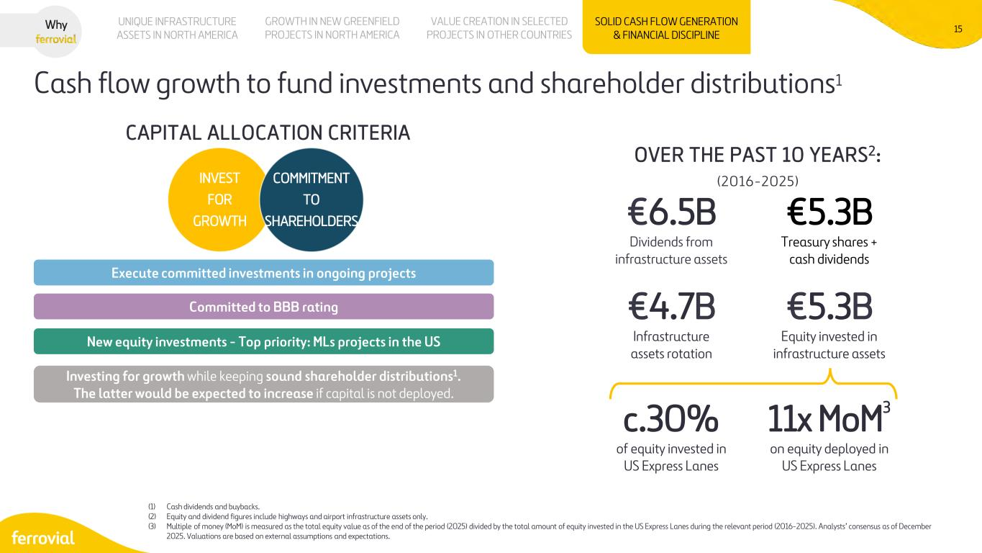
15 CAPITAL ALLOCATION CRITERIA Investing for growth while keeping sound shareholder distributions1. The latter would be expected to increase if capital is not deployed. New equity investments - Top priority: MLs projects in the US Committed to BBB rating Execute committed investments in ongoing projects Cash flow growth to fund investments and shareholder distributions1 (1) Cash dividends and buybacks. (2) Equity and dividend figures include highways and airport infrastructure assets only. (3) Multiple of money (MoM) is measured as the total equity value as of the end of the period (2025) divided by the total amount of equity invested in the US Express Lanes during the relevant period (2016-2025). Analysts’ consensus as of December 2025. Valuations are based on external assumptions and expectations. OVER THE PAST 10 YEARS2: €6.5B Dividends from infrastructure assets €5.3B Treasury shares + cash dividends €5.3B Equity invested in infrastructure assets c.30% of equity invested in US Express Lanes €4.7B Infrastructure assets rotation 11x MoM3 on equity deployed in US Express Lanes (2016-2025) UNIQUE INFRASTRUCTURE ASSETS IN NORTH AMERICA VALUE CREATION IN SELECTED PROJECTS IN OTHER COUNTRIES SOLID CASH FLOW GENERATION & FINANCIAL DISCIPLINE GROWTH IN NEW GREENFIELD PROJECTS IN NORTH AMERICA INVEST FOR GROWTH COMMITMENT TO SHAREHOLDERS Why

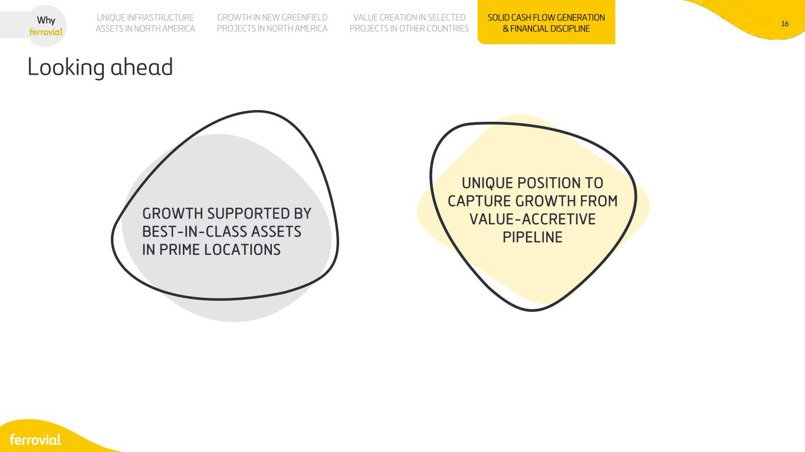
16 Looking ahead UNIQUE INFRASTRUCTURE ASSETS IN NORTH AMERICA VALUE CREATION IN SELECTED PROJECTS IN OTHER COUNTRIES SOLID CASH FLOW GENERATION & FINANCIAL DISCIPLINE GROWTH IN NEW GREENFIELD PROJECTS IN NORTH AMERICA Why UNIQUE POSITION TO CAPTURE GROWTH FROM VALUE-ACCRETIVE PIPELINE GROWTH SUPPORTED BY BEST-IN-CLASS ASSETS IN PRIME LOCATIONS


17 WHICH APPROACH BEST CAPTURES FERROVIAL’S REAL VALUE?

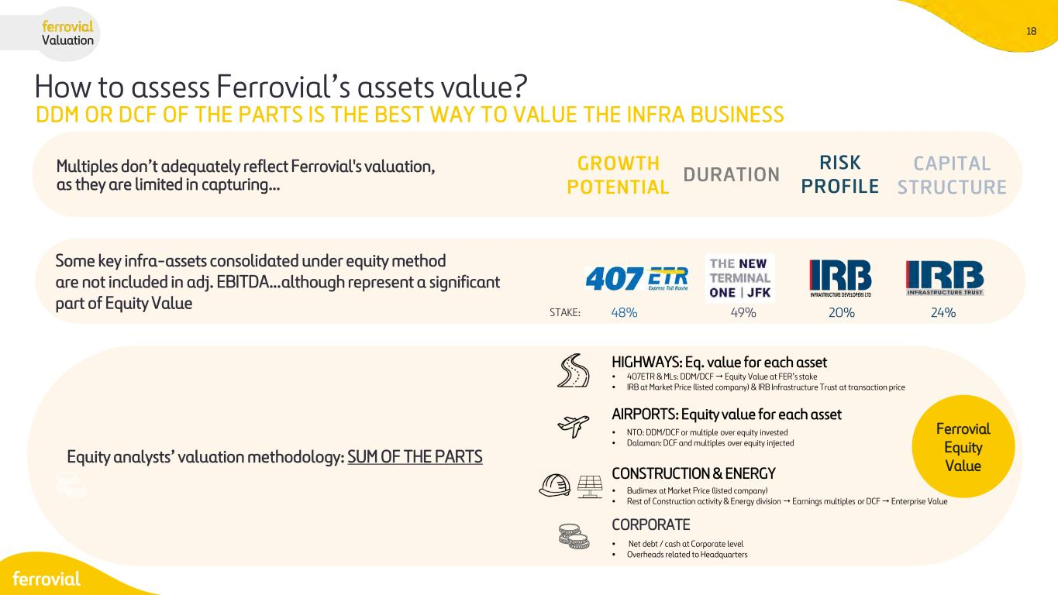
18 How to assess Ferrovial’s assets value? Valuation Multiples don’t adequately reflect Ferrovial's valuation, as they are limited in capturing… GROWTH POTENTIAL DURATION RISK PROFILE CAPITAL STRUCTURE Some key infra-assets consolidated under equity method are not included in adj. EBITDA…although represent a significant part of Equity Value 49% 20% 24%STAKE: Equity analysts’ valuation methodology: SUM OF THE PARTS HIGHWAYS: Eq. value for each asset AIRPORTS: Equity value for each asset CONSTRUCTION & ENERGY CORPORATE DDM OR DCF OF THE PARTS IS THE BEST WAY TO VALUE THE INFRA BUSINESS • 407ETR & MLs: DDM/DCF  Equity Value at FER’s stake • IRB at Market Price (listed company) & IRB Infrastructure Trust at transaction price • NTO: DDM/DCF or multiple over equity invested • Dalaman: DCF and multiples over equity injected • Budimex at Market Price (listed company) • Rest of Construction activity & Energy division  Earnings multiples or DCF  Enterprise Value • Net debt / cash at Corporate level • Overheads related to Headquarters Ferrovial Equity Value 48%


19 HIGHWAYS

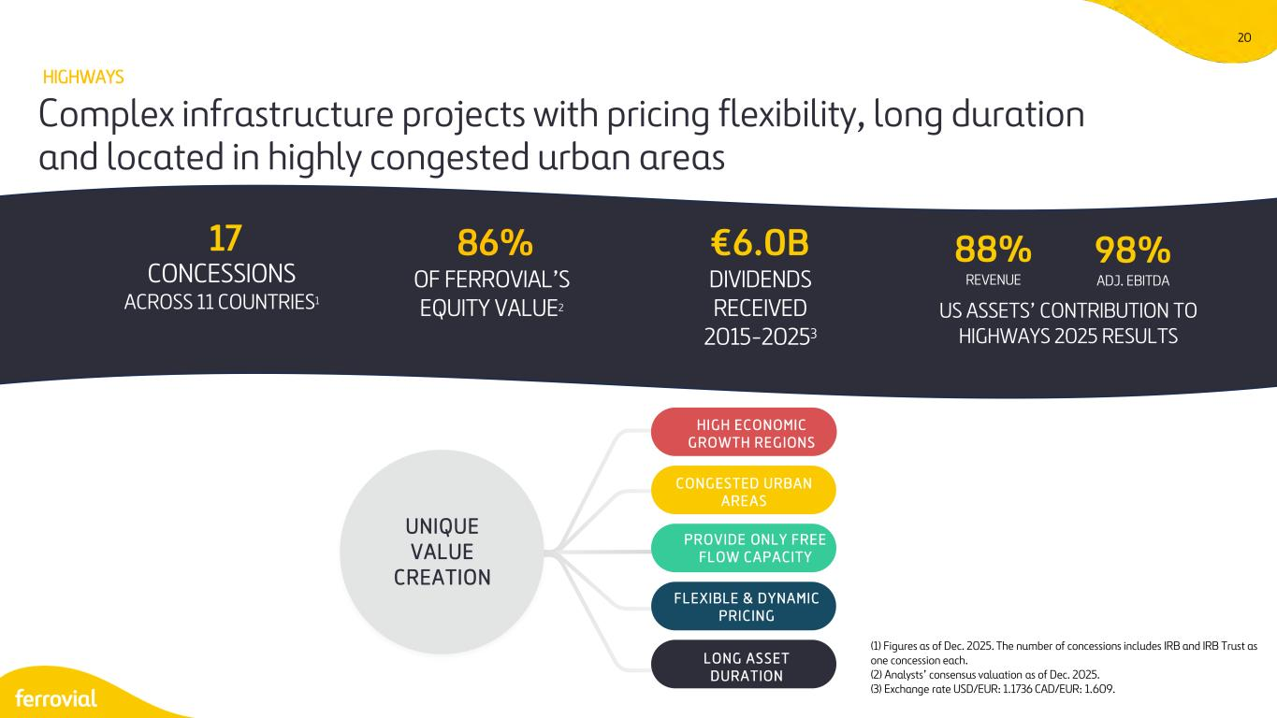
20 (1) Figures as of Dec. 2025. The number of concessions includes IRB and IRB Trust as one concession each. (2) Analysts’ consensus valuation as of Dec. 2025. (3) Exchange rate USD/EUR: 1.1736 CAD/EUR: 1.609. Complex infrastructure projects with pricing flexibility, long duration and located in highly congested urban areas UNIQUE VALUE CREATION HI G H E C O N OMIC G RO WTH RE G ION S C O N G ESTED URB A N A RE A S P RO V IDE ON LY F RE E F L OW C A P A C ITY F L E XIBLE & D Y N A M IC P RI C IN G L O N G A S S ET D URA T ION 88% REVENUE 98% ADJ. EBITDA 17 CONCESSIONS ACROSS 11 COUNTRIES1 €6.0B DIVIDENDS RECEIVED 2015-20253 86% OF FERROVIAL’S EQUITY VALUE2 HIGHWAYS US ASSETS’ CONTRIBUTION TO HIGHWAYS 2025 RESULTS

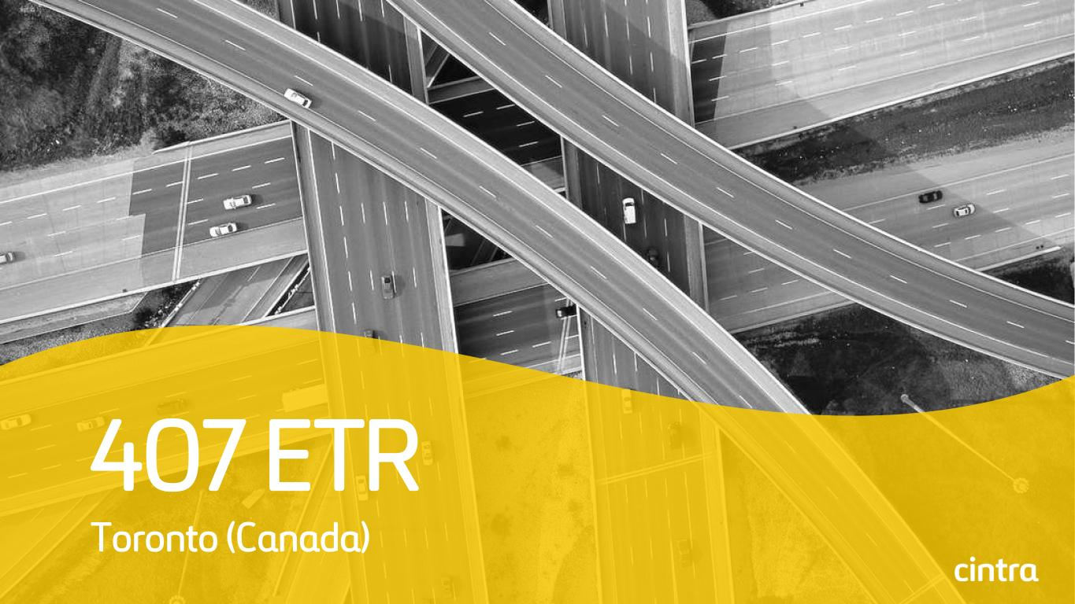
21 407 ETR Toronto (Canada)

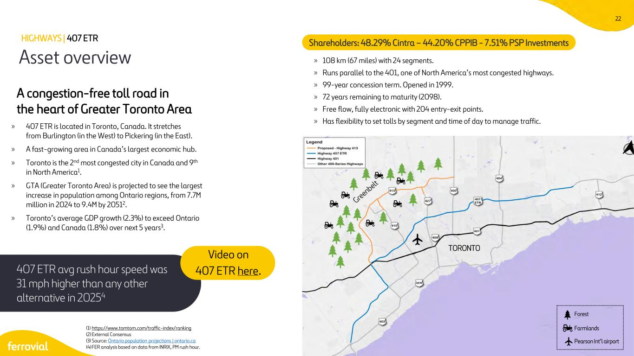
22 Asset overview » 407 ETR is located in Toronto, Canada. It stretches from Burlington (in the West) to Pickering (in the East). » A fast-growing area in Canada’s largest economic hub. » Toronto is the 2nd most congested city in Canada and 9th in North America1. » GTA (Greater Toronto Area) is projected to see the largest increase in population among Ontario regions, from 7.7M million in 2024 to 9.4M by 20512. » Toronto’s average GDP growth (2.3%) to exceed Ontario (1.9%) and Canada (1.8%) over next 5 years3. A congestion-free toll road in the heart of Greater Toronto Area » 108 km (67 miles) with 24 segments. » Runs parallel to the 401, one of North America’s most congested highways. » 99-year concession term. Opened in 1999. » 72 years remaining to maturity (2098). » Free flow, fully electronic with 204 entry-exit points. » Has flexibility to set tolls by segment and time of day to manage traffic. Shareholders: 48.29% Cintra – 44.20% CPPIB - 7.51% PSP Investments (1) https://www.tomtom.com/traffic-index/ranking (2) External Consensus (3) Source: Ontario population projections | ontario.ca (4)FER analysis based on data from INRIX, PM rush hour. HIGHWAYS | 407 ETR 407 ETR avg rush hour speed was 31 mph higher than any other alternative in 20254 Video on 407 ETR here. TORONTO Forest Farmlands Pearson Int’l airport

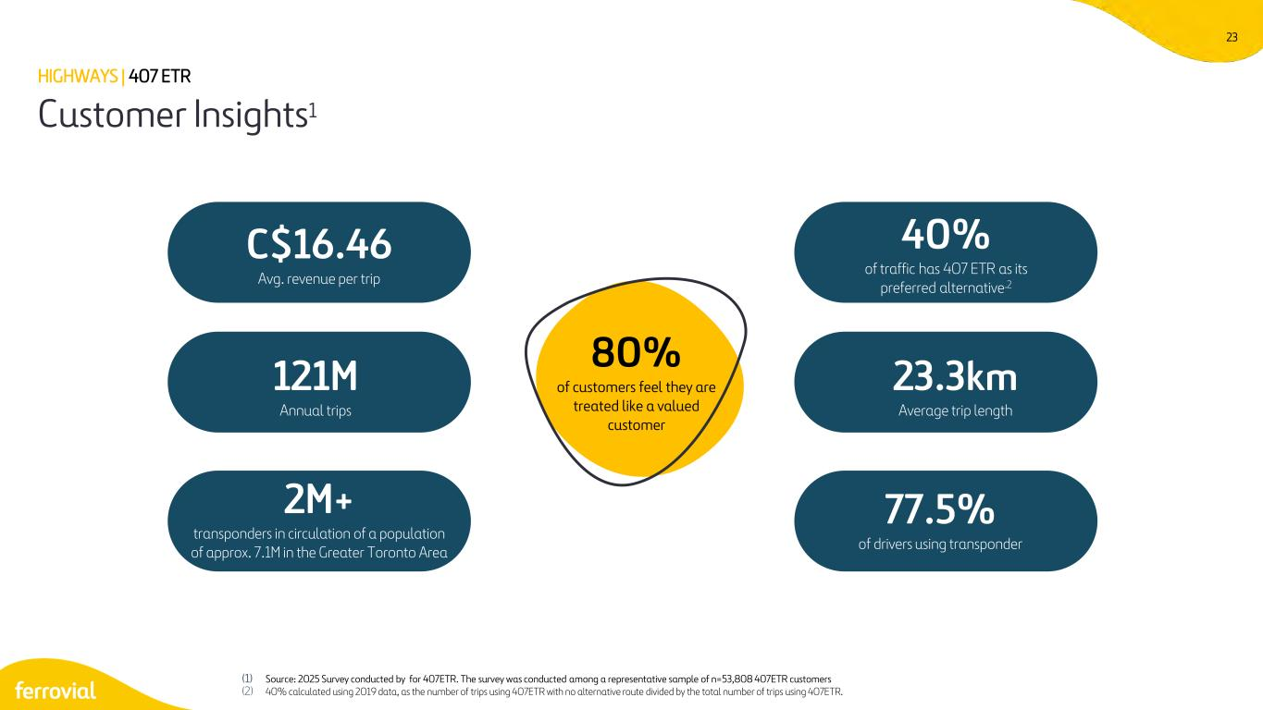
23 Customer Insights1 (1) Source: 2025 Survey conducted by for 407ETR. The survey was conducted among a representative sample of n=53,808 407ETR customers (2) 40% calculated using 2019 data, as the number of trips using 407ETR with no alternative route divided by the total number of trips using 407ETR. C$16.46 Avg. revenue per trip 121M Annual trips 23.3km Average trip length 77.5% of drivers using transponder 2M+ transponders in circulation of a population of approx. 7.1M in the Greater Toronto Area HIGHWAYS | 407 ETR 80% of customers feel they are treated like a valued customer 40% of traffic has 407 ETR as its preferred alternative.2

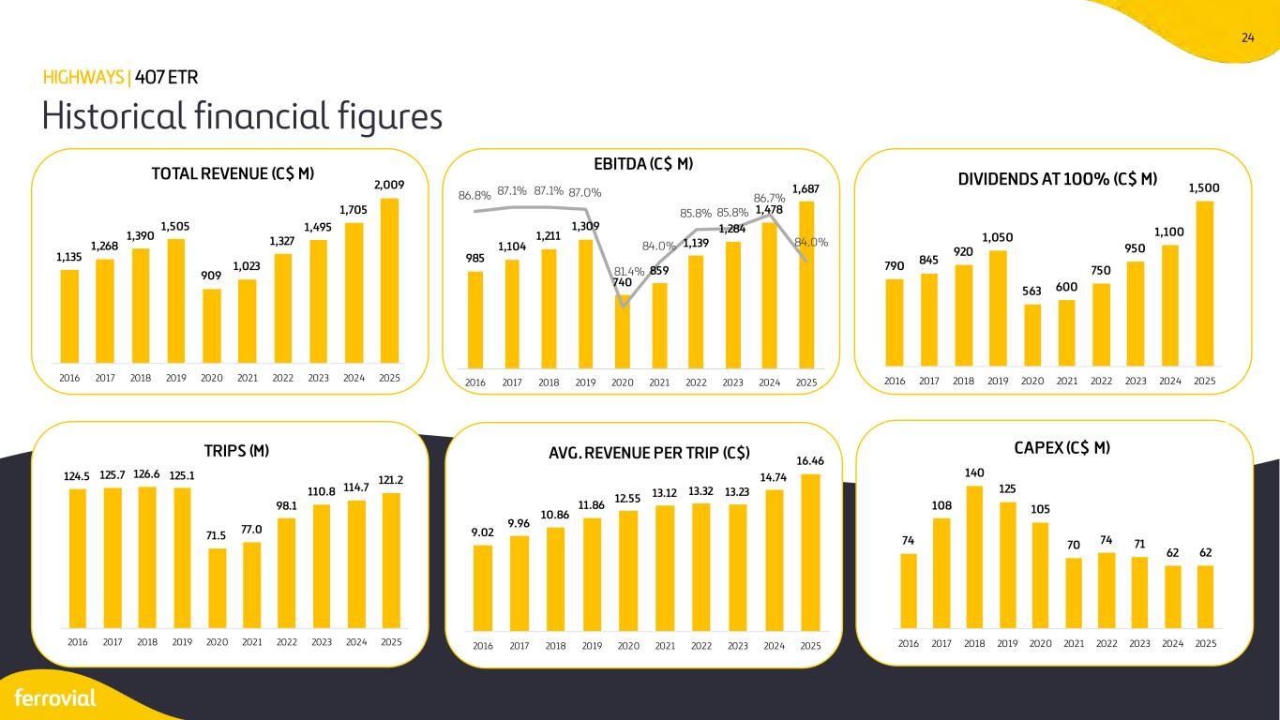
24 Historical financial figures HIGHWAYS | 407 ETR 1,135 1,268 1,390 1,505 909 1,023 1,327 1,495 1,705 2,009 2016 2017 2018 2019 2020 2021 2022 2023 2024 2025 TOTAL REVENUE (C$ M) 790 845 920 1,050 563 600 750 950 1,100 1,500 2016 2017 2018 2019 2020 2021 2022 2023 2024 2025 DIVIDENDS AT 100% (C$ M) 124.5 125.7 126.6 125.1 71.5 77.0 98.1 110.8 114.7 121.2 2016 2017 2018 2019 2020 2021 2022 2023 2024 2025 TRIPS (M) 9.02 9.96 10.86 11.86 12.55 13.12 13.32 13.23 14.74 16.46 2016 2017 2018 2019 2020 2021 2022 2023 2024 2025 AVG. REVENUE PER TRIP (C$) 74 108 140 125 105 70 74 71 62 62 2016 2017 2018 2019 2020 2021 2022 2023 2024 2025 CAPEX (C$ M) 985 1,104 1,211 1,309 740 859 1,139 1,284 1,478 1,68786.8% 87.1% 87.1% 87.0% 81.4% 84.0% 85.8% 85.8% 86.7% 84.0% 78.0% 79.0% 80.0% 81.0% 82.0% 83.0% 84.0% 85.0% 86.0% 87.0% 88.0% 0 200 400 600 800 1,000 1,200 1,400 1,600 1,800 2016 2017 2018 2019 2020 2021 2022 2023 2024 2025 EBITDA (C$ M)

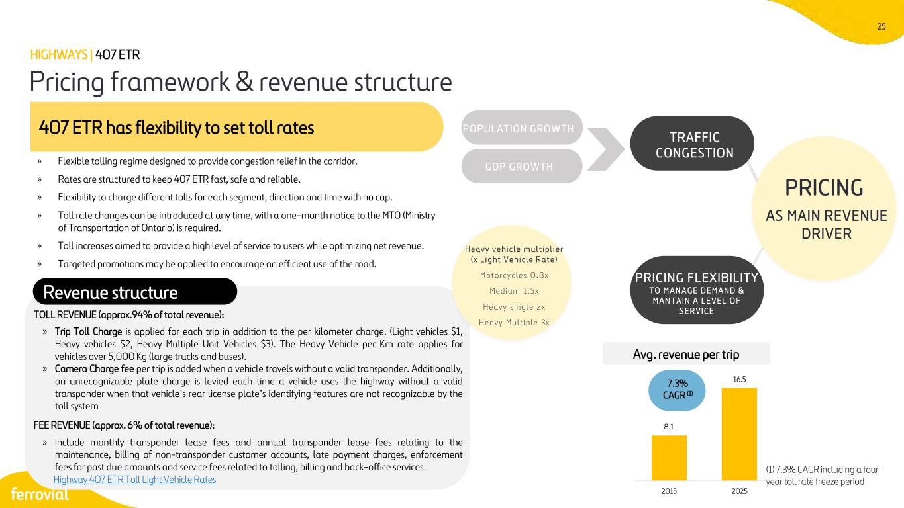
25 » Flexible tolling regime designed to provide congestion relief in the corridor. » Rates are structured to keep 407 ETR fast, safe and reliable. » Flexibility to charge different tolls for each segment, direction and time with no cap. » Toll rate changes can be introduced at any time, with a one-month notice to the MTO (Ministry of Transportation of Ontario) is required. » Toll increases aimed to provide a high level of service to users while optimizing net revenue. » Targeted promotions may be applied to encourage an efficient use of the road. 407 ETR has flexibility to set toll rates Pricing framework & revenue structure HIGHWAYS | 407 ETR PRICING AS MAIN REVENUE DRIVER P O P ULAT ION G RO WTH G D P G RO WT H TRAFFIC CONGESTION PRICING FLEXIBILITY T O M A N A G E D E M A N D & M A N T A I N A L E V E L O F S E R V I C ETOLL REVENUE (approx.94% of total revenue): » Trip Toll Charge is applied for each trip in addition to the per kilometer charge. (Light vehicles $1, Heavy vehicles $2, Heavy Multiple Unit Vehicles $3). The Heavy Vehicle per Km rate applies for vehicles over 5,000 Kg (large trucks and buses). » Camera Charge fee per trip is added when a vehicle travels without a valid transponder. Additionally, an unrecognizable plate charge is levied each time a vehicle uses the highway without a valid transponder when that vehicle’s rear license plate’s identifying features are not recognizable by the toll system FEE REVENUE (approx. 6% of total revenue): » Include monthly transponder lease fees and annual transponder lease fees relating to the maintenance, billing of non-transponder customer accounts, late payment charges, enforcement fees for past due amounts and service fees related to tolling, billing and back-office services. Highway 407 ETR Toll Light Vehicle Rates Revenue structure Avg. revenue per trip 7.3% CAGR (1) H e a v y v e h i c l e m u l t i p l i e r ( x L i g h t V e h i c l e R a t e ) M o t o r c y c l e s 0 . 8 x M e d i u m 1 . 5 x H e a v y s i n g l e 2 x H e a v y M u l t i pl e 3x (1) 7.3% CAGR including a four- year toll rate freeze period 8.1 16.5 2015 2025

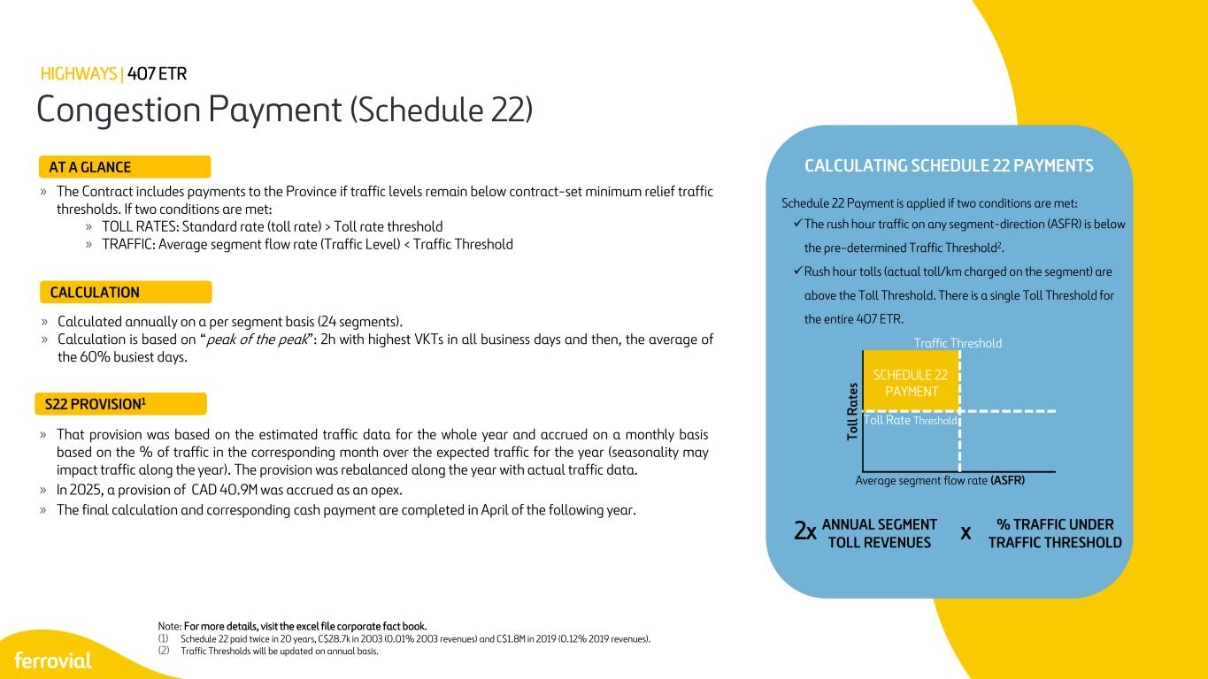
26 » The Contract includes payments to the Province if traffic levels remain below contract-set minimum relief traffic thresholds. If two conditions are met: » TOLL RATES: Standard rate (toll rate) > Toll rate threshold » TRAFFIC: Average segment flow rate (Traffic Level) < Traffic Threshold Congestion Payment (Schedule 22) HIGHWAYS | 407 ETR Note: For more details, visit the excel file corporate fact book. (1) Schedule 22 paid twice in 20 years, C$28.7k in 2003 (0.01% 2003 revenues) and C$1.8M in 2019 (0.12% 2019 revenues). (2) Traffic Thresholds will be updated on annual basis. » That provision was based on the estimated traffic data for the whole year and accrued on a monthly basis based on the % of traffic in the corresponding month over the expected traffic for the year (seasonality may impact traffic along the year). The provision was rebalanced along the year with actual traffic data. » In 2025, a provision of CAD 40.9M was accrued as an opex. » The final calculation and corresponding cash payment are completed in April of the following year. AT A GLANCE CALCULATION S22 PROVISION1 » Calculated annually on a per segment basis (24 segments). » Calculation is based on “peak of the peak”: 2h with highest VKTs in all business days and then, the average of the 60% busiest days. Toll Rate Threshold Traffic Threshold To ll Ra te s Average segment flow rate (ASFR) SCHEDULE 22 PAYMENT Schedule 22 Payment is applied if two conditions are met: ✓The rush hour traffic on any segment-direction (ASFR) is below the pre-determined Traffic Threshold2. ✓Rush hour tolls (actual toll/km charged on the segment) are above the Toll Threshold. There is a single Toll Threshold for the entire 407 ETR. 2x CALCULATING SCHEDULE 22 PAYMENTS ANNUAL SEGMENT TOLL REVENUES % TRAFFIC UNDER TRAFFIC THRESHOLDx

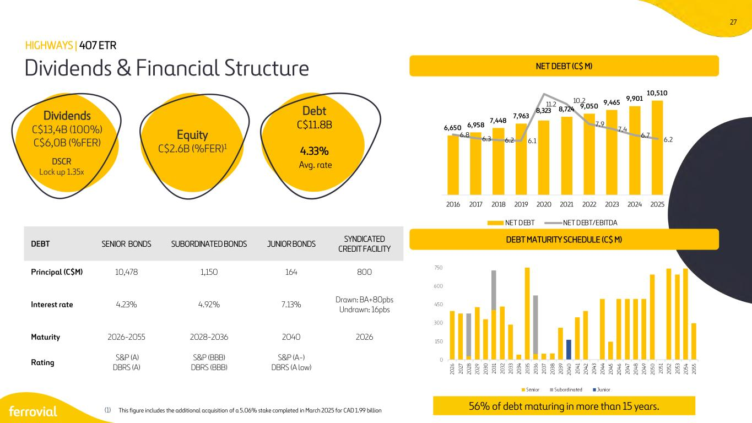
27 56% of debt maturing in more than 15 years. Dividends & Financial Structure HIGHWAYS | 407 ETR DEBT SENIOR BONDS SUBORDINATED BONDS JUNIOR BONDS SYNDICATED CREDIT FACILITY Principal (C$M) 10,478 1,150 164 800 Interest rate 4.23% 4.92% 7.13% Drawn: BA+80pbs Undrawn: 16pbs Maturity 2026-2055 2028-2036 2040 2026 Rating S&P (A) DBRS (A) S&P (BBB) DBRS (BBB) S&P (A-) DBRS (A low) Dividends C$13,4B (100%) C$6,0B (%FER) DSCR Lock up 1.35x Equity C$2.6B (%FER)1 Debt C$11.8B 4.33% Avg. rate (1) This figure includes the additional acquisition of a 5.06% stake completed in March 2025 for CAD 1.99 billion DEBT MATURITY SCHEDULE (C$ M) NET DEBT (C$ M) 6,650 6,958 7,448 7,963 8,323 8,724 9,050 9,465 9,901 10,510 6.8 6.3 6.2 6.1 11.2 10.2 7.9 7.4 6.7 6.2 0 2000 4000 6000 8000 10000 12000 2016 2017 2018 2019 2020 2021 2022 2023 2024 2025 NET DEBT NET DEBT/EBITDA

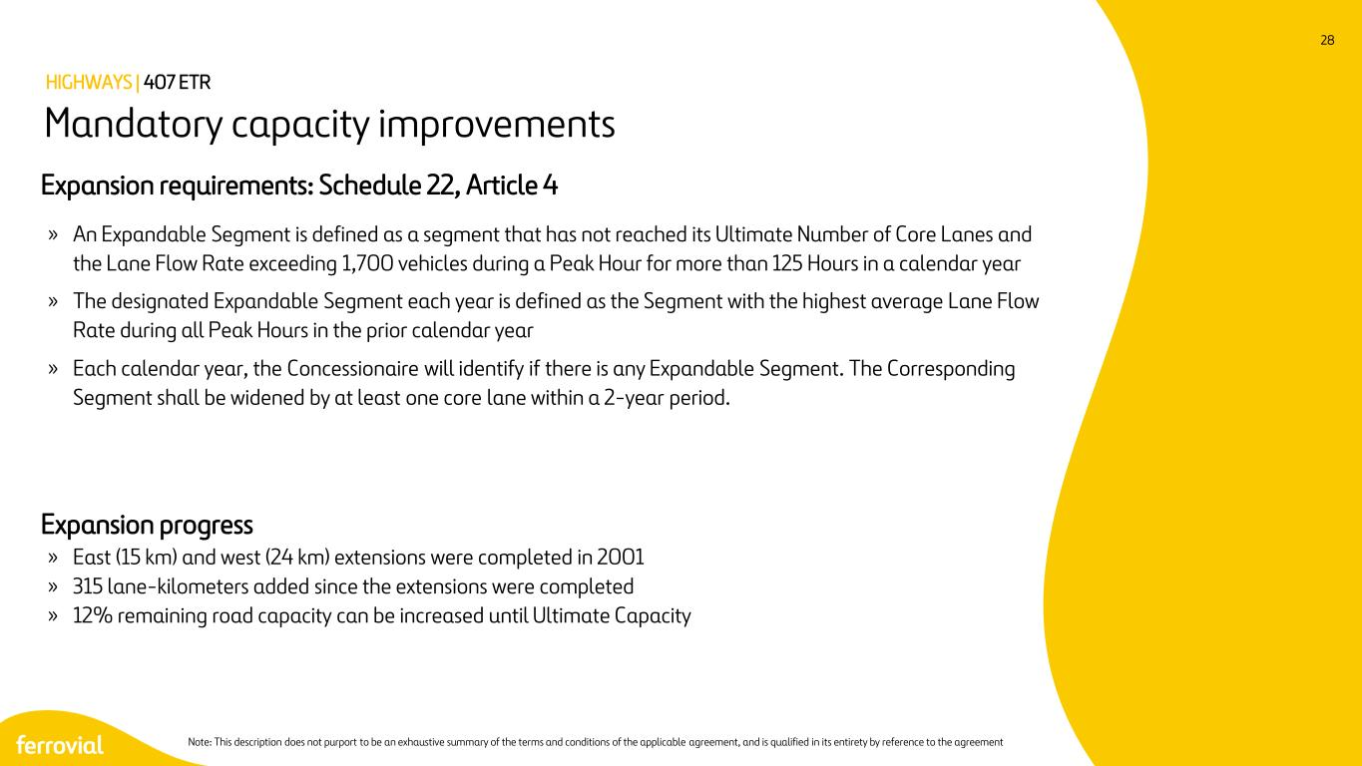
28 Expansion requirements: Schedule 22, Article 4 » An Expandable Segment is defined as a segment that has not reached its Ultimate Number of Core Lanes and the Lane Flow Rate exceeding 1,700 vehicles during a Peak Hour for more than 125 Hours in a calendar year » The designated Expandable Segment each year is defined as the Segment with the highest average Lane Flow Rate during all Peak Hours in the prior calendar year » Each calendar year, the Concessionaire will identify if there is any Expandable Segment. The Corresponding Segment shall be widened by at least one core lane within a 2-year period. Expansion progress » East (15 km) and west (24 km) extensions were completed in 2001 » 315 lane-kilometers added since the extensions were completed » 12% remaining road capacity can be increased until Ultimate Capacity Mandatory capacity improvements HIGHWAYS | 407 ETR Note: This description does not purport to be an exhaustive summary of the terms and conditions of the applicable agreement, and is qualified in its entirety by reference to the agreement

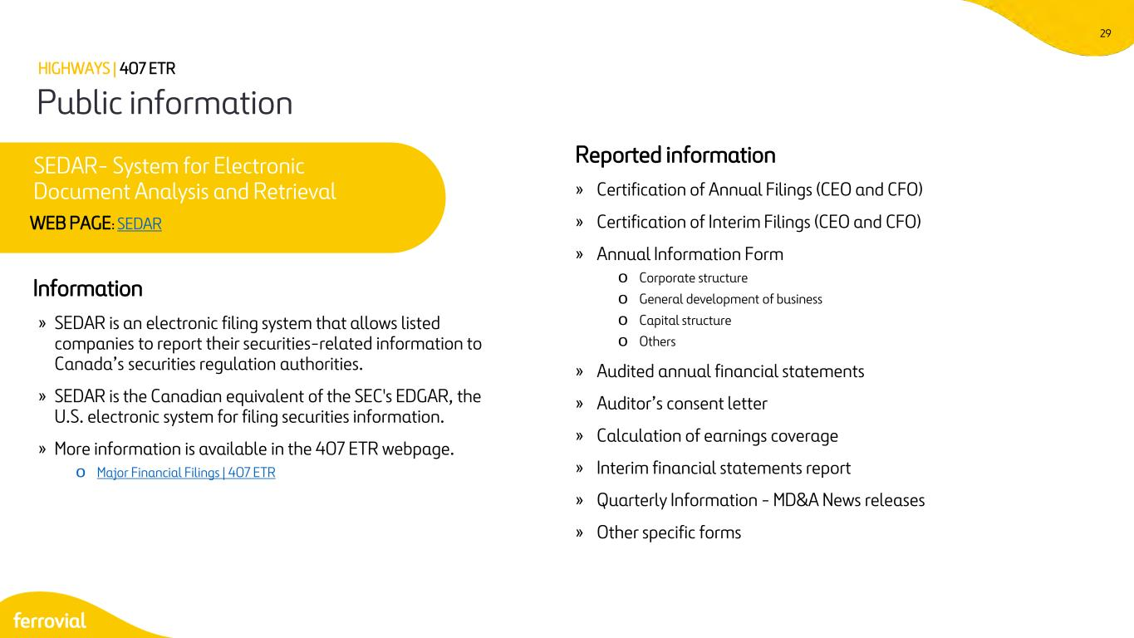
29 Information » SEDAR is an electronic filing system that allows listed companies to report their securities-related information to Canada’s securities regulation authorities. » SEDAR is the Canadian equivalent of the SEC's EDGAR, the U.S. electronic system for filing securities information. » More information is available in the 407 ETR webpage. o Major Financial Filings | 407 ETR Reported information » Certification of Annual Filings (CEO and CFO) » Certification of Interim Filings (CEO and CFO) » Annual Information Form o Corporate structure o General development of business o Capital structure o Others » Audited annual financial statements » Auditor’s consent letter » Calculation of earnings coverage » Interim financial statements report » Quarterly Information - MD&A News releases » Other specific forms Public information HIGHWAYS | 407 ETR SEDAR- System for Electronic Document Analysis and Retrieval WEB PAGE: SEDAR


US Express Lanes 30

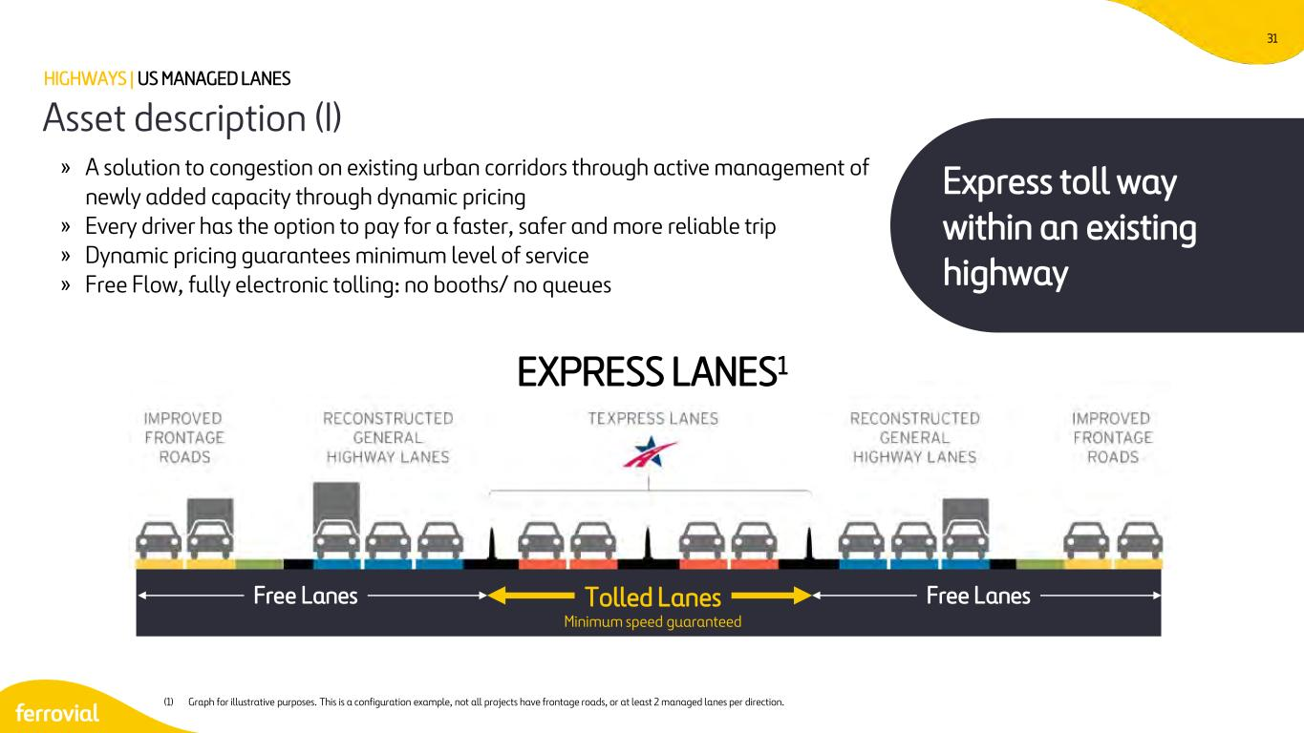
31 » A solution to congestion on existing urban corridors through active management of newly added capacity through dynamic pricing » Every driver has the option to pay for a faster, safer and more reliable trip » Dynamic pricing guarantees minimum level of service » Free Flow, fully electronic tolling: no booths/ no queues Asset description (I) HIGHWAYS | US MANAGED LANES Free Lanes Free LanesTolled Lanes Minimum speed guaranteed EXPRESS LANES1 Express toll way within an existing highway (1) Graph for illustrative purposes. This is a configuration example, not all projects have frontage roads, or at least 2 managed lanes per direction.

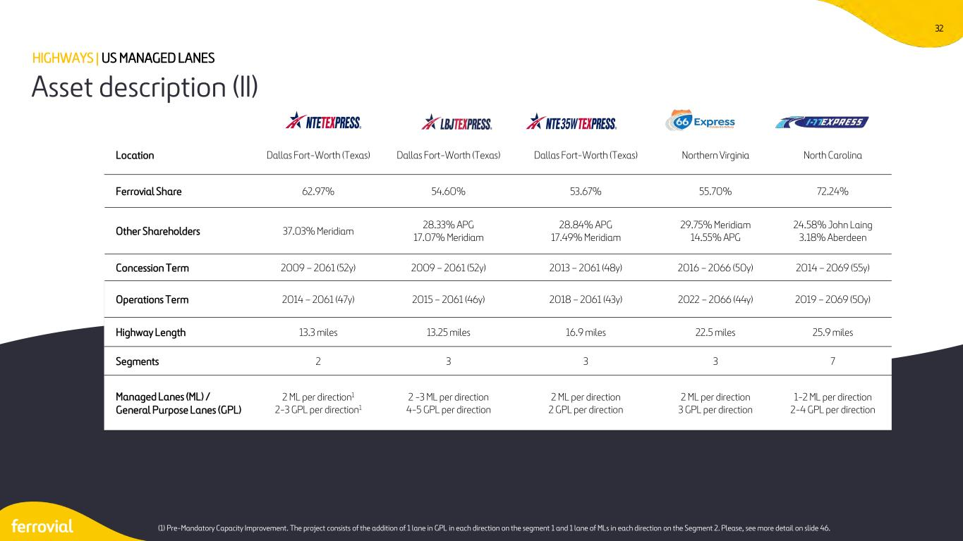
32 Asset description (II) HIGHWAYS | US MANAGED LANES (1) Pre-Mandatory Capacity Improvement. The project consists of the addition of 1 lane in GPL in each direction on the segment 1 and 1 lane of MLs in each direction on the Segment 2. Please, see more detail on slide 46. Location Dallas Fort-Worth (Texas) Dallas Fort-Worth (Texas) Dallas Fort-Worth (Texas) Northern Virginia North Carolina Ferrovial Share 62.97% 54.60% 53.67% 55.70% 72.24% Other Shareholders 37.03% Meridiam 28.33% APG 17.07% Meridiam 28.84% APG 17.49% Meridiam 29.75% Meridiam 14.55% APG 24.58% John Laing 3.18% Aberdeen Concession Term 2009 – 2061 (52y) 2009 – 2061 (52y) 2013 – 2061 (48y) 2016 – 2066 (50y) 2014 – 2069 (55y) Operations Term 2014 – 2061 (47y) 2015 – 2061 (46y) 2018 – 2061 (43y) 2022 – 2066 (44y) 2019 – 2069 (50y) Highway Length 13.3 miles 13.25 miles 16.9 miles 22.5 miles 25.9 miles Segments 2 3 3 3 7 Managed Lanes (ML) / General Purpose Lanes (GPL) 2 ML per direction1 2-3 GPL per direction1 2 -3 ML per direction 4-5 GPL per direction 2 ML per direction 2 GPL per direction 2 ML per direction 3 GPL per direction 1-2 ML per direction 2-4 GPL per direction

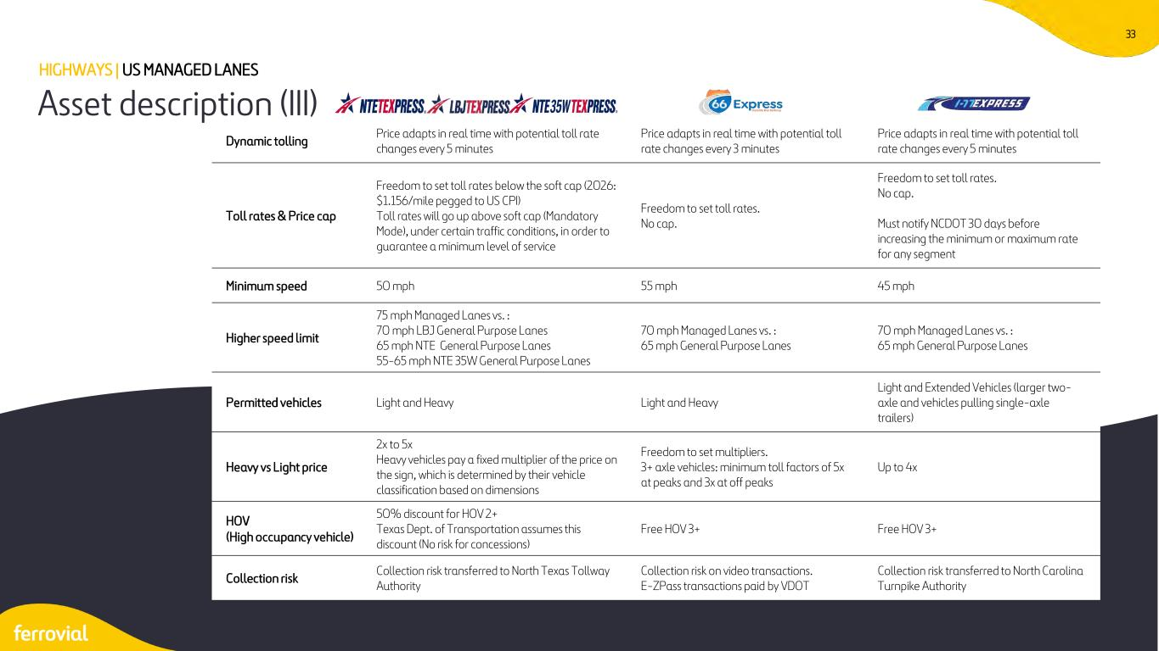
33 Asset description (III) HIGHWAYS | US MANAGED LANES Dynamic tolling Price adapts in real time with potential toll rate changes every 5 minutes Price adapts in real time with potential toll rate changes every 3 minutes Price adapts in real time with potential toll rate changes every 5 minutes Toll rates & Price cap Freedom to set toll rates below the soft cap (2026: $1.156/mile pegged to US CPI) Toll rates will go up above soft cap (Mandatory Mode), under certain traffic conditions, in order to guarantee a minimum level of service Freedom to set toll rates. No cap. Freedom to set toll rates. No cap. Must notify NCDOT 30 days before increasing the minimum or maximum rate for any segment Minimum speed 50 mph 55 mph 45 mph Higher speed limit 75 mph Managed Lanes vs. : 70 mph LBJ General Purpose Lanes 65 mph NTE General Purpose Lanes 55-65 mph NTE 35W General Purpose Lanes 70 mph Managed Lanes vs. : 65 mph General Purpose Lanes 70 mph Managed Lanes vs. : 65 mph General Purpose Lanes Permitted vehicles Light and Heavy Light and Heavy Light and Extended Vehicles (larger two- axle and vehicles pulling single-axle trailers) Heavy vs Light price 2x to 5x Heavy vehicles pay a fixed multiplier of the price on the sign, which is determined by their vehicle classification based on dimensions Freedom to set multipliers. 3+ axle vehicles: minimum toll factors of 5x at peaks and 3x at off peaks Up to 4x HOV (High occupancy vehicle) 50% discount for HOV 2+ Texas Dept. of Transportation assumes this discount (No risk for concessions) Free HOV 3+ Free HOV 3+ Collection risk Collection risk transferred to North Texas Tollway Authority Collection risk on video transactions. E-ZPass transactions paid by VDOT Collection risk transferred to North Carolina Turnpike Authority


NTE | LBJ | NTE 35W Dallas Fort-Worth

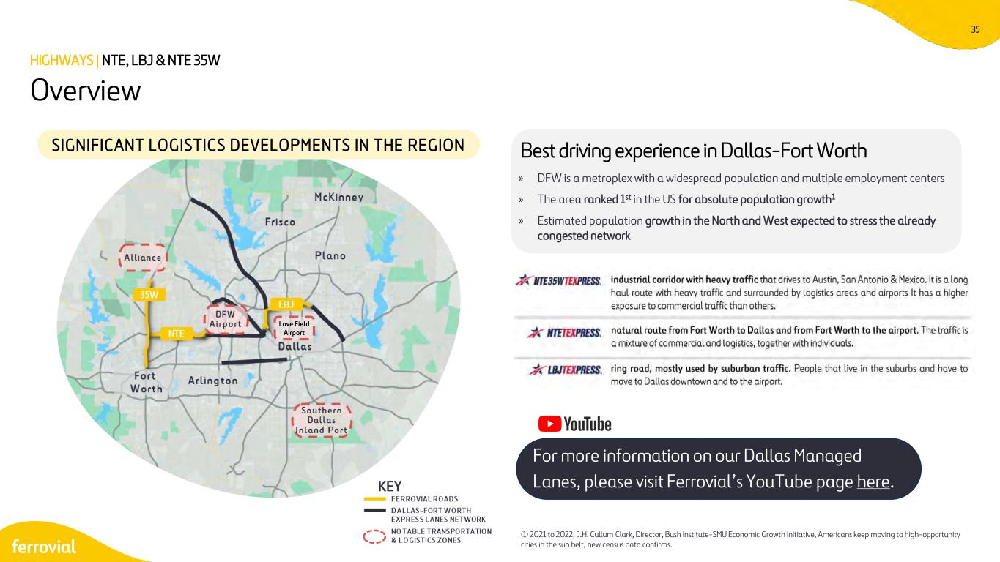
35 » DFW is a metroplex with a widespread population and multiple employment centers » The area ranked 1st in the US for absolute population growth1 » Estimated population growth in the North and West expected to stress the already congested network Overview HIGHWAYS | NTE, LBJ & NTE 35W SIGNIFICANT LOGISTICS DEVELOPMENTS IN THE REGION Best driving experience in Dallas-Fort Worth (1) 2021 to 2022, J.H. Cullum Clark, Director, Bush Institute-SMU Economic Growth Initiative, Americans keep moving to high-opportunity cities in the sun belt, new census data confirms. Love Field Airport For more information on our Dallas Managed Lanes, please visit Ferrovial’s YouTube page here.

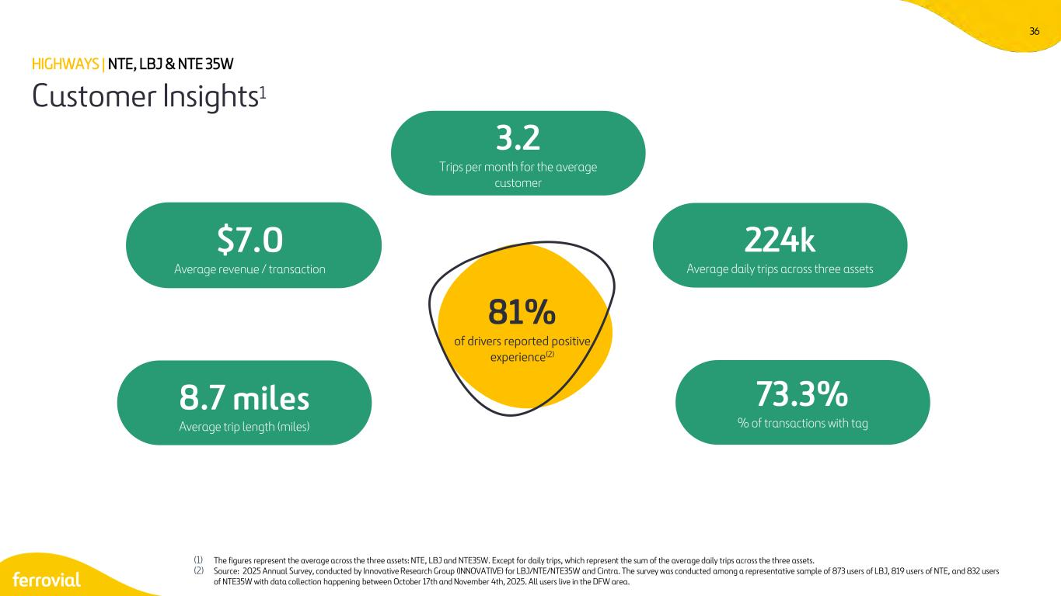
36 Customer Insights1 (1) The figures represent the average across the three assets: NTE, LBJ and NTE35W. Except for daily trips, which represent the sum of the average daily trips across the three assets. (2) Source: 2025 Annual Survey, conducted by Innovative Research Group (INNOVATIVE) for LBJ/NTE/NTE35W and Cintra. The survey was conducted among a representative sample of 873 users of LBJ, 819 users of NTE, and 832 users of NTE35W with data collection happening between October 17th and November 4th, 2025. All users live in the DFW area. $7.0 Average revenue / transaction 224k Average daily trips across three assets 8.7 miles Average trip length (miles) 3.2 Trips per month for the average customer 73.3% % of transactions with tag 81% of drivers reported positive experience(2) HIGHWAYS | NTE, LBJ & NTE 35W

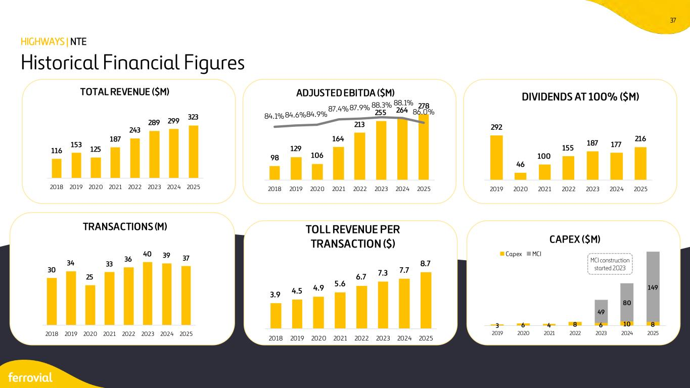
37 Historical Financial Figures HIGHWAYS | NTE MCI construction started 2023 116 153 125 187 243 289 299 323 2018 2019 2020 2021 2022 2023 2024 2025 TOTAL REVENUE ($M) 98 129 106 164 213 255 264 278 84.1% 84.6%84.9% 87.4% 87.9% 88.3% 88.1% 86.0% 2018 2019 2020 2021 2022 2023 2024 2025 ADJUSTED EBITDA ($M) 292 46 100 155 187 177 216 2019 2020 2021 2022 2023 2024 2025 DIVIDENDS AT 100% ($M) 30 34 25 33 36 40 39 37 2018 2019 2020 2021 2022 2023 2024 2025 TRANSACTIONS (M) 3.9 4.5 4.9 5.6 6.7 7.3 7.7 8.7 2018 2019 2020 2021 2022 2023 2024 2025 TOLL REVENUE PER TRANSACTION ($) 3 6 4 8 6 10 8 49 80 149 2019 2020 2021 2022 2023 2024 2025 CAPEX ($M) Capex MCI

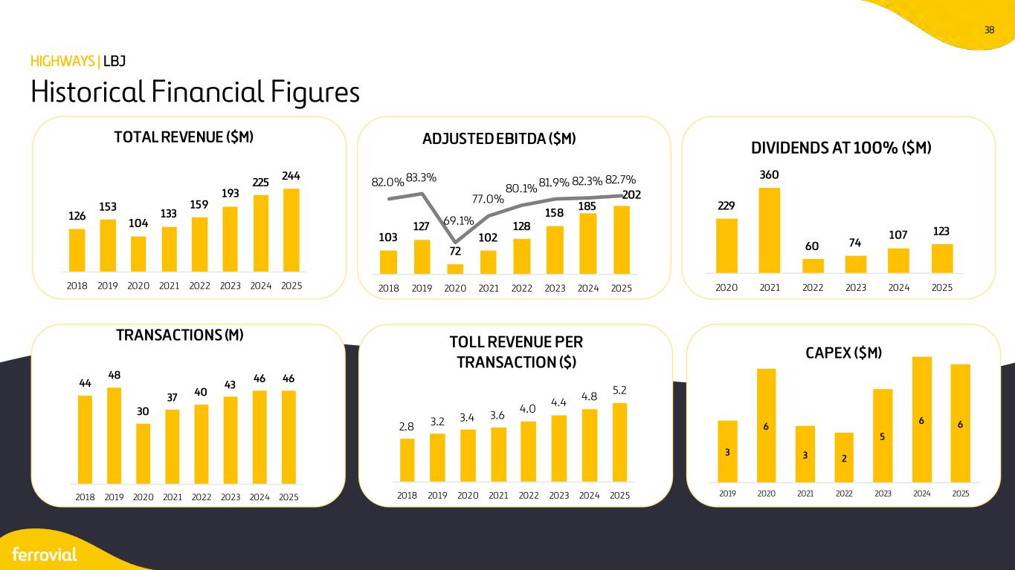
38 Historical Financial Figures HIGHWAYS | LBJ 126 153 104 133 159 193 225 244 2018 2019 2020 2021 2022 2023 2024 2025 TOTAL REVENUE ($M) 103 127 72 102 128 158 185 202 82.0% 83.3% 69.1% 77.0% 80.1% 81.9% 82.3% 82.7% 2018 2019 2020 2021 2022 2023 2024 2025 ADJUSTED EBITDA ($M) 229 360 60 74 107 123 2020 2021 2022 2023 2024 2025 DIVIDENDS AT 100% ($M) 44 48 30 37 40 43 46 46 2018 2019 2020 2021 2022 2023 2024 2025 TRANSACTIONS (M) 2.8 3.2 3.4 3.6 4.0 4.4 4.8 5.2 2018 2019 2020 2021 2022 2023 2024 2025 TOLL REVENUE PER TRANSACTION ($) 3 6 3 2 5 6 6 2019 2020 2021 2022 2023 2024 2025 CAPEX ($M)

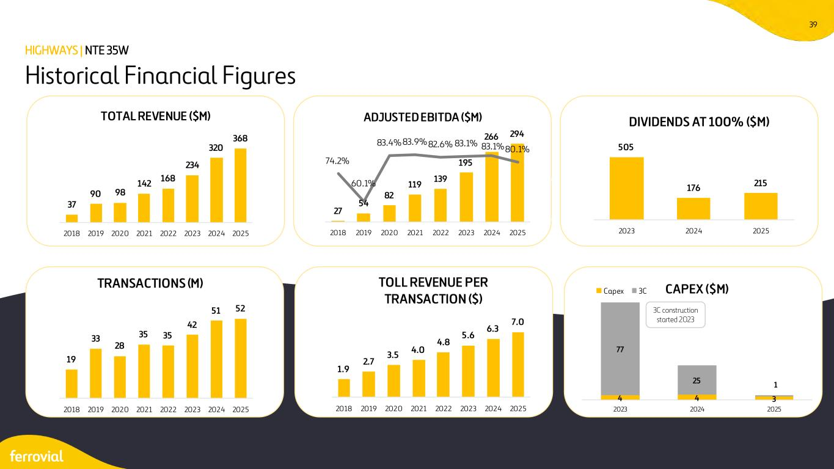
39 Historical Financial Figures HIGHWAYS | NTE 35W 3C construction started 2023 37 90 98 142 168 234 320 368 2018 2019 2020 2021 2022 2023 2024 2025 TOTAL REVENUE ($M) 27 54 82 119 139 195 266 294 74.2% 60.1% 83.4% 83.9% 82.6% 83.1% 83.1%80.1% 50% 70% 90% 25 125 225 2018 2019 2020 2021 2022 2023 2024 2025 ADJUSTED EBITDA ($M) 505 176 215 2023 2024 2025 DIVIDENDS AT 100% ($M) 19 33 28 35 35 42 51 52 2018 2019 2020 2021 2022 2023 2024 2025 TRANSACTIONS (M) 1.9 2.7 3.5 4.0 4.8 5.6 6.3 7.0 2018 2019 2020 2021 2022 2023 2024 2025 TOLL REVENUE PER TRANSACTION ($) 4 4 3 77 25 1 2023 2024 2025 CAPEX ($M)Capex 3C

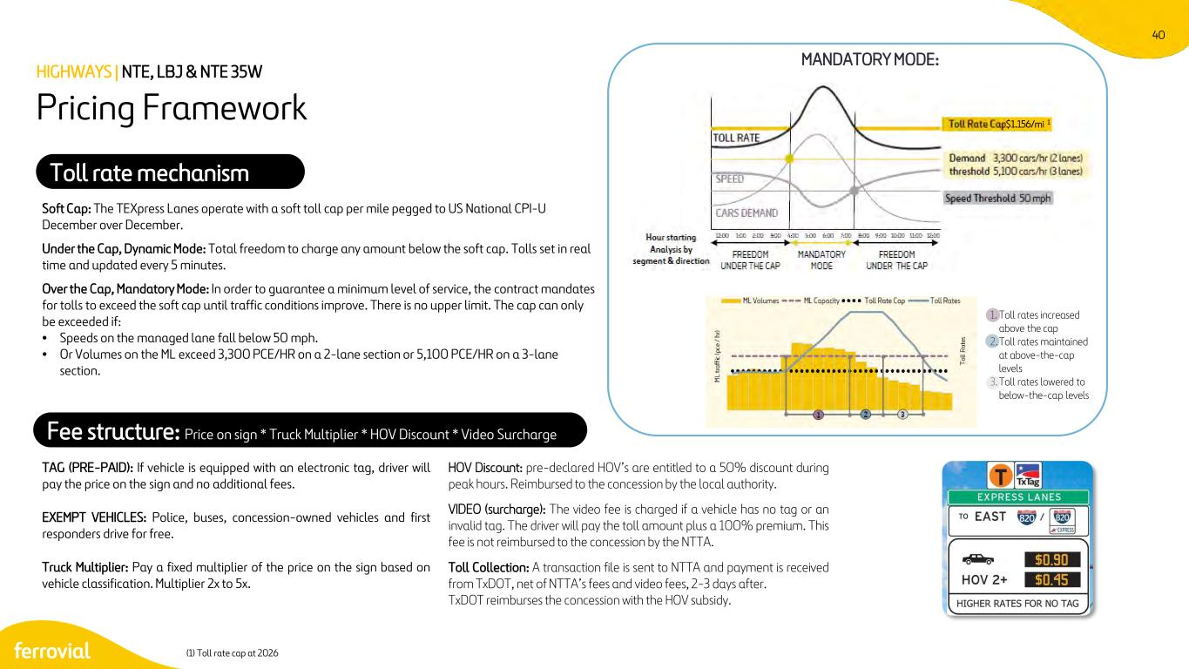
40 $1.156/mi 1 TAG (PRE-PAID): If vehicle is equipped with an electronic tag, driver will pay the price on the sign and no additional fees. HOV Discount: pre-declared HOV’s are entitled to a 50% discount during peak hours. Reimbursed to the concession by the local authority. EXEMPT VEHICLES: Police, buses, concession-owned vehicles and first responders drive for free. VIDEO (surcharge): The video fee is charged if a vehicle has no tag or an invalid tag. The driver will pay the toll amount plus a 100% premium. This fee is not reimbursed to the concession by the NTTA. Truck Multiplier: Pay a fixed multiplier of the price on the sign based on vehicle classification. Multiplier 2x to 5x. Toll Collection: A transaction file is sent to NTTA and payment is received from TxDOT, net of NTTA’s fees and video fees, 2-3 days after. TxDOT reimburses the concession with the HOV subsidy. Soft Cap: The TEXpress Lanes operate with a soft toll cap per mile pegged to US National CPI-U December over December. Under the Cap, Dynamic Mode: Total freedom to charge any amount below the soft cap. Tolls set in real time and updated every 5 minutes. Over the Cap, Mandatory Mode: In order to guarantee a minimum level of service, the contract mandates for tolls to exceed the soft cap until traffic conditions improve. There is no upper limit. The cap can only be exceeded if: • Speeds on the managed lane fall below 50 mph. • Or Volumes on the ML exceed 3,300 PCE/HR on a 2-lane section or 5,100 PCE/HR on a 3-lane section. (1) Toll rate cap at 2026 Pricing Framework HIGHWAYS | NTE, LBJ & NTE 35W Fee structure: Price on sign * Truck Multiplier * HOV Discount * Video Surcharge Toll rate mechanism MANDATORY MODE: 1. Toll rates increased above the cap 2.Toll rates maintained at above-the-cap levels 3. Toll rates lowered to below-the-cap levels

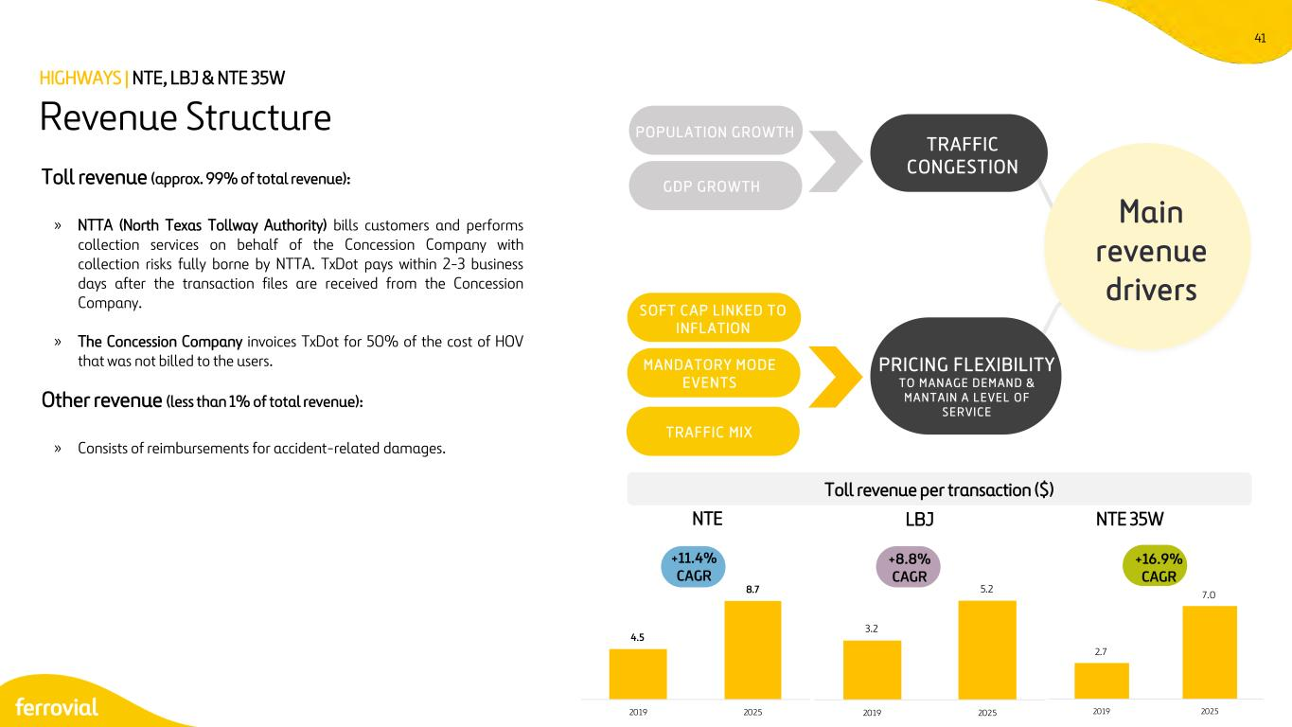
41 Toll revenue (approx. 99% of total revenue): » NTTA (North Texas Tollway Authority) bills customers and performs collection services on behalf of the Concession Company with collection risks fully borne by NTTA. TxDot pays within 2-3 business days after the transaction files are received from the Concession Company. » The Concession Company invoices TxDot for 50% of the cost of HOV that was not billed to the users. Other revenue (less than 1% of total revenue): » Consists of reimbursements for accident-related damages. Revenue Structure HIGHWAYS | NTE, LBJ & NTE 35W Main revenue drivers P O P ULAT ION G RO WTH G D P G RO WT H TRAFFIC CONGESTION PRICING FLEXIBILITY T O M A N A G E D E M A N D & M A N T A I N A L E V E L O F S E R V I C E S O F T C A P L I N K ED T O I N F L ATION M A N D A TORY M O D E E V E N TS T RA F FIC M IX NTE LBJ NTE 35W Toll revenue per transaction ($) +11.4% CAGR +8.8% CAGR +16.9% CAGR 4.5 8.7 2019 2025 3.2 5.2 2019 2025 2.7 7.0 2019 2025

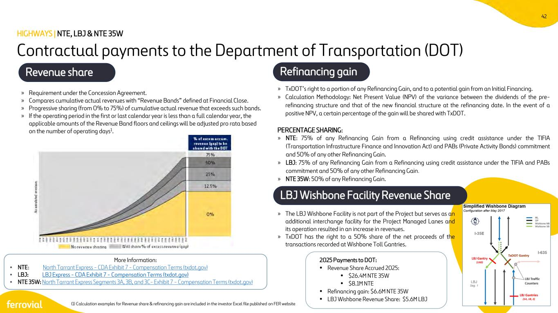
42 » TxDOT’s right to a portion of any Refinancing Gain, and to a potential gain from an Initial Financing. » Calculation Methodology: Net Present Value (NPV) of the variance between the dividends of the pre- refinancing structure and that of the new financial structure at the refinancing date. In the event of a positive NPV, a certain percentage of the gain will be shared with TxDOT. PERCENTAGE SHARING: » NTE: 75% of any Refinancing Gain from a Refinancing using credit assistance under the TIFIA (Transportation Infrastructure Finance and Innovation Act) and PABs (Private Activity Bonds) commitment and 50% of any other Refinancing Gain. » LBJ: 75% of any Refinancing Gain from a Refinancing using credit assistance under the TIFIA and PABs commitment and 50% of any other Refinancing Gain. » NTE 35W: 50% of any Refinancing Gain. Contractual payments to the Department of Transportation (DOT) Revenue share Refinancing gain » Requirement under the Concession Agreement. » Compares cumulative actual revenues with “Revenue Bands” defined at Financial Close. » Progressive sharing (from 0% to 75%) of cumulative actual revenue that exceeds such bands. » If the operating period in the first or last calendar year is less than a full calendar year, the applicable amounts of the Revenue Band floors and ceilings will be adjusted pro rata based on the number of operating days1. HIGHWAYS | NTE, LBJ & NTE 35W 2025 Payments to DOT: • Revenue Share Accrued 2025: • $26.4M NTE 35W • $8.1M NTE • Refinancing gain: $6.6M NTE 35W • LBJ Wishbone Revenue Share: $5.6M LBJ LBJ Wishbone Facility Revenue Share » The LBJ Wishbone Facility is not part of the Project but serves as an additional interchange facility for the Project Managed Lanes and its operation resulted in an increase in revenues. » TxDOT has the right to a 50% share of the net proceeds of the transactions recorded at Wishbone Toll Gantries. More Information: • NTE: North Tarrant Express - CDA Exhibit 7 - Compensation Terms (txdot.gov) • LBJ: LBJ Express - CDA Exhibit 7 - Compensation Terms (txdot.gov) • NTE 35W: North Tarrant Express Segments 3A, 3B, and 3C- Exhibit 7 - Compensation Terms (txdot.gov) (1) Calculation examples for Revenue share & refinancing gain are included in the investor Excel file published on FER website

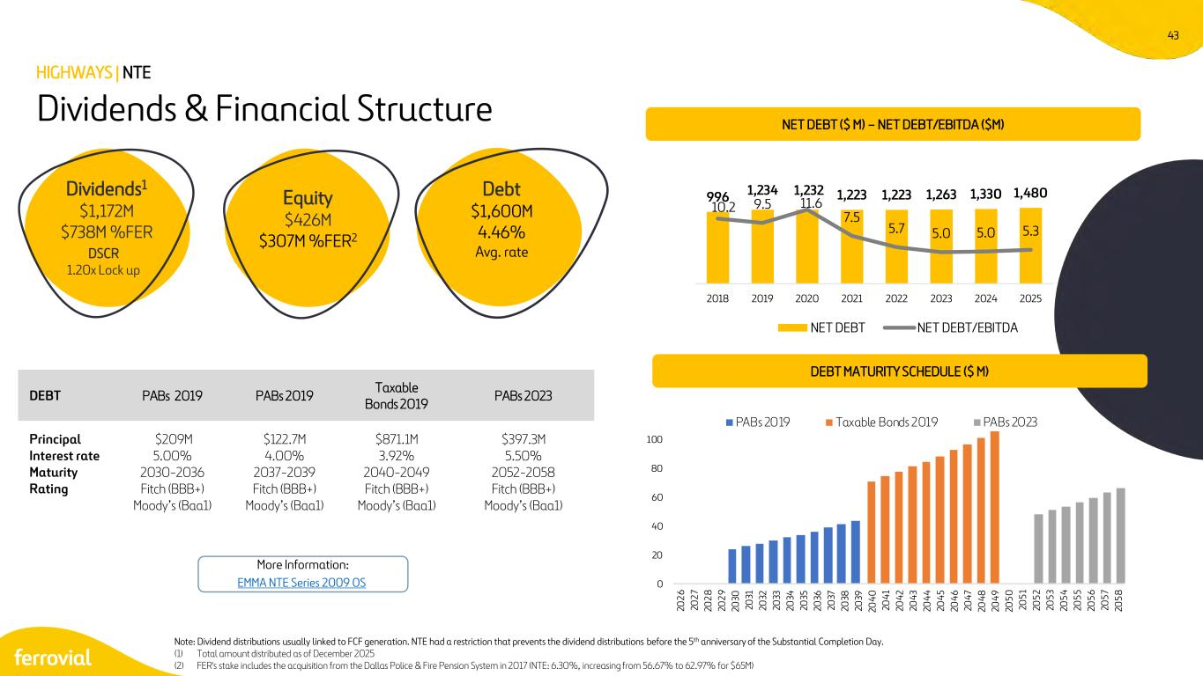
43 0 20 40 60 80 100 20 26 20 27 20 28 20 29 20 30 20 31 20 32 20 33 20 34 20 35 20 36 20 37 20 38 20 39 20 40 20 41 20 42 20 43 20 44 20 45 20 46 20 47 20 48 20 49 20 50 20 51 20 52 20 53 20 54 20 55 20 56 20 57 20 58 PABs 2019 Taxable Bonds 2019 PABs 2023 Dividends & Financial Structure DEBT MATURITY SCHEDULE ($ M) HIGHWAYS | NTE Dividends1 $1,172M $738M %FER DSCR 1.20x Lock up Equity $426M $307M %FER2 Debt $1,600M 4.46% Avg. rate DEBT PABs 2019 PABs 2019 Taxable Bonds 2019 PABs 2023 Principal Interest rate Maturity Rating $209M 5.00% 2030-2036 Fitch (BBB+) Moody’s (Baa1) $122.7M 4.00% 2037-2039 Fitch (BBB+) Moody’s (Baa1) $871.1M 3.92% 2040-2049 Fitch (BBB+) Moody’s (Baa1) $397.3M 5.50% 2052-2058 Fitch (BBB+) Moody’s (Baa1) NET DEBT ($ M) – NET DEBT/EBITDA ($M) Note: Dividend distributions usually linked to FCF generation. NTE had a restriction that prevents the dividend distributions before the 5th anniversary of the Substantial Completion Day. (1) Total amount distributed as of December 2025 (2) FER's stake includes the acquisition from the Dallas Police & Fire Pension System in 2017 (NTE: 6.30%, increasing from 56.67% to 62.97% for $65M) More Information: EMMA NTE Series 2009 OS 996 1,234 1,232 1,223 1,223 1,263 1,330 1,480 10.2 9.5 11.6 7.5 5.7 5.0 5.0 5.3 0 5 10 15 2018 2019 2020 2021 2022 2023 2024 2025 NET DEBT NET DEBT/EBITDA

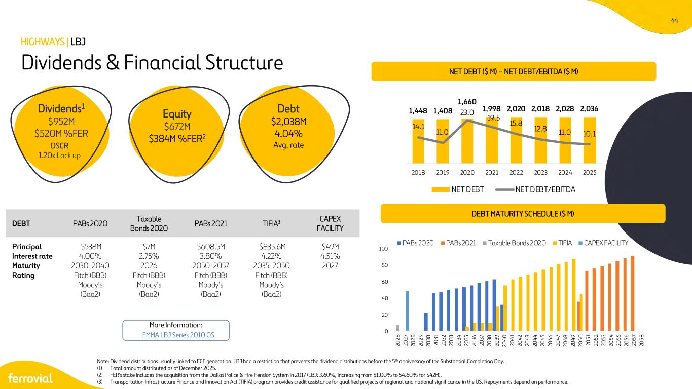
44 0 20 40 60 80 100 20 26 20 27 20 28 20 29 20 30 20 31 20 32 20 33 20 34 20 35 20 36 20 37 20 38 20 39 20 40 20 41 20 42 20 43 20 44 20 45 20 46 20 47 20 48 20 49 20 50 20 51 20 52 20 53 20 54 20 55 20 56 20 57 20 58 PABs 2020 PABs 2021 Taxable Bonds 2020 TIFIA CAPEX FACILITY Dividends & Financial Structure DEBT MATURITY SCHEDULE ($ M) HIGHWAYS | LBJ Dividends1 $952M $520M %FER DSCR 1.20x Lock up Equity $672M $384M %FER2 Debt $2,038M 4.04% Avg. rate Note: Dividend distributions usually linked to FCF generation. LBJ had a restriction that prevents the dividend distributions before the 5th anniversary of the Substantial Completion Day. (1) Total amount distributed as of December 2025. (2) FER's stake includes the acquisition from the Dallas Police & Fire Pension System in 2017 (LBJ: 3.60%, increasing from 51.00% to 54.60% for $42M). (3) Transportation Infrastructure Finance and Innovation Act (TIFIA) program provides credit assistance for qualified projects of regional and national significance in the US. Repayments depend on performance. More Information: DEBT PABs 2020 Taxable Bonds 2020 PABs 2021 TIFIA3 CAPEX FACILITY Principal Interest rate Maturity Rating $538M 4.00% 2030-2040 Fitch (BBB) Moody’s (Baa2) $7M 2.75% 2026 Fitch (BBB) Moody’s (Baa2) $608.5M 3.80% 2050-2057 Fitch (BBB) Moody’s (Baa2) $835.6M 4.22% 2035-2050 Fitch (BBB) Moody’s (Baa2) $49M 4.51% 2027 EMMA LBJ Series 2010 OS NET DEBT ($ M) – NET DEBT/EBITDA ($ M) 1,448 1,408 1,660 1,998 2,020 2,018 2,028 2,036 14.1 11.0 23.0 19.5 15.8 12.8 11.0 10.1 0 10 20 30 2018 2019 2020 2021 2022 2023 2024 2025 NET DEBT NET DEBT/EBITDA

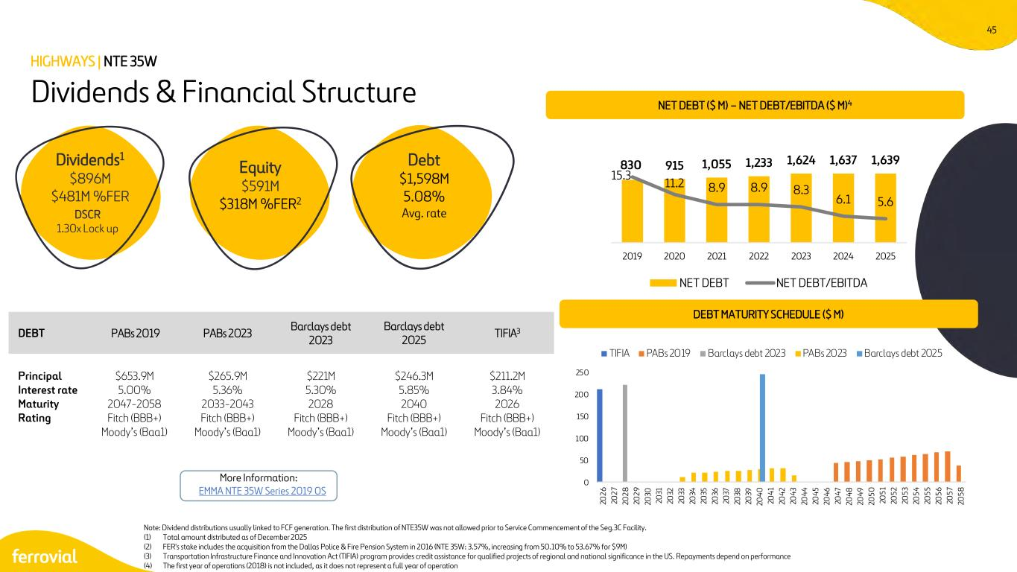
45 0 50 100 150 200 250 20 26 20 27 20 28 20 29 20 30 20 31 20 32 20 33 20 34 20 35 20 36 20 37 20 38 20 39 20 40 20 41 20 42 20 43 20 44 20 45 20 46 20 47 20 48 20 49 20 50 20 51 20 52 20 53 20 54 20 55 20 56 20 57 20 58 TIFIA PABs 2019 Barclays debt 2023 PABs 2023 Barclays debt 2025 Dividends & Financial Structure DEBT MATURITY SCHEDULE ($ M) HIGHWAYS | NTE 35W Dividends1 $896M $481M %FER DSCR 1.30x Lock up Equity $591M $318M %FER2 Debt $1,598M 5.08% Avg. rate More Information: EMMA NTE 35W Series 2019 OS DEBT PABs 2019 PABs 2023 Barclays debt 2023 Barclays debt 2025 TIFIA3 Principal Interest rate Maturity Rating $653.9M 5.00% 2047-2058 Fitch (BBB+) Moody’s (Baa1) $265.9M 5.36% 2033-2043 Fitch (BBB+) Moody’s (Baa1) $221M 5.30% 2028 Fitch (BBB+) Moody’s (Baa1) $246.3M 5.85% 2040 Fitch (BBB+) Moody’s (Baa1) $211.2M 3.84% 2026 Fitch (BBB+) Moody’s (Baa1) Note: Dividend distributions usually linked to FCF generation. The first distribution of NTE35W was not allowed prior to Service Commencement of the Seg.3C Facility. (1) Total amount distributed as of December 2025 (2) FER's stake includes the acquisition from the Dallas Police & Fire Pension System in 2016 (NTE 35W: 3.57%, increasing from 50.10% to 53.67% for $9M) (3) Transportation Infrastructure Finance and Innovation Act (TIFIA) program provides credit assistance for qualified projects of regional and national significance in the US. Repayments depend on performance (4) The first year of operations (2018) is not included, as it does not represent a full year of operation NET DEBT ($ M) – NET DEBT/EBITDA ($ M)4 830 915 1,055 1,233 1,624 1,637 1,639 15.3 11.2 8.9 8.9 8.3 6.1 5.6 0 5 10 15 20 2019 2020 2021 2022 2023 2024 2025 NET DEBT NET DEBT/EBITDA

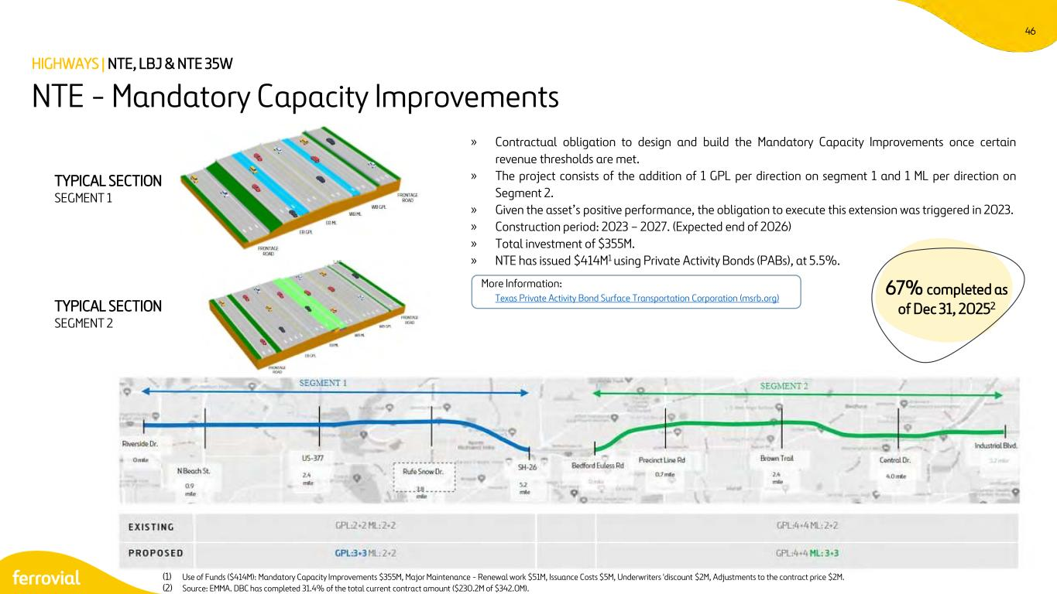
46 » Contractual obligation to design and build the Mandatory Capacity Improvements once certain revenue thresholds are met. » The project consists of the addition of 1 GPL per direction on segment 1 and 1 ML per direction on Segment 2. » Given the asset’s positive performance, the obligation to execute this extension was triggered in 2023. » Construction period: 2023 – 2027. (Expected end of 2026) » Total investment of $355M. » NTE has issued $414M1 using Private Activity Bonds (PABs), at 5.5%. Texas Private Activity Bond Surface Transportation Corporation (msrb.org) NTE - Mandatory Capacity Improvements HIGHWAYS | NTE, LBJ & NTE 35W TYPICAL SECTION SEGMENT 1 TYPICAL SECTION SEGMENT 2 (1) Use of Funds ($414M): Mandatory Capacity Improvements $355M, Major Maintenance - Renewal work $51M, Issuance Costs $5M, Underwriters 'discount $2M, Adjustments to the contract price $2M. (2) Source: EMMA. DBC has completed 31.4% of the total current contract amount ($230.2M of $342.0M). More Information: 67% completed as of Dec 31, 20252

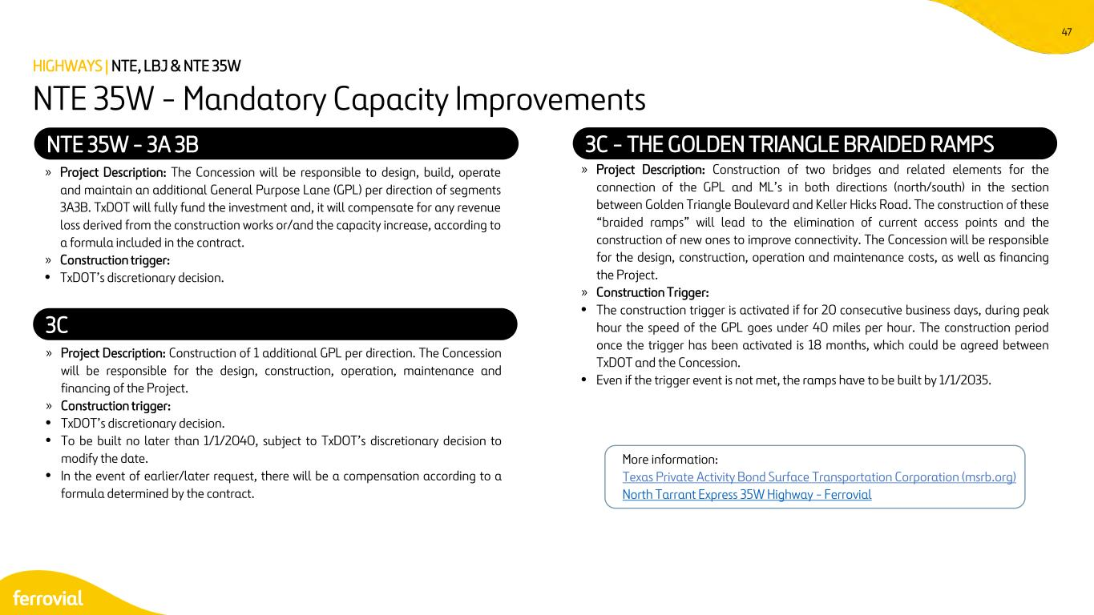
47 » Project Description: The Concession will be responsible to design, build, operate and maintain an additional General Purpose Lane (GPL) per direction of segments 3A3B. TxDOT will fully fund the investment and, it will compensate for any revenue loss derived from the construction works or/and the capacity increase, according to a formula included in the contract. » Construction trigger: • TxDOT’s discretionary decision. NTE 35W - 3A 3B 3C - THE GOLDEN TRIANGLE BRAIDED RAMPS » Project Description: Construction of two bridges and related elements for the connection of the GPL and ML’s in both directions (north/south) in the section between Golden Triangle Boulevard and Keller Hicks Road. The construction of these “braided ramps” will lead to the elimination of current access points and the construction of new ones to improve connectivity. The Concession will be responsible for the design, construction, operation and maintenance costs, as well as financing the Project. » Construction Trigger: • The construction trigger is activated if for 20 consecutive business days, during peak hour the speed of the GPL goes under 40 miles per hour. The construction period once the trigger has been activated is 18 months, which could be agreed between TxDOT and the Concession. • Even if the trigger event is not met, the ramps have to be built by 1/1/2035. » Project Description: Construction of 1 additional GPL per direction. The Concession will be responsible for the design, construction, operation, maintenance and financing of the Project. » Construction trigger: • TxDOT’s discretionary decision. • To be built no later than 1/1/2040, subject to TxDOT’s discretionary decision to modify the date. • In the event of earlier/later request, there will be a compensation according to a formula determined by the contract. 3C NTE 35W - Mandatory Capacity Improvements HIGHWAYS | NTE, LBJ & NTE 35W More information: Texas Private Activity Bond Surface Transportation Corporation (msrb.org) North Tarrant Express 35W Highway - Ferrovial

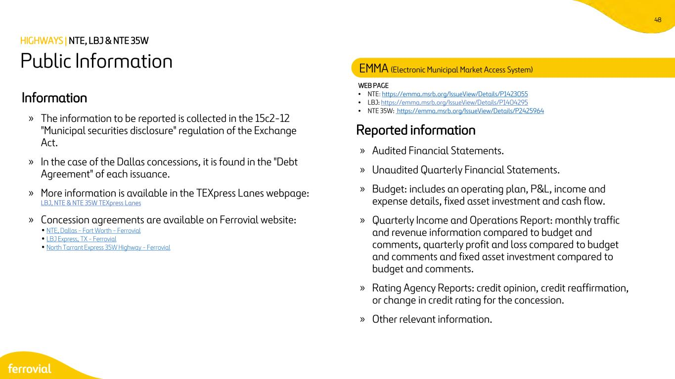
48 WEB PAGE • NTE: https://emma.msrb.org/IssueView/Details/P1423055 • LBJ: https://emma.msrb.org/IssueView/Details/P1404295 • NTE 35W: https://emma.msrb.org/IssueView/Details/P2425964 Reported information » Audited Financial Statements. » Unaudited Quarterly Financial Statements. » Budget: includes an operating plan, P&L, income and expense details, fixed asset investment and cash flow. » Quarterly Income and Operations Report: monthly traffic and revenue information compared to budget and comments, quarterly profit and loss compared to budget and comments and fixed asset investment compared to budget and comments. » Rating Agency Reports: credit opinion, credit reaffirmation, or change in credit rating for the concession. » Other relevant information. Information » The information to be reported is collected in the 15c2-12 "Municipal securities disclosure" regulation of the Exchange Act. » In the case of the Dallas concessions, it is found in the "Debt Agreement" of each issuance. » More information is available in the TEXpress Lanes webpage: LBJ, NTE & NTE 35W TEXpress Lanes » Concession agreements are available on Ferrovial website: • NTE, Dallas - Fort Worth - Ferrovial • LBJ Express, TX - Ferrovial • North Tarrant Express 35W Highway - Ferrovial Public Information HIGHWAYS | NTE, LBJ & NTE 35W EMMA (Electronic Municipal Market Access System)


I-66 Northern Virginia

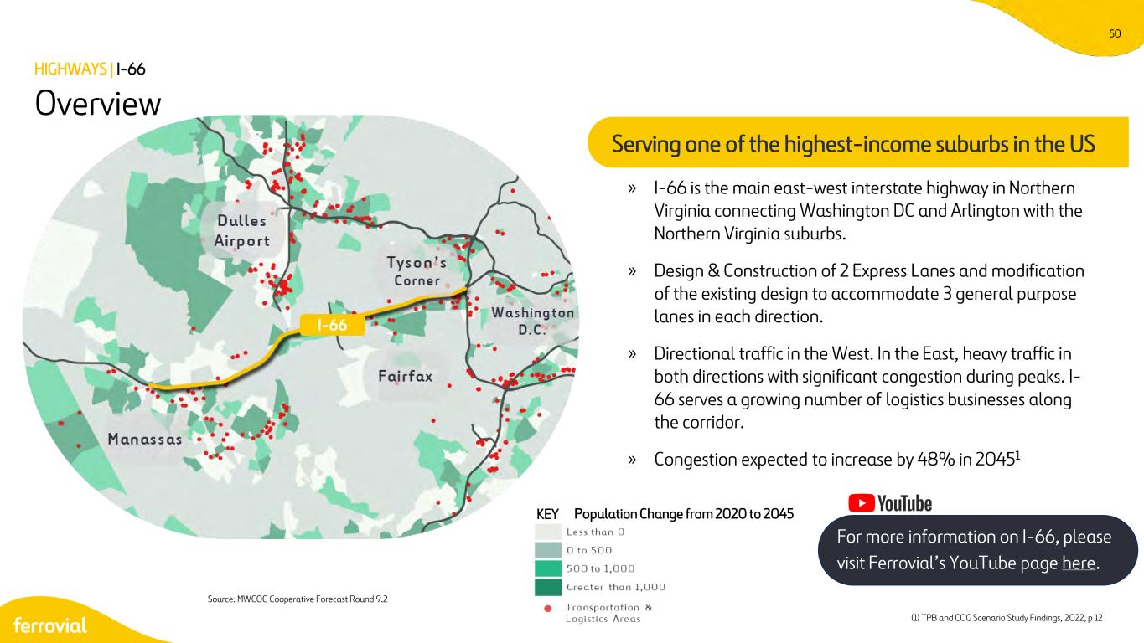
50 » I-66 is the main east-west interstate highway in Northern Virginia connecting Washington DC and Arlington with the Northern Virginia suburbs. » Design & Construction of 2 Express Lanes and modification of the existing design to accommodate 3 general purpose lanes in each direction. » Directional traffic in the West. In the East, heavy traffic in both directions with significant congestion during peaks. I- 66 serves a growing number of logistics businesses along the corridor. » Congestion expected to increase by 48% in 20451 KEY Source: MWCOG Cooperative Forecast Round 9.2 Population Change from 2020 to 2045 Overview HIGHWAYS | I-66 Serving one of the highest-income suburbs in the US (1) TPB and COG Scenario Study Findings, 2022, p 12 For more information on I-66, please visit Ferrovial’s YouTube page here.

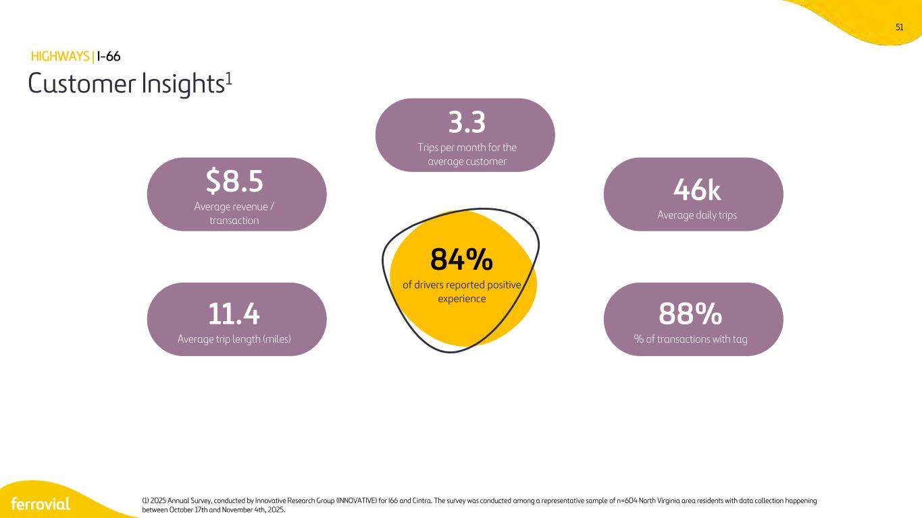
51 Customer Insights1 HIGHWAYS | I-66 (1) 2025 Annual Survey, conducted by Innovative Research Group (INNOVATIVE) for I66 and Cintra. The survey was conducted among a representative sample of n=604 North Virginia area residents with data collection happening between October 17th and November 4th, 2025. $8.5 Average revenue / transaction 46k Average daily trips 11.4 Average trip length (miles) 88% % of transactions with tag 3.3 Trips per month for the average customer 84% of drivers reported positive experience

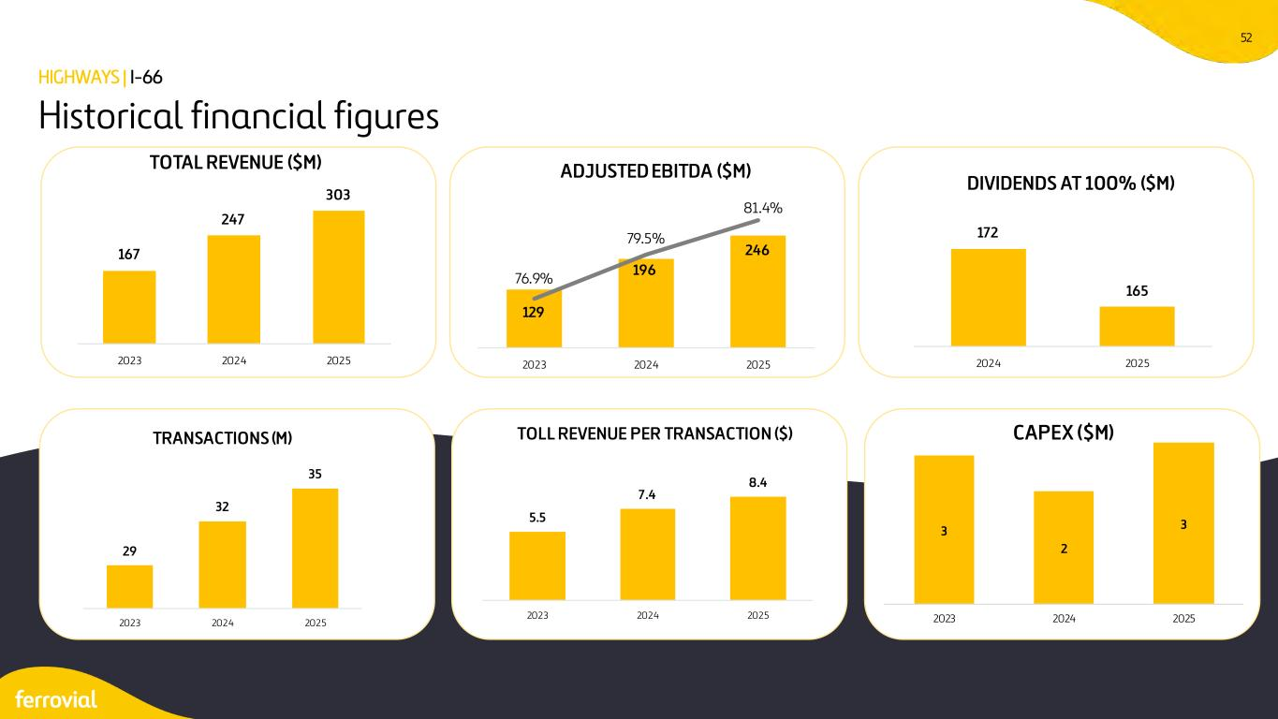
52 Historical financial figures HIGHWAYS | I-66 167 247 303 2023 2024 2025 TOTAL REVENUE ($M) 129 196 246 76.9% 79.5% 81.4% 1 1 1 1 1 2023 2024 2025 ADJUSTED EBITDA ($M) 172 165 2024 2025 DIVIDENDS AT 100% ($M) 29 32 35 2023 2024 2025 TRANSACTIONS (M) 5.5 7.4 8.4 2023 2024 2025 TOLL REVENUE PER TRANSACTION ($) 3 2 3 2023 2024 2025 CAPEX ($M)

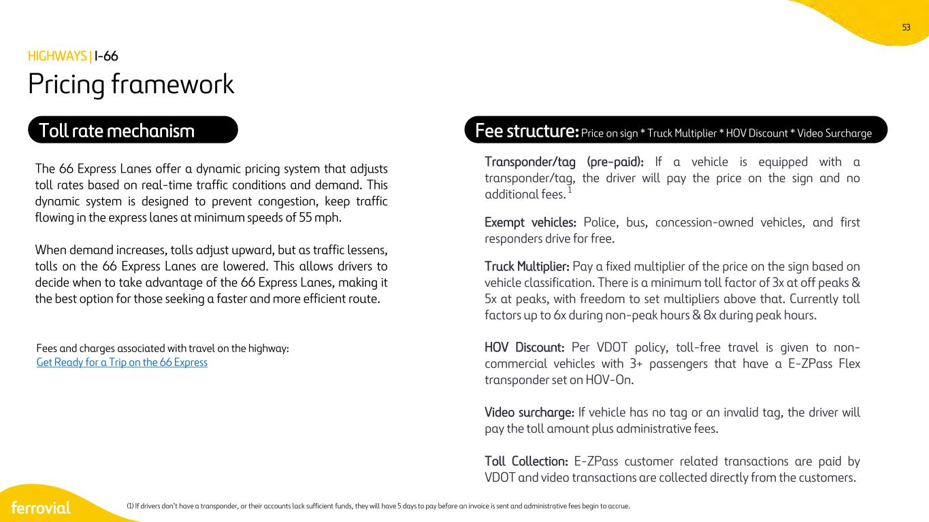
53 The 66 Express Lanes offer a dynamic pricing system that adjusts toll rates based on real-time traffic conditions and demand. This dynamic system is designed to prevent congestion, keep traffic flowing in the express lanes at minimum speeds of 55 mph. When demand increases, tolls adjust upward, but as traffic lessens, tolls on the 66 Express Lanes are lowered. This allows drivers to decide when to take advantage of the 66 Express Lanes, making it the best option for those seeking a faster and more efficient route. Fees and charges associated with travel on the highway: Get Ready for a Trip on the 66 Express Pricing framework Transponder/tag (pre-paid): If a vehicle is equipped with a transponder/tag, the driver will pay the price on the sign and no additional fees. 1 Exempt vehicles: Police, bus, concession-owned vehicles, and first responders drive for free. Truck Multiplier: Pay a fixed multiplier of the price on the sign based on vehicle classification. There is a minimum toll factor of 3x at off peaks & 5x at peaks, with freedom to set multipliers above that. Currently toll factors up to 6x during non-peak hours & 8x during peak hours. HOV Discount: Per VDOT policy, toll-free travel is given to non- commercial vehicles with 3+ passengers that have a E-ZPass Flex transponder set on HOV-On. Video surcharge: If vehicle has no tag or an invalid tag, the driver will pay the toll amount plus administrative fees. Toll Collection: E-ZPass customer related transactions are paid by VDOT and video transactions are collected directly from the customers. Fee structure: Price on sign * Truck Multiplier * HOV Discount * Video SurchargeToll rate mechanism (1) If drivers don’t have a transponder, or their accounts lack sufficient funds, they will have 5 days to pay before an invoice is sent and administrative fees begin to accrue. HIGHWAYS | I-66

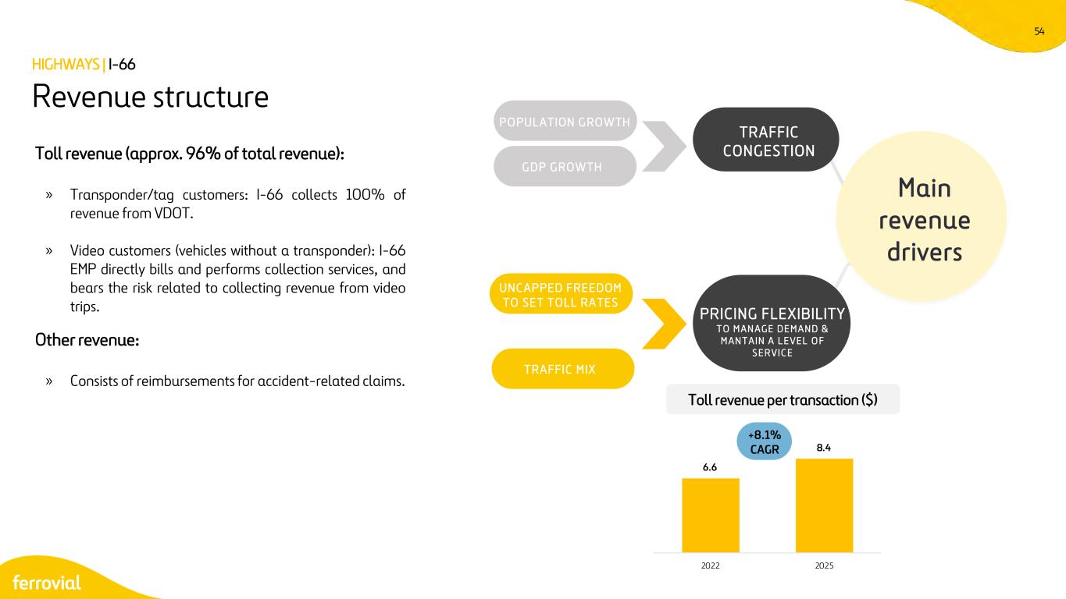
54 Toll revenue (approx. 96% of total revenue): » Transponder/tag customers: I-66 collects 100% of revenue from VDOT. » Video customers (vehicles without a transponder): I-66 EMP directly bills and performs collection services, and bears the risk related to collecting revenue from video trips. Other revenue: » Consists of reimbursements for accident-related claims. Revenue structure Main revenue drivers P O P ULAT ION G RO WTH G D P G RO WT H TRAFFIC CONGESTION PRICING FLEXIBILITY T O M A N A G E D E M A N D & M A N T A I N A L E V E L O F S E R V I C E UN C A P PE D F RE E DOM T O S E T T O L L RA T E S T RA F FIC M IX Toll revenue per transaction ($) HIGHWAYS | I-66 +8.1% CAGR 6.6 8.4 2022 2025

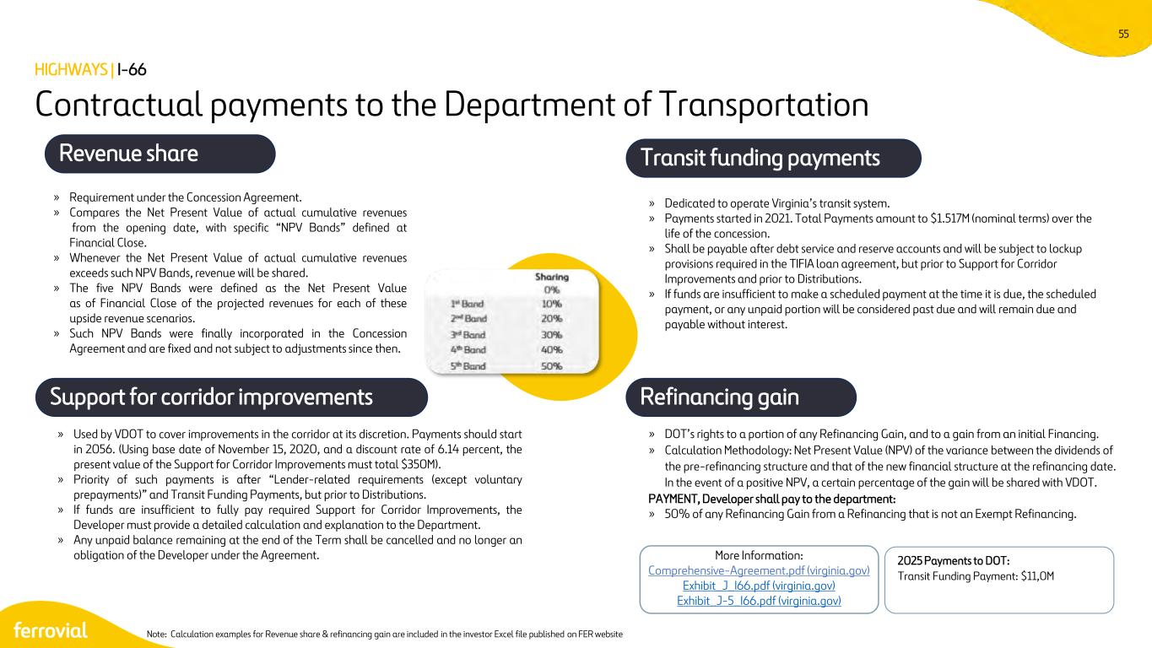
55 Contractual payments to the Department of Transportation » Requirement under the Concession Agreement. » Compares the Net Present Value of actual cumulative revenues from the opening date, with specific “NPV Bands” defined at Financial Close. » Whenever the Net Present Value of actual cumulative revenues exceeds such NPV Bands, revenue will be shared. » The five NPV Bands were defined as the Net Present Value as of Financial Close of the projected revenues for each of these upside revenue scenarios. » Such NPV Bands were finally incorporated in the Concession Agreement and are fixed and not subject to adjustments since then. » Dedicated to operate Virginia’s transit system. » Payments started in 2021. Total Payments amount to $1.517M (nominal terms) over the life of the concession. » Shall be payable after debt service and reserve accounts and will be subject to lockup provisions required in the TIFIA loan agreement, but prior to Support for Corridor Improvements and prior to Distributions. » If funds are insufficient to make a scheduled payment at the time it is due, the scheduled payment, or any unpaid portion will be considered past due and will remain due and payable without interest. » DOT’s rights to a portion of any Refinancing Gain, and to a gain from an initial Financing. » Calculation Methodology: Net Present Value (NPV) of the variance between the dividends of the pre-refinancing structure and that of the new financial structure at the refinancing date. In the event of a positive NPV, a certain percentage of the gain will be shared with VDOT. PAYMENT, Developer shall pay to the department: » 50% of any Refinancing Gain from a Refinancing that is not an Exempt Refinancing. » Used by VDOT to cover improvements in the corridor at its discretion. Payments should start in 2056. (Using base date of November 15, 2020, and a discount rate of 6.14 percent, the present value of the Support for Corridor Improvements must total $350M). » Priority of such payments is after “Lender-related requirements (except voluntary prepayments)” and Transit Funding Payments, but prior to Distributions. » If funds are insufficient to fully pay required Support for Corridor Improvements, the Developer must provide a detailed calculation and explanation to the Department. » Any unpaid balance remaining at the end of the Term shall be cancelled and no longer an obligation of the Developer under the Agreement. Support for corridor improvements Transit funding payments Refinancing gain More Information: Comprehensive-Agreement.pdf (virginia.gov) Exhibit_J_I66.pdf (virginia.gov) Exhibit_J-5_I66.pdf (virginia.gov) Revenue share HIGHWAYS | I-66 Note: Calculation examples for Revenue share & refinancing gain are included in the investor Excel file published on FER website 2025 Payments to DOT: Transit Funding Payment: $11,0M

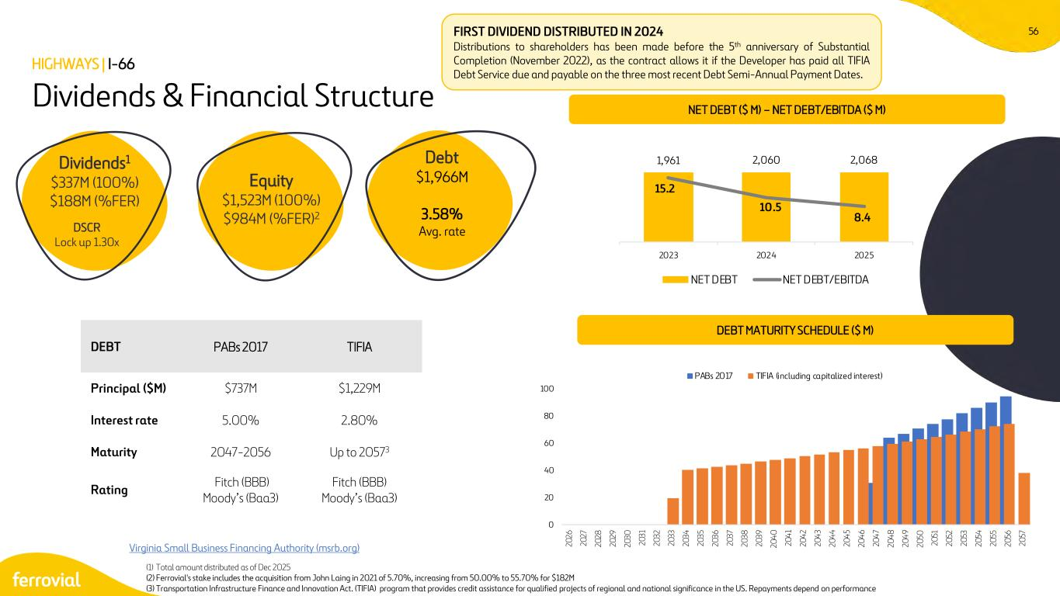
56 0 20 40 60 80 100 20 26 20 27 20 28 20 29 20 30 20 31 20 32 20 33 20 34 20 35 20 36 20 37 20 38 20 39 20 40 20 41 20 42 20 43 20 44 20 45 20 46 20 47 20 48 20 49 20 50 20 51 20 52 20 53 20 54 20 55 20 56 20 57 PABs 2017 TIFIA (including capitalized interest) Virginia Small Business Financing Authority (msrb.org) Dividends & Financial Structure DEBT MATURITY SCHEDULE ($ M) FIRST DIVIDEND DISTRIBUTED IN 2024 Distributions to shareholders has been made before the 5th anniversary of Substantial Completion (November 2022), as the contract allows it if the Developer has paid all TIFIA Debt Service due and payable on the three most recent Debt Semi-Annual Payment Dates. HIGHWAYS | I-66 DEBT PABs 2017 TIFIA Principal ($M) $737M $1,229M Interest rate 5.00% 2.80% Maturity 2047-2056 Up to 20573 Rating Fitch (BBB) Moody’s (Baa3) Fitch (BBB) Moody’s (Baa3) Dividends1 $337M (100%) $188M (%FER) DSCR Lock up 1.30x Equity $1,523M (100%) $984M (%FER)2 Debt $1,966M 3.58% Avg. rate (1) Total amount distributed as of Dec 2025 (2) Ferrovial's stake includes the acquisition from John Laing in 2021 of 5.70%, increasing from 50.00% to 55.70% for $182M (3) Transportation Infrastructure Finance and Innovation Act. (TIFIA) program that provides credit assistance for qualified projects of regional and national significance in the US. Repayments depend on performance NET DEBT ($ M) – NET DEBT/EBITDA ($ M) 1,961 2,060 2,068 15.2 10.5 8.4 0 5 10 15 20 2023 2024 2025 NET DEBT NET DEBT/EBITDA

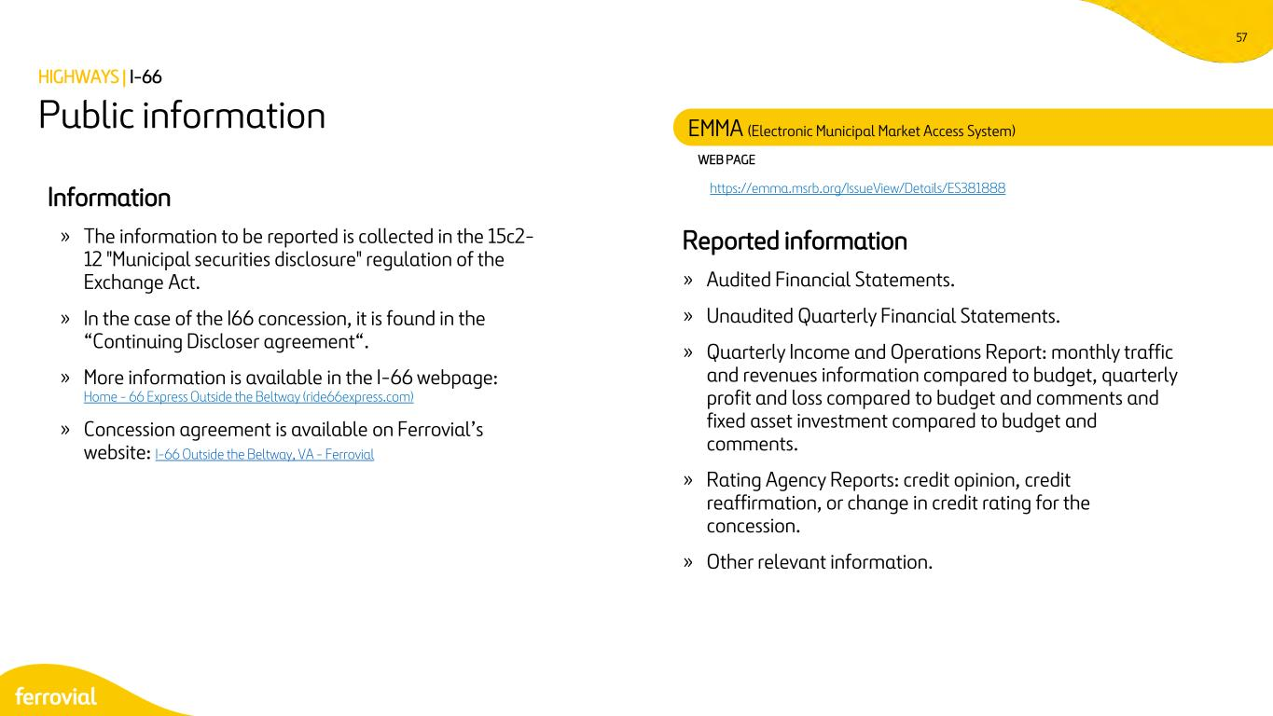
57 WEB PAGE https://emma.msrb.org/IssueView/Details/ES381888Information » The information to be reported is collected in the 15c2- 12 "Municipal securities disclosure" regulation of the Exchange Act. » In the case of the I66 concession, it is found in the “Continuing Discloser agreement“. » More information is available in the I-66 webpage: Home - 66 Express Outside the Beltway (ride66express.com) » Concession agreement is available on Ferrovial’s website: I-66 Outside the Beltway, VA - Ferrovial Reported information » Audited Financial Statements. » Unaudited Quarterly Financial Statements. » Quarterly Income and Operations Report: monthly traffic and revenues information compared to budget, quarterly profit and loss compared to budget and comments and fixed asset investment compared to budget and comments. » Rating Agency Reports: credit opinion, credit reaffirmation, or change in credit rating for the concession. » Other relevant information. Public information EMMA (Electronic Municipal Market Access System) HIGHWAYS | I-66

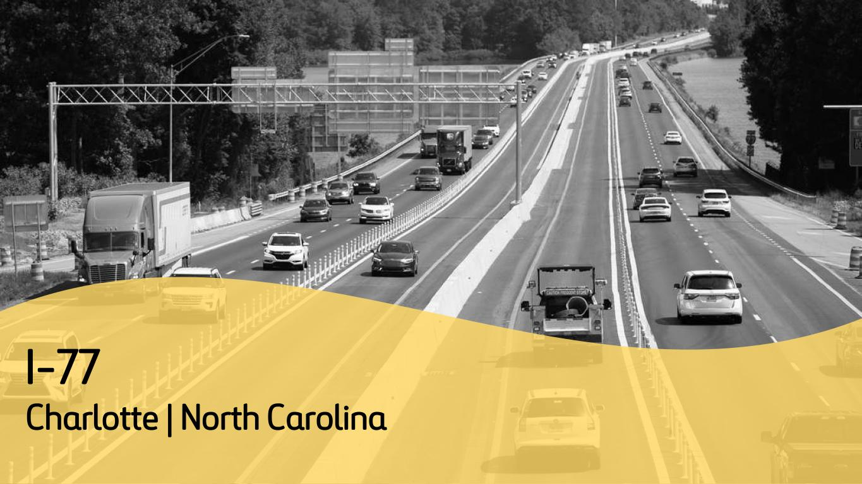
I-77 Charlotte | North Carolina

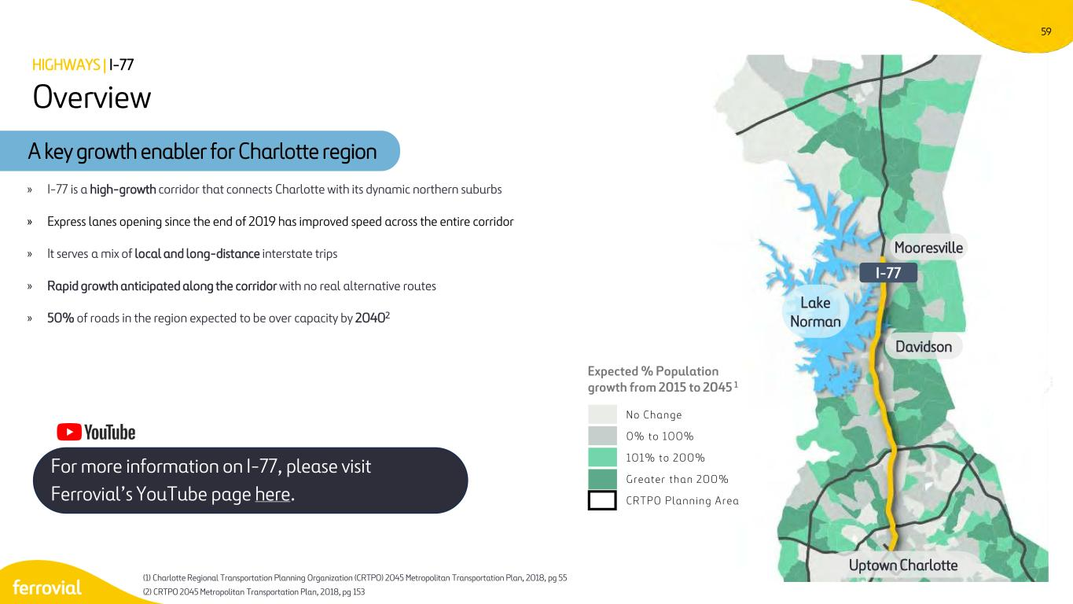
59 Davidson Uptown Charlotte I-77 Lake Norman Mooresville Overview HIGHWAYS | I-77 Expected % Population growth from 2015 to 2045 1 N o C h a n g e 0 % t o 1 0 0 % 1 0 1 % t o 2 0 0 % G r e a t e r t h a n 2 0 0 % C R T P O P l a n n i n g A r e a A key growth enabler for Charlotte region » I-77 is a high-growth corridor that connects Charlotte with its dynamic northern suburbs » Express lanes opening since the end of 2019 has improved speed across the entire corridor » It serves a mix of local and long-distance interstate trips » Rapid growth anticipated along the corridor with no real alternative routes » 50% of roads in the region expected to be over capacity by 20402 (1) Charlotte Regional Transportation Planning Organization (CRTPO) 2045 Metropolitan Transportation Plan, 2018, pg 55 (2) CRTPO 2045 Metropolitan Transportation Plan, 2018, pg 153 For more information on I-77, please visit Ferrovial’s YouTube page here.

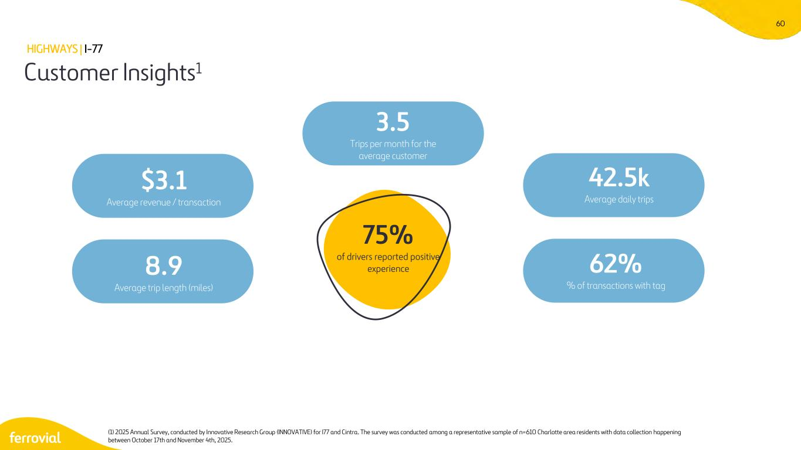
60 Customer Insights1 HIGHWAYS | I-77 (1) 2025 Annual Survey, conducted by Innovative Research Group (INNOVATIVE) for I77 and Cintra. The survey was conducted among a representative sample of n=610 Charlotte area residents with data collection happening between October 17th and November 4th, 2025. $3.1 Average revenue / transaction 42.5k Average daily trips 8.9 Average trip length (miles) 62% % of transactions with tag 3.5 Trips per month for the average customer 75% of drivers reported positive experience

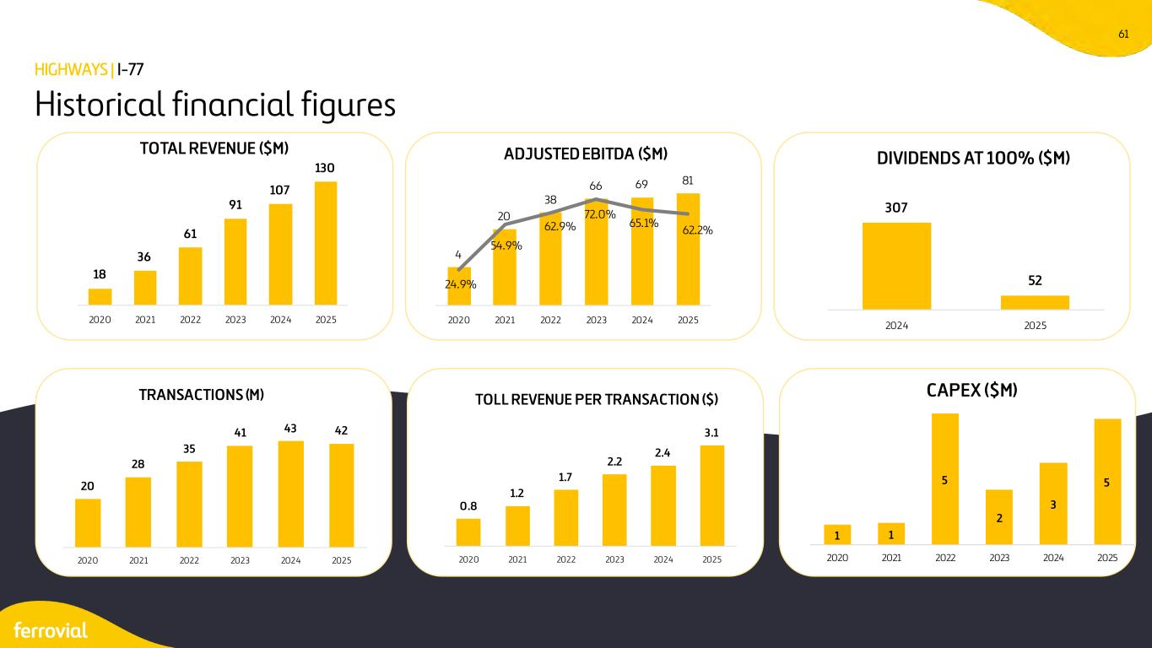
61 Historical financial figures HIGHWAYS | I-77 18 36 61 91 107 130 2020 2021 2022 2023 2024 2025 TOTAL REVENUE ($M) 4 20 38 66 69 81 24.9% 54.9% 62.9% 72.0% 65.1% 62.2% 1.00 10.00 100.00 0 0 0 1 1 2020 2021 2022 2023 2024 2025 ADJUSTED EBITDA ($M) 307 52 2024 2025 DIVIDENDS AT 100% ($M) 20 28 35 41 43 42 2020 2021 2022 2023 2024 2025 TRANSACTIONS (M) 0.8 1.2 1.7 2.2 2.4 3.1 2020 2021 2022 2023 2024 2025 TOLL REVENUE PER TRANSACTION ($) 1 1 5 2 3 5 2020 2021 2022 2023 2024 2025 CAPEX ($M)

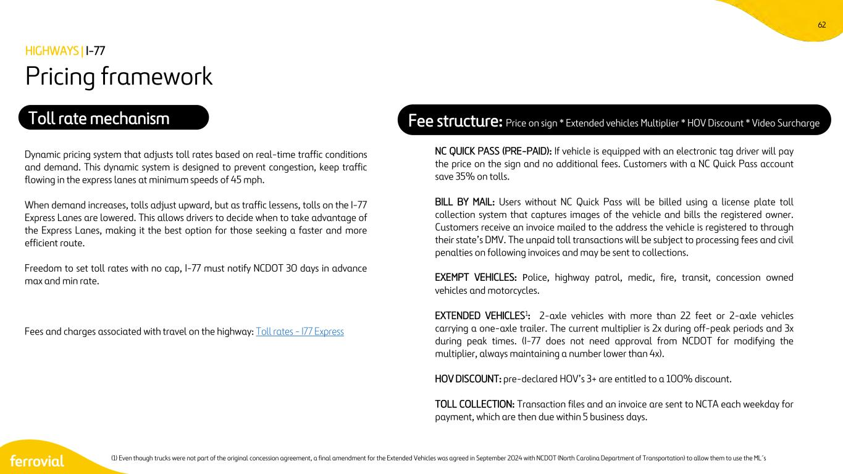
62 (1) Even though trucks were not part of the original concession agreement, a final amendment for the Extended Vehicles was agreed in September 2024 with NCDOT (North Carolina Department of Transportation) to allow them to use the ML´s Pricing framework HIGHWAYS | I-77 Dynamic pricing system that adjusts toll rates based on real-time traffic conditions and demand. This dynamic system is designed to prevent congestion, keep traffic flowing in the express lanes at minimum speeds of 45 mph. When demand increases, tolls adjust upward, but as traffic lessens, tolls on the I-77 Express Lanes are lowered. This allows drivers to decide when to take advantage of the Express Lanes, making it the best option for those seeking a faster and more efficient route. Freedom to set toll rates with no cap, I-77 must notify NCDOT 30 days in advance max and min rate. Fees and charges associated with travel on the highway: Toll rates - I77 Express Toll rate mechanism Fee structure: Price on sign * Extended vehicles Multiplier * HOV Discount * Video Surcharge NC QUICK PASS (PRE-PAID): If vehicle is equipped with an electronic tag driver will pay the price on the sign and no additional fees. Customers with a NC Quick Pass account save 35% on tolls. BILL BY MAIL: Users without NC Quick Pass will be billed using a license plate toll collection system that captures images of the vehicle and bills the registered owner. Customers receive an invoice mailed to the address the vehicle is registered to through their state’s DMV. The unpaid toll transactions will be subject to processing fees and civil penalties on following invoices and may be sent to collections. EXEMPT VEHICLES: Police, highway patrol, medic, fire, transit, concession owned vehicles and motorcycles. EXTENDED VEHICLES1: 2-axle vehicles with more than 22 feet or 2-axle vehicles carrying a one-axle trailer. The current multiplier is 2x during off-peak periods and 3x during peak times. (I-77 does not need approval from NCDOT for modifying the multiplier, always maintaining a number lower than 4x). HOV DISCOUNT: pre-declared HOV’s 3+ are entitled to a 100% discount. TOLL COLLECTION: Transaction files and an invoice are sent to NCTA each weekday for payment, which are then due within 5 business days.

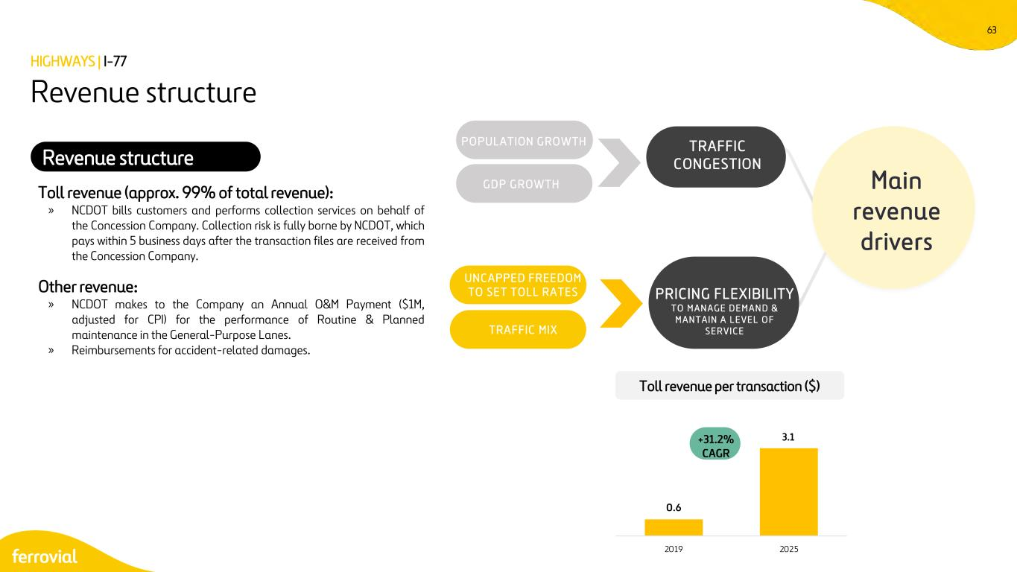
63 Revenue structure Toll revenue (approx. 99% of total revenue): » NCDOT bills customers and performs collection services on behalf of the Concession Company. Collection risk is fully borne by NCDOT, which pays within 5 business days after the transaction files are received from the Concession Company. Other revenue: » NCDOT makes to the Company an Annual O&M Payment ($1M, adjusted for CPI) for the performance of Routine & Planned maintenance in the General-Purpose Lanes. » Reimbursements for accident-related damages. HIGHWAYS | I-77 Main revenue drivers P O P ULAT ION G RO WTH G D P G RO WT H TRAFFIC CONGESTION PRICING FLEXIBILITY T O M A N A G E D E M A N D & M A N T A I N A L E V E L O F S E R V I C E UN C A P PE D F RE E DOM T O S E T T O L L RA T E S T RA F FIC M IX Revenue structure Toll revenue per transaction ($) +31.2% CAGR 0.6 3.1 2019 2025

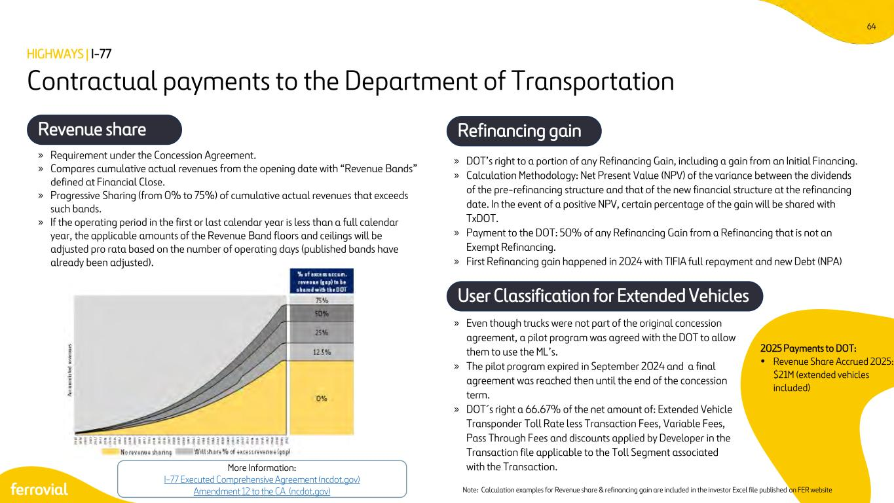
64 » DOT’s right to a portion of any Refinancing Gain, including a gain from an Initial Financing. » Calculation Methodology: Net Present Value (NPV) of the variance between the dividends of the pre-refinancing structure and that of the new financial structure at the refinancing date. In the event of a positive NPV, certain percentage of the gain will be shared with TxDOT. » Payment to the DOT: 50% of any Refinancing Gain from a Refinancing that is not an Exempt Refinancing. » First Refinancing gain happened in 2024 with TIFIA full repayment and new Debt (NPA) Contractual payments to the Department of Transportation Revenue share Refinancing gain » Requirement under the Concession Agreement. » Compares cumulative actual revenues from the opening date with “Revenue Bands” defined at Financial Close. » Progressive Sharing (from 0% to 75%) of cumulative actual revenues that exceeds such bands. » If the operating period in the first or last calendar year is less than a full calendar year, the applicable amounts of the Revenue Band floors and ceilings will be adjusted pro rata based on the number of operating days (published bands have already been adjusted). HIGHWAYS | I-77 More Information: I-77 Executed Comprehensive Agreement (ncdot.gov) Amendment 12 to the CA (ncdot.gov) User Classification for Extended Vehicles » Even though trucks were not part of the original concession agreement, a pilot program was agreed with the DOT to allow them to use the ML’s. » The pilot program expired in September 2024 and a final agreement was reached then until the end of the concession term. » DOT´s right a 66.67% of the net amount of: Extended Vehicle Transponder Toll Rate less Transaction Fees, Variable Fees, Pass Through Fees and discounts applied by Developer in the Transaction file applicable to the Toll Segment associated with the Transaction. Note: Calculation examples for Revenue share & refinancing gain are included in the investor Excel file published on FER website 2025 Payments to DOT: • Revenue Share Accrued 2025: $21M (extended vehicles included)

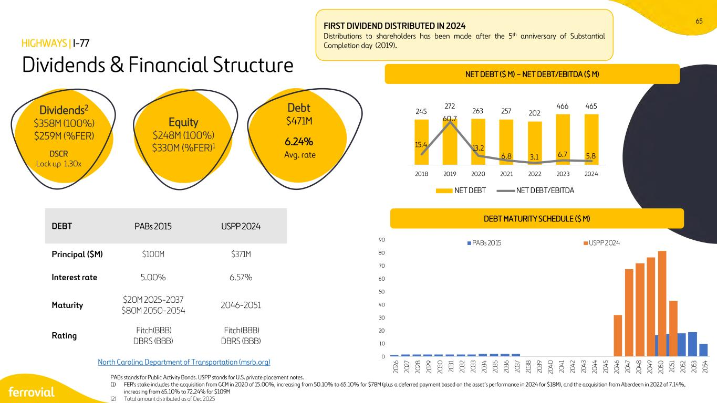
65 0 10 20 30 40 50 60 70 80 90 20 26 20 27 20 28 20 29 20 30 20 31 20 32 20 33 20 34 20 35 20 36 20 37 20 38 20 39 20 40 20 41 20 42 20 43 20 44 20 45 20 46 20 47 20 48 20 49 20 50 20 51 20 52 20 53 20 54 PABs 2015 USPP 2024 North Carolina Department of Transportation (msrb.org) HIGHWAYS | I-77 Dividends & Financial Structure DEBT MATURITY SCHEDULE ($ M) FIRST DIVIDEND DISTRIBUTED IN 2024 Distributions to shareholders has been made after the 5th anniversary of Substantial Completion day (2019). DEBT PABs 2015 USPP 2024 Principal ($M) $100M $371M Interest rate 5.00% 6.57% Maturity $20M 2025-2037 $80M 2050-2054 2046-2051 Rating Fitch(BBB) DBRS (BBB) Fitch(BBB) DBRS (BBB) Dividends2 $358M (100%) $259M (%FER) Equity $248M (100%) $330M (%FER)1 Debt $471M 6.24% Avg. rate PABs stands for Public Activity Bonds. USPP stands for U.S. private placement notes. (1) FER's stake includes the acquisition from GCM in 2020 of 15.00%, increasing from 50.10% to 65.10% for $78M (plus a deferred payment based on the asset’s performance in 2024 for $18M), and the acquisition from Aberdeen in 2022 of 7.14%, increasing from 65.10% to 72.24% for $109M (2) Total amount distributed as of Dec 2025 DSCR Lock up 1.30x NET DEBT ($ M) – NET DEBT/EBITDA ($ M) 245 272 263 257 202 466 465 15.4 60.7 13.2 6.8 3.1 6.7 5.8 0 20 40 60 80 2018 2019 2020 2021 2022 2023 2024 NET DEBT NET DEBT/EBITDA

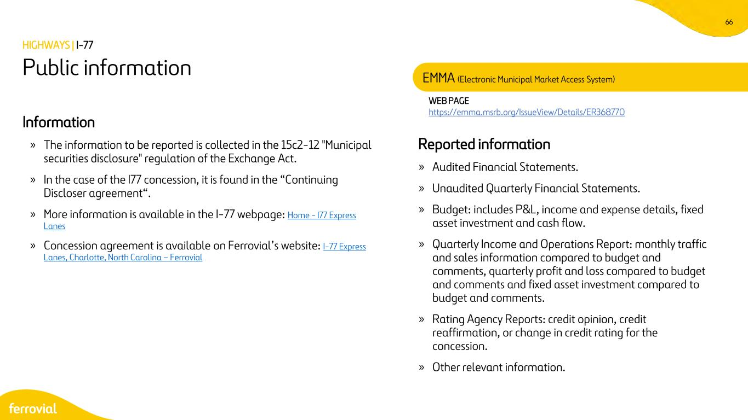
66 WEB PAGE https://emma.msrb.org/IssueView/Details/ER368770 Information » The information to be reported is collected in the 15c2-12 "Municipal securities disclosure" regulation of the Exchange Act. » In the case of the I77 concession, it is found in the “Continuing Discloser agreement“. » More information is available in the I-77 webpage: Home - I77 Express Lanes » Concession agreement is available on Ferrovial’s website: I-77 Express Lanes, Charlotte, North Carolina – Ferrovial Reported information » Audited Financial Statements. » Unaudited Quarterly Financial Statements. » Budget: includes P&L, income and expense details, fixed asset investment and cash flow. » Quarterly Income and Operations Report: monthly traffic and sales information compared to budget and comments, quarterly profit and loss compared to budget and comments and fixed asset investment compared to budget and comments. » Rating Agency Reports: credit opinion, credit reaffirmation, or change in credit rating for the concession. » Other relevant information. Public information EMMA (Electronic Municipal Market Access System) HIGHWAYS | I-77


IRB Infrastructure Developers LTD (India)

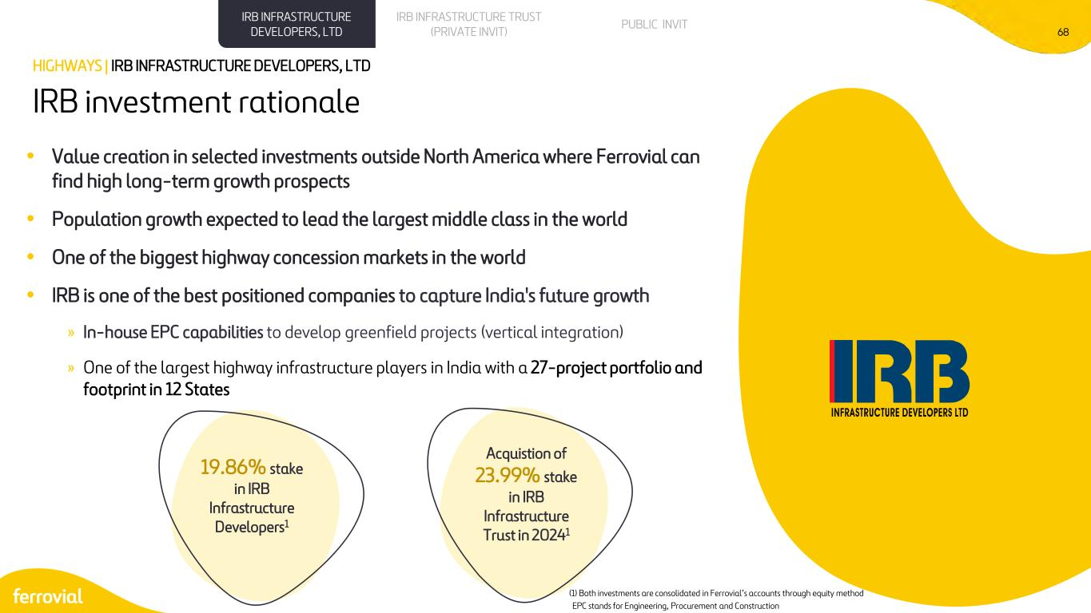
68 IRB investment rationale HIGHWAYS | IRB INFRASTRUCTURE DEVELOPERS, LTD • Value creation in selected investments outside North America where Ferrovial can find high long-term growth prospects • Population growth expected to lead the largest middle class in the world • One of the biggest highway concession markets in the world • IRB is one of the best positioned companies to capture India's future growth » In-house EPC capabilities to develop greenfield projects (vertical integration) » One of the largest highway infrastructure players in India with a 27-project portfolio and footprint in 12 States Acquistion of 23.99% stake in IRB Infrastructure Trust in 20241 19.86% stake in IRB Infrastructure Developers1 (1) Both investments are consolidated in Ferrovial’s accounts through equity method EPC stands for Engineering, Procurement and Construction PUBLIC INVITIRB INFRASTRUCTURE TRUST (PRIVATE INVIT) IRB INFRASTRUCTURE DEVELOPERS, LTD

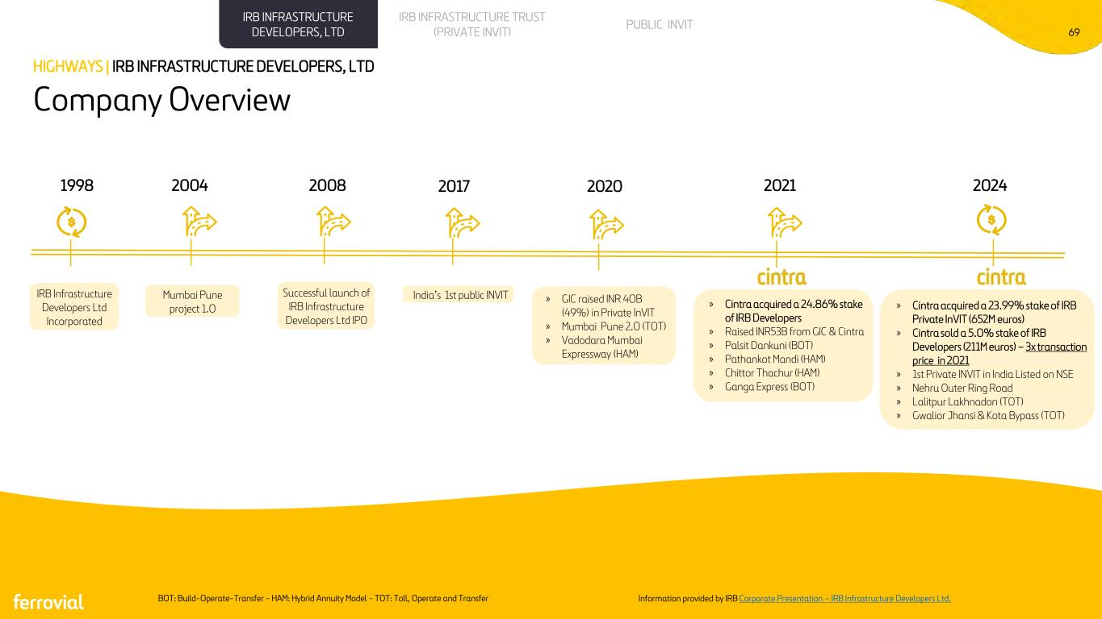
69 Company Overview HIGHWAYS | IRB INFRASTRUCTURE DEVELOPERS, LTD BOT: Build-Operate-Transfer - HAM: Hybrid Annuity Model - TOT: Toll, Operate and Transfer Information provided by IRB Corporate Presentation – IRB Infrastructure Developers Ltd. » Cintra acquired a 23.99% stake of IRB Private InVIT (652M euros) » Cintra sold a 5.0% stake of IRB Developers (211M euros) – 3x transaction price in 2021 » 1st Private INVIT in India Listed on NSE » Nehru Outer Ring Road » Lalitpur Lakhnadon (TOT) » Gwalior Jhansi & Kota Bypass (TOT) PUBLIC INVITIRB INFRASTRUCTURE TRUST (PRIVATE INVIT) IRB INFRASTRUCTURE DEVELOPERS, LTD 1998 2004 2008 2024 » Cintra acquired a 24.86% stake of IRB Developers » Raised INR53B from GIC & Cintra » Palsit Dankuni (BOT) » Pathankot Mandi (HAM) » Chittor Thachur (HAM) » Ganga Express (BOT) IRB Infrastructure Developers Ltd Incorporated 2017 2020 2021 Mumbai Pune project 1.0 Successful launch of IRB Infrastructure Developers Ltd IPO India’s 1st public INVIT » GIC raised INR 40B (49%) in Private InVIT » Mumbai Pune 2.0 (TOT) » Vadodara Mumbai Expressway (HAM)

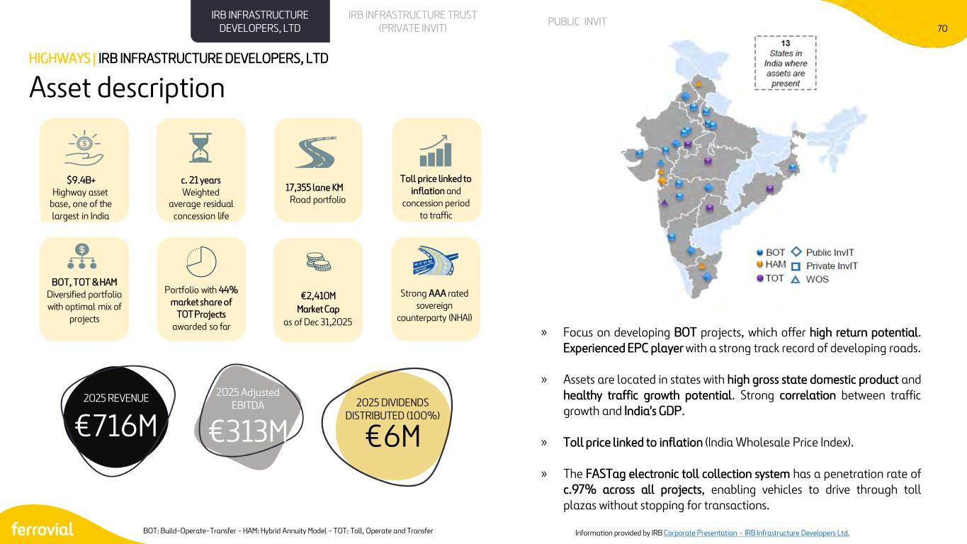
70 » Focus on developing BOT projects, which offer high return potential. Experienced EPC player with a strong track record of developing roads. » Assets are located in states with high gross state domestic product and healthy traffic growth potential. Strong correlation between traffic growth and India's GDP. » Toll price linked to inflation (India Wholesale Price Index). » The FASTag electronic toll collection system has a penetration rate of c.97% across all projects, enabling vehicles to drive through toll plazas without stopping for transactions. Asset description HIGHWAYS | IRB INFRASTRUCTURE DEVELOPERS, LTD BOT: Build-Operate-Transfer - HAM: Hybrid Annuity Model - TOT: Toll, Operate and Transfer $9.4B+ Highway asset base, one of the largest in India 17,355 lane KM Road portfolio BOT, TOT & HAM Diversified portfolio with optimal mix of projects €2,410M Market Cap as of Dec 31,2025 Portfolio with 44% market share of TOT Projects awarded so far c. 21 years Weighted average residual concession life Strong AAA rated sovereign counterparty (NHAI) Toll price linked to inflation and concession period to traffic PUBLIC INVITIRB INFRASTRUCTURE TRUST (PRIVATE INVIT) IRB INFRASTRUCTURE DEVELOPERS, LTD Information provided by IRB Corporate Presentation – IRB Infrastructure Developers Ltd. 2025 Adjusted EBITDA €313M 2025 DIVIDENDS DISTRIBUTED (100%) €6M€716M 2025 REVENUE

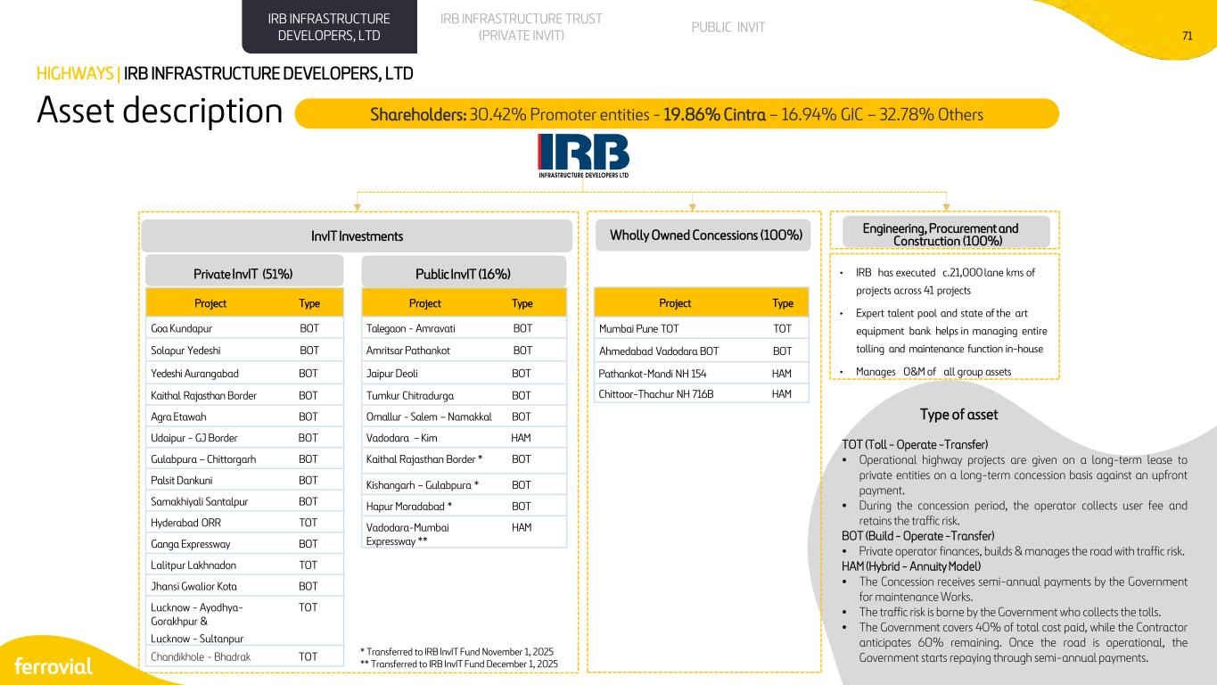
71 Asset description HIGHWAYS | IRB INFRASTRUCTURE DEVELOPERS, LTD Shareholders: 30.42% Promoter entities - 19.86% Cintra – 16.94% GIC – 32.78% Others InvIT Investments Public InvIT (16%) Project Type Mumbai Pune TOT TOT Ahmedabad Vadodara BOT BOT Pathankot-Mandi NH 154 HAM Chittoor-Thachur NH 716B HAM Project Type Goa Kundapur BOT Solapur Yedeshi BOT Yedeshi Aurangabad BOT Kaithal Rajasthan Border BOT Agra Etawah BOT Udaipur - GJ Border BOT Gulabpura – Chittorgarh BOT Palsit Dankuni BOT Samakhiyali Santalpur BOT Hyderabad ORR TOT Ganga Expressway BOT Lalitpur Lakhnadon TOT Jhansi Gwalior Kota BOT Lucknow - Ayodhya- Gorakhpur & Lucknow - Sultanpur TOT Chandikhole - Bhadrak TOT Project Type Talegaon - Amravati BOT Amritsar Pathankot BOT Jaipur Deoli BOT Tumkur Chitradurga BOT Omallur - Salem – Namakkal BOT Vadodara – Kim HAM Kaithal Rajasthan Border * BOT Kishangarh – Gulabpura * BOT Hapur Moradabad * BOT Vadodara-Mumbai Expressway ** HAM • IRB has executed c.21,000 lane kms of projects across 41 projects • Expert talent pool and state of the art equipment bank helps in managing entire tolling and maintenance function in-house • Manages O&M of all group assets Engineering, Procurement and Construction (100%) Private InvIT (51%) Wholly Owned Concessions (100%) PUBLIC INVITIRB INFRASTRUCTURE TRUST (PRIVATE INVIT) IRB INFRASTRUCTURE DEVELOPERS, LTD TOT (Toll - Operate -Transfer) • Operational highway projects are given on a long-term lease to private entities on a long-term concession basis against an upfront payment. • During the concession period, the operator collects user fee and retains the traffic risk. BOT (Build - Operate -Transfer) • Private operator finances, builds & manages the road with traffic risk. HAM (Hybrid - Annuity Model) • The Concession receives semi-annual payments by the Government for maintenance Works. • The traffic risk is borne by the Government who collects the tolls. • The Government covers 40% of total cost paid, while the Contractor anticipates 60% remaining. Once the road is operational, the Government starts repaying through semi-annual payments. Type of asset * Transferred to IRB InvIT Fund November 1, 2025 ** Transferred to IRB InvIT Fund December 1, 2025

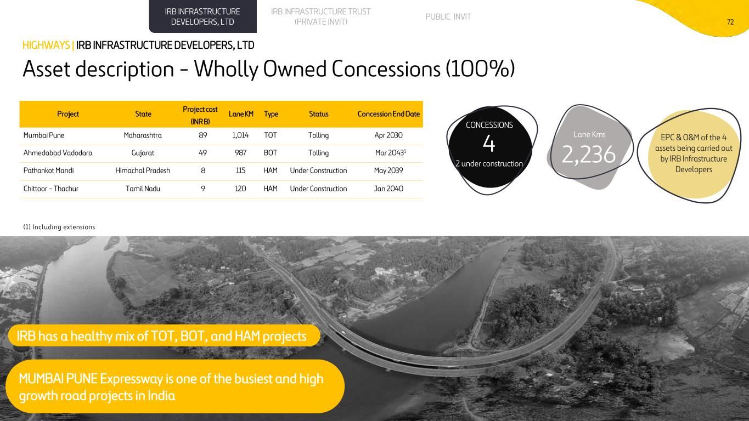
72 Asset description - Wholly Owned Concessions (100%) HIGHWAYS | IRB INFRASTRUCTURE DEVELOPERS, LTD IRB has a healthy mix of TOT, BOT, and HAM projects Project State Project cost (INR B) Lane KM Type Status Concession End Date Mumbai Pune Maharashtra 89 1,014 TOT Tolling Apr 2030 Ahmedabad Vadodara Gujarat 49 987 BOT Tolling Mar 20431 Pathankot Mandi Himachal Pradesh 8 115 HAM Under Construction May 2039 Chittoor – Thachur Tamil Nadu 9 120 HAM Under Construction Jan 2040 (1) Including extensions 4 2 under construction CONCESSIONS Lane Kms 2,236 EPC & O&M of the 4 assets being carried out by IRB Infrastructure Developers PUBLIC INVITIRB INFRASTRUCTURE TRUST (PRIVATE INVIT) IRB INFRASTRUCTURE DEVELOPERS, LTD MUMBAI PUNE Expressway is one of the busiest and high growth road projects in India

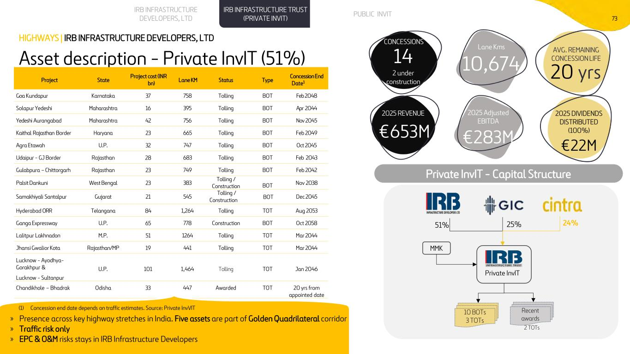
73 Asset description - Private InvIT (51%) HIGHWAYS | IRB INFRASTRUCTURE DEVELOPERS, LTD Private InvIT - Capital Structure 51% 25% 24% Private InvIT MMK 10 BOTs 3 TOTs Recent awards 2 TOTs Project State Project cost (INR bn) Lane KM Status Type Concession End Date1 Goa Kundapur Karnataka 37 758 Tolling BOT Feb 2048 Solapur Yedeshi Maharashtra 16 395 Tolling BOT Apr 2044 Yedeshi Aurangabad Maharashtra 42 756 Tolling BOT Nov 2045 Kaithal Rajasthan Border Haryana 23 665 Tolling BOT Feb 2049 Agra Etawah U.P. 32 747 Tolling BOT Oct 2045 Udaipur - GJ Border Rajasthan 28 683 Tolling BOT Feb 2043 Gulabpura – Chittorgarh Rajasthan 23 749 Tolling BOT Feb 2042 Palsit Dankuni West Bengal 23 383 Tolling / Construction BOT Nov 2038 Samakhiyali Santalpur Gujarat 21 545 Tolling / Construction BOT Dec 2045 Hyderabad ORR Telangana 84 1,264 Tolling TOT Aug 2053 Ganga Expressway U.P. 65 778 Construction BOT Oct 2058 Lalitpur Lakhnadon M.P. 51 1264 Tolling TOT Mar 2044 Jhansi Gwalior Kota Rajasthan/MP 19 441 Tolling TOT Mar 2044 Lucknow - Ayodhya- Gorakhpur & Lucknow - Sultanpur U.P. 101 1,464 Tolling TOT Jan 2046 Chandikhole – Bhadrak Odisha 33 447 Awarded TOT 20 yrs from appointed date PUBLIC INVITIRB INFRASTRUCTURE TRUST (PRIVATE INVIT) IRB INFRASTRUCTURE DEVELOPERS, LTD Lane Kms 10,674 AVG. REMAINING CONCESSION LIFE 20 yrs 14 2 under construction CONCESSIONS » Presence across key highway stretches in India. Five assets are part of Golden Quadrilateral corridor » Traffic risk only » EPC & O&M risks stays in IRB Infrastructure Developers (1) Concession end date depends on traffic estimates. Source: Private InvVIT 2025 Adjusted EBITDA €283M 2025 DIVIDENDS DISTRIBUTED (100%) €22M €653M 2025 REVENUE

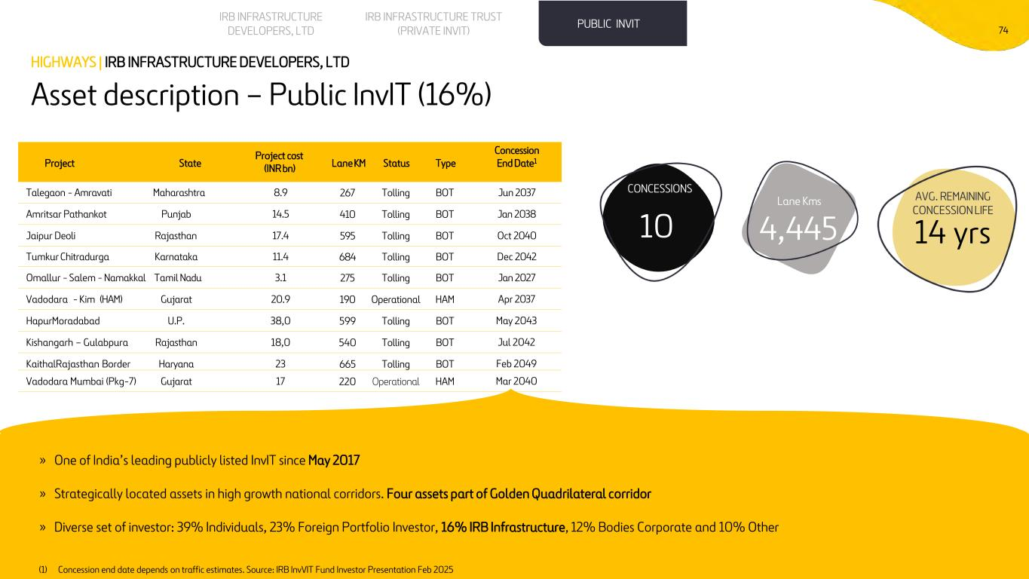
74 Asset description – Public InvIT (16%) HIGHWAYS | IRB INFRASTRUCTURE DEVELOPERS, LTD Project State Project cost (INR bn) Lane KM Status Type Concession End Date1 Talegaon - Amravati Maharashtra 8.9 267 Tolling BOT Jun 2037 Amritsar Pathankot Punjab 14.5 410 Tolling BOT Jan 2038 Jaipur Deoli Rajasthan 17.4 595 Tolling BOT Oct 2040 Tumkur Chitradurga Karnataka 11.4 684 Tolling BOT Dec 2042 Omallur - Salem - Namakkal Tamil Nadu 3.1 275 Tolling BOT Jan 2027 Vadodara - Kim (HAM) Gujarat 20.9 190 Operational HAM Apr 2037 HapurMoradabad U.P. 38,0 599 Tolling BOT May 2043 Kishangarh – Gulabpura Rajasthan 18,0 540 Tolling BOT Jul 2042 KaithalRajasthan Border Haryana 23 665 Tolling BOT Feb 2049 Vadodara Mumbai (Pkg-7) Gujarat 17 220 Operational HAM Mar 2040 PUBLIC INVITIRB INFRASTRUCTURE TRUST (PRIVATE INVIT) IRB INFRASTRUCTURE DEVELOPERS, LTD Lane Kms 4,445 AVG. REMAINING CONCESSION LIFE 14 yrs10 CONCESSIONS » One of India’s leading publicly listed InvIT since May 2017 » Strategically located assets in high growth national corridors. Four assets part of Golden Quadrilateral corridor » Diverse set of investor: 39% Individuals, 23% Foreign Portfolio Investor, 16% IRB Infrastructure, 12% Bodies Corporate and 10% Other (1) Concession end date depends on traffic estimates. Source: IRB InvVIT Fund Investor Presentation Feb 2025


Other Assets 75

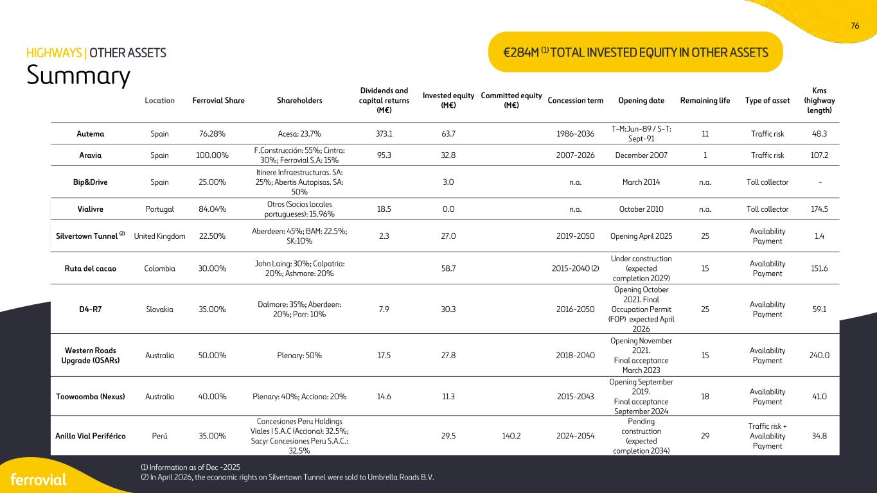
76 Summary HIGHWAYS | OTHER ASSETS €284M (1) TOTAL INVESTED EQUITY IN OTHER ASSETS Location Ferrovial Share Shareholders Dividends and capital returns (M€) Invested equity (M€) Committed equity (M€) Concession term Opening date Remaining life Type of asset Kms (highway length) Autema Spain 76.28% Acesa: 23.7% 373.1 63.7 1986-2036 T-M:Jun-89 / S-T: Sept-91 11 Traffic risk 48.3 Aravia Spain 100.00% F.Construcción: 55%; Cintra: 30%; Ferrovial S.A: 15% 95.3 32.8 2007-2026 December 2007 1 Traffic risk 107.2 Bip&Drive Spain 25.00% Itinere Infraestructuras. SA: 25%; Abertis Autopisas. SA: 50% 3.0 n.a. March 2014 n.a. Toll collector - Vialivre Portugal 84.04% Otros (Socios locales portugueses): 15.96% 18.5 0.0 n.a. October 2010 n.a. Toll collector 174.5 Silvertown Tunnel (2) United Kingdom 22.50% Aberdeen: 45%; BAM: 22.5%; SK:10% 2.3 27.0 2019-2050 Opening April 2025 25 Availability Payment 1.4 Ruta del cacao Colombia 30.00% John Laing: 30%; Colpatria: 20%; Ashmore: 20% 58.7 2015-2040 (2) Under construction (expected completion 2029) 15 Availability Payment 151.6 D4-R7 Slovakia 35.00% Dalmore: 35%; Aberdeen: 20%; Porr: 10% 7.9 30.3 2016-2050 Opening October 2021. Final Occupation Permit (FOP) expected April 2026 25 Availability Payment 59.1 Western Roads Upgrade (OSARs) Australia 50.00% Plenary: 50% 17.5 27.8 2018-2040 Opening November 2021. Final acceptance March 2023 15 Availability Payment 240.0 Toowoomba (Nexus) Australia 40.00% Plenary: 40%; Acciona: 20% 14.6 11.3 2015-2043 Opening September 2019. Final acceptance September 2024 18 Availability Payment 41.0 Anillo Vial Periférico Perú 35.00% Concesiones Peru Holdings Viales I S.A.C (Acciona): 32.5%; Sacyr Concesiones Peru S.A.C.: 32.5% 29.5 140.2 2024-2054 Pending construction (expected completion 2034) 29 Traffic risk + Availability Payment 34.8 (1) Information as of Dec -2025 (2) In April 2026, the economic rights on Silvertown Tunnel were sold to Umbrella Roads B.V.


Airports

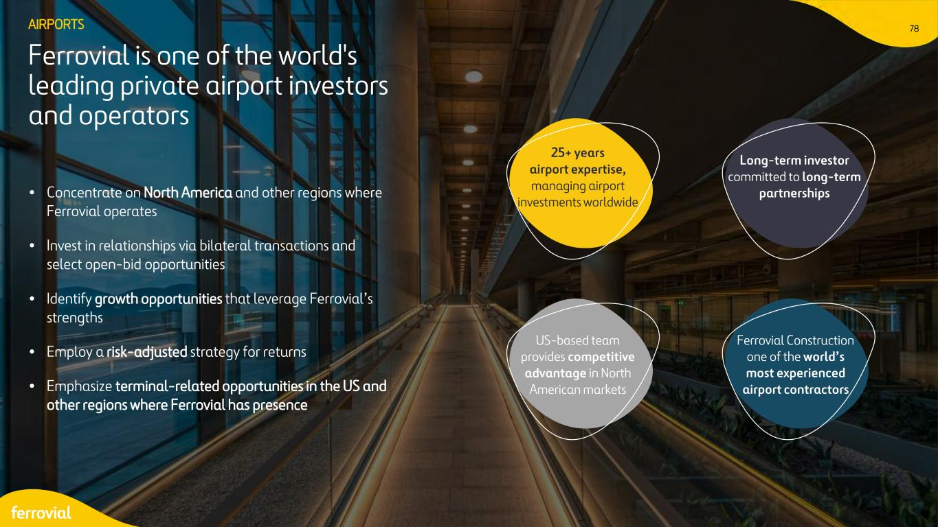
78 • Concentrate on North America and other regions where Ferrovial operates • Invest in relationships via bilateral transactions and select open-bid opportunities • Identify growth opportunities that leverage Ferrovial’s strengths • Employ a risk-adjusted strategy for returns • Emphasize terminal-related opportunities in the US and other regions where Ferrovial has presence Ferrovial is one of the world's leading private airport investors and operators AIRPORTS 25+ years airport expertise, managing airport investments worldwide Long-term investor committed to long-term partnerships US-based team provides competitive advantage in North American markets Ferrovial Construction one of the world’s most experienced airport contractors


79 Contents 1 New Terminal One - JFK 2 Dalaman Airport

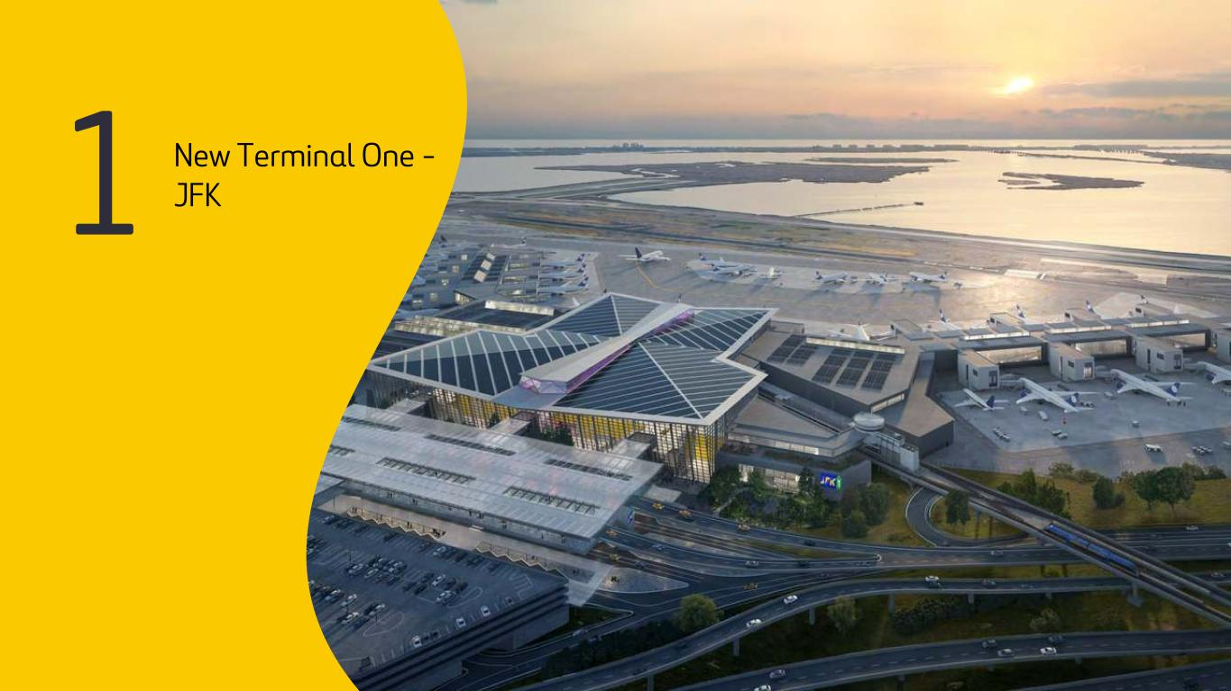
80 1 New Terminal One - JFK

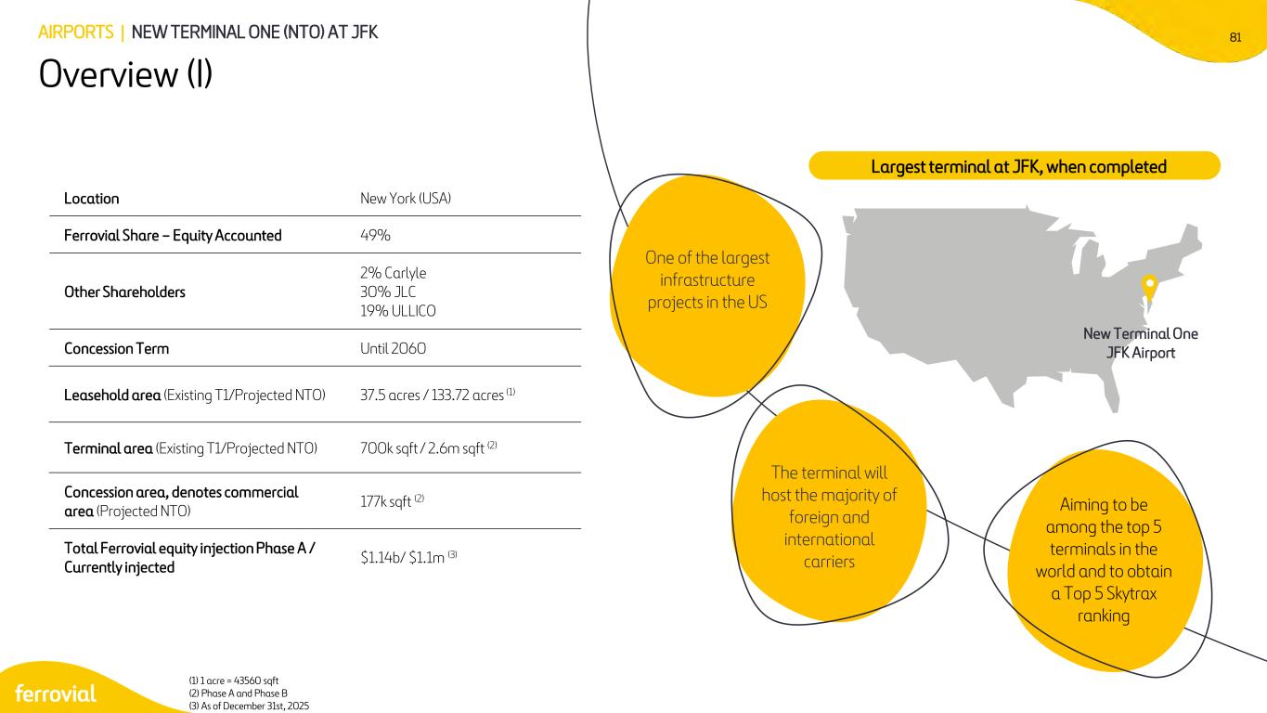
81 Location New York (USA) Ferrovial Share – Equity Accounted 49% Other Shareholders 2% Carlyle 30% JLC 19% ULLICO Concession Term Until 2060 Leasehold area (Existing T1/Projected NTO) 37.5 acres / 133.72 acres (1) Terminal area (Existing T1/Projected NTO) 700k sqft / 2.6m sqft (2) Concession area, denotes commercial area (Projected NTO) 177k sqft (2) Total Ferrovial equity injection Phase A / Currently injected $1.14b/ $1.1m (3) (1) 1 acre = 43560 sqft (2) Phase A and Phase B (3) As of December 31st, 2025 Overview (I) Largest terminal at JFK, when completed AIRPORTS | NEW TERMINAL ONE (NTO) AT JFK New Terminal One JFK Airport One of the largest infrastructure projects in the US The terminal will host the majority of foreign and international carriers Aiming to be among the top 5 terminals in the world and to obtain a Top 5 Skytrax ranking

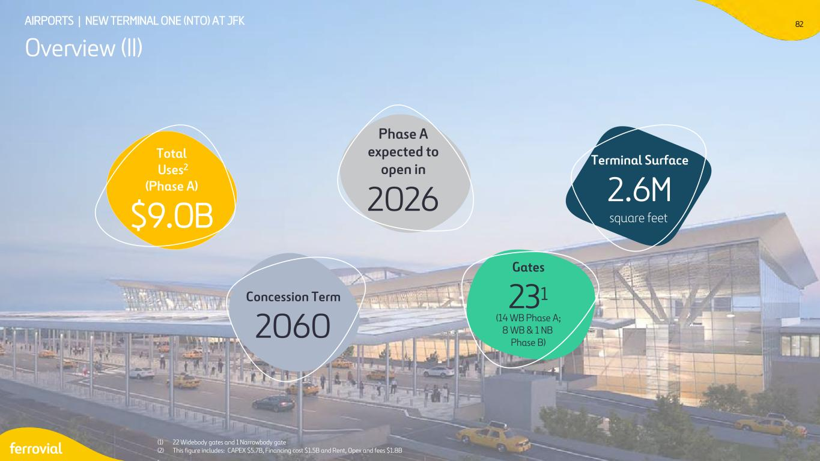
82AIRPORTS | NEW TERMINAL ONE (NTO) AT JFK Overview (II) (1) 22 Widebody gates and 1 Narrowbody gate (2) This figure includes: CAPEX $5.7B, Financing cost $1.5B and Rent, Opex and fees $1.8B . Phase A expected to open in 2026 Concession Term 2060 Total Uses2 (Phase A) $9.0B Gates 231 (14 WB Phase A; 8 WB & 1 NB Phase B) Terminal Surface 2.6M square feet

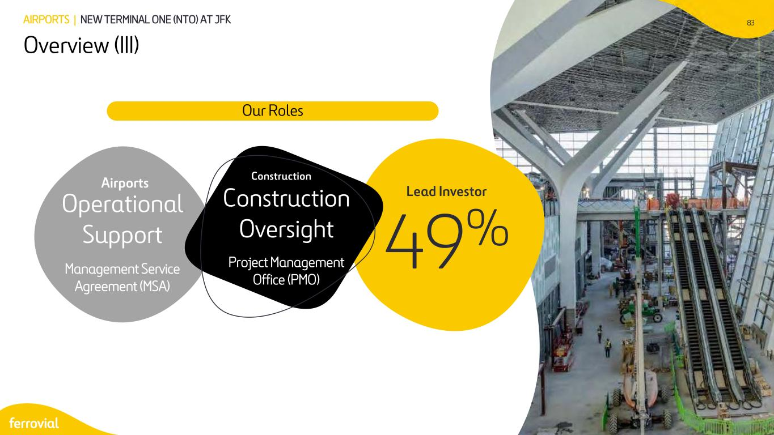
83 Overview (III) AIRPORTS | NEW TERMINAL ONE (NTO) AT JFK 49% Lead Investor Operational Support Management Service Agreement (MSA) Airports Construction Construction Oversight Project Management Office (PMO) Our Roles 83

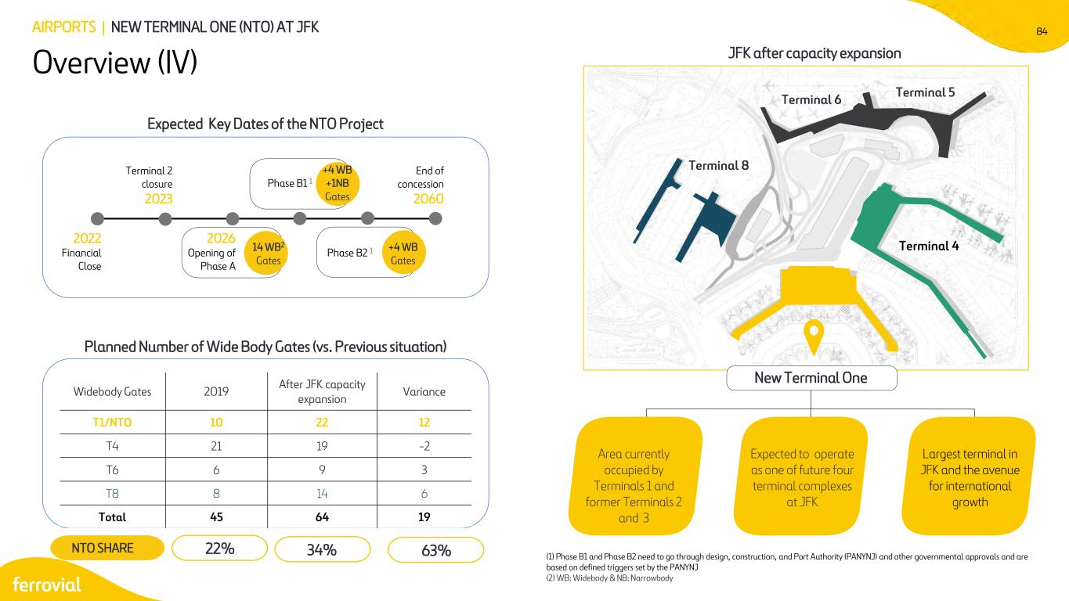
84 Expected Key Dates of the NTO Project Planned Number of Wide Body Gates (vs. Previous situation) Area currently occupied by Terminals 1 and former Terminals 2 and 3 (1) Phase B1 and Phase B2 need to go through design, construction, and Port Authority (PANYNJ) and other governmental approvals and are based on defined triggers set by the PANYNJ (2) WB: Widebody & NB: Narrowbody Terminal 6 Terminal 5 Terminal 8 Widebody Gates 2019 After JFK capacity expansion Variance T1/NTO 10 22 12 T4 21 19 -2 T6 6 9 3 T8 8 14 6 Total 45 64 19 Overview (IV) AIRPORTS | NEW TERMINAL ONE (NTO) AT JFK 2022 Financial Close Terminal 2 closure 2023 2026 Opening of Phase A Phase B1 1 Phase B2 1 End of concession 2060 Terminal 4 Expected to operate as one of future four terminal complexes at JFK Largest terminal in JFK and the avenue for international growth +4 WB +1NB Gates +4 WB Gates 14 WB2 Gates JFK after capacity expansion New Terminal One 22%NTO SHARE 34% 63%

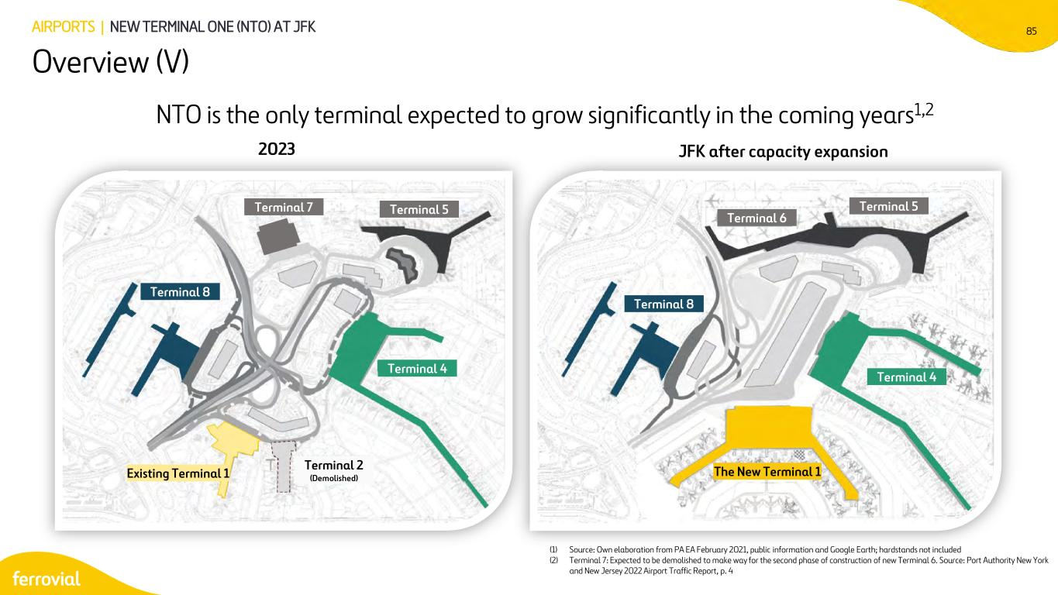
85 NTO is the only terminal expected to grow significantly in the coming years1,2 (1) Source: Own elaboration from PA EA February 2021, public information and Google Earth; hardstands not included (2) Terminal 7: Expected to be demolished to make way for the second phase of construction of new Terminal 6. Source: Port Authority New York and New Jersey 2022 Airport Traffic Report, p. 4 2023 Terminal 8 JFK after capacity expansion Terminal 7 Terminal 5 Terminal 4 Existing Terminal 1 Terminal 2 (Demolished) Terminal 8 Terminal 5 Terminal 6 Terminal 4 The New Terminal 1 Overview (V) AIRPORTS | NEW TERMINAL ONE (NTO) AT JFK

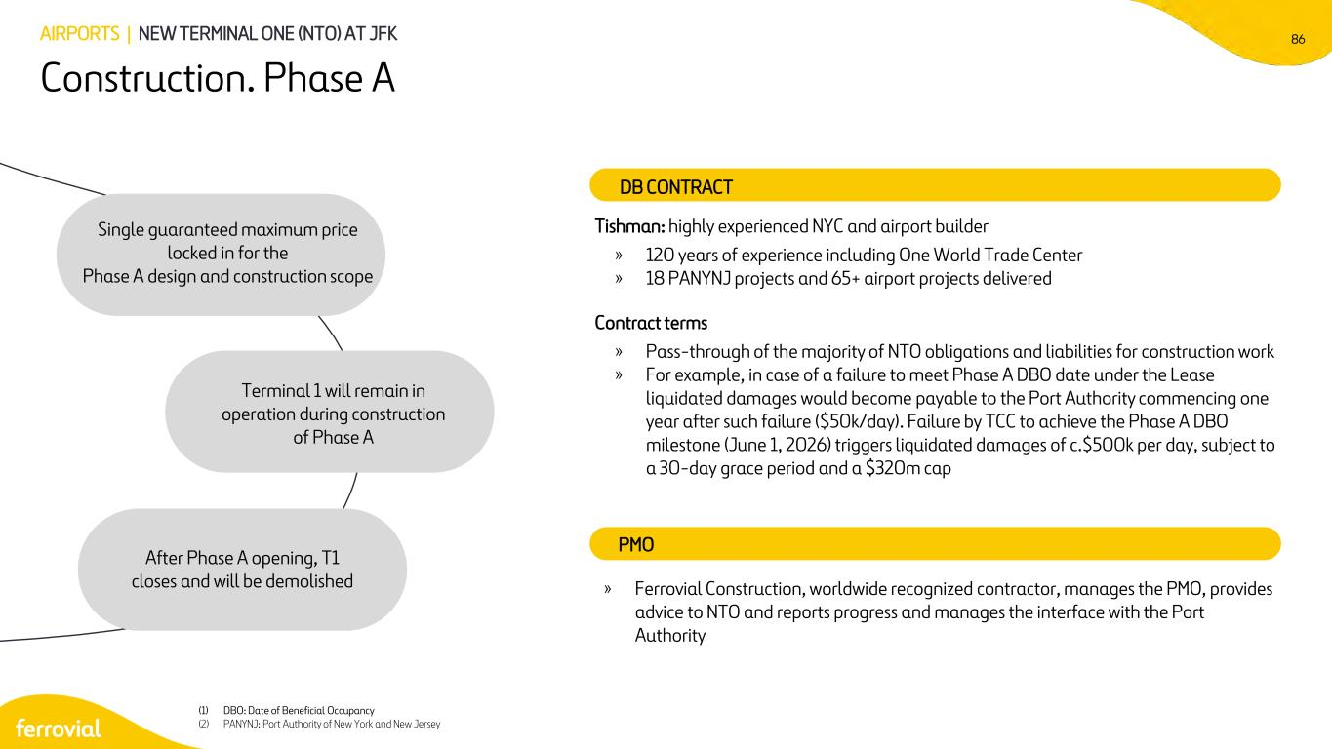
86 Construction. Phase A AIRPORTS | NEW TERMINAL ONE (NTO) AT JFK Single guaranteed maximum price locked in for the Phase A design and construction scope Terminal 1 will remain in operation during construction of Phase A After Phase A opening, T1 closes and will be demolished Tishman: highly experienced NYC and airport builder » 120 years of experience including One World Trade Center » 18 PANYNJ projects and 65+ airport projects delivered Contract terms » Pass-through of the majority of NTO obligations and liabilities for construction work » For example, in case of a failure to meet Phase A DBO date under the Lease liquidated damages would become payable to the Port Authority commencing one year after such failure ($50k/day). Failure by TCC to achieve the Phase A DBO milestone (June 1, 2026) triggers liquidated damages of c.$500k per day, subject to a 30-day grace period and a $320m cap DB CONTRACT PMO » Ferrovial Construction, worldwide recognized contractor, manages the PMO, provides advice to NTO and reports progress and manages the interface with the Port Authority (1) DBO: Date of Beneficial Occupancy (2) PANYNJ: Port Authority of New York and New Jersey

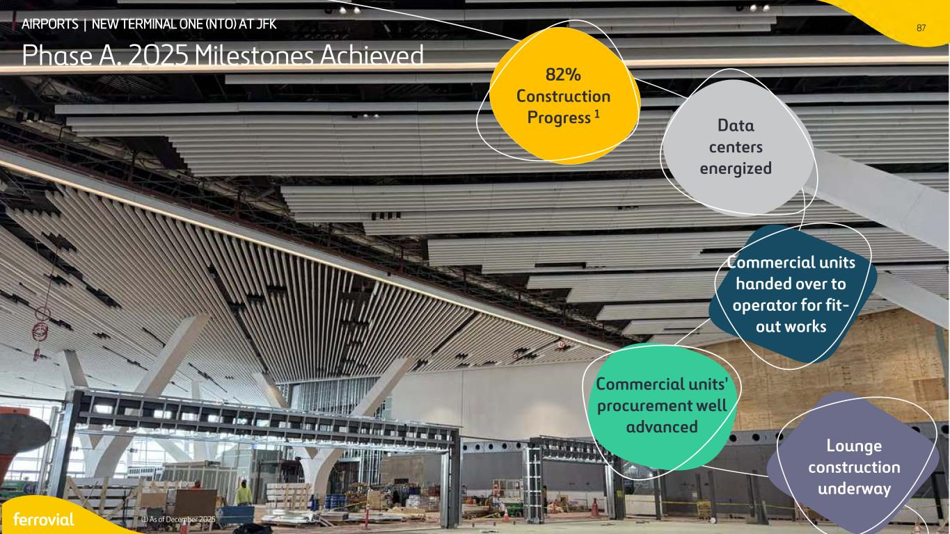
8787AIRPORTS | NEW TERMINAL ONE (NTO) AT JFK Phase A. 2025 Milestones Achieved (1) As of December 2025 Lounge construction underway Commercial units' procurement well advanced Commercial units handed over to operator for fit- out works Data centers energized 82% Construction Progress 1

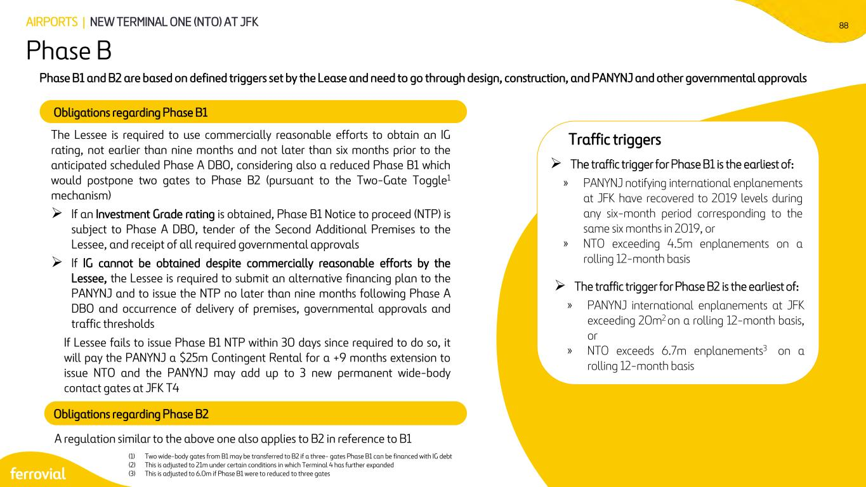
88 The Lessee is required to use commercially reasonable efforts to obtain an IG rating, not earlier than nine months and not later than six months prior to the anticipated scheduled Phase A DBO, considering also a reduced Phase B1 which would postpone two gates to Phase B2 (pursuant to the Two-Gate Toggle1 mechanism) ➢ If an Investment Grade rating is obtained, Phase B1 Notice to proceed (NTP) is subject to Phase A DBO, tender of the Second Additional Premises to the Lessee, and receipt of all required governmental approvals ➢ If IG cannot be obtained despite commercially reasonable efforts by the Lessee, the Lessee is required to submit an alternative financing plan to the PANYNJ and to issue the NTP no later than nine months following Phase A DBO and occurrence of delivery of premises, governmental approvals and traffic thresholds If Lessee fails to issue Phase B1 NTP within 30 days since required to do so, it will pay the PANYNJ a $25m Contingent Rental for a +9 months extension to issue NTO and the PANYNJ may add up to 3 new permanent wide-body contact gates at JFK T4 Obligations regarding Phase B1 Phase B AIRPORTS | NEW TERMINAL ONE (NTO) AT JFK Traffic triggers (1) Two wide-body gates from B1 may be transferred to B2 if a three- gates Phase B1 can be financed with IG debt (2) This is adjusted to 21m under certain conditions in which Terminal 4 has further expanded (3) This is adjusted to 6.0m if Phase B1 were to reduced to three gates Phase B1 and B2 are based on defined triggers set by the Lease and need to go through design, construction, and PANYNJ and other governmental approvals Obligations regarding Phase B2 A regulation similar to the above one also applies to B2 in reference to B1 ➢ The traffic trigger for Phase B1 is the earliest of: » PANYNJ notifying international enplanements at JFK have recovered to 2019 levels during any six-month period corresponding to the same six months in 2019, or » NTO exceeding 4.5m enplanements on a rolling 12-month basis ➢ The traffic trigger for Phase B2 is the earliest of: » PANYNJ international enplanements at JFK exceeding 20m2 on a rolling 12-month basis, or » NTO exceeds 6.7m enplanements3 on a rolling 12-month basis

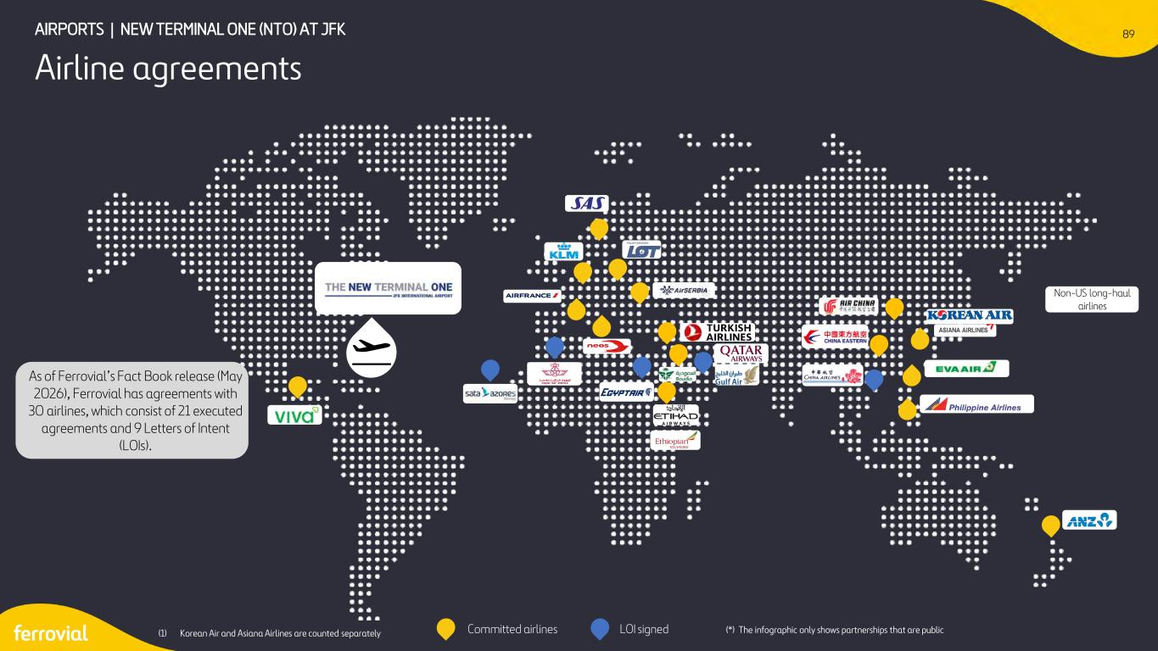
89 Airline agreements AIRPORTS | NEW TERMINAL ONE (NTO) AT JFK Committed airlines LOI signed Non-US long-haul airlines As of Ferrovial’s Fact Book release (May 2026), Ferrovial has agreements with 30 airlines, which consist of 21 executed agreements and 9 Letters of Intent (LOIs). (*) The infographic only shows partnerships that are public(1) Korean Air and Asiana Airlines are counted separately

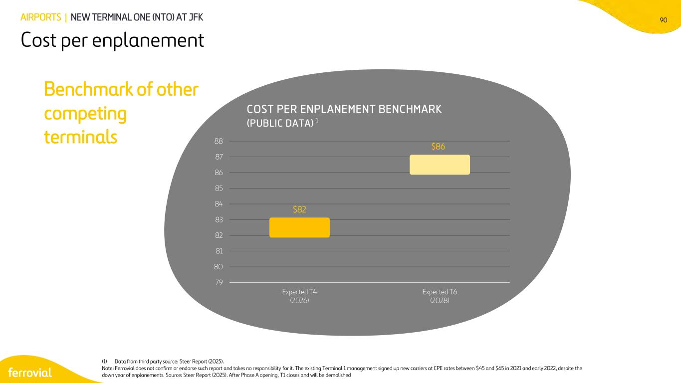
90 Cost per enplanement AIRPORTS | NEW TERMINAL ONE (NTO) AT JFK Benchmark of other competing terminals COST PER ENPLANEMENT BENCHMARK (PUBLIC DATA) 1 (1) Data from third party source: Steer Report (2025). Note: Ferrovial does not confirm or endorse such report and takes no responsibility for it. The existing Terminal 1 management signed up new carriers at CPE rates between $45 and $65 in 2021 and early 2022, despite the down year of enplanements. Source: Steer Report (2025). After Phase A opening, T1 closes and will be demolished $82 $86 79 80 81 82 83 84 85 86 87 88 Expected T4 (2026) Expected T6 (2028)

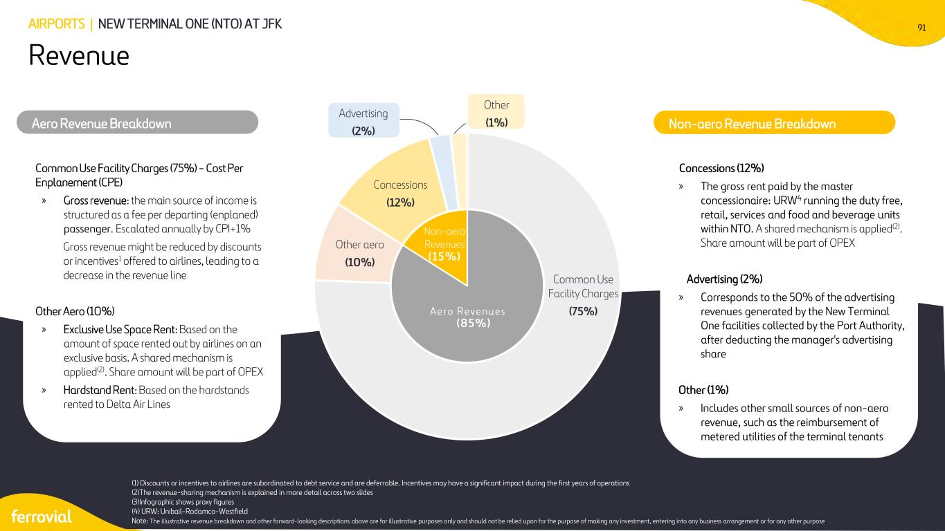
91 Revenue AIRPORTS | NEW TERMINAL ONE (NTO) AT JFK Aero Revenues Non-aero Revenues (15%) (85%) Common Use Facility Charges (75%) Other aero (10%) Concessions (12%) Advertising (2%) Other (1%)Aero Revenue Breakdown BASED ON THE AMOUNT OF SPACE RENTED OUT BY AIRLINES ON AN EXCLUSIVE BASIS Non-aero Revenue Breakdown Concessions (12%) » The gross rent paid by the master concessionaire: URW4 running the duty free, retail, services and food and beverage units within NTO. A shared mechanism is applied(2). Share amount will be part of OPEX Advertising (2%) » Corresponds to the 50% of the advertising revenues generated by the New Terminal One facilities collected by the Port Authority, after deducting the manager's advertising share Other (1%) » Includes other small sources of non-aero revenue, such as the reimbursement of metered utilities of the terminal tenants (1) Discounts or incentives to airlines are subordinated to debt service and are deferrable. Incentives may have a significant impact during the first years of operations (2)The revenue-sharing mechanism is explained in more detail across two slides (3)Infographic shows proxy figures (4) URW: Unibail-Rodamco-Westfield Note: The illustrative revenue breakdown and other forward-looking descriptions above are for illustrative purposes only and should not be relied upon for the purpose of making any investment, entering into any business arrangement or for any other purpose. Common Use Facility Charges (75%) - Cost Per Enplanement (CPE) » Gross revenue: the main source of income is structured as a fee per departing (enplaned) passenger. Escalated annually by CPI+1% Gross revenue might be reduced by discounts or incentives1 offered to airlines, leading to a decrease in the revenue line Other Aero (10%) » Exclusive Use Space Rent: Based on the amount of space rented out by airlines on an exclusive basis. A shared mechanism is applied(2). Share amount will be part of OPEX » Hardstand Rent: Based on the hardstands rented to Delta Air Lines

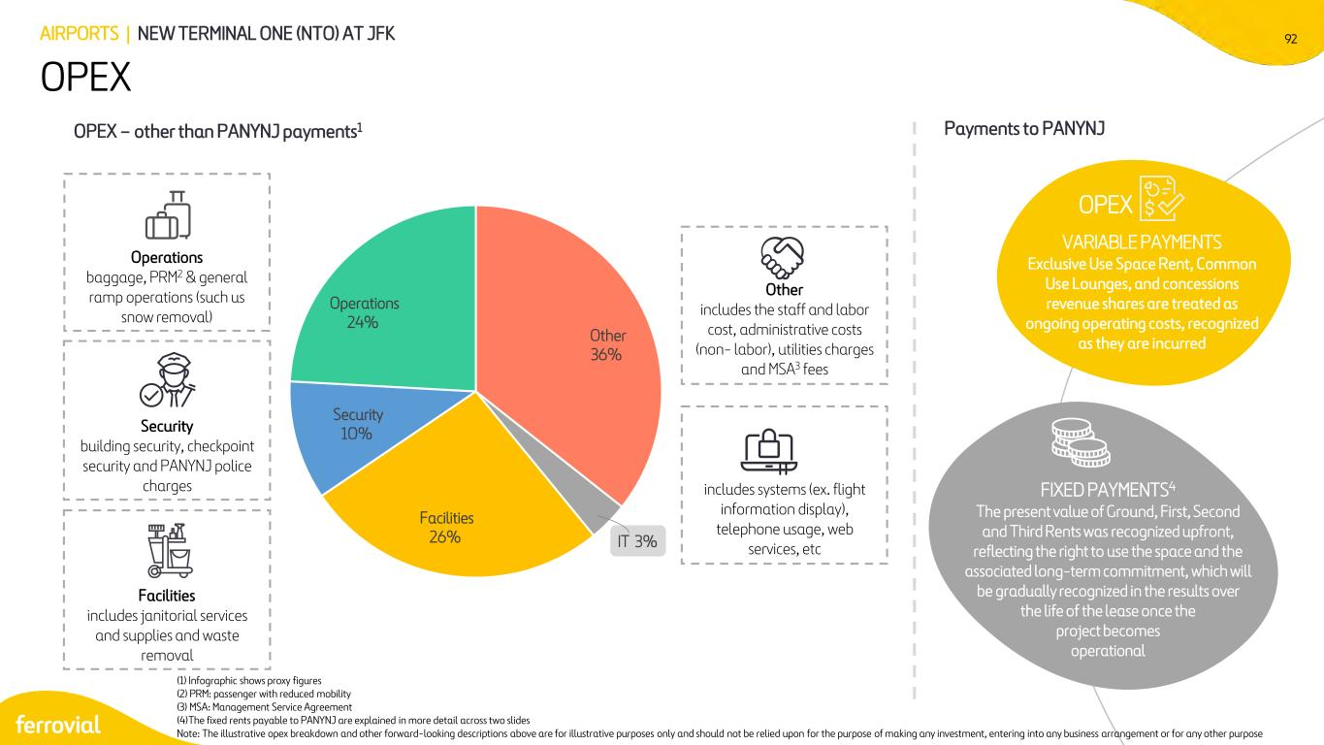
92 OPEX AIRPORTS | NEW TERMINAL ONE (NTO) AT JFK Operations baggage, PRM2 & general ramp operations (such us snow removal) Security building security, checkpoint security and PANYNJ police charges IT includes systems (ex. flight information display), telephone usage, web services, etc Other includes the staff and labor cost, administrative costs (non- labor), utilities charges and MSA3 fees (1) Infographic shows proxy figures (2) PRM: passenger with reduced mobility (3) MSA: Management Service Agreement (4)The fixed rents payable to PANYNJ are explained in more detail across two slides Note: The illustrative opex breakdown and other forward-looking descriptions above are for illustrative purposes only and should not be relied upon for the purpose of making any investment, entering into any business arrangement or for any other purpose Facilities includes janitorial services and supplies and waste removal Other 36% IT 3% Facilities 26% Security 10% Operations 24% 8% OPEX – other than PANYNJ payments1 Payments to PANYNJ FIXED PAYMENTS4 The present value of Ground, First, Second and Third Rents was recognized upfront, reflecting the right to use the space and the associated long-term commitment, which will be gradually recognized in the results over the life of the lease once the project becomes operational VARIABLE PAYMENTS Exclusive Use Space Rent, Common Use Lounges, and concessions revenue shares are treated as ongoing operating costs, recognized as they are incurred OPEX

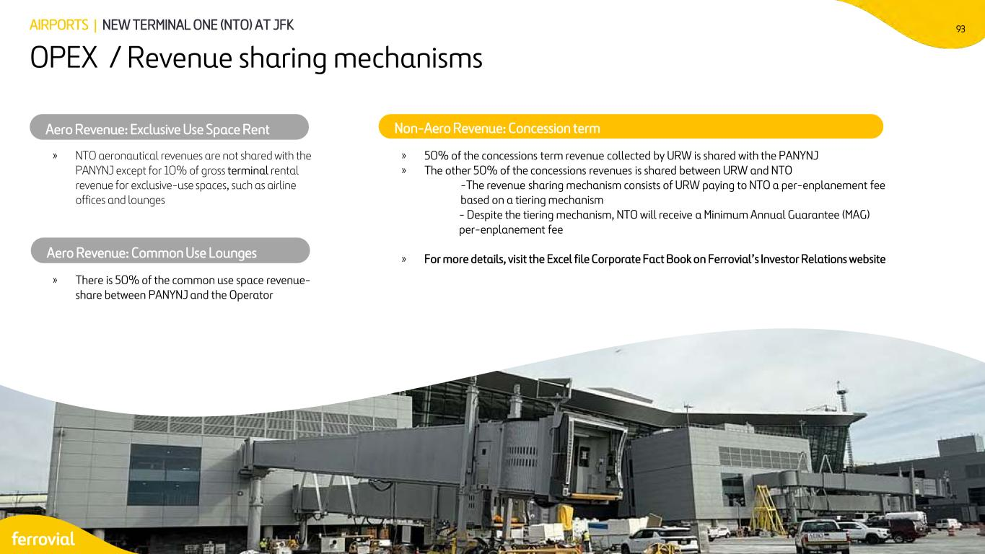
93AIRPORTS | NEW TERMINAL ONE (NTO) AT JFK OPEX / Revenue sharing mechanisms » NTO aeronautical revenues are not shared with the PANYNJ except for 10% of gross terminal rental revenue for exclusive-use spaces, such as airline offices and lounges Aero Revenue: Exclusive Use Space Rent » There is 50% of the common use space revenue- share between PANYNJ and the Operator » 50% of the concessions term revenue collected by URW is shared with the PANYNJ » The other 50% of the concessions revenues is shared between URW and NTO -The revenue sharing mechanism consists of URW paying to NTO a per-enplanement fee based on a tiering mechanism - Despite the tiering mechanism, NTO will receive a Minimum Annual Guarantee (MAG) per-enplanement fee » For more details, visit the Excel file Corporate Fact Book on Ferrovial’s Investor Relations website Non-Aero Revenue: Concession term Aero Revenue: Common Use Lounges

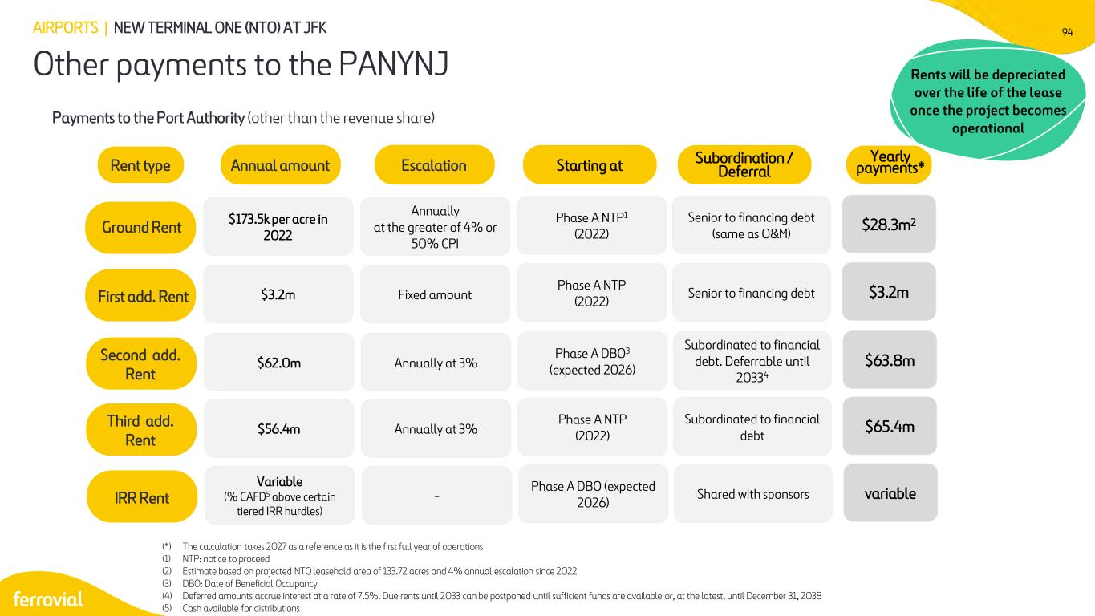
94 Other payments to the PANYNJ AIRPORTS | NEW TERMINAL ONE (NTO) AT JFK Payments to the Port Authority (other than the revenue share) Rent type Annual amount $173.5k per acre in 2022 Annually at the greater of 4% or 50% CPI $28.3m2Ground Rent Escalation Yearly payments* $3.2m Fixed amount $3.2mFirst add. Rent $62.0m Annually at 3% $63.8mSecond add. Rent Second add. Rent $56.4m Annually at 3% $65.4mThird add. ent Variable (% CAFD5 above certain tiered IRR hurdles) - Senior to financing debt (same as O&M) Subordination / Deferral Senior to financing debt Subordinated to financial debt. Deferrable until 20334 Subordinated to financial debt Shared with sponsors Phase A NTP1 (2022) Starting at Phase A NTP (2022) Phase A DBO3 (expected 2026) Phase A NTP (2022) Phase A DBO (expected 2026) variableIRR Rent (*) The calculation takes 2027 as a reference as it is the first full year of operations (1) NTP: notice to proceed (2) Estimate based on projected NTO leasehold area of 133.72 acres and 4% annual escalation since 2022 (3) DBO: Date of Beneficial Occupancy (4) Deferred amounts accrue interest at a rate of 7.5%. Due rents until 2033 can be postponed until sufficient funds are available or, at the latest, until December 31, 2038 (5) Cash available for distributions Rents will be depreciated over the life of the lease once the project becomes operational

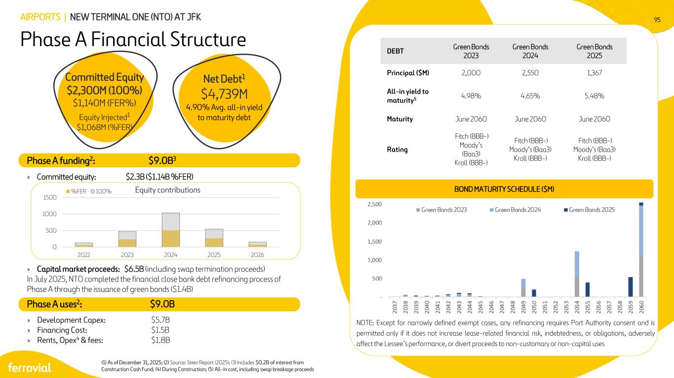
95 (1) As of December 31, 2025; (2) Source: Steer Report (2025); (3) Includes $0.2B of interest from Construction Cash Fund; (4) During Construction; (5) All-in cost, including swap breakage proceeds 0 500 1000 1500 2022 2023 2024 2025 2026 Equity contributions%FER 100% Phase A Financial Structure AIRPORTS | NEW TERMINAL ONE (NTO) AT JFK Phase A funding2: $9.0B3 » Committed equity: $2.3B ($1.14B %FER) » Capital market proceeds: $6.5B (including swap termination proceeds) In July 2025, NTO completed the financial close bank debt refinancing process of Phase A through the issuance of green bonds ($1.4B) » Development Capex: $5.7B » Financing Cost: $1.5B » Rents, Opex4 & fees: $1.8B DEBT Green Bonds 2023 Green Bonds 2024 Green Bonds 2025 Principal ($M) 2,000 2,550 1,367 All-in yield to maturity5 4.98% 4.65% 5.48% Maturity June 2060 June 2060 June 2060 Rating Fitch (BBB-) Moody’s (Baa3) Kroll (BBB-) Fitch (BBB-) Moody’s (Baa3) Kroll (BBB-) Fitch (BBB-) Moody’s (Baa3) Kroll (BBB-) BOND MATURITY SCHEDULE ($M) Committed Equity $2,300M (100%) $1,140M (FER%) Equity Injected1 $1,068M (%FER) Net Debt1 $4,739M 4.90% Avg. all-in yield to maturity debt Phase A uses2: $9.0B NOTE: Except for narrowly defined exempt cases, any refinancing requires Port Authority consent and is permitted only if it does not increase lease-related financial risk, indebtedness, or obligations, adversely affect the Lessee’s performance, or divert proceeds to non-customary or non-capital uses

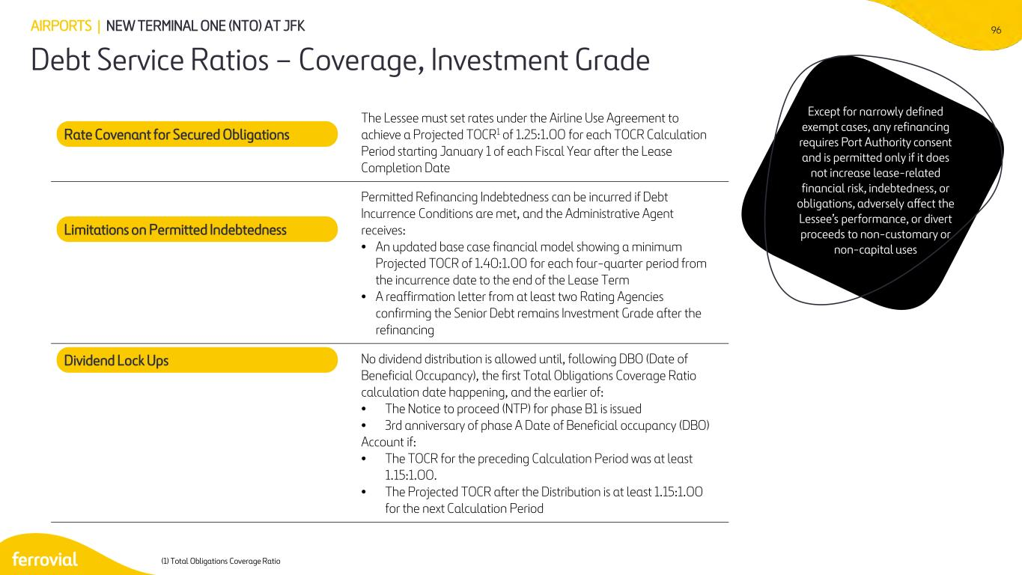
96 Debt Service Ratios – Coverage, Investment Grade AIRPORTS | NEW TERMINAL ONE (NTO) AT JFK (1) Total Obligations Coverage Ratio The Lessee must set rates under the Airline Use Agreement to achieve a Projected TOCR1 of 1.25:1.00 for each TOCR Calculation Period starting January 1 of each Fiscal Year after the Lease Completion Date Permitted Refinancing Indebtedness can be incurred if Debt Incurrence Conditions are met, and the Administrative Agent receives: • An updated base case financial model showing a minimum Projected TOCR of 1.40:1.00 for each four-quarter period from the incurrence date to the end of the Lease Term • A reaffirmation letter from at least two Rating Agencies confirming the Senior Debt remains Investment Grade after the refinancing No dividend distribution is allowed until, following DBO (Date of Beneficial Occupancy), the first Total Obligations Coverage Ratio calculation date happening, and the earlier of: • The Notice to proceed (NTP) for phase B1 is issued • 3rd anniversary of phase A Date of Beneficial occupancy (DBO) Account if: • The TOCR for the preceding Calculation Period was at least 1.15:1.00. • The Projected TOCR after the Distribution is at least 1.15:1.00 for the next Calculation Period Rate Covenant for Secured Obligations Limitations on Permitted Indebtedness Dividend Lock Ups Except for narrowly defined exempt cases, any refinancing requires Port Authority consent and is permitted only if it does not increase lease-related financial risk, indebtedness, or obligations, adversely affect the Lessee’s performance, or divert proceeds to non-customary or non-capital uses

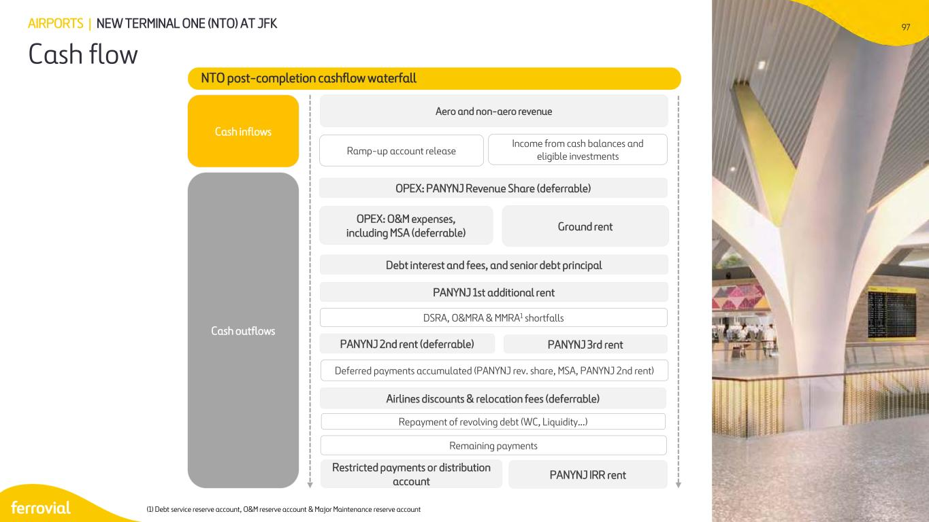
97 Cash flow AIRPORTS | NEW TERMINAL ONE (NTO) AT JFK NTO post-completion cashflow waterfall Aero and non-aero revenue Ramp-up account release Income from cash balances and eligible investments Cash inflows Cash outflows OPEX: PANYNJ Revenue Share (deferrable) OPEX: O&M expenses, including MSA (deferrable) Ground rent Debt interest and fees, and senior debt principal PANYNJ 1st additional rent DSRA, O&MRA & MMRA1 shortfalls PANYNJ 2nd rent (deferrable) PANYNJ 3rd rent PANYNJ IRR rent Deferred payments accumulated (PANYNJ rev. share, MSA, PANYNJ 2nd rent) Airlines discounts & relocation fees (deferrable) Repayment of revolving debt (WC, Liquidity…) Remaining payments Restricted payments or distribution account (1) Debt service reserve account, O&M reserve account & Major Maintenance reserve account

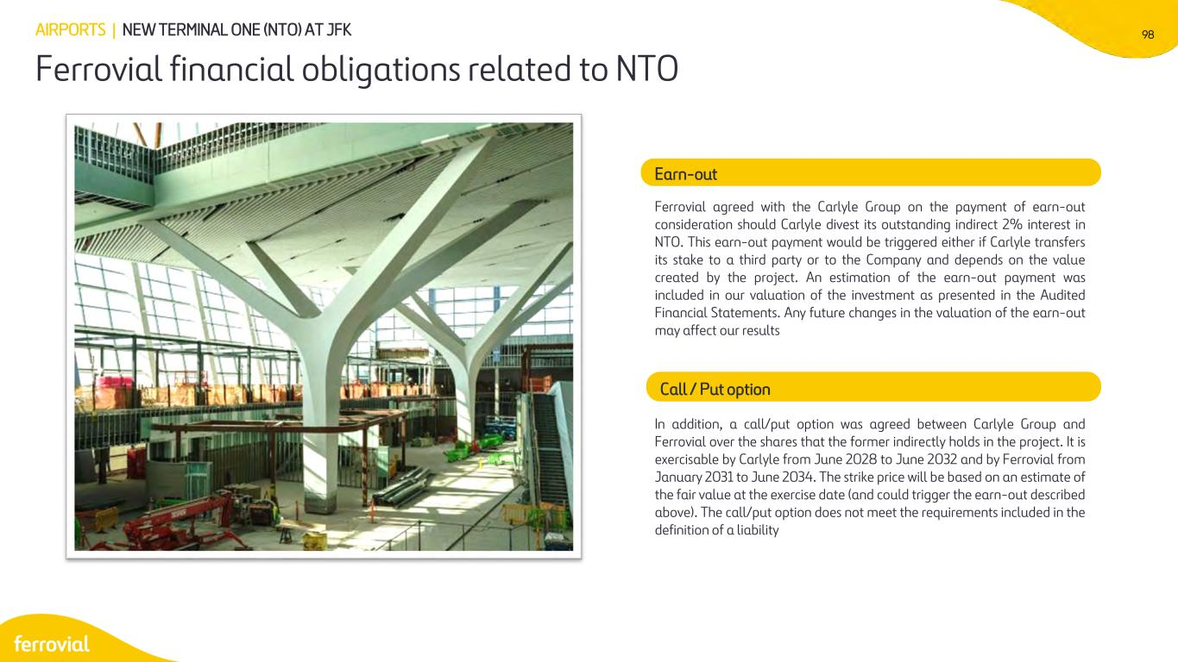
98 Ferrovial financial obligations related to NTO AIRPORTS | NEW TERMINAL ONE (NTO) AT JFK Earn-out Ferrovial agreed with the Carlyle Group on the payment of earn-out consideration should Carlyle divest its outstanding indirect 2% interest in NTO. This earn-out payment would be triggered either if Carlyle transfers its stake to a third party or to the Company and depends on the value created by the project. An estimation of the earn-out payment was included in our valuation of the investment as presented in the Audited Financial Statements. Any future changes in the valuation of the earn-out may affect our results Call / Put option In addition, a call/put option was agreed between Carlyle Group and Ferrovial over the shares that the former indirectly holds in the project. It is exercisable by Carlyle from June 2028 to June 2032 and by Ferrovial from January 2031 to June 2034. The strike price will be based on an estimate of the fair value at the exercise date (and could trigger the earn-out described above). The call/put option does not meet the requirements included in the definition of a liability

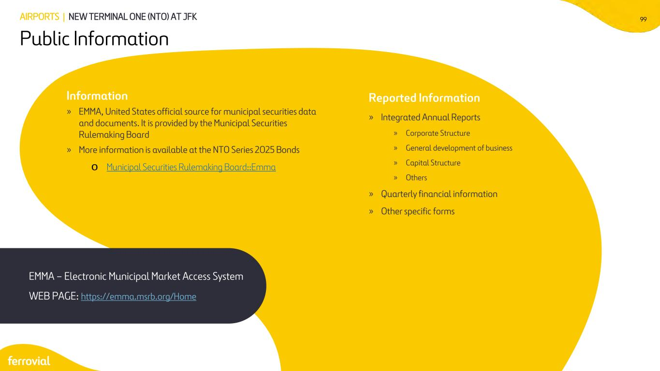
99 Information » EMMA, United States official source for municipal securities data and documents. It is provided by the Municipal Securities Rulemaking Board » More information is available at the NTO Series 2025 Bonds o Municipal Securities Rulemaking Board::Emma EMMA – Electronic Municipal Market Access System WEB PAGE: https://emma.msrb.org/Home Reported Information » Integrated Annual Reports » Corporate Structure » General development of business » Capital Structure » Others » Quarterly financial information » Other specific forms AIRPORTS | NEW TERMINAL ONE (NTO) AT JFK Public Information


100 2 Dalaman Airport

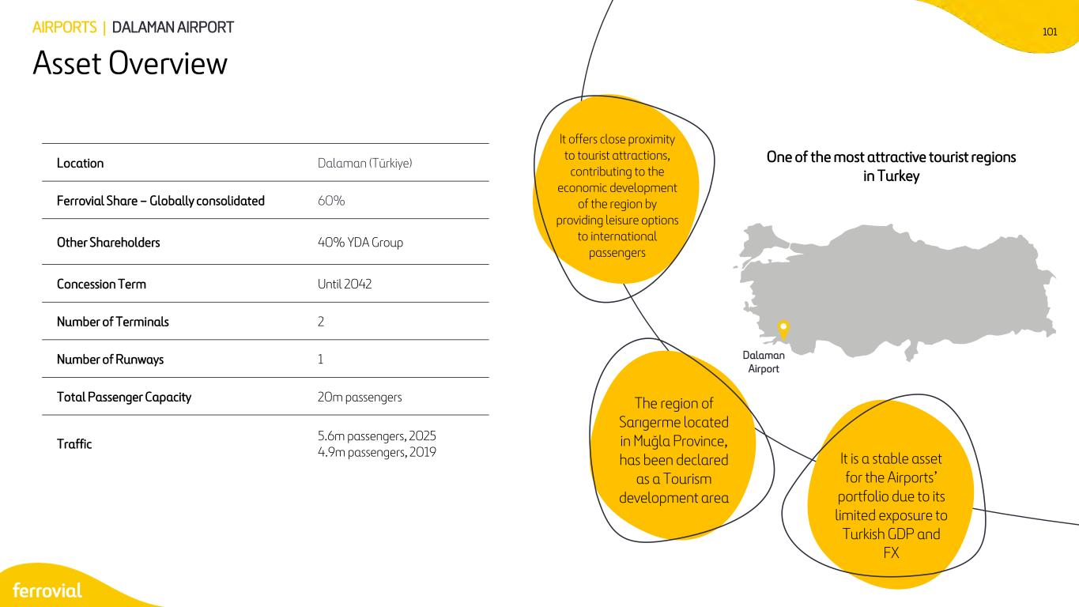
101 It is a stable asset for the Airports’ portfolio due to its limited exposure to Turkish GDP and FX One of the most attractive tourist regions in Turkey Location Dalaman (Türkiye) Ferrovial Share – Globally consolidated 60% Other Shareholders 40% YDA Group Concession Term Until 2042 Number of Terminals 2 Number of Runways 1 Total Passenger Capacity 20m passengers Traffic 5.6m passengers, 2025 4.9m passengers, 2019 AIRPORTS | DALAMAN AIRPORT Asset Overview It offers close proximity to tourist attractions, contributing to the economic development of the region by providing leisure options to international passengers Dalaman Airport The region of Sarıgerme located in Muğla Province, has been declared as a Tourism development area

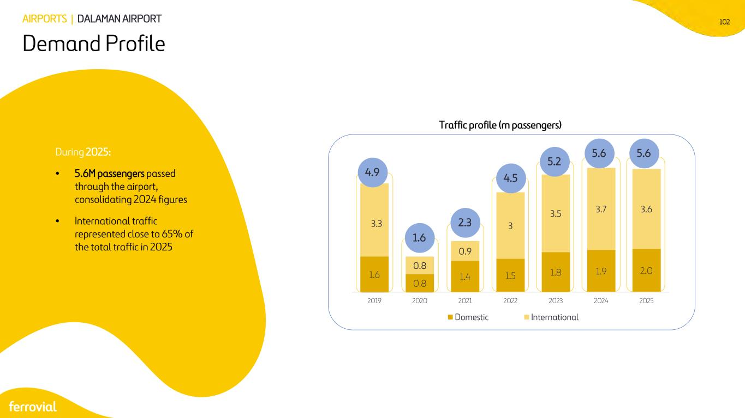
102 1.6 0.8 1.4 1.5 1.8 1.9 2.0 3.3 0.8 0.9 3 3.5 3.7 3.6 2019 2020 2021 2022 2023 2024 2025 Domestic International During 2025: • 5.6M passengers passed through the airport, consolidating 2024 figures • International traffic represented close to 65% of the total traffic in 2025 Traffic profile (m passengers) AIRPORTS | DALAMAN AIRPORT Demand Profile 5.2 4.5 2.3 1.6 4.9 5.6 5.6

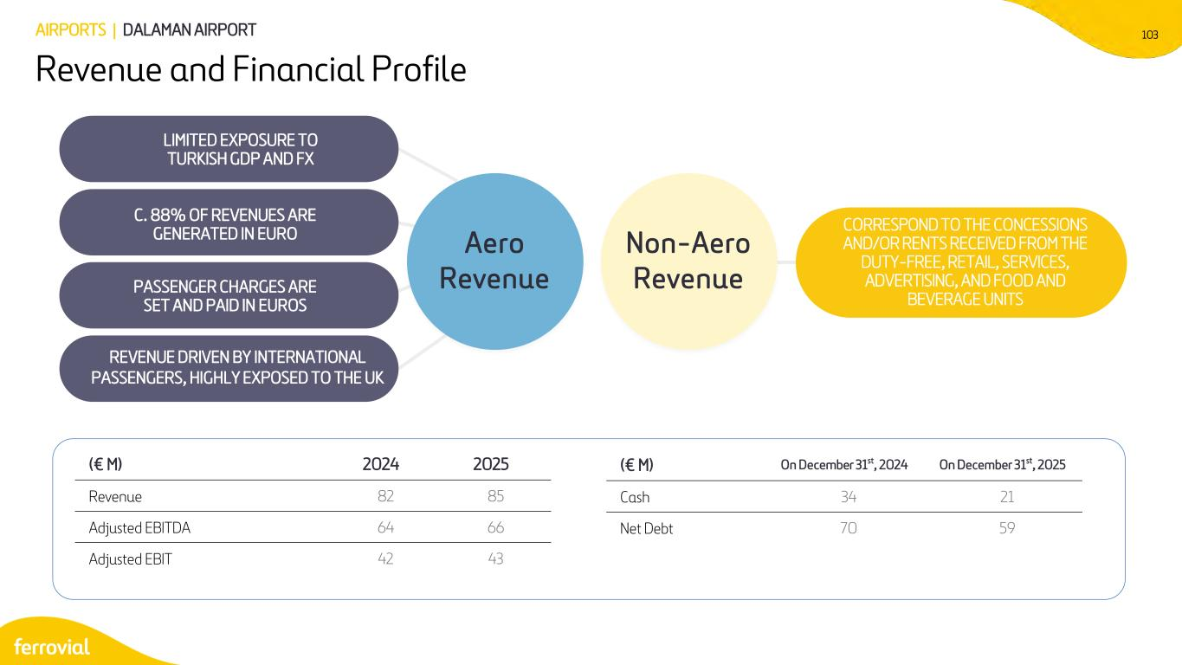
103AIRPORTS | DALAMAN AIRPORT Revenue and Financial Profile (€ M) 2024 2025 Revenue 82 85 Adjusted EBITDA 64 66 Adjusted EBIT 42 43 Aero Revenue Non-Aero Revenue CORRESPOND TO THE CONCESSIONS AND/OR RENTS RECEIVED FROM THE DUTY-FREE, RETAIL, SERVICES, ADVERTISING, AND FOOD AND BEVERAGE UNITS REVENUE DRIVEN BY INTERNATIONAL PASSENGERS, HIGHLY EXPOSED TO THE UK C. 88% OF REVENUES ARE GENERATED IN EURO LIMITED EXPOSURE TO TURKISH GDP AND FX PASSENGER CHARGES ARE SET AND PAID IN EUROS (€ M) On December 31st, 2024 On December 31st, 2025 Cash 34 21 Net Debt 70 59

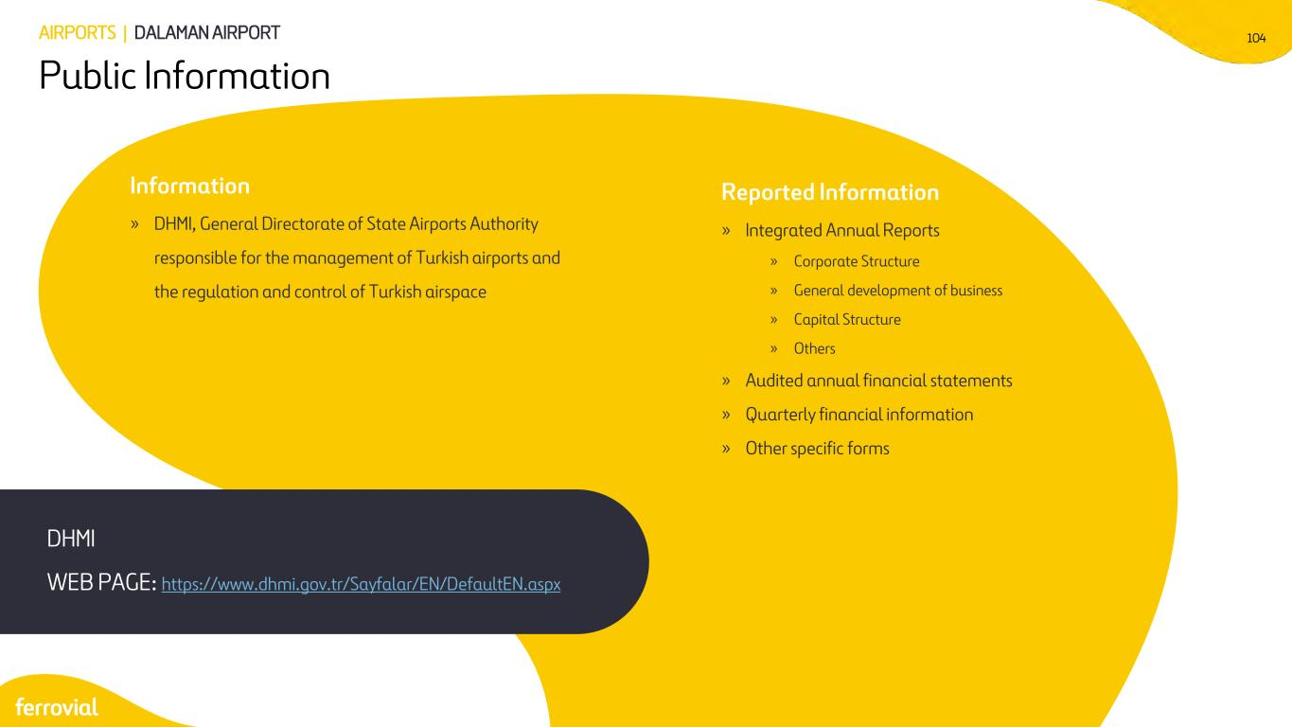
104 Public Information Information » DHMI, General Directorate of State Airports Authority responsible for the management of Turkish airports and the regulation and control of Turkish airspace DHMI WEB PAGE: https://www.dhmi.gov.tr/Sayfalar/EN/DefaultEN.aspx Reported Information » Integrated Annual Reports » Corporate Structure » General development of business » Capital Structure » Others » Audited annual financial statements » Quarterly financial information » Other specific forms AIRPORTS | DALAMAN AIRPORT


CONSTRUCTION

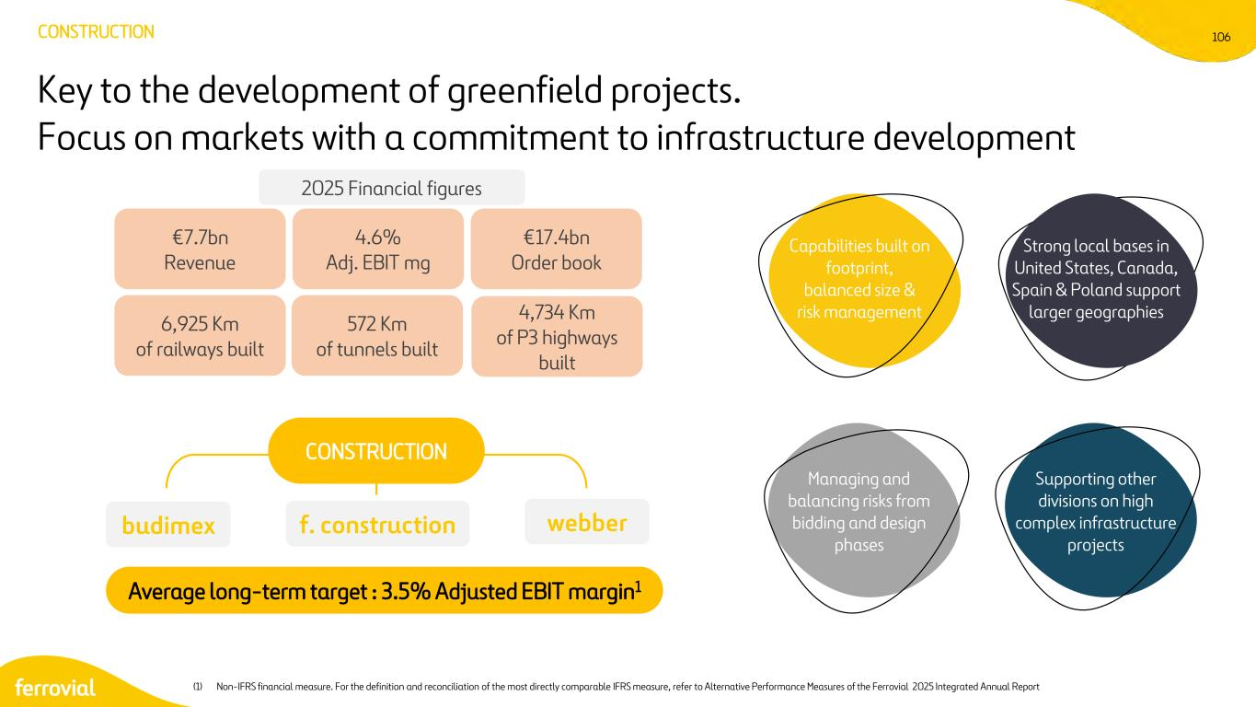
106 Key to the development of greenfield projects. Focus on markets with a commitment to infrastructure development CONSTRUCTION f. constructionbudimex webber CONSTRUCTION Capabilities built on footprint, balanced size & risk management Average long-term target : 3.5% Adjusted EBIT margin1 €7.7bn Revenue 4.6% Adj. EBIT mg €17.4bn Order book 6,925 Km of railways built 572 Km of tunnels built 4,734 Km of P3 highways built Strong local bases in United States, Canada, Spain & Poland support larger geographies Supporting other divisions on high complex infrastructure projects Managing and balancing risks from bidding and design phases 2025 Financial figures (1) Non-IFRS financial measure. For the definition and reconciliation of the most directly comparable IFRS measure, refer to Alternative Performance Measures of the Ferrovial 2025 Integrated Annual Report

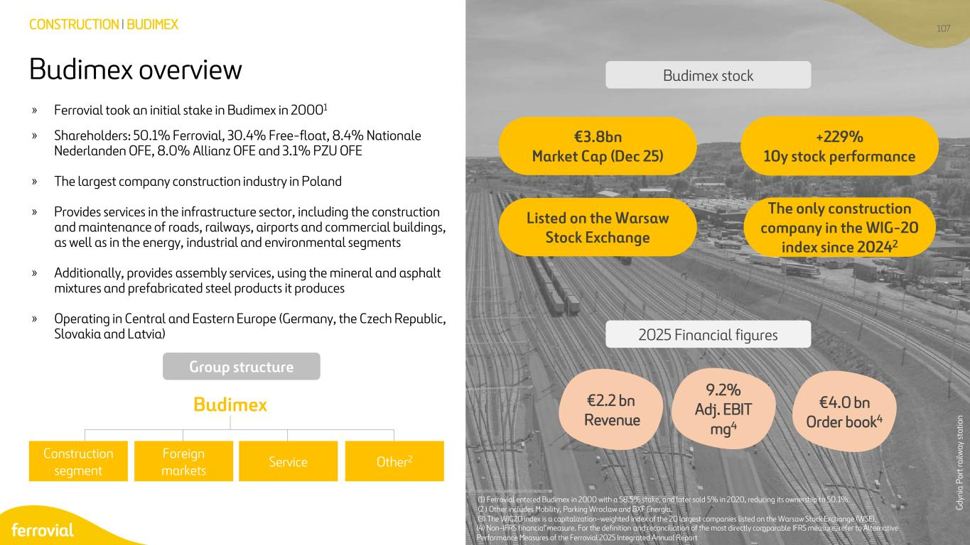
107CONSTRUCTION I BUDIMEX » Ferrovial took an initial stake in Budimex in 20001 » Shareholders: 50.1% Ferrovial, 30.4% Free-float, 8.4% Nationale Nederlanden OFE, 8.0% Allianz OFE and 3.1% PZU OFE » The largest company construction industry in Poland » Provides services in the infrastructure sector, including the construction and maintenance of roads, railways, airports and commercial buildings, as well as in the energy, industrial and environmental segments » Additionally, provides assembly services, using the mineral and asphalt mixtures and prefabricated steel products it produces » Operating in Central and Eastern Europe (Germany, the Czech Republic, Slovakia and Latvia) (1) Ferrovial entered Budimex in 2000 with a 58.5% stake, and later sold 5% in 2020, reducing its ownership to 50.1%. (2 ) Other includes Mobility, Parking Wroclaw and BXF Energia. (3) The WIG20 index is a capitalization-weighted index of the 20 largest companies listed on the Warsaw Stock Exchange (WSE). Construction segment Foreign markets Service Other2 Budimex Gd yn ia P or t r ai lw ay st at io n 2025 Financial figures €3.8bn Market Cap (Dec 25) The only construction company in the WIG-20 index since 20242 +229% 10y stock performance Listed on the Warsaw Stock Exchange €4.0 bn Order book4 Budimex stock Group structure 9.2% Adj. EBIT mg4 €2.2 bn Revenue Budimex overview (4) Non-IFRS financial measure. For the definition and reconciliation of the most directly comparable IFRS measure, refer to Alternative Performance Measures of the Ferrovial 2025 Integrated Annual Report

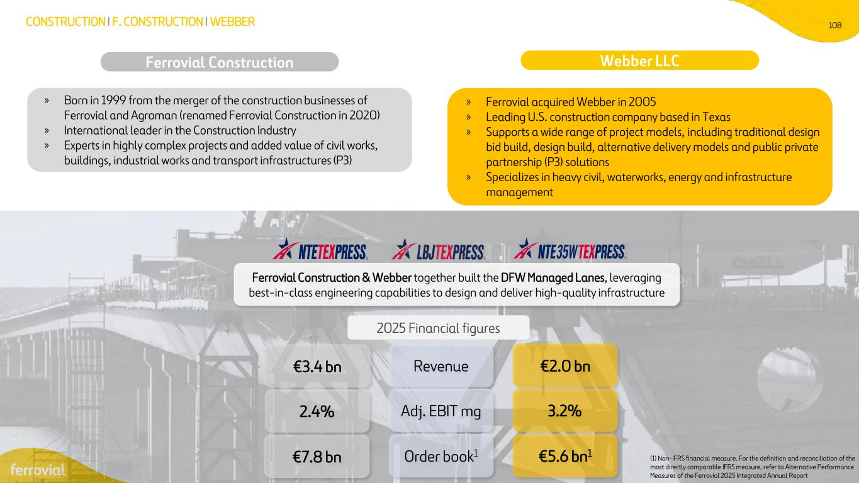
108 Ferrovial Construction CONSTRUCTION I F. CONSTRUCTION I WEBBER » Born in 1999 from the merger of the construction businesses of Ferrovial and Agroman (renamed Ferrovial Construction in 2020) » International leader in the Construction Industry » Experts in highly complex projects and added value of civil works, buildings, industrial works and transport infrastructures (P3) Webber LLC » Ferrovial acquired Webber in 2005 » Leading U.S. construction company based in Texas » Supports a wide range of project models, including traditional design bid build, design build, alternative delivery models and public private partnership (P3) solutions » Specializes in heavy civil, waterworks, energy and infrastructure management Ferrovial Construction & Webber together built the DFW Managed Lanes, leveraging best-in-class engineering capabilities to design and deliver high-quality infrastructure Revenue Adj. EBIT mg Order book1 €3.4 bn 2.4% €7.8 bn €2.0 bn 3.2% €5.6 bn1 2025 Financial figures (1) Non-IFRS financial measure. For the definition and reconciliation of the most directly comparable IFRS measure, refer to Alternative Performance Measures of the Ferrovial 2025 Integrated Annual Report

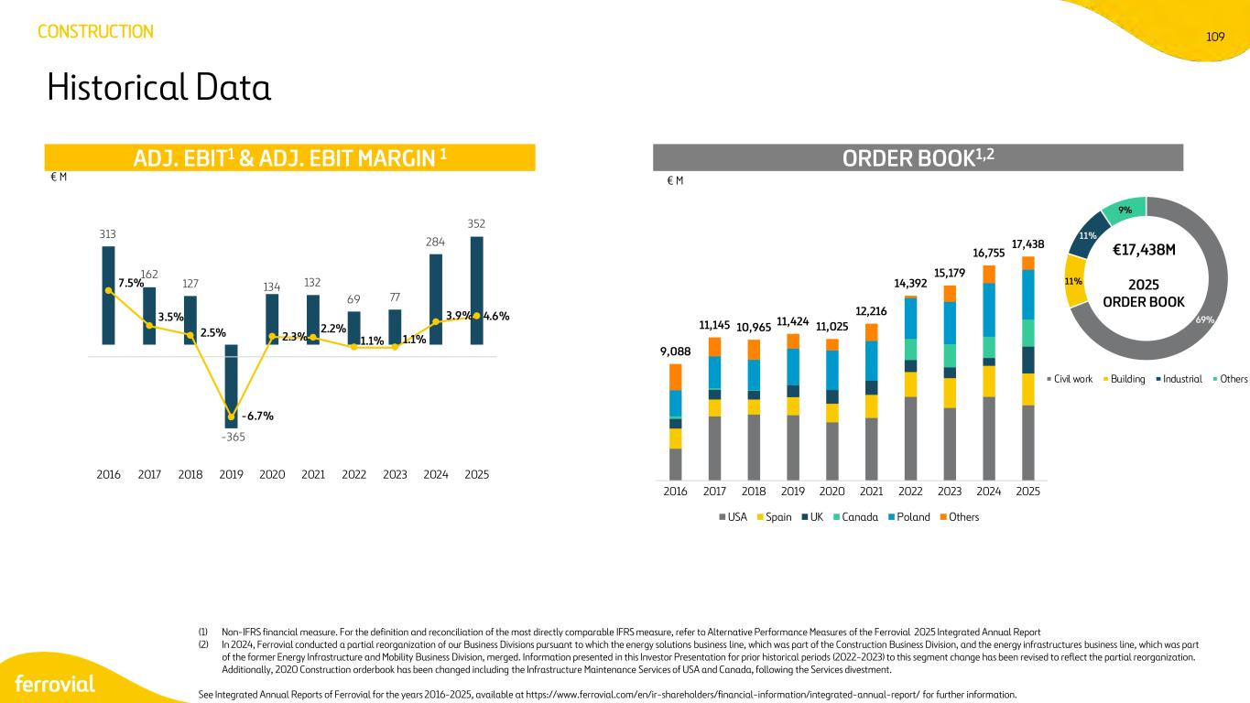
109 69% 11% 11% 9% Civil work Building Industrial Others (1) Non-IFRS financial measure. For the definition and reconciliation of the most directly comparable IFRS measure, refer to Alternative Performance Measures of the Ferrovial 2025 Integrated Annual Report (2) In 2024, Ferrovial conducted a partial reorganization of our Business Divisions pursuant to which the energy solutions business line, which was part of the Construction Business Division, and the energy infrastructures business line, which was part of the former Energy Infrastructure and Mobility Business Division, merged. Information presented in this Investor Presentation for prior historical periods (2022-2023) to this segment change has been revised to reflect the partial reorganization. Additionally, 2020 Construction orderbook has been changed including the Infrastructure Maintenance Services of USA and Canada, following the Services divestment. See Integrated Annual Reports of Ferrovial for the years 2016-2025, available at https://www.ferrovial.com/en/ir-shareholders/financial-information/integrated-annual-report/ for further information. Historical Data €17,438M 2025 ORDER BOOK ORDER BOOK1,2ADJ. EBIT1 & ADJ. EBIT MARGIN 1 € M € M CONSTRUCTION 313 162 127 -365 134 132 69 77 284 352 7.5% 3.5% 2.5% -6.7% 2.3% 2.2% 1.1% 1.1% 3.9% 4.6% 2016 2017 2018 2019 2020 2021 2022 2023 2024 2025 9,088 11,145 10,965 11,424 11,025 12,216 14,392 15,179 16,755 17,438 2016 2017 2018 2019 2020 2021 2022 2023 2024 2025 USA Spain UK Canada Poland Others


ENERGY

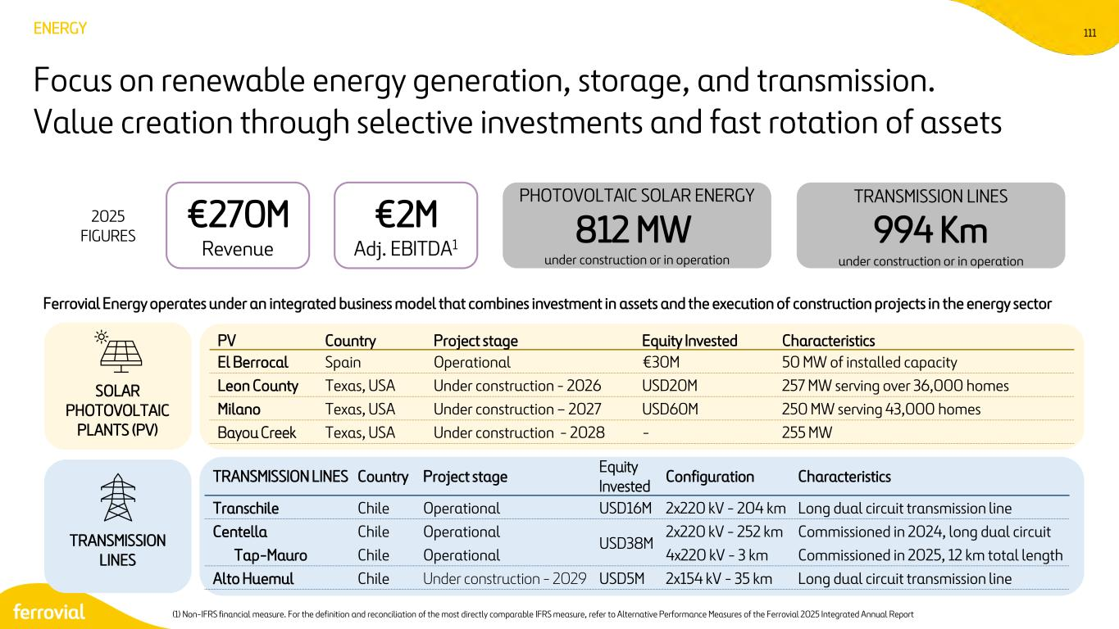
111 PHOTOVOLTAIC SOLAR ENERGY 812 MW under construction or in operation TRANSMISSION LINES 994 Km under construction or in operation ENERGY 2025 FIGURES Focus on renewable energy generation, storage, and transmission. Value creation through selective investments and fast rotation of assets €270M Revenue €2M Adj. EBITDA1 PV Country Project stage Equity Invested Characteristics El Berrocal Spain Operational €30M 50 MW of installed capacity Leon County Texas, USA Under construction - 2026 USD20M 257 MW serving over 36,000 homes Milano Texas, USA Under construction – 2027 USD60M 250 MW serving 43,000 homes Bayou Creek Texas, USA Under construction - 2028 - 255 MW SOLAR PHOTOVOLTAIC PLANTS (PV) TRANSMISSION LINES TRANSMISSION LINES Country Project stage Equity Invested Configuration Characteristics Transchile Chile Operational USD16M 2x220 kV - 204 km Long dual circuit transmission line Centella Chile Operational USD38M 2x220 kV - 252 km Commissioned in 2024, long dual circuit Tap-Mauro Chile Operational 4x220 kV - 3 km Commissioned in 2025, 12 km total length Alto Huemul Chile Under construction - 2029 USD5M 2x154 kV - 35 km Long dual circuit transmission line Ferrovial Energy operates under an integrated business model that combines investment in assets and the execution of construction projects in the energy sector (1) Non-IFRS financial measure. For the definition and reconciliation of the most directly comparable IFRS measure, refer to Alternative Performance Measures of the Ferrovial 2025 Integrated Annual Report

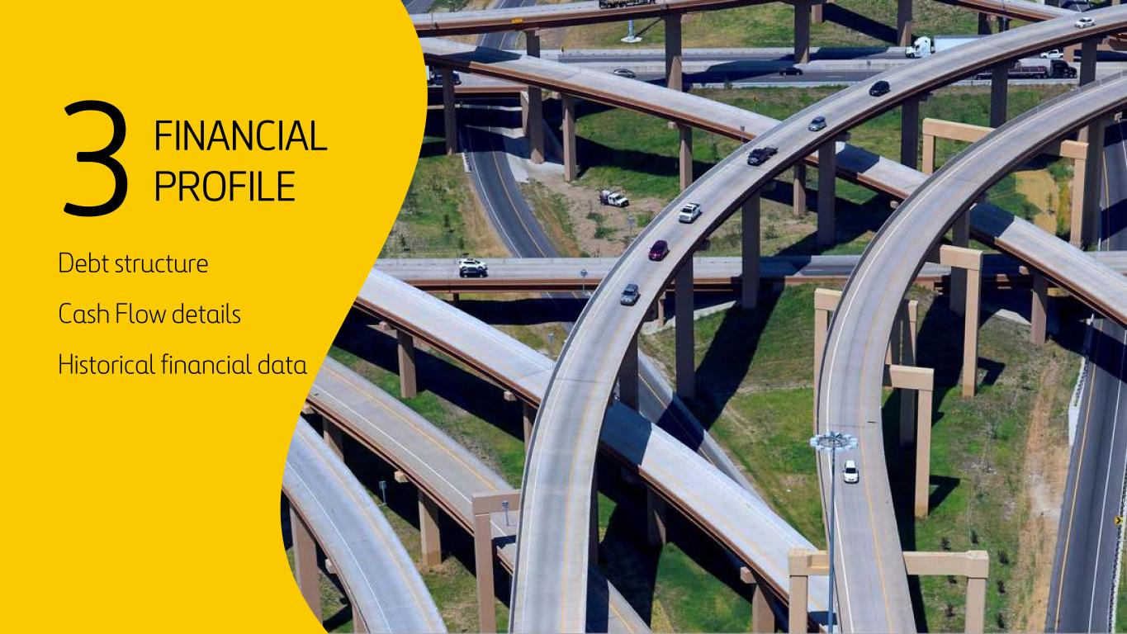
112 3 FINANCIAL PROFILE Debt structure Cash Flow details Historical financial data

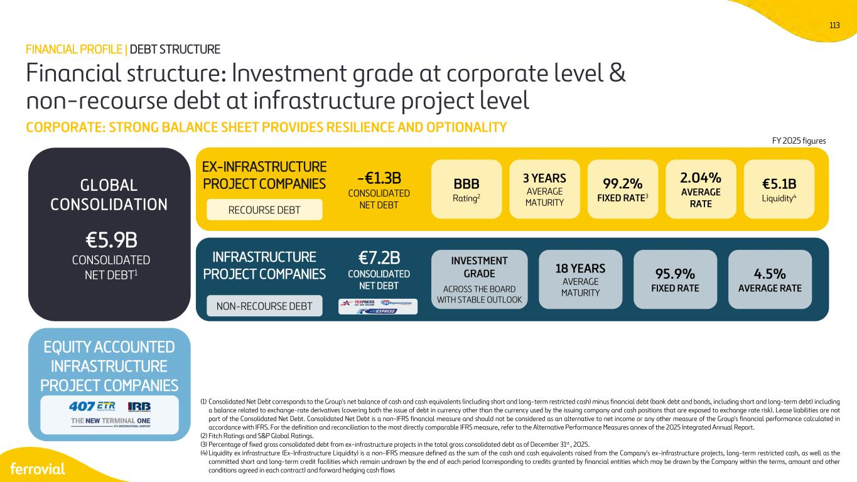
113 RECOURSE DEBT Financial structure: Investment grade at corporate level & non-recourse debt at infrastructure project level CORPORATE: STRONG BALANCE SHEET PROVIDES RESILIENCE AND OPTIONALITY GLOBAL CONSOLIDATION NON-RECOURSE DEBT EQUITY ACCOUNTED INFRASTRUCTURE PROJECT COMPANIES €5.1B Liquidity4 BBB Rating2 3 YEARS AVERAGE MATURITY 99.2% FIXED RATE3 EX-INFRASTRUCTURE PROJECT COMPANIES INFRASTRUCTURE PROJECT COMPANIES INVESTMENT GRADE ACROSS THE BOARD WITH STABLE OUTLOOK FY 2025 figures 2.04% AVERAGE RATE 18 YEARS AVERAGE MATURITY 95.9% FIXED RATE 4.5% AVERAGE RATE FINANCIAL PROFILE | DEBT STRUCTURE (1) Consolidated Net Debt corresponds to the Group's net balance of cash and cash equivalents (including short and long-term restricted cash) minus financial debt (bank debt and bonds, including short and long-term debt) including a balance related to exchange-rate derivatives (covering both the issue of debt in currency other than the currency used by the issuing company and cash positions that are exposed to exchange rate risk). Lease liabilities are not part of the Consolidated Net Debt. Consolidated Net Debt is a non-IFRS financial measure and should not be considered as an alternative to net income or any other measure of the Group's financial performance calculated in accordance with IFRS. For the definition and reconciliation to the most directly comparable IFRS measure, refer to the Alternative Performance Measures annex of the 2025 Integrated Annual Report. (2) Fitch Ratings and S&P Global Ratings. (3) Percentage of fixed gross consolidated debt from ex-infrastructure projects in the total gross consolidated debt as of December 31st , 2025. (4) Liquidity ex infrastructure (Ex-Infrastructure Liquidity) is a non-IFRS measure defined as the sum of the cash and cash equivalents raised from the Company's ex-infrastructure projects, long-term restricted cash, as well as the committed short and long-term credit facilities which remain undrawn by the end of each period (corresponding to credits granted by financial entities which may be drawn by the Company within the terms, amount and other conditions agreed in each contract) and forward hedging cash flows €5.9B CONSOLIDATED NET DEBT1 -€1.3B CONSOLIDATED NET DEBT €7.2B CONSOLIDATED NET DEBT

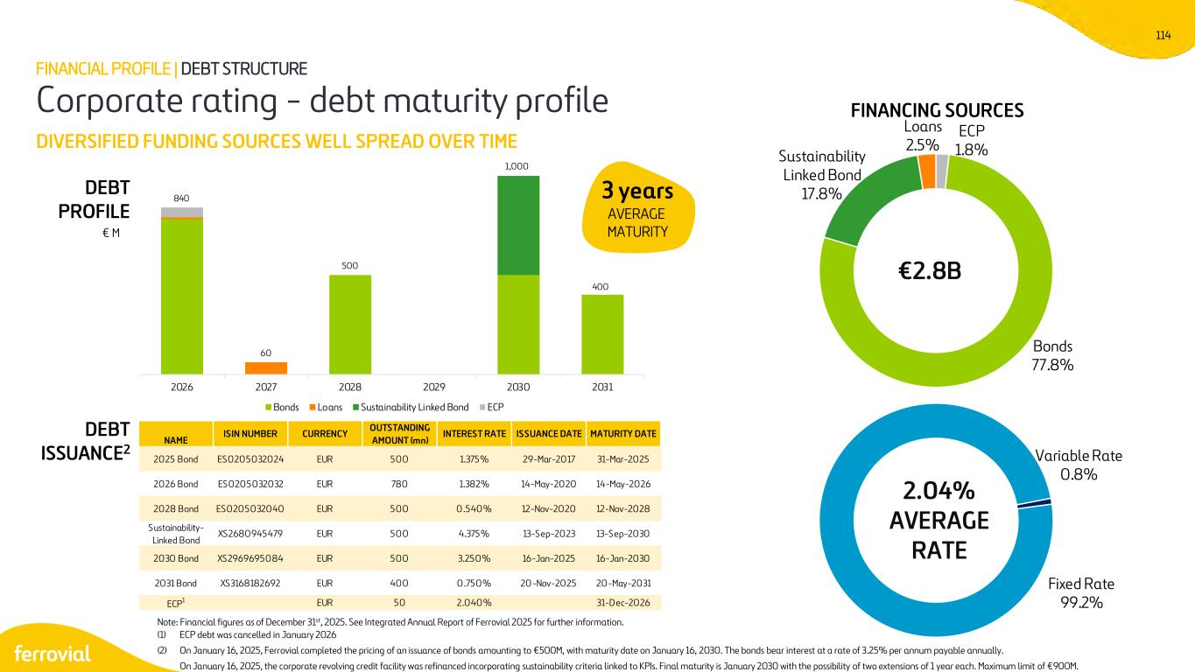
114 ECP 1.8% Bonds 77.8% Sustainability Linked Bond 17.8% Loans 2.5% Fixed Rate 99.2% Variable Rate 0.8% NAME ISIN NUMBER CURRENCY OUTSTANDING AMOUNT (mn) INTEREST RATE ISSUANCE DATE MATURITY DATE 2025 Bond ES0205032024 EUR 500 1.375% 29-Mar-2017 31-Mar-2025 2026 Bond ES0205032032 EUR 780 1.382% 14-May-2020 14-May-2026 2028 Bond ES0205032040 EUR 500 0.540% 12-Nov-2020 12-Nov-2028 Sustainability- Linked Bond XS2680945479 EUR 500 4.375% 13-Sep-2023 13-Sep-2030 2030 Bond XS2969695084 EUR 500 3.250% 16-Jan-2025 16-Jan-2030 2031 Bond XS3168182692 EUR 400 0.750% 20-Nov-2025 20-May-2031 ECP1 EUR 50 2.040% 31-Dec-2026 Corporate rating - debt maturity profile DIVERSIFIED FUNDING SOURCES WELL SPREAD OVER TIME FINANCING SOURCES DEBT PROFILE € M 3 years AVERAGE MATURITY FINANCIAL PROFILE | DEBT STRUCTURE Note: Financial figures as of December 31st, 2025. See Integrated Annual Report of Ferrovial 2025 for further information. (1) ECP debt was cancelled in January 2026 (2) On January 16, 2025, Ferrovial completed the pricing of an issuance of bonds amounting to €500M, with maturity date on January 16, 2030. The bonds bear interest at a rate of 3.25% per annum payable annually. On January 16, 2025, the corporate revolving credit facility was refinanced incorporating sustainability criteria linked to KPIs. Final maturity is January 2030 with the possibility of two extensions of 1 year each. Maximum limit of €900M. 2.04% AVERAGE RATE €2.8B DEBT ISSUANCE2 840 60 500 1,000 400 2026 2027 2028 2029 2030 2031 Bonds Loans Sustainability Linked Bond ECP

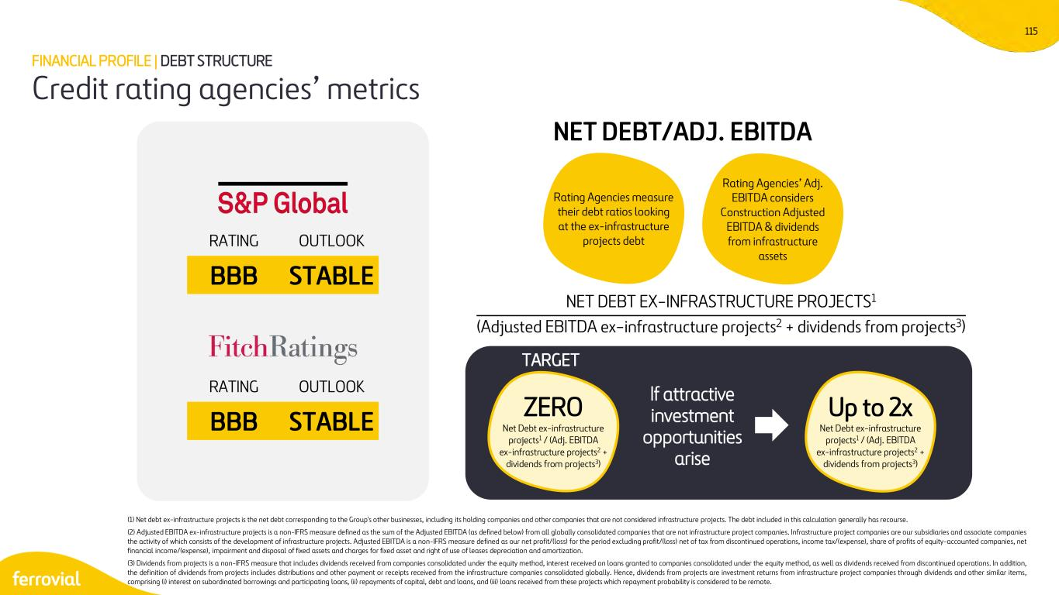
115 RATING OUTLOOK BBB STABLE RATING OUTLOOK BBB STABLE NET DEBT EX−INFRASTRUCTURE PROJECTS1 (Adjusted EBITDA ex−infrastructure projects2 + dividends from projects3) NET DEBT/ADJ. EBITDA Rating Agencies measure their debt ratios looking at the ex-infrastructure projects debt Rating Agencies’ Adj. EBITDA considers Construction Adjusted EBITDA & dividends from infrastructure assets Credit rating agencies’ metrics FINANCIAL PROFILE | DEBT STRUCTURE TARGET If attractive investment opportunities arise (1) Net debt ex-infrastructure projects is the net debt corresponding to the Group's other businesses, including its holding companies and other companies that are not considered infrastructure projects. The debt included in this calculation generally has recourse. (2) Adjusted EBITDA ex-infrastructure projects is a non-IFRS measure defined as the sum of the Adjusted EBITDA (as defined below) from all globally consolidated companies that are not infrastructure project companies. Infrastructure project companies are our subsidiaries and associate companies the activity of which consists of the development of infrastructure projects. Adjusted EBITDA is a non-IFRS measure defined as our net profit/(loss) for the period excluding profit/(loss) net of tax from discontinued operations, income tax/(expense), share of profits of equity-accounted companies, net financial income/(expense), impairment and disposal of fixed assets and charges for fixed asset and right of use of leases depreciation and amortization. (3) Dividends from projects is a non-IFRS measure that includes dividends received from companies consolidated under the equity method, interest received on loans granted to companies consolidated under the equity method, as well as dividends received from discontinued operations. In addition, the definition of dividends from projects includes distributions and other payment or receipts received from the infrastructure companies consolidated globally. Hence, dividends from projects are investment returns from infrastructure project companies through dividends and other similar items, comprising (i) interest on subordinated borrowings and participating loans, (ii) repayments of capital, debt and loans, and (iii) loans received from these projects which repayment probability is considered to be remote. Up to 2x Net Debt ex-infrastructure projects1 / (Adj. EBITDA ex-infrastructure projects2 + dividends from projects3) ZERO Net Debt ex-infrastructure projects1 / (Adj. EBITDA ex-infrastructure projects2 + dividends from projects3)

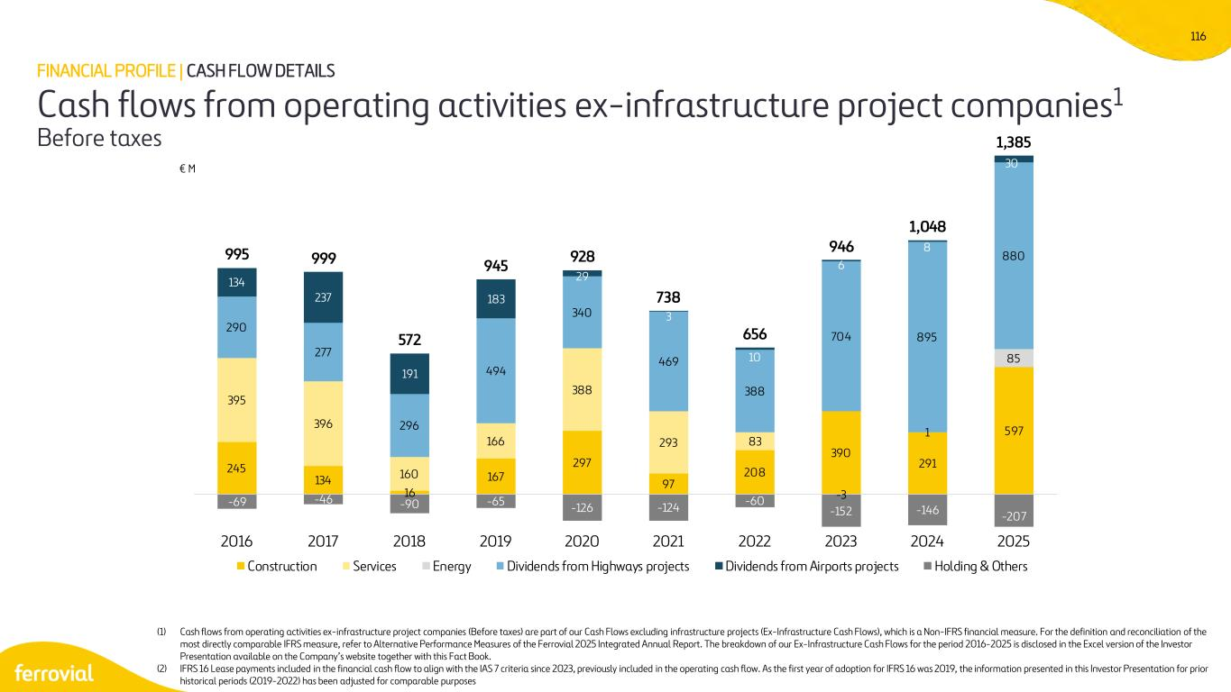
116 245 134 16 167 297 97 208 390 291 597 395 396 160 166 388 293 83 -3 1 85 290 277 296 494 340 469 388 704 895 880 134 237 191 183 29 3 10 6 8 30 -69 -46 -90 -65 -126 -124 -60 -152 -146 -207 995 999 572 945 928 738 656 946 1,048 1,385 2016 2017 2018 2019 2020 2021 2022 2023 2024 2025 Construction Services Energy Dividends from Highways projects Dividends from Airports projects Holding & Others (1) Cash flows from operating activities ex-infrastructure project companies (Before taxes) are part of our Cash Flows excluding infrastructure projects (Ex-Infrastructure Cash Flows), which is a Non-IFRS financial measure. For the definition and reconciliation of the most directly comparable IFRS measure, refer to Alternative Performance Measures of the Ferrovial 2025 Integrated Annual Report. The breakdown of our Ex-Infrastructure Cash Flows for the period 2016-2025 is disclosed in the Excel version of the Investor Presentation available on the Company’s website together with this Fact Book. (2) IFRS 16 Lease payments included in the financial cash flow to align with the IAS 7 criteria since 2023, previously included in the operating cash flow. As the first year of adoption for IFRS 16 was 2019, the information presented in this Investor Presentation for prior historical periods (2019-2022) has been adjusted for comparable purposes Cash flows from operating activities ex-infrastructure project companies1 Before taxes FINANCIAL PROFILE | CASH FLOW DETAILS € M

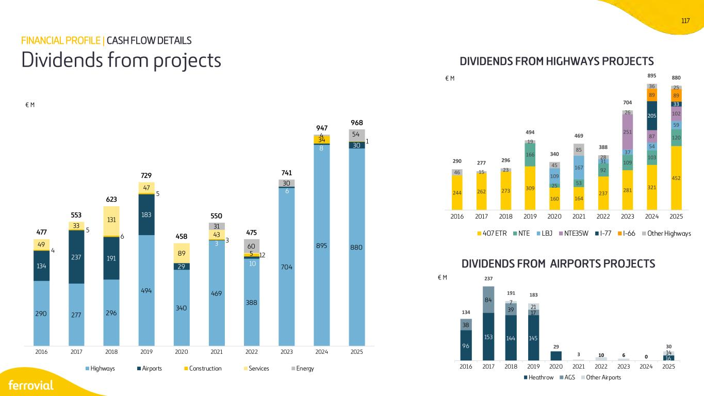
117 290 277 296 494 340 469 388 704 895 880 134 237 191 183 29 3 10 6 8 30 4 5 6 5 3 12 34 1 49 33 131 47 89 43 5 31 60 30 4 54 477 553 623 729 458 550 475 741 947 968 2016 2017 2018 2019 2020 2021 2022 2023 2024 2025 Highways Airports Construction Services Energy 96 153 144 145 16 38 84 39 17 7 21 10 6 0 14 134 237 191 183 29 3 30 2016 2017 2018 2019 2020 2021 2022 2023 2024 2025 Heathrow AGS Other Airports 244 262 273 309 160 164 237 281 321 452 166 25 53 92 109 103 120 109 167 31 37 54 59 251 87 102205 33 89 89 46 15 23 19 45 85 28 26 36 25 290 277 296 494 340 469 388 704 895 880 2016 2017 2018 2019 2020 2021 2022 2023 2024 2025 407 ETR NTE LBJ NTE35W I-77 I-66 Other Highways DIVIDENDS FROM HIGHWAYS PROJECTS DIVIDENDS FROM AIRPORTS PROJECTS € M € M € M Dividends from projects FINANCIAL PROFILE | CASH FLOW DETAILS

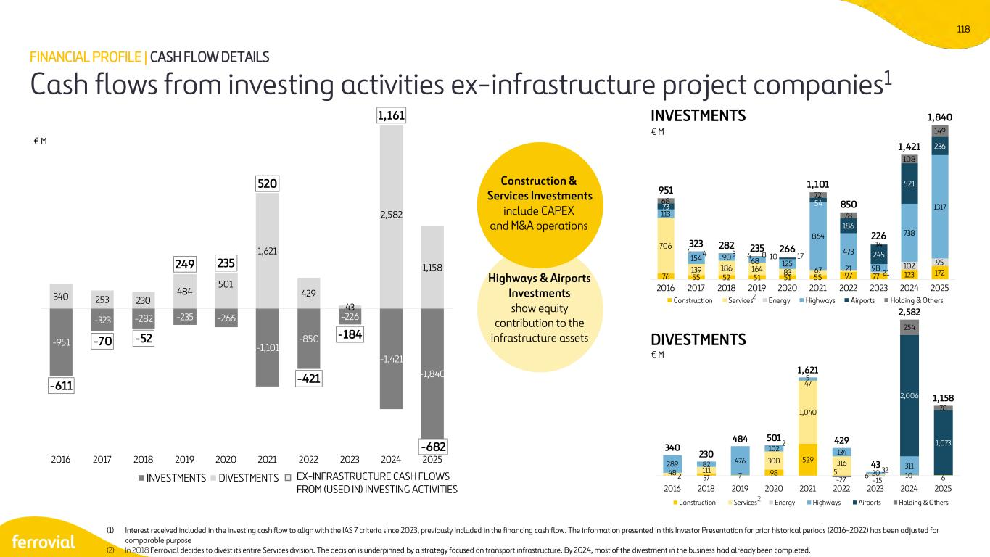
118 -951 -323 -282 -235 -266 -1,101 -850 -226 -1,421 -1,840 340 253 230 484 501 1,621 429 43 2,582 1,158 -611 -70 -52 249 235 520 -421 -184 1,161 -682 2016 2017 2018 2019 2020 2021 2022 2023 2024 2025 INVESTMENTS DIVESTMENTS Highways & Airports Investments show equity contribution to the infrastructure assets Construction & Services Investments include CAPEX and M&A operations EX-INFRASTRUCTURE CASH FLOWS FROM (USED IN) INVESTING ACTIVITIES INVESTMENTS € M € M € M DIVESTMENTS Cash flows from investing activities ex-infrastructure project companies1 FINANCIAL PROFILE | CASH FLOW DETAILS (1) Interest received included in the investing cash flow to align with the IAS 7 criteria since 2023, previously included in the financing cash flow. The information presented in this Investor Presentation for prior historical periods (2016-2022) has been adjusted for comparable purpose (2) In 2018 Ferrovial decides to divest its entire Services division. The decision is underpinned by a strategy focused on transport infrastructure. By 2024, most of the divestment in the business had already been completed. 76 55 52 51 51 55 97 77 123 172 706 139 186 164 83 67 21 113 154 90 68 125 864 473 98 738 131773 4 8 17 54 186 245 521 236 68 4 3 4 10 72 78 14 108 149 951 323 282 235 266 1,101 850 226 1,421 1,840 21 102 95 2016 2017 2018 2019 2020 2021 2022 2023 2024 2025 Construction Services Energy Highways Airports Holding & Others 2 37 7 98 529 5 6 10 6 48 111 300 1,040 316289 82 476 102 47 134 32 311 2,006 1,0732 5 -27 -15 254 78 340 230 484 501 1,621 429 43 2,582 1,158 20 2016 2018 2019 2020 2021 2022 2023 2024 2025 Construction Services Energy Highways Airports Holding & Others 2 2

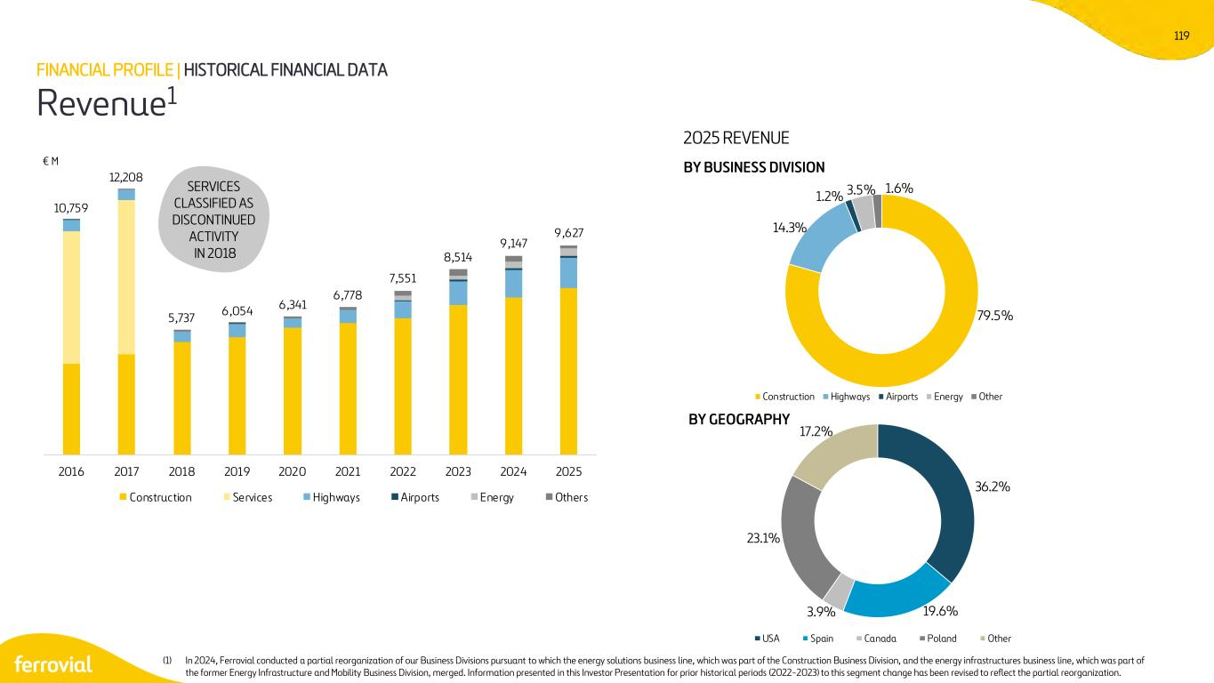
119 79.5% 14.3% 1.2% 3.5% 1.6% Construction Highways Airports Energy Other 36.2% 19.6%3.9% 23.1% 17.2% USA Spain Canada Poland Other 10,759 12,208 5,737 6,054 6,341 6,778 7,551 8,514 9,147 9,627 2016 2017 2018 2019 2020 2021 2022 2023 2024 2025 Construction Services Highways Airports Energy Others 2025 REVENUE Revenue1 FINANCIAL PROFILE | HISTORICAL FINANCIAL DATA BY BUSINESS DIVISION BY GEOGRAPHY € M SERVICES CLASSIFIED AS DISCONTINUED ACTIVITY IN 2018 (1) In 2024, Ferrovial conducted a partial reorganization of our Business Divisions pursuant to which the energy solutions business line, which was part of the Construction Business Division, and the energy infrastructures business line, which was part of the former Energy Infrastructure and Mobility Business Division, merged. Information presented in this Investor Presentation for prior historical periods (2022-2023) to this segment change has been revised to reflect the partial reorganization.

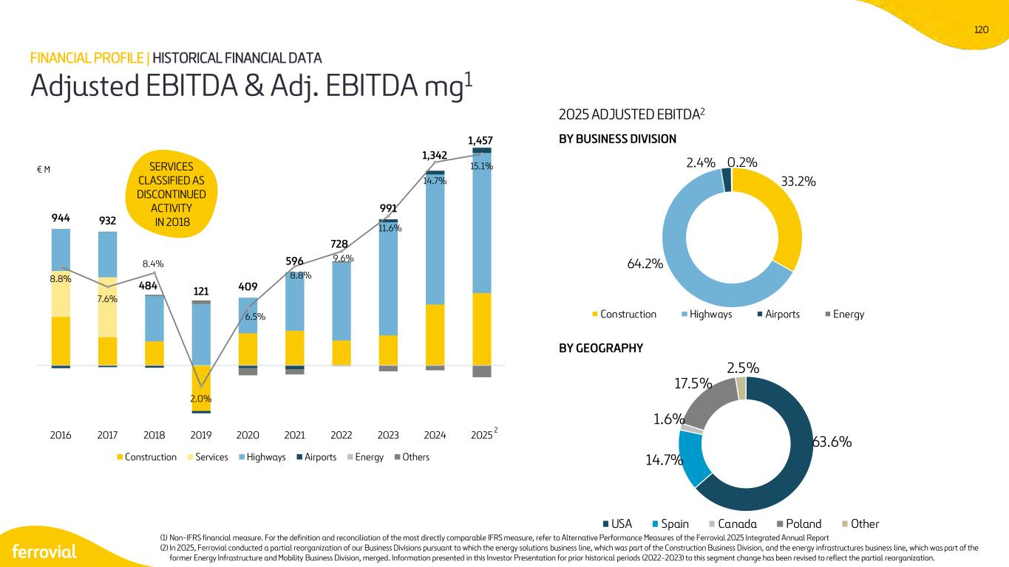
120 944 932 484 121 409 596 728 991 1,342 1,457 8.8% 7.6% 8.4% 2.0% 6.5% 8.8% 9.6% 11.6% 14.7% 15.1% 2016 2017 2018 2019 2020 2021 2022 2023 2024 2025 Construction Services Highways Airports Energy Others SERVICES CLASSIFIED AS DISCONTINUED ACTIVITY IN 2018 € M Adjusted EBITDA & Adj. EBITDA mg1 FINANCIAL PROFILE | HISTORICAL FINANCIAL DATA 2025 ADJUSTED EBITDA2 BY BUSINESS DIVISION BY GEOGRAPHY (1) Non-IFRS financial measure. For the definition and reconciliation of the most directly comparable IFRS measure, refer to Alternative Performance Measures of the Ferrovial 2025 Integrated Annual Report (2) In 2025, Ferrovial conducted a partial reorganization of our Business Divisions pursuant to which the energy solutions business line, which was part of the Construction Business Division, and the energy infrastructures business line, which was part of the former Energy Infrastructure and Mobility Business Division, merged. Information presented in this Investor Presentation for prior historical periods (2022-2023) to this segment change has been revised to reflect the partial reorganization. 33.2% 64.2% 2.4% 0.2% Construction Highways Airports Energy 63.6% 14.7% 1.6% 17.5% 2.5% USA Spain Canada Poland Other 2

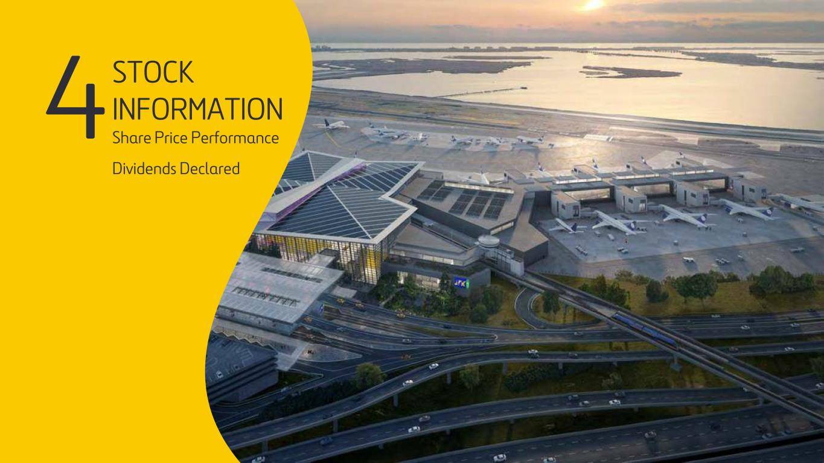
121 4STOCK INFORMATION Share Price Performance Dividends Declared

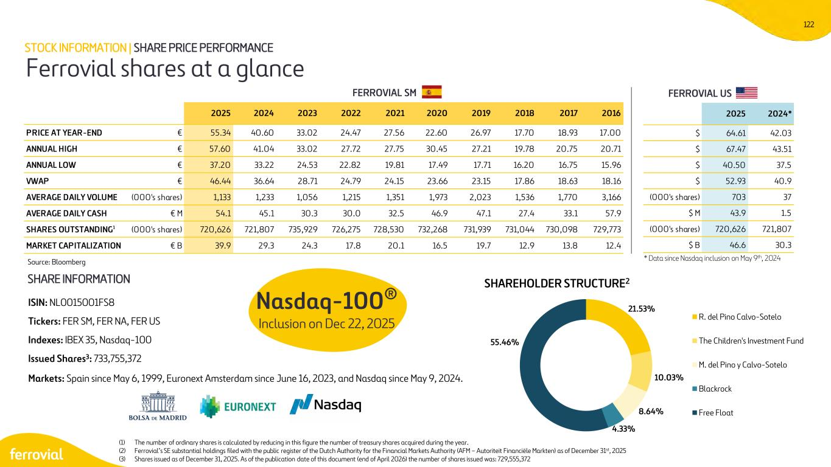
122 SHAREHOLDER STRUCTURE2 ISIN: NL0015001FS8 Tickers: FER SM, FER NA, FER US Indexes: IBEX 35, Nasdaq-100 Issued Shares3: 733,755,372 Markets: Spain since May 6, 1999, Euronext Amsterdam since June 16, 2023, and Nasdaq since May 9, 2024. Ferrovial shares at a glance STOCK INFORMATION | SHARE PRICE PERFORMANCE (1) The number of ordinary shares is calculated by reducing in this figure the number of treasury shares acquired during the year. (2) Ferrovial’s SE substantial holdings filed with the public register of the Dutch Authority for the Financial Markets Authority (AFM – Autoriteit Financiële Markten) as of December 31st, 2025 (3) Shares issued as of December 31, 2025. As of the publication date of this document (end of April 2026) the number of shares issued was: 729,555,372 Source: Bloomberg SHARE INFORMATION Nasdaq-100® Inclusion on Dec 22, 2025 * Data since Nasdaq inclusion on May 9th, 2024 FERROVIAL USFERROVIAL SM 2025 2024* $ 64.61 42.03 $ 67.47 43.51 $ 40.50 37.5 $ 52.93 40.9 (000's shares) 703 37 $ M 43.9 1.5 (000's shares) 720,626 721,807 $ B 46.6 30.3 2025 2024 2023 2022 2021 2020 2019 2018 2017 2016 PRICE AT YEAR-END € 55.34 40.60 33.02 24.47 27.56 22.60 26.97 17.70 18.93 17.00 ANNUAL HIGH € 57.60 41.04 33.02 27.72 27.75 30.45 27.21 19.78 20.75 20.71 ANNUAL LOW € 37.20 33.22 24.53 22.82 19.81 17.49 17.71 16.20 16.75 15.96 VWAP € 46.44 36.64 28.71 24.79 24.15 23.66 23.15 17.86 18.63 18.16 AVERAGE DAILY VOLUME (000's shares) 1,133 1,233 1,056 1,215 1,351 1,973 2,023 1,536 1,770 3,166 AVERAGE DAILY CASH € M 54.1 45.1 30.3 30.0 32.5 46.9 47.1 27.4 33.1 57.9 SHARES OUTSTANDING1 (000's shares) 720,626 721,807 735,929 726,275 728,530 732,268 731,939 731,044 730,098 729,773 MARKET CAPITALIZATION € B 39.9 29.3 24.3 17.8 20.1 16.5 19.7 12.9 13.8 12.4 21.53% 10.03% 8.64% 4.33% 55.46% R. del Pino Calvo-Sotelo The Children's Investment Fund M. del Pino y Calvo-Sotelo Blackrock Free Float

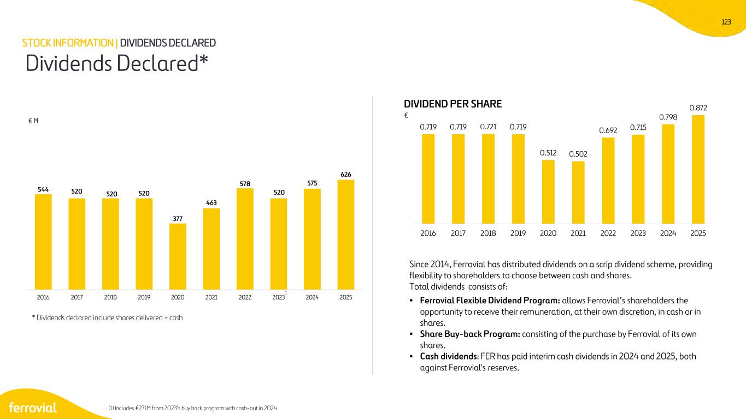
123 544 520 520 520 377 463 578 520 575 626 2016 2017 2018 2019 2020 2021 2022 2023 2024 2025 0.719 0.719 0.721 0.719 0.512 0.502 0.692 0.715 0.798 0.872 2016 2017 2018 2019 2020 2021 2022 2023 2024 2025 Since 2014, Ferrovial has distributed dividends on a scrip dividend scheme, providing flexibility to shareholders to choose between cash and shares. Total dividends consists of: • Ferrovial Flexible Dividend Program: allows Ferrovial’s shareholders the opportunity to receive their remuneration, at their own discretion, in cash or in shares. • Share Buy-back Program: consisting of the purchase by Ferrovial of its own shares. • Cash dividends: FER has paid interim cash dividends in 2024 and 2025, both against Ferrovial's reserves. DIVIDEND PER SHARE € Dividends Declared* € M (1) Includes €271M from 2023’s buy back program with cash-out in 2024 STOCK INFORMATION | DIVIDENDS DECLARED 1 * Dividends declared include shares delivered + cash


124 5 SUSTAINABILITY & CORPORATE GOVERNANCE

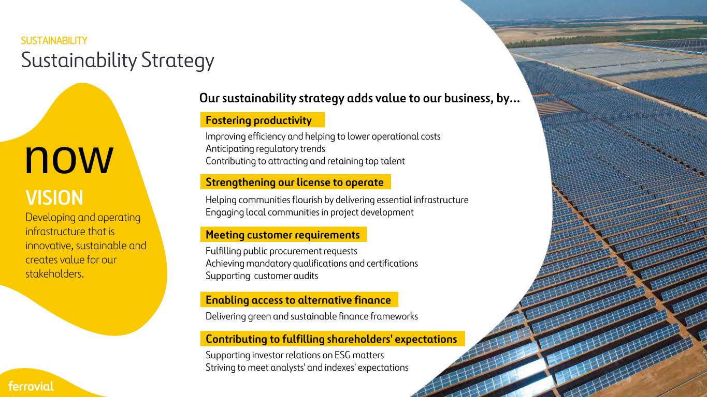
125 Sustainability Strategy SUSTAINABILITY Improving efficiency and helping to lower operational costs Anticipating regulatory trends Contributing to attracting and retaining top talent Helping communities flourish by delivering essential infrastructure Engaging local communities in project development Fulfilling public procurement requests Achieving mandatory qualifications and certifications Supporting customer audits Delivering green and sustainable finance frameworks Supporting investor relations on ESG matters Striving to meet analysts' and indexes' expectations Fostering productivity Strengthening our license to operate Meeting customer requirements Enabling access to alternative finance Contributing to fulfilling shareholders' expectations Our sustainability strategy adds value to our business, by... now VISION Developing and operating infrastructure that is innovative, sustainable and creates value for our stakeholders.

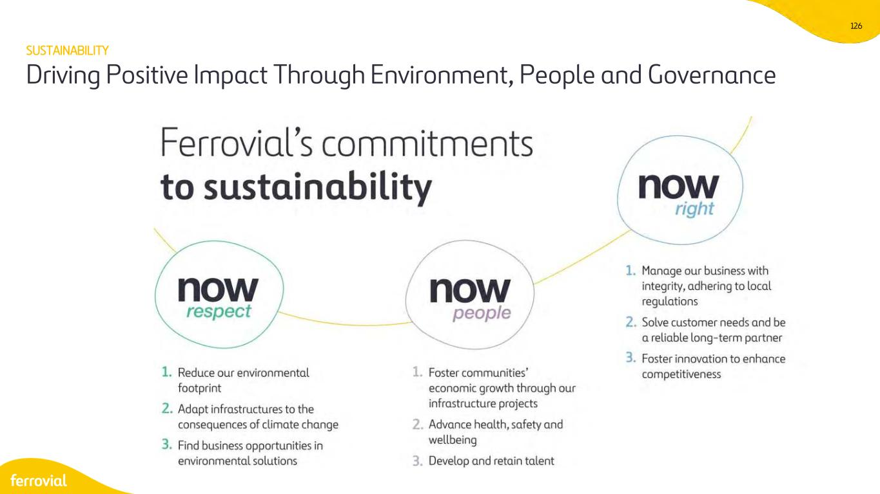
126 SUSTAINABILITY Driving Positive Impact Through Environment, People and Governance

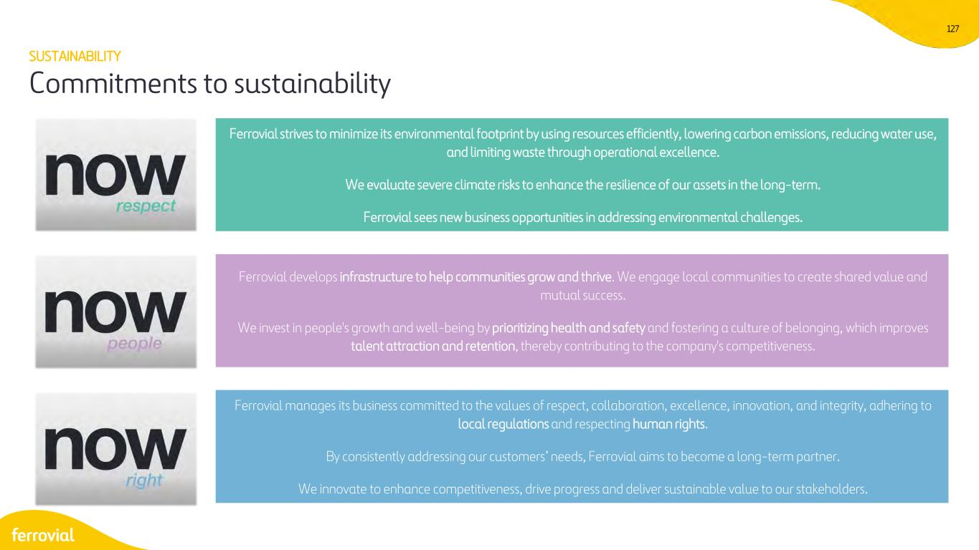
127 Ferrovial strives to minimize its environmental footprint by using resources efficiently, lowering carbon emissions, reducing water use, and limiting waste through operational excellence. We evaluate severe climate risks to enhance the resilience of our assets in the long-term. Ferrovial sees new business opportunities in addressing environmental challenges. POSITIVELY IMPACT SOCIETY Ferrovial develops infrastructure to help communities grow and thrive. We engage local communities to create shared value and mutual success. We invest in people's growth and well-being by prioritizing health and safety and fostering a culture of belonging, which improves talent attraction and retention, thereby contributing to the company's competitiveness. LEAD RESPONSIBLE BUSINESS Ferrovial manages its business committed to the values of respect, collaboration, excellence, innovation, and integrity, adhering to local regulations and respecting human rights. By consistently addressing our customers’ needs, Ferrovial aims to become a long-term partner. We innovate to enhance competitiveness, drive progress and deliver sustainable value to our stakeholders. Commitments to sustainability SUSTAINABILITY

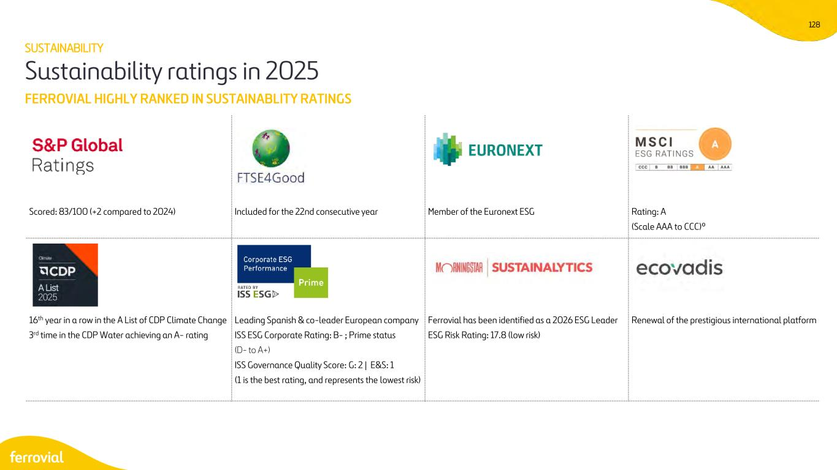
128 FERROVIAL HIGHLY RANKED IN SUSTAINABLITY RATINGS Sustainability ratings in 2025 Scored: 83/100 (+2 compared to 2024) Included for the 22nd consecutive year Member of the Euronext ESG Rating: A (Scale AAA to CCC)º 16th year in a row in the A List of CDP Climate Change 3rd time in the CDP Water achieving an A- rating Leading Spanish & co-leader European company ISS ESG Corporate Rating: B- ; Prime status (D- to A+) ISS Governance Quality Score: G: 2 | E&S: 1 (1 is the best rating, and represents the lowest risk) Ferrovial has been identified as a 2026 ESG Leader ESG Risk Rating: 17.8 (low risk) Renewal of the prestigious international platform SUSTAINABILITY

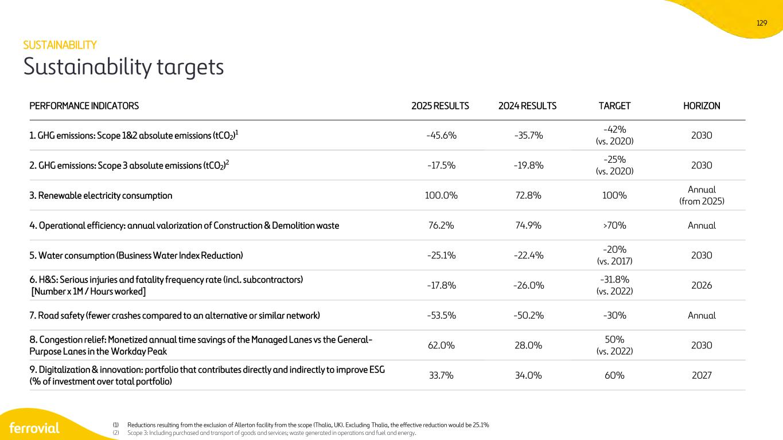
129 Sustainability targets SUSTAINABILITY PERFORMANCE INDICATORS 2025 RESULTS 2024 RESULTS TARGET HORIZON 1. GHG emissions: Scope 1&2 absolute emissions (tCO2)1 -45.6% -35.7% -42% (vs. 2020) 2030 2. GHG emissions: Scope 3 absolute emissions (tCO2)2 -17.5% -19.8% -25% (vs. 2020) 2030 3. Renewable electricity consumption 100.0% 72.8% 100% Annual (from 2025) 4. Operational efficiency: annual valorization of Construction & Demolition waste 76.2% 74.9% >70% Annual 5. Water consumption (Business Water Index Reduction) -25.1% -22.4% -20% (vs. 2017) 2030 6. H&S: Serious injuries and fatality frequency rate (incl. subcontractors) [Number x 1M / Hours worked] -17.8% -26.0% -31.8% (vs. 2022) 2026 7. Road safety (fewer crashes compared to an alternative or similar network) -53.5% -50.2% -30% Annual 8. Congestion relief: Monetized annual time savings of the Managed Lanes vs the General- Purpose Lanes in the Workday Peak 62.0% 28.0% 50% (vs. 2022) 2030 9. Digitalization & innovation: portfolio that contributes directly and indirectly to improve ESG (% of investment over total portfolio) 33.7% 34.0% 60% 2027 (1) Reductions resulting from the exclusion of Allerton facility from the scope (Thalia, UK). Excluding Thalia, the effective reduction would be 25.1% (2) Scope 3: Including purchased and transport of goods and services; waste generated in operations and fuel and energy.

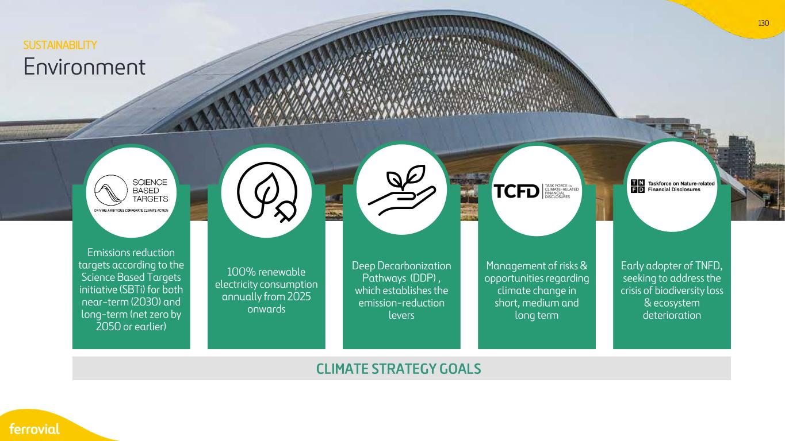
130 CLIMATE STRATEGY GOALS 100% renewable electricity consumption annually from 2025 onwards Deep Decarbonization Pathways (DDP) , which establishes the emission-reduction levers Emissions reduction targets according to the Science Based Targets initiative (SBTi) for both near-term (2030) and long-term (net zero by 2050 or earlier) Management of risks & opportunities regarding climate change in short, medium and long term Environment Early adopter of TNFD, seeking to address the crisis of biodiversity loss & ecosystem deterioration SUSTAINABILITY

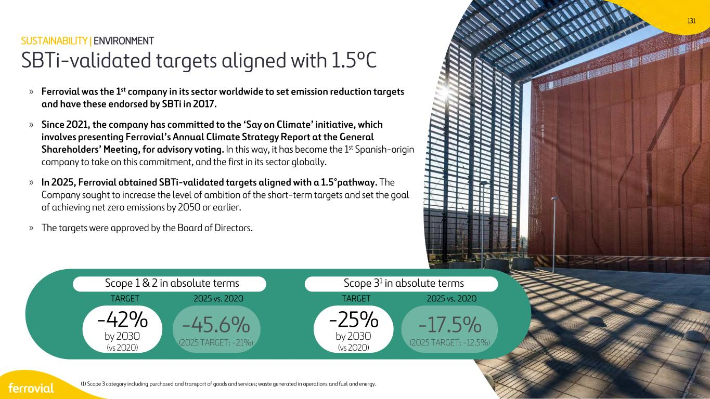
131 SBTi-validated targets aligned with 1.5ºC SUSTAINABILITY | ENVIRONMENT (1) Scope 3 category including purchased and transport of goods and services; waste generated in operations and fuel and energy. Scope 1 & 2 in absolute terms -42% by 2030 (vs 2020) -45.6% (2025 TARGET: -21%) -25% by 2030 (vs 2020) -17.5% (2025 TARGET: -12.5%) Scope 31 in absolute terms TARGET 2025 vs. 2020 TARGET 2025 vs. 2020 » Ferrovial was the 1st company in its sector worldwide to set emission reduction targets and have these endorsed by SBTi in 2017. » Since 2021, the company has committed to the ‘Say on Climate’ initiative, which involves presenting Ferrovial’s Annual Climate Strategy Report at the General Shareholders’ Meeting, for advisory voting. In this way, it has become the 1st Spanish-origin company to take on this commitment, and the first in its sector globally. » In 2025, Ferrovial obtained SBTi-validated targets aligned with a 1.5°pathway. The Company sought to increase the level of ambition of the short-term targets and set the goal of achieving net zero emissions by 2050 or earlier. » The targets were approved by the Board of Directors.

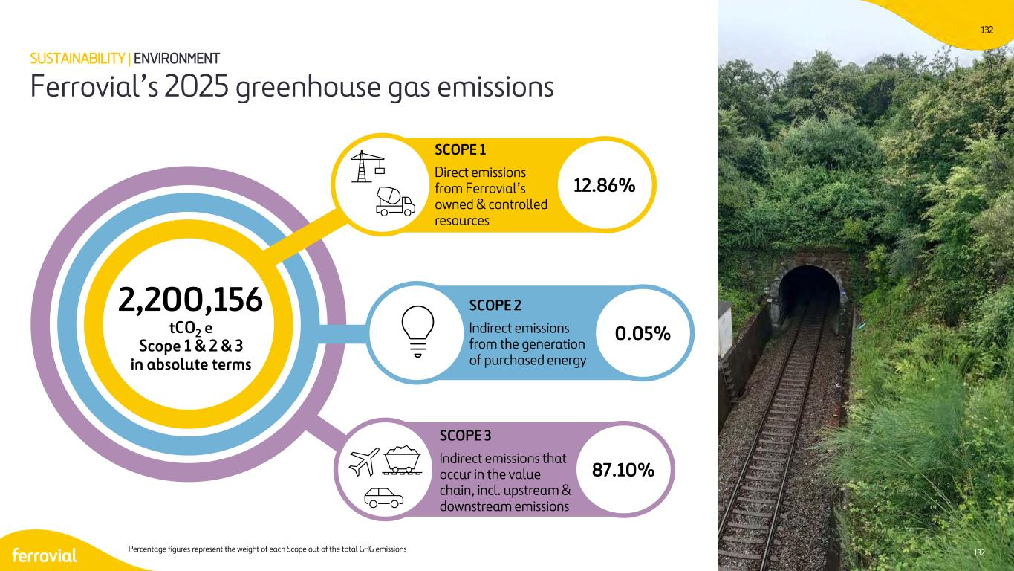
132 SCOPE 1 Direct emissions from Ferrovial’s owned & controlled resources SCOPE 2 Indirect emissions from the generation of purchased energy SCOPE 3 Indirect emissions that occur in the value chain, incl. upstream & downstream emissions 2,200,156 tCO2 e Scope 1 & 2 & 3 in absolute terms 12.86% 0.05% 87.10% Percentage figures represent the weight of each Scope out of the total GHG emissions 132 Ferrovial’s 2025 greenhouse gas emissions SUSTAINABILITY | ENVIRONMENT

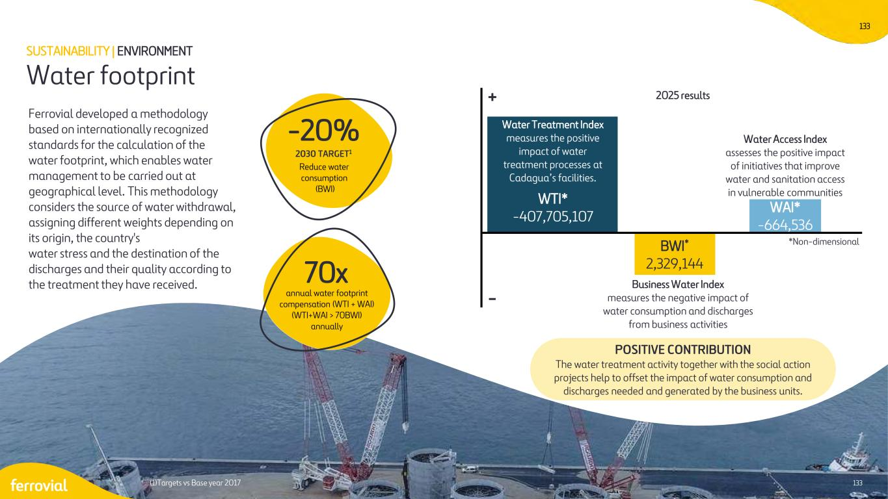
133 Ferrovial developed a methodology based on internationally recognized standards for the calculation of the water footprint, which enables water management to be carried out at geographical level. This methodology considers the source of water withdrawal, assigning different weights depending on its origin, the country's water stress and the destination of the discharges and their quality according to the treatment they have received. WTI* -407,705,107 Water Treatment Index measures the positive impact of water treatment processes at Cadagua’s facilities. Water Access Index assesses the positive impact of initiatives that improve water and sanitation access in vulnerable communities WAI* -664,536 BWI* 2,329,144 Business Water Index measures the negative impact of water consumption and discharges from business activities *Non-dimensional Reduce water consumption (BWI) - + -20% 2030 TARGET1 (1)Targets vs Base year 2017 133 Water footprint SUSTAINABILITY | ENVIRONMENT POSITIVE CONTRIBUTION The water treatment activity together with the social action projects help to offset the impact of water consumption and discharges needed and generated by the business units. annual water footprint compensation (WTI + WAI) (WTI+WAI > 70BWI) annually 70x 2025 results

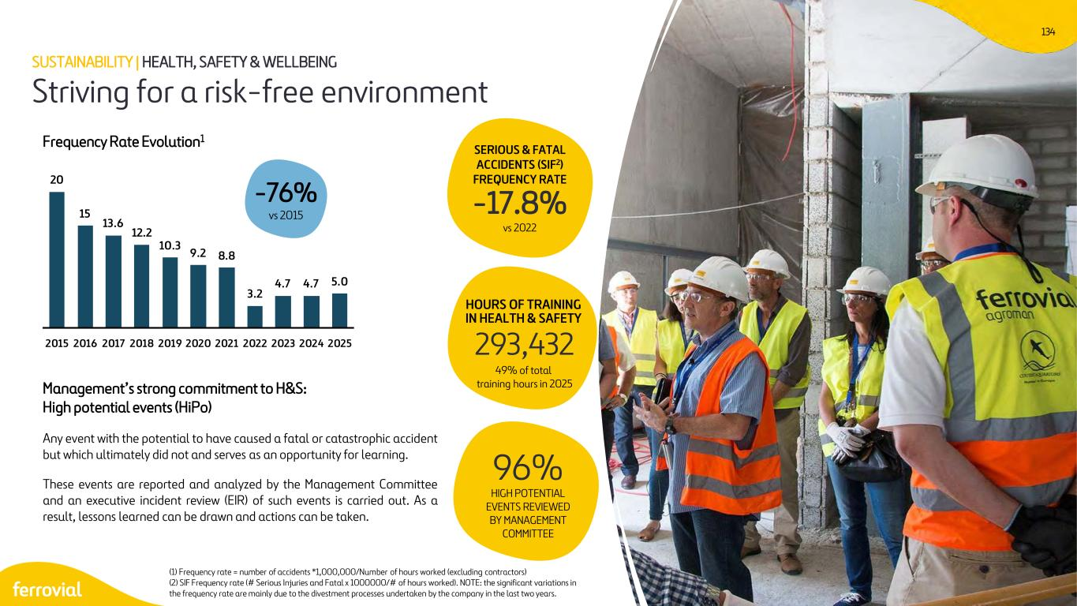
134 Any event with the potential to have caused a fatal or catastrophic accident but which ultimately did not and serves as an opportunity for learning. These events are reported and analyzed by the Management Committee and an executive incident review (EIR) of such events is carried out. As a result, lessons learned can be drawn and actions can be taken. Frequency Rate Evolution1 HIGH POTENTIAL EVENTS REVIEWED BY MANAGEMENT COMMITTEE 96% Management’s strong commitment to H&S: High potential events (HiPo) (1) Frequency rate = number of accidents *1,000,000/Number of hours worked (excluding contractors) (2) SIF Frequency rate (# Serious Injuries and Fatal x 1000000/# of hours worked). NOTE: the significant variations in the frequency rate are mainly due to the divestment processes undertaken by the company in the last two years. SERIOUS & FATAL ACCIDENTS (SIF2) FREQUENCY RATE -17.8% vs 2022 HOURS OF TRAINING IN HEALTH & SAFETY 293,432 49% of total training hours in 2025 Striving for a risk-free environment SUSTAINABILITY | HEALTH, SAFETY & WELLBEING 20 15 13.6 12.2 10.3 9.2 8.8 3.2 4.7 4.7 5.0 2015 2016 2017 2018 2019 2020 2021 2022 2023 2024 2025 -76% vs 2015

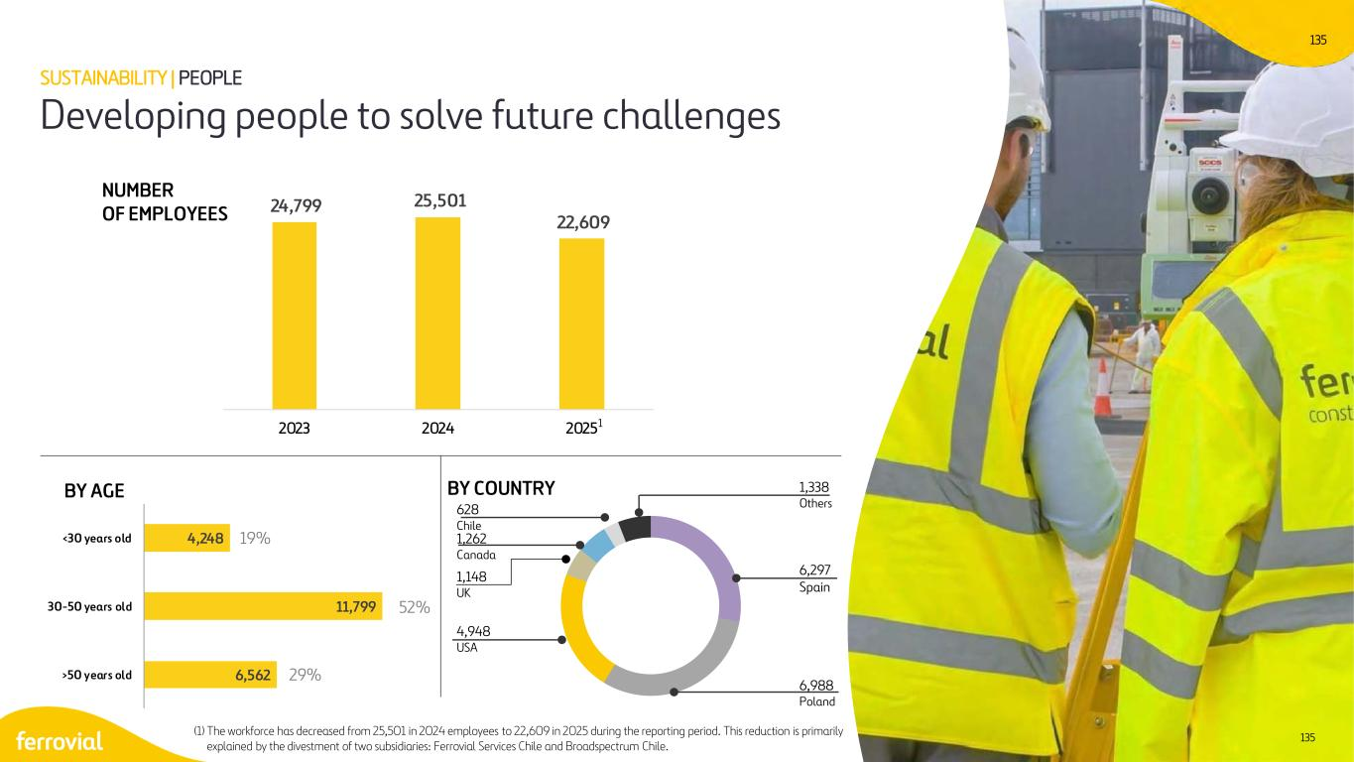
135 6,562 11,799 4,248 >50 years old 30-50 years old <30 years old 135 BY COUNTRY NUMBER OF EMPLOYEES Developing people to solve future challenges BY AGE SUSTAINABILITY | PEOPLE 19% 52% 29% 628 Chile 6,297 Spain 1,338 Others 6,988 Poland 4,948 USA 1,148 UK 1,262 Canada 24,799 25,501 22,609 2023 2024 20251 (1) The workforce has decreased from 25,501 in 2024 employees to 22,609 in 2025 during the reporting period. This reduction is primarily explained by the divestment of two subsidiaries: Ferrovial Services Chile and Broadspectrum Chile.

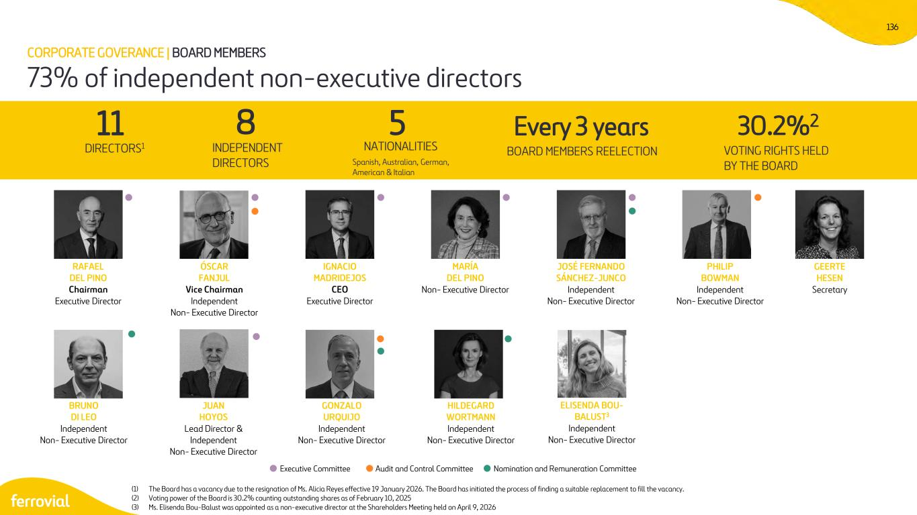
136 RAFAEL DEL PINO Chairman Executive Director IGNACIO MADRIDEJOS CEO Executive Director MARÍA DEL PINO Non- Executive Director ÓSCAR FANJUL Vice Chairman Independent Non- Executive Director JOSÉ FERNANDO SÁNCHEZ-JUNCO Independent Non- Executive Director PHILIP BOWMAN Independent Non- Executive Director ELISENDA BOU- BALUST3 Independent Non- Executive Director BRUNO DI LEO Independent Non- Executive Director JUAN HOYOS Lead Director & Independent Non- Executive Director GONZALO URQUIJO Independent Non- Executive Director HILDEGARD WORTMANN Independent Non- Executive Director GEERTE HESEN Secretary 11 DIRECTORS1 5 NATIONALITIES 8 INDEPENDENT DIRECTORS VOTING RIGHTS HELD BY THE BOARD 30.2%2 Executive Committee Audit and Control Committee Nomination and Remuneration Committee Spanish, Australian, German, American & Italian Every 3 years BOARD MEMBERS REELECTION 73% of independent non-executive directors CORPORATE GOVERANCE | BOARD MEMBERS (1) The Board has a vacancy due to the resignation of Ms. Alicia Reyes effective 19 January 2026. The Board has initiated the process of finding a suitable replacement to fill the vacancy. (2) Voting power of the Board is 30.2% counting outstanding shares as of February 10, 2025 (3) Ms. Elisenda Bou-Balust was appointed as a non-executive director at the Shareholders Meeting held on April 9, 2026

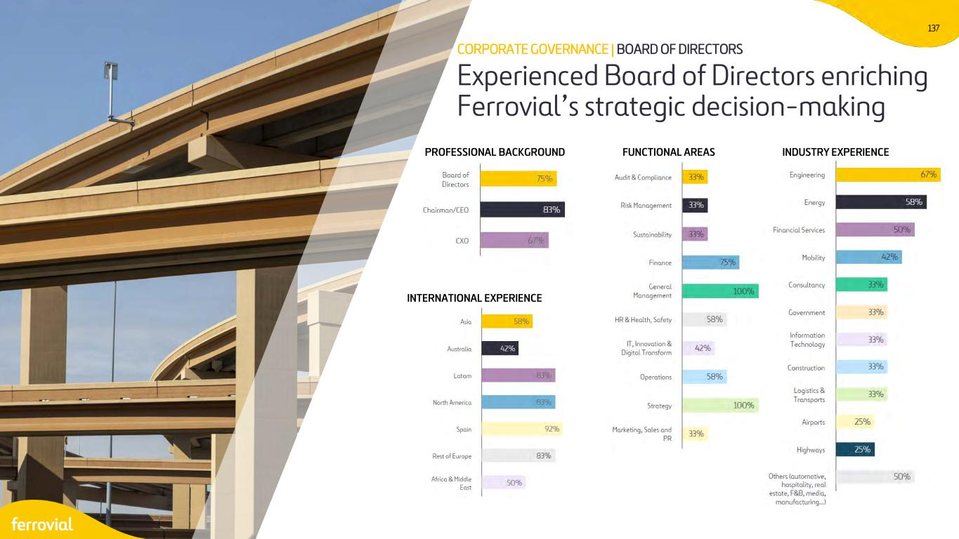
137 Experienced Board of Directors enriching Ferrovial’s strategic decision-making CORPORATE GOVERNANCE | BOARD OF DIRECTORS PROFESSIONAL BACKGROUND INTERNATIONAL EXPERIENCE FUNCTIONAL AREAS INDUSTRY EXPERIENCE

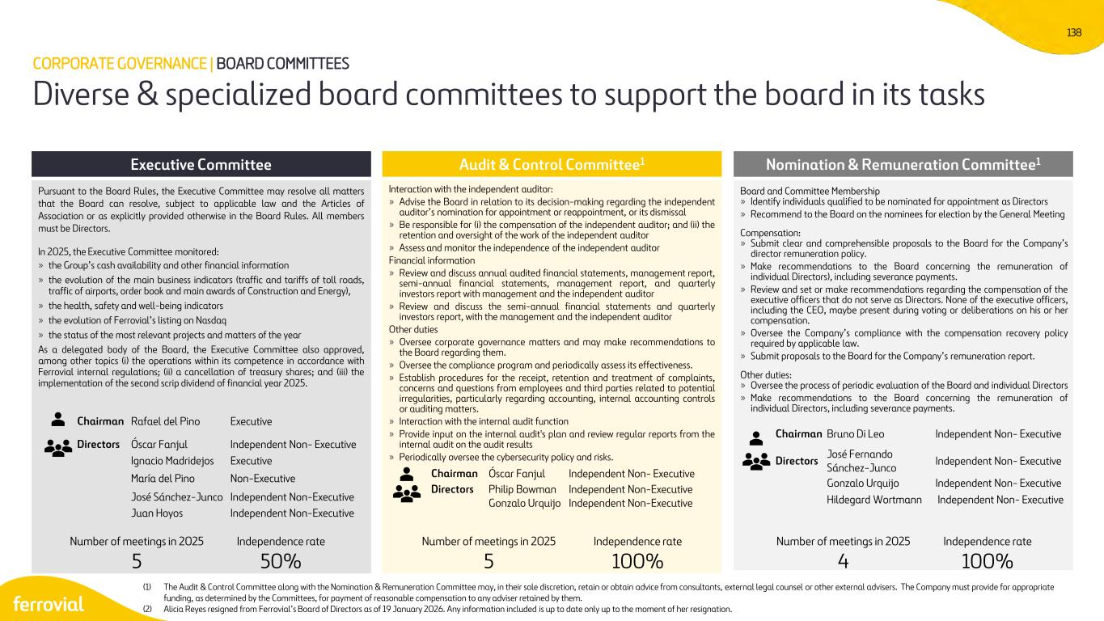
138 Executive Committee Pursuant to the Board Rules, the Executive Committee may resolve all matters that the Board can resolve, subject to applicable law and the Articles of Association or as explicitly provided otherwise in the Board Rules. All members must be Directors. In 2025, the Executive Committee monitored: » the Group’s cash availability and other financial information » the evolution of the main business indicators (traffic and tariffs of toll roads, traffic of airports, order book and main awards of Construction and Energy), » the health, safety and well-being indicators » the evolution of Ferrovial’s listing on Nasdaq » the status of the most relevant projects and matters of the year As a delegated body of the Board, the Executive Committee also approved, among other topics (i) the operations within its competence in accordance with Ferrovial internal regulations; (ii) a cancellation of treasury shares; and (iii) the implementation of the second scrip dividend of financial year 2025. Audit & Control Committee1 Interaction with the independent auditor: » Advise the Board in relation to its decision-making regarding the independent auditor’s nomination for appointment or reappointment, or its dismissal » Be responsible for (i) the compensation of the independent auditor; and (ii) the retention and oversight of the work of the independent auditor » Assess and monitor the independence of the independent auditor Financial information » Review and discuss annual audited financial statements, management report, semi-annual financial statements, management report, and quarterly investors report with management and the independent auditor » Review and discuss the semi-annual financial statements and quarterly investors report, with the management and the independent auditor Other duties » Oversee corporate governance matters and may make recommendations to the Board regarding them. » Oversee the compliance program and periodically assess its effectiveness. » Establish procedures for the receipt, retention and treatment of complaints, concerns and questions from employees and third parties related to potential irregularities, particularly regarding accounting, internal accounting controls or auditing matters. » Interaction with the internal audit function » Provide input on the internal audit's plan and review regular reports from the internal audit on the audit results » Periodically oversee the cybersecurity policy and risks. Nomination & Remuneration Committee1 Board and Committee Membership » Identify individuals qualified to be nominated for appointment as Directors » Recommend to the Board on the nominees for election by the General Meeting Compensation: » Submit clear and comprehensible proposals to the Board for the Company’s director remuneration policy. » Make recommendations to the Board concerning the remuneration of individual Directors), including severance payments. » Review and set or make recommendations regarding the compensation of the executive officers that do not serve as Directors. None of the executive officers, including the CEO, maybe present during voting or deliberations on his or her compensation. » Oversee the Company’s compliance with the compensation recovery policy required by applicable law. » Submit proposals to the Board for the Company’s remuneration report. Other duties: » Oversee the process of periodic evaluation of the Board and individual Directors » Make recommendations to the Board concerning the remuneration of individual Directors, including severance payments. Number of meetings in 2025 5 Independence rate 50% Number of meetings in 2025 5 Independence rate 100% Number of meetings in 2025 4 Independence rate 100% Chairman Rafael del Pino Executive Directors Óscar Fanjul Independent Non- Executive Ignacio Madridejos Executive María del Pino Non-Executive José Sánchez-Junco Independent Non-Executive Juan Hoyos Independent Non-Executive Chairman Óscar Fanjul Independent Non- Executive Directors Philip Bowman Independent Non-Executive Gonzalo Urquijo Independent Non-Executive Chairman Bruno Di Leo Independent Non- Executive Directors José Fernando Sánchez-Junco Independent Non- Executive Gonzalo Urquijo Independent Non- Executive Hildegard Wortmann Independent Non- Executive Diverse & specialized board committees to support the board in its tasks CORPORATE GOVERNANCE | BOARD COMMITTEES (1) The Audit & Control Committee along with the Nomination & Remuneration Committee may, in their sole discretion, retain or obtain advice from consultants, external legal counsel or other external advisers. The Company must provide for appropriate funding, as determined by the Committees, for payment of reasonable compensation to any adviser retained by them. (2) Alicia Reyes resigned from Ferrovial’s Board of Directors as of 19 January 2026. Any information included is up to date only up to the moment of her resignation.

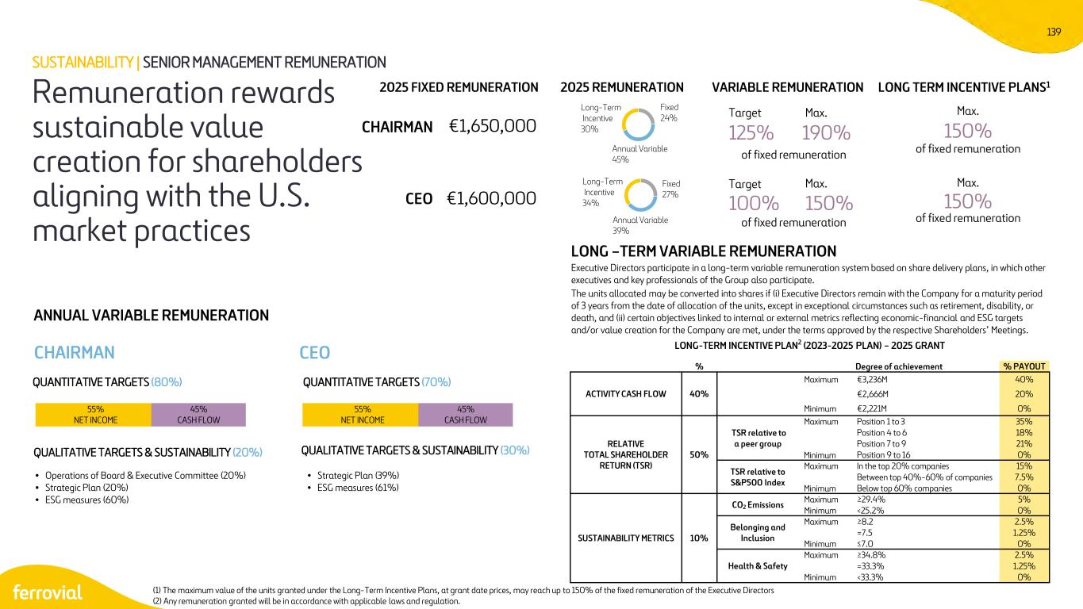
139 ANNUAL VARIABLE REMUNERATION CHAIRMAN QUALITATIVE TARGETS & SUSTAINABILITY (20%) • Operations of Board & Executive Committee (20%) • Strategic Plan (20%) • ESG measures (60%) • Strategic Plan (39%) • ESG measures (61%) QUANTITATIVE TARGETS (80%) CEO 55% NET INCOME 45% CASH FLOW 2025 FIXED REMUNERATION VARIABLE REMUNERATION LONG TERM INCENTIVE PLANS1 CHAIRMAN CEO €1,650,000 €1,600,000 Target Max. 125% 190% of fixed remuneration Target Max. 100% 150% of fixed remuneration Max. 150% of fixed remuneration Max. 150% of fixed remuneration Executive Directors participate in a long-term variable remuneration system based on share delivery plans, in which other executives and key professionals of the Group also participate. The units allocated may be converted into shares if (i) Executive Directors remain with the Company for a maturity period of 3 years from the date of allocation of the units, except in exceptional circumstances such as retirement, disability, or death, and (ii) certain objectives linked to internal or external metrics reflecting economic-financial and ESG targets and/or value creation for the Company are met, under the terms approved by the respective Shareholders’ Meetings. LONG –TERM VARIABLE REMUNERATION Remuneration rewards sustainable value creation for shareholders aligning with the U.S. market practices SUSTAINABILITY | SENIOR MANAGEMENT REMUNERATION LONG-TERM INCENTIVE PLAN2 (2023-2025 PLAN) – 2025 GRANT % Degree of achievement % PAYOUT ACTIVITY CASH FLOW 40% Maximum €3,236M 40% €2,666M 20% Minimum €2,221M 0% RELATIVE TOTAL SHAREHOLDER RETURN (TSR) 50% TSR relative to a peer group Maximum Position 1 to 3 35% Position 4 to 6 18% Position 7 to 9 21% Minimum Position 9 to 16 0% TSR relative to S&P500 Index Maximum In the top 20% companies 15% Between top 40%-60% of companies 7.5% Minimum Below top 60% companies 0% SUSTAINABILITY METRICS 10% CO2 Emissions Maximum ≥29.4% 5% Minimum <25.2% 0% Belonging and Inclusion Maximum ≥8.2 2.5% =7.5 1.25% Minimum ≤7.0 0% Health & Safety Maximum ≥34.8% 2.5% =33.3% 1.25% Minimum <33.3% 0% Annual Variable 39% Long-Term Incentive 34% Fixed 27% Annual Variable 45% Long-Term Incentive 30% Fixed 24% 2025 REMUNERATION (1) The maximum value of the units granted under the Long-Term Incentive Plans, at grant date prices, may reach up to 150% of the fixed remuneration of the Executive Directors (2) Any remuneration granted will be in accordance with applicable laws and regulation. QUALITATIVE TARGETS & SUSTAINABILITY (30%) QUANTITATIVE TARGETS (70%) 55% NET INCOME 45% CASH FLOW

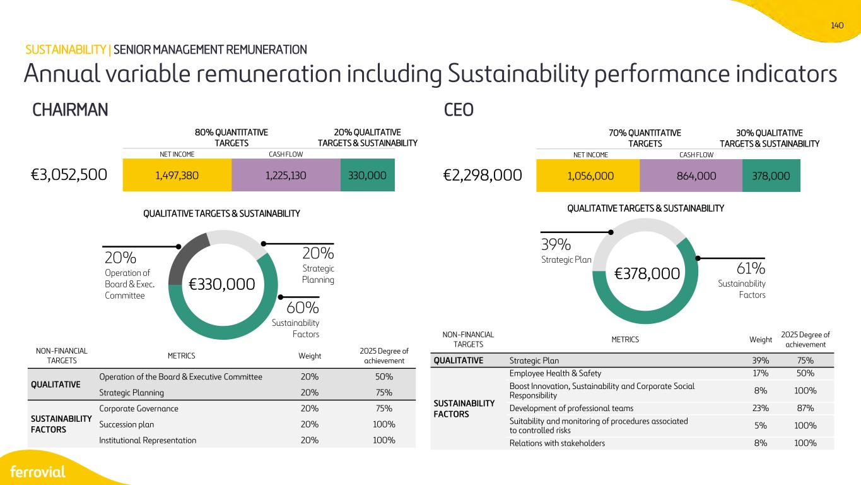
140 30% QUALITATIVE TARGETS & SUSTAINABILITY NON-FINANCIAL TARGETS METRICS Weight 2025 Degree of achievement QUALITATIVE Operation of the Board & Executive Committee 20% 50% Strategic Planning 20% 75% SUSTAINABILITY FACTORS Corporate Governance 20% 75% Succession plan 20% 100% Institutional Representation 20% 100% NON-FINANCIAL TARGETS METRICS Weight 2025 Degree of achievement QUALITATIVE Strategic Plan 39% 75% SUSTAINABILITY FACTORS Employee Health & Safety 17% 50% Boost Innovation, Sustainability and Corporate Social Responsibility 8% 100% Development of professional teams 23% 87% Suitability and monitoring of procedures associated to controlled risks 5% 100% Relations with stakeholders 8% 100% CHAIRMAN CEO 20% Operation of Board & Exec. Committee 20% Strategic Planning 60% Sustainability Factors €330,000 61% Sustainability Factors 39% Strategic Plan Annual variable remuneration including Sustainability performance indicators SUSTAINABILITY | SENIOR MANAGEMENT REMUNERATION €3,052,500 1,497,380 1,225,130 330,000 20% QUALITATIVE TARGETS & SUSTAINABILITY 80% QUANTITATIVE TARGETS NET INCOME CASH FLOW QUALITATIVE TARGETS & SUSTAINABILITY €2,298,000 1,056,000 864,000 378,000 70% QUANTITATIVE TARGETS NET INCOME CASH FLOW €378,000 QUALITATIVE TARGETS & SUSTAINABILITY

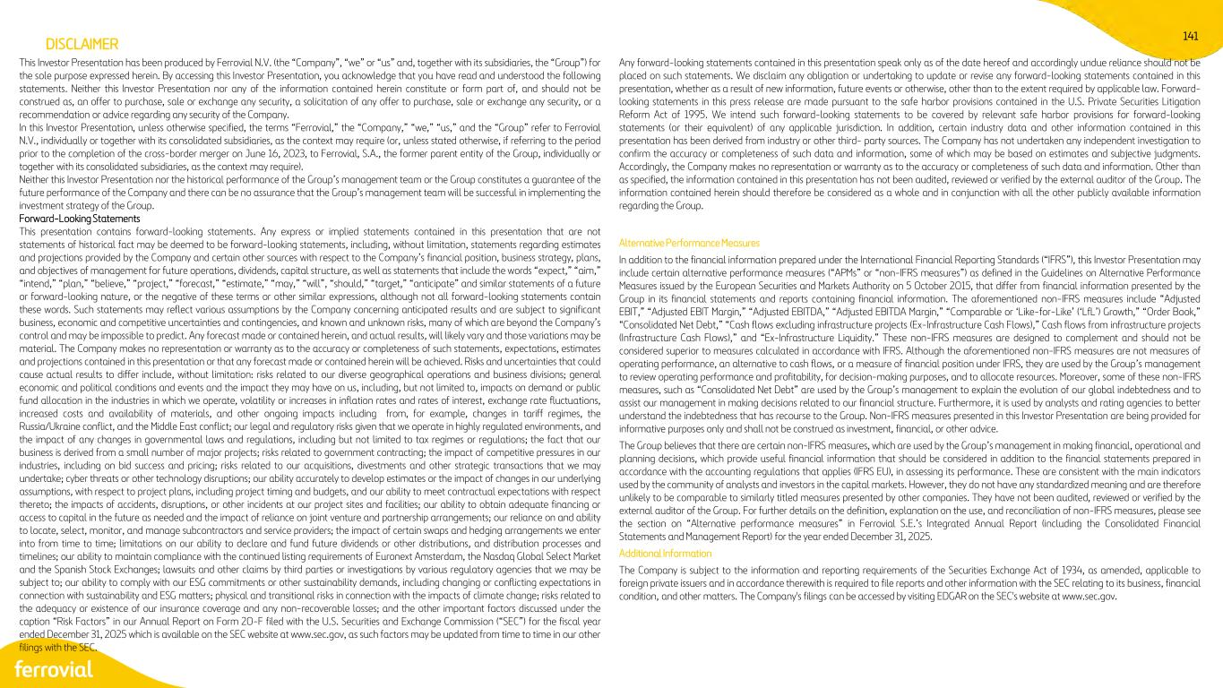
141 This Investor Presentation has been produced by Ferrovial N.V. (the “Company”, “we” or “us” and, together with its subsidiaries, the “Group”) for the sole purpose expressed herein. By accessing this Investor Presentation, you acknowledge that you have read and understood the following statements. Neither this Investor Presentation nor any of the information contained herein constitute or form part of, and should not be construed as, an offer to purchase, sale or exchange any security, a solicitation of any offer to purchase, sale or exchange any security, or a recommendation or advice regarding any security of the Company. In this Investor Presentation, unless otherwise specified, the terms “Ferrovial,” the “Company,” “we,” “us,” and the “Group” refer to Ferrovial N.V., individually or together with its consolidated subsidiaries, as the context may require (or, unless stated otherwise, if referring to the period prior to the completion of the cross-border merger on June 16, 2023, to Ferrovial, S.A., the former parent entity of the Group, individually or together with its consolidated subsidiaries, as the context may require). Neither this Investor Presentation nor the historical performance of the Group’s management team or the Group constitutes a guarantee of the future performance of the Company and there can be no assurance that the Group’s management team will be successful in implementing the investment strategy of the Group. Forward-Looking Statements This presentation contains forward-looking statements. Any express or implied statements contained in this presentation that are not statements of historical fact may be deemed to be forward-looking statements, including, without limitation, statements regarding estimates and projections provided by the Company and certain other sources with respect to the Company’s financial position, business strategy, plans, and objectives of management for future operations, dividends, capital structure, as well as statements that include the words “expect,” “aim,” “intend,” “plan,” “believe,” “project,” “forecast,” “estimate,” “may,” “will”, “should,” “target,” “anticipate” and similar statements of a future or forward-looking nature, or the negative of these terms or other similar expressions, although not all forward-looking statements contain these words. Such statements may reflect various assumptions by the Company concerning anticipated results and are subject to significant business, economic and competitive uncertainties and contingencies, and known and unknown risks, many of which are beyond the Company’s control and may be impossible to predict. Any forecast made or contained herein, and actual results, will likely vary and those variations may be material. The Company makes no representation or warranty as to the accuracy or completeness of such statements, expectations, estimates and projections contained in this presentation or that any forecast made or contained herein will be achieved. Risks and uncertainties that could cause actual results to differ include, without limitation: risks related to our diverse geographical operations and business divisions; general economic and political conditions and events and the impact they may have on us, including, but not limited to, impacts on demand or public fund allocation in the industries in which we operate, volatility or increases in inflation rates and rates of interest, exchange rate fluctuations, increased costs and availability of materials, and other ongoing impacts including from, for example, changes in tariff regimes, the Russia/Ukraine conflict, and the Middle East conflict; our legal and regulatory risks given that we operate in highly regulated environments, and the impact of any changes in governmental laws and regulations, including but not limited to tax regimes or regulations; the fact that our business is derived from a small number of major projects; risks related to government contracting; the impact of competitive pressures in our industries, including on bid success and pricing; risks related to our acquisitions, divestments and other strategic transactions that we may undertake; cyber threats or other technology disruptions; our ability accurately to develop estimates or the impact of changes in our underlying assumptions, with respect to project plans, including project timing and budgets, and our ability to meet contractual expectations with respect thereto; the impacts of accidents, disruptions, or other incidents at our project sites and facilities; our ability to obtain adequate financing or access to capital in the future as needed and the impact of reliance on joint venture and partnership arrangements; our reliance on and ability to locate, select, monitor, and manage subcontractors and service providers; the impact of certain swaps and hedging arrangements we enter into from time to time; limitations on our ability to declare and fund future dividends or other distributions, and distribution processes and timelines; our ability to maintain compliance with the continued listing requirements of Euronext Amsterdam, the Nasdaq Global Select Market and the Spanish Stock Exchanges; lawsuits and other claims by third parties or investigations by various regulatory agencies that we may be subject to; our ability to comply with our ESG commitments or other sustainability demands, including changing or conflicting expectations in connection with sustainability and ESG matters; physical and transitional risks in connection with the impacts of climate change; risks related to the adequacy or existence of our insurance coverage and any non-recoverable losses; and the other important factors discussed under the caption “Risk Factors” in our Annual Report on Form 20-F filed with the U.S. Securities and Exchange Commission (“SEC”) for the fiscal year ended December 31, 2025 which is available on the SEC website at www.sec.gov, as such factors may be updated from time to time in our other filings with the SEC. Any forward-looking statements contained in this presentation speak only as of the date hereof and accordingly undue reliance should not be placed on such statements. We disclaim any obligation or undertaking to update or revise any forward-looking statements contained in this presentation, whether as a result of new information, future events or otherwise, other than to the extent required by applicable law. Forward- looking statements in this press release are made pursuant to the safe harbor provisions contained in the U.S. Private Securities Litigation Reform Act of 1995. We intend such forward-looking statements to be covered by relevant safe harbor provisions for forward-looking statements (or their equivalent) of any applicable jurisdiction. In addition, certain industry data and other information contained in this presentation has been derived from industry or other third- party sources. The Company has not undertaken any independent investigation to confirm the accuracy or completeness of such data and information, some of which may be based on estimates and subjective judgments. Accordingly, the Company makes no representation or warranty as to the accuracy or completeness of such data and information. Other than as specified, the information contained in this presentation has not been audited, reviewed or verified by the external auditor of the Group. The information contained herein should therefore be considered as a whole and in conjunction with all the other publicly available information regarding the Group. Alternative Performance Measures In addition to the financial information prepared under the International Financial Reporting Standards (“IFRS”), this Investor Presentation may include certain alternative performance measures (“APMs” or “non-IFRS measures”) as defined in the Guidelines on Alternative Performance Measures issued by the European Securities and Markets Authority on 5 October 2015, that differ from financial information presented by the Group in its financial statements and reports containing financial information. The aforementioned non-IFRS measures include “Adjusted EBIT,” “Adjusted EBIT Margin,” “Adjusted EBITDA,” “Adjusted EBITDA Margin,” “Comparable or ‘Like-for-Like’ (‘LfL’) Growth,” “Order Book,” “Consolidated Net Debt,” “Cash flows excluding infrastructure projects (Ex-Infrastructure Cash Flows),” Cash flows from infrastructure projects (Infrastructure Cash Flows),” and “Ex-Infrastructure Liquidity.” These non-IFRS measures are designed to complement and should not be considered superior to measures calculated in accordance with IFRS. Although the aforementioned non-IFRS measures are not measures of operating performance, an alternative to cash flows, or a measure of financial position under IFRS, they are used by the Group’s management to review operating performance and profitability, for decision-making purposes, and to allocate resources. Moreover, some of these non-IFRS measures, such as “Consolidated Net Debt” are used by the Group’s management to explain the evolution of our global indebtedness and to assist our management in making decisions related to our financial structure. Furthermore, it is used by analysts and rating agencies to better understand the indebtedness that has recourse to the Group. Non-IFRS measures presented in this Investor Presentation are being provided for informative purposes only and shall not be construed as investment, financial, or other advice. The Group believes that there are certain non-IFRS measures, which are used by the Group’s management in making financial, operational and planning decisions, which provide useful financial information that should be considered in addition to the financial statements prepared in accordance with the accounting regulations that applies (IFRS EU), in assessing its performance. These are consistent with the main indicators used by the community of analysts and investors in the capital markets. However, they do not have any standardized meaning and are therefore unlikely to be comparable to similarly titled measures presented by other companies. They have not been audited, reviewed or verified by the external auditor of the Group. For further details on the definition, explanation on the use, and reconciliation of non-IFRS measures, please see the section on “Alternative performance measures” in Ferrovial S.E.’s Integrated Annual Report (including the Consolidated Financial Statements and Management Report) for the year ended December 31, 2025. Additional Information The Company is subject to the information and reporting requirements of the Securities Exchange Act of 1934, as amended, applicable to foreign private issuers and in accordance therewith is required to file reports and other information with the SEC relating to its business, financial condition, and other matters. The Company's filings can be accessed by visiting EDGAR on the SEC's website at www.sec.gov. DISCLAIMER


142 Investor Relations ir@ferrovial.com www.ferrovial.com ferrovial

