UNITED STATES
SECURITIES AND EXCHANGE COMMISSION
Washington, D.C. 20549
___________________________
FORM 6-K
___________________________
REPORT OF FOREIGN PRIVATE ISSUER PURSUANT TO
SECTION 13a-16 OR 15d-16
UNDER THE SECURITIES EXCHANGE ACT OF 1934
Date: For the month of August 2026
Commission File Number: 001-41912
___________________________
Ferrovial N.V.
___________________________
Gustav Mahlerplein 61-63
Symphony Towers, 14th Floor
1082 MS Amsterdam
The Netherlands
Tel: +31 20798 37 02
(Address of principal executive office)
Indicate by check mark whether the registrant files or will file annual reports under cover of
Form 20-F or Form 40-F.
Form 20-F ☒ Form 40-F ☐

EXPLANATORY NOTE

Ferrovial N.V. is submitting this current report on Form 6-K to announce that the consortium in which Ferrovial
participates has been selected to deliver Tennessee’s I-24 Choice Lanes.
Attached to this current report on Form 6-K is:
(1) a press release dated August 20, 2026 as Exhibit 99.1.

EXHIBIT INDEX

SIGNATURES
99.1

Exhibit
No.
Description
Pursuant to the requirements of the Securities Exchange Act of 1934, as amended, the registrant
has duly caused this report to be signed on its behalf by the undersigned, thereunto duly
authorized.
Ferrovial N.V.
Date: August 20, 2026
By: /s/ Geerte Gudule Hesen
Geerte Gudule Hesen
Chief Legal Officer
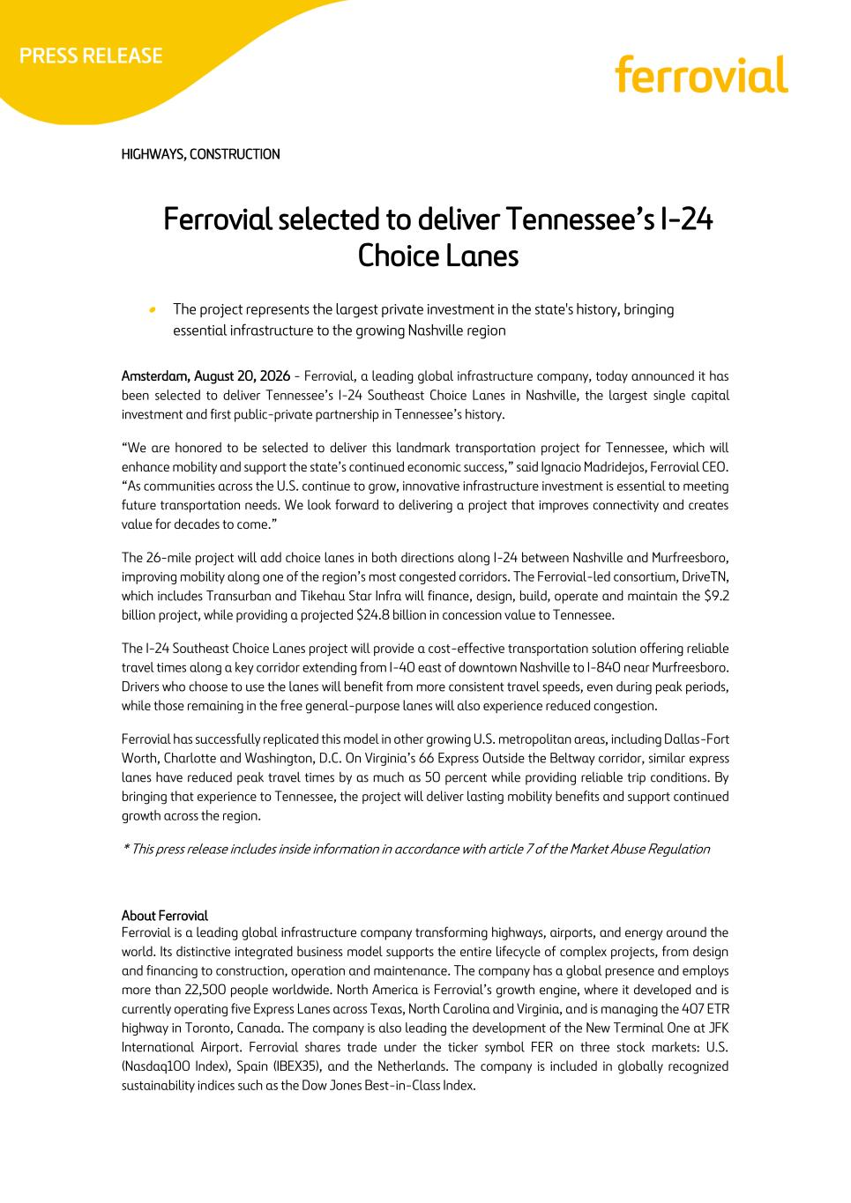
HIGHWAYS, CONSTRUCTION Ferrovial selected to deliver Tennessee’s I-24 Choice Lanes • The project represents the largest private investment in the state's history, bringing essential infrastructure to the growing Nashville region Amsterdam, August 20, 2026 - Ferrovial, a leading global infrastructure company, today announced it has been selected to deliver Tennessee’s I-24 Southeast Choice Lanes in Nashville, the largest single capital investment and first public-private partnership in Tennessee’s history. “We are honored to be selected to deliver this landmark transportation project for Tennessee, which will enhance mobility and support the state’s continued economic success,” said Ignacio Madridejos, Ferrovial CEO. “As communities across the U.S. continue to grow, innovative infrastructure investment is essential to meeting future transportation needs. We look forward to delivering a project that improves connectivity and creates value for decades to come.” The 26-mile project will add choice lanes in both directions along I-24 between Nashville and Murfreesboro, improving mobility along one of the region’s most congested corridors. The Ferrovial-led consortium, DriveTN, which includes Transurban and Tikehau Star Infra will finance, design, build, operate and maintain the $9.2 billion project, while providing a projected $24.8 billion in concession value to Tennessee. The I-24 Southeast Choice Lanes project will provide a cost-effective transportation solution offering reliable travel times along a key corridor extending from I-40 east of downtown Nashville to I-840 near Murfreesboro. Drivers who choose to use the lanes will benefit from more consistent travel speeds, even during peak periods, while those remaining in the free general-purpose lanes will also experience reduced congestion. Ferrovial has successfully replicated this model in other growing U.S. metropolitan areas, including Dallas-Fort Worth, Charlotte and Washington, D.C. On Virginia’s 66 Express Outside the Beltway corridor, similar express lanes have reduced peak travel times by as much as 50 percent while providing reliable trip conditions. By bringing that experience to Tennessee, the project will deliver lasting mobility benefits and support continued growth across the region. * This press release includes inside information in accordance with article 7 of the Market Abuse Regulation About Ferrovial Ferrovial is a leading global infrastructure company transforming highways, airports, and energy around the world. Its distinctive integrated business model supports the entire lifecycle of complex projects, from design and financing to construction, operation and maintenance. The company has a global presence and employs more than 22,500 people worldwide. North America is Ferrovial’s growth engine, where it developed and is currently operating five Express Lanes across Texas, North Carolina and Virginia, and is managing the 407 ETR highway in Toronto, Canada. The company is also leading the development of the New Terminal One at JFK International Airport. Ferrovial shares trade under the ticker symbol FER on three stock markets: U.S. (Nasdaq100 Index), Spain (IBEX35), and the Netherlands. The company is included in globally recognized sustainability indices such as the Dow Jones Best-in-Class Index.

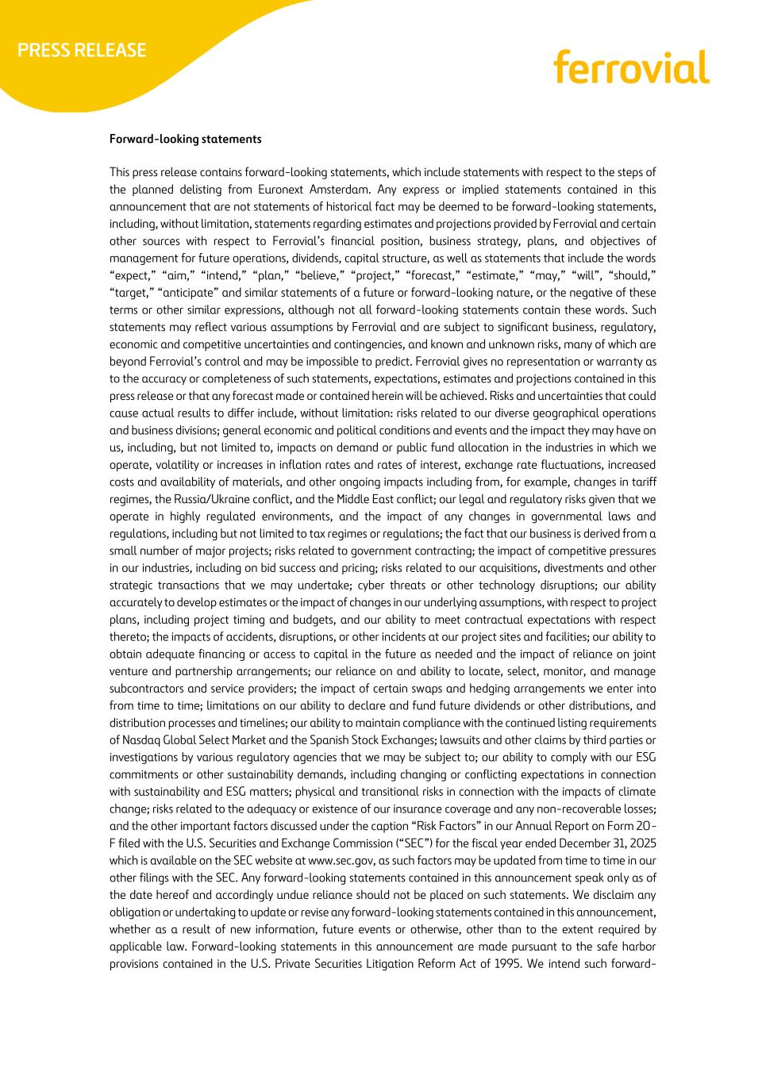
Forward-looking statements This press release contains forward-looking statements, which include statements with respect to the steps of the planned delisting from Euronext Amsterdam. Any express or implied statements contained in this announcement that are not statements of historical fact may be deemed to be forward-looking statements, including, without limitation, statements regarding estimates and projections provided by Ferrovial and certain other sources with respect to Ferrovial’s financial position, business strategy, plans, and objectives of management for future operations, dividends, capital structure, as well as statements that include the words “expect,” “aim,” “intend,” “plan,” “believe,” “project,” “forecast,” “estimate,” “may,” “will”, “should,” “target,” “anticipate” and similar statements of a future or forward-looking nature, or the negative of these terms or other similar expressions, although not all forward-looking statements contain these words. Such statements may reflect various assumptions by Ferrovial and are subject to significant business, regulatory, economic and competitive uncertainties and contingencies, and known and unknown risks, many of which are beyond Ferrovial’s control and may be impossible to predict. Ferrovial gives no representation or warranty as to the accuracy or completeness of such statements, expectations, estimates and projections contained in this press release or that any forecast made or contained herein will be achieved. Risks and uncertainties that could cause actual results to differ include, without limitation: risks related to our diverse geographical operations and business divisions; general economic and political conditions and events and the impact they may have on us, including, but not limited to, impacts on demand or public fund allocation in the industries in which we operate, volatility or increases in inflation rates and rates of interest, exchange rate fluctuations, increased costs and availability of materials, and other ongoing impacts including from, for example, changes in tariff regimes, the Russia/Ukraine conflict, and the Middle East conflict; our legal and regulatory risks given that we operate in highly regulated environments, and the impact of any changes in governmental laws and regulations, including but not limited to tax regimes or regulations; the fact that our business is derived from a small number of major projects; risks related to government contracting; the impact of competitive pressures in our industries, including on bid success and pricing; risks related to our acquisitions, divestments and other strategic transactions that we may undertake; cyber threats or other technology disruptions; our ability accurately to develop estimates or the impact of changes in our underlying assumptions, with respect to project plans, including project timing and budgets, and our ability to meet contractual expectations with respect thereto; the impacts of accidents, disruptions, or other incidents at our project sites and facilities; our ability to obtain adequate financing or access to capital in the future as needed and the impact of reliance on joint venture and partnership arrangements; our reliance on and ability to locate, select, monitor, and manage subcontractors and service providers; the impact of certain swaps and hedging arrangements we enter into from time to time; limitations on our ability to declare and fund future dividends or other distributions, and distribution processes and timelines; our ability to maintain compliance with the continued listing requirements of Nasdaq Global Select Market and the Spanish Stock Exchanges; lawsuits and other claims by third parties or investigations by various regulatory agencies that we may be subject to; our ability to comply with our ESG commitments or other sustainability demands, including changing or conflicting expectations in connection with sustainability and ESG matters; physical and transitional risks in connection with the impacts of climate change; risks related to the adequacy or existence of our insurance coverage and any non-recoverable losses; and the other important factors discussed under the caption “Risk Factors” in our Annual Report on Form 20- F filed with the U.S. Securities and Exchange Commission (“SEC”) for the fiscal year ended December 31, 2025 which is available on the SEC website at www.sec.gov, as such factors may be updated from time to time in our other filings with the SEC. Any forward-looking statements contained in this announcement speak only as of the date hereof and accordingly undue reliance should not be placed on such statements. We disclaim any obligation or undertaking to update or revise any forward-looking statements contained in this announcement, whether as a result of new information, future events or otherwise, other than to the extent required by applicable law. Forward-looking statements in this announcement are made pursuant to the safe harbor provisions contained in the U.S. Private Securities Litigation Reform Act of 1995. We intend such forward-

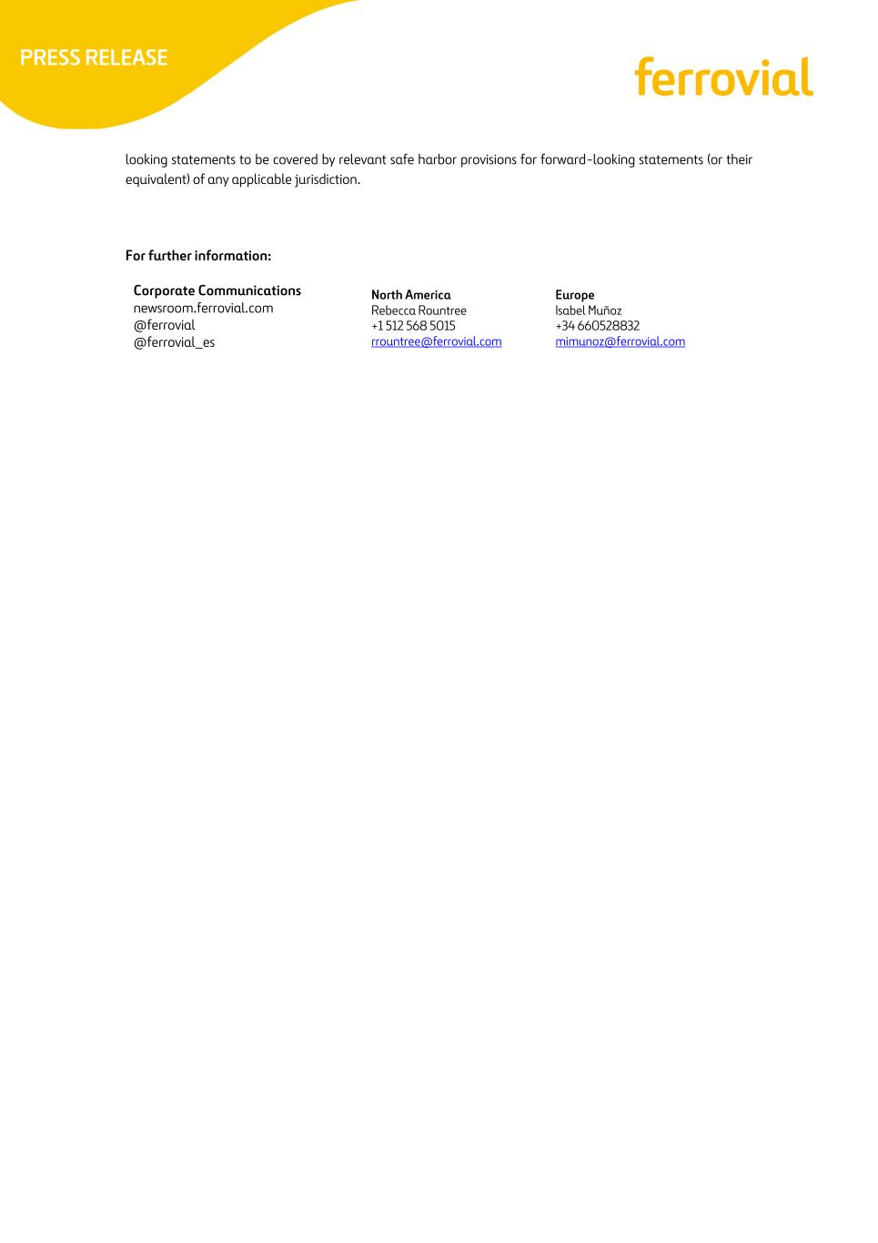
looking statements to be covered by relevant safe harbor provisions for forward-looking statements (or their equivalent) of any applicable jurisdiction. For further information: Corporate Communications newsroom.ferrovial.com @ferrovial @ferrovial_es North America Rebecca Rountree +1 512 568 5015 rrountree@ferrovial.com Europe Isabel Muñoz +34 660528832 mimunoz@ferrovial.com

